

Transforming Southbank Boulevard and Dodds Street: June 2018 Bulletin
Construction of the first stage of the Southbank Boulevard and Dodds Street Concept Plan will start in July 2018.
The transformation of Southbank Boulevard and Dodds Street will create 2.5 hectares of new public space in one of Melbourne’s most densely populated suburbs.
The Concept Plan, adopted by Council in 2017, outlines a new vision for Southbank that will:
- create 2.5 hectares of new public open space
- prioritise pedestrians, public transport and cyclists
- deliver a new, accessible tram stop on Sturt Street
- enhance the gateway into the Arts Precinct
- create a living link, connecting the Domain Parklands to the Yarra River
- create a ‘Melbourne Experience’ for Southbank
- build a new civic square for the precinct
- deliver a series of new neighbourhood parks for the community.
Located in the heart of Melbourne’s Arts Precinct, this project will transform this once busy street into one of Australia’s most pedestrian-friendly places. It recognises the rich history and stories of the site and it is based on extensive community and stakeholder engagement.

Upcoming works

JUL - SEP 2018
Early works construction.
Civil, road and tram infrastructure works in preparation for main tram works construction period.

22-30 SEP 2018
Main tram construction period.
Demolition of existing tram infrastructure, construction and recommissioning of new tram line and tram stop on Sturt Street.

OCT ‘18 - AUG ‘19
Civil construction works.
Civil, road and landscape construction works between Sturt Street and City Road.

Stages of construction

How will we build it?
Due to its size, scale and complexity, construction will be undertaken in six stages.
The first of these stages is the largest and the most complex. It involves altering the existing roadway and tram infrastructure to create new public space while still accommodating traffic. It is expected to take approximately 13 months to build.
Three stages of construction will start from July, 2018:
- Stage 1 A: Early works
- Stage 1 B: Tram occupation works
- Stage 1 C: Civil and footpath works.

What will happen during Stage 1 construction?
During this stage of work you will see:
- changes to the existing road by converting the east bound carriageway to accommodate two way traffic and the closure of the west bound carriageway to create new public open space
- installation of new tram poles and overhead infrastructure
- removal of some street trees and replanting of 68 new trees
- construction of new tram tracks with planting between St Kilda Road and Sturt Street
- the construction of a new central island tram stop on Sturt Street, between the ABC and Melbourne Recital Centre
- and installation of new street lighting.
Image: Construction staging plan for the six stages of the project. Description in alt text.
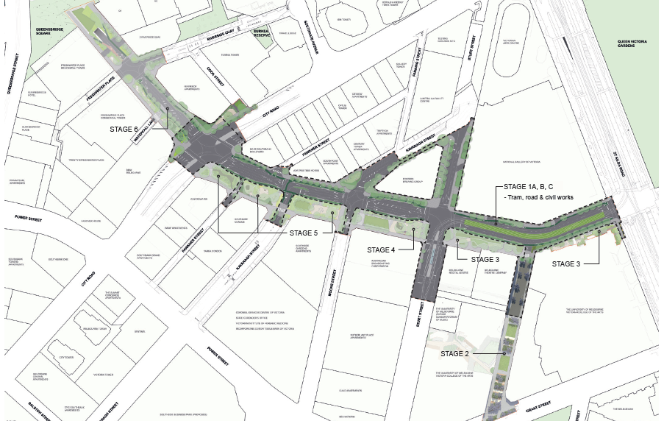

Stage 1 A - Early works
Early July to 21 September 2018
Southbank Boulevard will be closed to all traffic between St Kilda Road and Sturt Street in order to prepare for tram construction works.
During this period you will see the installation of new tram poles, installation of new kerb and channel, relocation and under-grounding of services such as power lines, and preparation for the main tram construction period in September.
During this time there will be no vehicle access to Southbank Boulevard between St Kilda Road and Sturt Street.
Trams will continue to operate, and buses will be diverted. Pedestrians will continue to have access to the precinct.

Stage 1 B - Tram occupation works
22-30 September 2018
For 9 days, construction of a new central island platform and new tram infrastructure will take place on Southbank Boulevard and Sturt Street. Tram tracks will be reconstructed on a new alignment, including new greening between the tracks.
During this time, vehicles will not have access to Southbank Boulevard, between St Kilda Rd and Sturt Street. A small section of Sturt Street, between the ABC and Melbourne Recital Centre will also be closed during this time.
Trams will NOT operate and buses will continue to be diverted. Pedestrians will continue to have access to the precinct.

Stage 1 C - Civil and footpath works
1 October 2018 to August 2019
Once the tram infrastructure and civil works are completed between St Kilda Road and Sturt Street, construction will start on the remainder of Southbank Boulevard between Sturt Street and City Road.
This portion of the project will be undertaken in a number of stages in order to minimise disruption. It will see the west bound carriageway discontinued to create new public open space, and the current east bound one way carriageway converted to two way traffic.
During these dates trams will recommence. Buses will continue to be diverted.
Southbank Boulevard will progressively be re-opened.

How will these works affect you?

Pedestrian Access
During construction, the precinct will remain open to pedestrians, and it will be business as usual for the various institutions along Southbank Boulevard, Sturt and Dodds Street.
At times, we will need to close footpaths in order to lay new pavement. We will, however, endeavour to keep one side of the street open to pedestrians at all times so that access to the precinct will be largely unchanged during construction.

Public Transport
During construction, there will be some disruption to public transport, including detours for buses and disruption to tram services.

Buses
The following bus services will diverted during construction:
- 216 Sunshine Station - Brighton Beach
- 219 Sunshine South - Gardenvale
- 220 Sunshine - City - Gardenvale
- 605 Gardenvale - Flagstaff Station
Further information on these diversions can be obtained through Public Transport Victoria (PTV).

Trams
The East Coburg / South Melbourne tram (route no. 1) will continue to operate during construction. The only disruption to this service will occur between 22 - 30 September 2018, during which time this service will not operate on Southbank Boulevard while the new tram stop is constructed.
For more information on trams visit the Yarra Trams website.

Vehicle Access
At times, portions of Southbank Boulevard will be closed to traffic to allow for construction to occur.
Detour plans, with detailed information, will be released prior to the start of each stage of the project to keep you informed and help you plan your travel.

Bicycle Access
At times, portions of Southbank Boulevard will be closed to cyclists to allow for construction to occur. During construction, we urge you to find an alternative route to use, while we build 1.1km of new separated cycle lanes.

Trees
In order to construct the new roadways and public open space we will need to remove 87 trees along the length of Southbank Boulevard. These trees will be removed in stages as construction is undertaken along the length of the boulevard, and will be replaced as each stage of the project is completed.
We will provide details of which trees will be removed and how we will be replacing them in future construction bulletins.
Further information about the implementation of Transforming Southbank Boulevard will be provided as the project progresses. To find out more, please contact 9658 9658 or visit the Participate website.

https://www.ptv.vic.gov.au/
https://yarratrams.com.au/
https://www.participate.melbourne.vic.gov.au/southbankboulevard

