

Western Pavilion redevelopment project update May 2021

The City of Melbourne will soon commence works on construction of the new Western Pavilion, located in Royal Park near Park Street. The existing pavilion is in poor condition and does not meet the current needs of the sporting clubs or modern building accessibility and construction standards.

The new pavilion will include spaces for social activities and food preparation, four gender-neutral change rooms and change rooms for umpires. This means more teams and community groups will be able to use the facilities.

Construction program

The new pavilion will be situated adjacent to the existing pavilion so sports activities can continue while the new facility is built.

Construction will commence at the end of May and is expected to be completed by April 2022 in time for the commencement of winter sports.

Works will be carried out in the following stages:

Foundation works and sewer upgrade

Construction of frame and roof

Fit-out of new pavilion

Landscaping works

Following completion of the new pavilion, the existing pavilion will be demolished and the area returned to parkland.

Construction impacts

Construction impacts Construction will take place during the day and will generate low levels of noise and some dust. Trucks will also be moving through the area to support construction of the pavilion.

A site compound and laydown (refer to worksite map) area will be set up in the car park, requiring the closure of a section of the car park. On-street parking will be available during this time however. The car park will be reconfigured as part of this project to incorporate new landscaped areas.

Normal sports activities will not be impacted and will be able to continue during construction of the new facility. Pedestrian access to the ovals will however be redirected around the work site.

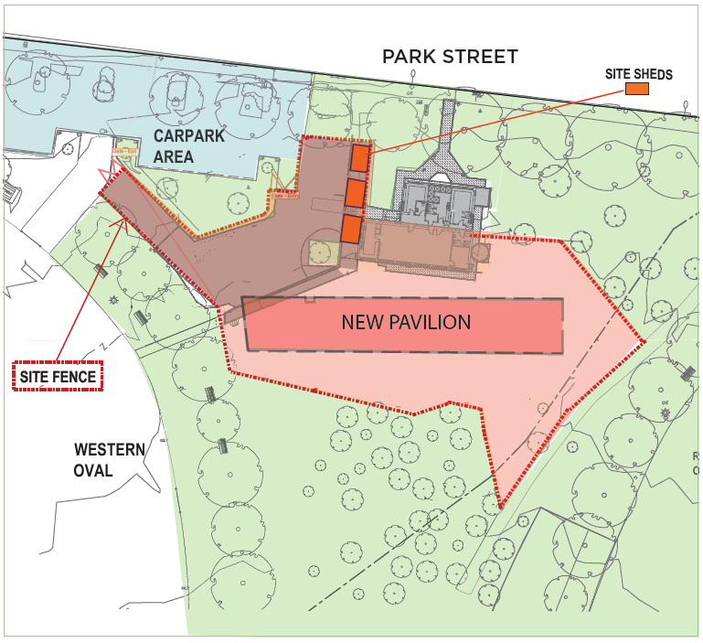
Map of worksite

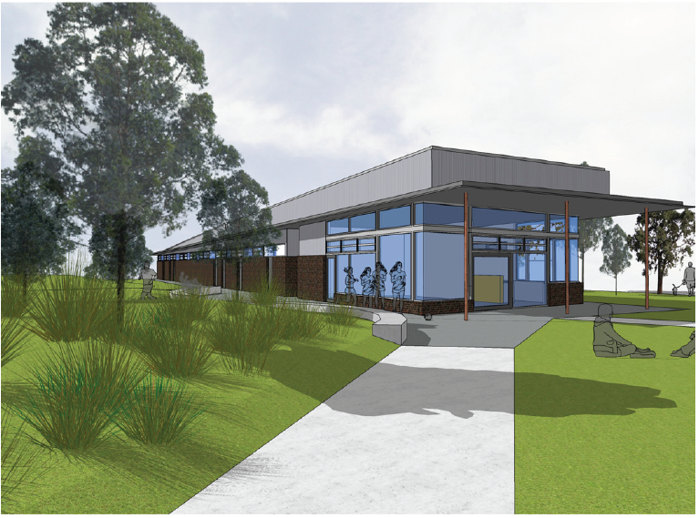

Artist impression – Western Pavilion

To find out more, please contact 9658 9658, or visit melbourne.vic.gov.au/cityprojects

https://www.melbourne.vic.gov.au/building-and-development/shaping-the-city/city-projects/Pages/city-projects.aspx

