

Transforming Southbank Boulevard and Dodds Street

Construction Bulletin 10

April 2019
With the majority of service works now complete, pavement and finishing works are well underway. Over the course of the next few weeks, bluestone footpaths will be completed. Asphalting will commence for cycle lanes and the roadway, with staged openings for pedestrian and vehicle areas.
Detours will be in place around the work site, please be aware of changing conditions for pedestrians and vehicles as construction takes place in the area.
Cyclists are asked to dismount as they move through the construction zone for safety reasons.

Current works

St Kilda Rd to Sturt Street
The concrete base for much of the bluestone paving has been laid, with the final pavement to follow. Bluestone paving works are underway, with contractors working hard to complete paving to footpath areas. Once complete, these areas will be reopened.
Once bluestone paving works are complete, further kerb installation works will be undertaken, and asphalt to cycle lanes and roadway will commence.

Sturt Street to City Road
Construction between Sturt Street and City Road has commenced, and will continue through until late-2019. Detours for this period of construction will be advised in advance of closures.

Landscape works
The construction of the first public spaces will commence in mid-2019. The construction of each of the landscape areas will continue through until mid-2020.
Once the current traffic works are complete we anticipate less of an impact on traffic in the surrounding area.
Local businesses in the area remain open during works.

Current works

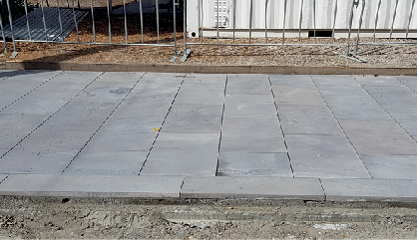
Bluestone pavement currently under construction on Southbank Boulevard

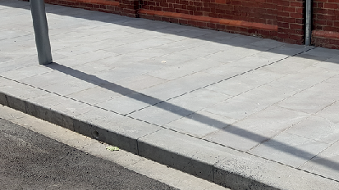
Completed bluestone pavement on Dodds Street.
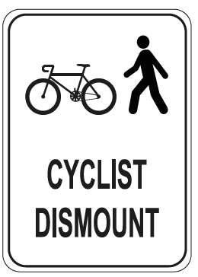
Cyclists please dismount as you move through the construction zone
Thank you for your patience.
To find out more, please contact 9658 9658, email southbankboulevard@melbourne.vic.gov.au, or visit melbourne.vic.gov.au/southbankboulevard

