

Transforming Southbank Boulevard - September 2019
Significant construction activity continues to take place along Southbank Boulevard. In the coming months, asphalting works will be undertaken to many of the areas which are currently under construction. As the roadway works are completed, sections of the boulevard will be reopened to vehicle traffic.

Current works

St Kilda Road to Sturt Street

Roadway construction works between St Kilda Road and Sturt Street are complete, and lighting installation works will commence in the near future. The green tram track will be replanted as we move into spring, after heavy rainfall caused significant damage to the area.

Sturt Street

Throughout the week commencing 2 September, asphalting and line-marking works will be carried out along Sturt Street. Some of these works will be noisy and involve the use of asphalting machinery, with some activity taking place outside of the usual construction working hours. Detours will be in place during these works, however northbound traffic along Sturt Street will be maintained for access to the precinct.

Sturt Street to Moore Street

Utility installation and traffic signal works are continuing along this section of Southbank Boulevard. Kerb and bike path construction is also underway, and asphalting to this section of roadway will take place in September.

Kavanagh Street to Fawkner Street

Traffic signal and utility installation is underway at the Kavanagh Street intersection, along with lighting installation works, and kerb and channel construction.

Landscape works

Bluestone pavement construction in front of the Melbourne Recital Centre and Southbank Theatre is progressing, with the Sturt Street pedestrian crossing now open. Concrete footings have been poured, and delivery of stone to the construction site will begin next month, along with the commencement of tree and ground level planting.
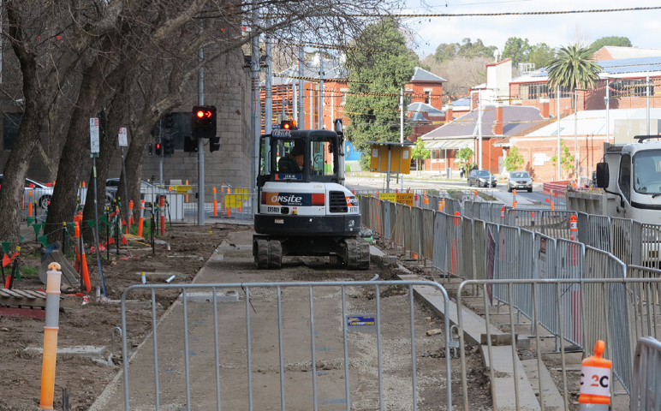

Cycle lane construction underway between Sturt Street and Moore Street.
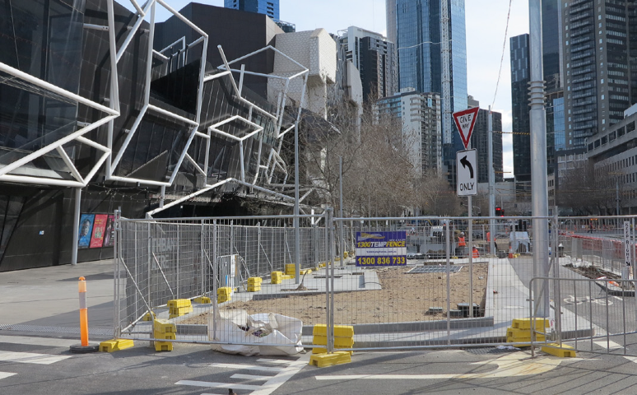

Progress of Stage 2 of Southbank Boulevard.
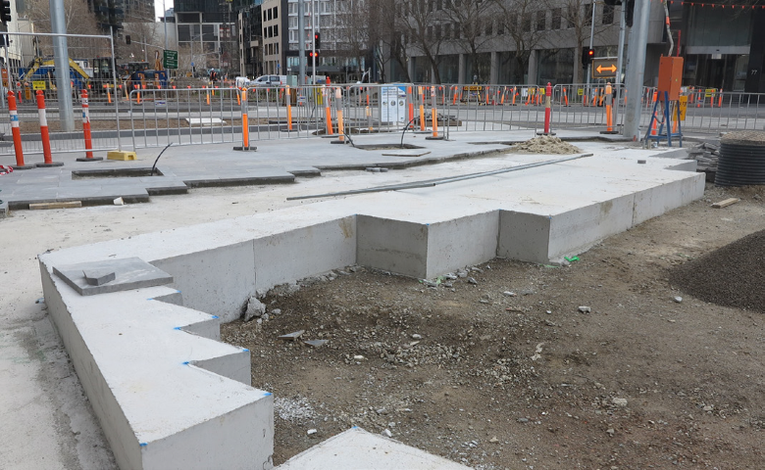
Concrete footings to the Melbourne Recital Centre and Southbank Theatre landscape.

Detours

Detours will continue to be in place around the worksite. Please be aware of changing conditions for pedestrians and vehicles as construction takes place in the area. For safety reasons cyclists are asked to discount as they move through the construction zone.
Thank you for your patience.

To find out more, please contact 9658 9658 or visit melbourne.vic.gov.au/southbankboulevard

