

Transforming Southbank Boulevard

Construction Bulletin November 2019
Works are currently underway between Kavanagh Street and City Road, and at the City Road and Southbank Boulevard intersection. Major signal infrastructure installation is occurring during the month of November.
All roadworks up to the City Road intersection are currently on track to be completed prior to Christmas 2019.
Stone installation also continues in the open space in front of the Melbourne Recital Centre and Southbank Theatre between Dodds Street and Sturt Street.

Current works

City Road Intersection
At the City Road intersection, works are continuing for the installation of major signal infrastructure. Southbank Boulevard, between Kavanagh Street and City Road, including entry from City Road, remains closed with detours in place to redirect vehicles and pedestrians.
In order to minimise traffic disruptions on City Road, signal infrastructure installation works are only permitted to be undertaken as night works between 8pm and 5am, Sunday to Thursday nights during November. The loudest works, including saw-cutting, jack hammering and excavation are being completed prior to midnight each night to reduce the impact on nearby residents.
Contractors are working to a tight schedule and works at the City Road intersection are tracking to be completed prior to Christmas. We apologise for any inconvenience caused during the delivery of these important works.

Sturt Street to Moore Street
Works still underway include the completion of bike lane construction, and commissioning of street lighting.

Kavanagh Street to City Road
Traffic signal, utility and public lighting installation are underway between Kavanagh Street and City Road. Over the coming month, the roadway realignment, kerb and channel construction and road re-asphalting will be progressively completed.
Arts Gateway Open Space
Construction of the open space area to the front of the Melbourne Recital Centre and Southbank Theatre is progressing, with stone installation, tree and ground level planting underway. Further information on timeframes for completion of this area will be provided in the coming month.
ABC Open Space
Construction is expected to commence in early 2020 on the largest of the Southbank Boulevard public open space areas. This space will include hardstand and lawn areas, along with plenty of seating, planting, and trees.

Detours

Detours will continue to be in place around the worksite. Please be aware of changing conditions for pedestrians and vehicles as construction takes place in the area.

Bike lanes are now partially open along Southbank Boulevard, however cyclists are asked to dismount when travelling on footpaths within the areas which do not have fully completed bike lanes.
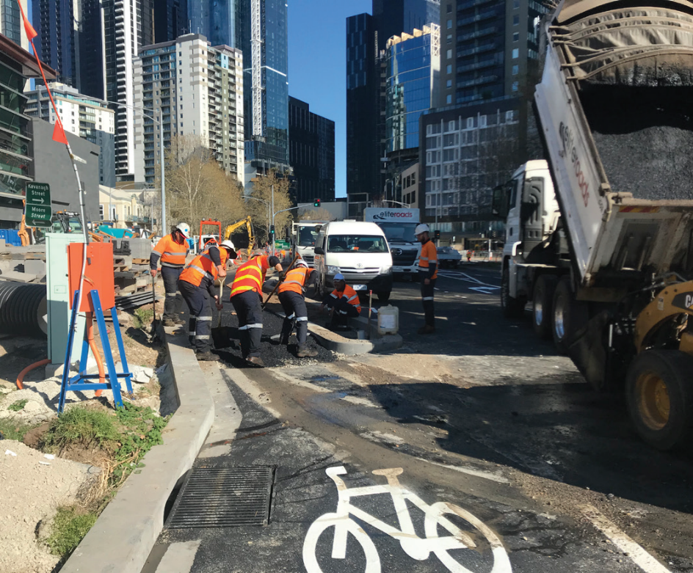

Bike path construction in progress
Thank you for your patience.

To find out more, please contact 9658 9658 email southbankboulevard@melbourne.vic.gov.au, or visit City Projects

https://www.melbourne.vic.gov.au/cityprojects

