

Transforming Southbank Boulevard and Dodds Street

Construction Bulletin 7
Stage 1C: December 2018 and January 2019

The holiday closure period for works to Southbank Boulevard and Dodds Street will be from 21 December until 13 January 2019. Works will resume on site on Monday 14 January 2019.
Expected construction works during December and January include:
- Electrical works in Southbank Boulevard and Sturt Street.
- Installation of traffic signals at the intersection of Sturt Street and Southbank Boulevard.
- Asphalting of the intersection of Sturt Street and Southbank Boulevard and parts of the roadway of Southbank Boulevard between St Kilda Road and Sturt Street. This may require intermittent lane closures and pedestrian detours.
- Continued works to the kerb and channel in Dodds Street and Southbank Boulevard.

Key dates
21 December 2018 to 13 January 2019: Holiday closure period
14 January 2019: Works resume

Vehicle Traffic
Southbank Boulevard between St Kilda Road and Kavanagh Street is currently closed to vehicle traffic and detours are in place.
New traffic lights will be installed at the intersection of Sturt Street and Southbank Boulevard in December 2018. Until then, traffic controllers will continue to assist with the safe operation of this intersection.
Southbank Boulevard between St Kilda Road and Sturt Street will gradually re-open in early 2019.
Image: Artist’s impression of completed landscape between St Kilda Road and Sturt Street.
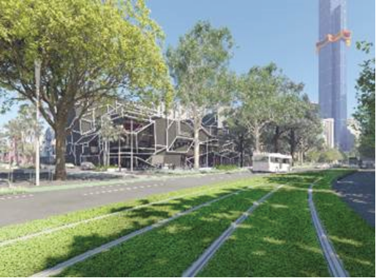
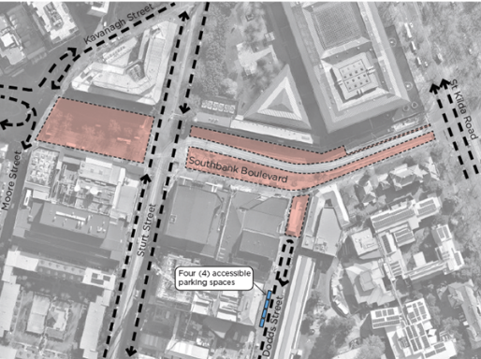

Pedestrians
Pedestrian access continues through the precinct. We ask you to take care while walking as conditions have changed.

Arts Precinct access and drop-off
Dodds Street, between Grant Street and the rear of the Melbourne Theatre Company, will continue to function as a road, parking area, and drop-off for the Arts Precinct. Four accessible car parks are available outside 24 Dodds Street. From there, you are able to walk along to Southbank Boulevard.

Thank you for your patience
We apologise for the inconvenience and thank you for your patience.
To find out more, please contact 9658 9658 or visit website: melbourne.vic.gov.au/cityprojects

https://www.melbourne.vic.gov.au/cityprojects

