Transforming Southbank Boulevard

Construction update

October 2021

The Transforming Southbank Boulevard project has reached a major milestone, with all open spaces along the boulevard now complete and open for the community to enjoy, just in time for the warmer weather and holiday period. The last part of this multi-stage project is construction of the new play space.

Neighbourhood parks

Following the opening of the neighbourhood park between Moore and Kavanagh streets, the second neighbourhood park located between Fawkner Street and City Road has also been completed. Works undertaken recently include the installation of a steel walkway through the park, new irrigation and lighting. Bluestone paving was also completed near the City Road intersection, including the pedestrian crossing.

New plants and 82 new trees have been planted in this new space, including Hickory Wattle, Silver Wattle, Australian Blackwood, Bush Cherry, Willow-leaved Hakea and Rose Gums. An additional 39 trees will also be planted during the 2022 planting season.

Play space

The final component of the Transforming Southbank Boulevard project is a new play space between Kavanagh and Fawkner streets which will commence in early 2022.

It has been designed as a natural play space with activities for children of all ages to enjoy, such as boulders for climbing, swings, slides and ladders.

Construction dates

We would like to thank all nearby residents and businesses for your support and patience in 2021 during construction of this important project for Southbank. Construction has wrapped up for the year, and works will recommence early in 2022 for the new play space.
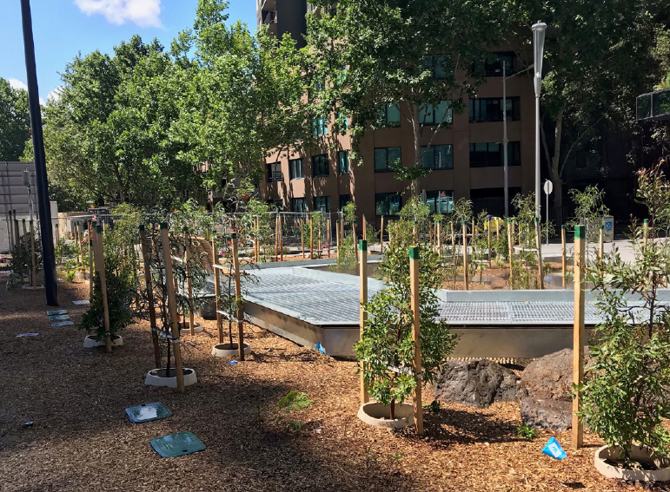
New trees
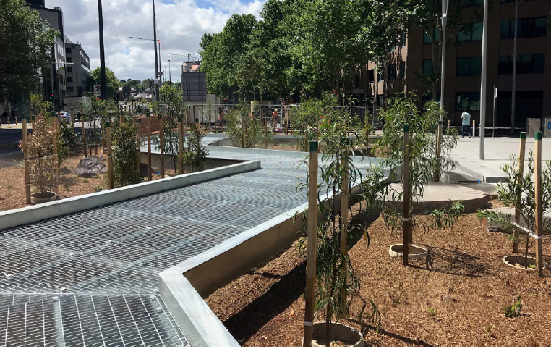
Steel walkway through the park

To find out more, please contact 9658 9658, or visit City projects

www.melbourne.vic.gov.au/cityprojects

