Section two, block – Miles Street, Wells Street, Dorcas Street and Dodds Street
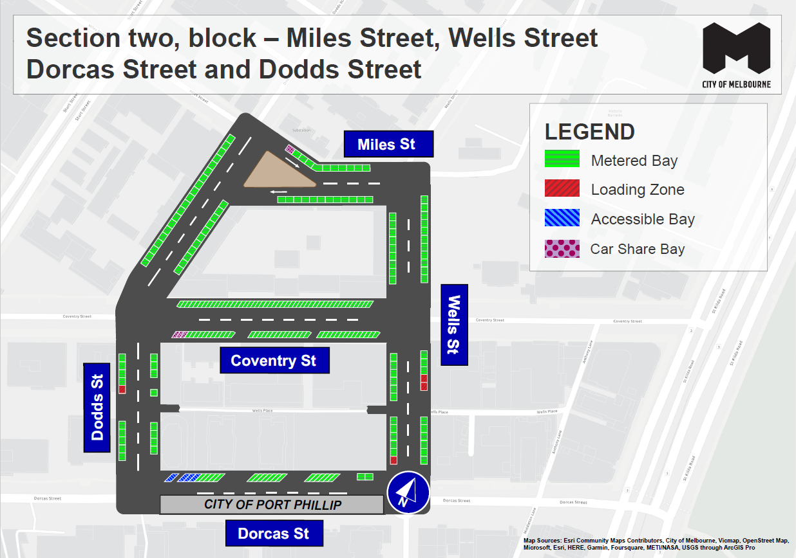
This map presents the parking conditions to be applied within this block as part of the parking improvement works in this neighbourhood.
Miles Street
The north side, from west to east includes 1 car share parking space and 10 metered parking spaces.
The south side includes 12 metered parking spaces.
Wells Street
The west side, from south to north, includes 1 loading zone parking space and 20 metered parking spaces.
The east side, from south to north includes 6 metered parking spaces, 2 loading zone parking spaces and 14 metered parking spaces.
Dorcas Street
The north side from west to east includes 4 accessible parking spaces and 20 metered parking spaces.
Dodds Street
The east side includes 19 metered parking spaces.
The west side, from south to north includes 5 metered parking spaces, 1 loading parking space and 24 metered parking spaces.
Coventry Street
The north side includes 47 metered parking spaces.
The south side from west to east, includes 3 car share parking spaces 39 metered parking spaces.
Parking controls to be applied in this area
Within this area, consistent parking controls will be applied to make parking fairer and more reliable.
Pick up/drop off spaces will typically be signed ‘No Parking’. We will add signage to explain that the space is for passenger pick up / drop off for up to 2 minutes.
Metered spaces will typically be signed ‘3P Meter, 7am – 10pm, Mon – Sun’. Outside CBD peak and off-peak pricing will apply at $4 per hour from 7am to 7pm and a reduced rate of $2 per hour after 7pm weekdays and all weekend. The offer of $0 payment for short stops of up to 15 minutes in any metered parking space via the EasyPark app will commence in this location from 18 March 2024. This allows short stops in any green-sign space rather than limiting short stops to a small number of specific bays (for example, ‘¼P’).
Loading Zones will typically be signed as ‘Loading Zone, 30-minute, 7am – 4pm, Mon – Fri’. These spaces will typically become ‘3P Meter, 4pm – 10pm, Mon – Fri’ and ‘7am – 10pm, Sat – Sun’. We will place some full time Loading Zones in areas with very high demand for deliveries. People making deliveries can also use green-sign spaces for short stays of up to 15 minutes for $0 via the EasyPark app. Resident permit exempt spaces will be maintained.
Accessible (disability) parking spaces will typically be signed ‘4P, Disability Only, 7am – 10pm, Mon – Sun’. We will apply blue line-marking to these spaces.
Motorcycle parking will be signed as ‘P, Motor Cycles Only’ with no time restrictions.
Car Share spaces will typically be signed as ‘Permit Zone, Car Share Vehicles’ for the permitted car share vehicle operator.
Postal Vehicle spaces will be signed as ‘No Parking, Postal Vehicles Excepted’. They can be used by Australia Post vehicles, and by any other vehicle needing to access an adjacent postbox for up to 2 minutes.
Taxi Zones will be placed in areas with high demand for taxis. This includes at railway stations to support transport interchange and at key tourist destinations.
Tourist coach spaces will typically be signed as ‘No Stopping, Buses Excepted’ with a time limit applied where there is demand for bus turnover.
Authorised vehicle parking means access for permitted uses only (for example, police vehicle parking).
Non-vehicle occupation includes temporary infrastructure in a parking space (for example, an outdoor dining parklet).
Construction Zones will be signed as ‘Permit Zone, Construction Vehicles’ to allow construction vehicles with a permit to stop and park.

