Block – Collins Street, Queen Street, Flinders Street, William Street
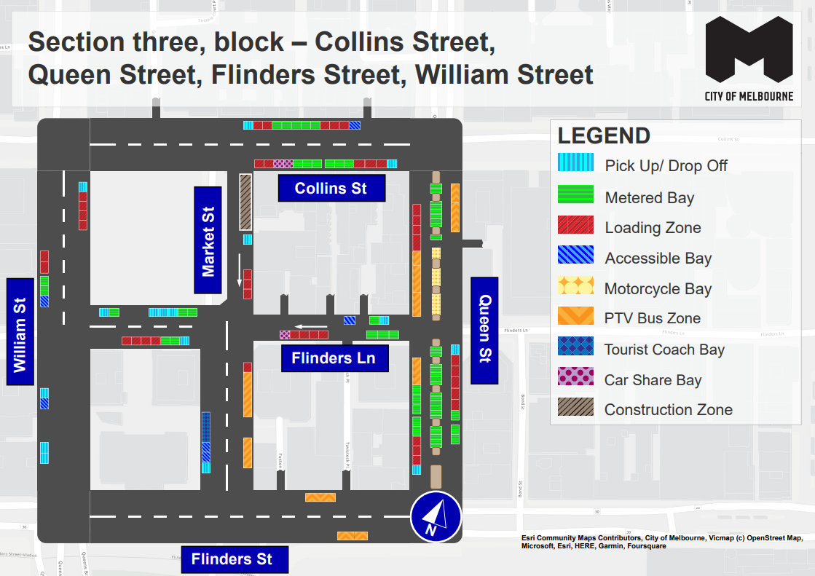
This map presents the parking conditions to be applied within this block as part of the CBD parking improvement project.

Collins Street
The north side, from west to east includes one pick up/drop off space, followed by two loading zones, five metered parking spaces, three additional loading zones and one accessible parking space.
The south side, from east to west includes one pick up/drop off space, followed by three loading zones, six metered parking spaces, two car share spaces and two loading zones.

Queen Street
The west side, from south to north, includes one pick up/drop off spaces, followed by three loading zones, five metered parking spaces and one PTV bus zone up to the intersection of Flinders Lane. This is followed by three additional PTV bus zone spaces and four loading zones.
The east side, from north to south, will include two PTV bus zone spaces to the intersection of Flinders Lane. This is followed by one pick up/drop off space, five loading zones and three metered parking spaces.
The centre of road, from north to south, includes nine metered parking spaces, followed by three areas of motorcycle parking up to the intersection of Flinders Lane. This is followed by eighteen metered parking spaces.

Flinders Street
The north side includes one PTV bus zone.
The south side includes one PTV bus zone.

William Street
The west side, from south to north, will include two pick up/drop off spaces, one accessible parking space and one additional pick up/drop off space to the intersection of Flinders Lane. This is then followed by one accessible parking space, two metered parking spaces and two loading zones.
The east side, from north to south, will include one pick up/drop off space, followed by four loading zones.

Flinders Lane
The south side, from east to west, will include three metered parking spaces, followed by four loading zones and one car share space to the intersection of Market Street. This is followed by one pick up/drop off space, two metered parking spaces and four loading zones.
The north side – between Queen Street and Market Street – from east to west, will include one pick up/drop off space followed one metered parking space and one accessible parking space.
The north side – between Market Street and William Street – from west to east, will include one pick up/drop off space, one metered parking space, followed by three additional pick up/drop off spaces and two metered parking spaces.

Market Street
The west side, from south to north, will include one pick up/drop off space followed by two accessible parking spaces and one tourist coach space up to the intersection of Flinders Lane.
The east side from north to south includes one construction zone, followed by one pick up/drop off space, three loading zones to the intersection of Flinders Lane. This is followed by an additional loading zone and two areas of PTV bus zones

Parking controls to be applied
Simplified and consistent parking controls will be applied across the CBD.
Pick up/drop off spaces will typically be signed ‘No Parking’. We will add signage to explain that the space is for passenger pick up / drop off for up to 2 minutes.
Metered spaces will typically be signed ‘2P Meter, 7am – 10pm, Mon – Sun’. Off-peak pricing in the CBD started on 3 July 2023 and includes a reduced rate of $4 per hour after 7pm weekdays and all weekend. The offer of $0 payment for short stops of up to 15 minutes in any CBD metered parking space via the EasyPark app started on 3 July 2023. This allows short stops in any green-sign space rather than limiting short stops to a small number of specific bays (for example, ‘¼P’).
Loading Zones will typically be signed as ‘Loading Zone, 30-minute, 7am – 4pm, Mon – Fri’. These spaces will typically become ‘2P Meter, 4pm – 10pm, Mon – Fri’ and ‘7am – 10pm, Sat – Sun’. We will place some full time Loading Zones in areas with very high demand for deliveries. People making deliveries can also use green-sign spaces for short stays of up to 15 minutes for $0 via the EasyPark app.
Accessible (disability) parking spaces will typically be signed ‘2P, Disability Only, 7am – 10pm, Mon – Sun’. We will apply blue line-marking to these spaces.
Motorcycle parking will be signed as ‘P, Motor Cycles Only’ with no time restrictions.
Car Share spaces will typically be signed as ‘Permit Zone, Car Share Vehicles’ for the permitted car share vehicle operator.
Postal Vehicle spaces will be signed as ‘No Parking, Postal Vehicles Excepted’. They can be used by Australia Post vehicles, and by any other vehicle needing to access an adjacent postbox for up to 2 minutes.
Taxi Zones will be placed in areas with high demand for taxis. This includes at railway stations to support transport interchange and at key tourist destinations.
Tourist coach spaces will typically be signed as ‘No Stopping, Buses Stopping Less Than 15 Minutes Excepted’. This allows passenger pick up / drop off in the CBD. We will provide longer term parking for tourist coaches at key tourist destinations and in selected areas outside the CBD.
Authorised vehicle parking means access for permitted uses only (for example, Swanston Street delivery permit holders).
Non-vehicle occupation includes temporary infrastructure in a parking space (for example, an outdoor dining parklet).
Construction Zones will be signed as ‘Permit Zone, Construction Vehicles’ to allow construction vehicles with a permit to stop and park.

