Block – Collins Street, Spring Street, Flinders Street, Exhibition Street
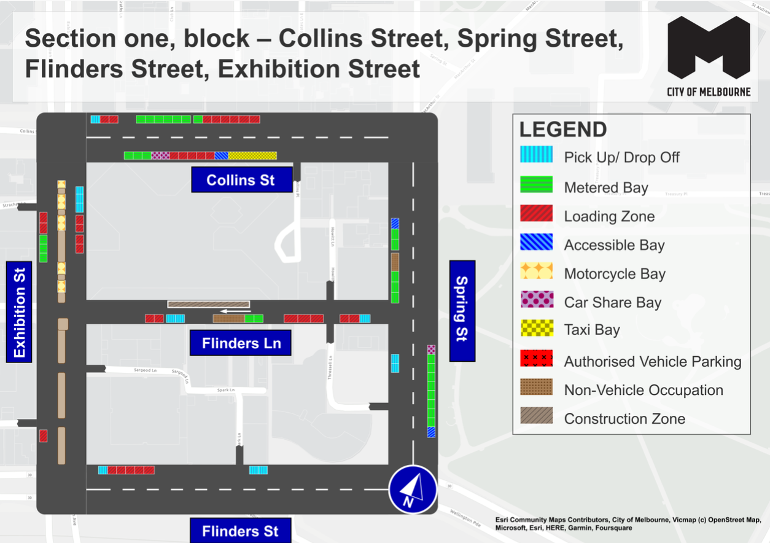
This map presents the parking conditions to be applied within this block as part of the CBD parking improvement project.

Collins Street
The north side, from west to east will include one pick up/drop off space, followed by two loading zones, seven metered parking spaces and six loading zones.
The south side, from east to west will include five taxi zone spaces, followed by one accessible parking space, five loading zones, two car share spaces and three metered parking spaces.

Spring Street
The west side, from south to north will include two pick up/drop off spaces near the corner of Flinders Lane, followed by three metered parking spaces, one non-vehicle occupation, two metered parking spaces and one accessible parking space.
The east side, from north to south will include one car share space, followed by eight metered parking spaces and one accessible parking space.

Flinders Street
The north side, from west to east includes one pick up/drop off space followed by five loading zones and two pick up/drop off spaces.

Exhibition Street
The west side, from south to north will include one loading near the corner of Flinders Street, then following the intersection with Flinders Lane, three metered parking spaces and two loading zones.
In the centre of road, there are five areas of motorcycle parking.
The east side, from north to south will include three pick up/drop off spaces and four loading zones.

Flinders Lane
The south side, from east to west will include one pick up/drop off space, followed by five loading zones, two metered parking spaces, one non-vehicle occupation, two pick up/drop off spaces and two loading zones.
The north side includes one temporary construction zone area.

Parking controls to be applied
Simplified and consistent parking controls will be applied across the CBD.
Pick up/drop off spaces will typically be signed ‘No Parking’ with supplementary signage indicating permitted use of the space for passenger pick up/drop off with a 2 minute limit.
Metered parking spaces will typically be signed 2P meter, 7am to 10pm, Monday to Sunday. Off-peak pricing in the CBD commenced from 3 July 2023 and includes a reduced rate of $4 per hour, Monday to Friday from 7pm and all weekend. The offer of $0 payment for short stays of up to 15 minutes in any CBD metered parking space commenced from 3 July 2023 via the EasyPark app. This allows flexibility for quick stays in any green-sign space rather than restricting them to a small number of designated bays (e.g. ¼P).
Loading Zones will typically be signed as 30 time limited spaces from 7am to 4pm Monday to Friday. Loading Zones will typically be converted to 2P meter parking spaces from 4pm to 10pm, Monday to Friday and 7am to 10pm Saturday and Sunday. Some full time Loading Zones will be placed in areas of very high demand. People making deliveries also have the option of using green-sign spaces for short stays of up to 15 minutes free via the EasyPark app.
Accessible parking spaces will typically be signed 2P, 7am to 10pm, Monday to Sunday. Blue line-marking will be applied.
Motorcycle parking will be signed as a designated motorcycle parking area with no time restrictions.
Car share spaces will typically be signed as Permit Zone for the permitted car share vehicle operator.
Postal Vehicle spaces will be signed as ‘No Parking, postal vehicles excepted’. They can be used by Australia Post vehicles and any other vehicle needing to access an adjacent postbox.
Taxi Zones will be designated in areas with high taxi demand. This includes at railway stations to support transport interchange and key tourist destinations.
Tourist coach spaces will typically be signed as ‘No Stopping, buses stopping less than 15 minutes excepted’ to facilitate passenger pick up / drop off in the CBD. Longer term tourist coach parking will be provided at key tourist destinations and in designated areas outside the CBD.
Authorised vehicle parking refers to access for permitted uses only.
Non-vehicle occupations include temporary infrastructure in place of a parking space (e.g. outdoor dining parklet).
Construction Zones will be signed as ‘Permit Zone’ to facilitate temporary use of street space for building construction.

