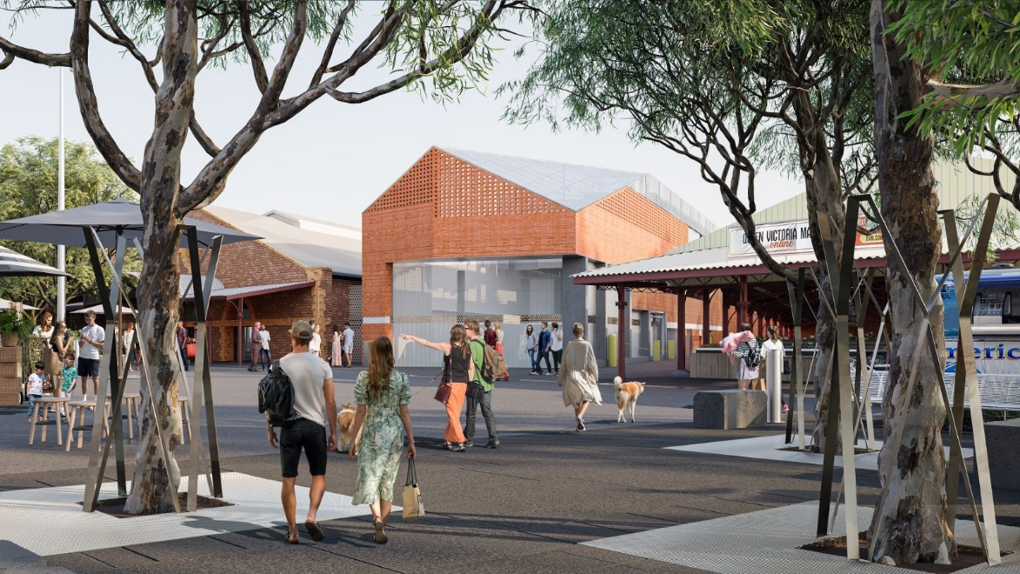

Works Notification October – December 2023

Trader Shed works commence
Works have commenced to deliver the three-storey Trader Shed, which will also include a four-storey basement. The new facility and contemporary infrastructure will improve safety and better support day to day operations for traders with climate controlled storage within basement levels, loading docks separated from pedestrianised areas, and access to back of house facilities. New trader and public amenities, including showers and toilets, will also be a feature of the facility
The works include:
- Site establishment
- Installation of solid hoarding
- Demolition of existing meat and fish delivery dock
- Typical construction hours are Monday to Friday, 7am to 6pm
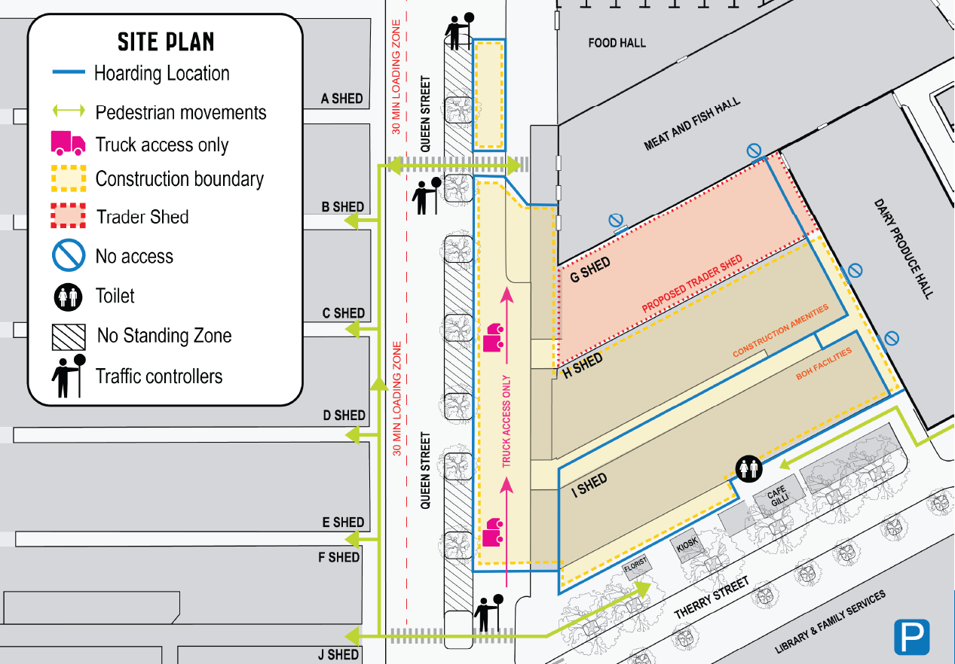
Aerial map of work zone and pedestrian access.

Queen Victoria Market Precinct Renewal
The City of Melbourne announced the renewal of the Queen Victoria Market in 2013 and worked with traders, the community and stakeholders to plan for the careful restoration and revitalisation of this seven hectare site in the heart of the city.
The vision for renewal is to modernise and revitalise one of the world’s great markets and surrounding precinct, while preserving and celebrating the Market’s heritage, traditional open-air atmosphere and authenticity.
The Market remains open for business throughout the renewal with plans in place to ensure it can maintain safe operations and continue to provide a great shopping experience.
Visit qvm.com.au for more information.

What’s happening October to December 2023
- Site establishment will include the set up of the builder’s site office and trader back of house operations and amenities, which will be located in H and I Sheds for the duration of the Trader Shed works.
- Installation of the solid hoarding around the work site will extend from Therry Street along Queen Street to Victoria Street.
- Demolition of the meat and fish delivery dock to make way for the new Trader Shed.

What to expect
There may be some disruption and changes to the way you navigate the Market. For your safety, please be patient and follow the signage in place. During the demolition of the existing meat and fish delivery dock works are expected to generate noise and dust during construction hours. However, there will be measures in place to minimise these impacts.

Changes to pedestrian access, parking and amenities
- The work area will be enclosed behind solid hoarding for the duration of works and pedestrians will be diverted around the site. Please take note of wayfinding and traffic controllers to assist with movement around the Market.
- Through-traffic and customer vehicles will not be permitted on Queen Street (between Therry and Victoria Streets) between 6am – 9.30am on Tuesday, Thursday and Friday. Outside of these times on Tuesday, Thursday, Friday and all-day Saturday, vehicle access will be permitted with a 30 minute restriction on parking. Queen Street will remain a pedestrianised area on Sundays.
- Construction vehicles will enter and exit the site from Queen Street, enclosed by the solid hoarding. Traffic controllers will be in place to direct traffic.
- Public toilets will be located on Therry Street

Upcoming works: October to December 2023

Site establishment
H and I Sheds will be secured and handed over to Built, the construction company delivering the Trader Shed, for site establishment and mobilisation of trader back of house operations and amenities.

Solid hoarding and wayfinding
Solid hoarding will be installed in stages, extending from Therry Street along Queen Street to Victoria Street. The hoarding will be utilised for wayfinding and project information to help customers navigate safely around the site.

Demolition of meat and fish delivery dock (G Shed)
Demolition of the existing meat and fish delivery dock to make way for construction of Trader Shed will commence in November. Works will comply with WorkSafe and EPA guidelines.

Location of toilets
The toilets between the Meat and Fish Hall and Dairy Produce Hall won’t be accessible once demolition of G Shed commences. Toilets will be located on Therry Street and are also available on Queen Street and the new Food Hall opening in November.

Access to Dairy Hall and Meat and Fish Hall
The Dairy Produce Hall and the Meat and Fish Hall remain open for business as usual. Enter the Dairy Hall via Therry Street and the Meat and Fish Hall via Queen Street by following the pedestrian crossing through the solid hoarding. Also accessible from Elizabeth Street.

Like to know more?
To find out more about the Market Infrastructure project and the Queen Victoria Market Precinct Renewal program, please contact 9658 9658, or visit Queen Victoria Market {Precinct Renewal.

https://www.melbourne.vic.gov.au/building-and-development/shaping-the-city/qvm-renewal/Pages/queen-victoria-market-precinct-renewal.aspx

