Mobile Printing Guide
There are three ways to print from a mobile device:
Using the web portal – best for one-off printing of documents, pdfs, images, webpages.
Forwarding via email – best for printing emails
Using the PrinterOn app- best for frequent mobile print users

NOTE: Large print jobs like PDFs take longer to appear at the Print Release station. Leave 10mins before collecting printing.
You can mobile print:
- Word, Excel, Powerpoint or Visio documents
- PDFs
- JPEG or TIFF images
- Webpages
- Documents stored on your mobile device or home computer.
- Documents stored in your Dropbox or Google Drive account.

Using the web portal:

- From the Melbourne Library Service website, select the mobile printing link for your most convenient library site:

www.printeron.net/mls/citylibrary
www.printeron.net/mls/kathleensymelibrary
www.printeron.net/mls/northmelbournelibrary
www.printeron.net/mls/thelibraryatthedock
www.printeron.net/mls/eastmelbournelibrary
www.printeron.net/mls/southbanklibrary
www.printeron.net/mls/narrm-ngarrgu-library

- Select your print options: Black& White or Colour, A4 or A3.

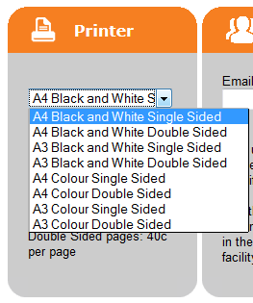

- Add your email address to identify your printing when collecting.

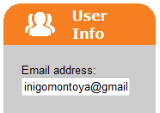

- Browse to your document or webpage. And select to upload.

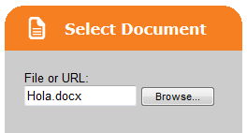

Press the arrow at the bottom right when done

- You’ll be prompted with the number of pages and cost.
- Click the Print icon to approve the job.
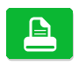
- When complete go any printer in the library to release your mobile printing.

Forwarding via email

The simplest way to print an email message or attachment is to forward your email to an address specific to your most convenient library site.

- To find the correct address, go to the Melbourne Library Service website, select a mobile printing link:

www.printeron.net/mls/citylibrary
www.printeron.net/mls/kathleensymelibrary
www.printeron.net/mls/northmelbournelibrary
www.printeron.net/mls/thelibraryatthedock
www.printeron.net/mls/eastmelbournelibrary
www.printeron.net/mls/southbanklibrary
www.printeron.net/mls/narrm-ngarrgu-library

- Select the ‘How do I print from a mobile device’ link.

- You’ll see a list addressing corresponding to format options. For example when printing a black and white, single sided document to City Library, select ‘citylibrary-a4-bw-single-sided@printspots.com’

- Copy this address.

- Paste it into the To: field of your web based email services, eg Gmail or Yahoo.

- Select Send.

- You’ll get a confirmation email and can then collect your printing.

The PrinterOn app

If you do a lot of mobile printing, the fastest way to print is using the PrinterOn app.

- First download the app, eg from the Google Play store for android phone and tablets, or App store for iPhones and iPads.

- From the app, to find your library printers:
- tap to select a printer,
- type your library’s suburb in the Search field, eg ‘Carlton’ or ‘Docklands’. Or use the Location feature which uses the GPS capabilities of your device to find the nearest printers to you.
Melbourne Library Service printers start with ‘MLS’

- Select your document, select Print and enter your email address.

- You’ll get a ‘Success’ message when complete.

- Click Print History to view your documents.

Collecting a print job

Enter your email address at the Print Release station. This verifies your identity to retrieve your printing.

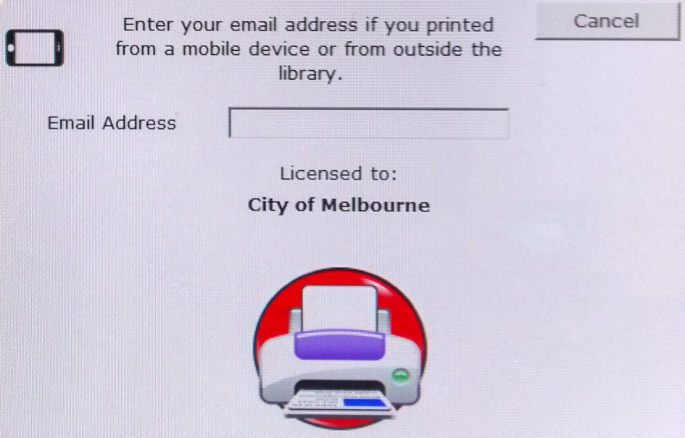

You’ll see a list of your mobile print jobs, insert payment and select to release.

