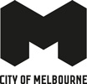
Greenline Implementation Plan
A Vision for the North Bank
December 2021

Acknowledgement of Traditional Owners
The City of Melbourne respectfully acknowledges the Traditional Custodians of the land, the Wurundjeri Woi Wurrung and Bunurong Boon Wurrung peoples of the Eastern Kulin Nation and pays respect to their Elders, past, present and emerging. We are committed to our reconciliation journey, because at its heart, reconciliation is about strengthening relationships between Aboriginal and non-Aboriginal peoples, for the benefit of all Victorians.
Contents
Forward from the Lord Mayor 4
Introduction and Executive Summary 5
Greenline 5
Vision 5
Themes 6
The River and its Context 7
A threshold between worlds 7
The heart of the city 8
Creation Story - Melbourne 10
A Path to the Future 31
Delivering Shared Objectives 36
Delivering on the Yarra River - Birrarung Strategy 37
Community and Stakeholder Engagement 40
Participate Melbourne and Key Stakeholder Workshops 40
Participate Melbourne Key Findings 42
Greenline Opportunity Statement 42
Greenline Themes and Objectives 44
Themes 44
Environment 46
Culture 48
Place 50
Connection 52
Implementation Plan 54
Birrarung Marr Precinct 55
The Falls* Precinct 58
River Park Precinct 62
Maritime Precinct 65
Salt Water Wharf Precinct 67
Themes and Objectives Summary Tables 69
Implementation Plan Summary Tables 70
Implementation Schedule 72
Next Steps 73
Appendix 1 74
Yarra River - Birrarung Strategy Summary Tables 74
Appendix 2 80
City of Melbourne Policy, Strategy and Guideline Summaries and Greenline Deliverables 80
Appendix 3 97
Quotes from consultation completed as part of the City River Strategy 97
This document uses Traditional Owners to refer to the Wurundjeri Woi Wurrung. Traditional Custodians is used where City of Melbourne policy and strategy is being quoted. This terminology was used by City of Melbourne prior to there being a Registered Aboriginal Party. Since 1 July 2021 the Wurundjeri Woi-Wurrung Cultural Heritage Aboriginal Corporation is the Registered Aboriginal party for the Greenline Study Area.
To find out how you can participate in the decision-making process for City of Melbourne’s current and future initiatives, visit melbourne.vic.gov.au/participate

Forward from the Lord Mayor
Greenline Implementation Plan
The Yarra River - Birrarung flows through the heart of Melbourne, set in a landscape that links our history with our future. The City of Melbourne’s Greenline proposal presents a once in a generation opportunity to transform the north bank of the river; to embrace the natural, social and cultural values associated with the river and celebrate its importance to Melbourne as a growing and liveable city.
Guided by this Implementation Plan, the Greenline will reinvigorate the public waterfront and re-establish its environment as an ecological corridor. It’s set to be one of the city’s biggest transformations. A 4 kilometre pathway will connect riverbank landscapes and wetlands, while recognising their significance to Aboriginal history and culture.
The Victorian Government’s Yarra River Protection (Wilip-gin Birrarung murron) Act 2017 is the first legislation in Australia to be co-titled in a Traditional Owner language, that of the Wurundjeri Woi Wurrung people. This is a significant step. It recognises the Wurundjeri Woi Wurrung people’s custodianship of the river and their unique connection to the lands through which it flows. The Act is also an Australian first in legally identifying a river and its corridor as a single living and integrated natural entity for protection
The City of Melbourne’s Yarra River - Birrarung Strategy (2019) seeks to reveal the layers of history, particularly the river’s significance to the Wurundjeri Woi Wurrung people and to other Aboriginal stakeholders. It emphasises the importance of our relationship with the river; and will guide our approach to improving the river environment.
The Greenline is centred around four key themes, shaping the revitalisation of the river front between Birrarung Marr and Docklands:
- Environment
- Culture
- Place
- Connection
As a major city-shaping project, Greenline requires us to work closely with many partners, including government agencies, businesses and private land owners and community groups. It also has a significant role to play in boosting the local economy and contributing to the city’s recovery.
The community’s response to the draft implementation plan has been overwhelmingly positive, revealing real enthusiasm for its aims – enhancing greening and improving the environmental health of the river and its banks.
This plan guides the development of the Greenline as a series of interconnected projects; separate precincts that will progress in stages. Capital works opportunities can be prioritised to bring us closer to realising this generational project – a waterfront landscape that leaves a legacy for all in our city to enjoy.

Lord Mayor
Sally Capp

Introduction and Executive Summary

Greenline
The Greenline will reposition the Yarra River - Birrarung as the centrepiece of Melbourne’s culture, economy, and liveability.
The Greenline will transform the river’s north bank into a reinvigorated and inspiring public waterfront. A 4km pathway will connect diverse, vibrant river side destinations. Aboriginal and contemporary cultures will be celebrated, as will the area’s historic values. The river and its surrounding environment will be re-established as an ecological corridor.
Today, walking and cycling through the area is limited by narrow and poorly connected paths, steep slopes, uneven pavements, and poor amenity. It offers little diversity of cultural expression, limited ecological value, and few opportunities for social and civic engagement.
Yet this is a place of spiritual, cultural and historical significance. Long before Melbourne existed this was Wurundjeri Country. This place has played a central role in Melbourne’s evolution. As a maritime port, the focus of metropolitan rail networks, and more recently as an elite arts and leisure precinct.
The Greenline will express and celebrate these layers of history. Compelling journeys will be created and opportunities to connect with the water will be enhanced. All Melbourne residents and visitors will benefit from connected spaces. These spaces will embrace the river, prioritise safety and inclusion, and provide opportunities for public activities that improve health and wellbeing. The Greenline will also address environmental and climate-related challenges. It will focus on improved river health, increased tree canopy and reintroduced riparian vegetation to support biodiversity and environmental education.
This document guides the implementation of the Greenline as a series of interconnected projects. It sets out a vision, aims and objectives, and design strategies that apply throughout the area. It then breaks down the full extent of the Greenline into implementation precincts and identifies a series of separate projects that will enable improvements to progress in stages. A prioritised program of improvements is proposed, highlighting capital works opportunities and directions for advocacy and cooperation with key stakeholders.

Vision
The Greenline will transform the north bank of the Yarra River - Birrarung into an inspiring public waterfront in the heart of urban Melbourne. The creation of a 4km connection will prioritise safe and inclusive access for people and link vibrant destinations.
The many cultural and historical values of the area will be celebrated. At the forefront of this will be Aboriginal connection to country. A connected ecological corridor will create new habitat, encouraging the return of wildlife and contributing to the health of the river.

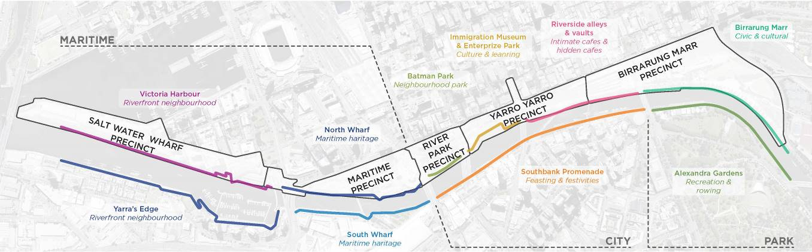
Image: the Greenline Major Initiative area and implementation precincts. Yarra River - Birrarung Strategy character areas.

Themes

Environment – Healthy ecosystems
The river will be enhanced as an ecological corridor. Increased planting and revitalisation of the riparian edge will improve biodiversity and river health and increase resilience. Water quality and flood management will be addressed to help mitigate the effects of climate change.

Culture – Authentic stories and experiences
Melbourne’s heritage will be made more tangible by creatively embedding stories into the landscape. Spaces that inspire and educate will celebrate Wurundjeri Woi Wurrung and broader Aboriginal significance along the Birrarung, and our immigration and maritime past.

Place – Great places for people
Open spaces along the river will be re-imagined through bold interventions, strengthening their identities and respecting existing values. These spaces will provide opportunities for public activities and places of respite. They will build on connections with nearby areas to encourage new economic opportunities. The Greenline will provide for and welcome everyone, ensuring diverse and safe places and experiences.

Connection – An uninterrupted journey
Access along the river and to the Greenline public spaces will be improved, as will connections between the river and city. Physical barriers will be reduced, modal conflicts will be minimised and wayfinding will be enhanced. Safety and inclusivity will be prioritised. Compelling journeys will be created through varying landscape experiences and will enable opportunities to connect with the water.

The River and its Context

A threshold between worlds
The Wurundjeri Woi Wurrung of the Eastern Kulin thrived on this land for 60,000 years before European arrival.
Not far from the bay as the crow flies, but a longer trip following the meandering Birrarung was The Falls. Here a deep pool was formed by water cascading over an ancient lava flow separating the estuary from fresh water. West of the falls was tea tree scrub. Further downstream were wetlands, salt marshes and mangroves. Upstream were billabongs and woodlands among low hills. Water and land teemed with wildlife. Tracks from far away converged at this river crossing. Camps were made and nearby the five groups of the Eastern Kulin nation would meet. These are the Woi Wurrung, Bunurong Boon Wurrung, Taungerung, Dja Dja Wurrung and Wadawurrung.
For the first Europeans, the Falls were as far as they could bring their boats. In 1835 two small groups dropped anchor here. These squatters had migrated from the Van Diemen’s Land colony without government sanction. They set up small farms and survived with the support and toleration of the First People. In return they paid a tribute in food, tools, and clothing.
When the settlement came under British law the following year, the Eastern Kulin population of the hinterland was estimated to be 800 people. The Europeans numbered 142.
In 1837 the ‘Hoddle’ street grid was laid out, with the first point thought to be the intersection of Swanston and Flinders Streets, near the surveyors’ camp. The hamlet that was emerging was declared a township and renamed to honour the British Prime Minister, William Lamb, 2nd Viscount Melbourne. Construction of urban infrastructure commenced and colonial names were imposed. Large vessels dropped anchor at Williamstown, and goods and passengers were ferried up the river to Queens Wharf. A new Customs House faced across Flinders Street onto the Falls, the base of which became the Turning Basin used by ships returning to sea.
In 1851, the discovery of gold in Bendigo and Ballarat sparked mass migration and spectacular growth of the newly declared colony of Victoria. This propelled Melbourne’s development as a great city of the British Empire. Millions of immigrants arrived, and Melbourne became a busy hub populated by sailors, stevedores, merchants, cartmen and others.
Melbourne’s success was a tragedy for the Woi wurrung and their neighbours the Boon wurrung people of the Eastern Kulin. It led to their marginalisation, a population collapse and almost complete dispossession from their land. In 1860 the Colonial Government created a Central Board to watch over the Interests of Aboriginal People in the Colony of Victoria. The board vigorously compelled Aboriginal people onto mission and reserve sites away from major towns.
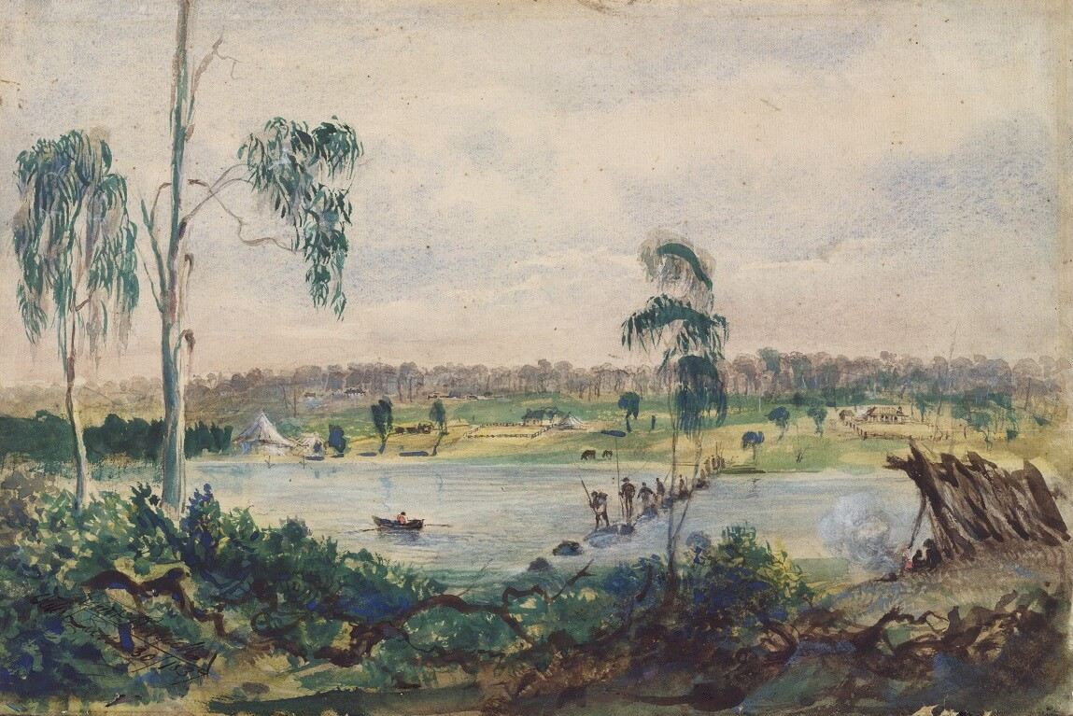Image: Melbourne from the falls, 30 June 1837 (Robert Russell, National Library of Australia)

The heart of the city
Even the land was remade. The Falls were blasted and dredged away in 1883. Other changes included filling the wetlands at Fishermans Bend and the West Melbourne lagoon, and rapid replacement of indigenous plants with European exotics, particularly willows. Around the turn of the century the meandering river was widened and straightened. Low banks were built up as roadways and bows in the old channel were filled. Low hills beside the river gave way to development, and redevelopment has created a mountain of buildings with canyon-like streets.
The early colonial government set aside large reservations of land in and around the Hoddle grid. Parts of these were later formalised as parks, while others were released to be developed as suburbs. The north bank of the river became dominated by railway lines, and Southbank became the city’s industrial hinterland. Collins Street was Melbourne’s fashionable promenade. The river was the city’s engine room and industrial drain.
By 1927, when the new Spencer Street Bridge blocked access for ships, Queens Wharf became a quaint relic in proportion to the huge docks downstream. The Turning Basin was filled in, Kings Bridge built, and Flinders Street elevated over King Street to speed traffic through the city. The north bank – from Spencer to Market Streets, and Flinders Street to the river edge – became a car park. The river was little more than the city’s main drain, yet it was also central to Melbourne’s political life. From 1889 through to the 1960s, east of Princes Bridge, both banks of the river were at different times the site of a people’s forum.
As noise and smoke began to disappear with industry moving to the suburbs, the underused and vacant land became the focus of urban renewal schemes. The State Government began by developing the new Southbank arts precinct in the 1960s. Olympic Park was developed for the 1956 games, and a new tennis stadium was built in 1988. This eventually expanded to be the Melbourne and Olympic Park sports and entertainment precinct. The Port of Melbourne Authority built the World Trade and World Congress Centres. Southgate shopping centre opened in 1992, the first development to face the river rather than turning its back to it. This sent a strong message that the river was now a place to enjoy. Proposals for a riverside casino were entertained from at least 1979, and the sprawling Crown Casino eventually opened in 1997. Construction started on a new riverside home for the Melbourne Museum, but during construction was redesigned and completed as the Exhibition Centre. This later expanded with the Convention Centre. Redevelopment of the Jolimont railyards, dreamed of since 1925, was realised in part with the creation of Federation Square. Finally, Birrarung Marr was opened in 2002.
Private investment followed on the heels of public. Southbank became one of the densest and fastest-growing suburbs in the metropolitan area. The central city now straddles the river, rather than lying to one side of it. As these changes unfold, Aboriginal presence and connection to the river has begun to be recognised. This presence has many layers, from the Wurundjeri Woi Wurrung’s custodianship of river and Country, to Aboriginal leaders participating in political debate at the river’s edge in the 1930s and 40s. Federation Square has played a key role in more recent times, including being the end point for the NAIDOC march, and a gathering location for the apology for the stolen generations. The naming of the Birrarung Marr and public art works along the river such as Birrarung Wilam and Scar – A Stolen Vision have gone some way to acknowledge Aboriginal language and history in this place. The Yarra River Protection (Wilip-gin Birrarung murron) Act 2017 is the first legislation in Australia co-titled in a Traditional Owner language, Woi Wurrung. It reasserts a Traditional Owner perspective on the river, and into the heart of the city.
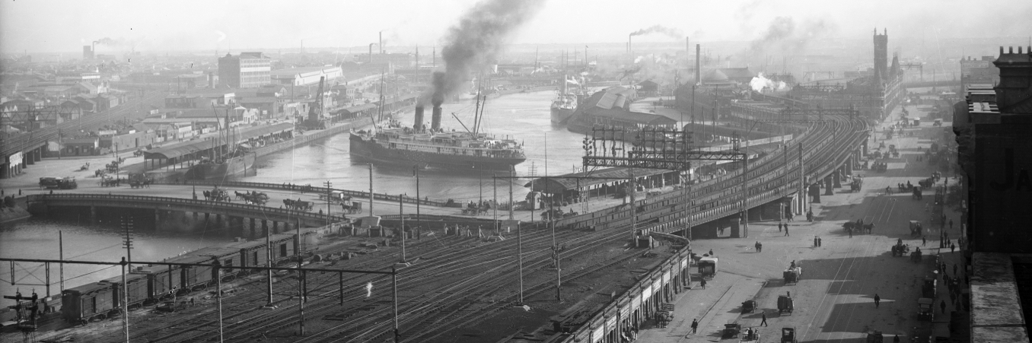Image: The Turning Basin, about 1920 (Kerr Brothers, State Library of Victoria)
The following pages provide a visual summary of this evolution.

Creation Story - Melbourne
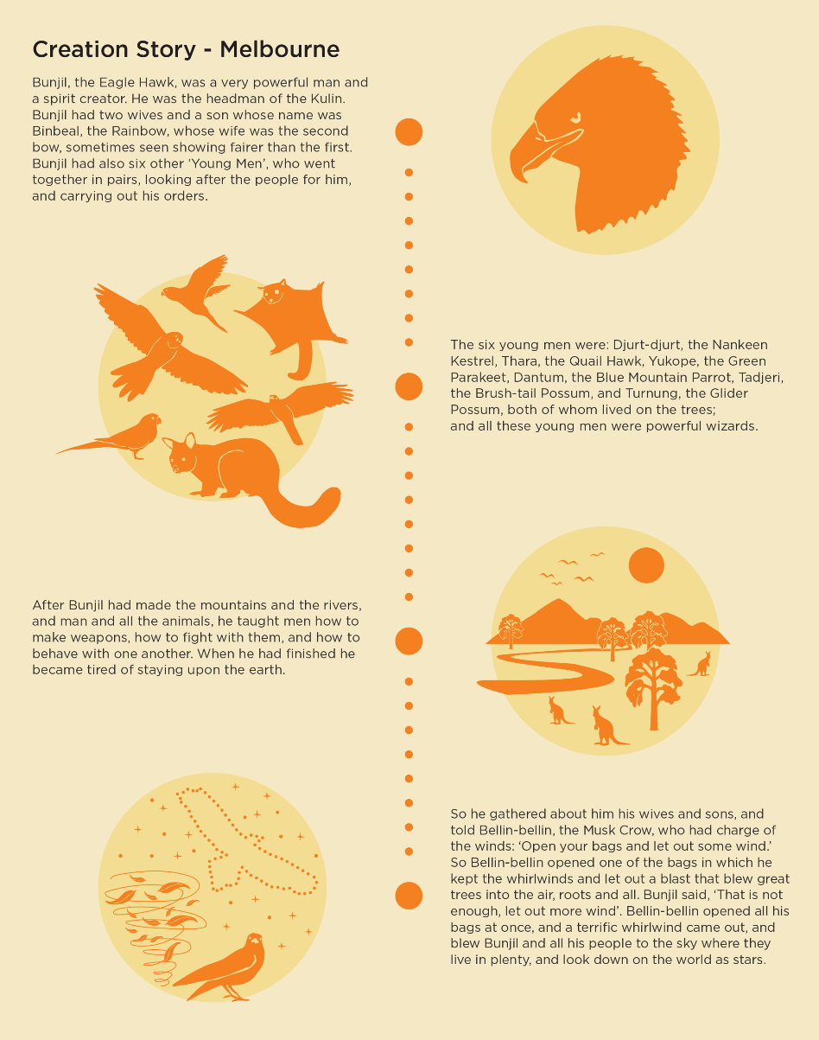
Image: Extract from the City of Melbourne’s Nature in the City Strategy 2017 (refer p .40). Permission to reproduce this story was provided by the Wurundjeri Tribe Land Compensation and Cultural Heritage Council

The Land and First People
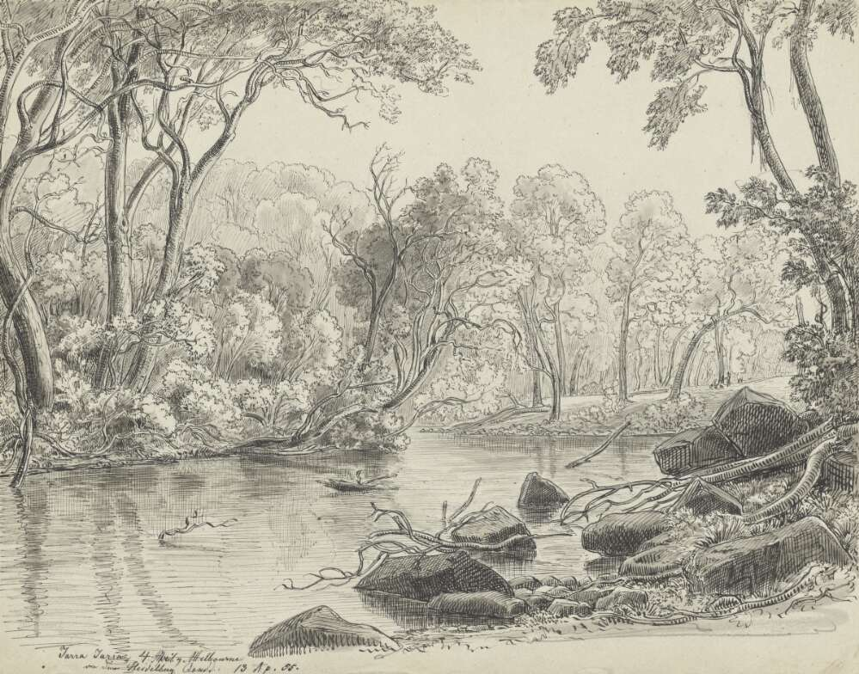Image: A view of Yarra Yarra by Eugen von Guerard, 1855. While this drawing was done further upstream near Heidelberg Road, it provides a sense of how the Yarra in Melbourne may have appeared in the 1830s. (National Library of Australia, nla.gov.au/nla.obj-134726888)
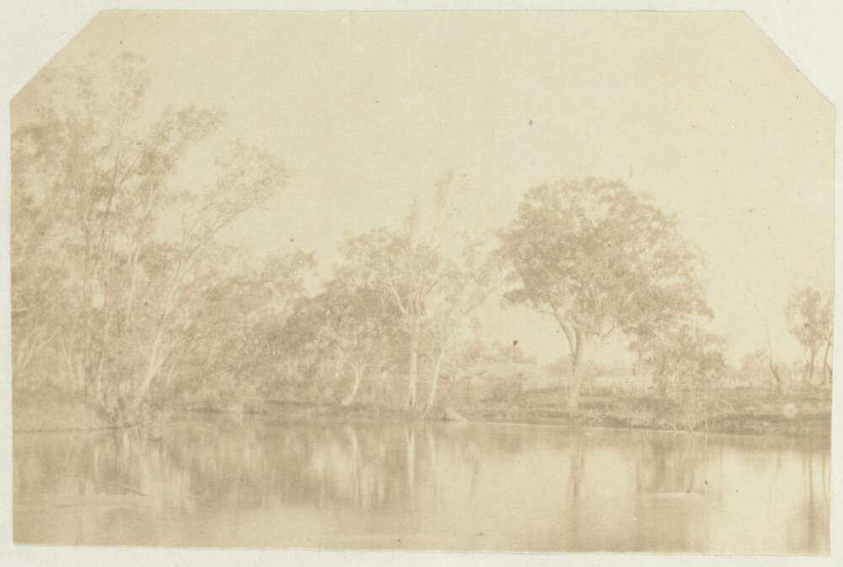Image: View of the Ovens River with a house in the background, near Beechworth, Victoria, 1856. By Walter Woodbury. This image may give a sense of how the Yarra River appeared in 1830s Melbourne. (National Library of Australia, nla.gov.au/nla.obj-151253750)
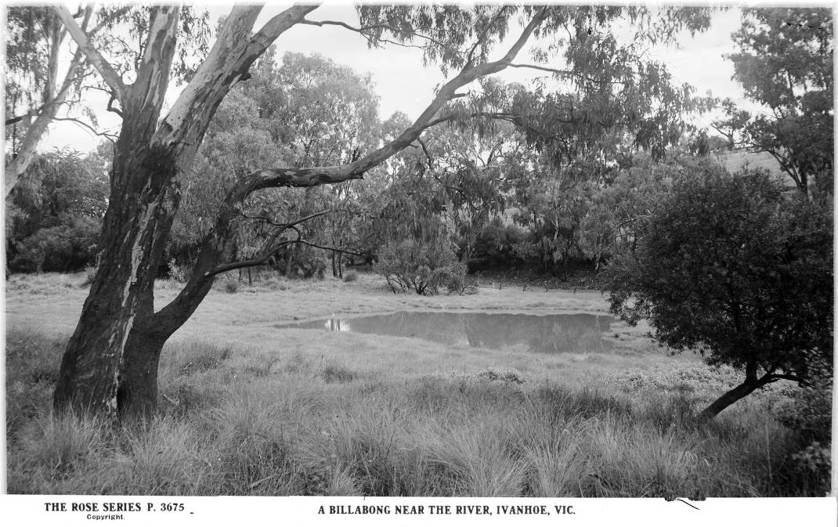
Image: A billabong near the Yarra in Ivanhoe, early to mid-20th century by the Rose Stereograph Co. It is possible that the billabongs along the Yarra, east of the falls looked like this in the 1830s. (State Library of Victoria, Accession no: H32492/5082)
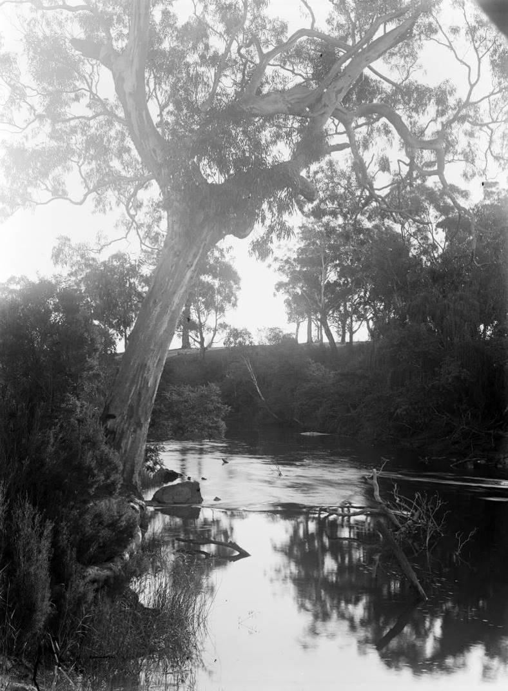
Image: A view of the Yarra in Ivanhoe. Photographed by Mark Daniel in 1909, this image of the river further upstream offers a glimpse of how Melbourne’s portion of the river may have appeared in the 1830s. (Mark James Daniel, 1909)
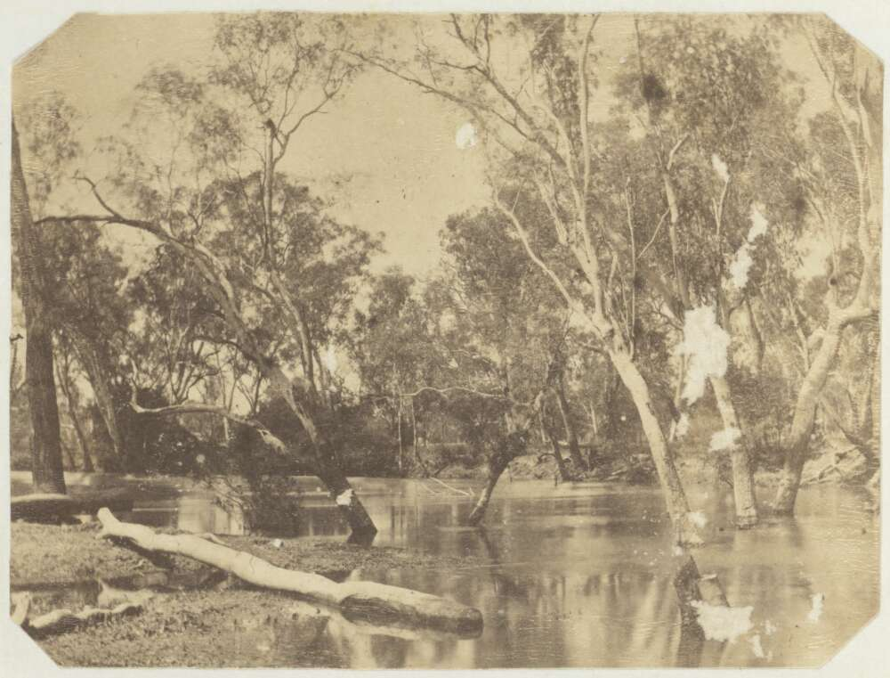
Image: Trees in the Ovens River near Beechworth, Victoria, 1856 by Walter Woodbury. This image may give a sense of how the Yarra River appeared in 1830s Melbourne. (National Library of Australia, nla.gov.au/nla.obj-151252702)
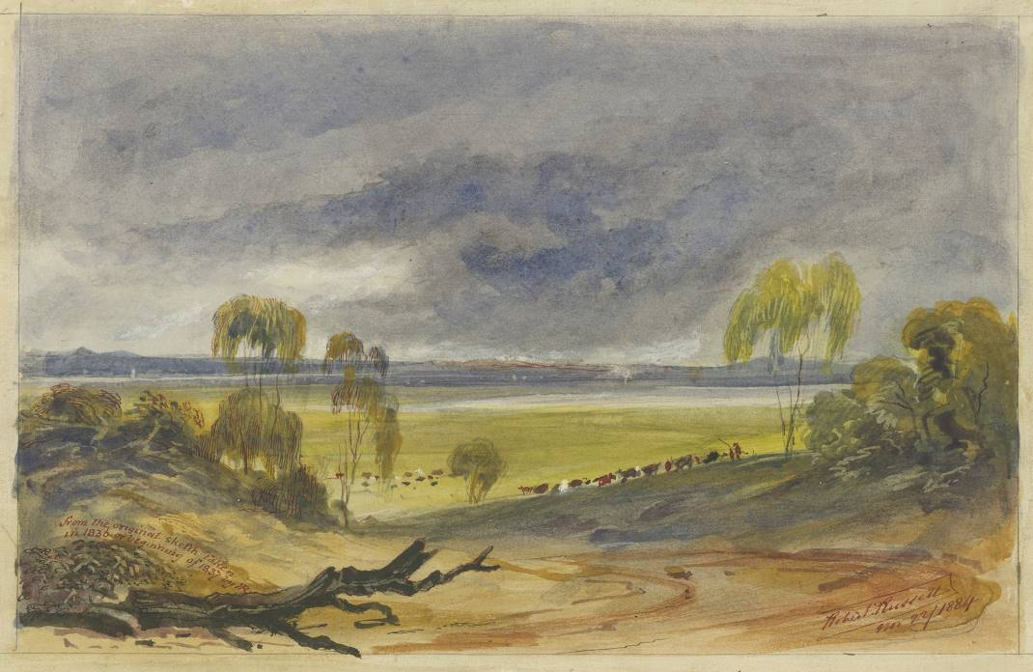
Image: View from Batman’s Hill looking westward, from an original sketch taken in 1836-1837. This painting by Robert Russell in 1884, shows the lagoon and what became known as Dudley Flats, now Docklands. (State Library of Victoria, Accession no: H24527)
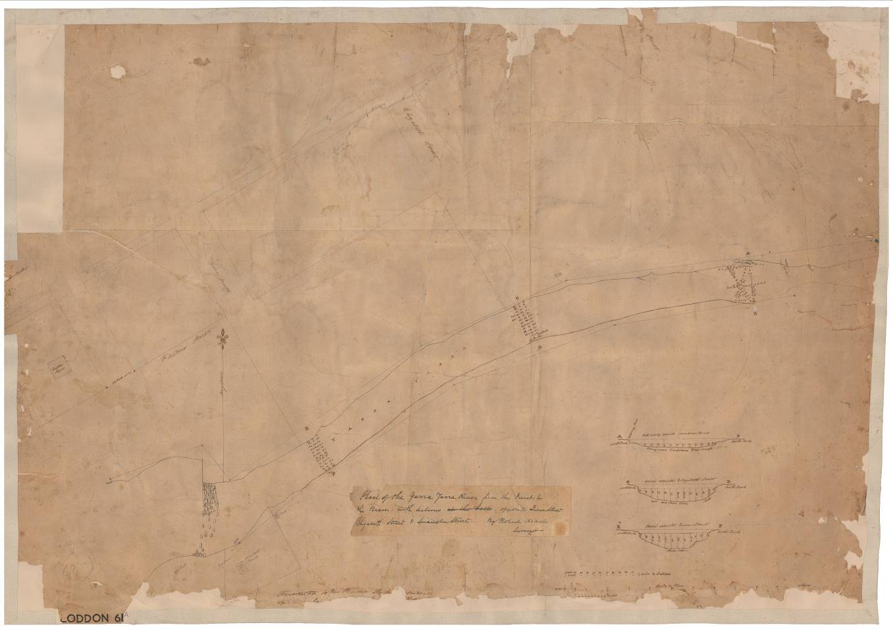Image: This rare early plan gives a sense of how the river and falls appeared in the c1830s-1850s.
Yarra Yarra River, Hoddle. (Public Records Office Victoria, VPRS 8168/P0002, LODDON61A)

The Foundation of Melbourne, 1835-1850
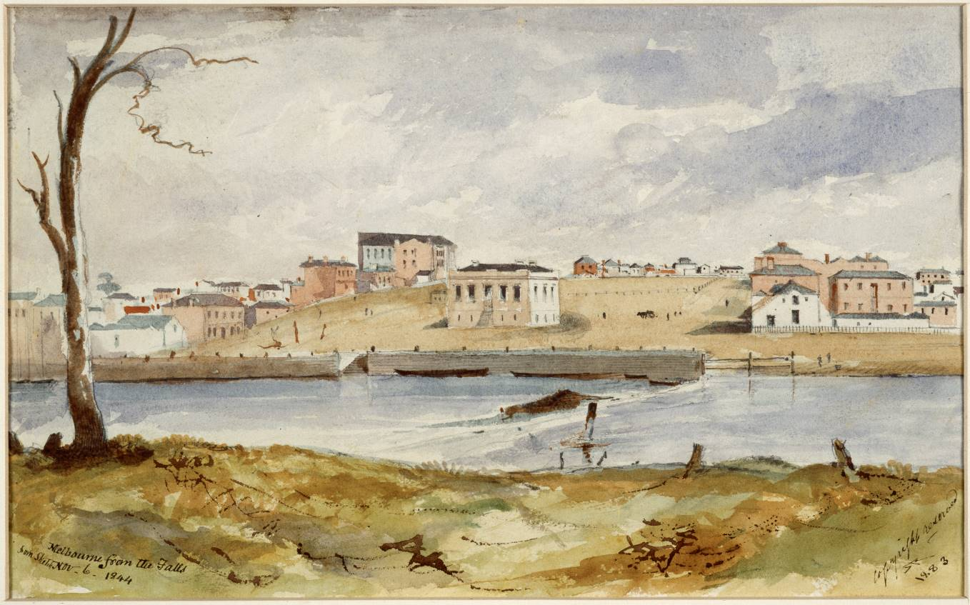Image: John Pascoe Fawkner and John Batman start an unauthorised settlement in 1835. This is located on the north bank at The Falls where there is access to the sea and to fresh water. (Robert Russell, 1844, State Library of Victoria)
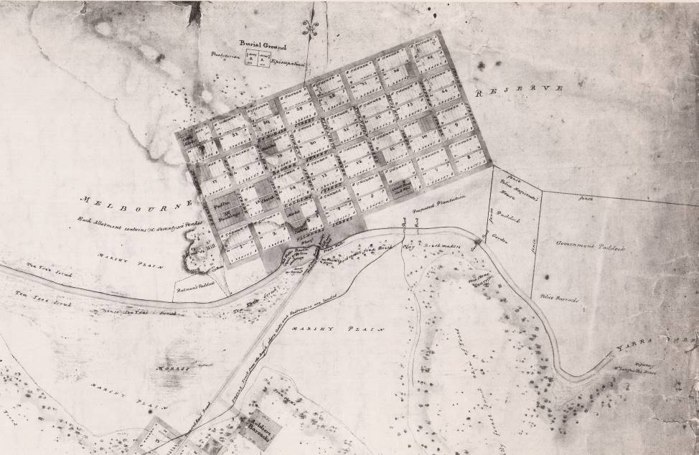
Image: Melbourne is brought under British law in 1836. It is declared a township in 1837 at which point the ‘Hoddle grid’ of streets is set out parallel to the river at the Falls. (Robert Hoddle, 1839, State Library of Victoria)
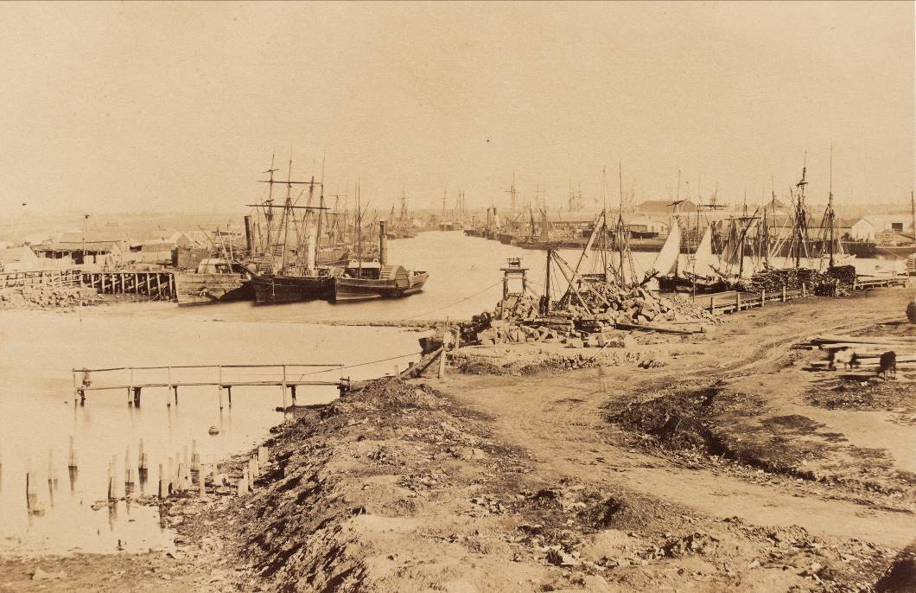
Image: The pool below The Falls develops as the city’s port, with wharves built then rebuilt at a larger scale. (Richard Daintree, 1858, State Library of Victoria)

Port and Rail Infrastructure, 1851-1900
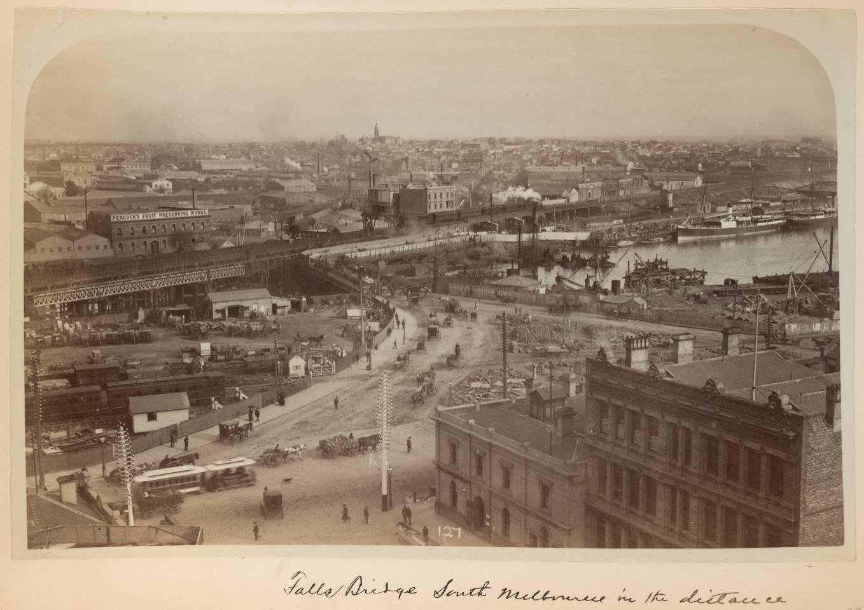Image: Starting in 1851, the gold rush leads to the expansion of the river’s maritime and industrial focus to support a rapidly growing city. The Sandridge Rail Bridge (1888) and Falls Bridge (1890) are built. The Falls are dredged away and the present Queen’s Bridge built, shown here under construction. (Charles Rudd, 1890, State Library of Victoria)
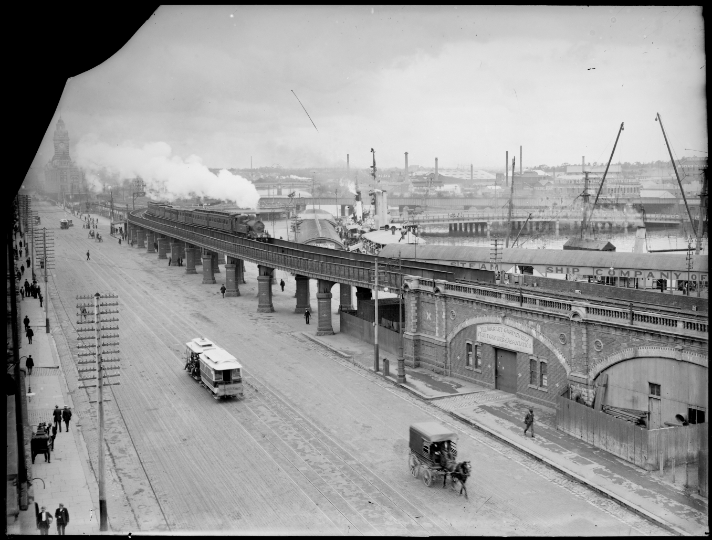Image: A viaduct is built between 1890-1894 linking Princes Bridge Station and Spencer Street Station. This is supported on a colonnade-like structure at the Turning Basin. The Banana Alley Vaults are built as part of this link. (State Library of Victoria)
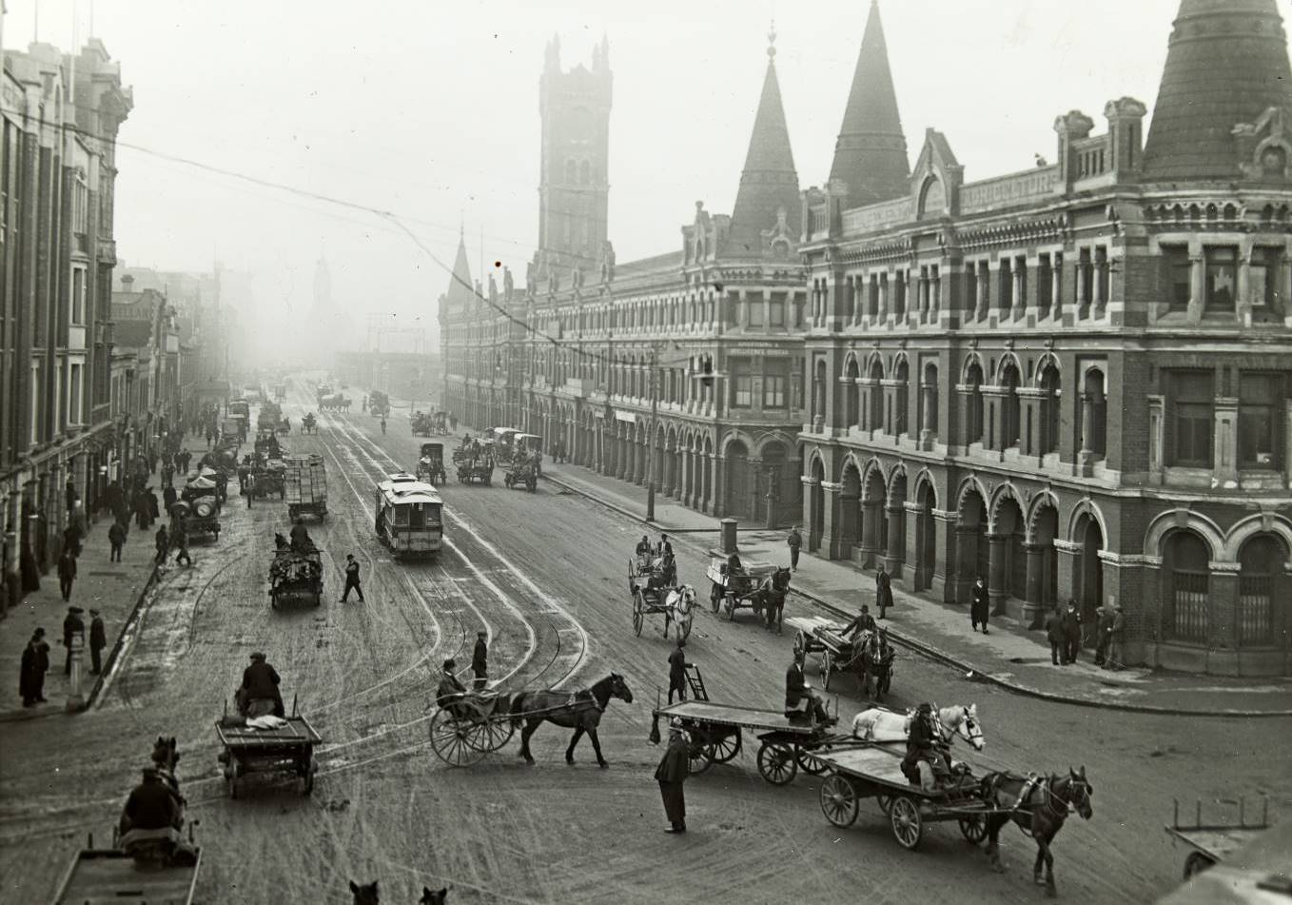Image: The Fish Market is built in 1890 along the rail viaduct to the south side of Flinders Street. This creates a grand commercial and architectural expression of the link between water and city. (Charles Compton Reade, State Library of Victoria)

Rebuilding the River, 1886-1900
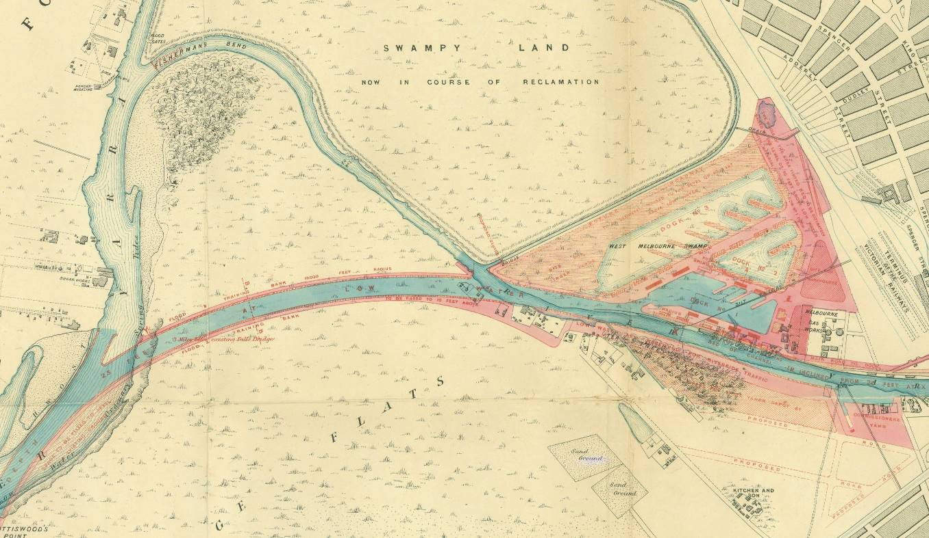Image: Major reconstruction of the river estuary includes excavation of the Coode Canal in 1886 and Victoria Dock from 1887 to 1892. A new Princes Bridge and vaults to its east are completed in 1888. (State Library of Victoria)
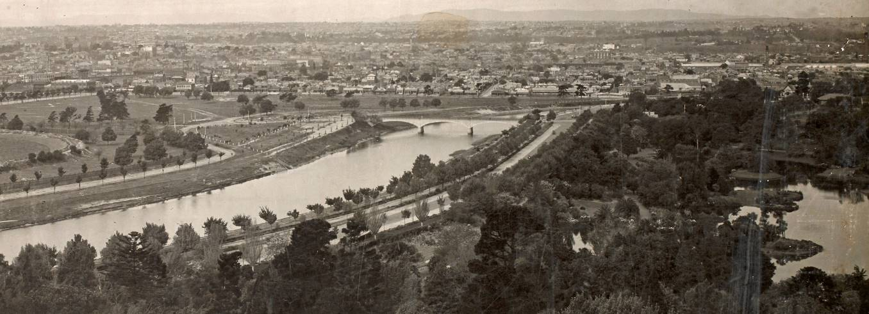Image: The river upstream is widened and straightened and tree-lined avenues built up along both sides. Part of the old channel is retained as the lake in the Botanic Gardens (right of image). The bend that was to the north of the Morell Bridge was filled (left of image). (State Library of Victoria)
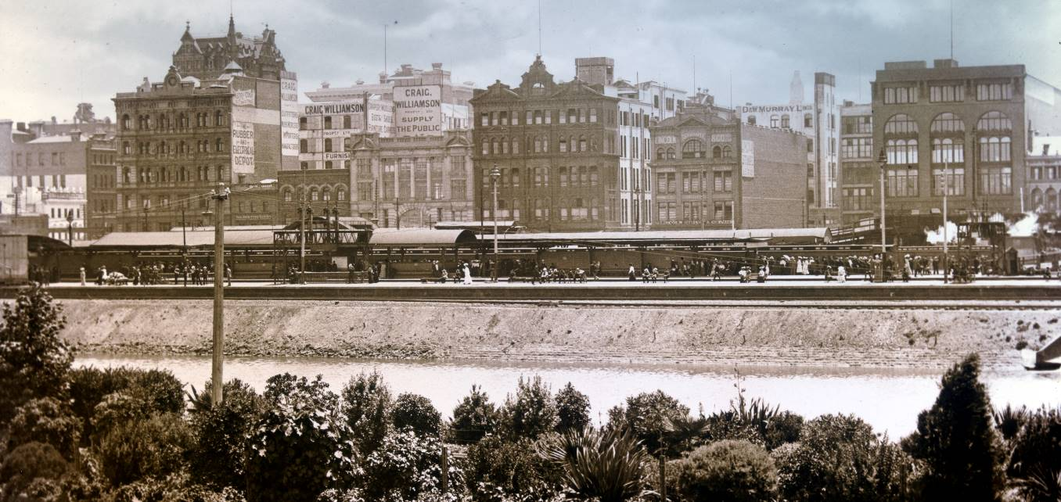Image: The reconstruction of the river and development of rail stations and yards creates engineered waterway and landscape with little resemblance to the old Birrarung. (John Henry Harvey, State Library of Victoria)

From Port to Car Park to Park, 1927-1981
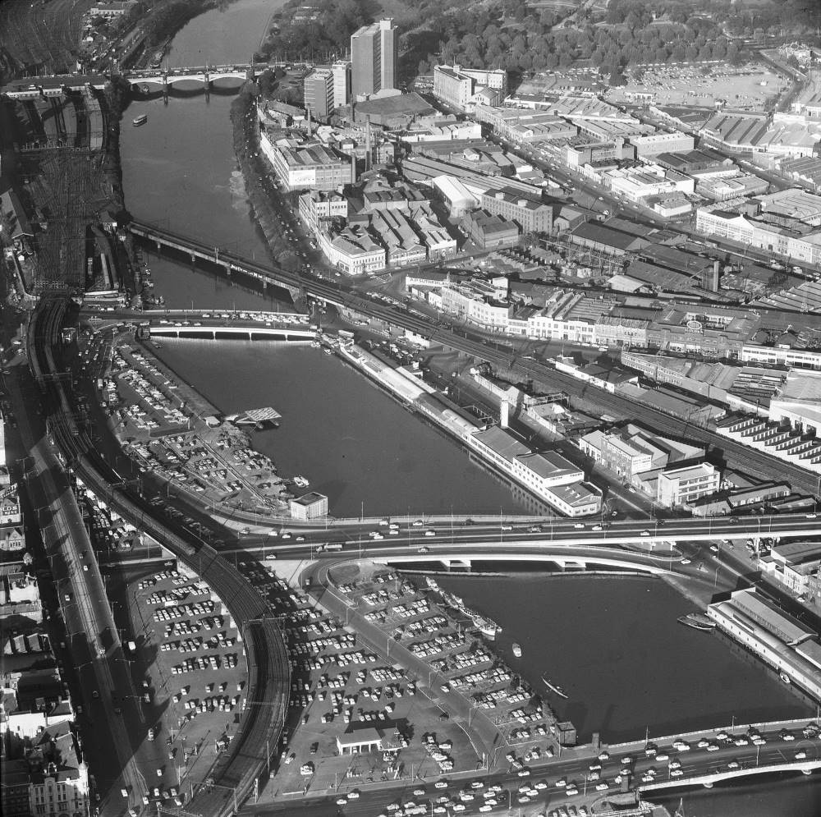
Image: Construction of the Spencer Street Bridge in 1927 cuts off upstream areas from the port. In 1953 the turning basin is filled in and converted to a car park. This is expanded after the demolition of the Fish Market in 1959. Kings Way and King Street Bridge are completed in 1961. (Jim Payens, Museums Victoria)
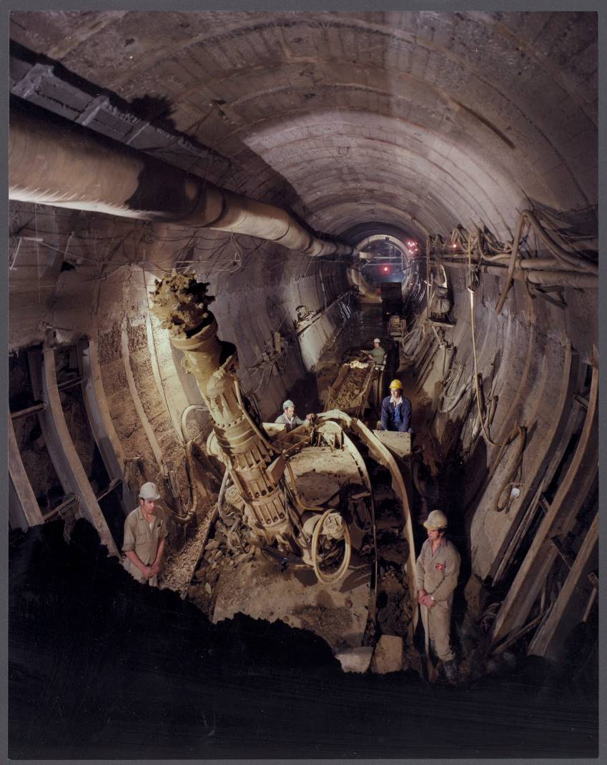
Image: Following the 1969 Melbourne Transportation Plan, the City Loop was completed in 1978. This added an additional rail viaduct along the north bank. (John Holland Constructions, “The Loop” by Wolfgang Sievers, 1977. State Library of Victoria, Accession no: H2004.49/72)
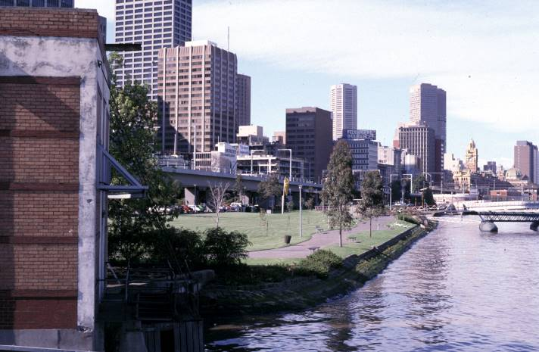
Image: Car parking is removed between the river and the new City Loop viaduct and the area is converted to Batman Park. In 1981 Ron Robertson-Swann’s sculpture Vault is relocated here from the City Square. (Ron Jones, City of Melbourne)

Big Ticket Attractions, 1959-2019
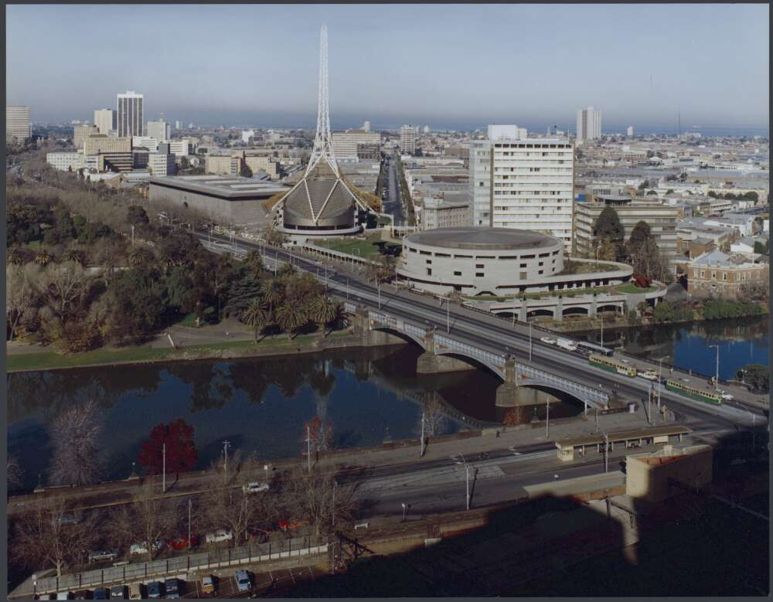Image: In 1960 the State Government commissions Roy Grounds to plan a new arts precinct on the south bank. This is followed by completion of the National Gallery of Victoria in 1968, Hamer Hall in 1981 and the Theaters in 1984. (By Wolfgang Sievers, 1983. National Library Australia, nla.gov.au/nla.obj-160881316)
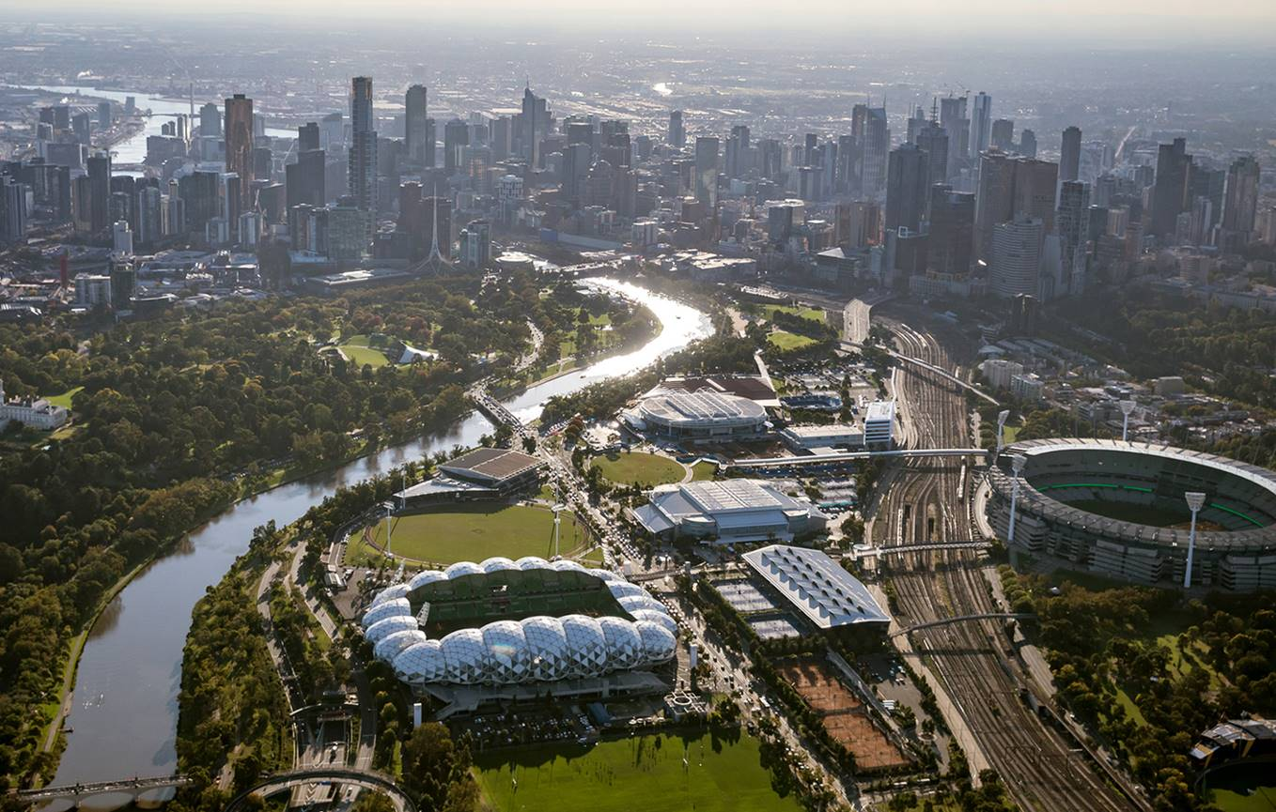Image: Olympic Park is developed for the 1956 games. A new tennis stadium built in 1988 becomes the core of the vast Melbourne and Olympic Park sports and entertainment precinct. [Andrew Curtis, City of Melbourne]

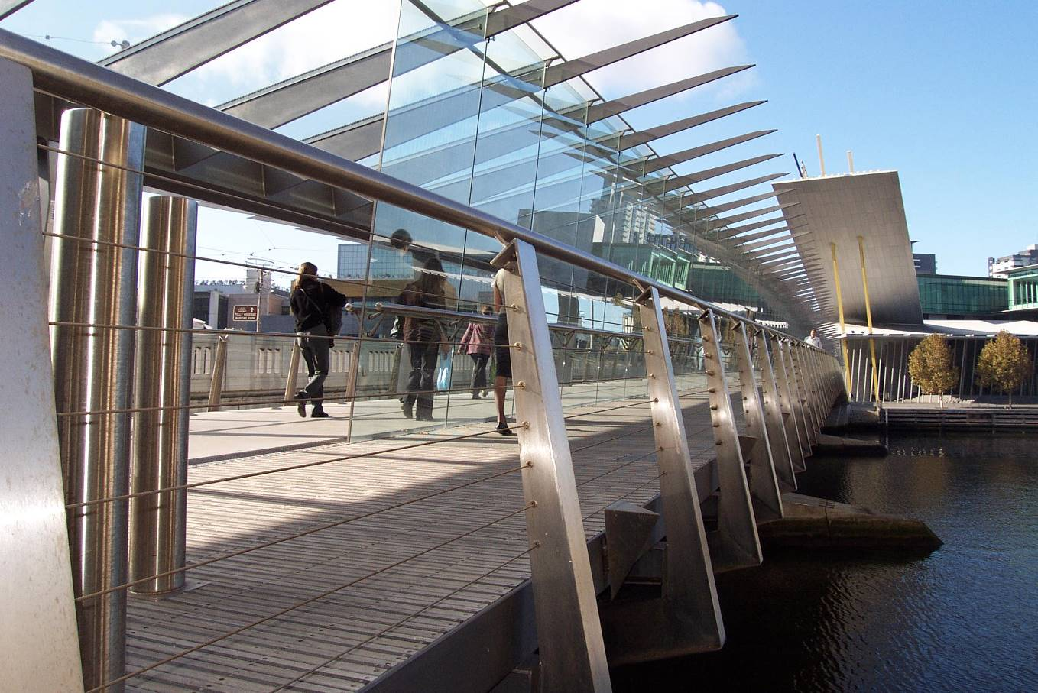Image: Major exhibition and conference facilities are built: the World Trade Centre (1983), Congress Centre (1990), Exhibition Centre (1996), and Convention Centre (2009, expanded 2018). A footbridge is added alongside Spencer Street in 1998.
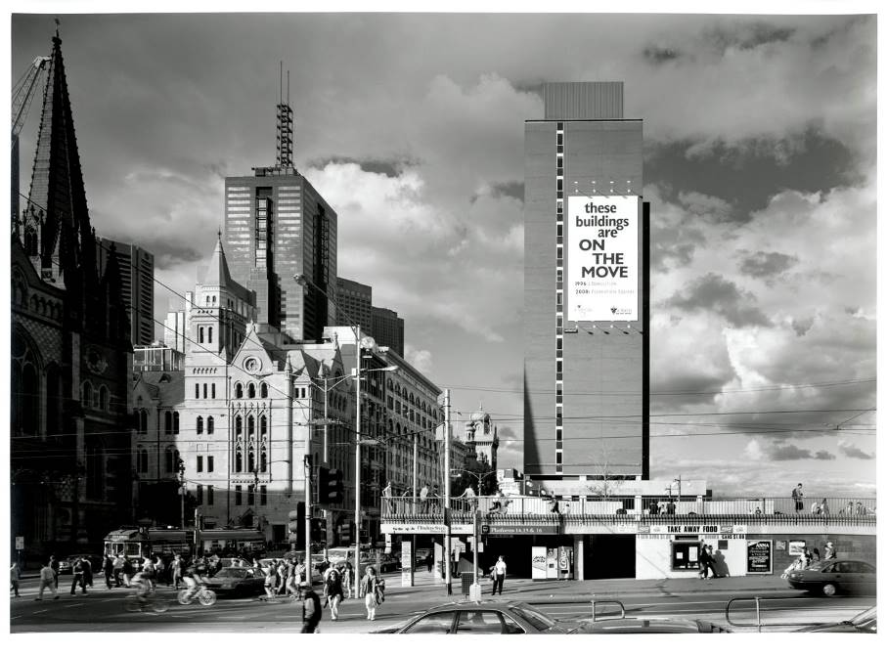
Image: After decades of failed schemes for the site, the Gas and Fuel buildings and Princes Gate Plaza are completed in 1967. They are demolished 30 years later to make way for Federation Square, which opens in 2002. (Ian Hill, City of Melbourne)

New City Spaces, 1980s and 1990s
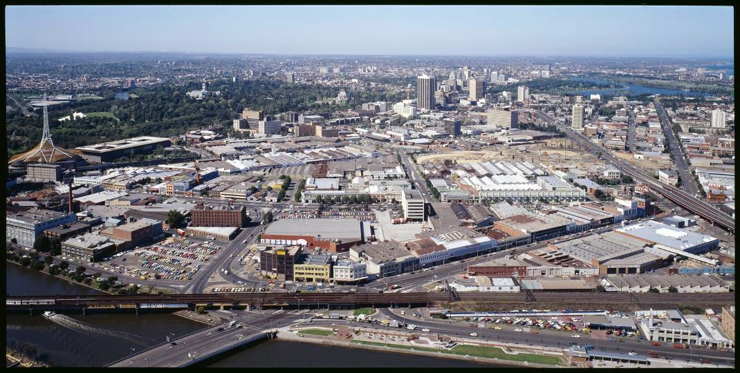
Image: In 1980 The Age mounts its ‘Give the Yarra a Go’ campaign and the state works to refocus Melbourne on the river. An early project, a small Southbank park among industrial sites, goes largely unnoticed and is later replaced by the Casino. (Thomas Laurie, State Library of Victoria)
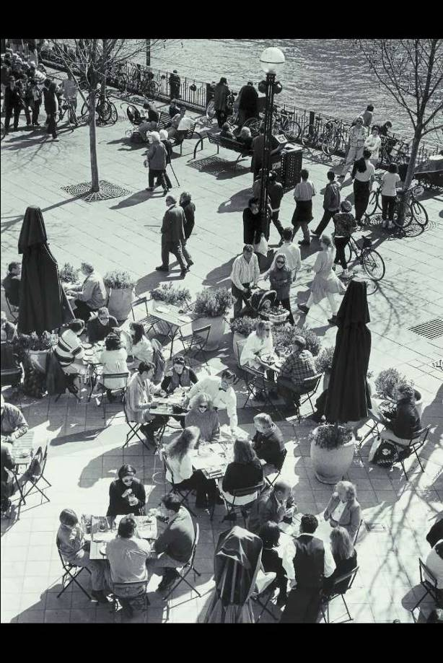
Image: Southbank Promenade and Southgate open in 1992. This successfully coordinates the delivery of a new open space, activation by adjoining development, and improved access via the new Evan Walker Bridge. (Francis Reiss, National Library of Australia)
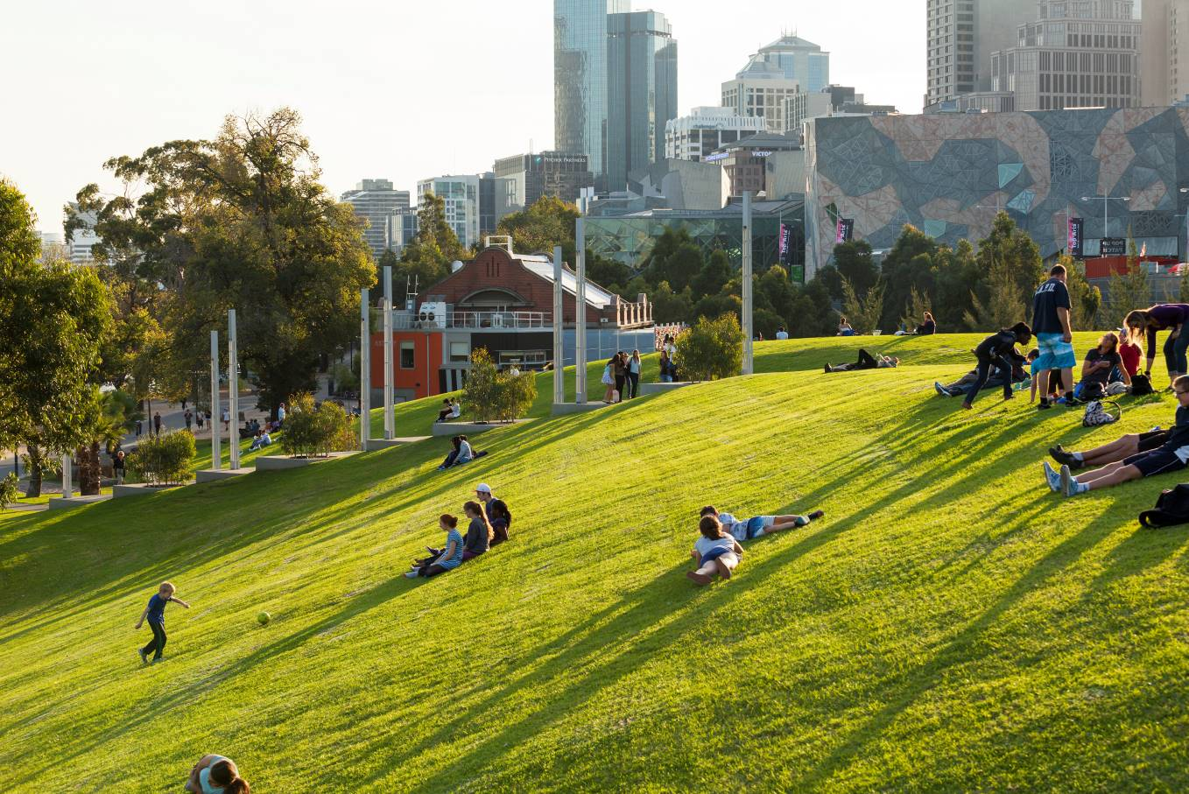Image: The first stage of Birrarung Marr is opened in 2002, creating a new park and events space on land reclaimed from the Jolimont yards. ArtPlay opens in 2004. The sculpture Angel is relocated from the moat of the National Gallery of Victoria into the park in 2006. (Drew Echberg)

Urban Repair, 1996-2014
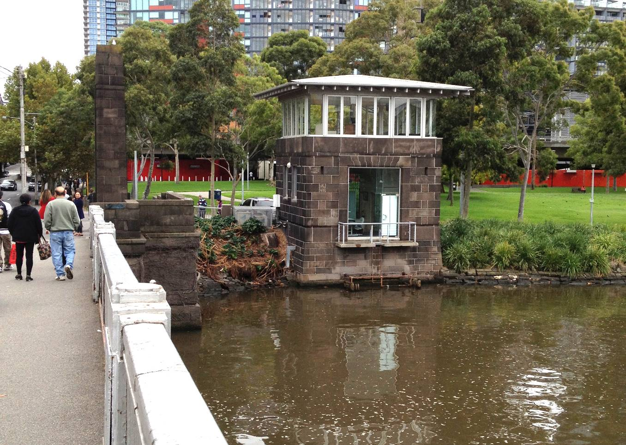Image: A structure formerly used to circulate water from the river to cool the Spencer Street power station is converted to z heliport office in 1996. This replaces a relocatable in Batman Park. (Ron Jones, City of Melbourne)
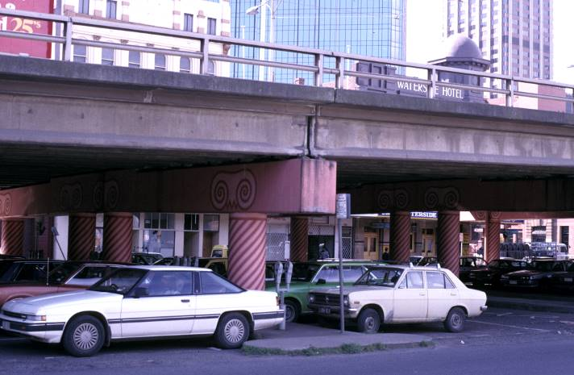
Image: The Flinders Street overpass of King Street, built as part of the Kingsway project, is removed in 2005. The aim is to revitalize the western end of Flinders Street and to enable redevelopment of the car park on the old Fish Market site. (Ron Jones, City of Melbourne)
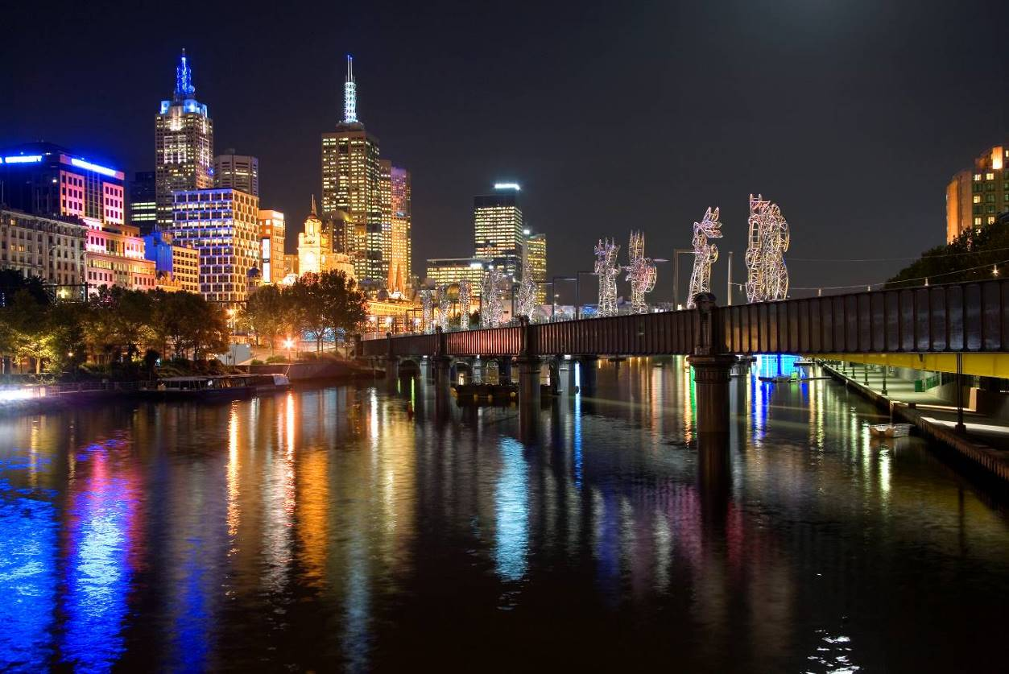
Image: Sandridge Bridge is converted to a pedestrian and cycle path in 2006. It includes a major art commission – The Travellers by Nadim Karam – commemorating the bridge’s role as an entry to Melbourne for millions of migrants. (John Gollings)
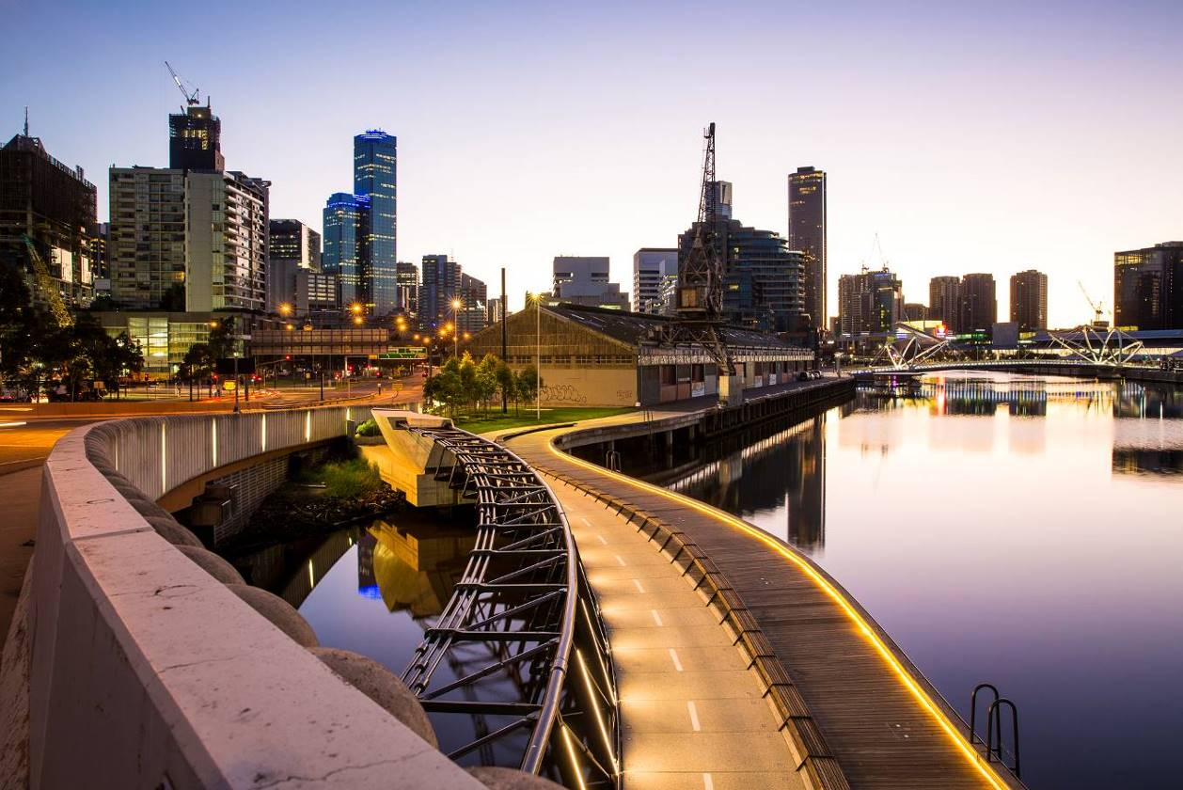
Image: The Jim Stynes Bridge is completed in 2014. The bridge spans below the Charles Grimes Bridge to provide a walking and cycling link between the Docklands and central city. (Cox Architects/Oculus Landscape Architects)

Big Money, 1996 - Present
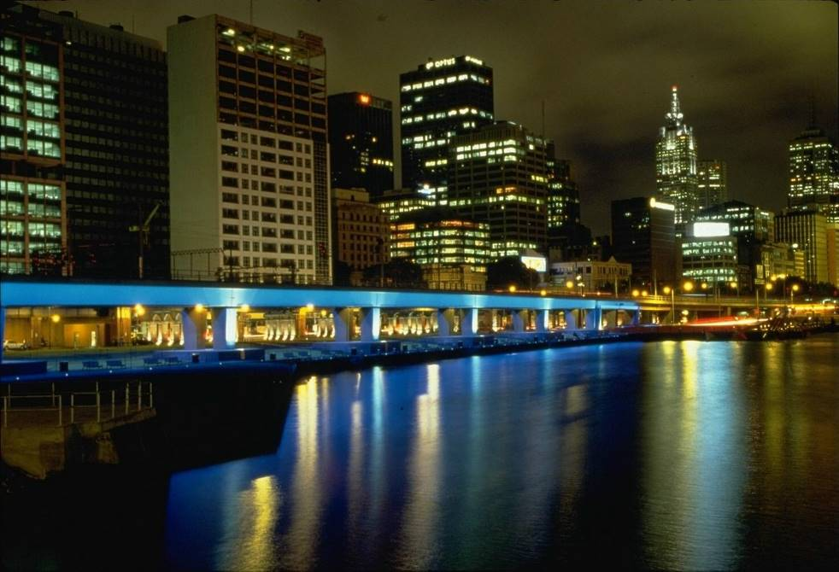
Image: Crown Casino is built in 1996, extending the Southbank Promenade westward. In parallel, the Turning Basin is partially recreated, service buildings beneath the viaducts demolished and the ground level lowered to re-open views. The Melbourne Aquarium opens in 2000. The new building blocks the river promenade and its direct connection to a King Street crossing created as part of the new Turning Basin. (City of Melbourne)
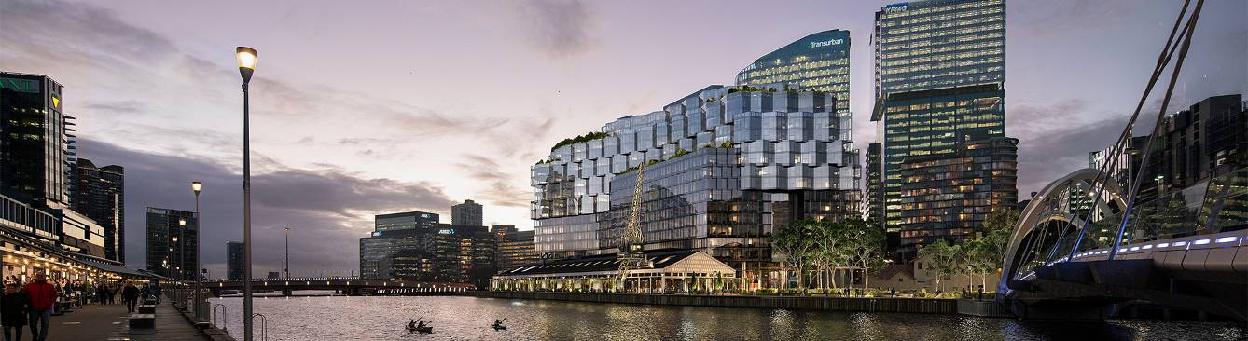Image: After a number of false starts, redevelopment of the Docklands as an extension of the city center begins in 1997. Former wharves are rebuilt as public promenades, and lined by apartments and major corporate headquarters. (Image: render of proposed Seafarers Rest development, Riverlee/Binyan Studios. Architects: Fender Katsalidis/Oculus Landscape Architects)

A Path to the Future
Today, the north bank is in the heart of Melbourne and on the doorstep of many major visitor destinations. Despite immense investment in development along the river and public space projects like Southbank Promenade, the north bank remains underwhelming. Spaces are disconnected and feel unsafe. Pathways are indirect and inadequate for the crowds that squeeze through them. Surfaces are rough and poorly maintained. A complex tangle of infrastructure, services and land management arrangements have stymied improvements. Relics from the city’s rich history and assets worth billions sit in a ruined landscape.
Looking to the future, the need for Melbourne to evolve will continue as we address:
- Population growth and demographic shifts
- Technological development
- Changes in the economy and workplaces
- Climate change
Melbourne’s west, south and central city are being transformed rapidly. Many large developments are planned, approved or under construction. Port Melbourne, Southbank and West Melbourne are predicted to grow significantly by 2040, with expanding residential and worker populations.
This growth will put more pressure on public spaces, waterways and streets that are already sub-par. On top of this, climate change is introducing new pressures on the same restricted spaces with the prospect of:
- Hotter temperatures and more days of extreme heat
- Rising sea levels
- More extreme storms and increased frequency and severity of floods
- More erratic rainfall
These issues all increase stress on vegetation and wildlife. Further, they make irrigation (water consumption) both more necessary and more difficult to sustain.
The Greenline major initiative will address these issues, creating a safer, more vibrant space for generation to come and connects to country and the river.

Annual visitor numbers to key destinations within walking distance of the Greenline
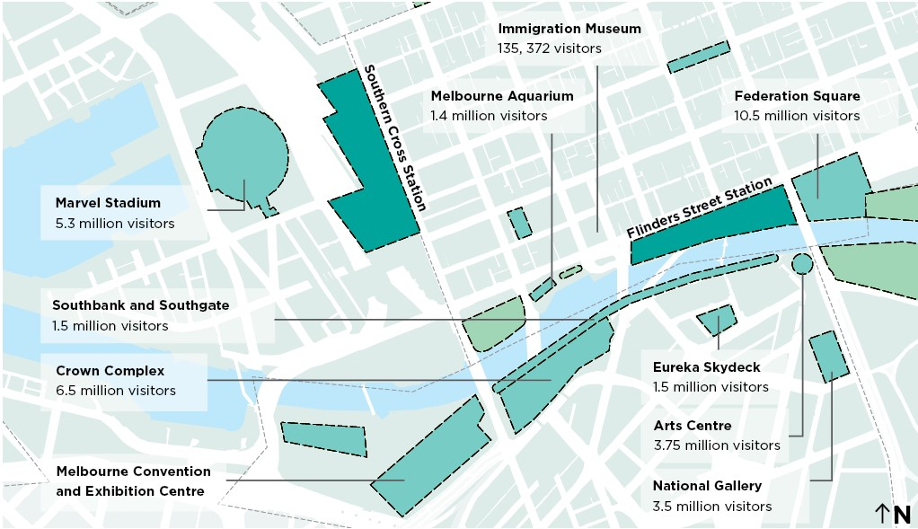

Significant City Growth
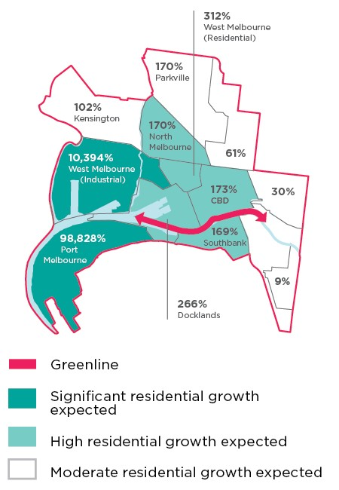
Significant residential growth expected
- West Melbourne (Industrial) 10,394%
- Port Melbourne 98,828%
High residential growth expected
- North Melbourne 170%
- West Melbourne (Residential) 312%
- CBD 173%
- Docklands 266%
Moderate residential growth expected
- Kensington 102%
- Parkville 170%
- Carlton 61%
- East Melbourne 30%
- South Yarra (within City of Melbourne) 9%

Developments in the project study area
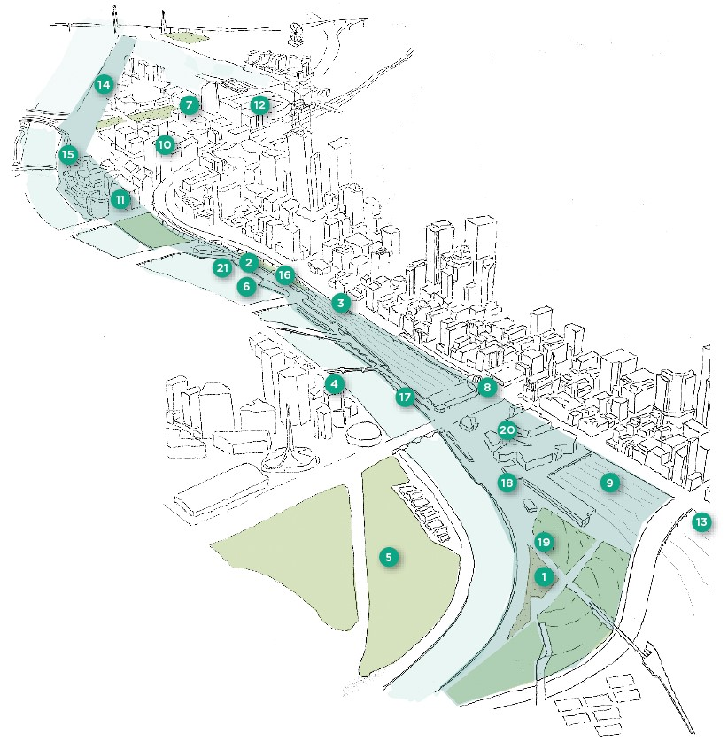

City of Melbourne projects
- Draft Birrarung Marr Masterplan
- Enterprize Park landscape upgrades
- Flinders Street bike lanes investigations
- Southbank Promenade landscape upgrade
- Domain Parklands Masterplan
- Birrarung Trial Floating Wetlands

Victorian Government projects
- Harbour Esplanade redevelopment
- Town Hall Station construction and future Flinders Street Station refurbishment
- Richmond to Docklands Planning Framework

Private developments
- Melbourne Quarter by Lendlease
- Flinders Bank by Century Group
- Marvel Stadium redevelopment (with the Victorian Government)
- Treasury Square development (with the Victorian Government)
- Collins Wharf by Lendlease
- Seafarers Rest by Riverlee (including Seafarers Rest Park renewal)

Temporary and other intervention opportunities/proposals
- Good Cycles Bike Hub (Customs Square)
- Expanding Hospitality presence on the Yarra River - Birrarung including Arbory, Arbory Afloat, Ponyfish Island, etc.
- Joost Baker ‘Future Food System’, Birrarung Marr
- Birrarung Marr Festivals and Events
- Federation Square Activations

Delivering Shared Objectives
The Greenline Major Initiative is informed by strategies and policies that recognise the Yarra River - Birrarung as a culturally significant place and major environmental asset. These strategies and policies were developed by Traditional Owners, the Victorian Government and City of Melbourne.

State Policies
The Wurundjeri Woi Wurrung Birrarung Water Policy (2019) outlines aspirations for community and Country, and their fundamental connection to the Birrarung.
- Victorian Government policies and strategies related to the river include:
- Yarra River Protection (Wilip-gin Birrarung murron) Act 2017
- Yarra River 50 Year Community Vision (2018)
- Yarra Strategic Plan (Draft, 2020)
- Lower Yarra River Management Advisory Committee Report
- Protecting Victoria’s Environment – Biodiversity 2037
- Water for Victoria (2016)
- Melbourne Water’s Healthy Waterways Strategy (2018)
The Yarra River Protection (Wilip-gin Birrarung murron) Act 2017 is the first legislation in Australia to be co-titled in a Traditional Owner language. ‘Wilip-gin Birrarung murron’ translates as ‘keep the Birrarung alive’ in Woi-wurrung, the traditional language of the Wurundjeri Woi-wurrung people. This title recognises the Traditional Owners’ custodianship of the river and their unique connection to the lands through which it flows. The Act is also an Australian first in legally identifying a river and its corridor as a single living and integrated natural entity for protection.
The Yarra Strategic Plan gives effect to Wurundjeri Woi-wurrung people’s place-based policy response to the Act. It also prescribed the establishment of a new statutory body, the Birrarung Council – the independent voice of the Yarra River - Birrarung as a living entity.

City Strategies
The City of Melbourne has a range of policies, strategies and guidelines addressing various issues impacting the municipality. These have been supported by extensive community consultation.
These policies, strategies and guidelines set out Council’s expectations for all City of Melbourne projects and inform advocacy with other agencies. Many of these have direct bearing on and will drive decision making for the Greenline Major Initiative.
The hierarchy of these documents for the Greenline is as follows:
- The Yarra River - Birrarung Strategy is Council’s key document dealing with the Greenline area.
- Future Melbourne 2026 sets out the community’s aspirations for the city. It provides a foundation for individuals and institutions to work towards common goals.
- The Council Plan 2021-25 builds on the aspirations in Future Melbourne, setting out what the Council intends to achieve in this period.
- Other Council strategies.
Appendices 1 and 2 include summaries of City of Melbourne strategies relevant to the Greenline. Specific deliverables that will be targeted through the Greenline are noted. Additional ways to support these objectives may also be identified through the design process.
There are frequent overlaps between the content of various strategies. Where the same or similar actions or targets are identified in more than one strategy, they are listed under only the one they are most relevant to.

Council Plan 2021-25
The Council Plan 2021-25 is the Council’s key strategic document. It describes the community’s long-term vision for Melbourne and shows how the Council will strive towards that vision during its four-year term.
When we meet, we look out at one of our favourite places in the municipality - the beautiful Birrarung - and acknowledge and celebrate our Traditional Custodians of the land, part of the longest surviving culture in the world. Melbourne is an Aboriginal city where we govern with our Traditional Custodians and all have a shared commitment towards treaty, justice and reconciliation with our First Peoples. - Council Plan 2021-25, p.12
The Greenline is included in Council Plan 2021-25 as a Major Initiative. It is listed under the strategic objective ‘Melbourne’s unique identity and place’.
Partner with the Victorian Government and other stakeholders to deliver specific components of Greenline along the north bank of the Yarra River (including implementation of the Yarra River Birrarung Strategy). - Council Plan 2021-25, p.23
“Our Yarra River - Birrarung, is recognised around the world as an iconic example of a nurturing relationship between a river and its community...”
Yarra River 50 Year Community Vision

Delivering on the Yarra River - Birrarung Strategy
The City of Melbourne’s Yarra River - Birrarung Strategy (2019) is a key guiding document for the Greenline. The Greenline themes build on those outlined in the Yarra River - Birrarung Strategy. This spread provides a summary of the strategy’s strategic directions that can be delivered through the Greenline. For a full list of actions and policies from the strategy refer Appendix 1.

Yarra River - Birrarung Strategy Themes and Strategic Directions

Ecology
- Transform the hard edges of the riverbanks to promote a healthy river ecosystem
  - Increase riparian greening along the river including existing riverbanks
  - Deliver a trial project of riparian vegetation on the riverbank
  - Deliver a trial project for floating vegetation in the river
- Prioritise indigenous planting and increase greening to improve biodiversity and ecological networks
  - Use a native and resilient planting palette along the river
  - Encourage the extension of riparian habitats into urban parks along the river
  - Develop a plan for interpretive signage highlighting the natural river environment
- Address flood risk and improve water quality
  - Apply Sponge City strategies in the public realm and encourage their use in private development
  - Encourage initiatives to improve water quality including filtration of water runoff

Culture
- Collaborate with Traditional Owner groups to help tell the living cultural story of their connection to the river
  - Establish a Memorandum of Understanding to guide future engagement
  - Develop an Aboriginal Cultural Narrative for the area
  - Research the pre-contact landscape character and botanical aspects of the river including landscape management aspects to inform plantings
- Increase the public visibility of intangible Aboriginal heritage
  - Identify sites of significance and culturally significant species in collaboration with Traditional Owner groups and explore opportunities to reintroduce these to the river
  - Develop an interpretation strategy including storytelling and signage based on the Aboriginal cultural narrative and post-contact histories
  - Explore opportunities for creative installations that elevate understanding of Aboriginal culture in the past, present and future
- Recognise the historical and contemporary importance of the maritime uses of the river
  - Consider maritime heritage in planning and design of key areas. Encourage interpretation and a connected network between heritage precincts

Place
- Create an inviting destination
  - Work with the Victorian Government and adjacent landowners to develop an agreed design and deliver improvements to the central city north bank area
- Celebrate character areas and encourage new economies
  - Encourage educational, cultural, hospitality and water-related uses that complement high quality public spaces
  - Build on diverse character districts to create locally authentic experiences
- Sustain a civic focus with activation that supports an inclusive, public waterfront
  - Ensure unrestricted public access
  - Encourage buildings to address the water with active frontages
  - Discourage helicopter facilities and car parking in riverfront areas and work to minimise ambient noise
  - Promote activities that support a public, safe, and attractive riverfront
  - Develop a long-term program of events and activities that will transform key locations into vibrant, safe and inclusive destinations
- Rationalise clutter and infrastructure to protect views
  - Deliver maintenance upgrades - graffiti removal, etc.
  - Construct new bridges only if connectivity is critical

Movement
- Distinguish the river as a slow-paced environment by creating safe alternative bicycle routes
  - Deliver continuous protected bike lanes on Flinders Street to provide an alternative commuter route to north bank
  - Continue delivery of the alternative Southbank commuter cycle route
- Better integrate pathways along and leading to the river, particularly to the north-west
  - Improve universal accessibility along riverfront pathways and crossings
  - Improve the accessibility, legibility and amenity of pathways along and to the river
  - Improve street crossing arrangements and amenity at the river edge, at Queensbridge, Kings Way, Spencer Street and Russell Street/Hosier Lane
  - Investigate the potential to lower Wurundjeri Way to improve access along the river
  - Undertake a detailed audit of existing conditions and develop a coordinated maintenance and physical upgrade program

Community and Stakeholder Engagement

Participate Melbourne and Key Stakeholder Workshops
On 4 May 2021 Council’s Future Melbourne Committee resolved to endorse the Draft Greenline Implementation Plan for targeted and public consultation.
The resolution specified that the consultation should include:
- An opportunity for public feedback via the Participate Melbourne portal for a period not less than six weeks.
- Targeted stakeholder engagement undertaken by management.
It was also noted that a final version of the Implementation Plan is to be recommended to Future Melbourne Committee after the consultation period. This is to be provided alongside a public consultation report.
Public and targeted feedback on the Draft Implementation Plan was sought via Participate Melbourne from August to October 2021. Over 3000 individuals visited the website and 390 completed the survey. In addition targeted stakeholders were interviewed and participated in two on-line workshops held on 21 September and 5 October 2021.
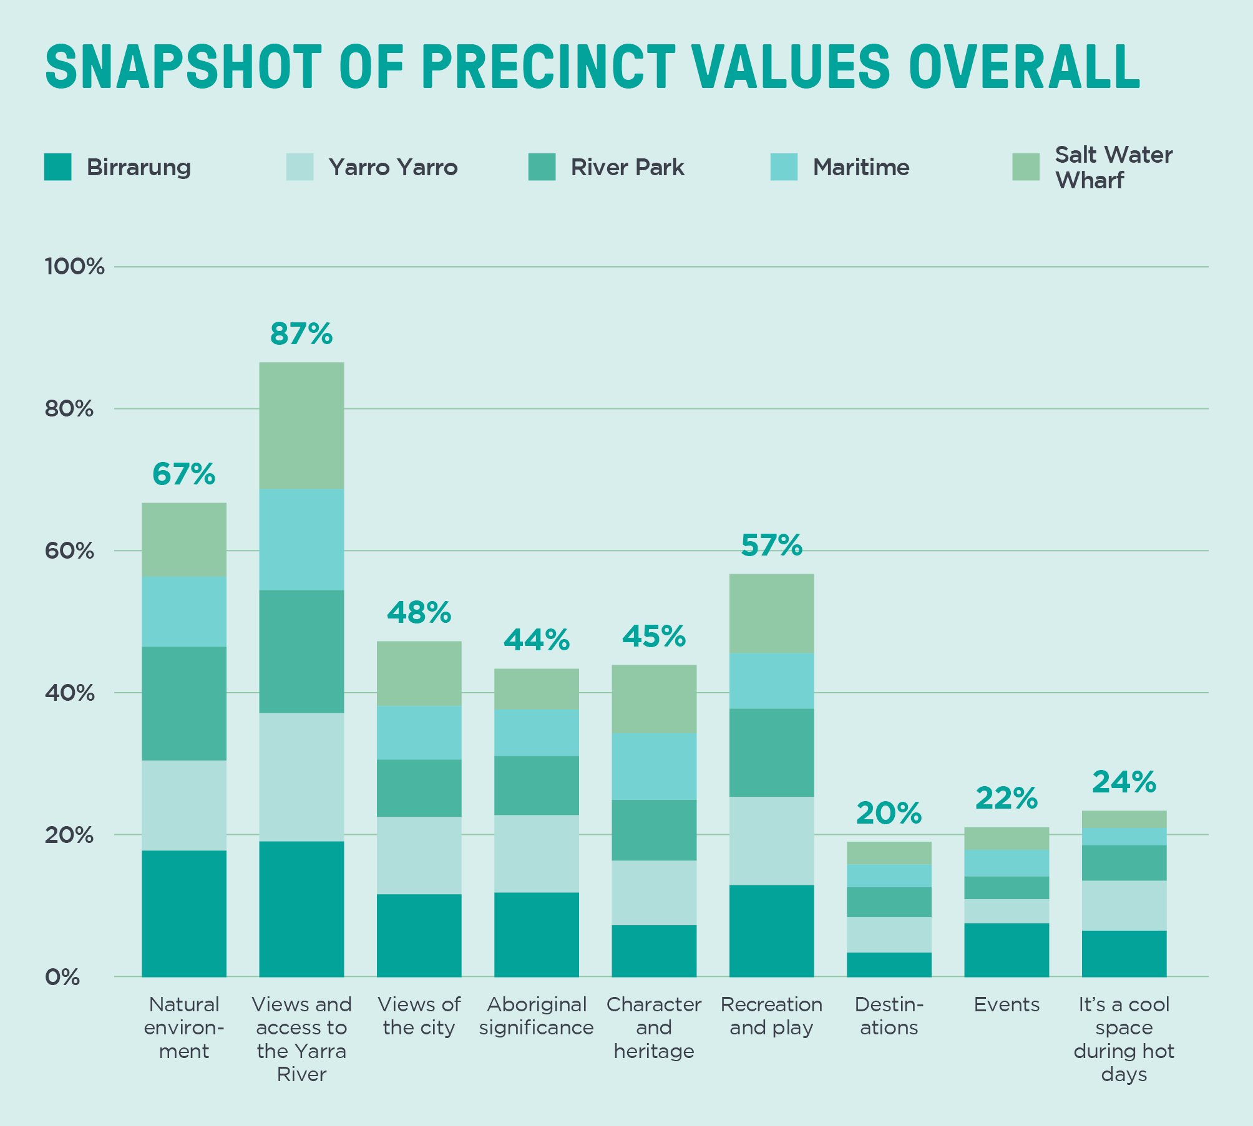
Why do you visit the North Bank of the Yarra River, Birrarung?
- 51% visit for exercise and recreation (for example running, walking, cycling, games/sports, and group fitness)
- 14% visit for relaxation (for example picnics, family gatherings, quiet contemplation)
- 8% are commuting to/from work by bicycle
- 6% are commuting to/from work on foot
- 4% are attending events
- 3% are visiting tourism destinations
- 2% visit for lunch breaks
- 2% visit for children’s play opportunities
- 6% visit for other reasons
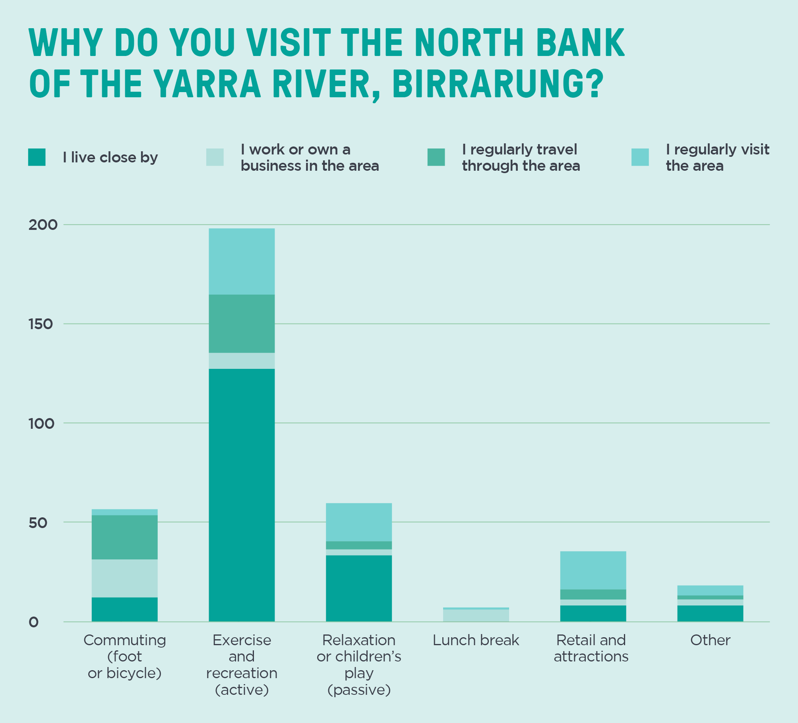

Participate Melbourne Key Findings
Response to the draft Greenline Implementation Plan was overwhelmingly positive. Across all feedback channels, participants demonstrated enthusiasm for the plan and strong support for the proposal.
In particular, feedback focused heavily on opportunities to enhance greening and improve the environmental health of both the riverbank and water components of the precinct. A strong focus on greening and enhancement of natural landscaping was supported for its contribution to the local environment and biodiversity, public open space, active transport, and community health and wellbeing through the upcoming period of COVID-19 recovery.
Participants across all channels were grateful for the opportunity to be involved in this early stage of engagement and reiterated the importance of ongoing engagement with communities and stakeholders throughout all stages of this major program of works.
“This is an opportunity to create a real centrepiece for Melbourne. Celebrate the opportunity and energy and don’t get bogged down in complaints. Create a space that enables rather than restricts.”
“This extensive plan will encourage more use and be an attraction. It will also bring the river into special focus. The link with Aboriginal Melbourne is such a special and long awaited relationship.”
“It’s been forgotten and abandoned for all this time and the Yarra has so much potential to balance the offering that Southbank has and provide a link across the northern CBD”
“The north bank of the river has too many hard surfaces and needs a lot more greenery and landscaping to soften the edge of the city with the water.”
“It needs to be more than a park along the river. Landscape and seating are not enough to attract people to spend their time there. It requires other spaces that are more engaging.”
- Extract from Capire Consulting Draft Greenline Implementation Plan - Community and Stakeholder Engagement Summary Report

Greenline Opportunity Statement
The following statement was developed with key stakeholders who participated in two targeted workshops.
The Greenline presents a significant and timely opportunity to transform the north bank of the Yarra River - Birrarung. It will seamlessly integrate and connect the riverfront with the water itself, and the city around it. This will improve access to the river and encourage movement to and through the precinct, prioritising walking, recreational cycling and public transport.
The Greenline will be distinctly Melbourne. It will be grounded in Aboriginal heritage and living culture while also reflecting and building on collective histories and broad cultural values of place. Focal points along the north bank and on-river activities will celebrate this aspect of the river’s unique role in the city.
Importantly, the ecology of the river and its surrounds will be carefully considered and will inform how the Greenline is designed and maintained. This is in line with the Victorian Government’s Yarra Strategic Plan. An integrated water management approach will be applied, bringing together natural and urban systems to function cohesively. This will support clean water, thriving biodiversity and human health and safety.
The Greenline will be a place for everyone, designed to ensure all feel welcome and safe. A range of place types and programming will ensure diverse experiences that cater to all users, providing an inclusive mix of spaces for activation and respite.
In the near term, early works along the north bank of the river will contribute to economic revitalisation in response to COVID-19. This will generate energy in Melbourne in alignment with current uses of the city. The Greenline will reinvigorate the CBD by attracting Melburnians and visitors alike to the river and the businesses surrounding it.
Over time, the Greenline will evolve to meet the changing needs of Melbourne’s growing population, cooling the city and providing valuable open space. This will contribute to the health of the river and its environment and to human wellbeing, building the city’s resilience to climate change.
Successful delivery of the Greenline will be realised through collaboration and investment by a range of partners. Coordination of multiple landowners and managers will be essential, especially in interfacing with large, strategic initiatives led by government and the private sector. This will enable the Greenline to plan for and integrate with adjacent infrastructure and precincts, ensuring a cohesive and future-focused outcome for the city.
This transformation will reorient our relationship with the Yarra River - Birrarung, celebrating and nurturing it to the benefit of people and the river itself. The Greenline will allow new memories to be made, unique to Melbourne and of this place.
Quotes from workshop participants
“This is a 100-year project, so needs to be forward thinking and not just trying to fix today’s problems.”
“The land tenure of any public open space shouldn’t get in the way of a coordinated vision and a coordinated feel to people when they visit.”
“The Greenline offers an opportunity around improving the way people connect with and value the river.”
“The North Bank feels patchy and neglected in parts, especially compared with Southbank.”
“People currently see the river as dirty and they don’t understand the story behind it and the benefits that it brings to us.”
“The Greenline could provide a seamless connection to place and country.”

Greenline Themes and Objectives

Themes
The following themes build on the strategic directions of the Yarra River - Birrarung Strategy. They set the framework for the objectives that will guide the development of the Greenline.

Environment – Healthy ecosystems
The river will be enhanced as an ecological corridor. Increased planting and revitalisation of the riparian edge will improve biodiversity and river health and increase resilience. Water quality and flood management will be addressed to help mitigate the effects of climate change.

Objectives
- Improve river health
- Design for and mitigate impacts of climate change, rising sea levels and flood risks
- Create a connected ecological corridor to improve the city’s biodiversity
- Increase tree canopy cover and vegetation to improve urban cooling
- Provide opportunities for environmental education and interaction with the river

Culture – Authentic stories and experiences
Melbourne’s heritage will be made more tangible by creatively embedding stories into the landscape. Spaces that inspire and educate will celebrate Wurundjeri Woi Wurrung and broader Aboriginal significance along the Birrarung, and our immigration and maritime past.

Objectives
- Provide opportunities for the ongoing practice and celebration of Aboriginal culture
- Recognise and reflect the many cultural narratives and values linked with the river
- Enhance the unique characters of the north bank including celebrating its heritage assets
- Balance a consistent identity with responsiveness to each individual place

Place – Great places for people
Open spaces along the river will be re-imagined through bold interventions, strengthening their identities and respecting existing values. These spaces will provide opportunities for public activities and places of respite. They will build on connections with nearby areas to encourage new economic opportunities. The Greenline will provide for and welcome everyone, ensuring diverse and safe places and experiences.

Objectives
- Create spaces that embrace and express the Yarra River - Birrarung as a unique place and the focus of the Greenline
- Create spaces that respond boldly to the urban qualities of adjoining areas
- Provide amenity and diverse experiences that support community health and wellbeing
- Create high quality places that prioritise safety and inclusion

Connection – An uninterrupted journey
Access along the river and to the Greenline public spaces will be improved, as will connections between the river and city. Physical barriers will be reduced, modal conflicts will be minimised and wayfinding will be enhanced. Safety and inclusivity will be prioritised. Compelling journeys will be created through varying landscape experiences and will enable opportunities to connect with the water.

Objectives
- Create a continuous, uninterrupted journey along the river edge
- Improve opportunities to connect to the river, visually and physically.
- Improve links to surrounding streets and walkways
- Ensure safe, inviting, and universal access for users
- Maintain access throughout the river corridor as a primarily public place

Environment

Healthy ecosystems
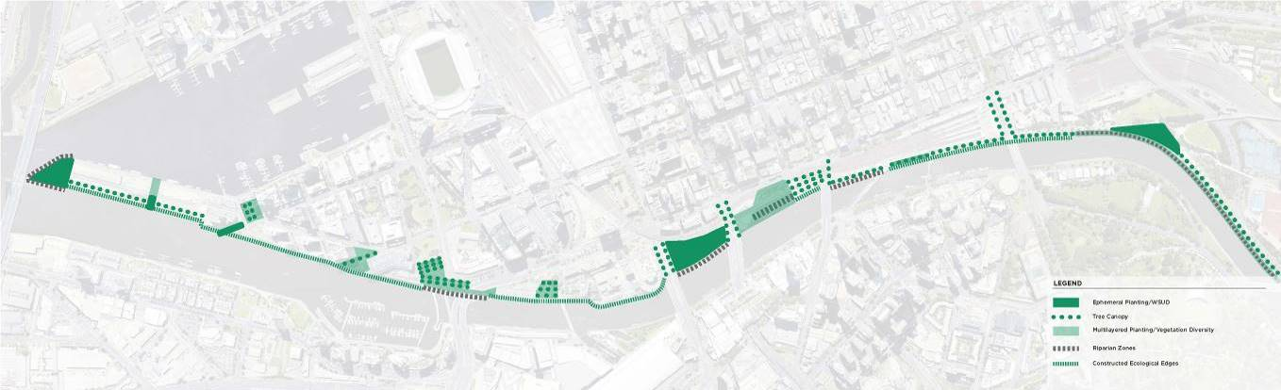
The City of Melbourne is facing significant environmental and climate-related challenges including flooding, urban heating and habitat loss. The Yarra River - Birrarung is a significant natural asset. It was recognised formally as a living entity in the Yarra River Protection (Wilip-gin Birrarung murron) Act 2017. A key element of recognising the river as living is acknowledging the leadership role of the Traditional Owners as environmental advocates.

Greenline Strategies

Redesign the riverbanks to work with river processes
Reconstructing and softening the river edge can allow for natural processes to shape the river. In a meandering river, water moves slowly on the inside of bends, drops sediments and builds up a gently sloping bank. Riparian vegetation can then grow on this bank. At the outside of the bend, swifter water erodes a steeper face which is likely to be overhung by established trees. Restoration of an ecological edge to the river should respect and express these processes. Where the edge needs to be built with walls, these can be designed to reflect geological forms.

Apply ecological principles to current conditions
To create an effective ecological corridor, understandings of the past natural environment and of existing conditions should be applied in combination. Research on the pre-contact landscape should include areas of the Birrarung well beyond the Greenline. This may provide guidance for responses to micro-climates in the shade of today’s high-rise CBD. Key fauna species that have been locally identified should be targeted and designed for.

Re-establish diverse water and wetland conditions
Historically, the Birrarung was a narrow meandering river situated within a flood plain and surrounded by billabongs. It flowed into the bay through an estuary flanked by salt marshes. It was not a single, simple channel but a complex series of water bodies, seasonal wetlands and streams. A variety of water edge and water body conditions should be created along the Greenline. This would support diverse flora and fauna communities. It could also help to deal with functional issues, such as filtration of stormwater runoff before it enters the river.

Improve soil volumes and quality to support increased greening
The Greenline area faces a range of issues regarding soil health. In some areas the ground is made up of low quality soil that cannot support vegetation. Provision of sufficient soil depth to support healthy trees on wharf structures is a challenge. Areas with low ground levels also leave only a shallow soil layer above the water table. These conditions result in containerisation and stunting of trees. Excavation and replacement with better soil is potentially problematic due to contamination, services and where existing trees are retained. Excavation and replacement also require disposal of contaminated spoil off-site as waste. Raising ground levels will therefore often be the most feasible option; this will also protect from salinity, with rising sea levels.

Increase flood protection within the Greenline and for the CBD
The CBD and Greenline face threats of rising sea levels and major storms caused by climate change. These pose serious concerns for infrastructure, activities, and people along the Greenline. Minimum levels need to be resolved for paths and structures to build long term resilience into the design. Low-lying areas may need to be protected by bunds (as Banana Alley is). Overhead clearances for access under bridges will become more difficult. Overland flow paths and stormwater outfalls must be respected and maintained to avoid flooding other areas.

Culture

Authentic stories and experiences
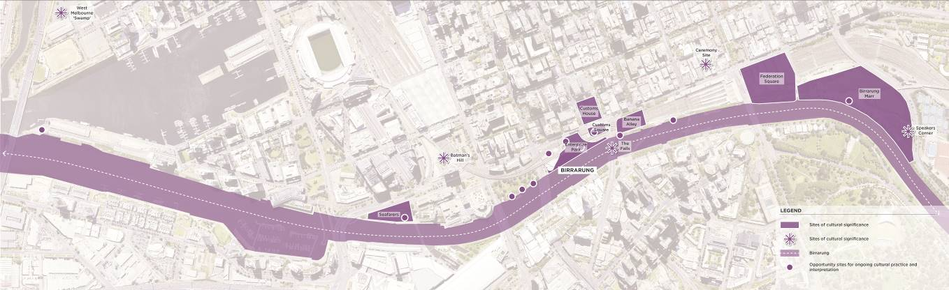
The north bank of the Yarra River - Birrarung is representative of multiple layers of heritage and culture. While the river landscape includes a myriad of significant sites, they do not ‘tell the stories’ of the diverse cultures and histories of the Yarra River - Birrarung.

Greenline Strategies

Develop a cultural narrative strategy to guide storytelling
The Greenline must be underpinned by a Cultural Strategy, developed in collaboration with Traditional Owners. This will guide an interpretative strategy that respects and recognises Aboriginal culture, maritime trading heritage and shared post-contact histories. It will form the basis of storytelling and signage throughout the Greenline.

Support and celebrate contemporary cultural activities
Our culture connects us to our past, present and future. The Greenline’s location is amid many vital institutions focused on arts, culture, sport and entertainment. The Greenline should support the ongoing practice of Melbourne’s cultures, including Aboriginal culture. It should make bold contemporary expressions of cultural values.

Add amenity to spaces dominated by heritage engineering structures
Large areas of the Greenline are dominated by formally protected heritage structures – predominantly engineering works such as bridges and viaducts. While valued for the stories they tell, and in many cases handsome structures, few of these create amenable places for public use. Pervasive problems include:
- Overshadowing
- Noise
- Poor visibility
- Perceived lack of safety
- Previous use of surrounding areas for utilitarian functions
To make the Greenline an attractive destination it will be integral to respect the heritage of the area while also addressing amenity issues.

Develop an integrated creative strategy for the Greenline
There are many significant artworks along the Greenline. There is also an assortment of commemorative plaques and monuments. The Greenline will respect and build on qualities of existing works and continue to enrich the sense of place with an integrated creative approach. The approach will celebrate and be expressive of the local landscape – both natural and manmade.

Place
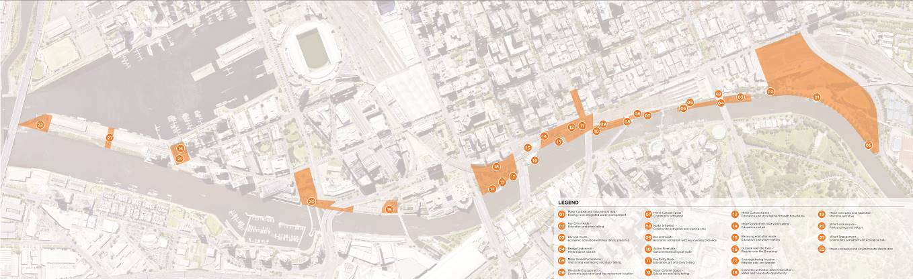

Great places for people
- Major Cultural and Educational Hub - Ecology and integrated water management
- Key Entry Node - Education and story telling
- Bar and Vaults - Economic activation with key dining presence
- Bridge Undercroft - Performance and art
- Major Greenline Gateway - Welcoming wayfinding and story telling
- Riverside Engagement - Economic activation and key movement location
- Minor Cultural Space - Community activation
- Nodal art-piece - Community activation and waiting area
- Bar and Vaults - Economic activation with key evening presence
- Active Riverside - Cultural and ecological node
- The Falls Interpretation - Cultural and art
- Key Entry Node - Education, art and storytelling
- Major Cultural Space - Education and storytelling
- Minor Cultural Space - Education and storytelling through flora/fauna
- Major location for river story-telling - Education and art
- Birrarung education node - Education and place-making
- Outlook over the river - Respite over the Birrarung
- Social gathering location - Respite, play and wonder
- Economic activation and revitalisation - Retail and hospitality opportunity
- Major local park and education - Maritime narrative
- Wharf-side respite - Park and local activation
- Wharf Engagement - Community activation and ecological hub
- Major ecological and environmental destination
The character of the north bank has been shaped by its histories and changing use over the past 200 years. As the population of Melbourne continues to grow, so too does the need for high quality public open space, and an enhanced north bank.

Greenline Strategies

Develop a sequence of spaces that complement adjoining neighbourhoods through their character and uses
The Greenline intersects a diverse range of adjacent contexts. The activities of the parkland and events spaces in Birrarung Marr differ fundamentally from the busy transport functionality of Flinders Street Station. Equally dramatic changes occur moving further downstream. The Greenline should respond to these activities, providing spaces that complement activities and opportunities nearby.

Provide spaces to accommodate varied uses for a growing city
Melbourne’s city centre is a place of intensive activity. Large volumes of people travel through spaces daily, and huge crowds gathering during major events such as New Year’s Eve. The Greenline and the spaces in it must be bold in scale to accommodate these crowds. While they do not need to be monumental, they need to be generous, open, and inviting.

Create places of respite and retreat
The Greenline is a part of the central city. It is also an important refuge from it – a place to pause and reflect, a cool space in a hot city. These opportunities will be of increasing importance in building Melbourne’s resilience to climate change, as well as in coping with increasing development density.

Create spaces for active use
It is important that the spaces along the Greenline provide for and accommodate a diverse range of recreational uses. The Open Space Strategy, the Skate Melbourne Plan and the Docklands Public Realm Plan identify a variety of specific recreational activities. These activities should be incorporated into the Greenline to support residents, workers and visitors.

Provide safe and inclusive spaces that are activated during both day and night
The Greenline will be safe, welcoming and inclusive of all people. It is important that it offers diverse spaces, and that they are activated throughout the day and night. Uses and programs need to appeal to locals and visitors of all cultures, backgrounds, ages, genders, sexualities, beliefs and abilities.

Connection

An uninterrupted journey
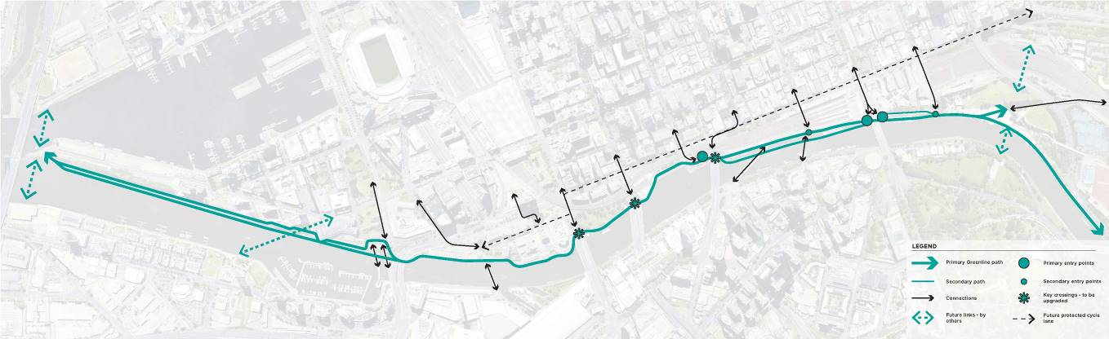
The north bank of the Yarra River - Birrarung offers a unique, linear setting. Its undulating and varied landscape is a key drawcard for many users wishing to both enjoy the river, and to use the corridor to connect with other destinations.

Greenline Strategies

Deliver a unique, continuous, and connected Greenline
The Greenline will provide a continuous, uninterrupted journey along the north bank of the Yarra River - Birrarung. It will offer a uniquely Melbourne experience, celebrating its cultural, environmental and historic contexts. It is important that the Greenline connects seamlessly to the CBD and surrounding areas to ensure easy and equitable access. The Greenling will link existing, new and future destinations.

Create a generous and universally accessible promenade
Path widths will enable people to move comfortably at their own pace. They will also allow for a mix of stationary activities. Furniture, trees, lighting and other features will be provided to support a safe and comfortable journey for all users throughout the day and night. The Greenline will prioritise pedestrians of all ages and abilities. Recreational cycling will be supported, but riding at high speeds will be discouraged. Other routes for commuter cycling will be promoted parallel to the river, including along Flinders Street.
- Design street crossings to improve access along and to the river
- Crossings at all streets along the river should be improved to:
- Align the crossing as near to the riverbank as is practicable
- Reduce traffic capacity where appropriate
- Minimise total crossing distances
- Provide generous crossing widths

Ensure safe sightlines, accessible gradients and cross-falls
The amenity of streets leading to and crossing the river should also be improved. These improvements could include widened footpaths, protected bike lanes, improved lighting, and enhanced planting.

Provide connection and close access to the water
The Greenline will provide opportunities for people to connect visually and physically to the water. Providing clear and diverse views of the river will be a priority. Due to the tidal nature of the river floating wharves will be used to allow people close access to the water. Floating wharves help to ensure safe access on and off boats despite changing tidal levels. They will also maximise resilience in relation to flooding and rising sea levels.

Ensure that vertical circulation links are generous, gentle, and easy to traverse
Where level changes require stairs and ramps, these should be generous, gentle, and easy to traverse. Examples of this include Princes Bridge, access between promenade levels and access to floating wharves. Ground levels will be manipulated where possible to reduce the height differences at key links. Impediments to travel along the river edge should be minimised.

Implementation Plan
To support the planning and delivery of the Greenline program, a series of precincts has been identified. These precincts reflect land management, activity and character attributes. The Greenline will be implemented through key improvements, coordination and advocacy along the length of the north bank of the Yarra River - Birrarung within the following five precincts:
- Birrarung Marr
- The Falls*
- River Park
- Maritime
- Salt Water Wharf

Birrarung Marr Precinct
An enhanced civic and cultural precinct acts as a gateway to the Greenline. Aboriginal culture and Melbourne’s unique ecology is visibly and boldly celebrated through the design of the landscape. A re-imagined edge provides an activated river frontage adjacent to Federation Square and Flinders Street Station.

Priorities
- Continue to engage meaningfully and respectfully with the Traditional Owners at all stages of the project.
- Work with the Traditional Owners to ensure the cultural narrative of the river is celebrated and embedded into the project delivery process and built outcome.
- Provide places for Aboriginal cultural practice and ceremony.
- Create a city gateway and prominent entry to the Greenline.
- Connect the existing sports, cultural, arts and transport destinations with the Greenline.
- Provide increased space for pedestrians along the river edge.
- Provide places to pause and enjoy the river’s edge.
- Enhance riparian greening along the Birrarung Marr rivers edge.
- Improve access from Flinders Street into Birrarung Marr.

Unlocking actions
- Provide universal access from upper to lower promenade.
- Work with land owners and managers on improvements to public space.
- Consider current and future events as the precinct develops.
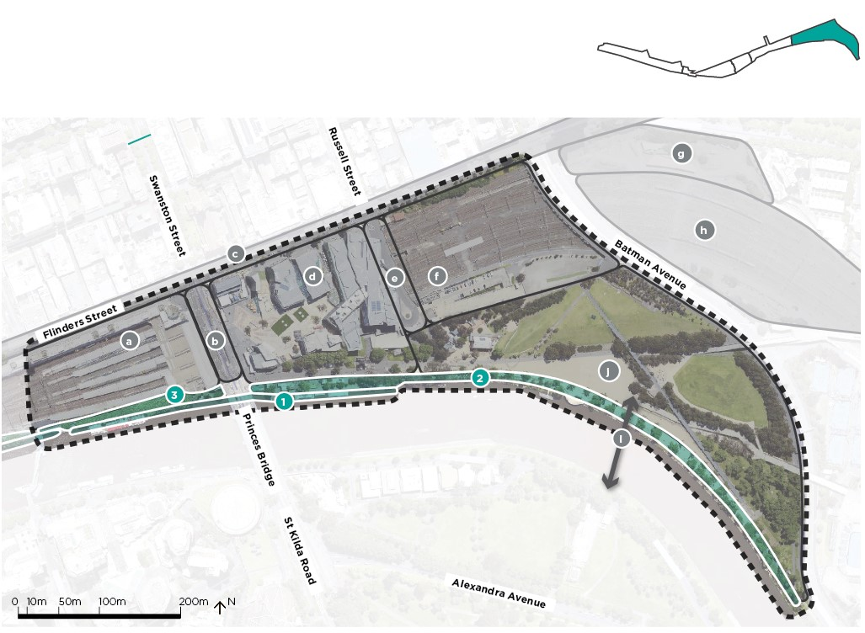

Key improvements
- Expanded Promenade
  - Improve pedestrian and recreational cyclist connections along the River.
  - Improve visual and physical connections to the River.
  - Investigate ecology and habitat improvements.
- Ecological Edge
  - Improve ecology and habitat value of river edge and park interface with Birrarung Marr.
  - Plan and commence implementation of tree succession in existing tree avenues, including soil re-mediation as required.
  - Enhance visibility to, and engagement with the river edge.
- Flinders Walk Improvements
  - Improve interface between Flinders Walk, Flinders Street Station and Princes Bridge.
  - Resolve conflicts between pedestrians and recreational cyclists at existing pinch points.
  - Improve universal access from Swanston Street to the River.

Coordination and advocacy
- Flinders Street Station
  - Coordinate with VicTrack and PTV station operations and access requirements.
  - Coordinate with future plans for the Station’s redevelopment.
  - Consider access and way-finding improvements from the train station to the Greenline.
- Swanston Street Tram Stop
  - Consider access and way-finding improvements from existing Swanston Street tram stop to the Greenline.
  - Integrate with future Swanston Street tram stop.
- Flinders Street
  - Coordinate with pedestrian and cycling upgrades to Flinders Street.
  - Improve pedestrian and recreational cycling connections between Flinders Street and the Greenline.
- Federation Square
  - Advocate for improved connections between Federation Square and the River.
- Russell Street Connection
  - Advocate for improved visual and physical connections, and improved greening from Russell Street to the Greenline and the River.
- Federation Square East
  - Coordinate with future plans for Federation Square East.
- Treasury Square
  - Coordinate with future plans for Treasury Square development.
- Rail Corridor
  - Coordinate with future plans for the rail corridor.
- Bridge Link
  - Investigate a bridge to improve pedestrian and cycle access across the Birrarung.
- Draft Birrarung Marr Master Plan by City of Melbourne
  - Incorporate opportunities identified during phase one of community consultation on the Draft Birrarung Marr Master Plan.

Next steps
- Continue to engage with Traditional Owners (the Wurundjeri Woi Wurrung) and other Aboriginal Stakeholders
- Continue to engage with land owners and managers on potential improvements
- Continue to interface with Parks Victoria assets including berthing operations at Federation Wharf
- Continue to interface with Melbourne Water assets including Elizabeth Street main drain outfall
- Investigate heritage impacts of works interfacing with Princes Bridge and Flinders Street Station
- Undertake climate impact and asset vulnerability assessment

The Falls Precinct (previously Yarro Yarro Precinct)
Aboriginal, maritime and immigration histories are revealed through artistic interpretations and adaptive re-use of physical assets. Major landscape interventions will transform Enterprize Park into a space of natural respite and an Aboriginal cultural destination for the Central City. The addition of high quality activation opportunities will draw increased visitation to this precinct.

Priorities
- Continue to engage meaningfully and respectfully with the Traditional Owners at all stages of the project.
- Work with the Traditional Owners to ensure the cultural narrative of the River is celebrated and embedded into the project delivery process and built outcome.
- Celebrate the cultural narrative of the River including the site of The Falls).
- Resolve conflicts between service vehicle access, pedestrians and cyclists.
- Improve space for pedestrians along the river’s edge.
- Create connections between the varying levels of the river’s edge.
- Unify and integrate existing and new public open spaces.
- Create a continuous pedestrian connection.
- Advocate for the activation of existing heritage assets.
- Incorporate water sensitive urban design approach to the Enterprize Park and surrounds.

Unlocking actions
- Redefine existing edge between upper and lower promenade at Flinders Walk.
- Work with land owners and managers on improvements to public space.
- Upgrade pedestrian crossing at Queens Bridge Street.
- Investigate realignment of vehicle carriageways.
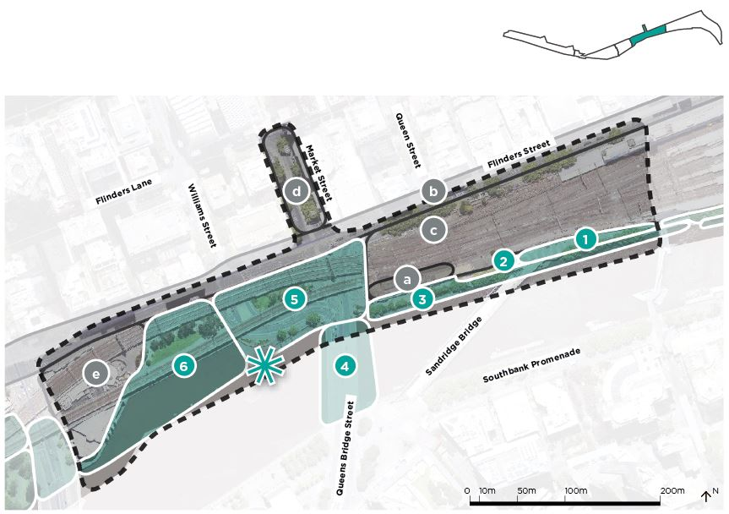

Key improvements
- Key Cultural Precinct
  - Areas 4, 5 and 6, as well as areas on the Southbank will involve significant engagement with Traditional Owners. The brief and experience of this precinct will be shaped by Traditional Owner aspirations, and will recognise cultural values and significance.
- Upper Promenade
  - Investigate opportunities for economic activation.
  - Enhance pedestrian experience to Flinders Street Station and Elizabeth Street underpass.
  - Improve physical and visual connections between the upper and lower promenade.
  - Resolve pedestrian and recreational cyclist conflicts and existing pinch points.
- Signal
  - Investigate opportunities for additional activation which is complementary to the Signal creative studio and program.
- Banana Alley and Lower Promenade
  - Investigate opportunities for public realm improvements and potential to rationalise parking.
  - Separate service vehicles from public activity.
  - Improve existing berthing facilities and investigate opportunities for river based activities.
  - Investigate opportunities for recreational or health and wellbeing activities that complement the adjacent existing business.
  - Improve pedestrian and recreational cyclist experience of Lower Promenade.
  - Improve ecological and habitat value.
- The Falls Interpretation
  - Investigate opportunities for cultural interpretation and a memorable landscape or art installation at the site of The Falls on both sides of the river.
- Customs Square
  - Improve street level pedestrian and recreational cyclist connections across Queens Bridge Street along the river front.
  - Improve access and way-finding to the Immigration Museum and Market Street Park.
  - Coordinate with proposed tram stop works.
  - Investigate short to medium term project or activation opportunities in existing open space.
  - Investigate long term removal of William Street S Bend to expand and upgrade Customs Square.
- Enterprize Park/Turning Basin
  - Improve existing open space.
  - Improve access and way-finding from surrounding streets.
  - Investigate ecology and habitat improvements.
  - Improve river edge path capacity and interaction with river.

Coordination and advocacy
- Banana Alley Vaults
  - Coordinate with land owners on any future plans and changes.
  - Advocate for improvements to highlight the historical significance of the Banana Alley heritage structures.
- Flinders Street
  - Coordinate with pedestrian and cycling upgrades to Flinders Street.
  - Improve pedestrian and recreational cycling connections between Flinders Street and the River.
- Flinders Street Station
  - Coordinate with VicTrack and PTV regarding current station operations and access requirements.
  - Coordinate with the Victorian Government and land owners and managers on any future plans for the Station’s redevelopment.
  - Consider access and way-finding improvements from the train station to the Greenline.
- Market Street South
  - Advocate for further public realm expansion.
- Melbourne Aquarium
  - Advocate for improved interfaces and active frontages along the streets and the River.
  - Improve interface with Enterprize Park.
  - Investigate opportunities for improved connections and interface between the Melbourne Aquarium and river.

Next steps
- Continue to engage with Traditional Owners (the Wurundjeri Woi Wurrung) and other Aboriginal Stakeholders
- Continue to interface with land owners and managers on potential improvements
- Undertake climate impact and asset vulnerability assessment

River Park Precinct
The re-imagined local park provides a place of respite, exploration, play and wonder for city workers and residents. A resilient landscape approach integrates seasonal inundation as an exciting, changing wetland experience.

Priorities
- Continue to engage meaningfully and respectfully with the Traditional Owners at all stages of the project.
- Work with the Traditional Owners to ensure the cultural narrative of the River is celebrated and embedded into the project delivery process and built outcome.
- Work with topography, vegetation and integrated water management approaches to enhance the landscape resilience to climate change.
- Provide opportunities for increased safety, amenity and activation.
- Improve the legibility of pedestrian pathways and interconnections with adjacent precincts and the central city.
- Provide areas of respite and social connection for workers and residents of all ages.
- Provide elements of play, delight and curiosity in a submersible river landscape.
- Mitigate the impacts of rail infrastructure on open space amenity.

Unlocking actions
- Projected flood modelling.
- Upgrade pedestrian crossing at King Street.
- Upgrade pedestrian crossing at Spencer Street.
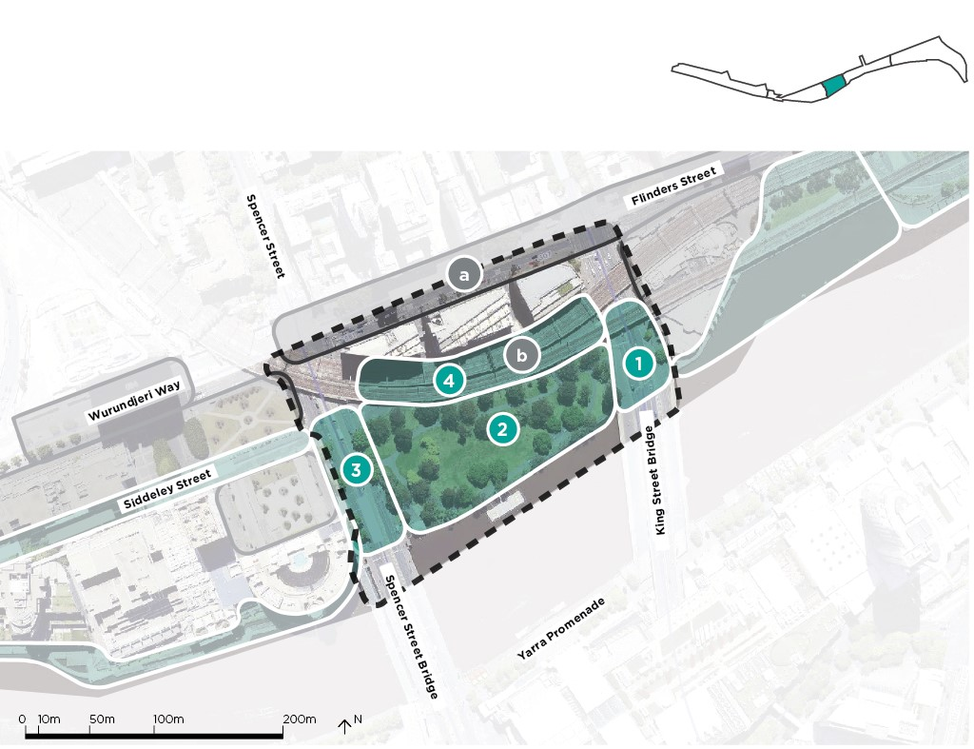

Key improvements
- King Street Crossing
  - Improve King Street crossing to prioritise pedestrian movement including potential signal relocation.
  - Investigate opportunity for footpath expansions by reducing traffic lane widths.
- Batman Park
  - Enhance Batman Park as a public open space to serve the surrounding community.
  - Improve ecological and habitat value.
  - Ensure compatible programming and use of open space, and investigate long term use of heritage pump house building.
  - Provide opportunities to experience the river’s edge
  - Investigate opportunities for recreational or health and wellbeing activities.
- Spencer Street Crossing
  - Improve Spencer Street crossing to prioritise pedestrian movement including potential signal relocation.
  - Improve access and way-finding from pedestrian crossing towards the River and adjacent open spaces.
  - Provide a safe recreational cycling connection from future Flinders Street cycle lanes to Siddeley Street and the River front.
- Rebecca Walk
  - Work with VicTrack and Rebecca Walk management on activation opportunities integrated with park uses and experiences.
  - Investigate opportunities to mitigate rail viaduct impacts on the park e.g. noise reduction.

Coordination and advocacy
- Flinders Street
  - Coordinate with pedestrian and cycling upgrades to Flinders Street.
  - Improve pedestrian and recreational cycling connections between Flinders Street and the River.
- Railway Infrastructure
  - Advocate for mitigation of rail viaduct impacts on the park e.g. noise reduction.

Next steps
- Continue to engage with Traditional Owners (the Wurundjeri Woi Wurrung) and other Aboriginal Stakeholders
- Undertake climate impact and asset vulnerability assessment
- Continue to coordinate with asset owners and authorities

Maritime Precinct
Seafarers Rest Park provides a new public space that reveals Melbourne’s significant maritime heritage. The enhanced pedestrian and cycling connections allow for easier and more enjoyable travel into the CBD, Docklands and Southbank.

Priorities
- Continue to engage meaningfully and respectfully with the Traditional Owners at all stages of the project.
- Work with the Traditional Owners to ensure the cultural narrative of the River is celebrated and embedded into the project delivery process and built outcome.
- Unify disparate public open spaces and improve legibility of pedestrian connections on the water’s edge.
- Improve public and private interfaces along the river.
- Improve recreational cycling connections through the precinct including the Capital City Trail.
- Create a new park destination.
- Provide opportunities for greening, vegetation and creation of constructed ecological edges.
- Celebrate cultural maritime history through interpretation.
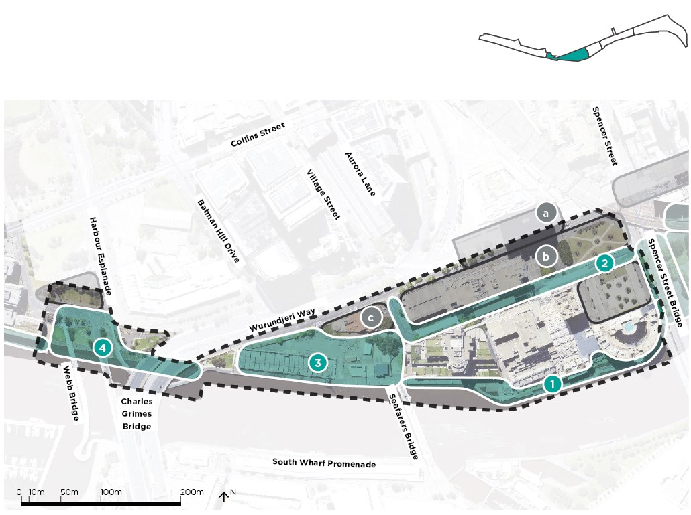

Key improvements
- World Trade Centre Waterfront
  - Work with adjacent property owners to improve access and way-finding to and along the river.
  - Work with adjacent property owners and business to improve management of water front spaces for public use.
- Siddeley Street
  - Develop streetscape design for Siddeley Street that prioritise active transport and tree canopy coverage to inform and guide development outcomes.
- Seafarers Rest Park and Seafarers development
  - Coordinate with the developer to deliver new open space.
  - Coordinate with future private development and with the Victorian Government plans for Mission to Seafarers.
  - Provide infrastructure to support small local events.
- Docklands Link
  - Improve access and way-finding to existing spaces.
  - Improve pedestrian and cyclist crossing across Navigation Drive from Jim Stynes Bridge towards Harbour Esplanade (Capital City Trail).
  - Resolve conflicts between pedestrian and recreational cyclists at intersections on the existing shared paths.
  - Maintain and enhance ecological value of the riparian edge to the river and connections to Docklands Park.

Coordination and advocacy
- Melbourne Quarter Connection
  - Advocate for improved connection across Flinders Street to Melbourne Quarter.
- Siddeley Street Developments
  - Investigate opportunities to coordinate with private developments to improve the public realm.
- Mission to Seafarers
  - Investigate opportunities with the Victorian Government for future redevelopment of this building as a visitor destination.

Next steps
- Continue to engage with Traditional Owners (the Wurundjeri Woi Wurrung) and other Aboriginal Stakeholders
- Undertake climate impact and asset vulnerability assessment
- Explore options for enhanced uses of the Missions to Seafarers building
- Explore potential for private developments to contribute to the public realm improvements
- Support the adjoining developer’s implementation of Seafarers Rest Park

Salt Water Wharf Precinct
A new park at the end of the wharf provides an ecological focused destination with sweeping views of the Port, Victoria Harbour and the city. Adaptive reuse of the control tower recognises the industrial and port history of the area.

Priorities
- Continue to engage meaningfully and respectfully with the Traditional Owners at all stages of the project.
- Work with the Traditional Owners to ensure the cultural narrative of the River is celebrated and embedded into the project delivery process and built outcome.
- Acknowledge the Aboriginal History including the Time of Chaos (filling of Port Phillip Bay).
- Enhance the river front neighbourhood on the wharf.
- Create an ecological park.
- Investigate opportunities for adaptive re-use of port infrastructure.
- Improve legibility of pedestrian connections on the river’s edge.
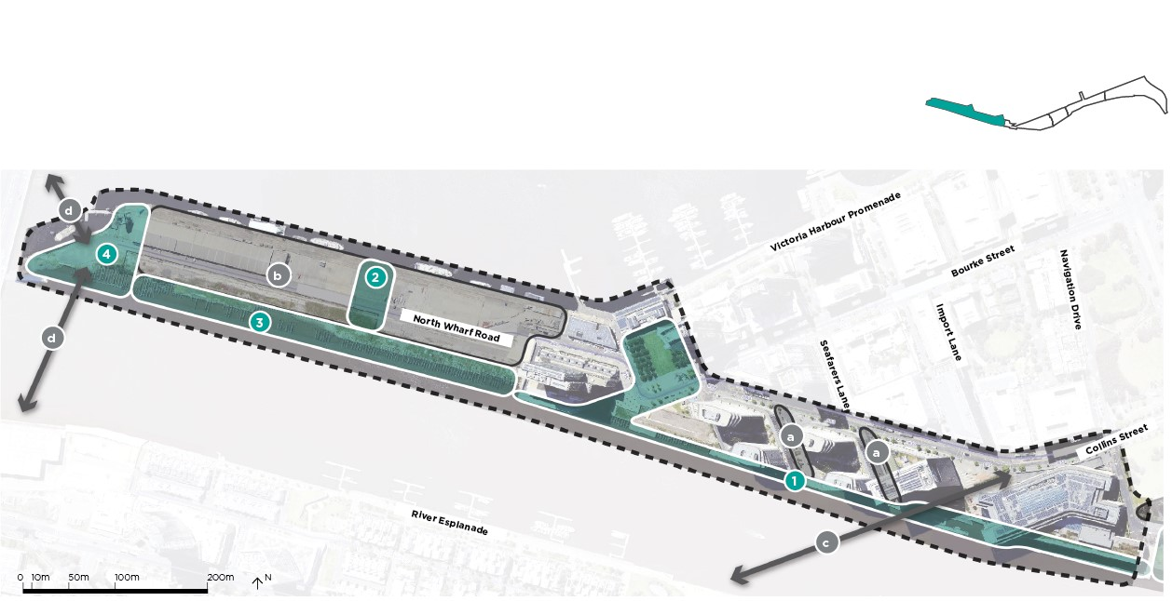

Key improvements
- Australian Wharf
  - Investigate opportunity to improve the existing wharf experience.
  - Investigate ecology and habitat improvements.
  - Improve signage and way-finding.
  - Work with Development Victoria to co-ordinate berthing requirements for chartered boats.
- Community Green
  - Provide a new public park as part of future private development (by others).
- Collins Wharf Promenade
  - Provide new pedestrian and recreational cyclist promenade (by others).
  - Improve connections to the River.
  - Investigate ecology and habitat improvements
- Eco Park
  - Provide new public, ecological park as part of future private development (by others).
  - Prioritise ecology and strengthen ecological links to Moonee Ponds Creek.
  - Protect views to Melbourne Port and back to the city.
  - Connect people with the water, including investigating opportunities to provide for fishing and boating.
  - Retain the maritime character including protecting the rock edge and remnant navigational light structures.
  - Encourage mixed land-use activation to the edge of the park.
  - Restore the existing control tower and investigate opportunities for adaptive re-use of this building.
  - Limit vehicle access to maintenance/service vehicles only.
  - Provide informal play opportunities.

Coordination and advocacy
- Seafarers and Adela Lanes
  - Advocate for improved pedestrian and recreational cycling connections between adjacent streets to the River.
  - Investigate opportunities to improve signage and way-finding.
- Collins Wharf
  - Investigate opportunities to coordinate with private developments to improve the public realm.
- Collins Street Bridge
  - Coordinate with authorities on any future pedestrian, cyclist and tram bridge connection to Fisherman’s Bend.
- Western Park/Yarra’s Edge Connection
  - Accommodate future connection to Moonee Ponds Creek and Fisherman’s Bend.

Next steps
- Continue to engage with Traditional Owners (the Wurundjeri Woi Wurrung) and other Aboriginal Stakeholders
- Continue to engage with developer and Development Victoria
- Consider development timing and delivery of public realm works
- Undertake climate impact and asset vulnerability assessment

Themes and Objectives Summary Tables

Environment
Objective reference | Objective description
En1 | Improve river health
En2 | Create a connected ecological river corridor
En3 | Provide opportunities for environmental education and public interaction with the river
En4 | Increase canopy cover and vegetation to improve cooling
En5 | Design for and mitigate impacts of flooding and sea level rise

Culture
Objective reference | Objective description
Cu1 | Provide a platform for the ongoing practice and celebration of aboriginal culture along the river
Cu2 | Reveal the many and layered cultural narratives and values associated with the Yarra River - Birrarung
Cu3 | Enhance the unique character of the north bank by celebrating the existing heritage assets

Place
Objective reference | Objective description
Pl1 | Create spaces that embrace the river context
Pl2 | Sustain the Yarra River - Birrarung as a primarily public place
Pl3 | Balance a consistent identity, with a series of diverse offers
Pl4 | Provide amenity and experiences that support community health and wellbeing
Pl5 | Provide high quality places for people
Pl6 | Prioritize safety and inclusion

Connection
Objective reference | Objective description
Co1 | Create a continuous, uninterrupted journey along the river edge
Co2 | Improve opportunities to visually and physically connect to the river and the north bank
Co3 | Better connect the north bank into the streets of the Central City
Co4 | Provide safe, inclusive and universally accessible connections
Co5 | Enhance conditions for pedestrians and recreational cyclists

Implementation Plan Summary Tables

Birrarung Marr Precinct
Key Improvement | Stakeholder/Partnerships | Timeline for Delivery | Cost | Objective reference
Expanded Promenade | Parks Victoria/Melbourne Water | Short | Medium | Co1, Co2, Co4, Co5, Pl2, Pl6
Ecological Edge | Parks Victoria/Melbourne Water | Short | Low | En1, En2, En3, Pl1, Pl4, Pl6, Pl7
Flinders Walk Improvements | Parks Victoria/Vic Track | Medium | Medium | Co2, Co4, Co5

The Falls Precinct
Key Improvement | Stakeholder/Partnerships | Timeline for Delivery | Cost | Objective reference
Upper Promenade | Parks Victoria/Vic Track | Medium | Medium | Co1, Co2, Co3, Co4, Pl5
Signal | Vic Track | Medium | Low | Pl1, Pl5
Banana Alley and Lower Promenade | Parks Victoria/Melbourne Water/Vic Track | Medium | High | Cu2, Cu3, Pl1, Pl3, Pl4, Pl5, Co1, Co4, Co5
The Falls Interpretation | Parks Victoria/Melbourne Water | Medium | Medium | Cu1, Cu2
Customs Square | Vic Track/DoT | Medium | High | Co1, Co2, Co3, Co4, Co5
Enterprize Park and the Turning Basin | Parks Victoria/Melbourne Water/Vic Track | Medium | High | En1, En2, En3, Pl1, Pl2, Pl4, Pl6

River Park Precinct
Key Improvement | Stakeholder/Partnerships | Timeline for Delivery | Cost | Objective reference
King Street Crossing | DoT | Short | Medium | Co1, Co2, Co4, Co5
Batman Park | Parks Victoria/Melbourne Water | Short | High | En4, En5, Pl1, Pl2, Pl4, Pl5, Pl6, Co2
Spencer Street Crossing | DoT | Short | Medium | Co1, Co2, Co3, Co4, Co5
Rebecca Walk | Vic Track | Medium | Low | Pl3, Pl5

Maritime Precinct
Key Improvement | Stakeholder/Partnerships | Timeline for Delivery | Cost | Objective reference
World Trade Centre Waterfront | Asset 1 - Riverlee | Short | Low | Co1,Co2, Co4, C05
Siddeley Street | DoT/Developers | Medium | Medium | Pl5, Pl6, Co4, Co5
Seafarers Rest Park and development | Asset 1 - Riverlee | Short | Low | En3, En4, Pl5,
Docklands Link | Parks Victoria/Melbourne Water | Short | Low | Co5

Salt Water Wharf Precinct
Key Improvement | Stakeholder/Partnerships | Timeline for Delivery | Cost | Objective reference
Australian Wharf | Development Victoria/Lendlease | Medium | By others | En2, Pl1,
Wharf Park | Development Victoria/Lendlease | Long | By others | Pl1, Pl4, Pl5
Collins Wharf Promenade | Development Victoria/Lendlease | Long | By others | Co2, Co5
North Wharf Point Park | Development Victoria/Lendlease | Long | By others | En1, En2, En3, Pl1, Pl2, Pl4, Pl6

Implementation Schedule

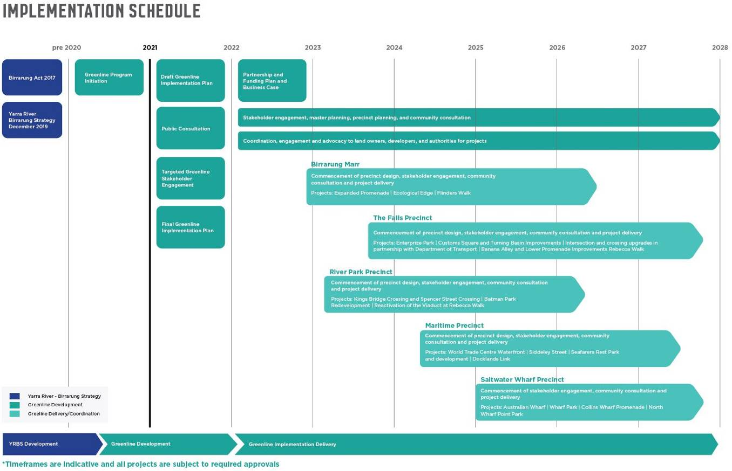
2021
- Draft Greenline Implementation Plan
- Public Consultation
- Targeted Greenline Stakeholder Engagement
- Final Greenline Implementation Plan
2022
- Partnership and Funding Plan, and Business Case
- Precinct planning, stakeholder engagement and community consultation
- Coordination, engagement and advocacy to land owners, developers and authorities for projects
Schedule for community and stakeholder engagement, and project delivery for each precinct:
- Birrarung Marr Precinct: mid 2022 - 2026
- River Park Precinct: 2023 – 2026
- The Falls Precinct: Late 2023 – late 2027
- Maritime Precinct: Mid 2024 – mid 2027
- Saltwater Wharf Precinct: 2025 – late 2027
Timeframes are indicative and all projects are subject to required approvals.

Next Steps
Successful delivery of the Greenline will be realised through collaboration and investment with relevant partners. Coordination of multiple landowners and managers will be essential. City of Melbourne will interface with government, private industry and the community on a wide range strategic initiatives. This coordination will enable the Greenline to plan for and integrate with adjacent infrastructure and precincts, ensuring a cohesive and future-focused outcome for the city. Further, it will aim to gain support for ongoing research, discussion and engagement. This will help to identify further opportunities and challenges as the program evolves.
The Implementation Plan is an important tool for collaboration. It sets out aspirational objectives and practical actions. The Implementation Plan will facilitate engagement with government agencies and stakeholders including:
- Traditional Owners
- The Victorian Government
- State Government agencies including:
  - Development Victoria
  - Parks Victoria
  - Melbourne Water
  - VicTrack
- Property owners
Feedback and responses received will be analysed to identify and agree priorities and opportunities. A Partnership and Funding Plan incorporating stakeholder feedback will be developed and agreed with partner organisations. This plan will include funding commitments. It will also form a key input into the Greenline business case. The business case will outline how the City of Melbourne will collaboratively deliver on the Greenline aspirations over the next 20-50 years.

Appendix 1

Yarra River - Birrarung Strategy Summary Tables

Yarra River - Birrarung Strategy: Actions Summary
Extract from the Yarra River - Birrarung Strategy
The Greenline will need to support the broader actions from the Yarra River - Birrarung Strategy that relate to the north bank.

Ecology
Actions | Timeframe | Cost | Potential collaborations | Relevance to Greenline
1. Deliver a trial project of riparian vegetation on the river bank in collaboration with State Government. | Short | Medium | Parks Victoria; Royal Botanical Gardens | Action is specific to, or can be focused on, the Northbank as part of the Greenline.
2. Deliver a trial project for floating vegetation in the Yarra River, Birrarung, in collaboration with State Government. | Short | Medium | Parks Victoria; Melbourne Water | Action scope is wider than the Northbank, however the Greenline will play a key role in delivering outcomes within the project area.
3. Develop a plan for interpretive signage highlighting  the natural river environment in collaboration with Parks  Victoria and Royal Botanic Gardens. | Mid | Low | Parks Victoria; Royal Botanical Gardens | Action scope is wider than the Northbank, however the Greenline will play a key role in delivering outcomes within the project area.
4. Address planning scheme gaps regarding sunlight protection to the Yarra River, Birrarung, and adjacent public spaces (outside Capital City Zone). | Mid | Medium | Department of Environment, Land, Water and Planning | Action is a strategic activity that will inform the Greenline program.
5. Develop urban design guidelines for flood prone areas across the municipality in the public and private realm. | Short | Low | Melbourne Water; Department of Environment, Land, Water and Planning | Action is a strategic activity that will inform the Greenline program.

Culture
Actions | Timeframe | Cost | Potential collaborations | Relevance to Greenline
6. Establish a Memorandum of Understanding for future engagement with each of the Traditional Owner groups. | Short | Low | Traditional Owner Groups | Action is a strategic activity that will inform the Greenline program.
7. Develop an Aboriginal Cultural Narrative of the city section of the Yarra River, Birrarung, in collaboration with Traditional Owner groups. | Short | Low | Traditional Owner Groups; Aboriginal Victoria; Birrarung Council | Action is a strategic activity that will inform the Greenline program.
8. Research the pre-contact landscape character and botanical aspects of the Yarra River Birrarung, including the landscape management aspects to establish a reference planting guide. | Short | Low | Traditional Owner Groups; Aboriginal Victoria; Birrarung Council | Action is a strategic activity that will inform the Greenline program.
9. Identify underrepresented sites of significance and culturally significant species for the Yarra River, Birrarung, in collaboration with the Traditional Owner groups and explore opportunities to reintroduce these to the river. | Short | Low | Traditional Owner Groups; Aboriginal Victoria; Birrarung Council | Action scope is wider than the Northbank, however the Greenline will play a key role in delivering outcomes within the project area.
10. Develop an interpretation strategy including storytelling and signage for the Yarra River, Birrarung, on the basis of the Aboriginal cultural narrative, maritime trading heritage and shared post contact history. | Short | Low | Traditional Owner Groups; Aboriginal Victoria; Birrarung Council | Action is a strategic activity that will inform the Greenline program.
11. Explore opportunities for creative installations that position the river as an environmental educator, elevating understanding of aboriginal culture in the past, present and into the future. | Short | Low | Traditional Owner Groups; Aboriginal Victoria; Birrarung Council | Action scope is wider than the Northbank, however the Greenline will play a key role in delivering outcomes within the project area.

Place
Actions | Timeframe | Cost | Potential collaborations | Relevance to Greenline
12. Work with the Victorian Government and adjacent landowners to develop an agreed design, and deliver improvements to the central city Northbank area. | Mid | High | Parks Victoria; Department of Environment, Land, Water and Planning | Action is specific to, or can be focused on, the Northbank as part of the Greenline.
13. Develop a long term program of high quality events and activities that align with The Activation Plan and work towards transforming key locations of the riverfront into vibrant, safe and inclusive destinations. | Short | Low | Parks Victoria; Yarra River Business Association | Action is a strategic activity that will inform the Greenline program.
14. Incorporate within the City of Melbourne Design Standards relevant technical guidance for waterfront treatments and signage to establish a consistent palette. | Short | Low | Parks Victoria | Action scope is wider than the Northbank, however the Greenline will play a key role in delivering outcomes within the project area.
15. Work with the Victorian government to deliver  general maintenance upgrades - decluttering, graffiti  removal, street furniture, lighting etc. | Mid | High | Parks Victoria, VicTrack | Action scope is wider than the Northbank, however the Greenline will play a key role in delivering outcomes within the project area.
16. Investigate the location, purpose and need for a new bridge to improve pedestrian and bicycle access between Birrarung Marr and Domain Parklands and, if supported, work with the Victorian Government to fund and deliver. | Mid | High | Parks Victoria; Department of Environment, Land, Water and Planning | Action scope is wider than the Northbank, however the Greenline will play a key role in delivering outcomes within the project area.

Movement
Actions | Timeframe | Cost | Potential collaborations | Relevance to Greenline
17. Further investigate the feasibility and deliver Flinders Street bicycle lanes. | Mid | Medium | Department of Transport | Action is a strategic activity that will inform the Greenline program.
18. Continue delivery of the alternative Southbank commuter cycle route, including Alexandra Avenue, City Road, Kavanagh Street and Clarendon Street segments. | Mid | High | Department of Transport | Action is a strategic activity that will inform the Greenline program.
19. Work with the Victorian Government to deliver amenity improvements and better pedestrian crossing arrangements along key riverfront desire lines of Queensbridge Street, Kings Way, Spencer Street and Russell Street/Hosier Lane. | Mid | High | Department of Transport | Action is specific to, or can be focused on, the Northbank as part of the Greenline.
20. Work with the Victorian Government to investigate future reconfiguration of and deliver improvements to the Williams and Flinders Street intersection. | Mid | High | Department of Transport | Action is specific to, or can be focused on, the Northbank as part of the Greenline.
21. Undertake a detailed audit of existing access conditions and work with the Victorian Government to develop a coordinated maintenance and physical upgrade program. | Short | Medium | Department of Transport | Action scope is wider than the Northbank, however the Greenline will play a key role in delivering outcomes within the project area.

Yarra River - Birrarung Strategy: Policy Summary
Extract from the Yarra River - Birrarung Strategy

Ecology
Policy | Relevance to Greenline
1. Encourage riparian greening along the Yarra River - Birrarung, including existing river banks. | Policy is specific to, or can be focused on, the Northbank as part of the Greenline.
2. Encourage a native and resilient planting palette along the Yarra River - Birrarung, promoting nature in the city. | Policy scope is wider than the Northbank, however the Greenline will play a key role in delivering outcomes within the project area.
3. Encourage riparian habitats in urban parks edging the Yarra River - Birrarung. | Policy is specific to, or can be focused on, the Northbank as part of the Greenline.
4. Encourage Sponge City strategies in the public realm and private development adjacent to the river. | Policy scope is wider than the Northbank, however the Greenline will play a key role in delivering outcomes within the project area.
5. Encourage initiatives in the city reach of the river to improve water quality in collaboration with Melbourne Water including filtration of water runoff. | Policy scope is wider than the Northbank, however the Greenline will play a key role in delivering outcomes within the project area.

Culture
Policy | Relevance to Greenline
6. Advocate for Maritime Heritage to be considered in planning and design for key opportunity areas. Encourage interpretation and a connected network between heritage precincts through a city-wide strategy (refer action 10) | Policy scope is wider than the Northbank, however the Greenline will play a key role in delivering outcomes within the project area.

Place
Policy | Relevance to Greenline
7. Encourage a range of high quality civic, educational, cultural, hospitality and water dependent uses that complement a focus on high quality public spaces. | Policy scope is wider than the Northbank, however the Greenline will play a key role in delivering outcomes within the project area.
8. Build on diverse character districts to create a series of unique, locally authentic experiences. | Policy is specific to, or can be focused on, the Northbank as part of the Greenline.
9. Ensure unrestricted public waterfront access. | Policy scope is wider than the Northbank, however the Greenline will play a key role in delivering outcomes within the project area.
10. Encourage waterfront buildings to address the water with physical openings and active edge uses. | Policy scope is wider than the Northbank, however the Greenline will play a key role in delivering outcomes within the project area.
11. Discourage helicopter facilities and car parking along riverfront area and work to minimise ambient noise. | Policy scope is wider than the Northbank, however the Greenline will play a key role in delivering outcomes within the project area.
12. Promote activities that support a public, safe and attractive riverfront. | Policy is specific to, or can be focused on, the Northbank as part of the Greenline.
13. Rationalise existing and proposed clutter to ensure unobstructed appreciation to identified views and landmarks. | Policy is specific to, or can be focused on, the Northbank as part of the Greenline.
14. Consider impact on views in design and location of additional bridges only where cross river connectivity is critical. | Policy scope is wider than the Northbank, however the Greenline will play a key role in delivering outcomes within the project area.

Movement
Policy | Relevance to Greenline
15. Better integrate pathways along and leading to the riverfront by creating direct pedestrian crossing arrangements and amenity improvements. | Policy is specific to, or can be focused on, the Northbank as part of the Greenline.
16. Advocate to the Victorian Government to investigate the potential to lower Wurundjeri Way and create a seamless waterfront link. | Policy scope is wider than the Northbank, however the Greenline will play a key role in delivering outcomes within the project area.
17. Advocate for universal accessibility to ensure the river environment safely caters for everyone. | Policy is specific to, or can be focused on, the Northbank as part of the Greenline.

Appendix 2

City of Melbourne Policy, Strategy and Guideline Summaries and Greenline Deliverables

The Climate Change and Biodiversity Emergency
The City of Melbourne declared a climate and biodiversity emergency in 2019. In doing so it joined around 1400 jurisdictions across 27 countries in recognising the serious risks posed by climate change. Melbourne’s people, plants, animals, and economy are under threat. Health and social impacts from floods, bushfires, extreme heat and storms especially affect Melbourne’s most vulnerable residents. These events will all be worsened by climate change. Older people, young children, those with existing medical conditions and people who cannot afford air conditioning are at risk during extreme heat. Immediate action is needed to reduce emissions and adapt to the impacts of climate change.
To support this declaration Council committed to reaching a zero emissions target for the municipality by 2040. This is ten years earlier than planned in the previous Climate Change Adaptation Strategy (2017) and Climate Change Mitigation Strategy (2018).
Trees, such as our elms and even some indigenous eucalypts, will struggle to grow in drought conditions – higher temperatures mean we could lose 35 per cent of the city’s trees in the next 20 years.
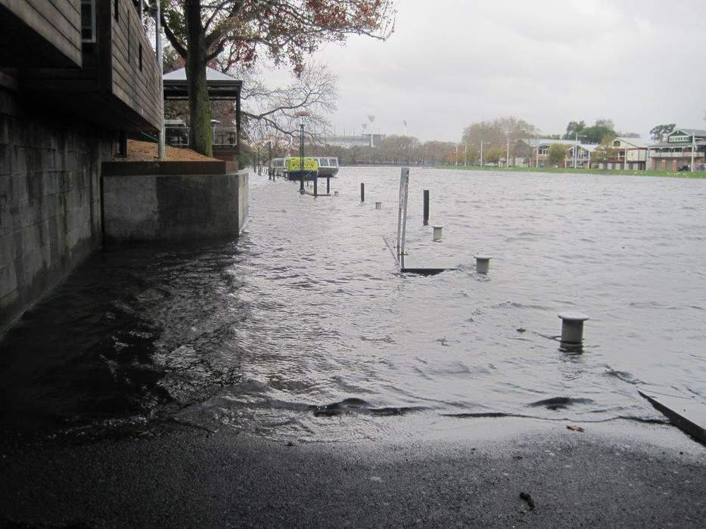Image: The northbank next to Riverland flooded by an overflowing Yarra River June 2014 Source: Chingaipe, S 2014, accessed on 21 April 2021: sbs.com.au

What does climate change mean for our city?

Heat
- Heatwaves have serious impacts on human and animal health, antisocial behaviour, the performance of infrastructure and the delivery of essential services
- The 2009 heatwave increased demand on health services, with a 46% increase in ambulance callouts. 374 people died due to heat-related illness
- Businesses in the municipality lost revenue estimated at $37 million over the four-day heatwave in 2014
- Urban areas are usually warmer than their rural surroundings, creating the ‘urban heat island effect’, which worsens the impact of heat waves. Significant areas of the city average 5-10°C above the non-urban baseline, while the river and parklands are cooler, ranging between 2°C above or below non-urban baseline
- Victoria’s climate has already warmed by 1°C. We now average 11 days greater than 35 degrees; by 2050 this will increase to 16 days
- Temperature rise above 1.5°C will lead to major irreversible damage to ecosystems and endanger Melbourne’s liveability. It could lead to the loss of many city trees, which will endanger threatened animals like the powerful owl, grey-headed flying fox, and swift parrot

Bushﬁres
- Victoria has had longer fire seasons since the mid-1990s. Fire days are projected to increase 42% per year in Melbourne by 2050
- The cost of the 2009 Black Saturday bushfires was estimated at $4.4 billion
- In January 2020 Melbourne’s air quality was the worst in the world due bushfire smoke. The estimated cost of smoke haze in Melbourne, Sydney and Canberra from 2019–2020 bushfires is $500 million

Flooding
- In 2018 Melbourne experienced a 1 in 1000-year storm. Flash flooding caused suspended train services and power outages across the city.
- Significant areas of the Greenline are already at risk of flooding during major storms.
- Climate change is projected to increase average sea levels along Victoria’s coast. In combination with more frequent, heavy rainfall events this means more areas will be inundated during storms and riverine flooding will be more frequent and severe.

Drought and water supply
- The millennium drought and heat stress accelerated the decline of the city’s current tree population.
- In 2019 Melbourne’ rainfall was down 40% on our average.
- By 2050, there will be 20% less rainfall during spring in Melbourne. This means more severe conditions in the lead up to the summer bushfire season.
- Increasing frequency of drought poses challenges to Melbourne’s water supply and the health of parks and trees throughout the city. Some existing trees in the project area are already in severe decline. More are likely to die due to future droughts.
- Some open spaces in the Greenline area are irrigated with potable water. In the event of a drought and water restrictions, trees in these spaces will be at risk.

Greenline deliverables

Measure and assess the environmental impact
- Collect base line date for air quality, microclimate and biodiversity.

Plan for heatwaves
- Increase vegetation, shading and reflective or permeable surfaces to provide a cool place of respite close to the city.
- Prioritise plant species which are identified as climate ready.

Plan for drought
- Develop integrated water management plan for the project area.
- Invest in stormwater harvesting infrastructure to ensure security of water for irrigation.

Flood mitigation
- Locate and design spaces and structures to minimise disruption and damage due to flooding and sea level rise. Protect people, access routes, important uses and assets.

Environmentally sustainable procurement
- Apply the Sustainable Procurement Framework during the development and delivery of the Greenline.

Reconciliation Action Plan
The Reconciliation Action Plan (2021-2023) supports and facilitates reconciliation within the City of Melbourne, within Australia and internationally.
It focuses on five key areas:
Respect
- Demonstrate respect for the culture, land and history of Aboriginal and Torres Strait Islander people.
Relationships
- Ensuring people participate and feel connected through our relationships with Aboriginal and Torres Strait Islander peoples.
Opportunities
- Greater participation by Aboriginal and Torres Strait Islander people to create a sustainable and resilient municipality.
Governance
- Exploring and delivering opportunities for ‘Truth Telling’ to facilitate learning, healing, and change throughout community.
Truth Telling
- Embed an effective reconciliation governance structure into Council processes and systems.

Greenline deliverables

Engage meaningfully with the Traditional Owners
- Involve Melbourne Aboriginal communities and Traditional Custodian groups in the design process. Embed understandings of their cultural values in the project.
- Establish a Memorandum of Understanding for future engagement with Traditional Custodian Groups.
- Work with Traditional Owners to understand and integrate existing policies such as the Wurundjeri Woi Wurrung Birrarung Water Policy.

Recognise the tangible and intangible connection of aboriginal people to place
- Support the City of Melbourne Annual Plan initiative to fully recognise and celebrate Aboriginal Culture and knowledge along the Yarra River Birrarung.
- Support Aboriginal communities to hold events and activities on the site.
- Express Melbourne’s Aboriginal history and culture through the design of spaces and features. Any elements representing Aboriginal themes to involve an Aboriginal artist or designer in their creation.
- Select a new name for the Greenline, and/or for spaces along it, in consultation with Traditional Custodian groups.
- Support the development of an Aboriginal Cultural Narrative of the city section of the Yarra River - Birrarung
- Identify under-represented sites of significance and culturally significant species for the Yarra River - Birrarung. Explore opportunities to reintroduce these to the river.

Nature in the City Strategy
The vision set out in the Nature in the City Strategy (2017) is diverse, resilient, and healthy ecosystems that improve the environment and wellbeing of our community, providing the foundation for a liveable city. Its goals and priorities, and related targets include:
- Create a more diverse, connected, and resilient natural environment: Improve ecosystem health and biodiversity and connectivity to ensure a net increase in biodiversity, habitats, and ecosystem health within the City of Melbourne.
- Connect more people to nature to improve social resilience, health, and wellbeing by ensuring more residents, workers, and visitors encounter, value, and understand nature in the city more often.
- Demonstrate leadership in urban ecology and conservation. Be recognised by delivering flagship biodiversity and urban ecology projects that are recognised locally and internationally as innovative and outstanding examples of enhancing nature in the city.

Urban Forest Strategy
The vision set out in the Urban Forest Strategy: Making a Great City Greener (2012) is that the City of Melbourne’s urban forest – comprising all trees and other vegetation in the municipality – will be resilient, healthy and diverse, will contribute to community health and wellbeing, and help make a more liveable city. Its goals and priorities, and related targets include:
- Increase canopy cover to 40% on public land across the municipality.
- Increase diversity; the urban forest should be composed of no more than 5% of any one species, no more than 10% of any genus and no more than 20% of any family.
- Improve vegetation health.
- Improve soil moisture and water quality to support healthy growth of vegetation.
- Protect and enhance a level of biodiversity that contributes to a healthy ecosystem.
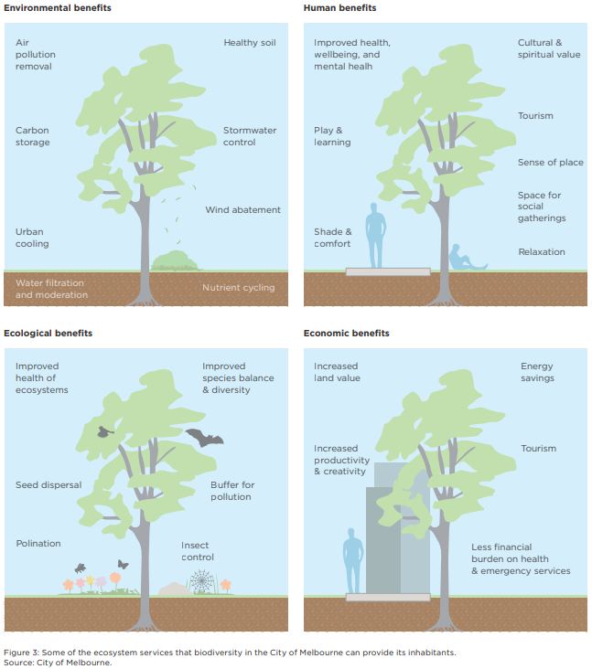
Image: Nature in the City Strategy 2017: Some of the ecosystem services that biodiversity in the City of Melbourne can provide its inhabitants
Environmental benefits
- Air pollution removal
- Carbon storage
- Urban cooling
- Healthy soil
- Stormwater control
- Wind abatement
- Water filtration and moderation
- Nutrient recycling
Human benefits
- Improved health, wellbeing and mental health
- Play and learning
- Shade and comfort
- Cultural and spiritual value
- Tourism
- Sense of place
- Space for social gathering
- Relaxation
Ecological benefits
- Improved health of ecosystems
- Seed dispersal
- Pollination
- Improved species balance and diversity
- Buffer for pollution
- Insect control
Economic Benefits
- Increased land value
- Increase productivity and creativity
- Energy savings
- Tourism
- Less financial burden on health and emergency services

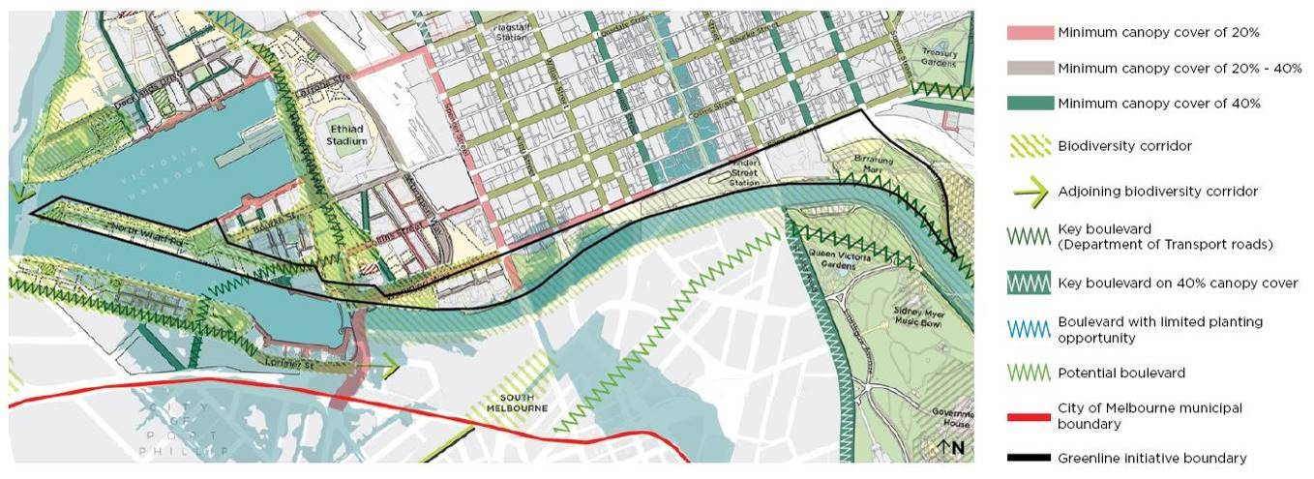Image: Urban Forest Strategy and Nature in the City Strategy 2017 – map of required canopy cover and biodiversity corridors

Greenline deliverables

Improve the river as a biodiversity corridor
- Prioritise habitat improvements that extend the range of species in nearby areas.
- Increase structural complexity of vegetation to support nesting opportunities.
- Incorporate pollen, nectar and fruit bearing plants favoured by indigenous species, using mixed plantings to provide year-round food.
- Mitigate the impact of artificial night light on fauna and flora.

Connect people to nature
- Focus on support for visible, recognisable species.
- Develop a plan for interpretive signage highlighting the natural river environment.
- Work with the Traditional Owners to develop a planting guide which acknowledges the significance of the pre-contact landscape and considers the climate impacts.

Contribute to a healthy urban forest
- Pursue a pro-active program of tree removal and replacement to increase the overall health of the urban forest.
- Increase tree canopy coverage.
- Improve soil structure to allow for oxygenation and water movement. Provide sufficient soil depth to support long term healthy tree growth.
- Use species that are suited to emerging climate conditions, and that avoid species over-represented elsewhere in the municipality.
- Use planting types and arrangements that are appropriate to management regimes that can be expected for the site.

Integrated Water Management
The Municipal Integrated Water Management Plan (2017) envisions a healthy city in a healthy catchment. It considers natural and built catchments, including roads, roofs and impermeable surfaces in relation to aims to:
- Reduce exposure to flood risk and impacts.
- Improve stormwater quality so to waterways health and cleanliness. This will be achieved by reducing the nitrogen contributed from Melbourne’s catchment to the waterways.
- Increase soil moisture to support a healthy urban forest.
- Access to waterways and public open spaces help support a healthy population.
- Optimise fit-for-purpose water use, with at least 50% of all water use by Council sourced from alternative (non-potable) water sources.
One of the key ideas in the strategy is to mimic the natural water cycle by retaining more rainwater in the upper catchment and reducing runoff.
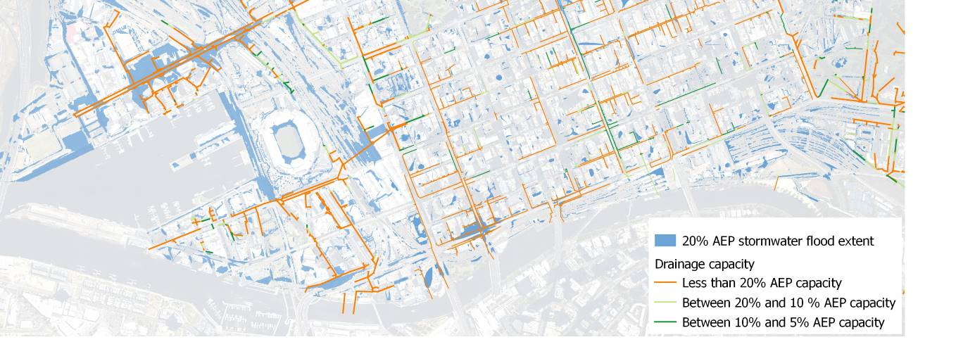Image: Map of modelled storm water drainage network capacity (for illustration only)

Greenline deliverables

Reduce storm water run off
- Proposed works must not increase storm water run-off from the 2021 baseline.
- Maximise the extent of permeable ground surfaces.
- Incorporate stormwater harvesting, stormwater detention, stormwater cleansing, and passive irrigation systems.

Improve water quality
- Consider capture and treatment of runoff from uphill areas prior to discharge into the river to improve river health and water quality.
- Minimise use of potable water.
- Use rainwater for irrigation and other uses not requiring potable water.
- Achieve no less than 50% alternative water supply for non-potable uses.

Waste and Resource Recovery Strategy
The Waste and Resource Recovery Strategy 2030 (2019) envisions a future where Melbourne produces less waste and maximises the life of materials. It works towards a zero-waste city by focusing on reuse, recycling and recovery. Development of a circular economy is prioritised to reduce environmental impacts, improve amenity and liveability, and make the waste and resource recovery system more resilient.
The Strategy addresses the community and the City of Melbourne’s operations. The high-level principles of the strategy are applicable to the Greenline. The key actions relevant to the Greenline pertain to reduction of waste generated by construction. These include:
- Reduction of waste generated by construction
- Recovering 90% of construction demolition waste from City of Melbourne led developments
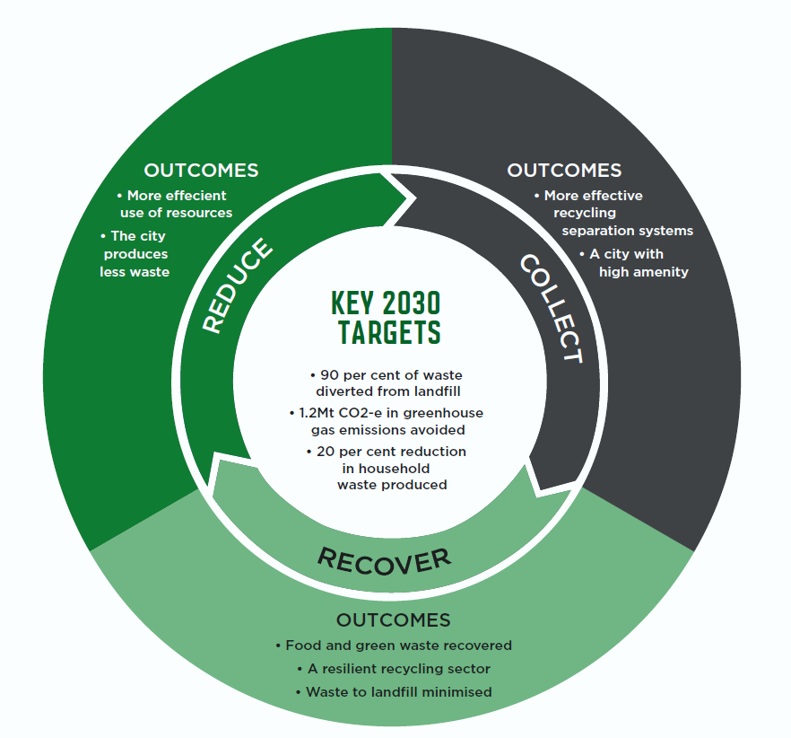

Greenline deliverables

Minimise the environmental footprint of works
- Minimise embodied energy and life cycle costs and adopt circular economy principles to reduce impacts and emissions.

Minimise resource consumption and the generation of waste
- Re-use excavated spoil on site where possible.
- Salvage and re-use bluestone and other materials where possible.

Minimise future needs to adapt or rebuild
- Design and implement projects to minimise wasted work at the interfaces between stages.
- Prepare integrated designs that respond to all relevant strategic objectives to avoid the need for further adaptive works.
- Ensure that the designs allow for flexibility in use.

Open Space Planning
The Open Space Strategy: Planning for Future Growth (2012) guides public space planning in Melbourne. It responds to challenges including:
- Impacts of recent drought, water restrictions and extreme weather
- Predicted impacts of climate change
- Increasing demand for open space as Melbourne’s population grows
- The need to ensure that spaces can adapt to meet evolving needs
The overall directions it sets are to:
- Maintain and expand a quality open space network, with well-located and designed spaces. These spaces must be relevant to the community and provide diverse spaces supporting varied uses
- Provide open space within easy walking distance of all users. This will be achieved by creating new spaces in major renewal areas and in established neighbourhoods where it is inequitably distributed
- Improve community health and wellbeing, by encouraging a range of physical activities and social interaction in open spaces
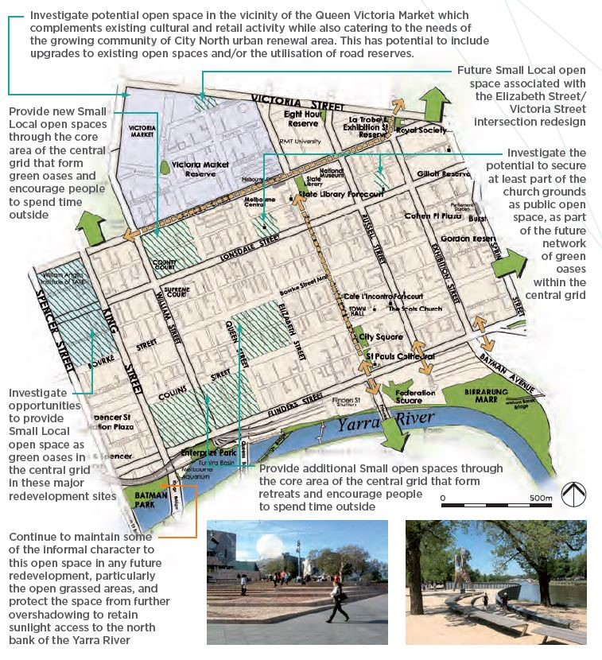Image: Open Space Strategy map – CBD Snapshot
The Docklands Public Realm Plan (2012–2022) provides additional guidance for public spaces in Docklands. It aims to create better connectivity and experiences of public space within Docklands and surrounding areas. Principles set out in it include:
- Provide a range of public spaces and streets. These must support the needs of current and future populations during the day and night, and throughout the year
- Ensure public spaces respond to embedded qualities in Docklands and ensure streetscapes are in keeping with the essence of Melbourne
- Design public spaces and streets that minimise pressure on non-renewable resources and maximise environmental values
- Ensure all ground level interfaces enhance the character and experience of public waterways, streets and spaces
- Design public spaces and streets with high standards of comfort and convenience.
- Ensure public spaces and streets embrace public life. Enable community participation in public space design
- Ensure the public realm network within Docklands is well connected and provides seamless links to surrounding areas
A preferred combination of uses is identified for each space in the Docklands Public Realm Plan. This aims to achieve a balance in the provision of recreational opportunities across Docklands. The Greenline encompasses spaces identified in the plan.
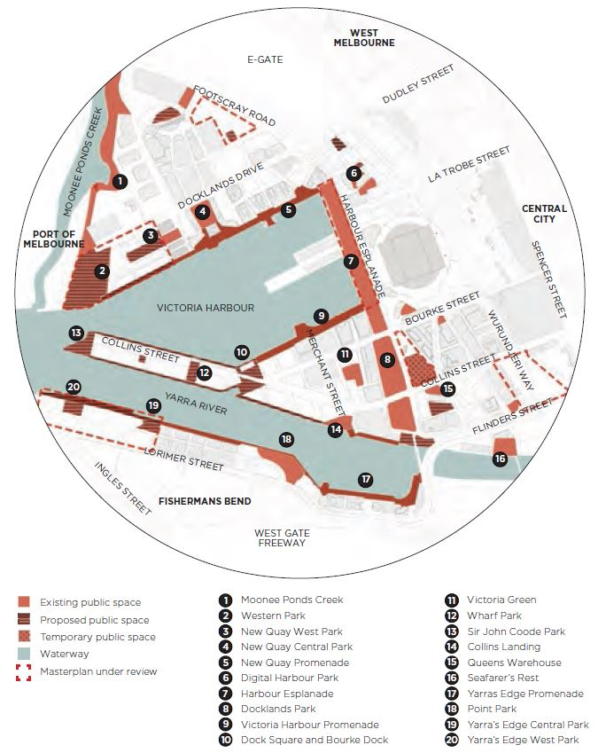
Image: Docklands Realm Plan – Map of key public streets, spaces and waterways
The Skate Melbourne Plan (2017-2027) sets out a vision to support a healthy and inclusive skate culture for all people. It aims to:
- Encourage safe, inclusive and multi-use public spaces for all city users
- Promote and support a healthy and inclusive skate culture and community
- Plan for and provide adequate and accessible spaces for diverse skating styles
There are five locations for ‘potential small integrated skate spaces’ are recommended for consideration along the route of the Greenline.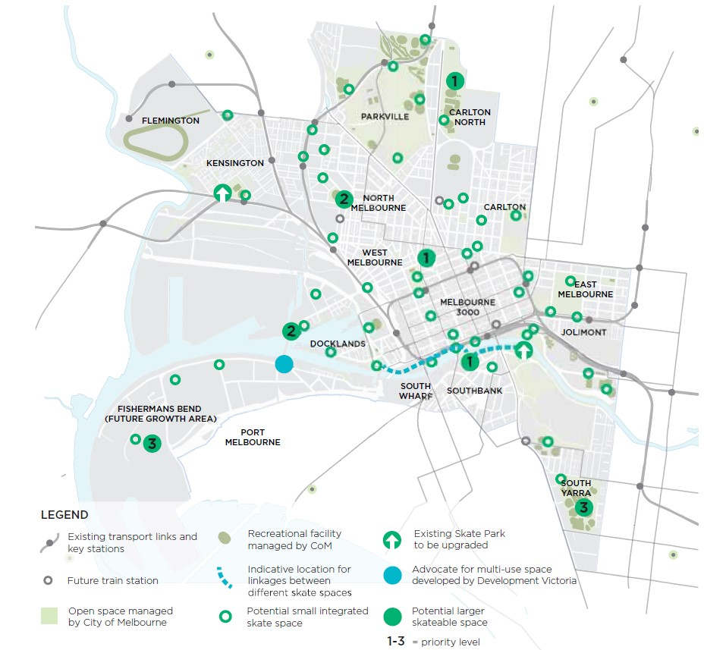Image: Skate Melbourne Plan – Map of opportunities to increase skate provision – indicative skateable spaces.

Greenline deliverables

Provide new open spaces
- Work with developers to deliver new open spaces with access to the Yarra River frontage.
- Enhance the amenity and usability of existing spaces throughout the Greenline area.
- Improved access to existing open spaces
- Use the Greenline to improve access to and between spaces, creating an integrated open space system along the Yarra River.

Provide Diverse community recreational opportunities
- Maintain informal character of Batman Park and protect the space from further overshadowing.
- Integrate recreational priorities identified by the Docklands Public Realm Plan, Skate Melbourne, and the draft Birrarung Marr master plan engagement.

Create Synergies between uses
- Co-locate complementary activities and support social interaction by enabling people to observe activities as well as to participate directly.
- Ensure safety, inclusiveness and accessibility by day and night.
- Manage spaces to balance programmed events with informal uses. Ensure spaces are always accessible, even during events.
- Locate and design spaces to avoid conflicts between uses.

Design and Construction Standards for Public Infrastructure Works
A consistent approach to the design of public spaces is important for many reasons. The City of Melbourne has well-established standards for public infrastructure works which it uses in projects as a matter of routine. Design and Construction Standards for Public Works have been prepared for Docklands as well as for the Metro Tunnel Project. These support the process of working with developers in achieving consistently high standards of public realm works. These documents are either embedded in Local Laws or contractual agreements, making compliance mandatory. In other areas, the standards simply represent best practice for public realm design in the City of Melbourne.
Using design standards does not preclude unique and expressive designs. Many City of Melbourne standard materials, such as bluestone kerbs and paving, have been selected to reinforce a sense of place. Many are also modular components that can be assembled and arranged in a variety of ways to create unique designs.

Greenline deliverables

Use appropriate City of Melbourne design standards
- Standard City of Melbourne materials and details should be used where they suit requirements.
- Design and construction standards for civil and maritime works should be met or exceeded. The minimum design life for all structural maritime elements must be 50 years. The infrastructure in total, including all piles, decking, pontoons and associated elements, must be designed to last a minimum of 25 years with minimal maintenance.

Transport Strategy
The vision set out in the City of Melbourne’s Transport Strategy 2030 (2019) is that:
- Walking on our streets and laneways will be safe and comfortable with expansive unobstructed footpaths, seating and substantial tree canopy coverage
- We will extend Melbourne’s renowned laneway culture linking the ‘little’ streets. Our future laneways will be places for people, knowledge exchange and hospitality, walking, meeting, eating and drinking
- Melbourne will be Australia’s premier bicycle city. More people will be confident to ride with a connected network of safe and protected bicycle lanes and high-quality bicycle parking facilities
- Our train stations will be international gateways to our city. They will be iconic public spaces celebrating arrival to our city for hundreds of thousands of people. They will provide seamless interchange between transport modes that is intuitive and easy
- Public transport will be safe, accessible, fast and frequent
- Private vehicle access to the city will be prioritised for efficient deliveries, servicing and for people who need to use a car
- We will embrace the future with smart city and micro-mobility trials that deliver public benefit
- Disruption will be coordinated, managed and communicated
Key targets set out in the strategy include:
- Reduce by half the number of people killed or seriously injured on our streets
- Reduce by half the proportion of central city through-traffic
- Increase public transport, walking and cycling mode share to 70% of all trips
- Increase the proportion of women cycling to 40%
A key action relevant to the Greenline is the completion of plans and delivery of capital works for major station precincts (Action 17). This includes Flinders Street Station and Spencer Street (Southern Cross) Station. This will ensure that surrounding spaces are welcoming and are adapted to match the City’s aspirations for an efficient, modern and sustainable transport system.
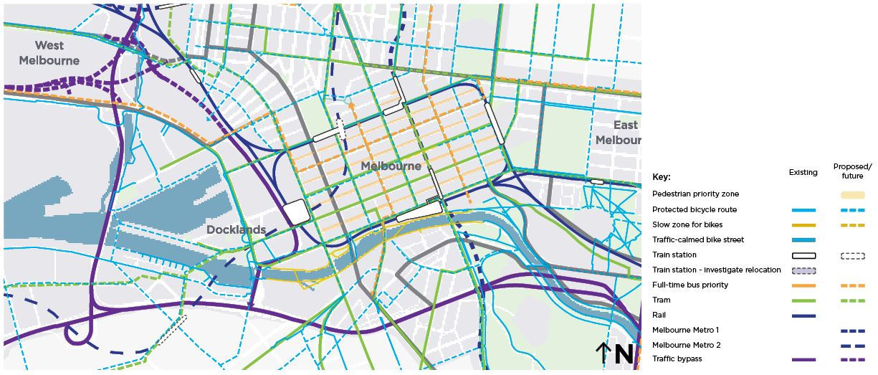Image: Transport Strategy – Map of 2030 proposed integrated network.

Greenline deliverables

Improved connectivity
- Create a continuous path along the river that provides seamless links to all key destinations along it.
- Improve walking links to and from the river.
- Provide protected bike lanes along routes crossing the river.

A ‘slow zone’ along the river
- Prioritise casual pedestrian movement and public activity, rather than commuting, in riverside spaces.

Improved access, capacity and amenity to public transport
- Work with the Victorian State Government to improve pedestrian connections and amenity to tram stops.
- Coordinate with the future tram extension from Collins Street to Fishermans Bend.

Creative Strategy and Public Art Framework
The Creative Strategy (2018–2028) outlines the rationale for, and a commitment to involving creative practitioners in City of Melbourne projects. It identifies opportunities for these practitioners to be involved in developing bold proposals in response to Future Melbourne’s nine over-arching goals. The Strategy aims to challenge people to imagine how Melbourne might respond to these goals if it were the most creative city in the world.
The Public Art Framework (2020–2030) translates the strategic direction and ambition of the Arts Infrastructure Framework and Creative Strategy into operational detail. It considers temporary and permanent works throughout the city, in the public and private realm. Priority is given to works of international standing that are unique to place, and to processes that build capability.
Key principles set out in the Framework are that public art should:
- Be informed by the values and insights of Traditional Owners
- Express the unique history, meaning and future of its location, its people and their stories
- Be inspired by new connections and thinking
- Be of enduring significance
- Push the bar of creative excellence and potential for critical success
- Feature a strong degree of boldness and experimentation
- Transform the experience of the public realm
- Appeal to or inspire wide public engagement
Melbourne’s City Collection already includes several significant artworks in the Greenline area.
Birrarung Marr
- Birrarung Wilam
- Angel
- Eel Trap
- Warin the Wombat
- Futurescape
Sandridge Bridge
- The Travellers
- Blue Line
Enterprize Park
- Constellation
- Scar – A Stolen Vision
Docklands
- The River Runs Through It
- Blowhole
There are City established protocols for managing works in the City Collection.

Greenline deliverables

Embed place-specific artworks in the design.
- Integrate existing and new artworks into the design to contribute to the cultural narrative of the Greenline.

Draft Inclusive Melbourne Strategy
The Draft Inclusive Melbourne Strategy sets out a vision and plan for realising a truly inclusive Melbourne. This means ensuring people of all cultures, backgrounds, ages, genders, sexualities, beliefs and abilities are welcomed, celebrated and protected. By delivering on this strategy the aim is that the City of Melbourne ensures sustainable, safe, affordable and inclusive urban communities. By providing inclusive communities it aims to draw people from around the world to visit, work and live.
The priorities set out in the plan are:
Priority 1 - Organisation, services, programs and places for all
- A diverse and inclusive workforce underpins our delivery of services, programs and places that are accessible and meet the needs of our diverse communities.
Priority 2 - Sustainable and fair recovery
- The city’s recovery and regeneration from COVID-19 provides an opportunity to build back better for all. A diverse and resilient community is at the centre of a livable city.
Priority 3 - Empowered, participatory communities
- We want to encourage participation from all community members, ensuring that people feel heard and their needs are addressed.

Greenline deliverables

Create a Greenline that provides for everyone
- Ensure that the Greenline spaces, connections and programs support safety, accessibility and affordability for all.
- Work with diverse communities to ensure the Greenline is responding to evolving priorities.
- Develop an information and way finding strategy that is accessible and inclusive in its messaging.
- Encourage inclusive economic activation along the Greenline.
- Apply the Sustainable Procurement Framework (economic, social and environmental) during the development and delivery of the Greenline.

Appendix 3

Quotes from consultation completed as part of the City River Strategy
https://participate.melbourne.vic.gov.au/city-river-strategy/

What we value...
“The river is important to Melbourne and anything to enhance it – and the public’s use of the river and waterfront – are to be encouraged.”
“Keeping Aboriginal history alive, especially in an essential location like the Birrarung, is crucial to actually being able to re-tell the story of the river.”
“The ecology of the river is crucial to promote and restore urban ecology within the city, for both local fauna and the benefit of humans.”

What we want to improve...
“Dirty, noisy, but prime real estate.”
“There are many areas that are polluted with rubbish. [The north bank] needs to be worked on for the health of the river.”
“These spaces are underwhelming and are difficult to get to due to obstructions such as large built form, unpleasant rail viaduct conditions and busy, multi-lane roads which are difficult for pedestrians to cross.”
“I have seen a lot of pressure on the area, it has many tourists so would benefit from alternative routes for fast cyclists.”

How to contact us
Online:
melbourne.vic.gov.au
In person:
Melbourne Town Hall - Administration Building
120 Swanston Street, Melbourne
7.30am to 5pm, Monday to Friday
(Public holidays excluded)
Telephone:
03 9658 9658
7.30am to 6pm, Monday to Friday
(Public holidays excluded)
Fax:
03 9654 4854
In writing:
City of Melbourne
GPO Box 1603
Melbourne VIC 3001
Australia
Interpreter services:
We cater for people of all backgrounds. Please call 03 9280 0726.
National Relay Service:
If you are deaf, hearing impaired or speech-impaired, call us via the National Relay Service: Teletypewriter (TTY) users phone 1300 555 727 then ask for 03 9658 9658
9am to 5pm, Monday to Friday (Public holidays excluded)

