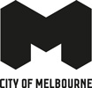

Enterprize Park Landscape Upgrade

Construction update

December 2021
The City of Melbourne is excited to announce that the new Enterprize Park will open this summer to residents and the public. Please keep an eye out for the fence around the site to come down in the coming weeks.
The new area boasts:
- 1000 square metres of new green space – the size of an Olympic swimming pool
- Reinstated Aboriginal vegetation in the area
- New seating along the river edge, as well as BBQ and picnic areas
- Improved access to the river and promenade
- Enhanced views of the river.
Enterprize Park was the first traditional camping ground for Aboriginal people before European settlers arrived aboard the Enterprize ship in 1835. This location played an important role in Melbourne’s history as a hub for shipping and immigration.
The renewal of this site is a step towards re-establishing the land’s significance for the local Aboriginal community. The new Enterprize Park also plays a key role in the City of Melbourne’s Greenline project, which will create a continuous 4km link between Birrarung Marr and the Bolte Bridge – delivering new spaces for the community, businesses and events.
Due to COVID-19 restrictions, the project was delayed at several stages of construction through both 2020 and 2021. This impacted the second stage of works, which originally was set to be completed by mid-2021. We thank residents, traders and the community for their patience during this period. The new Enterprize Park is the first project to be completed as part of the Greenline, a 4km link that will connect Birrarung Marr to the Bolte Bridge.
The project has been informed by the following City of Melbourne strategies and goals:
- Yarra River – Birrarung Strategy 2019
- Open Space Strategy
- Urban Forest Strategy and Precinct Plan
- Nature in the City Strategy
- Walking Plan
- Bicycle Plan 2016–2020
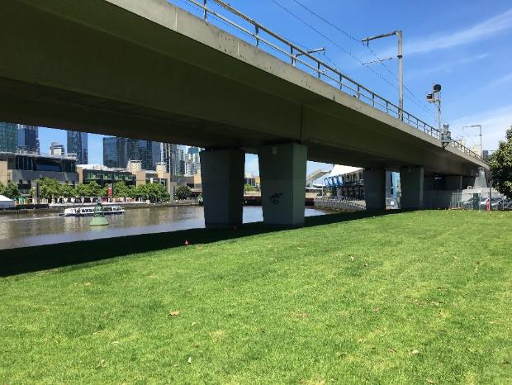
New green space at Enterprize Park

To find out more, please contact 9658 9658, or visit City projects

www.melbourne.vic.gov.au/cityprojects

