

Elizabeth Street South Streetscape Improvements

Construction update

May 2021

The Elizabeth Street streetscape works are progressing well with a considerable amount of work carried out since works commenced in February.

Works update

Demolition of the roadway and part of the footpath has been completed, along with installation of in-ground infrastructure services such as electrical cables and stormwater drainage.

Signals, drainage and paving works at the Elizabeth Street and Flinders Lane intersection are continuing and will be completed by the end of May.

Paving of the new pedestrianised area has also commenced and will continue over the next six weeks.

Towards the end of April, the 120-year-old brick drain beneath Elizabeth Street was exposed in order for Melbourne Water to inspect the condition of the drain.

Works to expand the footpath and upgrade signals will commence at the Elizabeth Street and Flinders Street intersection at the end of May.

Updated timeframe

In line with Melbourne Water requirements, a new protective slab needs to be installed over the brick drain to prolong the life of the drain. This work was not part of the original scope of the project.

The slab works will take approximately four week to complete, resulting in the completion date for the project shifting to the end of June instead of the end of May.

We apologise for this unavoidable delay in the program.
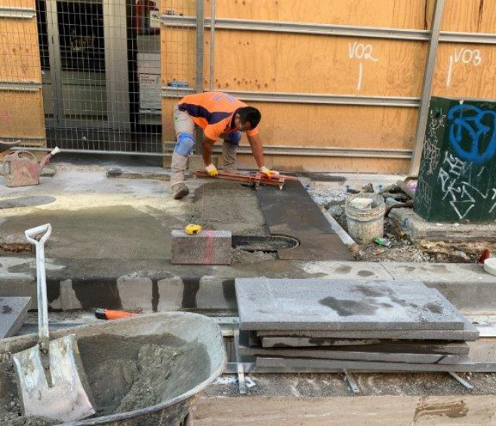
First pavers for the new pedestrianised area being laid

d
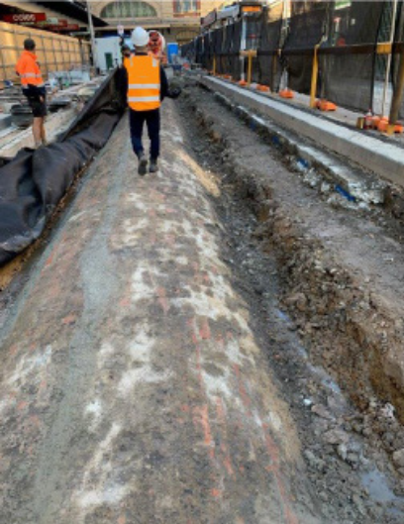
Exposed 120-year-old brick drain

To find out more, please contact 9658 9658, or visit melbourne.vic.gov.au/cityprojects or melbourne.vic.gov.au/contactus

https://www.melbourne.vic.gov.au/building-and-development/shaping-the-city/city-projects/Pages/city-projects.aspx
https://www.melbourne.vic.gov.au/Pages/contact-us.aspx

