A Community-led Approach to Climate Justice
A case study in collaborative partnerships for climate ready and resilient communities
April 2023
Prepared by Jesuit Social Services’ Centre for Just Places and the City of Melbourne in partnership with Kensington Neighbourhood House, Living Learning Australia, Transition Town Kensington, Unison and The Venny Inc.

Acknowledgement of Traditional Owners
We respectfully acknowledge the Traditional Owners of the lands we operate on, the Wurundjeri Woi-wurrung and Bunurong Boon Wurrung peoples of the Eastern Kulin Nation, and pay our respects to their Elders past and present.
We acknowledge and honour the unbroken spiritual, cultural and political connection the Wurundjeri, Bunurong, Dja Dja Wurrung, Taungurung and Wadawurrung peoples of the Eastern Kulin Nation have had to this unique place for more than 2000 generations.
We are committed to our reconciliation journey, because at its heart, reconciliation is about strengthening relationships between Aboriginal and non-Aboriginal peoples, for the benefit of all Victorians.

The Carbon Neutral Cities Alliance (CNCA) is a collaboration of leading global cities working to achieve carbon neutrality in the next 10-20 years – the most aggressive greenhouse gas reduction targets undertaken anywhere by any city. The City of Melbourne is an active member.
A Community-led Approach to Climate Justice was funded by the Carbon Neutral Cities Alliance as a process and guide to enable deeper and more deliberative collaboration between local communities and local governments to address climate justice issues.
This project was initiated by the City Resilience and Sustainable Futures and Community Neighbourhood Teams at City of Melbourne, in partnership with Jesuit Social Services’ Centre for Just Places. The Centre for Just Places was established by Jesuit Social Services, with seed funding from the Gandel Foundation and Victorian Government, to enable and support place-based approaches nationally through research, collaboration, engagement and knowledge exchange.
Developed over 12 months, this guidance document was informed and prepared by many contributing organisations and networks including the City of Melbourne, Jesuit Social Services’ Centre for Just Places, Kensington Neighbourhood House, Living Learning Australia, Transition Town Kensington, Unison and The Venny Inc.
For more information, please contact City Resilience and Sustainable Futures at resilience@melbourne.vic.gov.au.

Contents
Acknowledgement of Traditional Owners 2
A Community-led Approach to Climate Justice 7
Purpose of this document 7
What do we mean by climate justice? 7
Why take a collaborative approach to climate justice? 9
Taking a place-based approach 9
1. What are place-based approaches? 9
The role of local government 9
2. What is the City of Melbourne doing towards climate justice? 10
Our process: A Community-led Approach to Climate Justice 11
Overall process 12
Phase 1 12
Phase 2 12
Phase 1 – Strengthening literacy and a shared understanding of climate justice 14
3. Building a climate resilient community sector in the municipality 15
Phase 2 – Translating local insights into action 17
Introducing Kensington 17
4. Kensington climate justice partners 19
Kensington Neighbourhood House 19
Living Learning Australia 19
Unison 19
The Venny Inc 19
Case study – Local voices for change: tackling climate justice through food 22
Our Collaborative Process 25
1. Plan 25
Learnings from the ground 26
Insight 1 26
Insight 2 26
Insight 3 26
2. Engage 27
Learnings from the ground 28
3. Prepare 29
Learnings from the ground 30
Insight 1 30
Insight 2 30
Insight 3 30
4. Deliver 31
Learnings from the ground 32
Insight 1 32
Insight 2 32
Insight 3 32
5. Iterate 33
Learnings from the ground 34
Insight 1 34
Insight 2 34
Insight 3 34
A call to (collaborative) action 35

April 2023

Disclaimer
This report is provided for information and it does not purport to be complete. While care has been taken to ensure the content in the report is accurate, we cannot guarantee it is without flaw of any kind. There may be errors and omissions or it may not be wholly appropriate for your particular purposes. In addition, the publication is a snapshot in time based on historic information which is liable to change. The City of Melbourne and Jesuit Social Services accepts no responsibility and disclaims all liability for any error, loss or other consequence which may arise from you relying on any information contained in this report.

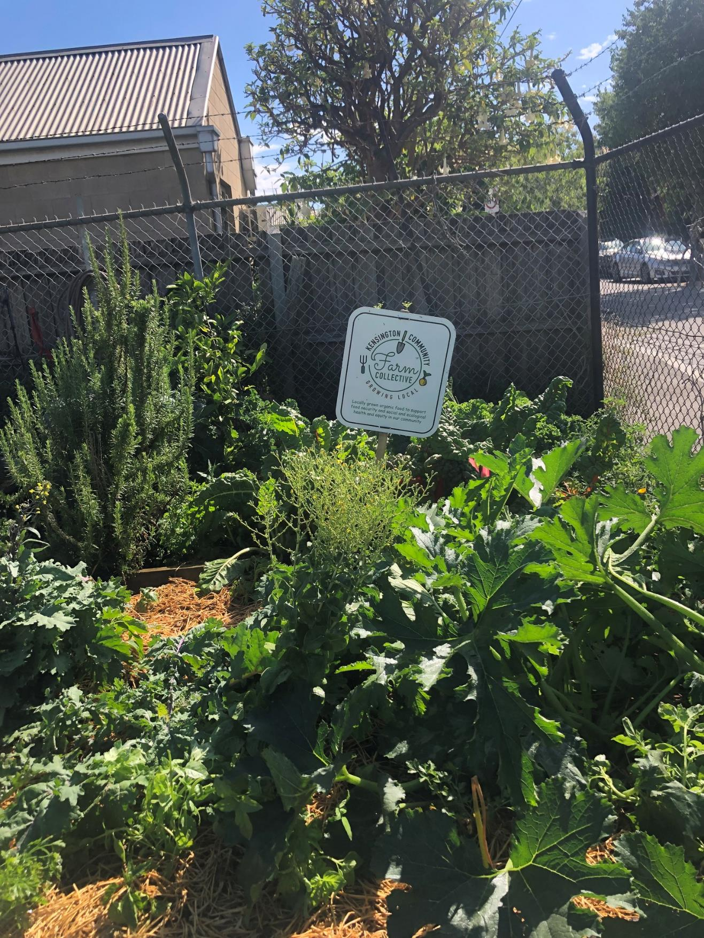

A Community-led Approach to Climate Justice
A case study in collaborative partnerships for climate ready and resilient communities.

Purpose of this document
This document is designed as a guide for the City of Melbourne, service providers, practitioners, and community members looking to initiate deeper and more deliberative collaboration on climate justice projects in the municipality. It outlines a collaborative process to support diverse groups in embedding climate justice across a range of policies, programs and strategies.
Developed over 12 months, this guidance document reflects the contributions of a core group of project partners who, collectively, comprise the Kensington Climate Justice Partnership (the Partnership). While set in Melbourne, Victoria, Australia, the lessons are applicable globally to local governments, community organisations, and community members looking for a starting point to initiating collaborative action on climate justice.
The following sections offer a little more insight into the key components of this process including:
- Building knowledge for communities, local government and service organisations to effectively and meaningfully act on lived experiences of climate and social injustice
- Piloting a place-based neighbourhood approach led by a local community
- Capturing and sharing learnings on delivering community-led climate justice projects.

What do we mean by climate justice?
Climate justice looks at the climate crisis through a human rights lens, with the belief that by working together we can create a better future for present and future generations.
When we speak of climate justice, we are thinking about the many ways that climate change impacts our social and ecological systems now. This means drawing attention to the uneven impacts of climate change for individuals, communities and the environment already at-risk due to existing and ongoing experiences of inequity: social, economic, health and so on.
We can think of climate justice as having four key pillars: procedural, intergenerational, distributive, and recognition:
- Procedural - decision-making processes that are fair, accountable and respond to local experiences of
- climate change
- Intergenerational - processes, policies and practices support climate equity over time and across
- different scales
- Distributive - the benefits of climate change interventions are collectively shared
- Recognition - the need for an intersectional lens to ensure inclusion and diversity
While not mutually exclusive, focusing on these four pillars helps to highlight the multiple and intersecting ways that people might experience inequity within their local area, as well as the practices and processes required to share decision-making and governance with these communities in the context of a changing climate. Despite efforts to adapt to a changing climate, communities across the City of Melbourne remain vulnerable. Those who may be considered most at risk to shocks, crisis and climate change impacts include the elderly, the very young, people from low socio-economic backgrounds, people from migrant and refugee backgrounds, people with pre-existing health conditions and people living in high-rise towers.

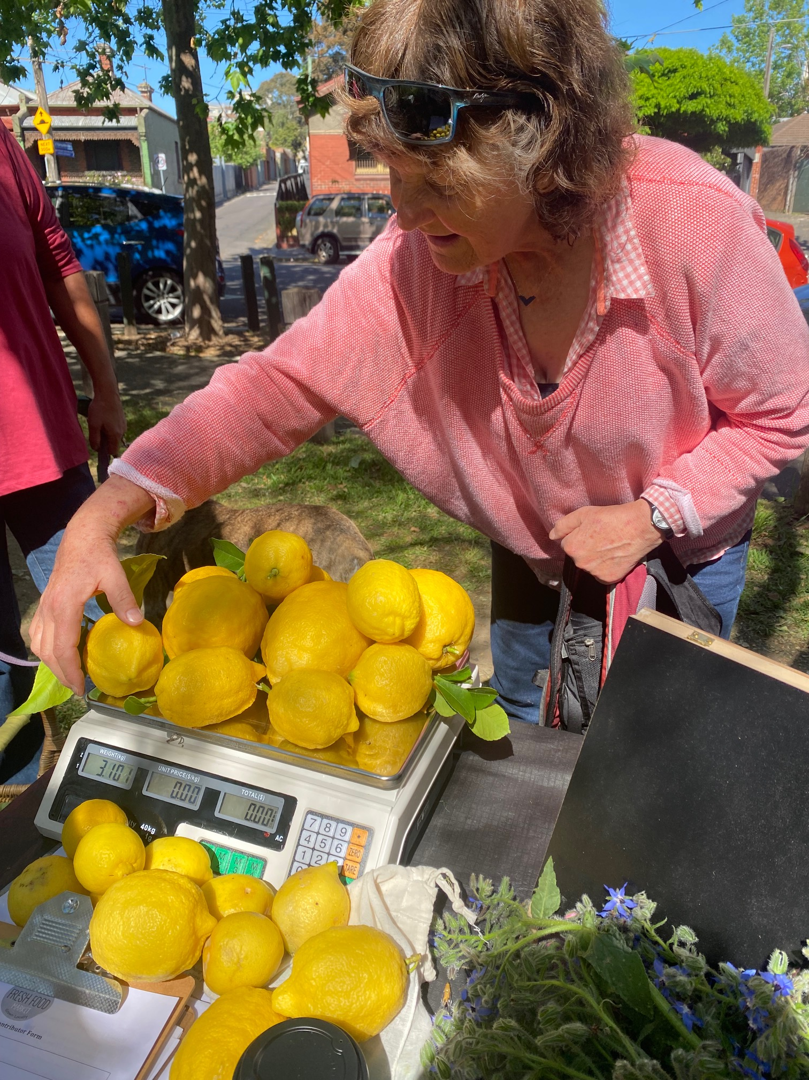

Why take a collaborative approach to climate justice?

Taking a place-based approach
From a climate justice lens, climate action must be driven by fair and inclusive processes and the equitable distribution of resources. But to help address vulnerabilities and marginalisation, there is also a need to understand how local governments can effectively and meaningfully act on what can be learned from community engagement and understanding of lived experience.
Community engagement can be understood on a spectrum, ranging from little to no engagement through to democratic participation and community-driven decision-making. In Victoria, Australia, community engagement is a legislated, core requirement of local government. The key driver of this is changing community expectations, with local community members increasingly seeking local governments to move beyond traditional activities towards partnering with the community in making decisions about how to meet their needs.
A collaborative place-based approach to climate justice brings together local governments, community sector organisations, and local community members to partner and share decision-making around complex and challenging issues. Such models are already being utilised to meet wellbeing needs, linking the self-identified strengths of the community with improved social, economic and ecological outcomes (see Box 1. What are place-based approaches?).
A place-based approach also accounts for the need for new practices and processes that look to create systemic change and work towards long-term outcomes based on community-defined priorities.

1. What are place-based approaches?
With rising social, economic and environmental inequities, place-based approaches have emerged as one way for Australian governments at all levels to work effectively with communities to address complex socio-economic disadvantage.
While there is no consensus on the definition of a place-based approach, they involve a collaborative, cross-sector way of working within a defined geographic location. They bring together diverse stakeholders from across government, local communities and organisations and importantly, require changes to the ways that governments plan, resource, and deliver services.

The role of local government
Local government plays a major role in protecting, improving and promoting public health within their municipality. By integrating climate action across social, cultural, built, economic and natural environments, council policies and practices can make major contributions to community development, climate risk reduction and population health outcomes (see Box 2. What is the City of Melbourne doing towards climate justice?).
The City of Melbourne has a strong commitment to community engagement, underpinned by the organisation’s long history of community engagement practice and its Community Engagement Policy. In 2021, the City of Melbourne commenced work on the Neighbourhood Model to strengthen understandings of how to work with different communities following the impacts of COVID-19. The Neighbourhood Planning Framework was adopted in 2022 and aims to activate local communities to lead their own change, ensure diversity of participation and enable place-based solutions that build on local strengths and priorities.

2. What is the City of Melbourne doing towards climate justice?
The City of Melbourne is committed to addressing climate injustice through progressing the United Nations Sustainable Development Goals to ensure a better future for all.
This project is also guided by a number of council strategies including Climate and Biodiversity Emergency, Climate Change Adaptation Strategy, Inclusive Melbourne Strategy and Neighbourhood Planning Framework. It is part of Major Initiative 52 on Community Disaster Resilience, a four year project in the Council Plan 2021-25 to better prepare the local community for disasters and the health impacts of climate change.
An extensive body of research shows that communities who are connected are more resilient because people are more likely to look out for the people around them. As highlighted in the climate justice approach of Jesuit Social Services' Centre for Just Places, this also requires an equity lens to direct efforts towards building resilience for people most at-risk to the localised impacts of climate change.
The emphasis on building capability within the community to deal with future shocks is critical. It is an essential part of ensuring that we can adapt, survive and thrive in response to hazards and shocks. In taking a climate justice lens to preparing for future shocks and stresses, it is important to identify how local governments and others can help address pre-existing inequities and strengthen community resilience.

Our process: A Community-led Approach to Climate Justice
On the following pages, we share a process to enable deeper and more deliberative collaboration between local communities and local governments to address climate justice issues (see Overall process).
While this work may be new for some organisations, it is important to recognise it is rooted in the care, trust and relationships long cultivated by local communities.
Our approach begins by bringing together a broad range of different individuals, organisations and groups through which to strengthen literacy and build a shared understanding of what local action on climate justice might consider. Opportunities to develop a place-based partnership are then identified, bringing together a select group of partners to translate these insights to a community-led initiative at the neighbourhood level.
Delivered across two phases the project, A Community-led Approach to Climate Justice, had four key objectives:
- Build more collaborative relationships between City of Melbourne, community service organisations (CSOs) and the broader community
- Better understand the strengths, needs and opportunities of CSOs and community to design and implement place-based approaches to building climate change resilience
- Develop a process to empower CSOs and communities with lived experience of climate change impacts to address climate change vulnerabilities and inequities at a municipal and neighbourhood scale
- Test a process that could be scaled across the municipality and used to further inform council policies and programs.

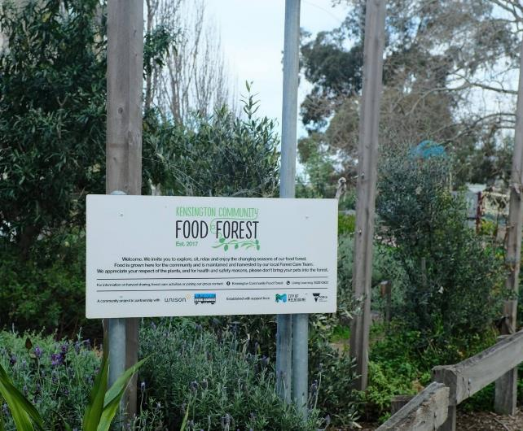

Overall process
Our objectives: Nurturing community-led climate justice.
Our guiding principles:
- Diverse and inclusive leadership
- Shared power and governance

Phase 1
Strengthening literacy and a shared understanding of climate justice.
- Identify localised impacts of climate change
- Define roles and responsibilities
- Establish local strengths, needs and priorities
- Consider missing voices
- Articulate the skills, capacities and capabilities needed

Phase 2
Translating local insights into action
Translating the Phase 1 insights on climate justice, local strengths and needs to a community-led initiative

1. Plan
- Identify the issue and opportunity
- Establish the project purpose, objectives and outcomes
- Design the project approach
- Seek internal approval
- Establish ways of working

2 Engage
- Define the project focus
- Identify what needs to be explored
- Test concepts
- Consider service design elements

3 Prepare
- Establish the working group
- Develop an event or project plan
- Seek volunteer support
- Register community interest

4 Deliver
- Setting up for success
- Engage attendees
- Listen to emerging priorities
- Respond to concerns

5 Iterate
- Debrief and review approach
- Share emerging lessons
- Recommend next steps
- Iterate and evaluate

Phase 1 – Strengthening literacy and a shared understanding of climate justice
Preparing for a collaborative approach first requires leadership and responsiveness from local government and community service organisations. Building a shared literacy and capacity is the foundational work that helps a broad cross-section of council teams and community sector groups understand the merged landscape of climate change and social inequity within our local context. For example, experiences of food insecurity are heightened by the impacts of climate change. Australia’s food supply chain is highly exposed to disruption from extreme weather events such as drought and floods, resulting in higher food prices, lesser quantities of fresh fruit and vegetables, and poorer health outcomes for people unable to access fresh and affordable food.
Not only does this phase help the group to identify how extreme weather events intersect with other social stresses that communities might be experiencing, but also account for the assets and strengths of different organisations in supporting resilience and systemic change (see Box 3. Building a climate resilient community sector in the municipality).
At this stage of the process, lead organisations are looking to bring together diverse organisations including local government, community health and service organisations, community groups and emergency planning representatives to collectively understand:
- Who is most at-risk of localised climate change impacts and why?
- What are the roles and responsibilities of different organisations, including key legislative and policy frameworks?
- What are the strengths, needs and priorities for local community health and service organisations?
- How can we strengthen cross-sector partnerships and enable greater inclusion of community voices in climate change and health and wellbeing planning?
- What skills, capacities and capabilities are required to design and implement place-based approaches to climate justice?
Beyond a shared understanding, it is at this phase that we can collectively determine the types of partnerships and projects that will have the greatest impact in addressing place-based experiences of climate injustice. To take the issue of food insecurity, for example, this might include looking to where there are existing food distribution initiatives or those actively engaging the community on food growing. These insights will inform the second phase of the project - shifting from identifying key issues to planning and action.

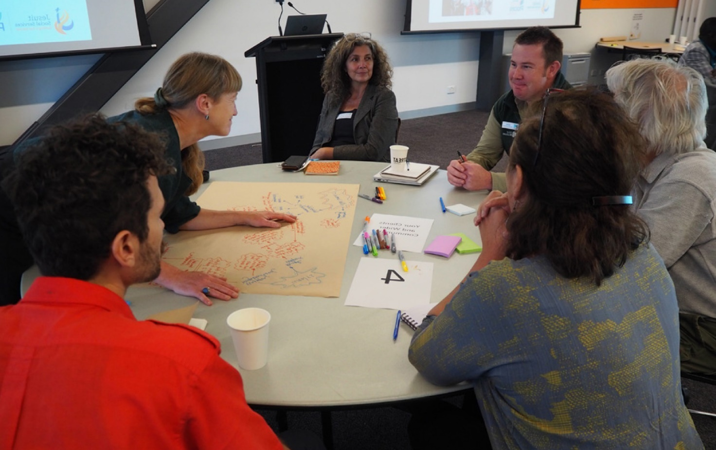

3. Building a climate resilient community sector in the municipality
In 2022, the City of Melbourne and Jesuit Social Services’ Centre for Just Places brought together 20 community health and service organisations, 10 council departments, as well as state government representatives and community groups for a workshop series, Building a climate resilient community sector in the City of Melbourne.
Over these two workshops, the group sought to deepen our understanding of local experiences of climate risks and vulnerabilities, strengthen relationships between council teams and groups in the city of Melbourne, and create collaborative opportunities for further action on shared priorities.
In the first workshop, this included building a shared understanding of vulnerability and risk in the City of Melbourne. The second workshop built on this understanding to explore a range of organisational and sector responses through a heatwave scenario exercise. Considering the local impacts on residents, organisations, and the local natural and built environment in relation to increasingly extreme heat, key climate justice issues identified by attendees included:
- The compounding challenges of increased demands on local service providers, alongside a reduced capacity to deliver services
- Inadequate access to the services and supports required to help people meet their daily needs, including the need to cancel events, workshops and activities
- Disruption to public transport networks resulting in reduced mobility of staff and service users, as well as potential site closures, social isolation and lost income (for casual workers)
- Mental health impacts including an increase in anxiety and stress from prolonged periods of pressure
- Increased cost-of-living pressures due to rising energy costs, disruption to food supply chains, and poor quality and unaffordable housing options.
Building this shared literacy was the foundational work to develop a shared understanding of the complex and intersectional nature of climate change impacts, and the holistic approaches required to alleviate them. For workshop attendees, this process identified the importance of:
- Closer collaboration and sustained working relationships between government service providers and local groups to help prepare for and tackle disasters and emergencies
- Earlier groundwork to build systems, processes and networks that are prepared for future shocks when they happen
- Working collaboratively with local community leaders and champions to plan and act
- Understanding the valuable assets and insights that can be collated when different stakeholders work together
- Time and resourcing for organisations to do this work while continuing to deliver core services and programs.
To identify a suitable pilot - and recognising the short timeframe to do so - at the end of the workshop, attendees nominated local, community-led initiatives that could demonstrate resilience in practice and respond to community need. It is through this process that a place-based, collaborative food growing initiative in Kensington was selected as our pilot project (see Phase 2).
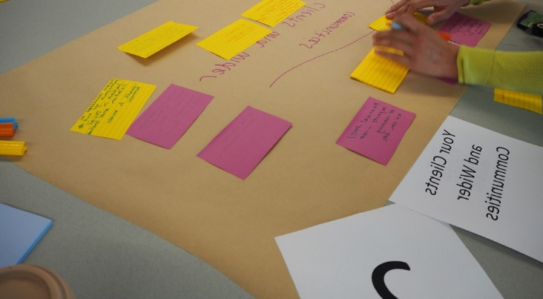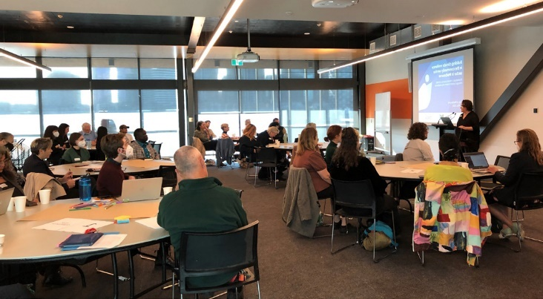
Building a climate resilient community sector workshops. Photo credit : Skye Davey

Phase 2 – Translating local insights into action
In Phase 2, the newly formed place-based partnership aims to translate the insights and strengths identified in the first phase to a community-led project for climate justice. Here, the partnership is looking to the fertile grounds already cultivated by local community members and networks to support their existing efforts to strengthen and nurture their community. This also involves understanding ways of connecting with community members who have lived experience of climate injustice to determine what a just model for collaborative action might include.
It is important to revisit the conceptual understanding of climate justice developed in Phase 1, to understand how the objectives around shared decision-making and governance translate to the local context. This includes early brainstorming of what a strengths-based, culturally appropriate approach might look like in working with socially, culturally, and economically diverse communities to adapt to a changing climate.
The steps outlined in the following pages support the strengthening of reciprocal relationships as the basis of shared decision-making, so that similar processes can be adapted for future work. Additionally, they support the identification of new ways of working to help guide council policies and programs that better support community-led action on climate justice. While our pilot focuses on food security in the inner metro neighbourhood of Kensington, the lessons are widely applicable to many contexts in which neighbourhood-level collaborative partnerships for climate justice are being explored.
Reflecting the diversity of partners in the project, the partnership has stepped out our process according to the type of contributor: local government, advisory body, community sector organisation, community network, and community members. Some partners may wear more than one hat - such as being a resident and working in a community sector organisation - and we have simplified this as a starting point to illustrate how a similar process might be initiated in other contexts.

Introducing Kensington
As an inner-city suburb of Melbourne, Kensington has rapidly changed from a post-industrial, lower socioeconomic area to a dynamic, community-minded suburb with residents from a range of backgrounds and income levels. These post-industrial roots have left a legacy of community sufficiency and care, with many locals passionate about taking action on climate change including the growing and sharing of their own food.
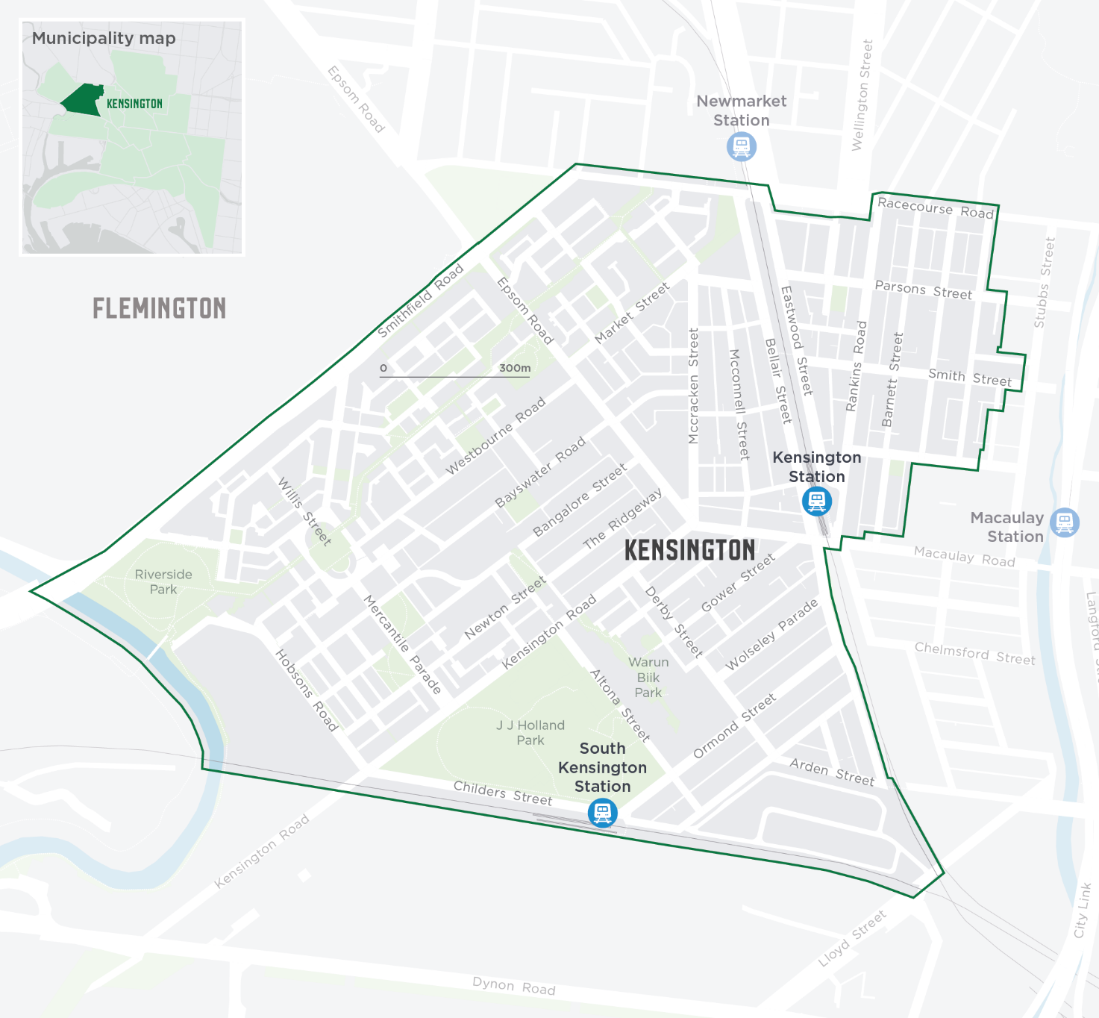
Kensington in the City of Melbourne

But the pace of the gentrification, combined with a rapidly ageing and diversifying neighbourhood, means there are some residents in Kensington who are missing from the conversation. For example, while much of Kensington has gentrified, there are still pockets of disadvantage, with 20% of income earners living on Commonwealth support payments in 2017. For low-income residents, the combination of COVID-19 supply chain pressures and the rising cost of living makes more people than ever vulnerable to indirect impacts of climate change, such as food insecurity.
Kensington is also home to many residents from migrant and refugee backgrounds, some of whom face unique challenges in terms of connecting with initiatives tackling climate change. Language barriers, cultural differences, racism, poverty, lived experience of trauma, and social isolation mean that despite climate change injustice being a daily lived experience - such as access to fresh, affordable, healthy food - they are limited in their ability to drive climate change action.
In response, the Kensington community has rallied to create opportunities for more diverse participation in climate change action - with food gardens and food distribution programs a point of connection with community members experiencing vulnerability. During the COVID-19 pandemic, this included utilising local open space to grow more food locally to distribute to community members in public housing unable to access fresh food.
This passion for re-localising food production was reflected in two phases of consultation recently undertaken by the City of Melbourne in Kensington. With feedback from almost 900 people, food security and local food production were identified as key neighbourhood priorities. Research undertaken on food insecurity across the City of Melbourne shows people in Kensington experience food security slightly more than other similar neighbourhoods outside the CBD.
These insights, along with a highly collaborative network of community organisations including Kensington Neighbourhood House, Living Learning Australia, Transition Town Kensington, Unison and The Venny Inc, have led to the establishment of our exciting pilot initiative - the Kensington Community Local Fresh Food Market
(see Box 4. 'Kensington climate justice partners). Underpinning the market is the understanding that to grow together, we also need to learn together. Over the following pages, we share key lessons and insights about what it takes to create an equitable, fair and inclusive approach to climate change action.

4. Kensington climate justice partners

Kensington Neighbourhood House
Kensington Neighbourhood House is a place where people of all abilities, backgrounds and ages come to participate in inclusive social, educational, vocational and recreational programs.

Living Learning Australia
Living Learning Australia collaborates with individuals, organisations and government to design and implement events, projects and programs that regenerate and care for our communities and the environment.

Unison
Unison is a not-for-profit organisation that provides a range of services to foster strong communities. They develop, own and manage social, transitional and affordable housing; and provide owners corporate management and cleaning and ground services.

The Venny Inc
The Venny Inc is a free communal backyard and safe space for children aged 5 to 16 located in JJ Holland Park, Kensington. The Venny Inc has been in the park for over 40 years and has a rich history within the Kensington community. It is a space where kids can engage in risk-taking play, creativity and connectedness with other young people. The Venny Inc also works with schools, agencies, families and more to facilitate intercultural sharing, food services, therapeutic support, and social cohesion in the local area.

Kensington statistics
The area of Kensington has 10,874 residents and businesses that provide 4,024 local jobs.
Kensington has a higher proportion of children (under 18) than the City of Melbourne average²¹ and a higher proportion of persons aged 60 or older than the City of Melbourne average.²¹
The median age of the population is 35.
31% of Kensington residents were born overseas²¹ and 25% speak a language other than English at home.²¹
The top 5 languages are Mandarin, Cantonese, Vietnamese, Spanish and Somali.²¹
29% of Kensington dwellings are flats or apartments,²¹ 48% of households are renting.²¹
11.5% of Kensington residents live with a mental health condition.²¹
33% of residences are lone person households,²¹ 54% are family households.²¹
19.5% of the residences are low income households (earning less than $881 a week).²¹

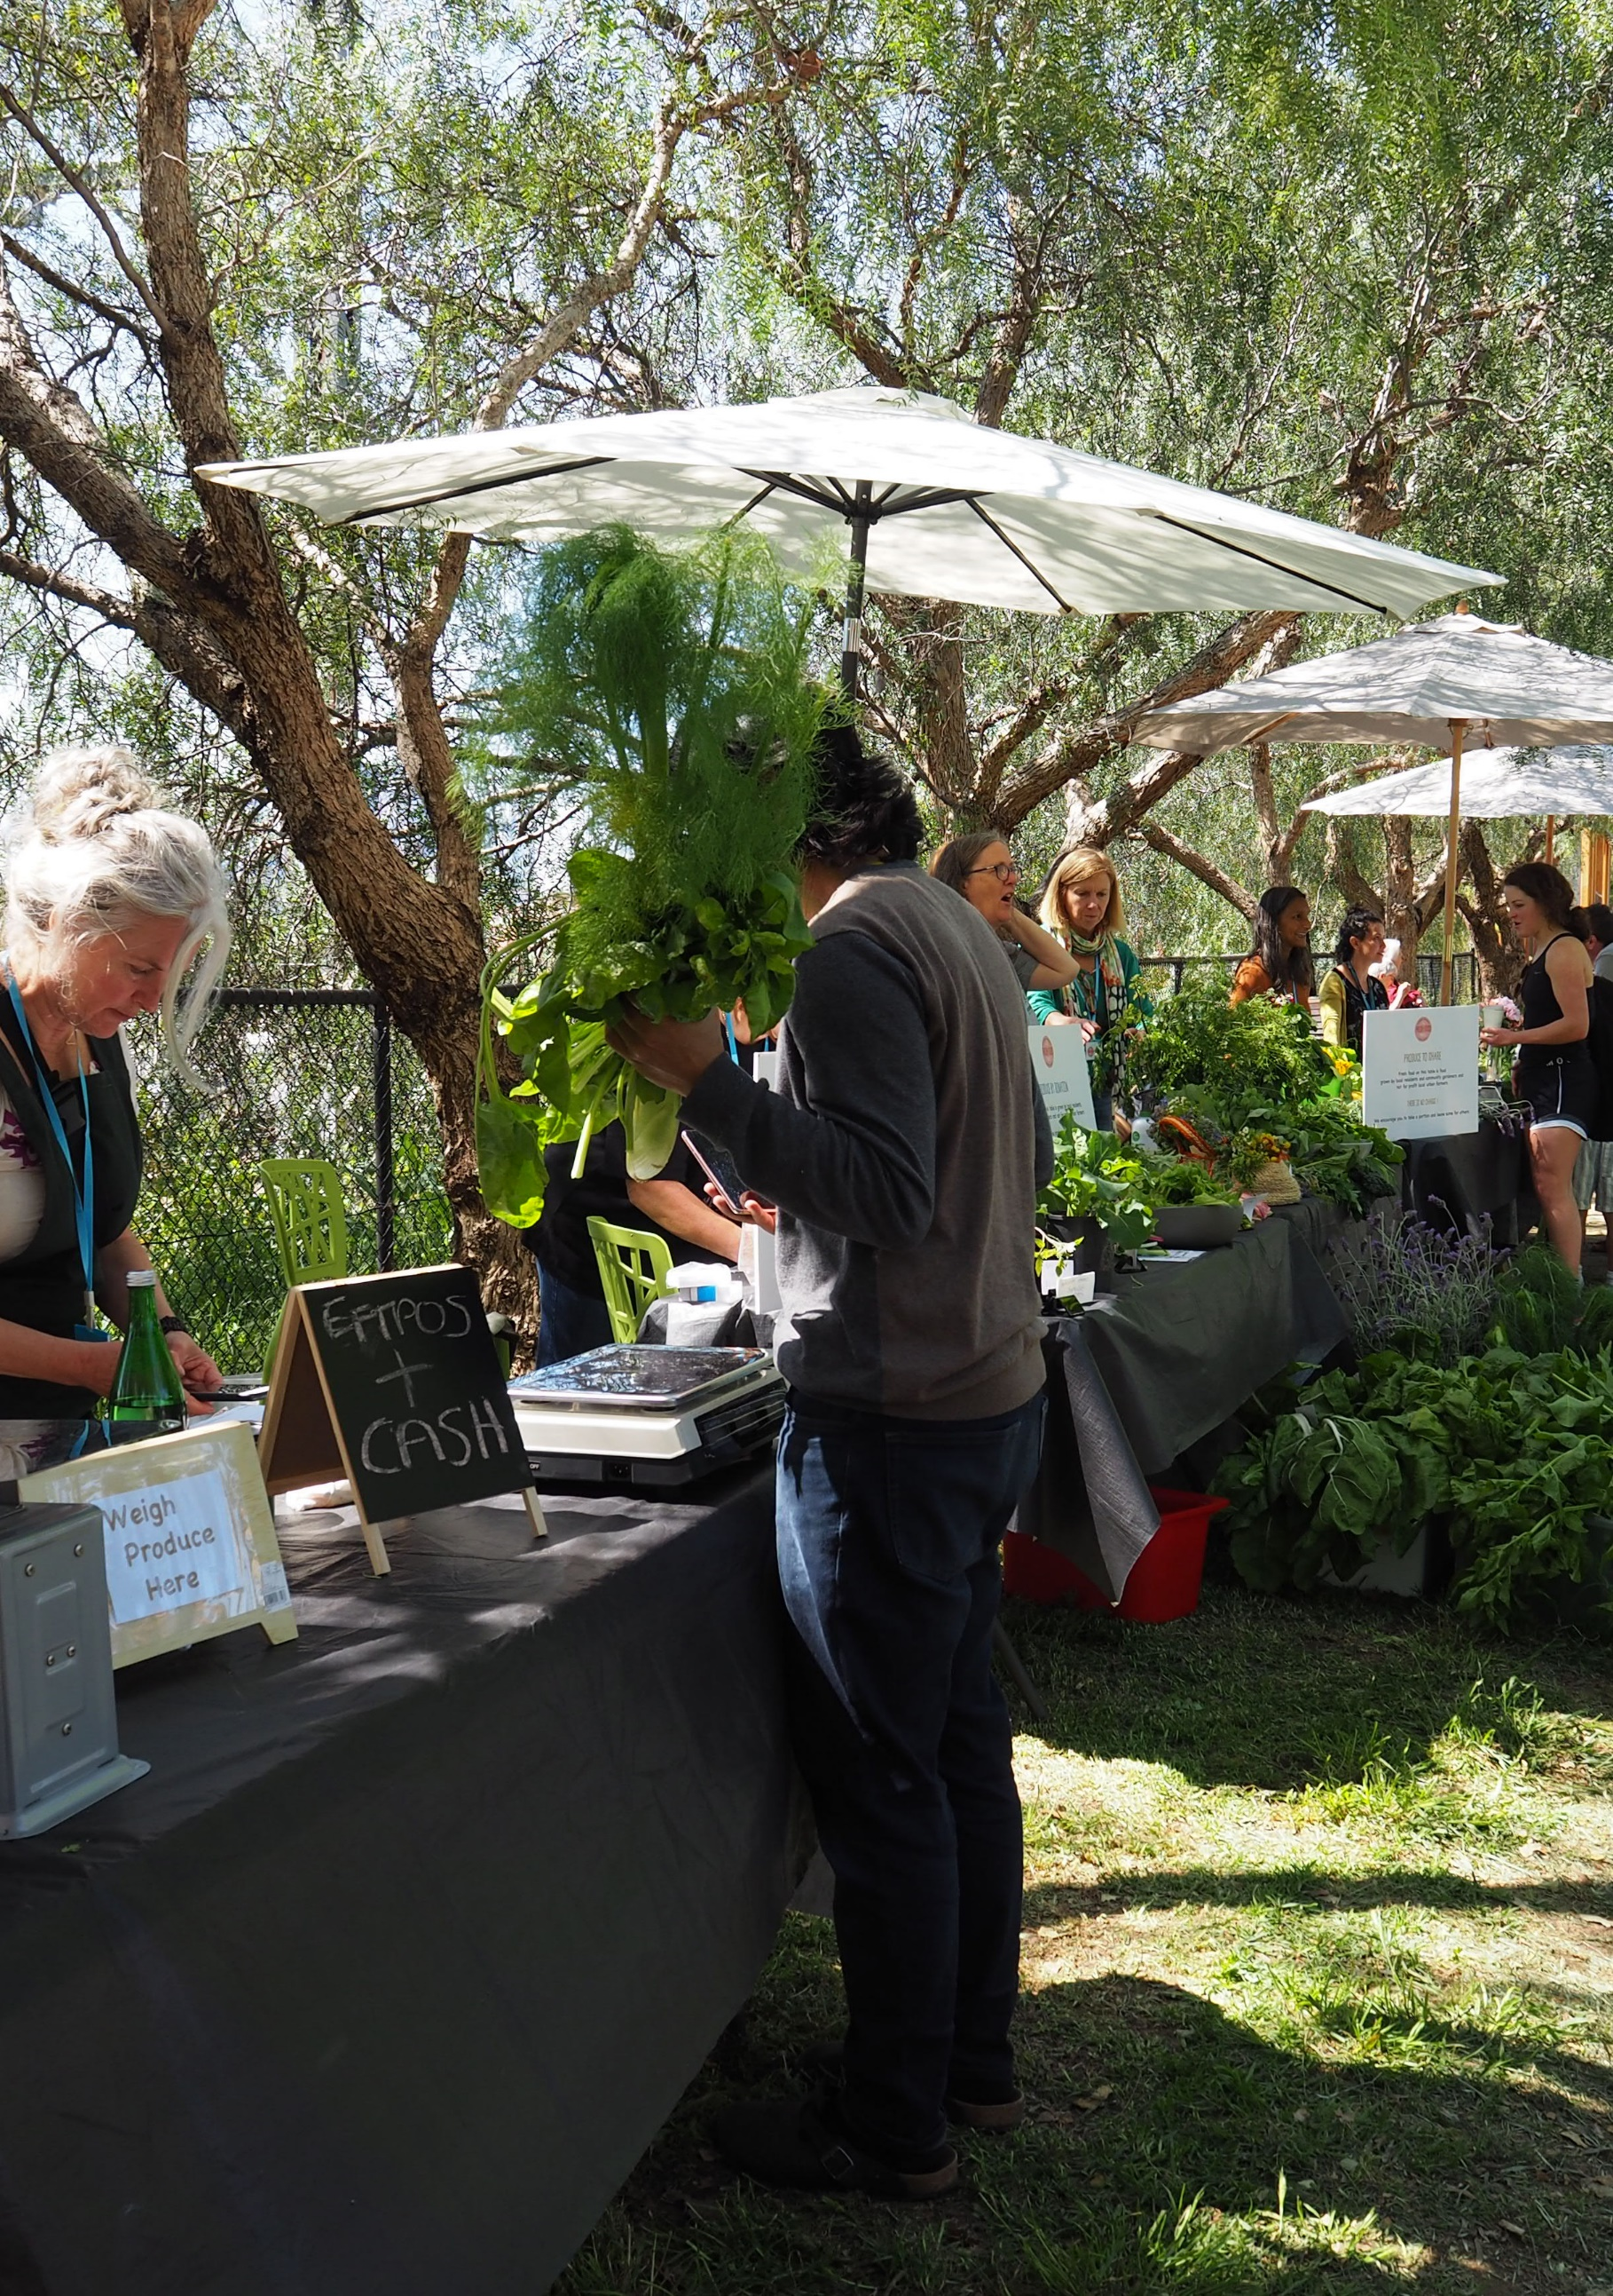

Case study – Local voices for change: tackling climate justice through food
The idea of sharing locally grown food through a market was developed by community service organisations and community members in Kensington. The purpose of the market was to coordinate existing local efforts, maximise impact in addressing food security, reduce carbon emissions and connect people to their food source.
Bringing together the abundance of the local community gardens along with the generous contributions of backyard growers, the market offers local residents access to organic, locally grown produce at little to no cost. For residents experiencing food insecurity, not only does this lift some of the burden of food costs in their everyday life, but allow them to choose what and how much they need without stigma or shame.
What makes the offering unique is that it is grounded in the principles of climate justice: recognising that everyone has a role to play in creating a local food system that can help reduce both the social and environmental impacts of climate change. This helps to demonstrate how more residents will become vulnerable in a changing climate, and that it is a shared responsibility to minimise this harm and foster the connection and reciprocity to keep everyone in the community safe and well.
The market builds on existing community programs and long-term relationships between local community leaders, local food growing experts, community organisations and Kensington residents from diverse backgrounds. Both as individuals and organisations, the Kensington group has long standing relationships formed through decades of project partnerships. Kensington Neighbourhood House and Unison Housing also co-convene the Kensington Community Network – with 30 community organisations and the City of Melbourne meeting regularly to identify and respond to existing and emerging community needs.
What we achieved:
- Established a working group of 10 project partners including Kensington Neighbourhood House,
- Living Learning Australia, Transition Town Kensington, Unison, The Venny Inc, Eastwood St Community Garden, Kensington Food Forest, Kensington Farm Collective, Jesuit Social Services’ Centre for Just Places and the City of Melbourne
- Contributed more than $30,000 AUD of in-kind support from the Kensington community, including project coordination, transport, volunteers, equipment, and garden maintenance
- Engaged more than 100 people directly through information sessions delivered via our existing learning and social support programs
- Shared 240 kilograms of fresh fruit and vegetables harvested from local community gardens, as well as 32 kilograms of produce donated by local backyard producers
- Developed a network of 12 volunteers to work across market roles including harvesting, weighing, engagement and coordination
- Connected with more than 420 market attendees.
Written by Kensington Neighbourhood House, Living Learning Australia, Transition Town Kensington, Unison and The Venny Inc.
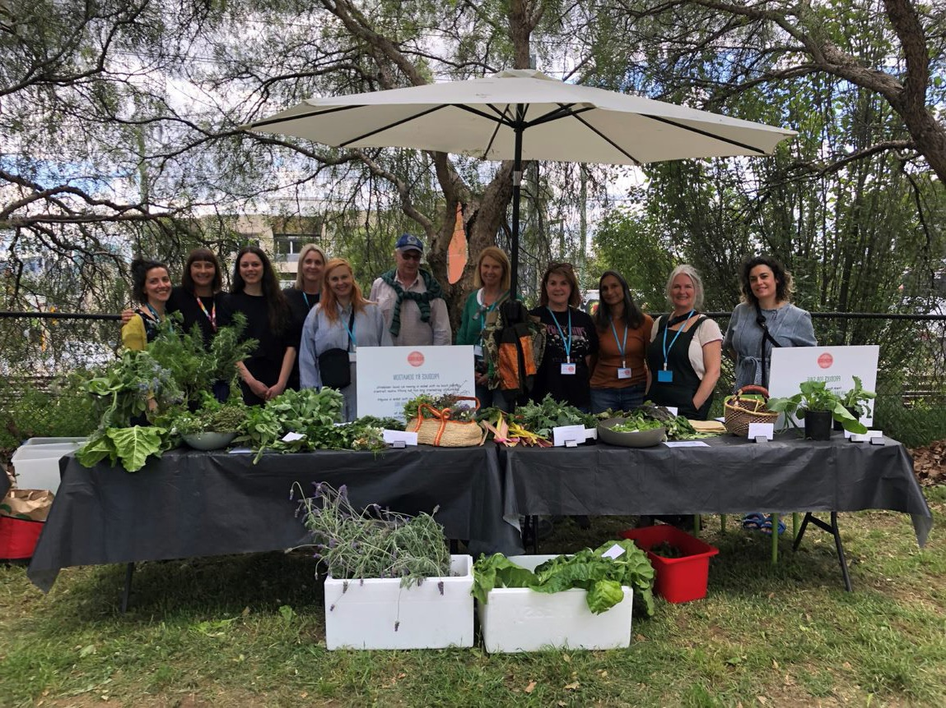
Setting up the first Kensington Community Local Fresh Food Market. Photo credit : Elissa McMillan

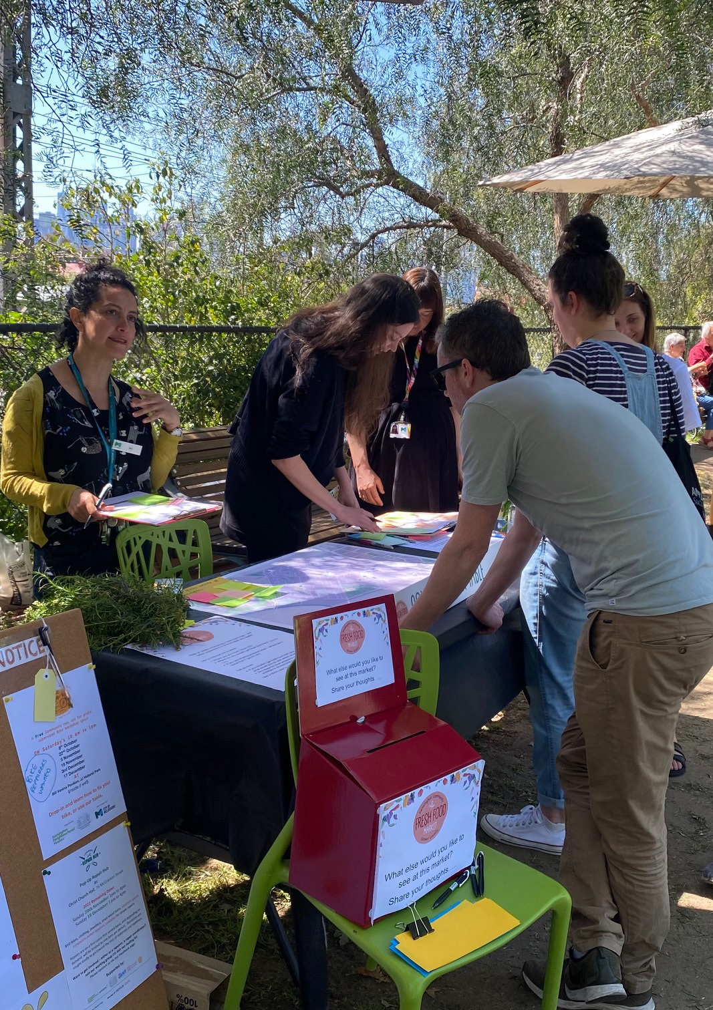

Our Collaborative Process

1. Plan
Our place-based approach recognises that each partner has a unique role to play in addressing community needs and vulnerabilities. At the planning stage, we are looking to establish the “why” of this work: collectively identifying the intersecting social, environmental, and economic inequities being experienced by local communities and in turn, what equitable, fair and inclusive responses might entail.
At this formative stage, we draw on the strengths of local government and the advisory body in research, funding and project administration to map the landscape of social and climate inequity through which to identify priority organisations, networks and communities with whom to connect. Once a priority location has been chosen, we then draw on the place-based skills, knowledge and relationships held within local community sector organisations to lead the design of a project approach that befits the needs and interests of their local community and addresses localised impacts of climate change.

IDENTIFY THE ISSUE AND OPPORTUNITY | ESTABLISH THE PROJECT PURPOSE, OBJECTIVES AND OUTCOMES | DESIGN THE PROJECT APPROACH | SEEK INTERNAL APPROVAL | ESTABLISH WAYS OF WORKING
Identify and evidence climate change and social inequities at the neighbourhood level  (G)(A) | Agree on the objectives and outcomes required to achieve the agreed priority or goal  (G)(O)(N) | Agree on shared principles that will guide the collaborative approach  (G) | Identify the internal processes and teams which this initiative is accountable to  (G) | Establish how data will be shared and stored, including the accessibility of the platform for all contributors  (G)(O)
Create a shared understanding of climate justice at the local level  (G)(O)(N)(A) | Establish preliminary metrics to measure impact - how will we know when our objectives and outcomes have been met?  (G)(O)(N) | Clarify who stands to benefit from this initiative and where there is the potential for maladaptation  (G)(O) | Consider the funding and legal processes that require approval – how accessible or relevant are these to all project partners?  (G) | Identify how community contributions will be reflected in the project outputs  (G)(O)(N)
Scan existing initiatives addressing place-based inequity and injustice  (G) | Outline the activities that are feasible within the project timeline and budget  (O)(N) | Identify existing strengths and assets within the community  (O) |  | Develop a preliminary strategy to communicate and share learnings  (G)(O)(N)
Identify priority organisations and networks to partner with given the local experiences of climate inequity  (G) |  | Agree on logistics and roles to implement the community-led initiative  (O)
Identify the key policies and practices that will be informed by the initiative
(G)

(G) Local government
(A) Advisory body
(O) Community sector organistations
(N) Community networks
(M) Community members

Learnings from the ground
Our partnership, composed of representatives from local government, community sector organisations and residents groups, had varying resourcing and capabilities to take on climate justice work. Transition Town Kensington, for example, is a group of passionate local residents motivated to localise food production, create circular economies, and reduce reliance on fossil fuels. Kensington Neighbourhood House, Living Learning Australia, Transition Town Kensington, Unison and The Venny Inc, are place-based not-for-profit organisations that provide a range of services to support local residents with housing, social connection, education and learning opportunities and much more.
Working with the City of Melbourne and Jesuit Social Services’ Centre for Just Places brought experience in planning, research and advocacy on community and climate resilience, but also a difference in approach and understanding of what that might translate to at the local level.
A community-led approach to planning for climate justice might consider:

Insight 1
Collectively establishing a purpose, objectives, and principles of governance from the outset to enable a diverse range of organisations to contribute to climate justice within their individual remit, and ensure that all partners move together.

Insight 2
Ensuring that understandings of concepts such as climate justice, food insecurity and community are not assumed. Creating shared definitions and in plain language helps to improve understanding, consistency and alignment, as well as tailor such concepts to place-based knowledge and experiences.

Insight 3
Identifying where business-as-usual needs to change, including where funding and permit approval processes can be streamlined and made more accessible. This helps to support a more diverse range of groups and organisations able to take leadership roles on climate justice, but also recognises the project administration limitations faced by many smaller groups and organisations reliant on project- based funding.

2. Engage
In taking a climate justice approach, the lived experience of inequity is engaged actively and early on. This is because the impacts of climate change are some among many inequities experienced by community members, requiring a systems thinking, whole-of-person approach driven by both grassroots and government actors.
Prioritising lived experience is the relational work that helps us refine what vulnerability to climate change looks like and how shared decision-making and governance can shift power to those who have the most to gain from a just and equitable approach.
Importantly, this work involves being clear on the expectations of those who are experiencing climate vulnerability. Impacts of trauma and everyday hardships mean that there can be limited capacity which should not be assumed as an unwillingness to engage in decision- making, governance and leadership on local climate change actions.

DEFINE THE PROJECT FOCUS | IDENTIFY WHAT NEEDS TO BE EXPLORED | TEST CONCEPTS | CONSIDER SERVICE DESIGN ELEMENTS
Identify the target audience/s for the initiative - is this different to who stands to gain from it?  (G) | Establish shared expectations around what community members might contribute to the initiative  (G)(O)(N) | Test the collective understanding about local priorities and needs with community members experiencing vulnerability  (O)(M) | Identify the key suppliers and local networks required to enable successful implementation beyond the core partners  (O)(N)
Establish how lived experience will inform the development of key messages  (G)(O)(N) | Create the engagement questions and activities that will help measure the value of this initiative for those experiencing vulnerability  (G)(O) | Assess the tested understanding against existing data and modelling on climate justice  (G)(A) | Establish contingencies to address shortfalls in supply or service delivery, such as staff turnover or supply shortages  (O)(N)
Determine what sensitivities there might be in facilitating co-design with communities experiencing vulnerability  (G)(O)(N) |  | Agree on how expertise will be reflected and remunerated in the decision-making and proposed goals  (G)(O)(N)(M)
Revisit the purpose, objectives and outcomes given the local priorities and needs identified
(G)(A)(O)(N)
(G) Local government
(A) Advisory body
(O) Community sector organistations
(N) Community networks
(M) Community members

Learnings from the ground
Trust and respect are the foundation of the long-standing relationships and networks developed in Kensington. From an engagement perspective, this means not assuming who might or might not be experiencing climate injustice but also, finding opportunities to connect with existing social and support groups for those we know might be.
Importantly, this means moving at the speed of trust. Residents at the Kensington Housing Estate, for example, have a decades-long history in community-led activism on housing and heat issues. But this has rarely translated to remuneration or policy change on the issues at hand.
A series of information sessions led by Kensington Neighbourhood House within existing social programs on the Kensington Housing Estate offered residents the space to explore what the market might offer them within a safe and trusted environment. This included opportunities to contribute produce, to volunteer and to visit the market without expecting or assuming their participation in the decision-making or governance of the approach - particularly in the timeframe of the pilot.
A community-led approach to engagement for climate justice might consider:

Insight 1
Centering trust and respect as guiding principles within the partnership, particularly when looking to engage people with lived experience of inequities. This is most effectively built through sustained and mutually beneficial ways of working that acknowledge the significant investment of resources required for relationship-building.

Insight 2
Making the experience of participation inviting and accessible for people to connect with - regardless of their personal circumstances. This includes not assuming knowledge or using jargon around climate justice, and being clear on what we are collectively looking to learn from community members. Focusing on everyday life and experiences rather than climate change itself can be most useful.

Insight 3
Distinguishing who the target audience is for the initiative versus the outputs produced. A just approach recognises the time required to successfully build community-led initiatives. For short-term projects in particular, that it is the collaborative process rather than the outcome itself that is key.

3. Prepare
The preparation phase marks a shift from planning to action - the beginnings of implementing our shared vision for place-based climate justice. Community-led, this stage supports the involvement and engagement of the priority communities and networks identified earlier on. Importantly, this phase allows us to refine the collaborative approach and resources developed with a wider audience.

ESTABLISH THE WORKING GROUP | DEVELOP AN EVENT PLAN | SEEK VOLUNTEER SUPPORT | REGISTER COMMUNITY INTEREST
Determine who should be part of the working group and why this might differ from the core partners  (G)(O)(N) | Develop the event plan in line with the shared vision, principles and objectives  (O)(N) | Identify the roles for volunteers and from which networks they can be drawn  (O)(N) | Establish how pre-event community interest in supporting the initiative will be captured  (O)
Share the safety and risk management plan, including roles and responsibilities for leading it  (G)(O)(N) | Determine the key messages, communication channels, and resources required to engage priority groups  (O)(N) | Outline opportunities for community members experiencing vulnerability to be involved in volunteering and what is needed to enable their participation  (O)(N) | Create materials to capture community interest and insights on event day, for example, questionnaires or maps  (G)
 | Identify how messages and resources will be translated and promoted for different audiences  (O)(N) | Establish how the broader local community network will be engaged and invited to support  (O)(N) | Identify any ethics considerations (including privacy and confidentiality) in collecting data from event attendees  (G)(A)(O)
 | Identify any anticipated barriers to community participation on the event day, such as location or accessibility needs  (O)(N) | Establish which internal teams could provide in-kind support for the event  (G)
(G) Local government
(A) Advisory body
(O) Community sector organistations
(N) Community networks
(M) Community members

Learnings from the ground
With the partnership featuring many place-based organisations - and indeed, residents - of Kensington, our pilot featured a significant investment of local time and capacity. But for most of the individuals and organisations involved, the existing relationships and networks held often do not translate to remuneration.
Moreover, there are many moving parts to organising community-led projects which in the case of the market, ranged from garden maintenance and harvesting through to community engagement and event day logistics.
From a partnership perspective, this involved being creative in considering what in-kind and volunteering support might be available to initiate the work. This included considering how to bring in local businesses to improve the promotion of the initiative and range of produce available, through to council staff committing their time to supporting the delivery of the initiative on the ground. This does not detract from the need for longer-term, sustained funding for locally-led climate justice initiatives, but rather, offers an opportunity to draw on local assets and strengths when initiating the approach.
A community-led approach to preparing for climate justice might consider:

Insight 1
Co-designing the event space and relevant messaging to be welcoming for all, as an alternative to conventional programs which might be more transactional or targeted only to communities experiencing inequities. Not only does this help combat the stigma and shame that might arise for community members seeking support, but establish a space for whole-of-community connection and conversation.

Insight 2
Collectively exploring opportunities for additional funding, volunteering and in-kind support to reflect the significant investment of place-based organisations in relationship- building in their local area.

Insight 3
Finding ways to activate local networks and register community interest to broaden the reach and community ownership of the initiative - regardless of what funding might be available (strengthening community sufficiency).

4. Deliver
Event day brings us to the practicalities of the project: what is needed to successfully deliver the event, to engage attendees, as well as generate insights on how to iterate future events. Here, it is important that the vision, principles, and messages be collectively understood by the group to optimise community engagement with the event and demonstrate the role they can play in supporting community-led action on climate change in their local area.
Our model of place-based engagement also recognises the importance of accountability to the community, including opportunities to share back insights and experiences in ways that are accessible and interactive (see Figure 2).
Not only will this inform the iteration and evaluation of the project, but ensure that the insights shared by community members are heard by local government and other organisations in a visible and tangible way.

SETTING UP FOR SUCCESS | ENGAGE ATTENDEES | LISTEN TO EMERGING PRIORITIES | RESPOND TO CONCERNS
Confirm the logistics considerations required to successfully deliver the event, including contingencies for bad weather, staff illness and so on  (G)(A)(O) | Consider how the level of engagement and value of the initiative will be captured and assessed  (G)(A) | Identify how the voices and insights of the community will be captured and shared back. For example, through the use of visual aids. (see Figure 2. Kensington Neighbourhood - Kensington Community Fresh Food Market Feedback)  (G)(O) | Make available resources and referral pathways for community members requiring additional support, such as accommodation or food relief  (G)
Confirm what provisions are available if stock runs out - how will you ensure those most in need of support do not miss out?  (O)(N) | Ensure that all team members understand how to document community insights in a consistent and transparent way  (G)(A)(O)(N) | Document how the community is engaging with the questions and messages shared - is there any unanticipated feedback or concepts that are unclear?  (G)(A) | Provide information for interested community members to connect and learn more about the initiative or related projects  (G)(O)
Identify how changes to the event plan will be communicated to team members, volunteers and the community on the day
(O)(N)
(G) Local government
(A) Advisory body
(O) Community sector organistations
(N) Community networks
(M) Community members

Learnings from the ground
What our pre-event work highlighted was first, there were many moving parts to ensure that the market would be a success and second, a key part of this collaborative work would include demonstrating the contributions and value of these efforts with the many people who shaped them.
Core to this was considering how to reflect back the contributions of the community as they were shared. Our approach, supported by the City of Melbourne’s Community Development team and Jesuit Social Services’ Centre for Just Places, was to facilitate a conversation table that supported market attendees to share their ideas of what a just and resilient food system looks like in Kensington (see Figure 1).
On this map, we included considerations of where attendees had travelled from, where produce was being grown locally, as well as ideas for where fresh food initiatives might be expanded or initiated. For some attendees, this conversation extended to thinking about who was missing from the market (such as lower-income residents) and what opportunities there might be to learn from one another (such as food growing workshops hosted by people from migrant backgrounds).
A community-led approach to delivery for climate justice might consider:

Insight 1
Establishing clear expectations around event day engagement and team communication to support effective, transparent and impactful ways of data collection and visualisation across partner groups and the community involved.

Insight 2
Recognising that while place-based, community-led initiatives might not appear to be directly addressing climate change, a justice approach recognises the many components that help keep people safe and well in place. For example, the market facilitated opportunities to strengthen social connections, referral to support services, and access to fresh and affordable food - all of which are part of creating a just and resilient neighbourhood.

Insight 3
Making available local referral pathways and additional mechanisms for support. This includes communicating to all project partners these resources in the advent of attendees disclosing the need for additional support.
Figure 1: Kensington Neighbourhood - Kensington Community Fresh Food Market Feedback
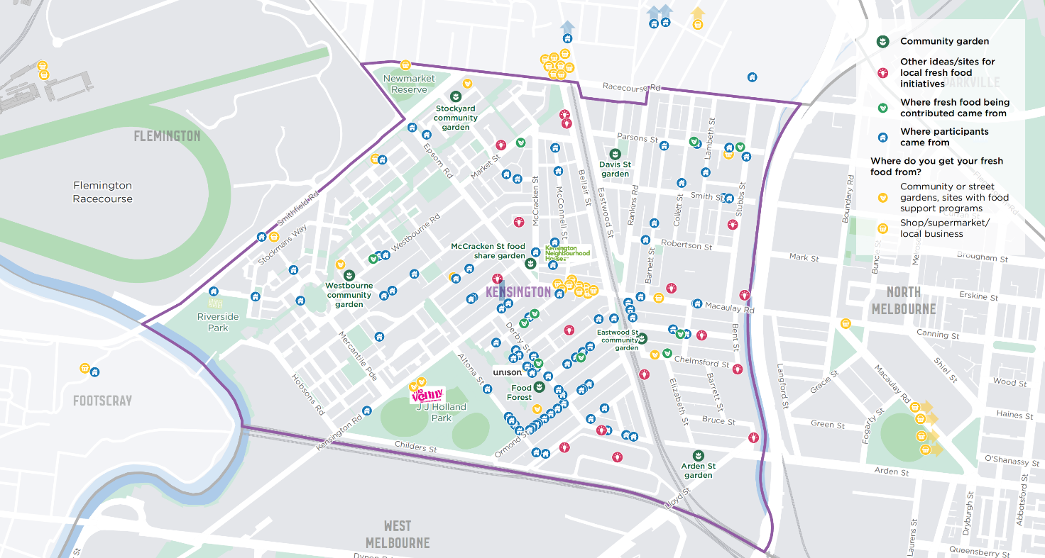

5. Iterate
When it comes to iterating this work, we are collectively revisiting the key questions and priorities to review and evaluate the project as it progresses. Not only does this help us to remain accountable within our organisations and to the communities involved, but to ensure that the project has tangible benefits for those involved.
Together, we are looking for opportunities to integrate the emerging learnings into policies and programs while communicating the progress towards a more equitable and inclusive approach to climate justice. This step also allows the place-based climate justice groups to plan for what is needed to sustain the initiative beyond the scope of the pilot project.
DEBRIEF AND REVIEW APPROACH | SHARE EMERGING LESSONS | RECOMMEND NEXT STEPS | ITERATE AND EVALUATE
Consider how you will come together to debrief following the events, including who will convene and document this process  (G)(A)(O)(N) | Share emerging lessons with local community members, including how their feedback is shaping the approach  (O)(N)(M) | Consider the narratives and community stories that will be most effective at demonstrating the value of the project  (G)(O) | Evaluate if priority communities are tangibly benefitting from the approach and in what ways  (G)(A)(O)(N)
Collaborate to review the feedback and refine the approach in line with ethics and principles established in the Plan stage  (G)(A)(O)(N) | Share lessons with the broader community on preferred channels, such as social media or local newspapers and radio stations.  (G)(A)(O)(N) | Determine the messages required to talk about the viability of the initiative, and the funding and commitment required to sustain it  (G)(O)(N) | Determine how the promotion and engagement approach might be broadened to include any missing groups  (G)(A)(O)(N)
Capture the lessons learnt and share the findings internally to advance policy and program discussions on climate justice  (G) |  |  | Report on how the approach is informing policy and program conditions on climate justice initiatives  (G)
(G) Local government
(A) Advisory body
(O) Community sector organistations
(N) Community networks
(M) Community members

Learnings from the ground
What we recognised early on in our post-market debrief was that while climate justice was not a concept known by many market attendees, the principles were clearly understood by most: connection, community, and care.
As a result, our engagement about local food systems translated to more targeted discussions about what is needed to support a community-led approach to climate justice in the long-term. From a collaboration perspective, ideas included:
- Connecting with cool refuges hosted by local service organisations to support access to locally grown produce on hot days
- Expanding the market to include learning and skill- sharing workshops in local community garden sites, including establishing a mentor or buddy system to help strengthen skills and knowledge
- Engaging local cafes and catering businesses to donate produce and use private land for community gardens
- Establishing additional community pantries to share surplus produce and provide opportunities to connect people with local services and programs beyond immediate need
- Working with body corporates, local government and community organisations to help people in apartments access fresh, locally grown food and integrate apartment dwellers with local community initiatives.
A community-led approach to iterating for climate justice might consider:

Insight 1
Playing to the strengths of different partner organisations to ensure accountability in the work, while allowing for agility and creativity in the response. This ranges from local government sharing how this work might be used in advocacy efforts, to local community organisations sharing emerging learnings with the community groups engaged.

Insight 2
Creating outputs that are tailored and useful to the audiences identified in the Plan stage. Returning to the importance of reciprocity, this includes reporting back to the community via channels identified in earlier stages.

Insight 3
Collecting a range of stories that best demonstrate the value of the process and the initiative beyond financial returns.

A call to (collaborative) action
This guidance document highlights the essential role that cross-sector, collaborative partnerships play for climate justice at the neighbourhood level. Not only to support local governments, community sector organisations and community members to understand climate justice within their local context, but to strengthen the trust, capacity and agency of the community in making decisions about how best to meet their needs. To work towards sustainable urbanisation, cities must build inclusive systems that reduce inequality while enabling pathways to decarbonisation.
Reflecting the significant contributions of a range of different place-based organisations over the past 12 months, this document outlines a process that will provide a starting point for similar groups looking to initiate collaborative action on climate justice.
Reflecting both local and international calls to action, our two-phased process emphasised the need for shared understandings, well-defined roles and responsibilities, and sustainable resourcing to collectively navigate the intersecting inequities that are being experienced in our neighbourhoods.
Based on the learnings of our collaborative approach, climate justice interventions should strive to:
- Diversify community leadership for climate resilience. Create space for leadership and shared decision-making for those most at-risk of climate change impacts
- Change views on risks and vulnerabilities based on evidence. Recognise the complex and contextual ways in which people experience climate change vulnerability, which necessitates ongoing work to understand who is at risk and at what scale
- Embed climate justice principles in municipal planning. Include climate actions that address intersecting social and environmental inequities within municipal health and wellbeing plans
- Build for extremes. Invest in green and blue infrastructure for those experiencing vulnerability to access locally sourced fresh food, as well as water, energy, and affordable low-carbon housing
- Move with the community. Align with community actors and social movements for just and inclusive cities, including supporting grassroots organisations to be organised and funded around neighbourhood mitigation, adaptation and resilience priorities
- Strengthen pathways for decision-making. Recognise the trust and relationships held within place-based organisations and neighbourhood led models, and embed these experiences for equitable and inclusive decision-making
- Resource for implementation. Integrate local actions and priorities with the broader policy and legislative context, including long-term resourcing for the implementation and maintenance of climate justice projects
- Build workforce capacity of community organisations. Provide long-term, sustainable forms of finance and funding to minimise the burden on place-based organisations and volunteers.

https://jss.org.au/programs/centre-for-just-places/
The core partners of this initiative were the City of Melbourne, Jesuit Social Services’ Centre for Just Places, Kensington Neighbourhood House, Living Learning Australia, Transition Town Kensington, Unison and The Venny Inc.
Dunn, K., Wolf, A., Moloney, S., Lansley, D., Hewitt, T., Cigdem-Bayram, M. & Gooder, H. (2022). Mobilising Climate Just and Resilient Communities in Melbourne’s West: Collaborative Action Plan. Melbourne: Jesuit Social Services.
Newell, P., Srivastava, S., Naess, L. O., Torres Contreras, G. A., & Price, R. (2021). Toward transformative climate justice: An emerging research agenda. WIREs Climate Change, 12(6). https://doi.org/10.1002/wcc.733
As defined by the International Association for Public Participation spectrum of engagement, a world recognised standard for community engagement. See also movementstrategy.org/resources/the-spectrum-of-community-engagement-to-ownership
There are updated legislative requirements for deliberative engagement stated in the Victorian Local Government Act 2020.
Alderton, A., Villanueva, K., Davern, M., Reddel, T., Lata, L.N., Moloney, S., Gooder, H., Hewitt, T., DeSilva, A., Coffey, B., McShane, I., Cigdem-Bayram, M. (2022). What works for place-based approaches in Victoria. Part 1: A review of the literature. Report prepared for the Victorian Department of Jobs, Precincts and Regions.
In Victoria, Australia, this is guided by the Public Health and Wellbeing Act 2008 (VIC)
The City of Melbourne has a role to deliver Major Initiative 52 under the Safety & Wellbeing objective in the Council Plan 2021-2025. The initiative seeks to understand the current context of disaster likelihood, risk and preparedness; build organisational capacity in disaster preparedness and risk management; and enable community preparedness and disaster resilience.
Aldrich, D. (2017). The Importance of Social Capital in Building Community Resilience. In Yan, W. and Galloway, W. eds. Rethinking resilience, adaptation and transformation in a time of change. Cham: Springer International Publishing. https://doi.org/10.1007/978-3-319-50171-0_23.
See https://jss.org.au/programs/centre-for-just-places/
Centre for Just Places (2022). Climate and Ecological Justice Resource Pack. Jesuit Social Services: Melbourne. Retrieved from https://climatechangeexchange.org.au/cms/wp-content/uploads/2020/12/climate-and-ecological-justice-resource-pack-jan-2022.pdf.
See https://jss.org.au/articles/centre-for-just-places-climate-resilience-community-sector/
Community networks are organised groups of community members working towards place-based change, such as Transition Town Kensington. We distinguish community members as being individuals not employed by or involved in local campaigns or organisations in an ongoing way.
Government of the Commonwealth of Australia - Australian Bureau of Statistics, (2020): ABS - Data by Region - Income (Including Government Allowances) (SA2) 2011-2019; accessed from AURIN on 28/02/2023.
VicHealth (2020). Vic Health Coronavirus Victorian Wellbeing Impact Study: Follow-up survey. Retrieved from https://www.vichealth.vic.gov.au/media-and-resources/publications/vichealth-coronavirus-victorian-wellbeing-impact-study-follow-up-survey.
See Unison (2020). Bumper harvest in times of COVID. Retrieved from https://unison.org.au/news/bumper-harvest-in-times-of-covid.
See https://participate.melbourne.vic.gov.au/kensington-neighbourhood-portal/priorities
Source: Estimated Resident Population 2021
Source: CLUE 2020
Source: ABS Census 2021
See Future Earth Australia (2022). A National Strategy for Just Adaptation. Canberra: Australian Academy of Science; Soanes, M., Bahadur, A., Shakya, C., Smith, B., Patel, S., Rumbaitis del Rio, C., Coger, T., Dinshaw, A., Patel, S., Huq, S., Musa, M., Rahman, F., Gupta, S., Dolcemascolo, G. and Mann, T. (2021) Principles for locally led adaptation: A call to action. London: International Institute for Environment and Development.

