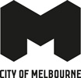
Oh

City Road Master Plan Implementation:
New dog park and skate space

Construction update – February 2022
The dog park at Kings Way and Moray Street Reserve has been completed and is now open to the public.
Located along Moray Street on the western side of the existing tram stop, the dog park provides the perfect space for dogs to stretch their legs, have fun and meet new friends.
The 400 m² area is fully enclosed, protecting dogs from surrounding roads and trams.
The park is fitted with:
- a new granitic surface
- a custom dog drinking fountain
- dog play furniture
- new lighting
- new trees and garden bed areas
- seats and bins.

The skate space on the eastern side of the tram stop, along Hannah Street, is also now open. The space includes new walls and surfaces suitable for skating, street furniture and new lighting.

Pedestrian crossing
We are awaiting final approval from the Department of Transport for a new pedestrian crossing and signals between Boyd Park and the dog park. We will provide another update when the approval process is complete.
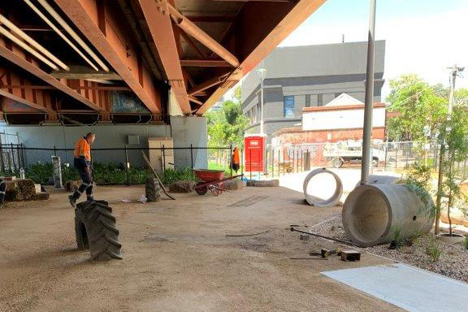
The new dog park during construction
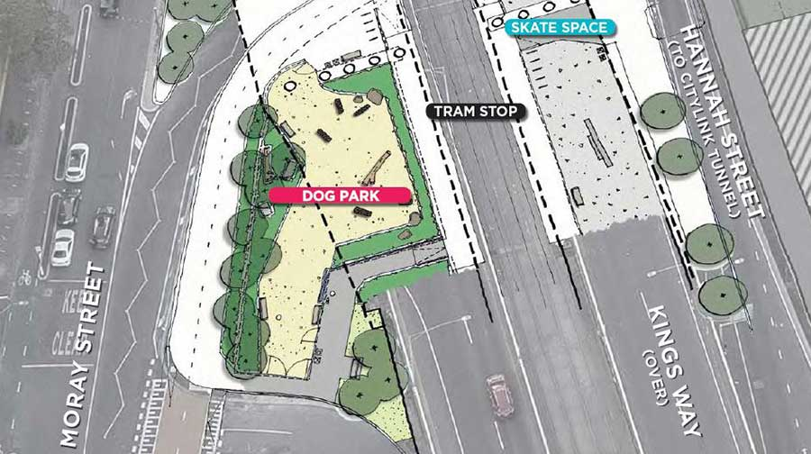Location of the new dog park and skate space
To find out more, please contact 9658 9658 or visit City projects

melbourne.vic.gov.au/cityprojects

