Business Event Sponsorship Program - Information Webinar

City of Melbourne

Contents
Acknowledgement of Country 3
Program Overview 3
What are we offering 4
Sponsorship levels 4
Additional support and opportunities 4
What we will fund 4
What we won’t fund 5
Key Dates 5
Eligibility criteria 5
City of Melbourne municipality 6
How to apply 7
Assessment criteria 7
Purpose and expected impact of the event (50%) 7
Purpose and expected impact of the event (50%) 8
Quality and viability of the event (50 per cent) 9
Lobbying or Canvassing 10
Outcome notification 10
Assistance and support 11
Program information 11
Technical assistance 11
Previous recipients 12

Acknowledgement of Country
The City of Melbourne respectfully acknowledges the Traditional Owners of the land, the Wurundjeri Woi Wurrung and Bunurong Boon Wurrung peoples of the Eastern Kulin and pays respect to their Elders past, present and emerging.
We are committed to our reconciliation journey, because at its heart, reconciliation is about strengthening relationships between Aboriginal and non-Aboriginal peoples, for the benefit of all Victorians.

Program Overview
The Business Events Sponsorship Program provides $100,000 to supports business events such as conferences, showcases, workshops, seminars, exhibitions and networking functions in the City of Melbourne municipality.
Funding of up to $10,000 per applicant is available to events that include in-person attendance, have high relevance to City of Melbourne’s knowledge workers and have vision and solutions that benefit the City of Melbourne.

Objectives
The objective of the program is to support and promote quality business events:
- That include in person attendance and have high relevance to City of Melbourne’s knowledge workers; and
- That have vision and solutions that benefit the City of Melbourne (defined broadly as economic, social and/or environmental benefits)

What are we offering
Sponsorships of up to $10,000 are available. Funding breakdown available for events based on attracting a certain number of attendees.

Sponsorship levels
- Up to $5,000: minimum attendance of 100 and up to 250 people
- Up to$7,250: minimum attendance of 250 and up to 500 people
- Up to $10,000: attendance above 500
Requested funding must be directly related to the set-up and delivery costs of the proposal. Only expenditure items that have been incurred from the day after lodging your application will be eligible

Additional support and opportunities
The City of Melbourne owns a variety of venues that may be of interest for your business event. More information on the City of Melbourne owned venues can be found in hubs and bookable spaces. Please be aware catering packages may apply for these venues.
Subject to agreement and availability, successful applicants may use the following services from the City of Melbourne at their event:
- Lord Mayor or Councillor speech
- City of Melbourne staff involvement with workshops or panels
- Promotion through City of Melbourne marketing channels.

What we will fund
Requested funding must be directly related to the set-up and delivery costs of the proposal. Only expenditure items that have been incurred after your application has been approved.
For hybrid events, City of Melbourne funding will apply to the live aspect of the event. The sponsorship must contribute directly to one or more of the following:
- set-up costs
- logistics
- venue hire
- catering
- presenters / speakers
- production / audio-visual costs
- marketing
- any other event enhancing expenditure that is additional to the core program must be agreed in writing with City of Melbourne.

What we won’t fund
- Operational expenses such as:
  - office rental payments
  - utilities
- Wages and expenses not directly related to the delivery of the event.
- Applications that do not meet the eligibility or assessment criteria
- Expenditure items incurred prior to approval of application funding

Key Dates
Opened on Tuesday 22 August 2023 at 9am AEST
Online information session Wednesday 12 September at 1pm AEST
Closes at 12 pm AEST on Monday 25 September 2023
Assessment period will be in October and November 2023
Outcomes announced once letters of agreement have been signed.

Eligibility criteria
- Type of events: multi-day program conference, exhibition, pitch competition, showcase, demo day, product demonstration, networking, or meeting with a minimum attendance of 100 people
- Event location: within the City of Melbourne municipality boundaries
- A valid Australian Business Number (ABN)
- be an Australian registered business, sole trader, company, business cooperative or partnership and provide documented evidence of its legal structure
- have no outstanding acquittals or debts to the City of Melbourne
- demonstrate financial viability: business plan, including projected financial statements.
- current public liability and professional indemnity insurance policies
- have failed to comply with the terms and conditions of any previous funding agreement or sponsorship from City of Melbourne.

City of Melbourne municipality

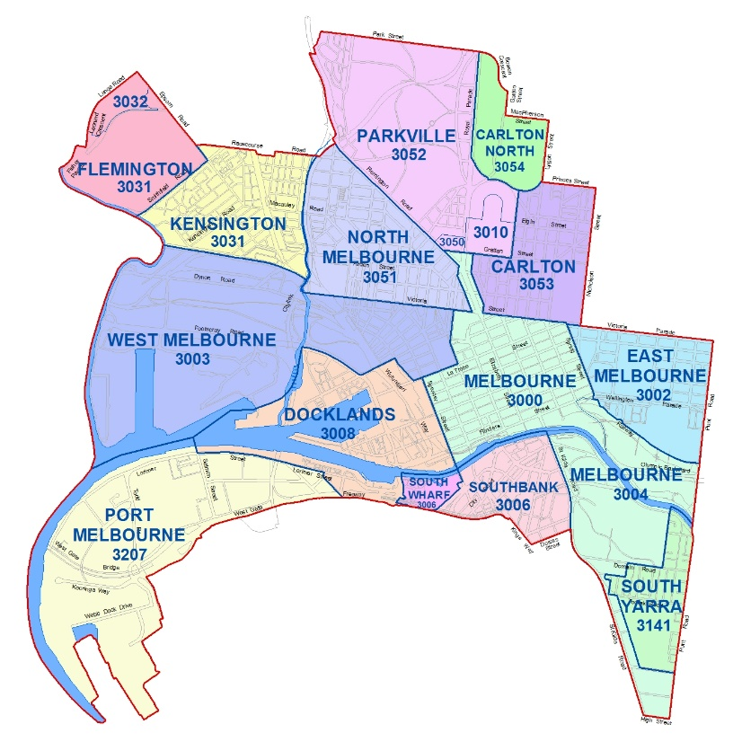

How to apply
- Read the guidelines
- Plan and gather information for application
- Complete and submit online application via SmartyGrants

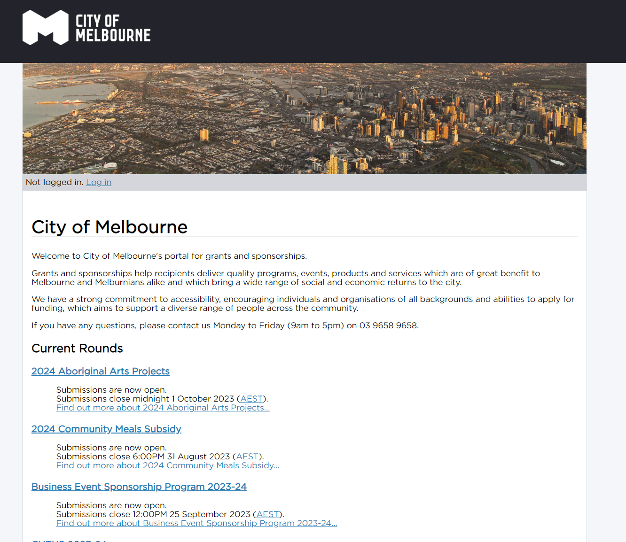

Assessment criteria

Purpose and expected impact of the event (50%)
- Explain the purpose for the event.
- Mention the target audience.
- Outline the main ways the event supports the program objectives.
- Include the expected impacts or benefits of the event – in terms of economic, social and/or environmental benefits for the City of Melbourne.
- Mention specifically if your event includes collaborations with other businesses or organisations in the City of Melbourne.

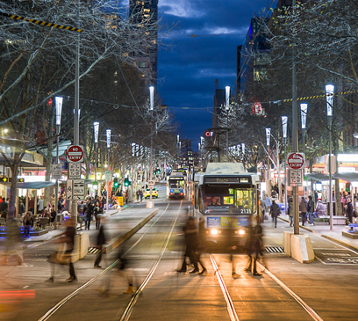

Purpose and expected impact of the event (50%)
Further information on how City of Melbourne aligns to your projects impacts and benefits can be sourced from:
- Council Plan 2021-25
- Economic Development Strategy 2031
- and the United Nations Sustainable Development Goals

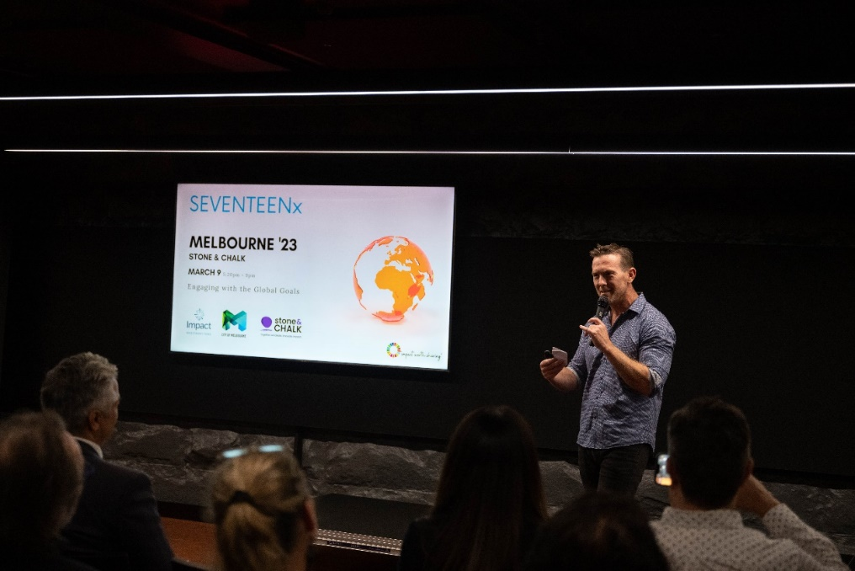

Quality and viability of the event (50 per cent)
- Demonstrate that your event is well researched and planned
- Introduce how you will attract your audience
- Mention who the main people are on the event planning team
- Explain briefly whether the team has a track record in delivering similar events, and summarise evidence of previous successes.
Timelines, project plans, marketing strategies and/or promotional plans will provide strength to this response as attachments.

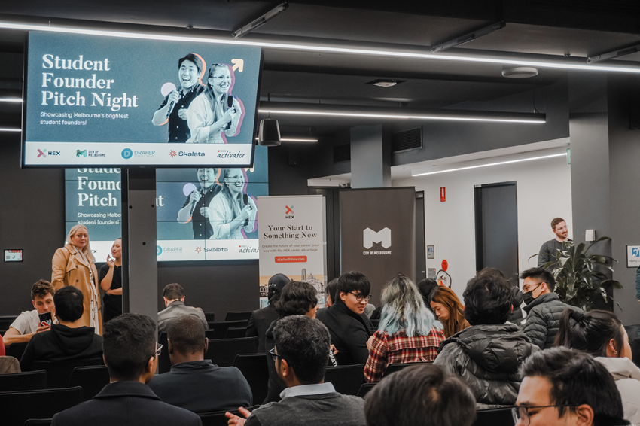

Lobbying or Canvassing
Canvassing or lobbying of Councillors, City of Melbourne employees or assessment panel members in relation to any funding application is prohibited. No further consideration will be given to an application submitted by an applicant who has canvassed or lobbied City of Melbourne staff, Councillors or assessors in relation to their application. Successful applicants are prohibited to lobby Councillors, City of Melbourne staff when seeking additional benefits in the sponsorship agreement.

Outcome notification
All applicants will be notified of their application outcome through SmartyGrants. Unsuccessful applicants will not be reimbursed for the time spent on the application process.

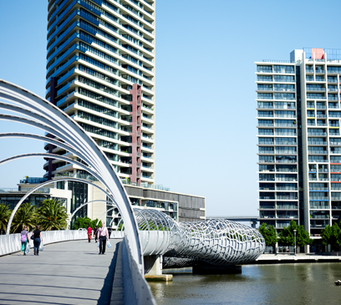

Assistance and support
Program information
Business Funding team
- Monday to Friday 8.30am to 5pm
- 03 9658 9658
- businessfunding@melbourne.vic.gov.au

Technical assistance
- The SmartyGrants support desk is open 9am to 5pm Monday to Friday
- 03 9320 6888
- service@smartygrants.com.au.

Previous recipients
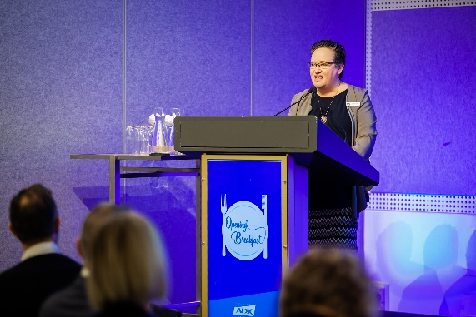
Councillor Dr Olivia Ball speaking at ADX Melbourne by the Australian Dental Industry Association.
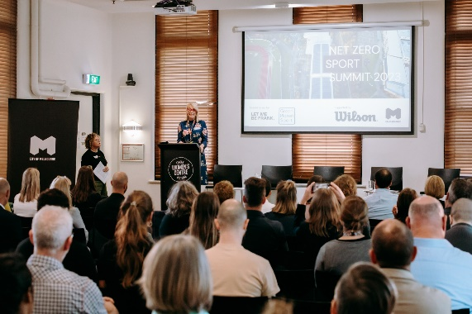
Lord Mayor Sally Capp speaking at the Net Zero Sport Summit by Let Me Be Frank.
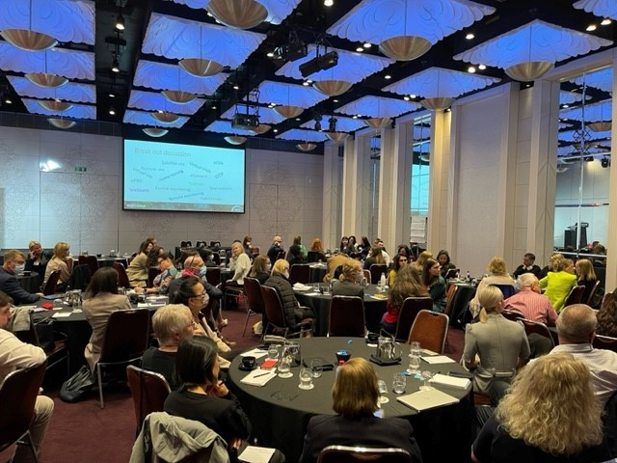
People attending The Connecting up Conference by Infoexchange.
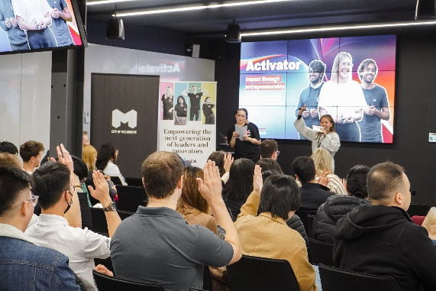
People attending Student Student Founder Pitch Night by HEX.
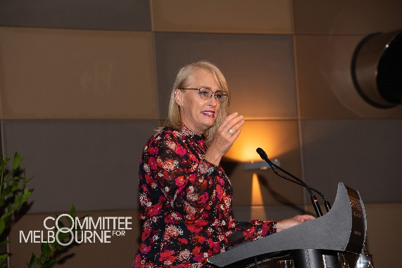
Lord Mayor Sally Capp speaking at the Melbourne Summit by the Committee for Melbourne.

https://www.melbourne.vic.gov.au/community/hubs-bookable-spaces/Pages/bookable-spaces.aspx
https://www.melbourne.vic.gov.au/community/hubs-bookable-spaces/Pages/bookable-spaces.aspx
https://www.melbourne.vic.gov.au/about-council/governance-transparency/policies-protocols/Pages/public-liability-insurance.aspx
https://www.smartygrants.com.au/sg/who/?menuId=7072

