Oh

Brens Pavilion redevelopment

Project update: December 2021
The City of Melbourne will soon commence works on construction of the new Brens Pavilion located in Royal Park between Melbourne Zoo and Royal Parade. The existing pavilion is in poor condition and does not meet the current needs of the sporting clubs or modern building accessibility and construction standards.
The new pavilion will provide a multi-use space for a range of community sport and recreation groups, including:
- eight gender neutral, accessible change rooms (including toilet and shower facilities)
- two umpire change rooms
- a first aid room
- improvements to the existing kitchen and social spaces.
The building has been designed using environmentally sustainable design and significant trees will be protected throughout the works.
Parts of the existing building and toilet block will be demolished, and the ring road around the building will be removed.
This project is being developed by the City of Melbourne in partnership with the Victorian Government. It is one of three pavilions in Royal Park to be upgraded by the City of Melbourne. Construction of the Western Pavilion is on track to be complete by April 2022, while Ryder Pavilion is currently in design. These works align with the Council Plan 2021–25’s major initiative to increase and upgrade accessible, inclusive spaces for women in City of Melbourne sports facilities.

Construction program
Early works will commence in December 2021 and construction is expected to be complete by December 2022. Works will be carried out in four stages:
- Demolition, foundation works and services upgrade.
- Construction of frame and roof.
- Fit-out of new pavilion.
- Landscaping and carpark works.

Construction impacts
Construction will take place during the day and will generate low levels of noise and some dust. Trucks will also be moving through the area to support construction of the pavilion.
We will work with clubs to provide temporary accommodation for the duration of construction, however normal sports activities on the sportsgrounds will not be impacted and will be able to continue.

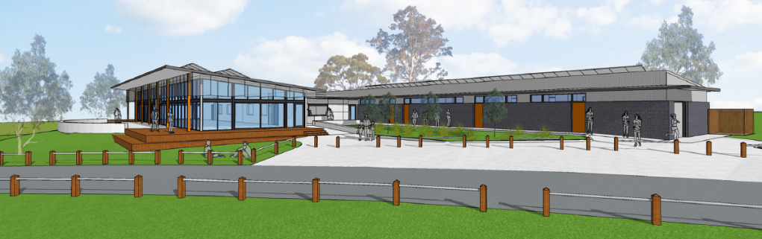

Artist impression of the new Brens Pavilion

Interpreter services
We cater for people of all backgrounds
Please call 03 9280 0726
To find out more, please contact 9658 9658, or visit City projects

melbourne.vic.gov.au/cityprojects

