City of Melbourne

Annual Report 2006-2007

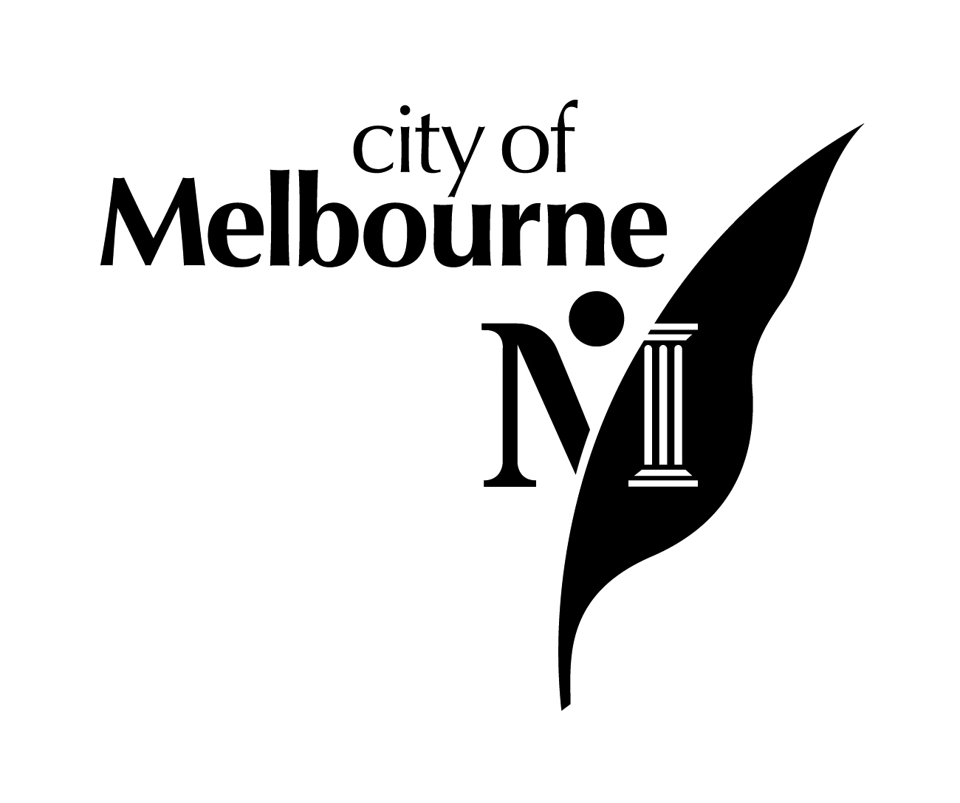

City of Melbourne
ANnual Report 2006-2007

Section One 3
About this report 3
Developing this report 3
Report boundaries and scope 4
Measuring performance 4
Sustainability reporting 4
The Global Reporting Initiative 5
Supplement for public agencies 5
The United Nations Global Compact 7
Our audience 7
New approach to publication 7
Spotlight on sustainability – our management approach to sustainable development 8
Our performance at a glance 10
Melbourne transformed 12
Working together for Melbourne 14
Section Two 16
Our city 16
Melbourne today 16
Council profile 19
Meet your Council 21
Our organisational profile 24
Our vision, mission and values 24
Operational and Efficiency Review 25
Organisational structure 26
Section three 31
Our performance 31
Strategic Objective One: A connected and accessible city 34
Strategic Objective Two: Innovative and vital business city 40
Strategic Objective Three: Inclusive and engaging city 44
Strategic Objective Four: Environmentally responsible city 53
Strategic Objective Five: Well-managed and leading corporation 65
Strategic Objective 6: Financially responsible corporation 91
Section four 98
Performance Statement 98
Events calendar 105
Global Reporting Initiative (GRI) Content Index 110
SECTION FIVE 134
Our financials 134
Understanding our financials 136
Standard Statements 142
Financial Report 149
Notes to and forming part of the Financial Report 153
Revenues from ordinary activities 164
Expenses from ordinary activities 167
Assets 168
Liabilities 176
Equity 178
Other disclosures 179
Statement by Councillors, Chief Executive and Principal Accounting Officer on the Financial Report 197
Auditor-General’s Report on the Financial Report 198
Melbourne City Council 198

Section One
About this report

This is a report on our performance over the 2006-2007 financial year incorporating our highlights and disappointments. The report also addresses our sustainability performance and issues that impact on the sustainability of our city and our organisation.

The report comprises three key parts. The first part provides an overview of the City of Melbourne and the communities we serve. The second part includes highlights of our performance over the year, a spotlight on sustainability issues identified through stakeholder feedback and our key performance indicators. The third part incorporates our financial statements.

The City of Melbourne Annual Report 2006-2007 integrates our Annual Report and our Sustainability Report, which were produced as separate documents in 2005-2006. The report meets our reporting obligations under Section 131 of the Local Government Act 1989 (Vic) and the Global Reporting Initiative (GRI) G3 reporting framework for sustainable reporting.

The structure of the report reflects the structure of the City of Melbourne’s Council Plan 2005-2009, our key planning document, with issues reported under our six strategic objectives.
Developing this report

A cross-organisational working group was formed to develop this Annual Report, which is based on the application of the Global Reporting Initiative’s Principles for Defining Report Content. These principles focus on inclusiveness, relevance, sustainability context and completeness.

The starting point for the development of the report was feedback from stakeholders on the City of Melbourne Sustainability Report 2005-2006. The issues and indicators included in this report have been selected to respond to the areas that stakeholders identified as being most relevant to them.

Regular consultation occurred with senior management throughout the development process regarding content, approach and process.

Internal controls

The content of this Annual Report has been reviewed by relevant managers, directors, councillors, and the Chief Executive. Preparation and publication of the report is the responsibility of our Corporate Services Director. A meeting of the Melbourne City Council will consider the City of Melbourne Annual Report 2006-2007 in October 2007.

External audit

Our Performance Statement and our Financial Report, including the standard statements, have been approved by the Victorian Auditor-General’s office.

Report boundaries and scope

Following stakeholder feedback and an external appraisal of our 2005-2006 Sustainability Report, we decided to narrow our focus for this report by applying a materiality test to select those indicators most relevant to our operations and of greatest interest to stakeholders.

A small cross-corporate group completed the materiality test in two phases. The first phase focused on those indicators not relevant to the City of Melbourne’s operating environment (eg. we do not produce products, therefore many product-related indicators were excluded in this first phase). In the second phase, we looked closely at the remaining indicators to determine the extent to which they would reveal relevant information meaningful to our key stakeholder groups.

Measuring performance

Our success is measured against the outcomes documented in our Council Plan 2005-2009.

Our Annual Plan and Budget 2006-2007 guides the activities and results that each of our work areas, and the individuals within them, has set out to achieve by 30 June 2007.

We have a set of strategic indicators, including standard Victorian Local Government Indicators (VLGI),to monitor progress against our Council Plan. Increasingly, we are incorporating the GRI indicators into our core set of indicators. You’ll find our performance against our strategic indicators under each Strategic Objective in this report.

The GRI indicators are reported throughout the document and can be referenced in the GRI Content Index Table at the back of this report.

Sustainability reporting

We define sustainable development as “development that meets the needs of the present without compromising the ability of future generations to meet their own needs.” (Bruntland Commission, 1987).

At the City of Melbourne we recognise collective action is needed if we are to maintain Melbourne’s intrinsic qualities for current and future generations. We must plan and manage our public assets, infrastructure and resources in a way that supports sustainable development objectives and promotes the public interest. As an employer, the City of Melbourne also recognises its responsibility to lead by example and report publicly and transparently on its activities to promote sustainability.

Last year, we produced a separate Sustainability Report, the City of Melbourne Sustainability Report 2005-2006. This year we are integrating sustainability reporting within our Annual Report as we regard sustainability as core business and aim to increasingly align the sustainability principles with our corporate governance practices.

Your feedback

We pride ourselves on reporting our activities clearly and confidently and your feedback helps us to do this.

In February 2007, the ICLEI Sustainability Services and the Centre for Public Agency Sustainability Reporting sought feedback from our stakeholders about the City of Melbourne’s Sustainability Report 2005-2006. Overall, stakeholders agreed with key issues against which we reported and so the 2006-2007 indicators remain similar to allow us to show our performance over time.

However, stakeholders told us the Sustainability Report 2005-2006 was too long, so this year we have integrated it into our Annual Report. Following stakeholder feedback, we are also providing the Annual Report in summary form as well as a full electronic version on the web.

Following the publication of this Annual Report we will undertake consultation with our stakeholders again in February/ March 2008 to identify further improvements.

The Global Reporting Initiative

The Global Reporting Initiative is a multi-stakeholder-governed institution that developed the world’s most widely used sustainability reporting framework. This framework sets out the principles and indicators that organisations can use to measure and report their economic, environmental, and social performance.

The Global Reporting Initiative’s internationally recognised indicators make it easier for stakeholders to compare our organisation’s performance with that of our peers and with any other organisation. Transparency, accountability and accuracy are important factors in sustainability reporting, and the Global Reporting Initiative encourages all three. You can find out more about this initiative at www.globalreporting.org

Supplement for public agencies

Different business and industry sectors have different reporting needs, and the Global Reporting Initiative has developed sector-specific reporting guidance to accommodate these needs. The Global Reporting Initiative Sector Supplement for Public Agencies recommends that public agencies provide both qualitative and quantitative data in three areas.

Diagram 1 shows the three different types of information recommended for inclusion.

Diagram 1:
Context or state of the environment – economic, environmental, or social conditions within our area of jurisdiction.
Public policies and implementation measures – external policies and actions related to sustainable development.
Organisational performance – internal policies and role as a consumer and employer.
mployer

For the City of Melbourne Annual Report 2006-2007 we have focused on organisational performance indicators. We have included a limited number of public policy and initiative indicators, complemented by some ‘state of environment’ indicators to provide contextual information.
The City of Melbourne reports on a more comprehensive number of ‘state of environment’ indicators in the City of Melbourne City Index Report 2005.
The United Nations Global Compact

The City of Melbourne was the first city in the world to engage with the United Nations Global Compact (UNGC). At the heart of the UNGC are 10 guiding principles covering human and labour rights, and environmental protection. These principles are drawn from the Universal Declaration of Human Rights, the International Labour Organization's Declaration on Fundamental Principles and Rights at Work, and the Rio Declaration on Environment and Development.

Council has supported the development of the Melbourne Model and establishment of the UNGC Cities Programme to help other cities solve intractable social, environmental and economic urban issues within the context of the UNGC and its principles. We continue to support the UNGC.

The City of Melbourne takes a collaborative approach to addressing the social, environmental and economic challenges facing our city. We believe our organisation’s policies and practices are closely aligned with the 10 principles of the UNGC. In addition to demonstrating the principles through our own actions, Council has also continued supporting the development of the UNGC Cities Programme. Its International Secretariat is based in Melbourne.

Melbourne principles

The Melbourne Principles for Sustainable Cities are the product of the United Nations Environment Program (UNEP) International Workshop on Building Urban Ecosystems, held in Melbourne in April 2002. They have been developed to help cities that wish to achieve sustainable development, and provide 10 simple statements on how a sustainable city should function.

The City of Melbourne has endorsed these principles and they are reflected in our future plans for the city.

Our audience

Residents, ratepayers, businesses, staff, partners, and government departments and agencies are all affected by the City of Melbourne’s decisions, and all stand to benefit from their relationship with our great city.

New approach to publication

The City of Melbourne is always looking for new opportunities to reduce our impact on the environment. This year we have decided not to produce a printed Annual Report. Instead the Annual Report is available online at www.melbourne.vic.gov.au. A limited number of CDs have been produced for frequent users of the Annual Report.
Spotlight on sustainability – our management approach to sustainable development

Economic

The City of Melbourne has a range of programs aimed at sustaining the economic performance of the city, from small business grants and training courses to overseas offices to help businesses grow and develop. Council has a website dedicated to attracting business and investment to Melbourne as well as listing coming events: www.businessmelbourne.com.au

Key policies in place to guide the economic development of the City include:

- Tourism Plan 2007-2012;
- Retail Strategy 2006-2012;
- Knowledge City Strategy; and
- Economic Development Policy (under development).

Principal responsibility for these policies lies with the Director Economic Development. You can read more about our approach, performance targets and key achievements under Strategic Objective 2 – Innovative and vital business city, page 40. The City of Melbourne has a 10 Year financial strategy to guide the long-term financial development of the organisation. The Four Year Strategic Resource Plan and annual plan and budget provide the shorter term financial parameters for the organisation. Our Sustainable Procurement Policy guides all decisions in relation to purchasing.

The City of Melbourne holds a AAA credit rating with global credit rating agency, Standard and Poor’s, the highest rating possible for fiscal responsibility.

Principal responsibility for financial sustainability of the organisation lies with the Director Corporate Services. You can read more about our approach, performance targets and key achievements under Strategic Objective 6 – Financially responsible corporation, page 91.

Environmental

The City of Melbourne is a leader in environmental sustainability. It has developed an impressive range of environmental policies and programs to create a more sustainable and liveable city. These programs aim to improve the municipality’s environmental performance, particularly by reducing energy consumption, greenhouse gas emissions, water consumption as well as improving water quality and waste management.

Key policies to guide the environmental sustainability of the city and the organisation include:

- Waste Management Strategy;
- Sustainable Energy and Greenhouse Strategy;
- Zero Net Emissions by 2020;
- Total WaterMark Strategy;
- Stormwater Management Plan.

These policies set some ambitious targets for Council and the community to achieve over the next decade. Principal responsibility for developing and monitoring these policies lies with the Director, Sustainability and Regulatory Services. You can read more about our approach, performance and key achievements under Strategic Objective 4 – An environmentally responsible city, page 53.

Social

Labour practices and decent work

The City of Melbourne is committed to creating a safe workplace where people are developed, encouraged and motivated to perform at their best. As well as maintaining our commitment to Safety Management Achievement Program (SafetyMAP) advanced accreditation, key guiding policies include:

Occupational Health and Safety Policies;

Work Flexibility Policy;

Corporate Learning and Development Program;

Equal Opportunity Policy;

Employee Assistance Policy;

Health and Wellbeing Policy;

Attraction and Retention Strategy;

Anti-harassment and Bullying Policy;

Recruiting Fairly Policy; and

Employee Disability Inclusion Plan.

All staff and management undergo training in relation to these policies as part of our Corporate Induction program and there is ongoing OH&S training for managers, contractors and staff managing contractors.

Human rights

In August 2001, Melbourne became the first city in the world to engage with the United Nations Global Compact (UNGC) and show its commitment to supporting and fostering responsible business operations and universal values.

The City of Melbourne has reinforced its commitment to being an inclusive and engaging city by supporting a Relationship Declaration Register, the first one of its kind in Victoria. An Indigenous Cultural Awareness program has been developed for City of Melbourne staff as an opportunity to increase understanding of contemporary Indigenous culture for Melbourne and Victoria.

The key policies guiding our operations include:
- Enterprise Bargaining Agreement;
- Indigenous Framework; and
- Multicultural Strategy.

The responsibility for developing and implementing policies aimed at creating an inclusive and welcoming city lies with the Director Community and Culture.

Society

As a local government authority, the City of Melbourne takes its community responsibilities very seriously. As a democratically elected body, Council ensures it is not subject, either knowingly or inadvertently, to any kind of fraud or corruption. Nor does Council engage in any behaviour that could be construed as anti-competitive.

Key policies that guide our operations include:

- National Competition Policy;
- Fraud & Corruption Policy;
- Whistleblowers’ Protection Act;
- Risk Management Strategy; and
- Code of Conduct.

The Corporate Learning & Development Program offers a number of training courses in this area, including Fraud Awareness, Governance Framework, and Risk Management. Principal responsibility for these policies lies with the Manager Governance Services.

Service responsibility

The City of Melbourne does not produce or manufacture products. However, we do demonstrate responsibility in the delivery of our services.

As part of the business planning process, each service is assessed against six Best Value principles to ensure we are delivering the right services to our community at the best value. Feedback is continually sought from the community through annual, large-scale surveys of target stakeholder groups.

Key policies guiding our operations include:
- The Privacy Act 1988 (Cth);
- Freedom of Information Act 1982 (Cth);
- Best Value legislation.

Principal responsibility for these policies lies with the Manager Governance Services.

Our performance at a glance

Following is a quick summary of our performance against our six strategic objectives in 2006/07.

SO1 Connected and accessible city | SO2 Innovative and vital business city | SO3 Inclusive and engaging city | SO4 Environmentally responsible city | SO5 Well-managed and leading corporation | SO6 Financially responsible city
Highlights  Our transport strategy Moving People and Freight was launched in August 2006.  $51.14 million worth of capital work improvement projects were delivered to improve our city.  Leading-edge ‘Copenhagen’-style bike lane was installed in Swanston Street.  The Melbourne Osaka Cup 2007 was a huge success. | Highlights  We signed an important Trade Development Alliance with the City of Seattle.  The Melbourne Business Festival attracted large audiences.  The Melbourne Retail Strategy launched in July.  $330,000 in funding provided through the Small Business Grants program. | Highlights  First Australian city to adopt an Action Plan under Reconciliation Australia’s new national program of action.  Resumed direct management of our three libraries.  The Relationship Declaration Register was launched in April 2007.  The city hosted more than 320 events. | Highlights  We joined the prestigious Chicago Climate Exchange in February 2007 and also became a member of the William J Clinton backed Large Cities Climate Leadership Group.  We achieved a 28.7% cut in greenhouse gas emissions from our operations during the year.  We reduced our total water usage by 17.8 per cent over the previous year.  A breakdown of total water use at the City of Melbourne  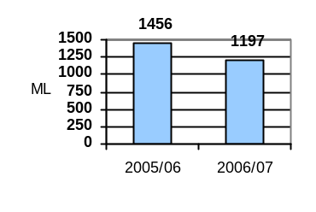 | Highlights  We achieved three-year re-certification of our SafetyMAP accreditation.  Our Workcover premium continues to drop and is now set at 1.15 per cent.  WorkCover premium as % of remuneration  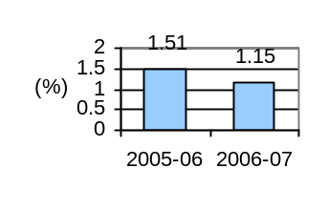  Two City of Melbourne teams of high achievers came first and second in the Victorian Local Government Management Challenge, with the first placed team going on to win the Australasian finals. | Highlights  We achieved a surplus of $7 million not including a once off payment of $167 million for the Docklands transition.  Our investment portfolio provided a return of 8.5 per cent.  We maintained our debt-free status and Standard and Poor’s AAA credit rating.  We provided $31.3 million in donations and grants to 594 organisations.

Disappointment  Our high hopes for the Travel Smart Map have failed to deliver in the capital city setting and so the program is being reviewed. | Disappointment  A disappointing response to the forums aimed at bringing small businesses in North West Melbourne community together resulted in a number of planned actions being deferred pending review. | Disappointment  The number of childcare places remains a major concern for this Council and is an issue it is committed to improving in 2007/08.  Children on child care waiting lists in the City of Melbourne  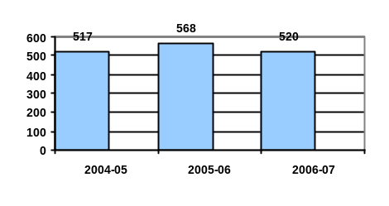 | Disappointment  The City of Melbourne’s Community Power program will come to an end in August 2007. The program educated residents about reducing emissions, however the response was disappointing. | Disappointment  A planned project to replace our corporate project management system was deferred due to a decision to pursue a new financial system. Although delayed this will provide a better long term solution. | Disappointment  The development of the Council's 10 Year Financial Plan has been delayed and will now be finalised in 2007/08.
Looking Ahead  The Docklands will add an exciting new dimension to Melbourne as a world class waterfront city. We will be working to review and improve the waterway management plan. | Looking Ahead  We will be piloting a Melbourne office of Knowledge Capital jointly financed by Council and eight Victorian Universities. | Looking Ahead  As well as looking at ways to improve services to Indigenous youth we will be developing a strategy to further strengthen the profile of the Victoria Market precinct. | Looking Ahead  We will be implementing Stage 1 of our Sustainability Water management Plan to future proof our city’s parks and gardens. | Looking Ahead  We will be implementing the outcomes of the major Operational and Efficiency Review and also finalizing Future Melbourne, our highly anticipated long term vision for our great city. | Looking Ahead  Along with the Financial Plan we will develop a 10 Year Infrastructure Plan to assist in planning resource requirements to meet future service and infrastructure needs.
Read more on page 34. | Read more on page 40. | Read more on page 44. | Read more on page 53. | Read more on page 65. | Read more on page 91.

Melbourne transformed

MESSAGE FROM THE LORD MAYOR OF MELBOURNE

It gives me great pleasure to present the City of Melbourne Annual Report 2006-2007.

Over the past decade, Melbourne has undergone a transformation not seen since the 19th century. Every aspect of our city is enjoying new levels of health and vitality. We are leading international thinking on areas as diverse as climate change and creative culture, and our economy is booming on every front.

Research has shown a more than 10 per cent increase in the number of city businesses and jobs between 2004 and 2006 and our mix of business types, occupations and residences is diversifying. The number of people visiting the city to work, study, shop, dine, access services and transact business on a daily basis is currently around 700,000 and forecast to reach one million within a decade.

Melbourne now has the highest population growth of any capital city in Australia. Since 1992, the number of residents has more than doubled to 70,000 and we expect that over the next 15 years another 50,000 residents will call our city ‘home’.

The City of Melbourne is also successfully positioning our city as a knowledge centre. We are capitalising on steady growth in the finance, education, public administration, arts, medical research and events industries. Applying sound financial management, backed by our AAA credit rating, we are investing in a range of programs and infrastructure to ensure we maintain the quality of life for which our city is so famous.

During the past year we opened the doors of our new office building, Council House 2 (CH2). Winner of a long list of awards, CH2 is one of the world’s most environmentally sustainable buildings. By investing in its construction, we are demonstrating our expectation that all city buildings should strive to minimise their environmental impact.

The City of Melbourne is also leading Australian local government in developing responses to climate change and its effects such as water scarcity. We are a core contributor to the Clinton Climate Initiative, informing global strategies.

The extreme weather conditions of recent years have focused our attention on recycled water and storm water retention initiatives. We are also laying more efficient watering systems in key areas. Firm in our resolve to reach zero net emissions targets, we will continue to roll out programs to minimise energy use in buildings across our municipality. We are also strongly advocating for improvements to transport infrastructure and systems.

As of 1 July 2007, the City of Melbourne became a truly waterfront city, welcoming Docklands residents and assuming responsibility for the delivery of services to that community. Melbourne now offers an even more diverse range of residential, employment and entertainment environments and we look forward to integrating our newest suburb into all aspects of the city over the coming year.

The 2007-2008 financial year will continue to see Melbourne host a diverse range of community, sporting, arts and cultural events. The City of Melbourne will also maintain its focus on arts and cultural development, ensuring a vibrant city centre and community interaction. Retailers can expect our programs to establish Melbourne’s national and international reputation as a shopping destination to gain pace.

We approach the new financial year with enthusiasm, and we are on track to achieve the goals before us. We also remain aware of the challenges facing our organisation and the local government sector.

Implementation of our operational and efficiency review is underway, with changes to the structure of the organisation and the roles of staff members. This is a challenging time for all our people. The Council offers its full support to the management and staff, led by the Chief Executive, David Pitchford.

The launch of Future Melbourne in early 2007 sees us capture the opinions, intellectual capacity and experience of a broad spectrum of Melburnians. On a scale never before attempted, Future Melbourne is exploring all dimensions of urban life, including social, cultural, economic and environmental data.

Through an intensive program of discussion, debate, consultation and analysis, Melbourne’s community will contribute to the development of a vision for the city in 2020 and beyond, as well as actions to achieve that vision. We are ensuring our current economic success supports investment in infrastructure and public amenities, improving quality of life for everyone who lives in, or accesses, the city.

We welcome involvement from all Melburnians.

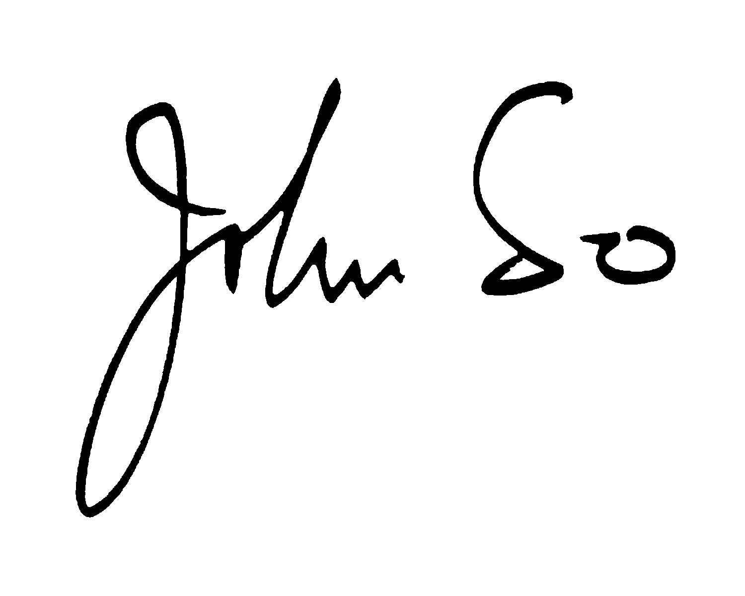

John So
Lord Mayor
Working together for Melbourne

MESSAGE FROM THE CHIEF EXECUTIVE

The past 12 months have been exceptional for Melbourne, which has continued to lead the world in sustainability.

The City of Melbourne opened its new, multi-award winning office building CH2 in 2006 – the first purpose-built office building in Australia to achieve a six Green Star certified rating from the Green Building Council of Australia. Meanwhile, we joined London, New York and Berlin as one of the first cities to sign up for former US President Bill Clinton’s global Energy Efficiency Building Retrofit Program. Another milestone was the transfer of municipal management of Docklands back to the City of Melbourne. This is one of the most complex exercises the City has undertaken and its seamless transfer is a testament to our expertise and that of our strategic partners.

We saw the launch of the Melbourne Retail Strategy, which will build the city’s reputation as a premier retail destination and boost its $2.4 billion annual retail turnover. The Council has committed $20 million over three years to catapult Melbourne into international retail destination status.

Financial performance

Financially the City of Melbourne is in great shape. The Council has $2.5 billion in assets and more than $276 million in the Investment Fund, which includes $119 million in cash reserves to start the 2007-2008 financial year. Our financial position is expected to strengthen in the lead up to 2008-2009.

The City of Melbourne has again received a AAA credit rating from Standard & Poor’s, the world’s foremost provider of independent credit and risk analysis.

Recent media reports have suggested the Council is in debt by $67 million. This is simply not the case. The $67 million was approved by the Council and strategically planned in preparation for the 2006 Commonwealth Games and CH2. The funds for CH2 were transferred from the Investment Fund to construct the building debt free. The asset is now listed on our asset register. These were planned activities over the 2004-2005 and 2005-2006 financial years. In addition, our operating performance during this period yielded a surplus of almost $30 million.

During this time, the City also contributed significantly to the Commonwealth Games, committed $43 million to the Melbourne Convention Centre and secured the return of the Docklands to the municipality.

Standard & Poor’s has reported the City of Melbourne is likely to keep its AAA credit rating given its strong financial position.

Future opportunities

Earlier this year, and with the support of councillors, I commissioned Ernst and Young to conduct an Operational and Efficiency Review to independently examine the way the City conducts its business and identify whether the 60,000 plus ratepayers were getting the best value for money. This was the first such review in more than 15 years.

The City of Melbourne has changed dramatically over this period. Today we are the fastest growing capital city in Australia, with more than 700,000 people coming into the City every day. We are experiencing extraordinary growth in business, employment and residents. In less than seven years we expect more than one million people in the City every day. The City of Melbourne has been at the forefront of this extraordinary transformation.

The outcome of the review will be an organisation that performs even better and is strategically positioned in the best way possible to leverage the opportunities that are coming our way.

For ratepayers, this review has achieved the twin gains of no reduction in service levels, but an improvement in our service delivery.

In 2006-2007 we started work, in partnership with the University of Melbourne, on the development of Future Melbourne, a 10-year plan to position Melbourne as the Asia Pacific region’s pre-eminent capital city for living, working, visiting and investing.

The City of Melbourne is a leading organisation and I congratulate our staff on their dedication, contribution and excellence.

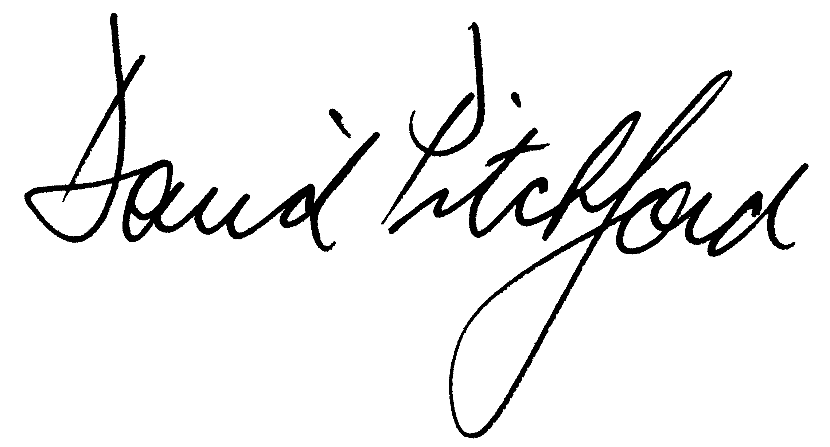

David Pitchford
Chief Executive

Section Two
Our city
Melbourne today

The City of Melbourne is the gateway to Victoria, the seat of the Victorian Government and the headquarters of many local, national and international companies, peak bodies, government and non-government agencies.

Melbourne is a cosmopolitan city, a happy community, a thriving business hub, a focal point for arts and culture, and a great place to work and play. Our population is growing and our boundaries are expanding. People from more than 140 countries call Melbourne home.

More about Melbourne
For more information about Melbourne visit www.melbourne.vic.gov.au. You will find information on:
- services for residents, businesses, students, workers and visitors;
- research, demographics and other statistics;
- a detailed history of the Council, the town hall and the city; and
- our plans for the future.

Melbourne, Australia
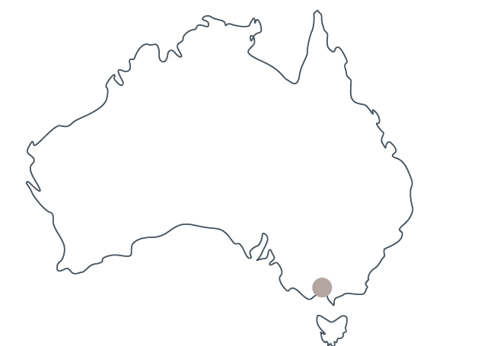

Melbourne, the capital of Victoria, is on the south-east edge of Australia, at the apex of one of the world’s largest bays, Port Phillip. Melbourne is Australia’s second-largest city.

Metropolitan Melbourne
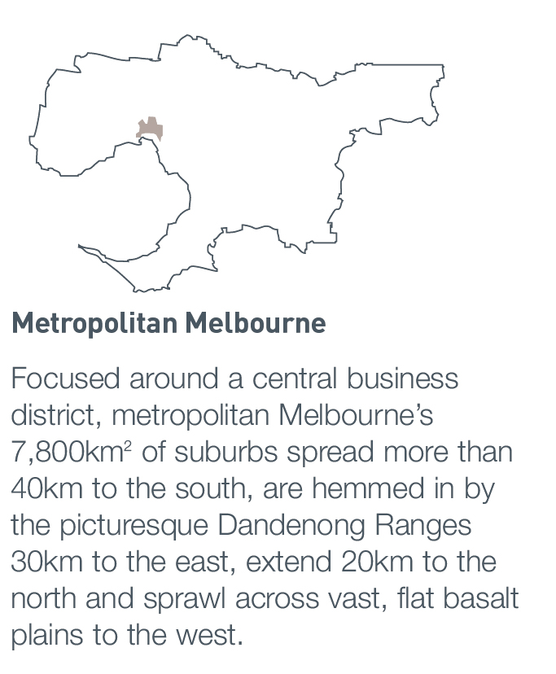

Focused around a central business district, metropolitan Melbourne’s 7,800km² of suburbs spread more than 40km to the south, are hemmed in by the picturesque Dandenong Ranges 30km to the east, extend 20km to the north and sprawl across vast, flat basalt plains to the west.

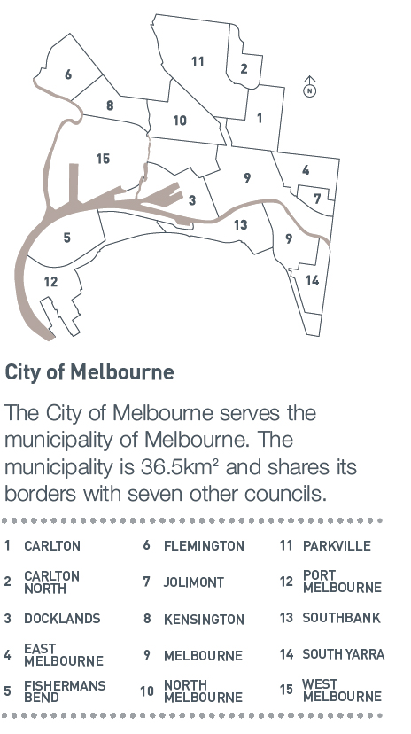
City of Melbourne

The City of Melbourne serves the municipality of Melbourne. The municipality is 36.5km² and shares its borders with seven other councils.

1 Carlton 6 Flemington (part) 11 Parkville
2 Carlton North 7 Jolimont 12 Port Melbourne
3 Docklands 8 Kensington 13 Southbank
4 East Melbourne 9 Melbourne 14 South Yarra (part)
5 Fishermans Bend 10 North Melbourne 15 West Melbourne

Snapshot of a growing city

 | Melbourne municipality now | Melbourne municipality in 1991 | Melbourne metro now | Did you know?
Population | In 2006, the City of Melbourne had almost 67,200 residents. | In 1991, our municipality had a population of around 34,660 people. | In 2006, metropolitan Melbourne had an estimated population of 3,684,460. The City of Melbourne makes up two per cent of this figure. | Our residential population grew at an average of 8.6% between 2001 and 2006. This made it the second fastest, and fourth largest-growing municipality in Victoria over that period.
Young people living in the city | 28 per cent of our residents were aged between 25 and 34 years in 2006. | 20 per cent of our residents were aged between 25 and 34 years in 1991. | In metropolitan Melbourne in 2006, 15 per cent of people were between 25 and 34 years. | More than 23,700 students live within our municipality, including more than11,800 international students.
Birthplace | 42 per cent of our residents were born overseas in 2006. | 38 per cent of residents were born overseas in 1991. | In metropolitan Melbourne, 29 per cent of residents were born overseas in 2006. | The official language in Melbourne is English, but more than 100 languages are spoken by our residents.
Languages spoken at home | 33 per cent of our residents spoke a language other than English at home in 2006. | 33 per cent of residents spoke a language other than English at home in 1991. | 26 per cent of residents in metropolitan Melbourne spoke a language other than English at home in 2006. | The most common languages (after English) are Mandarin, Cantonese, Indonesian, Italian and Korean.
Median house prices | The average cost of a home in the City of Melbourne in December 2006 was $572,500. | In 1991, the average cost of a home in the City of Melbourne was $132,320. | The average cost of a home in metropolitan Melbourne in  December 2006 was $391,000. | In 2006, 44 per cent of City of Melbourne households owned one or more cars.

Employment | In 2006, employment continued to grow, with more than 365,900 people employed within our municipality. | In 1986, 225,650 people were employed within the municipality. | 1,544,000 people were employed in metropolitan Melbourne in 2001. | The business services sector and the finance and insurance sector employ more city workers than any other industry.
Journey to work | In 2006, 40 per cent of workers used public transport to get to work. Forty-two per cent drove to work. | In 1996, 37 per cent of people used public transport and 49 per cent drove to work. | In 2001, across metropolitan Melbourne, 11 per cent of people used public transport to get to work, while 69 per cent travelled by car. | Melbourne's public transport system includes trains, trams and buses.

Information in this table was sourced from: City of Melbourne Census of Land Use and Employment, 2006; Australian Bureau of Statistics Census data for 1981, 1991, 2001 and 2006; Australian Bureau of Statistics Estimated Residential Population data; and the Real Estate Institute of Victoria (house prices).

Council profile

Melbourne City Council

Melbourne City Council is the local government body responsible for the municipality of Melbourne. The Council consists of a Lord Mayor, a Deputy Lord Mayor and seven councillors. As at 30 June 2007, the organisation had a chief executive, seven directors and more than 1,100 staff.

Under the provision of the City of Melbourne Act 2001 (Vic), the municipality is not divided into wards. This means the leadership team and councillors are elected by voters across the municipality.

The leadership team election is conducted using the preferential voting system, and the councillor election is conducted using the proportional representation voting system.

The current Council was elected for a four-year term in November 2004.

Role of the Council

The role of the Council is to provide leadership for the good governance of Melbourne. The Council serves the community including ratepayers, residents, businesses, workers, visitors, community groups and investors.

The Council is responsible for:
- acting as a representative government by taking into account the diverse needs of the local community in decision making;
- providing leadership by establishing strategic objectives and monitoring the achievement of those objectives;
- maintaining the viability of the Council by ensuring resources are managed in a responsible and accountable manner;
- advocating the interests of the local community to other communities and governments;
- acting as a responsible partner in government by taking into account the needs of other communities; and
- fostering community cohesion and encouraging active participation in civic life.

Relationship with other tiers of government

There are three tiers of government in Australia – local, state and federal. Local government is the third tier of government and statutory responsibility for local government lies with each Australian state or territory.

An Act of each State Parliament specifies local government powers, duties and functions. In Victoria, the legal basis for Councils is established under the Constitution Act 1975 (Vic) and the Local Government Act 1989 (Vic).

Council decisions
Council decisions are made by councillors either at Council meetings or at appropriately delegated committee meetings. Decisions made at committee meetings are subject to a referral notice process. (This process is enacted if fewer than five committee members vote in favour of a motion. Committee members have the option of referring a matter to the Council meeting under this circumstance.)

Meetings are open to all unless the Council or committee resolves to close the meeting to members of the public.

Office of the Lord Mayor
The Office of the Lord Mayor provides advisory and administrative support services for the Lord Mayor and Deputy Lord Mayor.

The Lord Mayor’s chief of staff works closely with the office of the Chief Executive, councillors, directors and managers, supporting the relationship between the Council and the organisation.

Delegations
The Melbourne City Council’s powers under the Local Government Act 1989 (Vic) or any other Act may be delegated by instrument of delegation to a committee of Council or to a City of Melbourne officer. The Council generally delegates powers, duties and functions to the Chief Executive, who may delegate some or all of those powers to other officers.

The Council and its committees provide clear and precise policy, and City of Melbourne staff make day-to-day decisions in accordance with that policy. The exercise of delegations is subject to the City of Melbourne’s Delegations Policy.

Meet your Council

Lord Mayor John So

First elected in 1991.

The Lord Mayor is chair of meetings of the Melbourne City Council and represents the City of Melbourne on the following advisory committees and external organisations:

- Audit Committee;
- Anti-Cancer Council of Victoria;
- Capital City Committee;
- Council of Capital City Lord Mayors;
- Committee for Melbourne;
- Victorian Crime and Violence Prevention Committee;
- Lord Mayor’s Charitable Fund;
- Shrine of Remembrance; and
- World Mayor’s Council on Climate Change.

Deputy Lord Mayor Gary Singer

First elected in December 2004.

The Deputy Lord Mayor is the acting chair for each Melbourne City Council committee, and represents the City of Melbourne on the following advisory committees and external organisations:

- Audit Committee;
- Arts Advisory Board;
- Capital City Committee; and
- Melbourne Symphony Orchestra.

Cr Catherine Ng

First elected in July 2001.

Cr Ng is chair of the Melbourne City Council Planning Committee and represents the City of Melbourne on the following advisory committees and external organisations:

- DoI MAV Public Transport Liaison Group;
- Inner Melbourne Action Plan (IMAP) Implementation Committee;
- Melbourne Transport Committee; and
- Metropolitan Transport Forum.

Cr Fraser Brindley

First elected in December 2004.

Cr Brindley is chair of the Melbourne City Council Environment Committee and represents the City of Melbourne on the following advisory committees and external organisations:

- International Council for Local Environment Initiatives (ICLEI) Executive Committee;
- Municipal Association of Victoria Strategic Environment Advisory Group;
- Metropolitan Waste Management Group Advisory Committee;
- Royal Park Master Plan Implementation Advisory Committee;
- Carlton Gardens Advisory Reference Group;
- City of Melbourne Sustainable Water Use Reference Group;
- Heritage Advisory Committee; and
- Environmental Impact of Commercial Waste Collection Sub-Committee.

Cr Fiona Snedden

First elected in December 2004.

Cr Snedden is chair of the Melbourne City Council Business and International Relations Committee, and represents the City of Melbourne on the following advisory committees and external organisations:

- Melbourne Retail Advisory Board;
- Melbourne Hospitality Advisory Board;
- Police Community Consultative Committee - Domain/Southbank;
- Melbourne Spring Fashion Week Advisory Committee;
- Environmental Impact of Commercial Waste Collection Sub-Committee; and

Cr Carl Jetter

First elected in December 2004.

Cr Jetter is chair of the Melbourne City Council Marketing and Events Committee and represents the City of Melbourne on the following advisory committees and external organisations:

- Melbourne International Flower and Garden Show Event Advisory Group;
- Melbourne Moomba Waterfest Taskforce;
- Osaka Cup Executive Group;
- Melbourne Awards Committee;
- Strategic Purchasing (MAPS Group Ltd trading as Strategic Purchasing);
- Victorian Local Governance Association;
- New Year's Eve Task Force;
- Precinct Advisory Committee;
- Cultural Precincts Advisory Board; and
- Melbourne Cycling Festival.

Cr Brian Shanahan

First elected in December 2004.

Cr Shanahan is chair of the Melbourne City Council Finance and Governance Committee and represents the City of Melbourne on the following advisory committees and external organisations:

- Audit Committee;
- Inner South Metropolitan Mayor’s Forum;
- Municipal Association of Victoria;
- Police Community Consultative Committee – North and West Melbourne;
- Community Infrastructure Implementation Sub-Committee;
- North Melbourne Recreation Reserve Landscape Plan Advisory Committee; and
- Environmental Impact of Commercial Waste Collection Sub-Committee.

Cr Peter Clarke

First elected in December 2004.

Cr Clarke is chair of the Melbourne City Council Docklands and Major Projects Committee and represents the City of Melbourne on the following advisory committees and external organisations:

- Community Infrastructure Implementation Sub-Committee; and
- Docklands Joint Working Group.

Cr David Wilson

First elected in December 2004.

Cr Wilson is chair of the Melbourne City Council Community Services Committee and represents the City of Melbourne on the following advisory committees and external organisations:

- Aboriginal Consultative Group
- City Safety Leadership Committee Taskforce;
- Disability Advisory Committee;
- Capital City Local Learning and Employment Network Management Committee;
- Carlton Community Liaison Committee;
- City Library Joint Venture Management Committee;
- Kensington Community Liaison Committee;
- Melbourne Affordable Housing;
- Police Community Consultative Committee – CAD;
- Police Community Consultative Committee – Carlton/Parkville;
- State Netball and Hockey Centre Advisory Committee;
- Yarra-Melbourne Regional Library Board;
- Drugs and Alcohol Advisory Group; and
- Community Infrastructure Implementation Sub-Committee.

Our organisational profile

Melbourne City Council is a public statutory body incorporated under the Local Government Act 1989 (Vic). The Act sets out the purposes and objectives of the Council, and defines its functions and powers.

Melbourne City Council’s headquarters is the Melbourne Town Hall in Swanston Street.

The Melbourne City Council also has three wholly owned subsidiary companies, two associated companies, one joint venture and a trust fund. All but one of the associated companies is based within the municipality.

Melbourne City Council is generally referred to as the City of Melbourne.

Our vision, mission and values

Vision

Melbourne, the capital of Victoria, will be internationally recognised for the opportunities it offers all Victorians to live, learn, work and prosper.

Melbourne is a vibrant, thriving and sustainable city that is viewed with pride by all Victorians.

Mission
We are committed to:

- ensuring the operations of Melbourne City Council are socially, economically and environmentally sustainable;
- encouraging and facilitating sustainable social, economic and environmental development and prosperity;
- promoting Melbourne’s advantages;
- transparent and accountable governance;
- best value customer service;
- maintaining and enhancing the liveability of the city by providing quality assets and associated services; and
- building on the city’s strategic advantages.

Values
Our values are:

- Integrity: I will do and others will see it.
- Respect: I will treat others as I expect to be treated.
- Excellence: I will do the best that I can.
- Courage: I will make a difference.

These values guide us in working together for Melbourne.

Realising our vision
Our Council Plan 2005-2009 identifies six strategic objectives that will guide us towards our vision of a thriving and sustainable city that all Victorians can be proud of.

Our aspirations for the city are reflected in the first four strategic objectives:

1. Connected and accessible city;
2. Innovative and vital business city;
3. Inclusive and engaging city; and
4. Environmentally responsible city.

A further two objectives relate to our internal performance and give direction for the good governance and management of our organisation:

5. Well-managed and leading corporation; and
6. Financially responsible corporation.

Operational and Efficiency Review

Over the past decade, inner Melbourne has undergone an urban renaissance. This exponential growth provided a timely opportunity to review the services and programs the City of Melbourne was delivering, and the way they were being delivered.

In February 2007, Ernst & Young was commissioned to conduct an Operational and Efficiency Review – to examine the way the City conducts its business, and to see if ratepayers were getting the best value for money.

It was an independent assessment of the performance of the organisation, which confirmed that essentially, there are no new significant revenue streams available to the Council.

Consequently, there was a review of every service the Council delivers to ascertain whether the organisation should be acting as the provider, the deliverer or the facilitator of that service.

For ratepayers, the outcomes of this review achieved the twin gains of no reduction in service levels, and an improvement in our service delivery. The total operational savings identified through the review were $11.8 million. Of this, a restructure in May 2007 will lead to net savings of $1.5 million in the 2007-2008 financial year and additional labour savings are expected in 2008/09. Further operational efficiencies will be implemented by the 2009/10 financial year.

These operational and service improvements will help position our organisation to be leaner, more efficient and responsive to the needs of our communities. They will mean the City can maintain its commitment to deliver these services to ratepayers with lowest rate rises of any capital city in Australia.

Organisational structure

At the start of the financial year, the City of Melbourne operated with seven divisions and 35 branches.

In December 2006, the Chief Executive restructured the organisation to provide a more logical ordering of responsibilities, aligning structure with program delivery. This transitional structure came into effect in February 2007 to lead us into the Operational and Efficiency Review.

As a result of the Operational and Efficiency Review, it was announced on 30 May 2007 the structure would be further refined. Effective from 2 July 2007, the existing seven divisions were rationalised to create a new organisational structure of five divisions and 28 branches.

City of Melbourne organisational structure as at 30 June 2007
Office of the
Chief Executive
CITY OF MELBOURNE
Organisation Structure
Community Services
Councillors
Lord Mayor & Deputy Lord Mayor
Business Information
Services
Parking & Traffic
Rates & Valuations
Financial Services
Street Activities
City
Sustainability
Sustainable
Regulatory Services
Melbourne City
Research
City Strategy
Finance
Sustainability
Corporate
Communications
Facilities Management
Arts & Culture
Docklands Transition
Melbourne Marketing &
Retail Development
Events Melbourne
Tourism Melbourne
Commerce & Marketing
Customer Relations &
Place Management
Media Relations
Corporate Services
Melbourne International
Community and Places
Statutory Services
Engineering Services
Asset Services
Continuous
Improvement
Legal Services
Human Resources
Councillor Support
Contracts
Lord Mayor’s Office
Governance Services
Business Melbourne
GRI Reporting*
Water Resources*
Environmental Leadership*
Future Melbourne*
Commercial Strategy*
Focus areas,
not branches
Design
Major Project Delivery
Urban Design
Works Program
City Design
Parks & Recreation
Knowledge City*

Directors

The following table shows the divisions of the City of Melbourne and the name of the director responsible for each area, taking into account the structural changes outlined above.

Directors and divisions

As at 1 July 2006 | Transitional structure | Final structure
Rob Adams – Design & Culture | Rob Adams – City Design | Rob Adams – Design and Urban Environment
Scott Chapman – Marketing, Tourism & Major Events | Scott Chapman – Commerce & Marketing | Scott Chapman – Economic Development
Martin Cutter – Finance | Martin Cutter – Finance | Martin Cutter – Corporate Services
Geoff Lawler – Sustainability & Innovation | Geoff Lawler – Sustainability | Geoff Lawler – Sustainability and Regulatory Services
Linda Weatherson – Corporate Performance | Linda Weatherson – Community & Places | Linda Weatherson – Community and Culture
Terry Makings – Assets & Services | Terry Makings – Statutory Services
Hayden Cock – Corporate Affairs | Hayden Cock – Corporate Services

For the purpose of this Annual Report, we are required to report our structure as at 30 June 2007, which was our transitional structure. As at 30 June 2007, the following divisions were in place:

City Design
The City Design Division designs, implements and manages major capital city projects and coordinates the Capital Works Program. The division also contributes to urban design and planning strategy, provides leisure opportunities and protects parks for future generations.

Commerce & Marketing
The Commerce and Marketing Division focuses on establishing strong private and public sector relationships in delivering services that position Melbourne as a world class city in local, national and international markets. Through its work in customer service, place management, tourism, major events and destination marketing, the division drives the high standards of customer contact and the Melbourne ‘brand’.

Finance
The Finance Division manages the City of Melbourne’s financial assets and resources to help the organisation provide quality services to customers and stakeholders.

Sustainability
The Sustainability Division monitors, plans, facilitates and manages Melbourne’s sustainable development, including our business and environmental development.

Community & Places
The Community & Places Division advocates for equity, fosters social and cultural sustainability, understands the needs and aspirations of our residents and ratepayers, demonstrates leadership and builds partnerships for community and place outcomes.

Statutory Services
The Statutory Services Division manages public spaces and infrastructure networks including roads, paths, parks, gardens, storm water, public lighting and recreational facilities.

Corporate Services
The Corporate Services Division provides information to residents, ratepayers and stakeholders, promotes services and programs, and is responsible for legal and governance services, continuous improvement, human resources and media relations.

As well as leading their own divisions, each director provides support and advice to the Council committees most relevant to the work of their division. Directors also have ‘ownership’ of strategic objectives most relevant to the work of their division.

The Office of the Chief Executive

David Pitchford is the Chief Executive of City of Melbourne. The Chief Executive is responsible for establishing and maintaining an organisational structure that ensures the decisions of the Melbourne City Council are implemented, that day-to-day management of the Council's operations are in accordance with our Council Plan and that timely advice is provided to the Council.

The functions and powers of the Chief Executive are principally determined by the Local Government Act 1989 (Vic).

The Office of the Chief Executive liaises with the offices of the Lord Mayor and Deputy Lord Mayor, councillors, City of Melbourne executives, the Federal and Victorian governments, and key community and corporate stakeholders to ensure the Council's objectives are met.

The Chief Executive also attends Council meetings.

Directors Forum

The Directors Forum includes the Chief Executive and the City of Melbourne’s directors. The Directors Forum meets weekly to consider ‘big picture’ issues such as the direction of the organisation and the City. The Directors Forum also considers administrative issues relating to the operation of the Council.

Managers and staff

The City of Melbourne’s executive management team is a team of executive-level officers who report to a director. The executive management team is responsible for liaising with staff and ensuring City of Melbourne initiatives and policies are complied with. At 30 June 2007, the City of Melbourne had 1,129 permanent staff. Most staff work in the Melbourne Town Hall and nearby administrative buildings including the newly constructed green office building, CH2. Some staff are located at other sites dispersed throughout the municipality.

Our integrated planning framework

The City of Melbourne's integrated planning framework is made up of a series of documents that cascade down from City Plan 2010. The purpose of the framework is to ensure that long-term goals are achieved through specific short-term plans.

Our Council Plan 2005-2009 is a vital part of our integrated planning framework and outlines the four-year strategies for the Council.

The cascading structure of the framework ensures all actions carried out across the organisation are aligned to the City of Melbourne's strategic objectives, from strategy development, through to staff individual performance plans. Our reporting regime builds in accountability at each level in the framework and includes regular monitoring of progress throughout the year.

Relationship between the Council’s key planning documents

City Plan 2010
Council Plan
Annual Plan and Budget
Branch Business Plans
Individual Performance Plans
City Plan Monitoring Report
Annual Report
Quarterly Reports
Public documents
Organisational documents

Section three
Our performance
Details of our performance in 2006-2007 against our Council Plan 2005-2009 are outlined in this section. Our performance is reported against six strategic objectives and includes our achievements, disappointments and future plans. We have also spotlighted a key sustainability issue within each of the six strategic objectives.
Our strategic objectives are:
1. Connected and accessible city
2. Innovative and vital business city
3. Inclusive and engaging city
4. Environmentally responsible city
5. Well managed and leading corporation
6. Financially responsible corporation
The City of Melbourne delivers a range of services that contribute to achieving our strategic objectives. The first four objectives reflect our aspirations for the City and the remaining two are focussed on the organisation's internal performance. The alignment of our services with our strategic objectives is shown in the table below.

Council Plan strategic objectives

Services | Connected and accessible City | Innovative and vital business city | Inclusive and engaging city | Environmentally responsible city | Well managed and leading corporation | Financially responsible corporation
Services | Roads and infrastructure | Business and retail development | Building development and planning | Street cleaning and waste management | Legal, governance and corporate support | Financial services
Services | Parks and gardens | Local laws compliance and street trading | Urban policy and design | Sustainable environmental management | Human resources
Services | Parking and traffic management |  | Arts and culture |  | Technology development
Services | International connections |  | Visitor and resident information services |  | Organisational development
Services | International connections |  | Events |  | Communications, media and public relations
Services | International connections |  | City promotion and tourism |  | Property and asset management
Services | International connections |  | Community services
Services | International connections |  | Public health promotion and management
Services | International connections |  | Recreation and leisure services

Percentage of Annual Plan and Budget 2006-2007 deliverables achieved
The City of Melbourne’s Annual Plan and Budget 2006-2007 set an ambitious program of 65 deliverables to be completed during the 2006-2007 financial year. Fifty of these 65 deliverables were 75 per cent or more complete as at 30 June 2007.

Thirty eight were complete. A further 12 deliverables were 75 per cent to 90 per cent complete. Six deliverables did not progress during the 2006-2007 financial year due to changing priorities, with the remainder progressing, but not yet significantly complete.

Annual Plan deliverables completion rate as at 30 June 2007

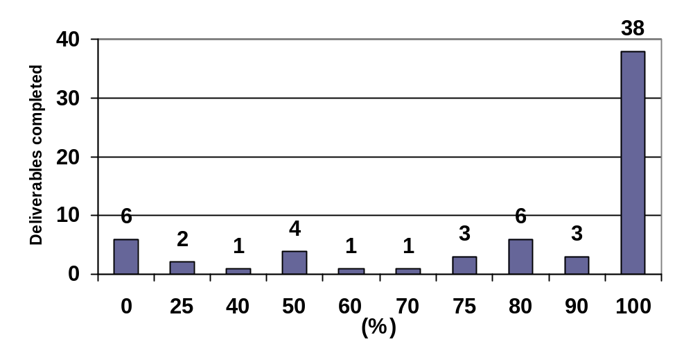

(Source: City of Melbourne Annual Plan and Budget 2006-2007.)

Strategic Objective One:
A connected and accessible city

A connected and accessible city: accessible infrastructure and connected to its immediate surrounds, the nation and the world.

Financial performance
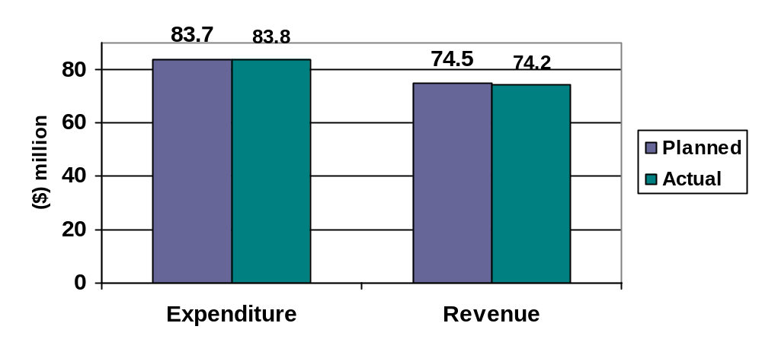
Variance: ($0.1 million) Variance: ($0.3 million)
% of budget: 100 per cent % of budget: 96 per cent

This chart shows the amount we spent (expenditure) and the amount we earned (revenue) in delivering our services and programs within this strategic objective.

Highlights

Transport Strategy – Moving People and Freight
Transport is one of the most critical issues facing the City of Melbourne and in August 2006, the Council adopted its Transport Strategy – Moving People and Freight. Implementation of the strategy will enable more people to use public transport to commute to the city; more people to access the city at off-peak times either by car or public transport for short periods to shop or transact business; more people to enjoy walking, cycling or public transport as a way of getting around the city; more use of the road network for freight to service the city's needs and for export; and a more sustainable environment. It enhances access to and around the city without affecting the liveability that makes Melbourne special.

The strategy also identified the need for significant spending on infrastructure during the next two decades to maintain Melbourne’s high living and economic standards. It advocates for:

- a metro style underground rail from Brunswick to South Yarra, with stations under the hospitals in Parkville, as well as Carlton and the Domain;
- a rail line from Doncaster, along the Eastern Freeway, then to Parkville by tunnel, to link with the proposed metro rail link; and
- an east-west road freight tunnel linking the Eastern Freeway with CityLink and the Port of Melbourne.

Melbourne International Strategy
The sister-city relationship between Melbourne and Milan was celebrated in the Italian city in early 2007 with numerous events to promote Melbourne. Melbourne a Milano included a chef exchange, a design-related business mission and a performance by Melbourne Symphony Orchestra. The program, presented by the City of Melbourne in partnership with Tourism Victoria and the Department of Foreign Affairs and Trade, generated outstanding media coverage both here and in Italy.

Melbourne participated in the Australia-Japan Year of Exchange with the running of the Melbourne Osaka Cup 2007, and furthered its relationship with the Indian city of Delhi via development of an indicative three-year program. The alliance with Delhi is expected to focus initially on the Commonwealth Games host-city exchange.

The development of Melbourne’s global positioning strategy continued in 2006-2007 and the Melbourne Office in Tianjin, China, recorded strong performances in the delivery of business, educational, cultural and city-management exchanges.

Bike lanes
In June 2007 the City of Melbourne completed installation of a Copenhagen-style bike lane on Swanston Street, between Franklin and Faraday streets. The $485,000 project, initiated by Bicycle Victoria and funded by VicRoads, provides an on-road cycle path that is physically separated from other road users and parked cars by a one-metre-wide island.

Other bike-related projects completed in 2006-2007 include the installation of bike lanes on Spring and Nicholson streets and Macaulay Road; line markings in Queensbury Street and on the Capital City Bike Path; work on the bluestone channels in Elgin and Gisborne streets; and the installation of 100 bike hoops across the municipality.

Building a better city
The Council works program included capital expenditure of $51.140 million. This amount includes $9.385 million for CH2, which was completed in October 2006. Other key projects delivered were:

- redevelopment of the Kings Domain section of the Tan Track including provision of new lighting;
- upgrade of streetscapes and bluestone paving throughout the city;
- an asset-renewal program at Queen Victoria Market including refurbishment of the Meat Hall and Dairy Hall;
- a significant program of IT hardware replacement; and
- renewal of roadways, footpaths and parks pathways.
A number of multi-year projects were in the planning and design phase with construction scheduled for 2007-2008. Significant projects include:
- Melbourne Zoo northern-entrance car park;
- Manningham Street pedestrian and cycling bridge;
- North Melbourne Recreation Reserve; and
- City of Melbourne Bowling Club (Flagstaff Gardens).
For more details on the City of Melbourne's capital works spending, turn to page 149 of our Financial Report.

Parks Interpretative Framework
Melbourne's parks and gardens are valuable assets that create economic, environmental and social prosperity. A benchmarking exercise of major capital cities of the world showed that Melbourne is one of the world’s greenest capital cities with the highest percentage of parkland within three kilometres of the CBD, ahead of Montreal, New York, London and Sydney.

During 2006-2007 a Draft Parks Interpretative Framework exploring the interpretation and community education potential for our parks and gardens was finalised. A range of interpretative programs and products will be implemented over the next couple of years.

Disappointments

Travel Smart program
Despite the popularity of the Travel Smart Map illustrating sustainable transport options, the program’s momentum has proven difficult to maintain in a capital city setting and its future is being reviewed by the City of Melbourne and the Department of Infrastructure. Alternative travel demand management tools are being considered and evaluated.

Looking ahead

Transport Strategy
Implementation of the city’s Transport Strategy – Moving People and Freight is ongoing with examination of European and American cities’ bike-hire schemes, assessment of our cycling infrastructure and how bicycle-friendly we are, and the continued rollout of ‘Wheels and Heels’ to make parking and local access easier for residents, and cycling and walking safer and more convenient.

Docklands waterways
With the transfer of Docklands to the City of Melbourne, we will complete a review of the management and operations of its waterways to ensure Docklands becomes a world-class maritime facility and boating destination.

Spotlight on sustainability – Wheels and Heels: moving people in and around the city

Melbourne relies heavily on its transport network. As Victoria’s primary business and activity destination, more than 700,000 people access the city each day. During the next three decades, the number of City of Melbourne residents is expected to reach one million. In the next 15 years, road freight tonnage is expected to increase by more than 80 per cent.

Moving People and Freight is the City of Melbourne’s transport strategy to provide access to the city for residents, workers, shoppers, visitors, businesses and freight over the next two decades. The strategy’s ‘Wheels and Heels’ program is one way of doing this.

‘Wheels and Heels’ makes parking and local access easier for residents, and cycling and walking safer and more convenient. The program gives residents their say on how to improve their community and make sustainable transport more viable.

The program has been successful in Carlton, with the Carlton Parking and Access Strategy adopted in April 2004 after extensive consultation and engagement with the community. In June 2005, work ‘on the ground’ began, and in August 2006 a review of the strategy received overwhelming support from the residents’ association and other community groups.

The results of the Carlton Parking and Access Strategy have been exciting. Installation of parking meters generated a 20 per cent increase in parking stock, the number of permits issued dropped by more than one-quarter and the community identified better walking and cycling links. The interaction and relationships developed between residents, traders, local institutions and the City of Melbourne has been a particularly positive outcome.

The success of ‘Wheels and Heels’ in Carlton has led to development of similar plans for other suburbs and the program has contributed to the connectivity and accessibility of Melbourne.

Strategic indicators
Council monitors the following key performance indicators to measure our progress towards a connected and accessible city.

No | Measure | 2006-2007 result | 2005-2006 result | Comments
1.1 | Number of daily visitors to the City of Melbourne. | 710,600 | 688,400 | These figures show estimates of visitors to the municipality. An improved methodology has been adopted resulting in the 2005-2006 city user estimate being revised up.
1.2 | Overall satisfaction rate of visitors to CoM parks. | Data not available. See comments. | 80% | Data not available as Annual Parks Satisfaction Research was not conducted.
1.3 | Mode share for public transport, motor bikes, walking and cycling. | Data not available. See comments. | The 2006 City User Survey showed transport modes used to travel to the central business district on weekdays included:  Public transport: 72% (trains 51%, trams 21%)  Car: 19%  Bicycle: between 1-2% with significant variations in winter and summer. | Annual data not available as City User Survey is conducted bi-annually.
1.4 | Total number of referrals (business, cultural, educational and other) that are facilitated through our International Relations. | 140 | 344 | Reduction from previous figures due to higher than average figures from Commonwealth Games City Hosting program in 2005-2006.
1.5 (VLGI) | Community satisfaction rating for overall performance of local roads and footpaths. | 69 | 67 | Indexed mean score. This score is higher than the mean of all inner Melbourne metropolitan councils.

1.6 (VLGI) | Community satisfaction rating for overall performance of appearance of public areas. | 74 | 75 | Indexed mean score. This score is higher than the mean of all inner Melbourne metropolitan councils.
1.7 (VLGI) | Community satisfaction rating for overall performance of traffic management and parking facilities. | 56 | 55 | Indexed mean score. This score remains relatively unchanged from 2006.
Strategic Objective Two:
Innovative and vital business city

An innovative and vital business city: business development, job growth and gateway infrastructure strengthened by its intelligence, creativity and progressive outlook.

Financial performance
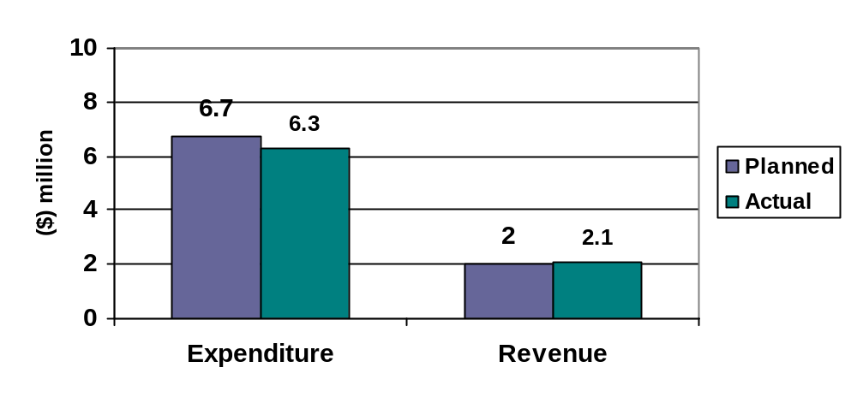
Variance: ($0.4 million) Variance: ($0.1 million)
% of budget: 94 per cent % of budget: 105 per cent

This chart shows the amount we spent (expenditure) and the amount we earned (revenue) in delivering our services and programs within this strategic objective.

Highlights

Boston Bio-Relationships Conference
The City of Melbourne was a major sponsor of the Boston Bio-Relationships Conference and part of the Victorian Government’s delegation to the BIO 2007 exhibition in May 2007.

The events brought together the world’s leading biotechnology and pharmaceutical companies, researchers and investors, and helped identify and progress several research, education and funds-management exchange projects.

Greater Metropolitan Universities Contributions Study
The City of Melbourne’s Greater Metropolitan Universities Contributions Study was completed in March 2007, and endorsed by the Melbourne Vice Chancellors' Forum. The study provides a thorough investigation of the role of the city’s universities in the economic, social and cultural life of Melbourne.

Land Use and Employment Census published
Findings from the City of Melbourne’s 2006 Census of Land Use and Employment (CLUE) survey were released, providing detailed information about the city’s economic activity, employment trends and changing land uses.

The CLUE survey is conducted every two years and the 2006 findings showed strong growth in employee numbers and business establishments in Melbourne since 2004.

Small Business Grants Program
The new City of Melbourne Small Business Grants Program is an amalgam of the former Export Entry Grants and Small Business Development programs.

Eight start-up businesses, 10 business expansions and one export entry benefited from approximately $330,000 in funding from the March 2007 round of Small Business Grants. Grant recipients included businesses in the biotechnology, retail, information technology, arts and finance sectors.

City of Melbourne and Seattle Trade Development Alliance
A foundation for co-operative trade, investment and other business activity between Seattle in the United States and the City of Melbourne was formalised in September 2006 with the signing of a Trade Development Alliance.

Melbourne Business Festival
The Melbourne Business Festival 2006 was held in October and attracted 2,300 people to 23 events.

The two-week festival included the Melbourne Business Lunch, the Women in Business Lunch, the launch of the Lord Mayor’s Small Business Proprietors Commendations and Small Business Success Stories – a celebration of 10 years of City of Melbourne small business grants.

Melbourne Retail Strategy
The Melbourne Retail Strategy 2006-2012, launched in July 2006, shows the way forward for Melbourne’s development as Australia’s premier shopping destination and international retail destination. The strategy is an initiative of the City of Melbourne and the Victorian Government and was developed in consultation with the Melbourne Retail Advisory Board. Its proposals include:

- developing affordable second- and third-floor city spaces for new and innovative retailers;
- creating a Melbourne Shopping Festival by 2009 to attract interstate and international shoppers;
- improving the mix of retail in Bourke Street, between Swanston and Spring streets; and
- identifying new laneway opportunities for retail development.

Business Partner Cities Network
Melbourne is the only Australian city to be a member of the Business Partner Cities (BPC) Network. Council participated in the 2006 BPC Roundtable in Mumbai in October and council representatives were accompanied by a Victorian trade mission. Melbourne has been confirmed as the host city for the 2007 Roundtable event to be held in October 2007.
Disappointments

Local business initiatives
Business interviews and forums targeted at the North West Melbourne area, which aimed to bring local businesses together to address concerns and opportunities, did not attract the anticipated interest. As a result, a number of planned actions, such as formation of a North West Melbourne Business and Industry Group, were not achieved. The City of Melbourne will reassess its approach in the coming year.

Looking ahead

Melbourne Office of Knowledge Capital
The City of Melbourne will pilot a Melbourne Office of Knowledge Capital, jointly financed by Council and eight Victorian universities. The office intends to establish Melbourne as Australia's knowledge capital by promoting the capabilities of the city and its universities internationally, and facilitating engagement between business and the community.

Spotlight on sustainability: City hotels go green

The Holiday Inn on Flinders is one of 30 city hotels cutting energy, water and waste consumption and saving money through the innovative environmental program, Savings in the City – Green Hotels.

The City of Melbourne developed the program, which has already generated significant benefits for the environment, including the conservation of more than 20 Olympic swimming pools’ worth of fresh water and the diversion of close to 1,200 tonnes of waste from landfill (equating to about 658 large skips of rubbish).

Participating hotels have reduced their total annual energy use by over 42,000 GJ, which is 11,200 tonnes of greenhouse gas or the same amount of greenhouse gas generated by 933 average Victorian households each year. The hotels have been rewarded for these reductions with annual savings of more than $700,000 in their energy bills.

The Holiday Inn on Flinders is just one example of the many hotels benefiting from the Green Hotels program. Since joining, Holiday Inn has increased the amount of waste it recycles from only seven per cent to 44 per cent.

The hotel’s $22,000 investment in water-saving devices has reduced water use by 23 per cent and will save $15,000 a year, while $4,000 spent on efficient lighting will save more than $22,000 annually in energy and maintenance costs.

Similar savings are being enjoyed by other city hotels through the Savings in the City – Green Hotels program, showing how small changes can make a big difference to the environment and to businesses’ bottom line.

Strategic indicators
Council monitors the following key performance indicators to measure our progress towards an innovative and vital business city.

No | Measure | 2006-2007 result | 2005-2006 result | Comments
2.1 | Number of new jobs in small business development program. | 171 | 134 full time, 43.5 part time and six casual
2.2 | Level of investment by businesses funded under the Small Business Development Fund. | In 2006-2007, 36 businesses received a Small Business Grant. An anticipated $7.4 million of investment will be generated by these businesses. | $2.9 million was invested in business creation or expansion in 2005-2006. | In 2006-2007, the Small Business Development Fund became the Small Business Grants Program, and now incorporates the Export Entry Grants Program.
2.3 | Growth in the number of businesses engaged in export as a result of their engagement with the City of Melbourne. | In 2006-2007, the Small Business Grants program assisted six businesses with their export activities. Five of these businesses are new exporters. | In the first year of the City of Melbourne's export grants program, 15 businesses received grants. One contract was signed, valued at approximately $0.5 million. Other contracts are in advanced stages of negotiation.
2.4 | Satisfaction rates of businesses with the support and advice provided by the City of Melbourne. | Data not available. See comments. | Satisfaction ratings collected through City of Melbourne's business leaders' consultation program were:  65% very satisfied  23% satisfied  6% dissatisfied  6% not relevant | In 2006-2007, past small business grant recipients were consulted, however data was not available before publication of this report.
2.5 (VLGI) | Community satisfaction rating for overall performance of economic development. | 72 | 72 | Indexed mean score. This score remains unchanged from 2006.
2.6 (VLGI) | Community satisfaction rating for overall performance of enforcement of bylaws. | 64 | 66 | Indexed mean score. This score remains relatively unchanged from 2006.
Strategic Objective Three:
Inclusive and engaging city

An inclusive and engaging city: creative with a strong cultural spirit, an inviting, inclusive and stimulating place for all who live, work and visit it.

Financial performance
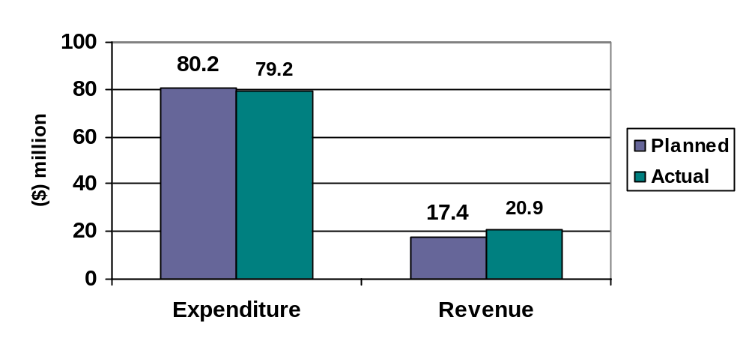
Variance: ($1.0 million) Variance: $3.5 million
% of budget: 99 per cent % of budget: 120 per cent

This chart shows the amount we spent (expenditure) and the amount we earned (revenue) in delivering our services and programs within this strategic objective.

Highlights

Indigenous social and economic development
Consultations for the development of an Indigenous Framework 2007-2010 were undertaken with the Indigenous and broader community in 2006-2007. The framework outlines the guiding principles under which the City of Melbourne will work with Indigenous communities. It includes actions to address Indigenous social and economic development and Indigenous culture and heritage in line with the Victorian Aboriginal Heritage Act 2006 (Vic).

Reconciliation Action Plan
In July 2006, the City of Melbourne became the country’s first municipality to adopt an Action Plan under Reconciliation Australia's new National Program of Action. The plan builds on the City of Melbourne’s history of commitment to Indigenous communities and commits to events and programs to improve social, economic, cultural, artistic and heritage outcomes.

The 2006-2007 City of Melbourne Reconciliation Action Plan, developed together with Reconciliation Australia, will increase Indigenous cross-cultural awareness, improve Indigenous wellbeing, and increase support, awareness, understanding, identification and protection of Indigenous culture, heritage and art.

Community infrastructure
Council endorsed the City of Melbourne’s Community Infrastructure Policy and Planning Framework in March 2007. Under the framework, developers are asked to contribute to community infrastructure such as family, aged or library services in their projects, as well as prepare a community infrastructure plan where developments exceed 50 dwellings and the City of Melbourne is the statutory planning or referral authority. Council will now apply for Victorian Government support for development of all facilities over $500,000.

Priorities for major community infrastructure work and its implementation over the next decade were defined in the City of Melbourne’s Community Infrastructure Plan 2007-2017, which was endorsed by Council in June 2007.

Tourism Melbourne
Tourism Melbourne expanded its Industry Partnership Opportunities program in 2006-2007. A suite of cost-effective, promotional opportunities for all tiers of the tourism industry was created across Tourism Melbourne's network of visitor services. The partnership program provided benefits to Council, the tourism industry and visitors to the city, as well as encouraging visitor dispersal and economic spend.

Tourism Melbourne's visitor information programs also continued to expand. As a result of two recruitment drives, 90 volunteers were successfully selected, inducted and trained. The City Ambassador Program successfully trialled a seven-day service, and better sharing of resources between visitor programs resulted in more flexible operations.

In June 2007, the Council adopted its five-year Tourism Plan, advocating ongoing collaboration with local, state and national agencies on planning, infrastructure, signage, product development, funding, standards and professionalism.

City safety
In 2006-2007, the City of Melbourne endorsed the Strategy for a Safer City 2007-2010 after an extensive consultation period. Melbourne’s designation as a World Health Organisation Safe Community in 2006-2007 was also reinforced with a study by the McCaughey Centre reporting high levels of perception of safety among people in Melbourne. The findings validate research undertaken by the City of Melbourne in 2006.

Perceptions of safety
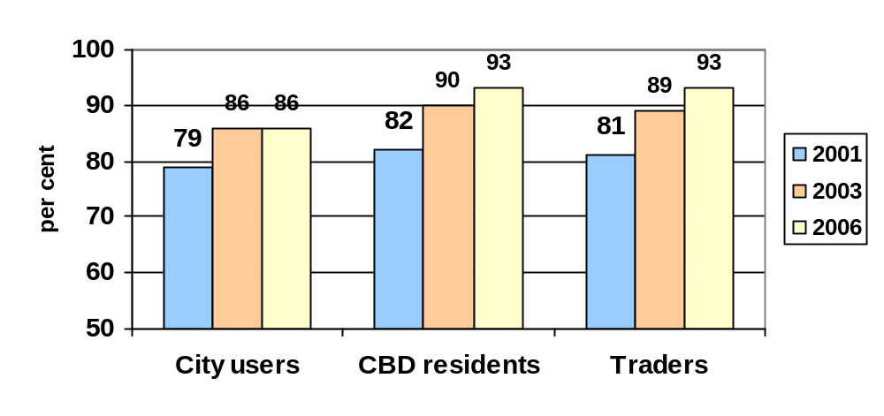
(Source: Perceptions of Safety Research 2006, conducted on behalf of the City of Melbourne.)

Lifelong Melbourne
The City of Melbourne’s Lifelong Melbourne 2006-2016 strategy was endorsed by Council in November 2006 to ensure that the municipality’s increasing number of older residents stay connected with the community and remain active. The strategy includes affordable physical activities and special interest options, expanded community transport facilities and flexible respite for carers of frail older residents.

Lifelong Melbourne commits to strengthening the City of Melbourne’s role in planning and coordinating local residential and home-package aged care services. Work was undertaken in 2006-2007 to explore how the city can respond to future need. Recommendations are outlined in the Lifelong Melbourne – Ensuring Our Place report, to be considered by Council later in 2007.

Libraries
In 2006-2007, the City of Melbourne resumed direct management of the three libraries located within its boundaries. (The Yarra-Melbourne Regional Library Corporation previously managed these libraries.)

A new East Melbourne Library was opened in August 2006, featuring a community meeting space, a local history room, facilities for internet access and an extensive range of Chinese and Vietnamese materials and bilingual picture books for children.

Loans from the City of Melbourne’s libraries increased by almost 10 per cent in 2006-2007.

Homelessness Framework
The City of Melbourne conducted research including interviews with people experiencing homelessness in the city and outlined future work and actions in the Homelessness Framework 2007-2009.

The framework outlines a number of initiatives linked to the key theme of creating and fostering sustainable pathways out of homelessness. Key initiatives include undertaking further research on the needs and aspirations of people who are homeless, supporting agencies to deliver services to those who are homeless and creating opportunities for more inclusive access to cultural, social and recreational activities in the city.

Municipal public health plan
The second year of implementation of the municipal public health plan, CityHealth 2005-2009, occurred across the organisation. Of the 123 initiatives, 96 per cent were actioned during 2006-2007 and of these, 32 per cent are fully complete with two years of the plan remaining. In 2006-2007, we achieved a more integrated and effective method of reporting the progress of CityHealth 2005-2009 to the community.

Youth precinct
The new Signal Youth Space, located at Northbank, was launched in October 2006 and celebrated with a one-day event featuring performers, interactive stalls and an information stand to promote safe skater behaviour. A Signal Youth Committee, comprising 14 young people, will work with Council to develop the Signal Arts Building and programs for the new youth-focussed space.

Relationship Declaration Register
In April 2007, the City of Melbourne launched the Relationship Declaration Register to enable Melbourne couples, regardless of gender, to formally declare their relationship. The register is the first of its type in Victoria, and while it does not confer legal rights in the way traditional marriage does, the register may be used to demonstrate the existence of a de facto relationship in relation to legislation involving domestic partnerships.

HPV immunisation
Immunisation of female secondary school students against the Human Papilloma Virus began in April 2007. Since then, more than 1,500 Gardasil vaccines have been provided to students in six schools across the municipality.

International students
The academic reputation of Melbourne’s educational institutions and the perception of Melbourne as a safe place to live were the main reasons students chose to study here, according to an online survey of 1,400 Melbourne-based international students in October 2006.

The survey also looked at the students’ experiences in Melbourne and factors that influenced them to stay on when they finished studying. The city’s cafes, entertainment and cultural diversity received positive feedback from the students.

Graffiti
Two graffiti audits conducted in 2006-2007 helped expand Melbourne’s graffiti removal processes and promote compliance with the Activities Local Law.

Almost 25,000 square metres of graffiti was removed in 2006-2007 using the City of Melbourne’s graffiti removal service, kits provided through the City’s incentive program, and an arrangement with the Department of Justice to remove graffiti from light industrial and commercial buildings.

Events in the City
The City of Melbourne hosted more than 320 major events in 2006-2007, including the FINA World Championships, New Year’s Eve 2006, the Melbourne Osaka Cup, Moomba Waterfest and the Motorola Melbourne Spring Fashion Week 2006.

The City of Melbourne issued 2,590 permits for events in the municipality in 2006-2007. Drought impacted on permit numbers with sportsgrounds closed for casual events and casual sports in November 2006 and some limitations were placed on seasonal users of the grounds.
A full list of events held in the city can be found on page 105.

Number of event permits issued
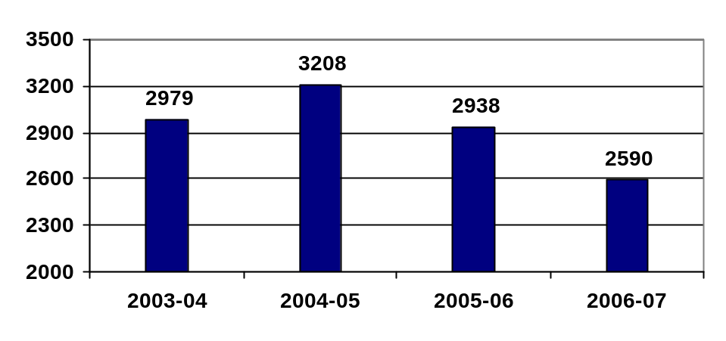
(Source: internal data.)

Melbourne Awards 2006
The 2006 Melbourne Awards honoured significant contributions to Melbourne’s profile, community and environment. The year-round program celebrated the award recipients with a prestigious ceremony on Melbourne Day: August 30, 2006.

Ron Barassi was honoured as Melburnian of the Year 2006 for his passion for the city and his dedication to the community.

Murundak Black Arm Band
Produced at the City of Melbourne’s Arts House, the Black Arm Band concert murandak (meaning ‘alive’ in Woirurrung language), won the 2007 Helpman Award for best Australian Contemporary Music Concert. The City of Melbourne’s Arts House develops innovative arts projects based at North Melbourne Town Hall and the Meat Market.

Publication of ‘Giving an unreal idea reality’
Each year the City of Melbourne encourages a vast array of arts activity, through its funding support and programs it delivers directly. One way to assess the long-term outcomes is to hear directly from the artists and arts organisations themselves. 'Making an unreal idea reality' is a collection of stories by artists and arts organisations that have been supported by the City of Melbourne. These stories are personal accounts of their artistic journey and relationships with the City of Melbourne in forging meaningful and long-term outcomes for themselves, the arts community and the people of Melbourne.

Disappointments

Child care places
While additional places were made available at one of Melbourne’s child care centres in 2006-2007, and the number of children on the municipality’s waiting list for places fell by eight per cent, there are still 520 children waiting for child care in the city. However Council is committed to extending its child care centres at Kensington and Fawkner Park and to building a $9 million centre in Docklands. These developments will provide more than 200 new child care places in the city.

Children on child care waiting lists in the City of Melbourne
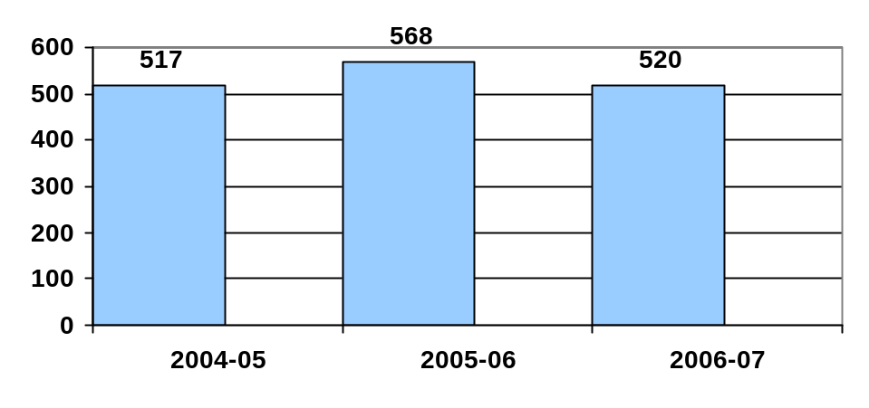
Looking ahead

Indigenous youth
The Safety and Wellbeing Branch received a grant from the Commonwealth Department of Family and Children's Services and Indigenous Affairs for a 12-month position to research, evaluate and make recommendations about service delivery to Indigenous youth.

Parkville Structure Plan
The major development of the Parkville Structure Plan is expected to occur late in the second half of 2007.

Arts strategy
The City of Melbourne Arts Strategy 2004-2007 was developed to encourage creative life in Melbourne and build our reputation as a city for the arts. All actions identified in the strategy were completed as planned in 2006-2007.

Spotlight on sustainability – Lion Garden

The City of Melbourne is committed to building sustainable pathways out of homelessness by supporting individuals, developing robust partnerships and building inclusive communities. In 2006-2007, two complementary frameworks – the Homelessness Framework 2006-2009 and the Social and Affordable Housing Framework 2006-2009 – were developed to respond to homelessness in the city and ensure the availability of affordable housing.

According to recent figures, approximately 1,000 homeless people live in the City of Melbourne. This is four per cent of the state’s total homeless population. Six in every 10 homeless people are relatively young, aged between 15 and 34 years.

The Lion Garden project in Little Bourke Street supports young people who are at risk of homelessness by providing a long-term secure base and access to support services. It provides accommodation in eight self-contained studio apartments and supports young residents with education, health care and personal issues to help them find jobs and develop independent living skills.

The practical program resulted from strong working relationships between the City of Melbourne, the Department of Human Services, the Sidney Myer Centenary Fund, the Lions Club, Gospel Hall, Urban Seed, Melbourne Citymission and Melbourne Affordable Housing.

The results of the program have been encouraging, with 15 young people benefiting from Lion Garden’s housing and services since September 2004 when the three-year pilot program was launched. Lion Garden’s residents are offered up to three years’ tenancy, however the program’s effective support services have resulted in stays as short as four months, with the longest period 25 months..

Young people involved in Lion Garden have generally exited the welfare system and moved into private rental, back to family, into community housing or on to another service provider. Many have found employment or undertaken further training and education.

Due to the program’s success, the Victorian Government has agreed to extend the program with recurrent funding to ensure that Lion Garden will continue to provide young people with a pathway out of homelessness.

Strategic indicators
Council monitors the following key performance indicators to measure our progress towards an inclusive and engaging city.

 | Measure | 2006-2007 result | 2005-2006 result | Comments
3.1 | Percentage of visitors who feel safe in the CBD. | Data not available. See comments. | An average of 89% of respondents felt safe in the city. | Perceptions of Safety Survey was conducted in April 2006. Next survey will take place in 2008-2009.
3.2 | Participation rates at key events, festivals and programs conducted by the City of Melbourne. | Attendance figures for events sponsored or delivered by City of Melbourne's Events Melbourne Branch total 7.1 million in the 2006-2007 financial year. | 4.6 million | This marks a significant increase on figures from the 2005-2006 financial year due to improved systems to capture this information.
3.3 | Number of cultural projects/events devised and managed or produced by indigenous communities and marginalised. | 32 | More than 30 projects.
3.4 | Customer satisfaction rating with Council owned recreational services. | 86% | 80% | Based on CERM Customer Satisfaction Surveys.
3.5 | Timeliness of delivery of Council's home care, personal care and respite care services for the aged and disabled. | 99.9% of services were delivered within the target of five days of receiving a service commencement order. | 47,818 hours of home care, personal care and respite care were provided. On 148 occasions, services were not provided as scheduled. | The 2006-2007 figure differs from that provided in 2005-2006 due to further investigation of the indicator and availability of a more meaningful statistic.
3.6 | Customer satisfaction with Family and Children's services. | Data not available. See comments. | Users of these services provided by the City of Melbourne reported the following satisfaction rates: Child Care: 99%  Maternal and Child Health: 82%  Family support services: 79%  Parenting services: 78% | Latest comprehensive customer satisfaction survey taken in December 2005 and as such annual data not available.
3.7 | Percentage of children between 72 and 75 months that are fully immunised. | 78% | 74.07% | Continued increase in performance since the service was brought in-house.
3.8 (VLGI) | Community satisfaction rating for overall performance of town planning policy and approvals. | 63 | 62 | Indexed mean score. This score is higher than the mean of all inner Melbourne metropolitan councils.
3.9 (VLGI) | Community satisfaction rating for overall performance of health and human services. | 70 | 67 | Indexed mean score. This score remains relatively unchanged from 2006.
3.10 (VLGI) | Community satisfaction rating for overall performance of recreational facilities. | 76 | 78 | Indexed mean score. This score is higher than the mean of all inner Melbourne metropolitan councils.
Strategic Objective Four:
Environmentally responsible city

An environmentally responsible city: sustainable decision-making and environmental leadership increases and improves its natural assets.

Financial performance

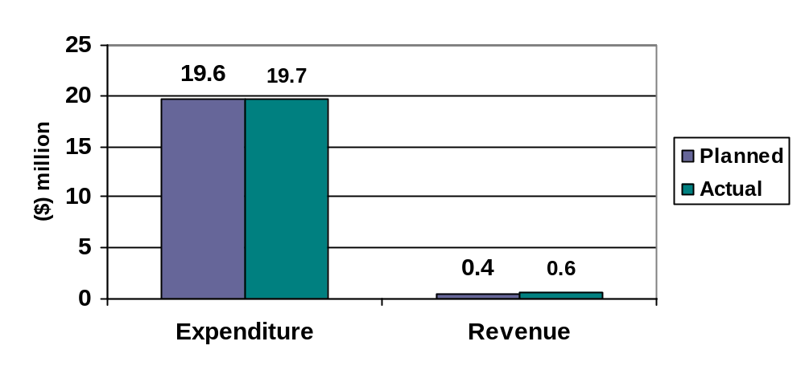
Variance: $0.1 million Variance: $0.2 million
% of budget: 101 per cent % of budget: 150 per cent

This chart shows the amount we spent (expenditure) and the amount we earned (revenue) in achieving the activities within this strategic objective.

Highlights
Climate change is arguably the most serious challenge facing the planet. Average global temperatures are rising. The majority of climate experts agree that society’s large and growing consumption of fossil fuels such as coal, petrol and gas is causing this dramatic increase in temperature. The City of Melbourne continues to take steps to improve its capacity to monitor its environmental footprint, particularly in the area of energy consumption.

We have identified greenhouse gas emissions, water and waste as being the most relevant and material sustainability issues for the City of Melbourne.

Greenhouse gas emissions
Australia is one of the highest per-capita greenhouse gas polluters in the world and therefore has a responsibility to lower emissions by reducing energy consumption and using renewable energy sources such as wind and solar power. The City of Melbourne’s Zero Net Emissions by 2020 strategy sets targets for the reduction of the City’s greenhouse gas emissions. The strategy is a natural extension of Council’s commitment to the International Council for Local Environmental Initiatives’ (ICLEI) Oceania Cities for Climate Protection Program and the Australian Government’s Greenhouse Challenge Plus Program. The strategy sets milestone targets leading up to 2020, and by 2010, the City of Melbourne aims to have achieved a 50 per cent reduction in emissions from its operations based on the 1997 baseline (Greenhouse Action Plan 2006-2010).

This table gives total direct and indirect greenhouse gas emissions by weight at the City of Melbourne from 1999-2000 to 2006-2007.
Co

Consumption | Base year | 99-00 | 00-01 | 01-02 | 02-03 | 03-04 | 04-05 | 05-06 | 06-07
Greenhouse gas (tonnes) | 31,165 | 30,034 | 29,427 | 28,821 | 26,274 | 24,326 | 22,931 | 23,563 | 18,311
Percentage change  (from base year) |  | -3.6% | -5.6% | -7.5% | -15.7% | -21.9% | -26.4% | -24.4% | -41.2%
Percentage change  (From previous year) |  | N/A | -2.0% | -2.1% | -8.8% | -7.4% | -5.7% | +2.8% | -28.7%

Note: In 1996-1997 a baseline was established which became our ‘base year’. Monitoring systems were established and data began to be collected on a routine basis from 1999-2000.

Emissions against the baseline level were reduced in 2006-2007 by 41 per cent and were 28 per cent below the levels for the same period in 2005-2006 (see table above), despite a minor increase in the level of energy of 0.03 per cent. This increase is primarily due to the construction of CH2 in this time, and the subsequent dual operation of CH1, CH2 and the Commonwealth Bank before consolidation of accommodation is finalised.

The most significant impact on emissions was an increased offset in the percentage of renewable energy from 20 per cent in 2005-2006 to 33 per cent in 2006-2007, which is in line with the Zero Net Emissions by 2020 strategy to increase renewable purchases to 50 per cent of total energy purchases by 2020.

Energy consumption
Council consumes energy in the daily operation of its administration buildings, community buildings such as child care centres, public lighting and its corporate fleet. Council currently monitors the consumption of three major energy types: electricity, gas and automotive fuel. These energy types are taken from five primary sources:

- black electricity from coal-based power stations;
- GreenPower from certified renewable electricity sources such as wind;
- natural gas;
- liquid petroleum gas (LPG); and
- unleaded petrol.

A breakdown of total energy use at the City of Melbourne from 1999-2000 to 2006-2007.

Consumption | 99-00 | 00-01 | 01-02 | 02-03 | 03-04 | 04-05 | 05-06 | 06-07
Energy  used (GJ) | 66,117 | 97,053 | 108,695 | 101,364 | 101,342 | 108,076 | 102,070 | 102,368
Percentage change  (from base year) |  | 46.8% | 64.4% | 53.3% | 53.3% | 63.5% | 54.4% | 54.8%
Percentage change  (from previous year) |  | 46.8% | 12.0% | -6.7% | 0% | 6.6% | -5.6% | 0.03%

Source: Billing data including the corporate database ‘Stark Essentials’. Due to delays in receiving some quarterly energy accounts at the time this report was prepared, figures are based on April to March results rather than July to June.

A breakdown of energy use by its source at the City of Melbourne from 2004-2005 to 2006-2007.

Energy by source | 04-05 (GJ) | 05-06 (GJ) | 06-07 (GJ)
Black electricity (coal fired) | 53,668 | 56,295 | 42,734
Green electricity (accredited GreenPower) | 23,494 | 22,296 | 34,107
Natural gas | 21,548 | 14,171 | 16,828
LPG fuel | 455 | 199 | 189
Unleaded petrol | 8,912 | 9,109 | 8,509
Total Energy Use | 108,077 | 102,070 | 102,367

A breakdown of energy by activity at the City of Melbourne from 2004-2005 to 2006-2007.

Energy by use | 04-05 (GJ) | 05-06 (GJ) | 06-07 (GJ)
Administration buildings | 8,955 | 20,202 | 17,585
Community use buildings | 30,069 | 22,153 | 24,949
Public lighting | 49,646 | 50,406 | 51,136
Corporate transport | 9,367 | 9,308 | 8,698
Total Energy Use | 98,037 | 102,069 | 102,368

Source: Billing data including the corporate database ‘Stark Essentials’.

Most of Council’s energy needs are sourced from electricity. In addition to using conventional or black electricity generated by coal-fired power stations, Council also uses accredited GreenPower. The table below shows the amount of GreenPower we consumed as an alternative to conventional energy.

Renewable energy as a percentage of total energy for the City of Melbourne from
1999 to 2006-2007.

 | 99-00 | 00-01 | 01-02 | 02-03 | 03-04 | 04-05 | 05-06 | 06-07
Energy used (GJ) | 66,117 | 97,053 | 108,695 | 101,364 | 101,342 | 108,076 | 102,070 | 102,368
Renewable (GJ) | 0 | 1,255 | 2,253 | 17,025 | 18,179 | 23,494 | 20,451 | 34,107
Renewable as percentage of total | 0% | 1.3% | 2.1% | 16.8% | 17.9% | 21.7% | 20.0% | 33.3%
99-00 00-01 01-02 02-03 03-04 04-05 05-06 06-07
Source: Billing data including the corporate database ‘Stark Essentials’.

The increase in 2006-2007 can be attributed to a one-off purchase of additional GreenPower credits.

Membership of Chicago Climate Exchange
The City of Melbourne joined the prestigious Chicago Climate Exchange (CCX) in
February 2007, complementing its commitments through the Zero Net Emissions by 2020 strategy. Membership of the CCX will prepare Melbourne for any future Australian emissions trading schemes and will provide the City with the potential to sell carbon credits in the future.

Large Cities’ Climate Leadership Group
Melbourne also furthered its aim to tackle global warming by becoming a member of the
Large Cities’ Climate Leadership Group (C20). This group is backed by the William J.
Clinton Foundation and paves the way for collaboration between member cities on reducing carbon emissions.

Melbourne joins London, Berlin and New York as one of the first cities to sign up to the Clinton Climate Initiative’s Global Energy Efficiency Building Retrofit Program. Through this program, the cities have agreed to make their municipal buildings more energy efficient and provide incentives for private building owners to retrofit their buildings with energy saving technologies.

The City of Melbourne was represented at the second Large Cities’ Climate Summit in
New York in May, which examined the power of collective buying arrangements between cities as a means to encourage and accelerate new technologies.

Water
The City of Melbourne is committed to reducing the pollutants and litter entering our waterways from the stormwater system. This has been set out in Total Watermark 2004 and the WSUD Guidelines 2005.

To implement these goals, Melbourne Water has provided significant technical and financial support to the City of Melbourne. Some of the results of this partnership have included:

- innovative street-tree pits installed in Little Bourke and Acland streets that capture the stormwater, both to water the trees and remove pollutants before they are discharged to the waterway;
- community-instigated raingarden in Davison Place in which the downpipes from adjacent buildings feed into a specially designed garden that removes pollutants before the water enters the stormwater system and ultimately the waterways; and
- completion and operation of the Royal Park Wetlands, which captures stormwater from the Brunswick sub-catchment and treats it for water reuse in the park. This reduces the total suspended solids reaching the waterways by 80 per cent.

The City of Melbourne’s water use
Keeping Melbourne’s parks and gardens healthy under drought conditions is a major challenge. The survival of the city’s trees is a priority but unfortunately some sportsgrounds and other turf areas have suffered under current water restrictions.

The City of Melbourne is reducing irrigation where possible and is installing drip irrigation in many areas. Other activities to comply with water restrictions include: restricting the operation of watering systems; using mobile water tankers with recycled water or hand-held hoses for additional watering; applying extra mulching around trees and in shrub beds; and raising mowing heights to improve water retention.

Water is a precious, finite resource. Its supply is under pressure from drought in the short term and increasing population in the long term. By 2020, the population of the City of Melbourne is expected to increase by 114 per cent. Council currently uses approximately six per cent of the municipality’s total water consumption. Nearly 82 per cent of water used by Council is to manage its parks and open spaces. The target for reducing water use by Council’s facilities, including parks and gardens, is 40 per cent by 2020. The table below details the total amount of water consumed by Council operations from 1999-2000 to 2006-2007 with the further two tables showing the amount of water consumed by Council operations by source and activity in 2006-2007.

A breakdown of total water use at the City of Melbourne from 1999-2000 to 2006-
2007.

Consumption | 99-00 | 00-01 | 01-02 | 02-03 | 03-04 | 04-05 | 05-06 | 06-07
Water used (ML) | 1,686 | 1,448 | 1,310 | 1,658 | 1,345 | 1,330 | 1,456 | 1,197
Percentage change  (from base year) |  | -14.1% | -22.3% | -1.6% | -20.2% | -21.1% | -13.6% | -29.2%
Percentage change  (from previous year) |  | -14.1% | -9.5% | 26.6% | -18.9% | -1.1% | 9.5% | -17.8 %

Source: Billing data including the corporate database ‘Stark Essentials’. Due to delays in receiving some quarterly energy accounts at the time this report was prepared, figures are based on April to March results rather than July to June.

A breakdown of water use by sources at the City of Melbourne from 2004-2005 to 2006-2007.

Water source | 04-05 (ML) | 05-06 (ML) | 06-07 (ML)
Potable (tap) water | 1,330 | 1,456 | 1,167
Recycled | 0 | 0 | 30
Total water use | 1,330 | 1,456 | 1,197

A breakdown of water use by activities at the City of Melbourne from 2004-2005 to 2006-2007.

Water use | 04-05 (ML) | 05-06 (ML) | 06-07 (ML)
Open spaces | 1,123 | 1,270 | 1,024
Buildings | 74 | 74 | 63
Queen Victoria and Fish Markets | 133 | 110 | 110
Total water use | 1,330 | 1,454 | 1,197

Recycled water
The City of Melbourne began its first significant use of reclaimed water in 2006-2007 as a result of the Royal Park Wetlands project which treats stormwater and reuses it to irrigate parts of Royal Park. This amounted to 30ML or 2.5 per cent of the City’s total water consumption.

A breakdown of water use by sources at the City of Melbourne from 1999-2000 to 2006-2007.

Consumption | 99-00 | 00-01 | 01-02 | 02-03 | 03-04 | 04-05 | 05-06 | 06-07
Water used (ML) | 1,686 | 1,448 | 1,310 | 1,658 | 1,345 | 1,330 | 1,456 | 1,197
Recycled water (ML) | 0 | 0 | 0 | 0 | 0 | 0 | 0 | 30
Recycled water as % of total | 0% | 0% | 0% | 0% | 0% | 0% | 0% | 2.5%

Source: Stark Essentials.

Water use by the community
It is estimated that the business and residential communities of the City of Melbourne cut their water use in 2006-2007 by about 28 per cent from the previous year. This was a reduction from 22,126ML to 15,829ML. The City of Melbourne continues to work with water retailers to improve the reliability of water consumption data.

Water saving programs for residents
For residents, many of these savings were prompted by water restrictions put in place by the Victorian Government. But further cuts were made through the efforts of residents in local projects such as Sustainability Street and the showerhead exchange program. The quarterly City of Melbourne newsletter, Green Leaflet, provides residents with information on environmental initiatives.

Water saving programs for businesses
Some water saving projects that the City of Melbourne has been assisting businesses with include:

- Savings in the City Green Hotels, with 30 hotels that have already saved enough water to fill over 20 Olympic swimming pools;
- Sustainable Living in the City, with four high-rise apartment buildings;
- Building Improvement Partnership with five high-rise commercial office buildings; and
- Vic 1000 (in association with the Northern Alliance for Greenhouse Action) with 20 small businesses.

Each of these projects combines water saving with energy and waste saving initiatives to provide the businesses with an efficient way to manage facilities, staff and clients.

Yarra River Youth Conference
Two schools in the City of Melbourne – North Melbourne Primary and University High – gave presentations at the June 2007 Melbourne Water Yarra River Youth Conference.
The conference provided students with skills in environmental education and promoted cultural change in the way that young people view, use and perceive the natural environment.

Waste reduction
Reducing waste helps conserve precious natural resources and minimises landfill.
Sending waste to landfill contributes to emissions of methane, a potent greenhouse gas.

Overall 72 per cent (by weight) of all waste generated in the City of Melbourne’s offices is being recycled and a further four per cent of organics sent for reprocessing. Recyclable and compostable material makes up a significant proportion of the general waste stream in all offices. CH2 has approximately half the waste to landfill per head of CH1 and Town Hall: a very significant difference.

A breakdown of total waste generated at the City of Melbourne from 2001-2002 to
2006-2007.

Generation | 01-02* | 03-04 | 06-07
Total weight of waste (tonnes) | 154.4 | 86.06 | 153.14
Waste to Landfill (tonnes) | 57.2 | 54.6 | 44.2
Recycled  (tonnes) | 98.8 | 31.2 | 108.94
Recycled waste as % of total | 64% | 36% | 71%
Generation 01-02* 03-04 06-07
Waste audits are conducted approximately every two years.
Note: Annual total is modelled from an audit of a single working day’s waste from all our administration and community child care buildings.

A breakdown of waste to landfill per person at the City of Melbourne from 2001-2002 to 2006-2007.

Generation | 01-02* | 03-04 | 06-07
Waste per person  (kg) | 55 | 58 | 42
Percentage change  (from previous year) | N/A | 5% | -27%

*2002 figures include administration buildings only, as child care centre data was not collected.

A breakdown of waste by type at the City of Melbourne for 2006-2007.
W
Waste type | Administration  buildings (Kg) | Child care buildings (Kg) | Total (kg)
General waste (to landfill) | 113.5 | 54.1 | 167.6
Recycling (bottle/can) | 1.8 | 2.1 | 3.9
Recycling (paper) | 213.2 | 8.3 | 221.5
Recycling (cardboard) | 5.7 | 0 | 5.7
Recycling (co-mingled) | 98.1 | 0 | 98.1
Recycling (security paper) | 33.2 | 0 | 33.2
Organics | 19.4 | 39.1 | 58.5
Total waste | 484.9 | 103.6 | 588.5

Protecting Melbourne’s biodiversity
At 170 hectares, Royal Park is Melbourne’s largest park. Designed as native bushland,
Royal Park contains remnants of the area’s indigenous vegetation including an abundance of eucalypts and casuarina trees. It also has a new native wetland habitat that will act as a natural filter for the city's stormwater system.

Throughout 2006-2007, the City of Melbourne continued to monitor and manage the areas of remnant vegetation as well as the habitat for the regionally significant population of White's Skink (Egernia whitii). The new Trin Warren Tam-boore wetlands have also encouraged new bird species into the area.

The City of Melbourne also continued to fund and support the work of the Moonee
Ponds Creek Coordinating Committee, which is involved in revegetation and environmental improvements along the length of the creek.

Disappointments

Community Power
The City of Melbourne’s Community Power program will come to an end in August 2007. The program educated the community about reducing emissions, however response from residents was disappointing, with only 19 signing up to green power.

The City of Melbourne has reviewed the program and decided the new offer from the
Community Power supplier was not adequate for its residents. It is expected that many residents have and will continue to take up green power without using the Community Power model.

As an off-shoot of Community Power, the City of Melbourne partnered with the cities of Darebin and Yarra on a Greenhouse Outreach project. Greenhouse Outreach workers were engaged to attend events, set up stalls in shopping centres and give presentations on climate change to community groups. These workers attended 15 events in the City of Melbourne during March to June 2007, handing out free compact fluorescent globes and shower timers to participants.

Water mining proposal
The Victorian and Federal governments have not provided funding for the City of Melbourne and City West Water’s major water mining project, which was to reduce reliance on potable water and increase use of recycled water for Council's open spaces, trees and recreational facilities. The project will not proceed at this stage and alternative water recycling projects will be investigated.

Looking ahead

Green building results
Evaluation of the City of Melbourne’s green building retrofit programs with hotels, commercial offices, food premises and high-rise apartments will reveal results in the coming year to set the scene for the roll-out of these programs.

Water quality improvements
Further water-sensitive urban design projects will be developed and become operational in the coming year to provide reduction in stormwater pollutant loads as well as helpful case studies. Rainwater tanks will also be installed on a range of buildings including those at the Queen Victoria Markets.

Yarra River Youth Conference
The City of Melbourne is examining options for providing sponsorship for the 2008
Melbourne Water Yarra River Youth Conference – given the event’s importance and its success in 2007.

Parks Sustainable Water Management Plan
As a result of climate change and the ongoing water restrictions, the City of Melbourne will be implementing Stage 1 of a Parks Sustainability Water Management Plan to ensure the future of the City's parks and gardens.

Spotlight on sustainability – Setting a new world standard in green buildings

Think like a termite. That was the challenge for the designers of Council House 2 (CH2), the City of Melbourne’s purpose-built green office building. Termite mounds, which make use of the sun and wind to control climate, provided the nature-based design inspiration for CH2.

CH2’s many parts work together for heating, cooling, power and water. For example, shutters that respond to the sun’s position use natural ventilation and light to cool and heat. Evaporative cooling in the form of ‘shower towers’ provide cool water for building reticulation and cool air to supplement ground floor and retail cooling.

Fresh air from outside is supplied to the building though vertical ducts and, unlike recycled air in conventional buildings, the air is used only once. Healthy air leads to healthier staff, with predictions of an annual saving of $1.12 million in reduced sick leave and better staff health.

The cost and environmental benefits of CH2 are extensive. CH2 emissions will be 64 per cent less than a five-star building. When compared with the existing Council House, CH2 is expected to: reduce electricity and gas consumption by more than 80 per cent respectively; produce only 13 per cent of the emissions; and reduce water mains supply by 72 per cent.

CH2 provides a ‘living’ example of ecologically sustainable design. Its environmental features are expected to pay for themselves within 10 years, when compared with a conventional building.

CH2 is Australia’s greenest multi-storey office building and is fast becoming a leading example for sustainable building in Melbourne, Australia and the world.

The first annual review of CH2’s performance is pending and the results will be reported in the City of Melbourne’s Annual Report 2007-2008.

Strategic indicators

Council monitors the following key performance indicators to measure our progress towards an environmentally responsible city.

No | Measure | 2006-2007 result | 2005-2006 result | Comments
4.1 | Reduction in net emissions of greenhouse gases in the City of Melbourne, compared with the baseline year of 1999-2000. | Data not available. See comments. | Annual data is unavailable | City of Melbourne data is held by energy suppliers and is currently inaccessible. Further work will be done to gain access to accurate data in 2007-2008.
4.2 | Reduction of residential waste to landfill per household. | 11% reduction. | 1% reduction. | The result excludes waste from illegally dumped rubbish and litter bins which has been included in previously reported waste totals. Without this change the outcome would have been an increase in waste per household due to greater quantities of residential waste disposed to landfill for the year.
4.3 | Percentage of municipal waste diverted for recycling. | 22% | 24% | There has been a 5% increase in commingled recyclables collected, however this has not kept pace with the 8% growth in residential waste to landfill. The slight fall in recycling levels also reflects a reduction in the amount of garden organics collected for the year.
4.4 | Reduction in the consumption of drinking quality water within the City of Melbourne, compared with the baseline year of 1999-2000. | Data not available. See comments. | 5% reduction. | Unable to obtain data from retailers before publication of this report.
4.5 | Reduction of waste to landfill from Council facilities (offices). | 32% reduction since the previous audit in 2004. | N/A | The improvement mainly comes from the greater levels of commingled recycling as well as organics recovered through the system implemented in Council's new CH2 office building. Refer to table on page 60.
4.6 | Reduction of greenhouse gas emissions from Council operations | 41.2% reduction against base year (1996-1997) and 22.3% reduction from previous year. | 26% reduction against base year (1996-1997) and 5.7% reduction from previous year. | Refer to table on page 54..
4.7 | Reduction of drinking quality water consumed for Council buildings and gardens. | 30.8% reduction against base year (1999-2000) and 19.9% reduction from previous year. | 20% reduction against base year (1999-2000) and 0.4% increase from previous year. | Refer to table ‘A breakdown of water use by sources at the City of Melbourne’ on page 58.
4.8 | Community satisfaction rating for overall performance of waste management. | 72 | 73 | Indexed mean score. This score remains relatively unchanged from 2006

Strategic Objective Five:
Well-managed and leading corporation

A well-managed and leading corporation: recognised for its high-calibre staff, processes, products and interactions with stakeholders, it delivers effective and accountable governance and business processes.

Financial performance
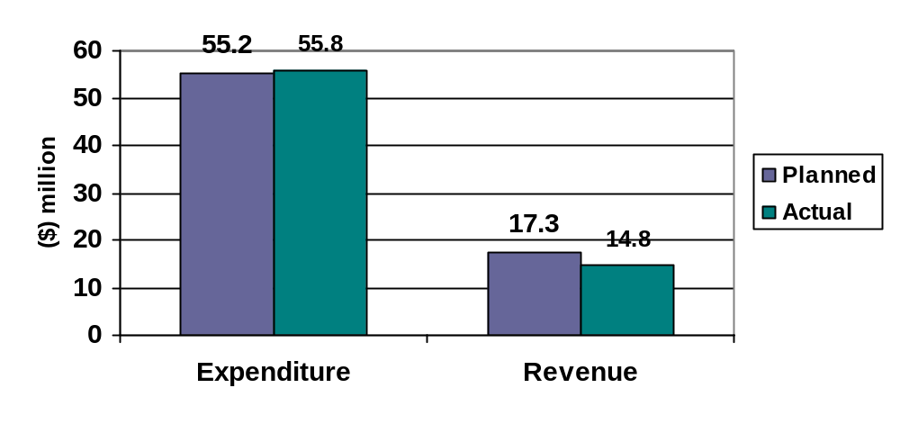
Variance: $0.6 million Variance: ($2.5 million)
% of budget: 101 per cent % of budget: 86 per cent

This chart shows the amount we spent (expenditure) and the amount we earned (revenue) in achieving the activities within this strategic objective.

Highlights

Future Melbourne
Future Melbourne, a process of learning from the past and looking to the future to build a shared vision for the city, was launched by the Lord Mayor and the Chancellor of the University of Melbourne in May 2007.

Three of five proposed Future Melbourne public forums were held in 2006-2007 and were well attended. Forum recordings and transcripts can be found on the Future Melbourne website www.futuremelbourne.com.au. The site also contains the Future Melbourne eVillage discussion boards, featuring talking points that arose from the public forums.

Metropolitan Mayors Forum
The City of Melbourne hosted the Metropolitan Mayors Forum, which includes the mayors of 31 municipalities, in September 2006. The mayors agreed to make representation to the Victorian and Federal governments on an expanded metropolitan railway system, a push for east-west and freight links, priority road and rail freight access to Melbourne’s port and interstate rail lines, increased incoming flights, and the freeing-up of air rights for new foreign carriers.

Emerging leaders
The City of Melbourne’s Leadership Development Program builds on the talents of emerging leaders in the organisation. Eighteen participants in this year’s program worked on four learning projects: identifying new revenue streams, engaging international students, the enterprise agreement and the Melbourne Plan.

Management challenge
In March 2007, 12 City of Melbourne future leaders participated in the Local Government Managers Australia (LGMA) management challenge, a leadership development program for local councils across Australia and New Zealand. The City of Melbourne’s two teams took out first and second places in the Victorian competition, with the first-placed team going on to win the Australasian finals.

Asset management
The City of Melbourne’s Asset Management Framework is complete and a project to introduce ‘whole of Council’ asset management software is underway. All staff involved in the management of assets participated in ‘acquisition and transfer of assets’ awareness sessions to support the new framework.

Recertification of Corporate Contract Management System
The City of Melbourne’s Corporate Contract Management System was recertified in May 2007 as an International Quality Management System in accordance with the Australian Standard ISO 9001:2000.

Disappointments

Corporate Project Management System
Plans to replace the current Corporate Project Management System have been put on hold, following a decision to replace the Finance System in 2007-2008. It is anticipated that contract and project management modules will be part of the new Finance System.

Looking ahead

Customer service strategy
A Customer Service Panel has been formed. The panel will start researching customer service charters from other local councils and private businesses in order to learn from best-practice customer service organisations. It will then develop a customer service charter for the City of Melbourne.

Spotlight on sustainability – Future opportunities

The City of Melbourne has changed dramatically during the past 15 years, with more people in the city, more demands on Council services and significant economic growth. The organisation went through its own evolution during 2006-2007, as it commissioned Ernst & Young to conduct an Operational and Efficiency Review.

The review was intended as an independent appraisal of the way the organisation conducts its business. It asked the important question: is the City of Melbourne giving its more than 60,000 ratepayers the best value for money?

The review identified opportunities to improve the way the City of Melbourne does business, saving the organisation – and therefore its ratepayers – money. A new structure for the organisation has been developed that matches future business needs with existing services.

Following the release of the review in May 2007, the City of Melbourne responded with a list of actions to be completed in 2007-2008 and beyond, including:

- a data governance working group, formed to identify better ways to collect, store, manage and interpret the organisation’s data;
- a services working group, formed to further examine and refine services the organisation provides, now and in the future;
- a corporate planning working group, formed to improve the way we plan, prepare budgets and forecast expenditure;
- a reduction in divisions within the organisation’s structure, from seven divisions to five and from 35 branches to 28 branches, effective from Monday, 2 July 2007;
- directions to directors and managers to identify further efficiencies to save at least $5.7 million a year; and
- working groups established to look at a new performance management system, and improve recruitment of new staff and retention of existing staff.

With completion of these actions, the City of Melbourne will enter a new phase in its governance as a leaner and more efficient model for a growing and thriving city.
Strategic indicators
Council monitors the following key performance indicators to measure our progress towards a well-managed and leading corporation.

No | Measure | 2006-2007 result | 2005-2006 result | Comments
5.1 | Percentage of external customer contacts resolved within the target date. | Data not available. See comments. | N/A | Corporate reporting standards for the CRM Pathway system are currently under review as part of the re-development of Customer Service Strategy and design of a customer service charter for the organisation.
5.2 | Percentage of total labour days lost to staff absenteeism/sickness. | 3.16% | 3.40% | Slightly reduced from 2005-2006 figures.
5.3 | Rate of annual staff turnover. | 12.72% | 15.00% | Slightly reduced from 2005-2006 figures.
5.4 | Overall employee satisfaction rating. | Not rated | 75.6% of employees rated satisfied or very satisfied. | Culture survey not taken in 2006-2007.
5.5 | Percentage of telephone calls resolved at first point of contact. | Not measured within the 2006-2007 financial year. | 86% | Will be addressed in 2007-2008 within the call centre management system upgrade.
5.6 | Degree of compliance with GRI guidelines for sustainable reporting. | Level B | We have not sought a verification rating for 2005-2006. | As a 'B' level reporter we have not sought verification but will pursue this in later years. See page 110 for further information on sustainable reporting guidelines.
5.7 (VLGI) | Community satisfaction rating for overall performance generally of the Council. | 72 | 70 | Indexed mean score. This result remains relatively unchanged from 2006.
5.8 (VLGI) | Community satisfaction rating for Council's interaction and responsiveness and dealing with the public. | 73 | 78 | Indexed mean score. Although this is a slight decrease, this score is similar to scores from all inner metropolitan Councils.
5.9 (VLGI) | Community satisfaction rating for Council's advocacy and community representation on key local issues. | 66 | 65 | Indexed mean score. This score remains relatively unchanged from 2006.
5.10 (VLGI) | Community satisfaction rating for Council's engagement in decision making on key local issues. | 61 | 61 | Indexed mean score. This score remains unchanged from 2006.

Our corporate governance
Governance encompasses the processes, protocols, conduct and relationships that guide the City of Melbourne’s actions and decision-making as a local government. Some mechanisms of governance are legislative requirements and others are City of Melbourne initiatives.

In this section, you will find information on our performance in areas including Council and councillor information, legislative compliance, risk and audit operations.

Good Governance Charter
The City of Melbourne’s commitment to good governance is confirmed by the Good Governance Charter, signed by the Melbourne City Council and the Chief Executive on behalf of City of Melbourne staff. The charter includes eight good governance principles and defines the roles, responsibilities and expected standards for councillors and the organisation.

Councillor conduct
The City of Melbourne’s Councillor Code of Conduct outlines the role of the Council and gives an overview of councillor responsibilities, in accordance with the Local Government Act 1989 (Vic).

The code includes guidelines for rules of conduct, Council decision-making and the use of City of Melbourne resources. It also includes procedures for disclosure on interests and conflicts of interest that go beyond legislative requirements.

No known breaches of the code by councillors occurred in 2006-2007.

Council meetings
The Melbourne City Council generally meets monthly and a schedule of meeting dates is available on notice boards at the Melbourne Town Hall, North Melbourne Library, East Melbourne Library, Carlton Community Centre, and on the City of Melbourne website.

All meetings of the Council and its committees are conducted in accordance with the Conduct of Meetings local law. While meetings are open to the public and the public is encouraged to attend, the Council may resolve to close any meeting to members of the public to consider a confidential item.

Council committees
As well as full Council meetings, Melbourne City Council has seven committees that meet either monthly or every two months. Committees have defined roles and Council delegates responsibilities and certain powers, duties and functions to each committee. Each committee is made up of and chaired by councillors.

Planning Committee
This committee deals with powers, duties and functions directly relating or ancillary to Planning including City Plan, Heritage, Statutory Planning and Building Control, Strategic Planning, Transport Planning, Traffic and Parking, Urban Design, Planning Scheme Amendments, Street Activities, 10 Year Detailed Infrastructure Plan, Local Activities Law and Noise Abatement.

Environment Committee
This committee deals with powers, duties and functions directly relating or ancillary to Environment including Air Quality, Enhancing Environmental Partnerships, Greenhouse Emissions Reduction Strategy, Sustainable Melbourne Fund, Environmental Issues and Initiatives, Waste Management and Minimisation, Water Conservation and Quality including Stormwater Management, Parks and Gardens Planning and ICLEI.

Business and International Relations Committee
This committee deals with powers, duties and functions directly relating or ancillary to Business and International Relations including Business Development, Business Melbourne, Business Development Fund, International Relations, International Marketing, International Trade, Investment Attraction, Federal Government Partnerships, Retail and Hospitality, International Conference/Convention and International Tourism/Visitation.

Marketing and Events Committee
This committee deals with the powers, duties and functions directly relating or ancillary to Marketing and Events including Commonwealth Games, Conference/Convention Attraction, Tourism/Visitation, Precinct Enhancement Program, City Events, Customer Relationship Management, Corporate Affairs and Communication and Sports.

Finance and Governance Committee
This committee deals with the powers, duties and functions directly relating or ancillary to Finance and Governance including Annual Budget, Council Works Program and the Four Year Financial Plan, Asset Management Strategy, Financial and Control Systems/Reporting, Investment Fund and Property Portfolio, Rates and Valuations, Subsidiary Companies and Associated Entities, Continuous Improvement including Best Value, Tender and Contract Policies, Council Plan, Information Technology, Audit, Triple Bottom Line Processes and Reporting, Governance, Good Governance Charter, Councillor Travel Arrangements, Councillor Expenses, and Parking Operations.

Docklands and Major Projects Committee
This committee dealt with the powers, duties and functions directly relating or ancillary to Docklands and Major Projects including Governance; Financial; Community; and Infrastructure for Docklands, and major projects within the municipality with a total value of greater than $10 million in which Council had a financial interest.

In accordance with the Council resolution of 31 July 2007, the Docklands and Major Projects Committee ceased to function as at 7 August, 2007.

Community Services Committee
This Committee deals with the powers, duties and functions directly relating or ancillary to Community Services including Children’s, Family, Aged, Youth, Disabled and Ethnic Services, Emergency Management/Services, Housing, Indigenous Affairs, Libraries and Community Centres, Recreation Strategies, Safety and Health, Service Contracts, Social Policy, Community Sports and Community Grants, Arts and Arts Grants, Culture,
Place Management and Community Forums.

Melbourne City Council meeting attendance: 1 July 2006 to 30 June 2007

 | Number of meetings held | Lord Mayor John So | Deputy Lord Mayor Gary Singer | Cr Fraser Brindley | Cr Peter Clarke | Cr Carl Jetter | Cr Catherine Ng | Cr Brian Shanahan | Cr Fiona Snedden | Cr David R Wilson
Melbourne City Council meetings | 18 | 17 | 15 | 16 | 14 | 17 | 13 | 18 | 16 | 17

Committee meetings

 | Number of meetings held | Deputy Lord Mayor Gary Singer* | Cr Fraser Brindley | Cr Peter Clarke | Cr Carl Jetter | Cr Catherine Ng | Cr Brian Shanahan | Cr Fiona Snedden | Cr David R Wilson
Business and International Relations | 6 | 2 | 6 | 5 | 5 | 2 | 6 | 6 | 5
Community Services | 11 | 9 | 10 | 10 | 10 | 4 | 8 | 11 | 10
Docklands and Major Precincts | 6 | 4 | 6 | 6 | 6 | 4 | 4 | 6 | 5
Environment | 6 | 5 | 6 | 5 | 5 | 4 | 6 | 5 | 6
Finance and Governance | 13 | 10 | 12 | 12 | 12 | 6 | 12 | 12 | 12
Marketing and Events | 5 | 5 | 5 | 4 | 4 | 2 | 4 | 5 | 5
Planning | 11 | 7 | 11 | 10 | 10 | 7 | 10 | 10 | 10

* The Lord Mayor is an ex-officio member of all committees. The Deputy Lord Mayor is a full member of each committee and is the representative of the Leadership Team. During the year the Lord Mayor attended three meetings of the Finance and Governance Committee, two meetings of the Planning Committee and one meeting of the Environment Committee.

Councillor allowances
Councillors are paid an allowance set by the Victorian Government. This allowance is paid in recognition of the demands placed on councillors in carrying out their civic and statutory duties and for their work on policy development, as spokespersons on community matters and as representatives of the Melbourne City Council and Melbourne, both in Australia and overseas.

The allowances are:
- Lord Mayor: $110,000;
- Deputy Lord Mayor: $45,000;
- Councillors: $25,000.

Expenses
Councillors incur expenses in the course of fulfilling their role as representatives of Melbourne City Council. Expenditure is regulated by the Councillor Expenses and Resources Guidelines and is reported in detail every quarter on the City of Melbourne website.

Schedule of councillor expenses, 2006-2007

 | Lord Mayor  John So | Deputy Lord Mayor  Gary Singer | Cr Catherine Ng | Cr David Wilson | Cr Carl Jetter | Cr Fraser Brindley | Cr Brian Shanahan | Cr Fiona Snedden | Cr Peter Clarke | Total
1. Conferences and functions | $0.00 | $0.00 | $480.00 | $864.54 | $1,854.54 | $1,393.64 | $512.73 | $1,684.83 | $0.00 | $6,790.28
2. Training and development | $0.00 | $0.00 | $0.00 | $0.00 | $0.00 | $0.00 | $0.00 | $5,600.00 | $0.00 | $5,600.00
3. Travel – local | $20.00^ | $883.17^ | $898.89 | $1,026.93 | $10,382.29 | $1,462.54 | $2,699.51 | $3,674.45 | $198.64 | $21,246.42
4. Travel – interstate | $4,164.12 | $0.00 | $0.00 | $841.27 | $0.00 | $0.00 | $57.54 | $0.00 | $0.00 | $5,062.93
5. Travel – overseas | $14,567.57 | $0.00 | $0.00 | $1,796.58 | $6,742.27 | $0.00 | $8,466.57 | $9,117.14 | $0.00 | $40,690.13
6. Communication – local | $2,265.46 | $2,748.14 | $3,132.08 | $1,748.96 | $1,735.49 | $934.83 | $2,641.27 | $3,760.36 | $6,856.65 | $25,823.24
7. Communication – interstate | $0.00 | $0.00 | $68.15 | $0.00 | $0.00 | $0.00 | $0.00 | $0.00 | $0.00 | $68.15
8. Communication – overseas | $1,449.17 | $0.00 | $907.12 | $72.63 | $435.38 | $0.00 | $436.56 | $514.38 | $0.00 | $3,815.24
9. Functions external to Town Hall | $0.00 | $0.00 | $1,922.17 | $0.00 | $122.38 | $0.00 | $0.00 | $0.00 | $42.30 | $2,086.85
10. Child care | $0.00 | $0.00 | $0.00 | $0.00 | $0.00 | $0.00 | $0.00 | $8,440.08 | $0.00 | $8,440.08
Total Expenses | $22,466.32 | $3,631.31 | $7,408.41 | $6,350.91 | $21,272.35 | $3,791.01 | $14,814.18 | $32,791.24 | $7,097.59 | $119,623.32

^ In accordance with section 4.2.6 of the Councillor Expense and Resources Guidelines, the Lord Mayor and Deputy Lord Mayor are provided with access to Council fleet vehicles to assist in meeting the demands and expectations of their positions while representing the City. An allocation for these vehicles is provided as part of the Council's annual budget processes.
Legislative compliance

Freedom of Information
The Freedom of Information Act 1982 (Vic) gives any individual or organisation a general right to information held by the City of Melbourne unless that information is deemed exempt under the Act.

In 2006-2007, the City of Melbourne received 41 valid Freedom of Information requests seeking information such as details about road and footpath conditions, building and planning matters, and costs and activities of councillors and officers.

One 2006-2007 request was denied in full, there were no requests for internal review or appeals to the Victorian Civil and Administrative Tribunal, and no complaints were received by the Ombudsman.

The Freedom of Information Act 1982 (Vic) specifies a 45-day statutory time limit to process requests. The average process time for City of Melbourne requests is 39 days.

National Competition Policy compliance
In 2006-2007, the City of Melbourne complied with the requirements of the Local Government Improvement Incentive Program in respect to National Competition Policy, which covers compliance in the areas of trade practices, local laws and competitive neutrality.

Privacy Act
Standards set out by the Information Privacy Act 2000 (Vic) and the City of Melbourne’s Privacy Policy Statement control how we manage personal information.

Privacy compliance is included in our staff induction program. A staff survey was conducted in May and June 2007 to establish the types of ‘personal’ information collected, used and stored so that high-risk areas can be identified and responsive training sessions developed.

The City of Melbourne has a dedicated privacy officer within our Governance Services Branch to guide and assist staff and members of the public with privacy-related queries or issues.

The City of Melbourne received two privacy complaints from members of the public during 2006-2007.

Whistleblowers Protection Act
Complaints about improper conduct of any Council officer can be made confidentially, under the Whistleblowers Protection Act 2001 (Vic), to the Victorian Ombudsman or to any one of the following Council officers appointed to receive disclosures:
- David Pitchford, Chief Executive
- Geoff Lawler, Director Sustainability and Regulatory Services
- Linda Weatherson, Director Community and Culture
- Jane Sharwood, Acting Manager Marketing and Business Development
In 2006-2007, there were no disclosed matters referred to Council by, or from Council to, the Ombudsman. A number of recommendations received from the Ombudsman during June 2007 will be implemented during 2007-2008.
Risk management

The City of Melbourne manages its risks to maximise opportunity and minimise loss. Risk management planning is done as an organisation-wide exercise, but is also part of our daily business activities by individual branches and contractors.

Risk management strategy and training
The Risk Management Strategy 2007-2010 guides the City of Melbourne’s approach to risk management. In 2006-2007, risk exposures were recorded in the corporate risk register database, the risk management framework was formalised, and the fraud awareness and corruption prevention policy and procedures were revised.

More than 100 City of Melbourne staff attended nine different risk management courses this year and training options were expanded to cover new topics and cater to specific operational needs.

Insurance and risk financing
No new claims were submitted to the City of Melbourne’s insurers during 2006-2007 for the major insurance classes of public liability and professional indemnity. One claim was submitted for property.

Research to consider alternative risk financing arrangements was completed in 2006-2007. Recommendations to streamline processes and reduce costs for premiums and insurable losses received Council endorsement and will be implemented in 2007-2008.

Business continuity planning and influenza pandemic
The City of Melbourne undertook significant re-development of the Corporate Business Continuity Plan in 2006-2007, and developed business continuity recovery plans for each work branch. An Influenza Pandemic Action Plan was also developed, detailing our planning, prevention, response and recovery requirements in the event of an influenza pandemic.

Audit operations

Audit Committee
In line with good governance practices, and in accordance with Section 139 of the Local Government Act 1989 (Vic), the City of Melbourne has operated an Audit Committee since 1996. The committee, formally appointed by the Melbourne City Council, oversees the activities of the City of Melbourne’s external and internal auditors, and gives independent advice to the Finance and Governance Committee on appropriate accounting, auditing, internal control, business risk management, compliance and reporting systems, processes and practices within the organisation.

The Audit Committee met five times during 2006-2007. The committee considered and made recommendations to the Council and the Council’s management on many issues and internal audits including:

- internet security;
- review of occupational health and safety;
- the City of Melbourne’s business continuity planning procedures;
- reports on the City of Melbourne’s risk profile and legislative compliance frameworks;
- policy and procedures framework;
- accounts payable;
- fraud control framework;
- implementation of Council and Special Committee resolutions;
- governance responsibilities applicable to associated entities and trusts in which the City of Melbourne has either an indirect interest or stake; and
- legal action reports.

Audit Committee members – external
John Warburton – Chair
John Warburton was re-appointed as a member of the Audit Committee by the Melbourne City Council for a further three-year period in June 2006.

Qualifications:
- Certified Practising Accountant;
- experienced director of many private and public sector organisations and their audit committees; and
- appointed to the Melbourne City Council Audit Committee in June 1999.

Tim Dixon
Tim Dixon is a founding member of the City of Melbourne Audit Committee (started 1997).

Qualifications:
- Partner, PricewaterhouseCoopers, Melbourne;
- Senior Partner, PricewaterhouseCoopers, Fiji; and
- member of the Institute of Chartered Accountants.

Claire Filson
Claire Filson was appointed as an external member of the Audit Committee for a three-year period, starting July 2004.

Qualifications:
- Bachelor of Law; MBA;
- experienced director and company secretary of both private and public organisations; and
- Chair of the risk, finance and audit committee of South East Water Ltd and the audit committee of the Southern Cross Station Authority.

Audit Committee members – internal
Our Audit Committee’s internal membership consists of:
- Lord Mayor John So;
- Deputy Lord Mayor Gary Singer; and
- Councillor Brian Shanahan (Chair of the Melbourne City Council Finance and Governance Committee).

Internal audit
The internal audit service helps the City of Melbourne, its management, and the management of its subsidiary companies, perform their responsibilities. The internal audit service helps us maintain an organisational environment with strong, relevant and effective internal controls.

The City of Melbourne’s internal auditor reports to our Audit Committee. The service is contracted to Ernst & Young, which started its second three-year term in March 2005.

A strong internal control environment ensures our systems will effectively manage operations. Services provided by the internal audit service include:
- risk assessment;
- development and management of an audit program;
- conducting audits and reviews;
- reporting audit opinions, findings and recommendations; and
- presenting, discussing and providing advice on key issues.

External audit
The Victorian Auditor-General is responsible for the external audit of the City of Melbourne and its subsidiary companies. Our external audit focuses on three key areas:
- strategic planning;
- detailed audit system testing; and
- review of financial statements.

Documents available for inspection
Regulations attached to the Local Government Act 1989 (Vic) require the City of Melbourne to keep certain information in statutory registers and documents, which can be viewed on request, or, in certain cases, on application. Available documents include:
- Council and committee meeting agendas and minutes;
- list of special committees established or abolished;
- agreements to establish regional libraries;
- list of contracts valued at $100,000 or more, which the Council entered into outside the competitive process, except Section 186(5) contracts;
- names of councillors and City of Melbourne officers required to submit a return of interest and the date returns were submitted;
- details of interstate and overseas travel by councillors and City of Melbourne officers;
- details of senior officers’ total salary packages;
- details of all property, finance and operating leases involving land, buildings, plant, computer equipment or vehicles entered into by the City of Melbourne (as lessor or lessee);
- list of donations and grants made by the Council;
- list of organisations of which the Council is a member, and membership fees;
- mayoral and councillor allowances;
- register of authorised officers;
- register of delegations;
- Whistleblowers Protection Act 2001 (Vic) procedures; and
- submissions received under S223.

Want to know more?
For more information about any governance issue, or for access to documents or registers mentioned in this report, please contact the City of Melbourne’s Governance Services Branch on 9658 9173 or visit www.melbourne.vic.gov.au

To access some City of Melbourne registers or documents, you will need to submit a written application.
Our people

Employment figures in this report are for City of Melbourne employees only and do not include employees of our subsidiary companies.

Staff profile
As at 30 June 2007, the City of Melbourne employed 1,129 people. In 2005-2006, the organisation employed 1,147 people. We have:
- 927 full-time staff; and
- 202 part-time staff.

Of these, 133 are non-permanent staff, including:
- 107 fixed-term temporary; and
- 26 casual.

The mix of staff at the City of Melbourne continues to be split approximately 55 per cent female and 45 per cent male. Males are more likely to hold executive positions, with 45 male and 13 female executives employed by the organisation. Females are more likely to hold lower-paying Class 1, 2 and 3 positions, with 196 females in these positions compared with 172 males.

Graph: Employee classification by gender

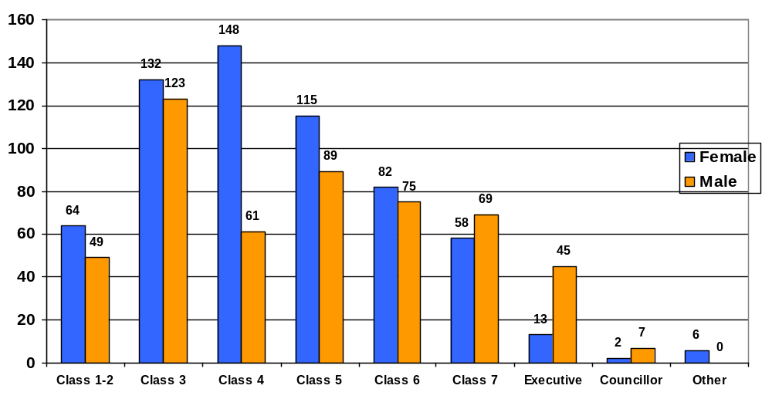
Total: 113 Total: 255 Total: 209 Total: 204 Total: 157 Total: 127 Total 58 Total: 9 Total: 6

(Source: internal data.)

Staff classifications
Staff classifications include:

Class 1 and 2: Child care workers
Class 3: Parking and traffic, office administration support
Class 4: Administrative/support
Class 5 and 6: First level professionals, technical staff and programmers
Class 7: Team leaders and professionals
Executive: Managers and directors.

The City of Melbourne employs staff in a range of age groups.

Graph: Number of staff by age group
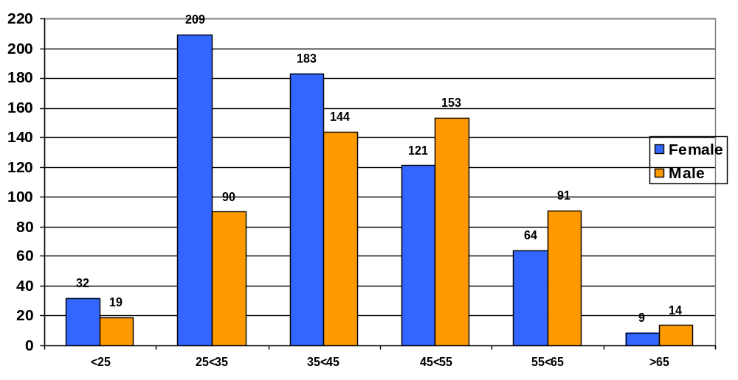
Total: 51 Total: 299 Total: 327 Total: 274 Total: 155 Total: 23

Graph: Number of staff by age group

Staff are grouped by tenure:

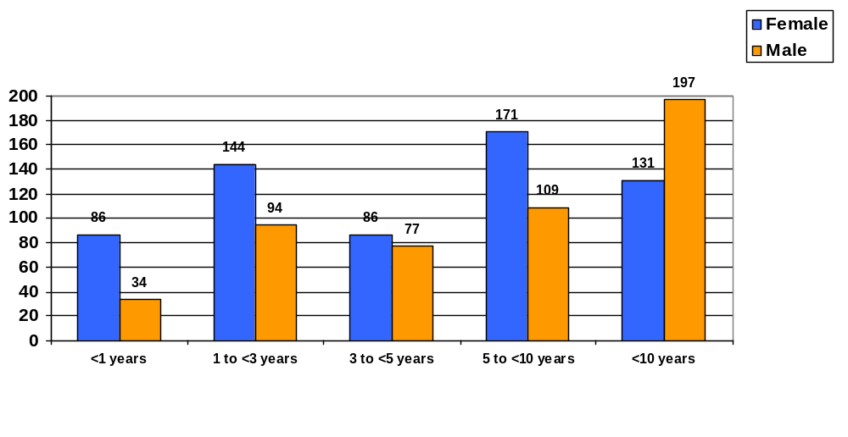
Total: 120 Total: 238 Total: 163 Total: 280 Total: 328

Programs for staff
The City of Melbourne believes in its people. We offer many programs to help our staff develop, improve, overcome challenges, balance work and life – and to lead within our organisation.

Corporate Learning and Development Program
The City of Melbourne’s Corporate Learning and Development Program builds on staff capabilities and attributes, maximises their contribution to the organisation, and enhances their careers. In 2006-2007, the program ran 102 development workshops and assisted the organisation to administer cultural awareness, risk management and other courses.

Nationally accredited learning and development programs
In 2006-2007, 29 City of Melbourne staff participated in the nationally accredited Diploma of Business or Masters of Business Administration Pathway administered through the organisation’s Corporate Learning and Development Program and managed through DeakinPrime, a corporate arm of Deakin University.

Staff retention
Voluntary staff turnover decreased in 2006-2007 and fewer positions were advertised largely due to a recruitment freeze imposed during the Operational and Efficiency Review.

Staff retention

 | 2006-07 | 2005-06 | 2004-05
Positions advertised | 164 | 223 | 252
Average applicants per position | 34 | 37 | 35
Staff turnover ⁽¹⁾ | 12% | 15% | 12%
Absenteeism ⁽²⁾ | 3% | 3% | 4%

Notes:
(1) Voluntary (resignations) turnover only.
(2) Total sick leave absences as a percentage of ordinary time available.

Health, wellbeing and safety of staff
Employee Recreation Association (CoMLife)
Health and wellbeing activities offered by the City of Melbourne’s Employee Recreation Association in 2006-2007 included health assessments, health education, fitness classes and discounted event tickets. The association also supported charity with activities including fundraising for the Cancer Council and staff blood donations to the Red Cross.

People Assist
Our People Assist program offers individual counselling, vocational guidance and career-ending support and management coaching. Numbers increased in 2006-2007 because of increased awareness of the program and partly due to the organisational restructure.

 | People Assist consultations
2006-2007 | 140
2005-2006 | 107
2004-2005 | 131
2003-2004 | 105

Occupational health and safety
An organisation-wide health and wellbeing survey was conducted at the City of Melbourne in April 2007 to assist in addressing future risks and to improve workplace health and safety.

The City of Melbourne achieved three-year re-certification of the SafetyMAP Fourth Edition – Initial Level Certification in November 2006 and our occupational health and safety management system was also reviewed to support our progress to Advanced Level SafetyMAP certification.

Occupational rehabilitation
In 2006-2007, the City of Melbourne supported 31 staff with return-to-work plans following illness or injury.

WorkCover
Twenty-six WorkCover claims were approved by the City of Melbourne in 2006-2007. Our WorkCover premium continued to fall and is now set at 1.15 per cent.

WorkCover claims

Year | Standard claims | Minor claims | Premium inc. GST | Premium as % of remuneration
2006-07 | 7 | 19 | $940,358.00 | 1.15%
2005-06 | 12 | 13 | $1,141,112.31 | 1.51%
2004-05 | 13 | 33 | $1,282,241.00 | 1.81%
2003-04 | 30 | 34 | $1,329,314.20 | 2.27%
2002-03 | 32 | 26 | $1,324,974.72 | 2.27%
2001-02 | 36 | 26 | $1,250,253.39 | 2.42%

(Source: Victorian WorkCover Authority)

Equal Employment Opportunity
The City of Melbourne maintains its commitment to a workplace that is free from discrimination, harassment and bullying. Regular training and quarterly forums are held for our EEO representatives to ensure they are continually up-skilled and supported to deal with any issues in the workplace.

Diversity is essential to EEO and the City of Melbourne has a number of policies and programs to support flexible work options for staff. In 2006-2007 there were 112 approved work-flexibility agreements, a significant increase on the 2005-2006 figure of 36. Half of the agreements were to accommodate carer and family responsibilities.

During 2006-2007 there were 34 women on maternity leave, nine fewer than in 2005-2006; and 18 fathers took paternity leave compared with 14 in 2005-2006.

Women in leadership continues to be an issue for the City of Melbourne and a paper is being developed to investigate options to improve our performance in this area.

Union representation
The City of Melbourne estimates more than 400 staff are members of independent trade unions.

The Melbourne City Council Enterprise Agreement (2005) is a collective bargaining agreement covering 1,065 staff during 2006-2007, excluding executives.

The Melbourne City Council Award (2001) also covers all staff (excluding executives).

Remuneration of senior executives
The City of Melbourne’s philosophy for remunerating all staff is to reward performance and achievement of our performance targets. Senior executive remuneration comprises fixed components and an ‘at risk’ incentive component. Payment is based on achievement of agreed key result areas (KRAs), which include financial and non-financial objectives. Fifty per cent of the performance evaluation relates to the achievement of the strategies documented in the Council Plan 2005-2009. The other 50 per cent relates to demonstration of the agreed leadership behaviours, which incorporate behaviours aligned to economic, social and environmental responsibility.

Celebrating excellence and innovation
Best Value 2006-2007
The City of Melbourne is committed to the continuous improvement of its services and projects to ensure best value for our community. In 2000, the Local Government Act 1989 (Vic) was amended to incorporate six Best Value principles, including that all councils must:

• offer services that are the best possible quality and value for money;
• offer services that are responsive to community needs;
• offer services that are accessible to the people they are intended for;
• show continuous improvement in service performance;
• regularly consult the community about service standards; and
• regularly report to the community on its achievements in relation to the five requirements listed above.

All Victorian councils were required to review all services, following these Best Value principles, by December 2005.

The City of Melbourne has continued to apply the Local Government Act 1989 (Vic) Best Value principles in assessing and improving its services in a variety of ways:

• Business planning
During 2006-2007, a review of the organisation’s business planning methods found that this service needed to be better aligned with Best Value principles.

A new four-year business-planning process has been introduced and includes a new method for assessing services: a ‘Best Value analysis’ tool. Each Council branch will now automatically assess all services included in its business plan against the six Best Value principles. Business plans now include actions to improve the service to bring it to a standard that meets Best Value principles.

The City of Melbourne conducted an Operational and Efficiency Review in 2006-2007.
The review looked at the way the City of Melbourne conducts its business to ensure ratepayers were getting best value for money, reflecting the Best Value principle of showing continuous improvement of service performance.

The report identified potential savings from our operating budget of at least $11.4 million annually. However, it will take at least two financial years for the City of Melbourne to fully realise these savings.

For more information on the City of Melbourne’s Operational and Efficiency review, please turn to page 25.

• Future Melbourne – a new strategy for the city
Future Melbourne will set the agenda for the City of Melbourne’s activities during the next decade and beyond, following on from our current city strategy, City Plan 2010.

The development of Future Melbourne, in partnership with the University of Melbourne, demonstrates the City of Melbourne’s commitment to Best Value principles, particularly in regard to services reflecting changes in community needs.

A series of public forums and events is being held to collect our community’s thoughts, ideas, issues and values. Melbourne’s public sector, academic and business communities and the general population are all welcome to participate in the development of Future Melbourne, expected to be completed in 2008.

• Customer surveys
During 2006-2007, the City of Melbourne sought feedback on its performance from groups such as residents, businesses, and international students. Survey results help the organisation set targets for continuous improvement in the delivery of services, and provide data to support and reflect Best Value principles in our planning, decision making and actions.

Awards to the City of Melbourne
The City of Melbourne received acknowledgement and/or awards for excellence and innovation in the delivery of many different services and projects (see table below).

Award | Awarded for | Awarded by
Asia Pacific Spatial Excellence Awards 2006 | GIS and the Commonwealth Games | Australia Spatial Information Business Association
Asia Pacific Spatial Excellence Awards 2006 | Aerial imagery | Australia Spatial Information Business Association
2007 National Awards for Planning Excellence, President’s Award | CH2 Building | Planning Institute of Australia
Australian Award for Urban Design 2006, Public Domain Award | Sandridge Bridge Precinct Redevelopment | Planning Institute of Australia
Australian LGMA Management Challenge | Winner of Management Challenge | Local Government Managers Australia
Award for Excellence, Special Projects Initiative Award | Places for People | LGPro
Award for Municipal Excellence and Subdivision Officer of the Year Award 2006-2007 | Excellence in subdivision application processing | Association of Consulting Surveyors
Awards for Planning Excellence 2006, Environmental Planning or Conservation Award | CH2 Building | Planning Institute of Australia, Victoria Division
Awards for Planning Excellence 2006, President’s Award | Places for People 2004 | Planning Institute of Australia, Victoria Division
Awards for Planning Excellence 2006, Part A, Local Government Award | Places for People | Planning Institute of Australia, Victoria Division
Banksia Environment Awards, Local Government category | Water for an Active Future in a Dry City | Banksia Environmental Foundation
DB Reef Heritage Property Award | Sandridge Bridge | Australian Property Institute (Victorian Division)
Excellence in Construction Award, Specialist Subcontractor Category | Piazza Italia at Argyle Square | Master Builders Association
Gold Award in Best Practice Reporting | City of Melbourne Annual Report 2005-2006 | Australasian Reporting Awards
Greenhouse Expenditure Award | The largest per capita expenditure on greenhouse friendly products | ECO-Buy
Making a Difference Award | Supporting people who are blind or have low vision to be able to access and fully participate in everyday life | Vision Australia
Merit Award 2006 | Little Bourke Street underground tree pits to save water and improve water quality | Stormwater Industry Association Victoria
National Awards for Planning Excellence 2007, Environmental Planning or Conservation Award | CH2 Building | Planning Institute of Australia
National Project Awards, National Merit Award for Research and Communication in Landscape Architecture | Places for People | Australian Institute of Landscape Architects
Project Management Achievement Awards, Community Services and/or Development | ‘The Travellers’ Public Art Project | Australian Institute of Project Management
Property Valuation Achievement Award | Continual pursuit of defending municipal valuation under constant change | Municipal Group of Valuers Victoria
Public Artworks, Commendation | Bourke Street Mall Tramway Zone | Public Domain Awards 2007
Recycled Expenditure Award | The largest per capital expenditure on recycled content goods | ECO-Buy
The Hey Big Spender Award | The largest per capita expenditure on green products across all categories, including recycled, energy saving, water-saving and non-toxic products | ECO-Buy
United Nations Environment Day Awards, Water Category | New urban wetland in Royal Park | United Nations
Urban Design, Plans and Ideas Award, Merit | Places for People | Planning Institute of Australia

Our stakeholders
City of Melbourne stakeholders include anyone with an interest in what we do and the services and programs we provide. Stakeholders include:

Partners | Community | Global
Government bodies and agencies | Residents | International city partners
Suppliers | Ratepayers | Potential international investors and businesses
Consultants | Businesses | International event organisers
Neighbouring communities | Workers | International not-for-profit organisations
Other partners | Students | Melbourne-headquartered multi-nationals
 | Visitors | Melbourne-headquartered multi-nationals
 | Unions | Melbourne-headquartered multi-nationals
 | Media | Melbourne-headquartered multi-nationals
 | Community groups and not-for-profit organisations | Melbourne-headquartered multi-nationals
 | Victorian universities | Melbourne-headquartered multi-nationals
 | Educational institutions | Melbourne-headquartered multi-nationals
 | Associations | Melbourne-headquartered multi-nationals
 | Other local governments | Melbourne-headquartered multi-nationals

Subsidiaries and joint ventures
The City of Melbourne has three wholly owned subsidiaries:
- CityWide Service Solutions Pty Ltd provides competitive contract services to public and private sector clients;
- Queen Victoria Market Pty Ltd manages and develops Queen Victoria Market; and
- Melbourne Wholesale Fish Market Pty Ltd manages and develops the operation of the wholesale fish market's activities. The company has a landlord role while fish trading is conducted by the tenants.

The City of Melbourne has an interest in other entities including:

- Sustainable Melbourne Fund (100 per cent owned by the City of Melbourne), a strategic trust that supports and promotes sustainable development;
- Regent Management Company Limited (50 per cent interest) which manages the Regent Theatre in Collins Street; and
- MAPS (trading as Strategic Purchasing Ltd) (City of Melbourne is a majority shareholder) which is a cooperative purchasing company, working on behalf of member local governments.

The City of Melbourne previously had interests in Yarra-Melbourne Regional Library Corporation and City Library Joint Venture, both of which were dissolved in 2006-2007. Library services are now provided through the in-house Melbourne Library Service.

Engaging with stakeholders
The City of Melbourne encourages communication and collaboration with all our stakeholders. Here are some of the ways our external stakeholders have their say:

Council and committee meetings
Melbourne City Council welcomes and encourages members of the public to attend and participate in Council and committee meetings.

There are approximately 60 Council and committee meetings each year. Open meetings are accessible to all, with a hearing/audio loop and disabled access available.

Public submissions and addresses
Members of the public may make submissions to the Council or a committee on any matter or matters listed on an agenda.

A register of public submissions made under S223 of the Local Government Act 1989 (Vic) is available for viewing at the Council Secretariat offices at the City of Melbourne.

In Council meetings, any written documentation is generally dealt with as an ‘item of correspondence’, with a reference made to the relevant agenda item. Verbal submissions are also accepted. Any person may submit a request to address a committee on an item listed on the agenda.

Public consultations
The City of Melbourne consults with the public on the development of and changes to significant policies, programs and services. Public consultations collect opinions and information about how the City of Melbourne can improve its services and program delivery. Major public consultations are advertised in newspapers, Melbourne News (our resident newsletter), and on our corporate website.

The City of Melbourne generally consults with the public on its policies and strategies by publishing them in draft form, with an invitation for written or online comments. Submitted comments are considered when the final version of the strategy or policy is developed.

Public consultations were held in 2006-2007 about the following:
- busking survey;
- delivering for Docklands;
- Draft Active Melbourne Strategy;
- Draft Urban Design Strategy;
- Draft Social and Affordable Housing Framework;
- Indigenous, Social and Economic, and Cultural and Heritage frameworks;
- Lifelong Melbourne Aged Care Plan;
- Open Space Strategy;
- proposed street art permit process;
- Relationship Declaration Register;
- Southbank Open Space;
- Southbank Plan and Southbank 3006 Study;
- South Kensington Station;
- Swanston Street Tour bus-stop relocation; and
- Draft Homelessness Framework.
Number of public consultations per year

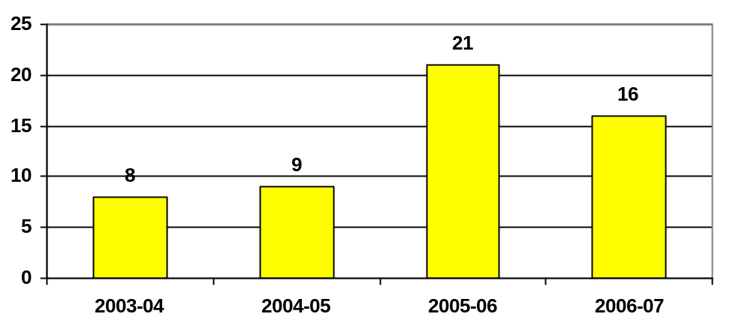
(Source: internal data.)

The significant increase shown in public consultations for 2005-2006 is a result of improved data collection processes.

The City of Melbourne’s consultation agenda remained busy in 2006-2007 with 16 major public consultations, not including the extensive Working Together for Melbourne forum series.

eVillage Melbourne
eVillage Melbourne is the City of Melbourne’s new web-based interactive form of community consultation. Launched in 2006-2007, eVillage is being piloted as part of the organisation’s Future Melbourne project.

Members of eVillage are encouraged to post their views on a range of topics, comment on the views of others, and rate their concerns on issues in the city. Information collected on eVillage will tell us what issues matter to Melbourne and these will inform the development of the Future Melbourne 10-year city strategy.

Given the early success of eVillage, it is expected that web-based interactive consultation will become an increasingly valuable way for the community to share its views and ideas with us.

www.evillagemelbourne.com.au
www.futuremelbourne.com.au

Working Together for Melbourne forums
Three Working Together for Melbourne forums were held in 2006-2007. Councillors, directors and senior staff answered questions that the public submitted before the forums and the City of Melbourne provided information about activities such as local projects and consultations.

Issues discussed at Working Together for Melbourne forums included transport and traffic management, heritage, parking, child care services, graffiti, noise and rubbish collection.

The forums were well-received with 50 community members attending. Records of meetings are available on the City of Melbourne website.

Listening to our staff
Employees are important stakeholders in the City of Melbourne and we engage staff in improving our working environment in the following ways:
- consultative committees – a number of committees allow staff to be involved in addressing various issues; and
- staff survey – a pulse staff culture survey was conducted in 2006-2007. A full survey will be undertaken in 2007-2008.
Strategic Objective 6:
Financially responsible corporation

A financially responsible corporation: long-term sustainability is ensured through strategic planning and well-managed finances and assets.

Financial performance
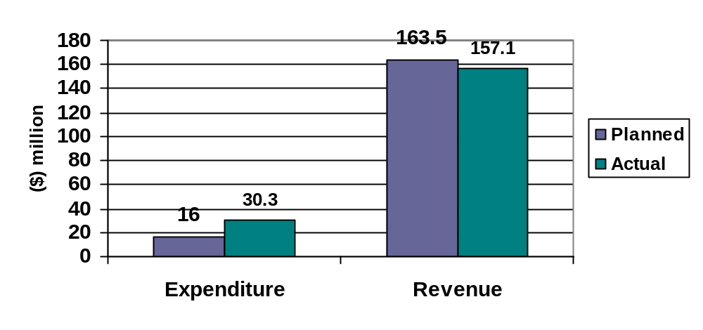
Variance: ($14.3 million) Variance: $6.4 million
% of budget: 189 per cent % of budget: 96 per cent

This chart shows the amount we spent (expenditure) and the amount we earned (revenue) in achieving the activities within this strategic objective.

To achieve our strategic objective of a financially responsible corporation, we need to demonstrate excellence in long-term financial sustainability.

Our operations
The City of Melbourne’s operations are located in the State of Victoria, within Melbourne’s central business district and surrounding suburbs of Carlton, East Melbourne, North and West Melbourne and Southbank. The majority of revenue and expenditure is derived and expended within this geographic area.

There were no changes to the size, structure or ownership of the City of Melbourne during 2006-2007, although it was gearing up to ensure the smooth takeover of responsibility for the municipal activities of the Docklands precinct. As of 1 July 2007, the Docklands precinct returned to the City of Melbourne.

Major suppliers
The City of Melbourne’s major suppliers, by value, in 2006-2007 were:
- Citywide Service Solutions $42.2 million;
- Spotless Services Australia $8.7 million;
- Hansen Yuncken $8.3 million; and
- Victorian Urban Development Authority $7.8 million.

Highlights

Docklands
In April 2004 the Victorian Government announced that local democracy would be brought to Docklands in time for Council elections in November 2008. This decision responded to the recommendations of the Docklands and Adjacent Areas Inter-Departmental Committee’s 2003 report on the area’s governance.

Since that time, the Council, VicUrban and the Victorian Government have worked together to ensure a smooth transition of municipal responsibility for Docklands to the City of Melbourne. While the transition formally occurred on 1 July 2007, the collaboration continues, with VicUrban retaining its role as the planning referral authority in Docklands and the Victorian Government being the responsible authority for planning in the precinct.
The City of Melbourne has formed the Docklands Coordination Committee (DCC) to manage the waterways and the other important public spaces to be created at Docklands. The DCC is a special committee of the City of Melbourne to allow the relevant parties to constructively and openly discuss issues. The committee also creates a forum for feedback to the City and VicUrban.

The City of Melbourne’s three-year strategy, Delivering for Docklands, has been through an extensive community consultation process and is being prepared for sign-off by the Council.

The City of Melbourne achieved all deliverables in the Memorandum of Understanding established between VicUrban and the Council.

Investing in development
Investment in Council works projects continue to meet the needs of the City, and provide adequately for the delivery of services to both ratepayers and stakeholders who live and work in the municipality. The City of Melbourne spent $57.4 million on its Council works program in 2006-2007, including the funding of major projects such as:

- completion of works on CH2 ($9.4 million);
- works on Flinders Lane streetscape upgrade ($1.2 million);
- traffic management and road safety programs ($1.1 million);
- works in parks and gardens ($4.2 million); and
- refurbishment of the Queen Victoria Market Dairy and Meat Halls ($1.3 million).

Graph: 2006-2007 surplus
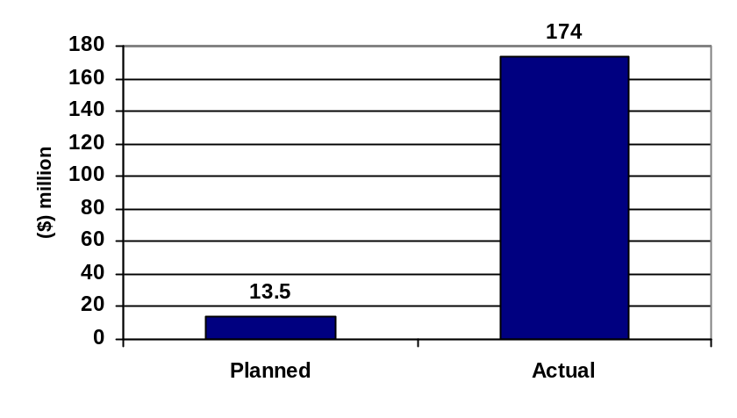

Operating surplus
The City of Melbourne has continued to deliver an operating surplus since 2000-2001. In 2006-2007, the City of Melbourne enjoyed a very strong financial performance, achieving a surplus of $174 million against a planned surplus of $13.5 million.

The major item contributing to our operating surplus in 2006-2007 was the once-off recognition of a receivable – the forthcoming Docklands transition – which had a net $167 million non-cash effect. The graph below depicts our operating surplus trend.

Operating surplus
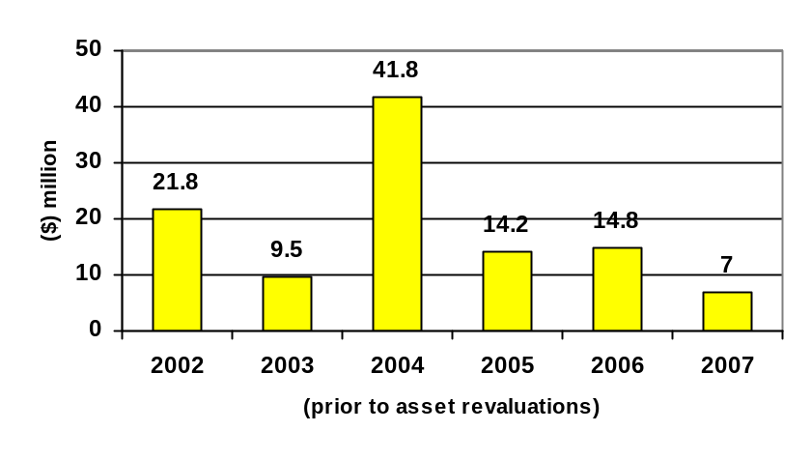
(excluding Docklands)
(Source: internal data).

Investing wisely
The investment portfolio provided revenue of $22.3 million, representing an 8.5 per cent return. Investment property income was lower but stronger performance of the other asset classes helped to lift the total cash return, equalling last year’s cash return performance.

The City of Melbourne’s investment success continues to help underpin modest rate increases and reflects our prudent management of investment assets in a challenging investment environment.

Our subsidiary companies’ performance was strong, returning 12 per cent. This performance is expected to strengthen with Citywide Service Solutions’ acquisition of the Open Space Management Contract from the Spotless Group.

In 2005-2006, a strategic reserve of $24 million was established, to be used in achieving the City of Melbourne’s strategic initiatives. None of these funds was used over the course of the 2006-2007 financial year.

Investments portfolio – annual yield (2006-2007)
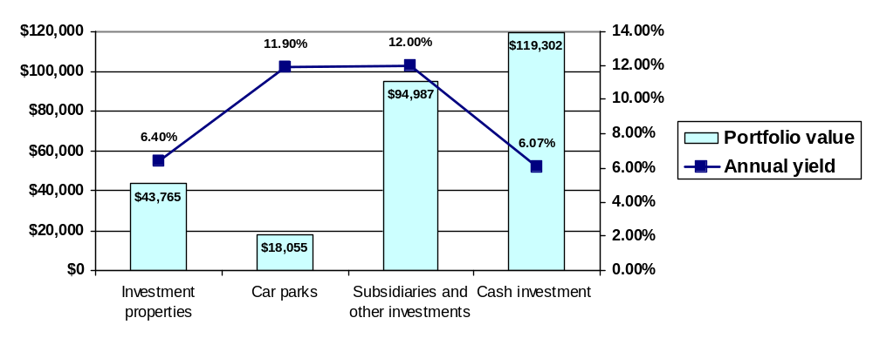 (Source: internal data).

Operational and Efficiency Review
In May 2007, the Chief Executive announced the outcomes of the Operational and Efficiency Review conducted by Ernst & Young. It was the first time in more than 15 years that a major review of the organisation had been conducted. The review included an analysis of the City’s operations in order to identify opportunities and provide recommendations for improvements.

As a result of the review, modest costs were incurred in 2006-2007 of approximately $1.5 million. It is expected that once the recommendations of the full organisational services review are implemented in 2007-2008, Council’s financial performance will be further strengthened.

Donations and grants
The City of Melbourne provides support through the distribution of donations and grants to a range of organisations, individuals and groups. In 2006-2007, it funded 594 organisations to the value of $31.3 million.

Types of grants 2006-2007
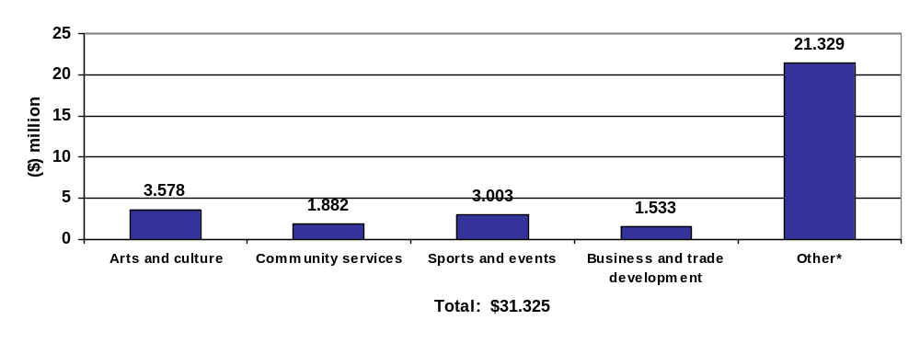* Includes recognition of the full $20 million committed to the Melbourne Convention Centre.

Financial strength
The City of Melbourne maintained its debt-free status and Standard and Poor’s AAA credit rating, first achieved in March 2000. To support expansion of Citywide Service Solutions, a lending facility was put in place during the year and at June 2007 this amounted to $9.4 million.

Total assets amounted to $2.526 billion with total liabilities of $82 million. The net assets of the Council increased by $231 million to $2.444 billion over the year.

Further information on grants and contributions received, employee costs, operating result by function, Council works’ expenditure and basis of reporting can be found in Section Five of this report, Our financials, starting on page 133.

Disappointment s

10 Year Financial Plan
The development of the Council's 10 Year Financial Plan has been delayed. Work so far has produced a detailed model and draft strategic report that identifies key financial drivers, major assumptions and financial outcomes of key strategic plans at a branch level. The plan will be completed in early 2007-2008.

Looking ahead

10 Year Infrastructure Plan
In order to meet the needs and priorities for the city's future infrastructure development, maintenance and service delivery, we will be developing and implementing a 10 Year Infrastructure Plan. The long-term nature of service needs and infrastructure requirements is such that forward projections are required beyond the contemporary four-year plan.

Spotlight on sustainability – Sustainable Council works

During the past three years, Council has spent more than $170 million on capital works. Some of the key projects delivered over this period include Council House 2, the East Melbourne Library, Artplay, Argyle Square – Piazza Italia, Lincoln Square (Bali Memorial), Princes Bridge refurbishment, roads and footpath infrastructure and parks improvement projects.

The City of Melbourne is committed to delivering sustainable outcomes in all aspects of its operations including the capital works program. Since 2003, all capital works projects have been subjected to a sustainability analysis to determine the extent to which the project will contribute to Council’s long-term sustainability objectives. This analysis has been used in the evaluation and selection of projects by our Capital Works Panel.

In 2007 the Capital Works Panel further strengthened this process by implementing a sustainability checklist for use in the early design stages of selected projects in the 2007-2008 Council works projects.

The sustainability checklist is to be used alongside the briefs for projects that have a design element. It is intended to address issues relating to environmental, cultural, social and economic impacts. The checklist identifies various principles and opportunities in the delivery of sustainable outcomes for our projects. A number of principles relate to minimising water consumption and the reuse of existing materials. Protecting and enhancing cultural significance and diversity to foster a sense of community and belonging and maximising value for money are also key principles.

Examples of projects to be subjected to the checklist in 2007-2008 include the City of Melbourne Bowling Club (Flagstaff Gardens), Kensington Children’s Centre, Royal Park Zoo Northern Entrance and various parks and streetscape projects.

Strategic indicators
Council monitors the following key performance indicators to measure our progress towards a financially responsible corporation.

No | Measure | 2006-2007 result | 2005-2006 result | Comments
6.1 | Annual Financial Plan targets: within + or - 5% variation to budget Financial Performance Surplus. | Actual surplus: $174 million compared with budget surplus of $13.5 million (see page 93) | Actual surplus: $14.8 million compared with budget surplus $3.6 million. | Surplus exceeded budget largely due to recognition of assets receivable as part of Docklands transition.
6.2 | Total revenue. | Actual revenue: $269.6 million compared with budget $262.7 million. | Actual revenue: $264.1 million compared with budget $247.2 million. | Variance less than 3%.
6.3 | Total operating expenditure. | Actual operating expenditure: $275 million compared with budget $249.2 million. | Actual operating expenditure: $247.3 million compared with budget $243.5 million. | Higher expenditure due to recognition of Council's contribution to the Melbourne Convention Centre.
6.4 | Council Works Program. | Total value of works was $57.378 million. This equates to a completion rate of 90.6% of projects. | The total value of works was $97 million. 97.6% of projects completed after adjustment for CH2, child care and parking levy projects.
6.5 | Rate of Investment Portfolio return. | Cash investment return: 6.07% compared with budget 6% (see page 94) | Cash investment return: 5.25% compared with budget 5.75%. | Investment returns on cash were in line with budget.

Section four
Performance Statement

Our Performance Statement is a statement of performance against targets set in our City of Melbourne 2006-2007 Annual Plan and Budget. This statement addresses the key strategic activities we planned to complete in 2006-2007 and includes explanations of the targets and our results. The statement is subject to internal and external audits.

Performance against key strategic activities

KSA 1
Extend the Access and Management Framework to Southbank
Performance measure and target |  |  | Achievements |  |  | Issues |  |  | Percent complete
Consult with the Southbank community about potential access and parking management tools for Southbank by November 2006. |  |  | This initiative has been substantially achieved. The Southbank ‘Wheels and Heels’ Plan has undergone extensive community engagement in its development. Two public forums have been held at the Arts Centre and input has been received regarding the key transport, parking and access priorities within the community.  Booz Allen Hamilton has been awarded the competitive tender to undertake this process on behalf of Council. |  |  | It is anticipated that the Southbank ‘Wheels and Heels’ Plan will go to Planning Committee in August or September 2007.  The process was delayed due to unexpected internal work load constraints and difficulties securing venues for the two public forums. |  |  | 75%
KSA 2
Develop and implement a five-year Knowledge City Strategy
Performance measure and target |  |  | Achievements |  |  | Issues |  |  | Percent complete
Strategy developed by June 2007. |  |  | This initiative has been substantially achieved. An audit of the economic and social contribution that universities make to metropolitan Melbourne has been completed and will be launched in the first quarter of 2007-2008. This was undertaken through the Melbourne Vice-Chancellors Forum, chaired by the Lord Mayor, and will form the platform for working strategically with the tertiary education sector in the coming years. A subsidiary outcome, demonstrating the success of this relationship, is the partnership formed between the City of Melbourne and the University of Melbourne (with the support of RMIT and others) to create a new strategic plan for the city called Future Melbourne. |  |  | Ongoing work on Knowledge City is being integrated into the Future Melbourne project, from which a new and more comprehensive Knowledge City Strategy will emerge. |  |  | 75%  Target Completion Date
Performance measure and target |  |  | Achievements |  |  | Issues |  |  | Percent complete
Work commenced with RMIT and the Melbourne Vice Chancellors Forum in examining the needs of International students to extend Melbourne's capacity as a Knowledge City. |  |  | This initiative has been partially achieved. Although some preliminary work was done as part of the cross-Council working group on international students, including a survey of International students, this project has been deferred to 2007-2008. |  |  | The additional time needed to finalise the Universities Contributions Study and related outcomes has meant that the Melbourne Vice Chancellors' Forum was unable to commence a new project on International Students. This will be addressed in 2007-2008. |  |  | 25%  Target Completion Date
KSA 3
Establish Signal youth hub on Northbank
Performance measure and target |  |  | Achievements |  |  | Issues |  |  | Percent complete
Open a youth hub initiative on Northbank by 30 June 2007 |  |  | This initiative has been partially achieved. The outdoor space for Signal was officially opened by the Lord Mayor on 6 October 2006. A number of youth activities have been held in this space since then.  Finance for capital works of Signalbox is now in place with design work underway. The expected delivery date is May 2008. |  |  | A delay in financial support for the project has meant the program will now be completed in 2008. |  |  | 50%  Target Completion Date
KSA 4
Implement the Management of Noise from Waste Collection – A Code of Practice
Performance measure and target |  |  | Achievements |  |  |  | Issues |  |  | Percent complete
Coordinate an annual review of the Code of Practice and include amendments to the ‘Restricted Access Zones' by April 2007 |  |  | This initiative has not been achieved. Whilst planning took place for this review during the 2006-2007 financial year, the annual review of the Code of Practice did not take place until 11 July 2007.  There were no alterations to the current list of Restricted Access Zones. Noise complaints were assessed throughout the year but changes to the current list were considered unnecessary. |  |  |  | The review did not take place until July 2007 due to a delay in coordinating schedules between Council and representatives from the Residents 3000 group and the Victorian Waste Management Association.  Residents within Cocker Alley (part of a Restricted Access Zone) complained that trucks were still collecting waste before 6am. In response, surveillance has been established and further dialogue with residents is planned. |  |  | 0%
KSA 5
Plan for and implement improvements in service delivery to meet the requirements of the organisation and the community
Performance measure and target | Achievements |  |  |  | Issues |  |  | Percent complete
Develop and implement the 'Total Customer Contact Centre' by June 2007 | This initiative has been fully achieved. All incoming customer interactions into the organisation, including those via telephone, face-to-face, SMS and email are now managed through the centralised 'Total Customer Contact Centre'. This ensures a more responsive and consistent service to the community. |  |  |  | Further work on the web/email channel will be done in 2007-2008 to identify further efficiencies on customer interactions via the web channel. |  |  | 100%
KSA 6
Complete an environmental scan to identify additional revenue opportunities
Performance measure and target |  | Achievements |  | Issues |  |  |  | Percent complete
Deliver a detailed report identifying possible alternative/increased revenue opportunities by February 2007. |  | This initiative was not achieved. In February 2007, Council resolved not to pursue this any further in 2006-2007. |  | This strategy will be re-assessed as part of the Council’s Operational and Efficiency Review. |  |  |  | 0%

Statement by Councillors, Chief Executive and Principal Accounting Officer on the Performance Statement

In my opinion the accompanying Performance Statement has been prepared in accordance with the Local Government Act 1989 (Vic)



Martin Cutter (FCA)
Principal Accounting Officer

In Council’s opinion the accompanying compulsory Performance Statement presents fairly the performance of the Melbourne City Council for the year ended 30 June 2007.

As at the date of signing, we are not aware of any circumstance, which would render any particulars in the Performance Statement to be misleading or inaccurate.

Signed in accordance with a resolution of Council, dated 28 August 2007.



John So Brian Shanahan
Lord Mayor Councillor

David Pitchford
Chief Executive

Melbourne
29 August, 2007
Independent Audit Report – Melbourne City Council

Auditor General Victoria

To the Councillors:

Matters Relating to the Electronic Presentation of the Audited Performance Statement

This auditor’s report for the financial year ended 30 June 2007 relates to the performance statement of Melbourne City Council included on its website. The Councillors of the Melbourne City Council are responsible for the integrity of the website. I have not been engaged to report on the integrity of the website. The auditor’s report refers only to the statements named below. An opinion is not provided on any other information which may have been hyperlinked to or from these statements. If users of this report are concerned with the inherent risks arising from electronic data communications, they are advised to refer to the hardcopy of the audited performance statement to confirm the information included in the audited financial report presented on this website.

The Performance Statement

The accompanying performance statement for the year ended 30 June 2007 of Melbourne City Council which comprises of statement, the related notes and the statement by Councillors, Chief Executive and Principal Accounting Officer on the performance statement has been audited.

The Responsibility of the Councillors for the Performance Statement

The Councillors of Melbourne City Council are responsible for the preparation and the fair presentation of the performance statement based on the audit, which has been conducted in accordance with Australian Accounting Standards. These standards require compliance with relevant ethical requirements relating to audit engagements and that the audit be planned and performed to obtain reasonable assurance whether the performance statement is free from material misstatement.

An audit involves performing procedures to obtain audit evidence about the amounts and disclosures in the performance statement. The audit procedures selected depend on judgement, including the assessment of the risks of material misstatement of the performance statement, whether due to fraud of error. In making those risk assessments, consideration is given to internal control relevant to the councillors’ preparation and fair presentation of the performance statement in order to design audit procedures that are appropriate in the circumstances, but not for the purpose of expressing an opinion on the effectiveness of the Council’s internal control. An audit also includes evaluating the overall presentation of the performance statement.

I believe that the audit evidence obtained is sufficient and appropriate to provide a basis for my audit opinion.

Independence
The Auditor-General’s independence is established by the Constitution Act 1975. The Auditor-General is not subject to direction by any person about the way in which his powers and responsibilities are to be exercised. The Auditor-General, his staff and delegates comply with all applicable independence requirements of the Australian accounting profession.

Auditor’s opinion
In my opinion, the performance statement of Melbourne City Council in respect of the 30 June 2007 financial year presents fairly, in all material respects, in accordance with the Local Government Act 1989 (Vic).



For D.R.R. Pearson
Auditor-General.

Melbourne
31 August, 2007

Events calendar

The City of Melbourne presents and supports a vast range of events for the community. Arts and culture, sports, and family entertainment feature in this busy calendar.

(O) = City of Melbourne owned
(SFS) = City of Melbourne sponsored, funded or otherwise supported

July 2006
Leonardo Da Vinci Machines Exhibition
Harvey Norman Rugby League State of Origin
Melbourne Design Festival 2006 (SFS)
World Cup Live Site – Italy v France (Final) (Soccer) (O)
Melbourne International Film Festival (SFS)
August 2006
Melbourne Art Fair 2006 (SFS)
Melbourne On Screen (SFS)
ARAV/Lord Mayor's Innovation Award (SFS)
ARIA Hall of Fame (SFS)
Australian Duathlon Championships (SFS)
CH2 Opening (O)
East Melbourne Library Launch (O)
The Age Melbourne Writers' Festival (SFS)
Hyundai A-League Premiership Season (Melbourne Victory) (SFS)
Ednafest: Dame Edna 50th Anniversary – Keys to the City (O)
Asian Food Festival (SFS)
Melbourne Awards 2006 (O)
Melbourne Day 2006 (O)
September 2006
Motorola Melbourne Spring Fashion Week 2006 (O)
Handworked to Wear Awards (SFS)
Toyota AFL Finals Series (SFS)
Royal Melbourne Show – Show Week in the City (SFS)
Earth from Above Exhibition (SFS)
Festival Indonesia (SFS)
ARAV Retail Awards (SFS)
Fifteen Restaurant Grand Opening (SFS)
Royal Melbourne Show 2006 (SFS)
Parklife Music and Arts Festival (SFS)
Toyota AFL Grand Final Week Activities Parade and Live Site (SFS)
AFL Australian Idol Concert (SFS)
Melbourne Fringe Festival 2006 (SFS)
Toyota AFL Grand Final Parade (SFS)
Toyota AFL Grand Final (SFS)
October 2006
Melbourne Business Festival (O)
Ride to Work Day 2006 (SFS)
State of Design Festival (SFS)
Signal Youth Space launch (O)
Samsung Melbourne Marathon 2006 (SFS)
Vietnamese Children's Lantern Festival (SFS)
Spring Open Day (SFS)
Tram It 2006: Yarra Trams 100th Anniversary (SFS)
Bollywood Masala Indian Film Festival (SFS)
Melbourne International Arts Festival 2006 (SFS)
2006 Jayco Herald Sun Tour – Final Stage Criterium, Lygon Street (SFS)
Portfolio Partners Around the Bay in a Day 2006 (SFS)
Hats off to the Races (SFS)
Diwali Indian Festival (SFS)
Tri-Nations Rugby League – Aust v NZ (SFS)
Spring Fling Festival (SFS)
Melbourne Cup Carnival Activities and Live Site
Melbourne Mobility Centre launch (O)
November 2006
VicSport Lord Mayor’s Sport Award (SFS)
Melbourne Cup Carnival 2006 (SFS)
Day Out on Elgin (SFS)
Emirates Melbourne Cup Parade (SFS)
Christmas – Santa's Grand Arrival (O)
Thessaloniki Festival – St Demetrious Day (SFS)
Melbourne 50 Years On Exhibition (SFS)
Make Poverty History – Waterfront City Live Site (SFS)
Make Poverty History Concert (SFS)
Christmas Tree Lighting Spectacular (O)
Melbourne 50th Anniversary Opening Ceremony (SFS)
Olympic Dream Fun Run (SFS)
Burnet Institute World Aids Day Concert (SFS)
December 2006
Christmas – Advent Calendar & Choirs (O)
Christmas – Nativity Story & Scenes (O)
AFI Awards 2006 (SFS)
Tattersall’s Australian DanceSport Championships (SFS)
Chanukah in the City (SFS)
Carols by Candlelight 2006 (SFS)
Boxing Day Test – Live Site (SFS)
3 Mobile Boxing Day Test – Ashes Series (SFS)
Christmas – Dream Seed (SFS)
New Year's Eve 2006 (O)
January 2007
Summer Fun In The City (O)
Christmas – La Befana (SFS)
Jayco Bay Cycling Classic (SFS)
Skandia Docklands Invitational (SFS)
Midsumma Festival (SFS)
Australian Open 2007 – Live Site (SFS)
Australia Day 2007 (SFS)
Australia Day Concert (SFS)
Big Day Out 2007
Dragon Boat Australia Day Cup (SFS)
February 2007
St George Open Air Cinema (SFS)
Docklands Summer Boat Show (SFS)
Contempora2 (SFS)
Sustainable Living Festival (SFS)
Chinese New Year Festival (SFS)
Hyundai National A-League Grand Final (SFS)
Sony Tropfest 2007 (SFS)
Parking and Traffic Uniform launch (O)
Lord Mayor Luna Festival Awards dinner (O)
Melbourne Marketing Strategy launch (O)
Hyundai National A-League Grand Final Celebrations: Melbourne Victory Premiers (O)
F1 Family Experience (SFS)
NAB Cup (AFL) + NAB Challenge Matches (SFS)
Centenary of Scouting Expo (SFS)
Melbourne Summer Cycle (SFS)
March 2007
Dame Edna Place Street Naming (O)
2007 Grand Prix Festival, Celebrating Ferrari’s 60th Anniversary (SFS)
Bike Path Discovery Day (SFS)
L'Oréal Melbourne Fashion Festival 2007 (SFS)
Melbourne International Motor Show Motorcade (SFS)
International Women’s Day Cocktail Function (O)
National Wakeboarding Championships (SFS)
Moomba Waterfest (O)
Melbourne International Dragon Boat Festival @ Docklands (SFS)
Formula 1TM ING Australian Grand Prix 2007 (SFS)
Melbourne Queer Film Festival (SFS)
Melbourne Food & Wine Festival (SFS)
Melbourne Osaka Cup Boat Week (O)
2007 Telstra NRL Premiership Season (Melbourne Storm) (SFS)
‘Off the Blocks!’ 12th FINA World Championships ANZ Live Site (O)
12th FINA World Championships (SFS)
Thai Culture and Food Festival (SFS)
Australian International Airshow 2007 (SFS)
Cultural Festival of 12th FINA World Championships (SFS)
Antipodes Festival 2007 (SFS)
Dragon Boat Melbourne Osaka Regatta (SFS)
East Melbourne Festa 2007 (SFS)
Opera in the Market (SFS)
Melbourne International Flower & Garden Show (SFS)
2007 Toyota AFL Premiership Season (SFS)
April 2007
Herald Sun / CityLink Run for the Kids 2007 (SFS)
Melbourne International Comedy Festival 2007 (SFS)
Giant Sky Wheel (SFS)
Anzac Day 2007 (SFS)
Dutch Orange Day (SFS)
La Plaza de Mercado (Spanish Mkt) (SFS)
May 2007
Mother's Day Classic 2007 (SFS)
Victorian Law Week (SFS)
Italian Festival and National Day (SFS)
2007 Buddha's Day & Multicultural Light Festival (SFS)
The Antennas 2007 (SFS)
The Long Walk (SFS)
June 2007
Laneway 3000: Winter Party (O)
Melbourne Italian Festival (SFS)
City of Melbourne Family Day (O)
Little Big Shots – Melbourne International Children's Film Festival (SFS)
The Age Run to the 'G 2007 (SFS)
Circus Oz 2007 (SFS)
Bledisloe Cup Qantas Wallabies Fan Day (SFS)
Bledisloe Cup Week Festival – including Wallabies Signing Session (SFS)
Bledisloe Cup (NZ v Aust) (SFS)
Sunny Day in Winter (SFS)
The Antennas (SFS)
Docklands Winter Wonderland (O)
Melbourne Winter Masterpieces: Guggenheim 1940s to Now (SFS)

Global Reporting Initiative (GRI) Content Index

Reading this index
The Global Reporting Initiative (GRI) appears in this Annual Report as a list of indicators that demonstrate the City of Melbourne’s sustainable practices.

Each of the indicators is listed in the following index with a page reference or a comment. Some of the GRI indicators are not relevant to our organisation and we are still developing our data collection systems to be able to report on other indicators.

To see how we performed against any of the indicators, turn to the page numbers listed and locate the relevant information on that page. To see how the City of Melbourne has applied the 10 United Nations Global Compact (UNGC) principles, refer to the reference next to the GRI indicator number.

GRI application level
The City of Melbourne started its sustainability reporting journey in its Annual Report 2004-2005 where we identified our intention to progress towards GRI reporting in 2010. As we have grown in our ability to report on the GRI Indicators, so too has the Global Reporting Initiative continued to evolve in response to feedback from reporting organisations.

Under the Sustainability Reporting Guidelines, reports intended to qualify for level C, C+, B, B+, A or A+ must contain each of the criteria that are presented in the column for the relevant level.
This report was prepared to meet the requirements of application level B.

Report application level | C | C+ | B | B+ | A | A+
G3 Profile Disclosures | Report on: 1.1, 2.1-2.10, 3.1 – 3.8, 3.10 – 3.12, 4.1 – 4.4, 4.14 – 4.15 | Report externally assured | Report on all criteria listed for Level C, plus: 1.2, 3.9, 3.13, 4.5 – 4.13, 4.16 – 4.17 | Report externally assured | Same as requirement for Level B | Report externally assured
G3 Management Approach Disclosures | Not required | Report externally assured | Management Approach Disclosures for each Indicator category | Report externally assured | Management Approach Disclosures for each Indicator category | Report externally assured
G3 Performance Indicators and Sector Supplement Performance Indicators | Report on a minimum of 10 Performance Indicators, including at least one from each of: social, economic and environmental. | Report externally assured | Report on a minimum of 20 Performance Indicators, including at least one from each of: economic, environmental, human rights, labour, society, product responsibility. | Report externally assured | Respond on each core G3 and Sector Supplement indicator with due regard to the materiality principle by either: a) reporting on the indicator, or b) explaining the reason for its omission. | Report externally assured

GRI Content Table

Topic | GRI Indicator | Requirements | Reference  (page / comment)
Report profile
Strategy and analysis | 1.1  (UNGC- P8) | Statement from CEO – to include:  - strategic priorities and key topics for short/medium term with regard to sustainability;  - broader trends affecting the organisation and influencing sustainability priorities;  - key events, achievements and failures during the reporting period;  - views on the performance with respect to targets;  - outlook on the main challenges and targets for the next year and goals for the coming three to five years; and  - other items pertaining to our strategic approach. | Working together for Melbourne – Message from the CE – page 14
Strategy and analysis | 1.2 | Description of key risks and opportunities. | Melbourne transformed – Message from the Lord Mayor – page 12  Working together for Melbourne – Message from the CE – page 14
Strategy and analysis | 1.3  (UNGC-P2) | Statement of continued support for UNGC. | The United Nations Global Compact – page 7
Organisation profile | 2.1 | Name of the organisation. | Melbourne City Council
Organisation profile | PA1 | Describe the relationship to other governments. | Relationship with other tiers of Government – page 20
Organisation profile | 2.2 | Major brands, products and services including volume or quantity. | List of Council services – page 32
Organisation profile | 2.3 | Operational structure. | Organisational structure – page 27
Organisation profile | 2.4 | Location of organisation's headquarters. | Our organisational profile – page 27
Organisation profile | 2.5 | Number of countries the organisation operates. | Our City – Melbourne today – page 16
Organisation profile | 2.6 | Nature of ownership and legal form. | Melbourne City Council – page 19
Organisation profile | 2.7 | Markets served (including geographic breakdown, sectors served and types of customers). | Role of the Council – page 19
Organisation profile | 2.8 | Scale of the reporting organisation, including:  - number of employees;  - net sales or net revenues; and  - total capitalisation broken down in terms of debt and equity. In addition we are encouraged to provide further information, as appropriate, such as: total assets. | - Staff profile – page78  - Standard Statements – page 142  - Standard Statement – page 148
Organisation profile | 2.9 | Significant changes during the reporting period regarding size, structure or ownership. | Operational and Efficiency Review – page 25
Organisation profile | 2.10 | Awards received in the reporting period. | Awards to the City of Melbourne – page 85
Report parameters
Report profile | 3.1 | Reporting period | About this report – page 3
Report profile | 3.2 | Date of most recent previous report | About this report – page 3
Report profile | 3.3 | Reporting cycle | About this report – page 3
Report profile | 3.4 | Contact point | City of Melbourne  PO Box 1603  Melbourne VIC 3001
Report scope and boundary | 3.5 | Process for determining report content including:  - determine materiality;  - prioritise topics within the Annual Report; and  - identify stakeholders the organisation expects to use the Annual Report. | - Report boundary and scope – page 4  - About this report – page 3  - Our audience – page 7
Report scope and boundary | 3.6 | Boundary of the report | Report boundaries and scope – page 4
Report scope and boundary | 3.7 | State any specific limitations on the scope or boundary of the report. | Report boundaries and scope – page 4
Report scope and boundary | 3.8 | Basis for reporting on joint ventures, subsidiaries’ leased facilities, outsourced operations, and other entities that can significantly affect comparability from period to period and/or between organisations. | At this stage the City of Melbourne report does not include data on subsidiary and outsourced entities
Report scope and boundary | 3.9 | Data measurement techniques and the bases of calculations including assumptions and techniques underlying estimations applied to the compilation of the indicators and other information in the report. | Data measurement techniques are reported throughout the report.
Report scope and boundary | 3.10 | Explanation of the effect of any re-statements of information provided in earlier reports, and the reasons for such re-statement (e.g. mergers, change of base years, nature of business, measurement methods. | No restatements of information in earlier reports
Report scope and boundary | 3.11 | Significant changes from previous years in the inclusion of, and measurement methods applied to, economic, environmental and social issues and indicators. | No significant changes from previous years
GRI Content Index | 3.12 | Table identifying the location of the Standard Disclosures in the report.  Identify the page number or web links where the following can be found:  - strategy and analysis 1.1 –1.2;  - organisational profile 2.1 – 2.10;  - report parameters 3.1 – 3.13;  - governance, commitments and engagement 4.1 – 4.17;  - disclosure of management approach per category;  - core performance indicators;  - any GRI additional indicators that were included;  - any GRI Sector Supplement Indicators included in the report. | - Our management approach to sustainable development - page 8  - Our organisational profile - page 24  - Report boundaries and scope - page 4  - Our corporate governance - page 69  - Our management approach to sustainable development - page 8  - Strategic indicators under each strategic objective – from page 34  - Nil  - Nil
Assurance | 3.13 | Policy and current practice with regard to seeking external assurance for the report.  If not included in the assurance report accompanying the Sustainability Report, explain the scope and basis of any external assurance provided. Also explain the relationship between the reporting organisation and the assurance providers. | GRI application level – page 110
Governance commitments and engagement
Governance | 4.1 | Governance structure of our organisation, including committees under the highest governance body responsible for specific tasks such as setting strategy or oversight or the organisation  Describe the mandate and composition (including number of independent members and/or non-executive members) of such committees and indicate any direct responsibility for economic, social and environmental performance. | Meet your Council – page 21
Governance | 4.2 | Indicate if the chair of the highest governance body is also an executive officer (and, if so, their function within the organisation's management and the reasons for this arrangements). | The Lord Mayor of the City of Melbourne is not an Executive Officer.
Governance | 4.3 | For organisations that have a unitary board structure, state the number of members of the highest governance body that are independent and/or non-executive members. | Not relevant to the City of Melbourne
Governance | 4.4 | Mechanisms for shareholders and employees to provide recommendations or direction to the highest governance body  include reference to processes regarding:  - the use of shareholder resolutions or other mechanisms for enabling minority shareholders to express opinions to the highest governance body; and  - informing and consulting employees about the working relationships with formal representation bodies such as organisation level 'work councils'; and representation of employees in the highest governance body. | - Engaging with stakeholders – page 88  - Listening to our staff – page 90
Governance | 4.5 | Linkage between compensation for members of the highest governance body, senior managers, and executives (including departure arrangements) and the organisation's performance (including social and environmental performance). | Staff profile – page 78
Governance | 4.6 | Processes in place for the highest governance body to ensure conflicts of interest are avoided. | On an annual basis, all councillors and senior management are required to complete Pecuniary and Conflict of Interest documentation to declare what interests they hold. These are recorded in a publicly accessible document.  Councillors are also required to declare any pecuniary/conflict of interests prior to committee and Council meetings.
Governance | 4.7 | Process for determining required qualifications and expertise of the members of the highest governance body to guide the strategy of the organisation, including on issues related to economic, environmental and social performance. | The Local Government Act 1989 (Vic) empowers Councils to establish advisory and special committees of the Council. These Committees have delegated powers, duties and functions relating to the Terms of Reference of that Committee. In February 2006, the Council reviewed the Committee structure in order to escalate the importance of certain matters, such as the impending return of Docklands to the City. The new structure was established to address all significant Council-related matters, spreading the workload more equitably and providing an opportunity for each councillor to take lead responsibility in a specific area of interest.
Governance | 4.8 | Internally developed mission and values statements, codes of conduct and principles relevant to economic, environmental and social performance and the status of their implementation.  Explain the degree to which these:  - are applied across the organisation in different regions and departments; and  - relate to internationally agreed standards. | Our mission and values – page 24
Governance | 4.9 | Procedures of the highest governance body for overseeing the organisation's identification and management of economic, environmental and social performance including the identification and management of relevant risks and opportunities and adherence or compliance with internationally agreed standards, codes of conduct and principles.  Include frequency with which the highest governance body assesses sustainability performance. | Risk management – page 75
Governance | 4.10 | Processes for evaluating the performance of the highest governance body, particularly with respect to economic, environmental and social performance. | As a demonstrated elected body, Council is subject to public elections every four years. Their performance over this period is measured against the delivery of the Council Plan they develop in the first year of their Council term.
Governance | 4.11  (UNGC-P7) | Explanation of whether and how the precautionary approach or principle is addressed by the organisation.  Article of the Rio Principles introduced the precautionary approach. A response to 4.11 could address the organisation’s approach to risk management in operational planning or the development and introduction of new products. | The City of Melbourne does not explicitly reference the precautionary approach in its risk management statements. However, our risk management framework is aligned to the Australian Standard AS/NZS 4360:2004 which includes our environmental risk assessment.
Governance | 4.12 | Externally developed voluntary economic, environmental and social charters, sets of principles, or other initiatives to which the organisation subscribes or which it endorses.  Include date of adoption, countries/operations where applied, and the range of stakeholders involved in the development and governance of these initiatives (e.g. multi-stakeholders.  Differentiate between non-binding, voluntary initiatives and those with which the organisation has an obligation to comply. | Our management approach to sustainable development – page 8
Governance | 4.13 | Memberships of associations (such as industry associations) and or national/international advocacy organisations in which the organisation:  - has positions in governance bodies;  - participates in projects or committees;  - provides substantive funding beyond routine membership dues; and  - views membership as strategic. | Meet your Council – page 21
Governance | 4.14 | Disclosure  List of stakeholder groups engaged by the organisation. For example:  - communities;  - civic society;  - customers;  - shareholders and providers of capital  - suppliers; and  - employees, other workers and their trade unions. | Engaging with stakeholders – page 88
Governance | 4.15 | Disclosure  Basis for identification and selection of stakeholders to engage.  This includes the organisation's process for defining its stakeholder groups and for determining the groups with which to engage and not to engage. | Engaging with stakeholders – page 88
Governance | 4.16 | Approaches to stakeholder engagement, including frequency of engagement by type and by stakeholder group.  This could include survey focus groups, community panels, corporate advisory panels, written communication, management /union structure and other vehicles. The organisation should indicate whether any of the engagement was undertaken specifically as part of the report preparation process. | Engaging with stakeholders – page 88  About this report – page 3
Governance | 4.17 | Key issues and concerns that have been raised through stakeholder engagement and how the organisation has responded to those key issues and concerns. | About this report – page 3
Public policies and implementation measures | PA2 | State the definition of sustainable development adopted, and identify any statements or principles adopted to guide sustainable development policies. | Management approach to sustainable development – page 8
Public policies and implementation measures | PA3 | Identify the aspects for which the organisation has established sustainable development policies. | Management approach to sustainable development – page 8
Public policies and implementation measures | PA4 | Identify the specific goals of the organisation for each of the aspects listed in PA3. | The appropriate goals are reported throughout Our performance section
Public policies and implementation measures | PA5 | Describe the process by which the aspects and goals in both PA3 and PA4 were set. | All strategies incorporating performance goals are approved by Council
Public policies and implementation measures | PA6 | For each goal, provide the following information:  - implementation measures;  - results of relevant assessments of the effectiveness of those measures before they are implemented;  - state targets and key indicators used to monitor progress, with a focus on outcomes;  - describe progress with respect to goals and targets in the reporting periods, including results of key indicators;  - actions to ensure continuous improvement towards reaching the public agency's goals and targets; and  - post-implementation assessment and targets for next time period. | Our performance – page 31 to 96 (partially reported)
Public policies and implementation measures | PA7 | Describe the role and engagement with stakeholders with respect to the items disclosed in PA6. | Our Stakeholders – page 87
Economic indicators
Economic performance | EC1 | Direct economic value generated and distributed including revenues, operating costs, employee compensation, donations and other community investments, retained earnings and payments to capital providers and governments. | Our financials – from page 134
Economic performance | EC2 | Financial implications and other risks and opportunities for the organisation’s activities due to climate change. | Data not available for 2006-2007, however the Council has allocated $4 million to 2007-2008 Capital Works Program to identify and implement drought mitigation projects
Economic performance | EC3 | Coverage of the organisation's defined benefit plan obligations. | Determined as not of material impact on City of Melbourne’s operations.
Economic performance | EC4 | Significant financial assistance from government. | Our financials – from page 134
Market presence | EC5 | Range of ratios of standard entry level wage compared with local minimum wage at significant locations of operation. | Determined as not of material impact on City of Melbourne’s operations.
Market presence | EC6 | Policy, practices, and proportion of spending on locally based suppliers at significant locations of operation. | Data not available for this report
Market presence | EC7 | Procedures for local hiring and proportion of senior management hired from local community at locations of significant operation. | Determined as not of material impact on City of Melbourne’s operations.
Indirect economic impacts | EC8 | Development and impact of infrastructure investment and services provided primarily for public benefit through commercial, in kind or pro bono engagement. | Determined as not of material impact on City of Melbourne’s operations.
Indirect economic impacts | EC9 | Understanding and describing significant indirect economic impacts, including the extent of the impacts. | Determined as not of material impact on City of Melbourne’s operations.
Expenditures | PA8 | Gross expenditures broken down by type of payment. | Our financials – from page 134
Expenditures | PA9 | Gross expenditures broken down by financial classification. | Our financials – from page 134
Expenditures | PA10 | Capital expenditures by financial classification. | Our financials – from page 134
Expenditures | PA11 | Describe procurement policy of the public agency as relates to sustainable development. | Management approach to sustainable development – page 8
 | PA12 | Describe economic, environmental and social criteria that apply to expenditures and financial commitments. | Sustainable capital works – page 96 (Partially reported)
Procurement | PA13 | Describe linkages between the public agency's procurement practices and its public policy priorities. | Determined as not of material impact on City of Melbourne’s operations.
Procurement | PA14 | Percentage of total value of goods purchased that were registered with voluntary environmental or social labels and/or certification programs broken down by type. | Council has a sustainable procurement policy that governs its procurement practices.
Environmental
Materials | EN1 | Weight of materials used | Determined as not of material impact on City of Melbourne’s operations.
Materials | EN2 | Percentage of materials used that are recycled input materials. | Data not available for this report
Energy | EN3 | Direct energy consumption by primary energy source. | Energy consumption – page 54
Energy | EN4 | Indirect energy consumption by primary source. | Determined as not of material impact on City of Melbourne’s operations.
Energy | EN5 | Renewable energy consumption. | Energy consumption – page 54
Energy | EN6 | Initiatives to provide energy-efficient or renewable energy based products and services and reductions in energy requirements as a result of these initiatives. | Energy consumption – page 54
Energy | EN7 | Initiatives to reduce indirect energy consumption and reductions achieved. | Energy consumption – page 54
Water | EN8 | Total water withdrawal by source. | The City of Melbourne water use – page 57
Water | EN9 | Water sources significantly affected by withdrawal of water | Determined as not of material impact on City of Melbourne’s operations.
Water | EN10 | Percentage and total volume of water recycled and reused. | Recycled water – page 58
Biodiversity | EN11 | Location and size of land owned, leased, managed in or adjacent to, protected areas and areas of high biodiversity value outside protected areas. | Determined as not of material impact on City of Melbourne’s operations.
Biodiversity | EN12 | Description of significant impacts of activities, products, and services on biodiversity in protected areas and areas of high biodiversity value outside protected areas. | Determined as not of material impact on City of Melbourne’s operations.
Biodiversity | EN13 | Habitats protected or restored. | Protecting Melbourne’s biodiversity – page 60
Biodiversity | EN14 | Strategies, current actions and future plans for managing impacts on biodiversity. | Protecting Melbourne’s biodiversity – page 60
Biodiversity | EN15 | Number of ICUN Red List species and national conservation list species with habitats in areas affected by operations, by level of extinction risk. | Determined as not of material impact on City of Melbourne’s operations.
Emissions, effluents and waste | EN16  (UNGC-P8) | Total direct and indirect greenhouse gas emissions by weight. | Greenhouse gas emissions – page 53
Emissions, effluents and waste | EN17 | Other relevant indirect greenhouse gas emissions by weight. | Data not available for this report.
Emissions, effluents and waste | EN18 | Initiatives to reduce greenhouse gas emissions and reductions achieved. | Greenhouse gas emissions – page 53
Emissions, effluents and waste | EN19  (UNGC-P8) | Emissions of ozone-depleting substances by weight. | Data not available for this report
Emissions, effluents and waste | EN20  (UNGC-P8) | NO, SO and other significant air emissions by type and weight. | Determined as not of material impact on City of Melbourne’s operations.
Emissions, effluents and waste | EN21 | Total water discharge by quality and destination. | Determined as not of material impact on City of Melbourne’s operations.
Emissions, effluents and waste | EN22 | Total weight of waste by type and disposal methods. | Waste reduction – page 53
Emissions, effluents and waste | EN23 | Total number and volume of significant spills. | Determined as not of material impact on City of Melbourne’s operations.
Emissions, effluents and waste | EN24 | Weight of transported, imported, exported or treated waste deemed hazardous under the terms of the Basel Convention Annex and percentage of transported waste shipped internationally. | Determined as not of material impact on City of Melbourne’s operations.
Emissions, effluents and waste | EN25 | Identity, size, protected status and biodiversity value of water bodies and related habitats significantly affected by the reporting organisations discharges of water and runoff. | Determined as not of material impact on City of Melbourne’s operations.
Products and services | EN26 | Initiatives to mitigate environmental impacts of products and services and extent of mitigation. | Determined as not of material impact on City of Melbourne’s operations.
Products and services | EN27 | Percentage of products sold and their packaging materials that are reclaimed by category. | Determined as not of material impact on City of Melbourne’s operations.
Compliance | EN28  (UNGC-P8) | Monetary value of significant fines and total number of non-monetary sanctions for non-compliance with environmental laws and regulations. | No significant fines for 2006- 2007.
Transport | EN29 | Significant environmental impacts of transporting products and other goods and materials used for the organisation's operations, and transporting members of the workforce. | Determined as not of material impact on City of Melbourne’s operations.
Overall | EN30 | Total environmental protection expenditures and investments by type. | Data not available for 2006-2007.
United Nations Global Compact | UNGC9 | Businesses should encourage the development and diffusion of environmentally friendly technologies. | The City of Melbourne has a sustainable approach to procurement and disposal of our assets. In 2006, the City undertook a review of its printing and copying contract. This identified where we could save energy and cut our paper consumption by installing new equipment with improved energy saving functions such as automatic ‘standby’ mode and double-sided printing. In relation to asset disposal, we have in place policies and procedures to ensure environmentally sound disposal of IT assets, including regenerating equipment through resale or redeployment. Other environmentally sound disposal methods are also in place for printer cartridges.
Social performance indicators
Employment | LA1 | Total workforce by employment type, employment contract and region. | Our people – page 78
Employment | LA2 | Total number and rate of employee turnover by age group, gender and region. | Our people – page 78
Employment | LA3 | Benefits provided to full-time employees that are not provided to temporary or part-time employees, by major operations. | Determined as not of material impact on City of Melbourne’s operations.
Labour/management relations | LA4  (UNGC-P3) | Percentage of employees covered by collective bargaining agreements. | Union representation – page 83
Labour/management relations | LA5 | Minimum notice periods regarding operational changes, including whether it is specified in collective agreements. | Under the City of Melbourne 2005 Enterprise Agreement, period of notice given to employees whose employment with Council is terminated shall be entitled to notice dependent upon continuous years of service.
Occupational health and safety | LA6 | Percentage of total workforce represented in formal joint management-worker health and safety committees that help monitor and advise on occupational health and safety. | 100% of workforce represented
Occupational health and safety | LA7 | Rates of injury and lost time etc. | WorkCover – page 82
Occupational health and safety | LA8 | Education, training, counselling, prevention and risk-control programs in place to assist workforce members, their families or community members regarding serious diseases. | Serious diseases including AIDS/HIV are covered by our general OH&S policies and processes and our EEO Policy. In 2006-2007 the City of Melbourne developed a strategy for dealing with pandemic outbreaks. See Strategic Objective 5 – Our governance.
Occupational health and safety | LA9 | Health and safety topics covered in formal agreements with trade unions. | Determined as not of material impact on City of Melbourne’s operations.
Training and education | LA10 | Data is not available this year. The City of Melbourne values learning and development opportunities for all staff. All staff members have the opportunity to attend training as determined by their performance and career development reviews. | Determined as not of material impact on City of Melbourne’s operations.
Training and education | LA11 | Programs for skills management and lifelong learning that support the continued employability of employees and assist them in managing career endings. | Programs for staff – page 80
Training and education | LA12 | Percentage of employees receiving regular performance and career development reviews. | 100% of employees receive reviews
Diversity and equal opportunity | LA13 | Composition of governance bodies and breakdown of employees per category according to gender, age group, minority group membership and other indicators of diversity. | Determined as not of material impact on City of Melbourne’s operations.
 | LA14 | Ratio of basic salary of men to women by employee category. | Staff profile – page 78
Human rights performance indicators
Investment and procurement policies | HR1  (UNGC-P1, P2) | Percentage and total number of significant investment agreements that include human rights clauses or that have undergone human rights screening. | Determined as not of material impact on City of Melbourne operations.
Investment and procurement policies | HR2 | Percentage of significant suppliers and contractors that have undergone screening on human rights and actions taken. | Determined as not of material impact on City of Melbourne’s operations.
Investment and procurement policies | HR3  (UNGC-P1) | Total hours of employee training on policies and procedures concerning aspects of human rights that are relevant to operations, including the percentage of employees trained. | Determined as not of material impact on City of Melbourne’s operations.
Non-discrimination | HR4  (UNGC-P6) | Total number of incidents of discrimination and actions taken. | Determined as not of material impact on City of Melbourne operations.
Freedom of association and collective bargaining | HR5 | Operations identified in which the right to exercise freedom of association and collective bargaining may be at significant risk, and actions taken to support these rights. | Determined as not of material impact on City of Melbourne’s operations.
Child labour | HR6  (UNGC-P4, P5) | Operations identified as having significant risk for incidents of child labour, and measures taken to contribute to the elimination of child labour. | The City of Melbourne only employs an adult workforce and ensures that its contractors and outsourced service providers also share this commitment.
Forced and compulsory labour | HR7  (UNGC-P4) | Operations identified as having significant risk for incidents of forced or compulsory labour, and measures to contribute to the elimination of forced or compulsory labour. | The City of Melbourne does not engage in forced or compulsory labour.
Security practices | HR8 | Percentage of security personnel trained in the organisation's policies or procedures concerning aspects of human rights that are relevant to operations. | Determined as not of material impact on City of Melbourne’s operations.
Indigenous rights | HR9 | Total number of incidents of violations involving rights of Indigenous people and actions taken. | City of Melbourne had no incidents this year.
Social performance indicators
Community | SO1 | Nature, scope, and effectiveness of any programs and practices that assess and manage the impacts of operations on communities, including entering, operating and exiting. | Strategic indicators – page 68  Best Value 2006-2007 – page 84
Corruption | SO2  (UNGC-P10) | Percentage and total number of business units analysed for risks relating to corruption. | 100%.  All business units undertake a risk management analysis as part of business planning requirements. For more information see Risk Management on page 75.
Corruption | SO3 | Percentage of employees training in organisation’s anti-corruption policies and procedures. | More than 100 (around 9%) of City of Melbourne staff attended nine different risk management courses this year and training options were expanded to cover new topics and cater to specific operational needs. See page 74
Corruption | SO4 | Actions taken in response to incidents of corruption. | No incidents of corruption for 2006-2007
Public policy | SO5 | Public policy positions and participation in public policy development and lobbying. | Determined as not of material impact on City of Melbourne’s operations.
Public policy | SO6 | Total value of financial and in-kind contributions to political parties, politicians and related institutions and lobbying. | The City of Melbourne did not receive any funding from political parties.
Anti-competitive behaviour | SO7 | Total number of legal actions for anti-competitive behaviours, anti-trust and monopoly practices and their outcomes. | No legal actions for 2006-2007
Compliance | SO8 | Monetary value of significant fines and total number of non-monetary sanctions for non-compliance with laws and regulations. | No significant fines for 2006-2007
Product responsibility indicators
Customer health and safety | PR1 | Life cycle stages in which health and safety impacts of products and services are assessed for improvement, and percentage of significant products and services categories subject to such procedures. | Determined as not of material impact on City of Melbourne’s operations.
Customer health and safety | PR2 | Total number of incidents of non-compliance with regulations and voluntary codes concerning health and safety impacts or products and services during their life cycle, by type of outcomes. | Determined as not of material impact on City of Melbourne’s operations.
Product and service labelling | PR3 | Type of product and service information required by procedures and percentage of significant products and services subject to such information requirements. | Determined as not of material impact on City of Melbourne’s operations.
Product and service labelling | PR4 | Total number of incidents of non-compliance with regulations and voluntary codes concerning product and service information and labelling by type of outcomes product and service labelling compliance. | Determined as not of material impact on City of Melbourne’s operations
Product and service labelling | PR5 | Practices related to customer satisfaction including results of surveys measuring customer satisfaction. | Engaging with stakeholders – page 88
Marketing communications | PR6 | Programs for adherence to laws, standards and voluntary codes related to marketing communications, including advertising, promotion, and sponsorship. | City of Melbourne’s marketing and communications (commercials) adhere to the relevant laws, standards and voluntary codes in accordance with the Free TV Australia Limited, the free-to-air commercial television broadcasters. In a broader sense the ACCC governs the industry and the Advertising Federation of Australia is a self-regulated body affiliated with the industry.
Marketing communications | PR7 | Total number of non-compliance with regulations and voluntary codes concerning marketing communications, including advertising, promotion and sponsorship by type of outcomes. | All of City of Melbourne’s advertising adhere to the relevant codes.
Customer privacy | PR8 | Total number of substantiated complaints regarding breaches of customer privacy and losses of customer data. | Privacy Act – page 74
Customer privacy | PR9 | Monetary value of significant fines for non-compliance with laws and regulations concerning the provision and use of products and services. | Determined as not of material impact on City of Melbourne’s operations

SECTION FIVE
Our financials

This section is prepared in accordance with the Local Government Act 1989 (Vic), the Local Government Regulations 2001 and applicable Australian Accounting Standards.

Understanding our financials 136
Our financial statements 137
Our Standard Statements 139
Basis of preparation 141
Standard Statements 142
Standard statement of income 142
Standard statement of income – comparison report 143
Standard statement of balance sheet 144
Standard statement of balance sheet – comparison report 145
Standard statement of cash flows (reconciliation) 146
Standard statement of cash flows – comparison report 147
Standard statement of Council works 148
Financial Report 149
Income statement 149
Balance sheet 150
Statement of cash flows 151
Statement of changes in equity (consolidated) 152
Statement of changes in equity (Council) 152
Notes to and forming part of the Financial Report 153
Note 1. Significant accounting policies 153
Note 2. Operating result attributable to functions/activities (consolidated) 162
Revenues from ordinary activities 164
Note 3. Revenues from ordinary activities 164
Expenses from ordinary activities 167
Note 4. Expenses from ordinary activities 167
Assets 168
Note 5. Trade and other receivables 168
Note 6. Inventories 168
Note 7. Other financial assets 169
Note 8. Other financial assets 169
Note 9. Property, plant, equipment and infrastructure 169
Note 10. Intangible assets 174
Note 11. Investment property 175
Liabilities 176
Note 12. Trade and other payables 176
Note 12(a). Non-Current. Trade and other payables 176
Note 13. Employee benefits 176
Note 14. Provisions 177
Equity 178
Note 15. Reserves 178
Other disclosures 179
Note 16. Gains/(loss) on sale of fixed and intangible assets 179
Note 17. Investments accounted for using the equity method 180
Note 18. Cash flow information 181
Note 19. Leases and commitments 182
Note 20. Contingent assets and liabilities 183
Note 20A. Melbourne Wholesale Fish Market 183
Note 20B. Docklands 183
Note 21. Superannuation 184
Note 22. Related party transactions 187
Note 23. Financial instruments 189
Note 24. Financial rations 195
Statement by Councillors, Chief Executive and Principal Accounting Officer on the Financial Report 197
Auditor-General’s Report on the Financial Report 198

Understanding our financials
What do financial statements show?

Our financial statements provide an insight into the City of Melbourne’s financial health. Our financial statements show:

- how the City of Melbourne and its subsidiaries performed during the year;
- the value of assets held by the City of Melbourne; and
- the ability of the City of Melbourne to pay its debts.

How are the financial statements audited?

These financial statements are prepared in accordance with the Local Government
Act 1989 (Vic) and the Australian Accounting Standards. They are audited by the Victorian Auditor-General, approved in principle by the City of Melbourne’s Audit Committee and by Melbourne City Council. These auditing measures ensure the information provided is correct. The City of Melbourne has received a clear audit of its financial statements for 2006/07.

What’s in the financial statements?

The financial statements consist of four financial reports, explanatory notes supporting the reports and endorsement from the Melbourne City Council and the Victorian Auditor-General. The four financial reports are:

- income statement;
- balance sheet;
- statement of cash flows; and
- statement of changes in equity.

The explanatory notes detail the City of Melbourne’s accounting policies and the make-up of values contained in the statements.

Consolidated and Council

Our financial statements show our results for the last two years in two columns. Our subsidiary companies are companies owned by the City of Melbourne, but managed independently. Subsidiary companies included in our financial statements are:

- CityWide Service Solutions;
- the Queen Victoria Market; and
- the Melbourne Wholesale Fish Market.

The City of Melbourne has 100 per cent ownership of these subsidiaries. Our Sustainable Melbourne Fund Trust is also included in the consolidated financial reports, but this is a trust and not a subsidiary company.

Consolidated | Council
This column shows the City  of Melbourne’s financial results  including subsidiary companies. | This column shows the City  of Melbourne’s financial results  excluding our subsidiary companies.

Our financial statements

Read on for a brief explanation of our four financial statements.

1. Income statement
The income statement shows how well we have performed during the year. This statement is prepared on an accrual basis, which means that all revenue and costs for the year are recognised even though the income may not yet be received or expenses not yet paid. The statement lists the sources of the City of Melbourne’s revenue under income headings (such as rates; grants; parking fines) and the expenses incurred in running the City of Melbourne during the year (such as employee costs; contract payments).

Expenses included in the income statement relate only to our operations (our day-to-day running costs). Costs associated with the purchase or building of assets are not included in the Income Statement. However, depreciation (the value of an asset that is used up during the year) is included.

The key figure to look at is the ‘surplus for the year’ figure. A surplus means that our revenue was greater than our expenses. Being in surplus for the year is equivalent to being in profit. For 2006/07, the income statement is in surplus. This means that in 2006/07, the City of Melbourne created sufficient funds to replace infrastructure assets when they needed to be replaced and met all our expenditure commitments. The recognition of assets receivable as part of the Docklands transition to the City of Melbourne was a large contributing factor to this year’s surplus.

2. Balance sheet

The balance sheet shows the assets the City of Melbourne owns and what it owes (its liabilities) as at 30 June, 2007.

Assets and liabilities are separated into ‘current’ and ‘non-current’. Current assets or liabilities will fall due in the next 12 months, such as money owed to the City of Melbourne by ratepayers (a current asset), or the amount provided to pay employees when they take annual leave (a current liability).

Non-current assets and liabilities will fall due beyond 12 months, or will not be converted to cash in the next 12 months, such as roads owned by the City of Melbourne (a non-current asset), or the amount paid to employees when they take long service leave (a noncurrent liability).

Assets, with the exception of assets held at cost, are reviewed each year to ensure they reflect their ‘fair’ value. The bottom line of the balance sheet is net assets. This is the net worth of the City of Melbourne, built up over many years.

As at June 2007, our balance sheet shows that the City of Melbourne is in a sound financial position. Our current assets are 4.2 times our current liabilities. This means that for every one dollar of current liabilities, the City of Melbourne has $4.20 of current assets to pay the debt. This demonstrates the City of Melbourne has sufficient funds on hand to pay liabilities as they fall due.

3. Statement of cash flows

The statement of cash flows summarises our cash receipts and payments for the financial year and shows the net increase or decrease in cash held by the City of Melbourne. The statement of cash flows represents cash ‘in hand’, whereas the income statement is prepared on an accrual basis (including money not yet paid or spent). This means the values in both statements may differ.

The City of Melbourne’s cash arises from, and is used in, three main areas:

- the ‘cash flows from operating activities’ section summarises all income and expenses relating to the City of Melbourne’s delivery of services; and
- the ‘net cash provided by operating activities’ figure must be in a surplus to ensure we can maintain our day-to-day operations and provide funds for future community assets.

The ‘cash flows from financing activities’ represents any proceeds from borrowings the City of Melbourne has received during the year.

The ‘cash flows from investing activities’ refers to the City of Melbourne’s capital works expenditure or other long-term revenue producing assets, as well as money received from the sale of assets. During the year, the City of Melbourne has operated with a net inflow of cash. An inflow of cash means that the City of Melbourne has increased cash holdings as cash receipts exceeded cash payments. In 2006/07, our cash at the end of the financial year increased by $5.4 million.

4. Statement of changes in equity

The statement of changes in equity summarises changes in the City of Melbourne’s net worth. Our net worth can change as a result of:

- a surplus (profit) or deficit (loss) recorded in the income statement;
- the use of monies from the City of Melbourne’s reserves (such as the
- public open space reserve, used to fund capital projects); or
- an increase in the value of non-current assets resulting from a revaluation of those assets.

With re-valued assets, the increased value amount is transferred to an Asset Revaluation Reserve until the asset is sold.

The note column
Our financial statements contain a note column, with additional information relating to an item. Notes are particularly useful where there has been a significant change from the previous year’s comparative figure.

Our Standard Statements

Our Standard Statements provide a comparison between the actual results for the year and the budget that was set at the start of the year. Any major differences are explained in the accompanying notes.

The Standard Statements section includes three of the four statements mentioned above (income statement, balance sheet and statement of cash flows) together with another statement, the statement of Council works.

The statement of Council works sets out our expenditure on maintaining, creating or buying property, infrastructure, plant and equipment assets. This statement shows how much has been spent on renewing, refurbishing, upgrading, expanding or creating new assets.

Statement by Councillors, Chief Executive Officer and Principal Accounting Officer

The Certification of the Principal Accounting Officer is made by the person responsible for the financial management of the City of Melbourne, that in his (or her) opinion, the financial statements have met all the statutory and professional reporting requirements.

The Certification of Councillors is made by two councillors on behalf of the Melbourne City Council that, in their opinion, the financial statements are fair and not misleading.

Auditor-General’s Report on the Financial Report

This document provides a written undertaking of the accuracy, fairness and completeness of the accounts. The audit report from the Auditor-General provides an independent view of the statements and advises the reader if there are any issues of concern.

No issues were raised by the Auditor-General in regard to the 2006/07 statements.

Who do we work with?

- The City of Melbourne’s external auditor is the Victorian Auditor-General.
- The City of Melbourne’s internal auditor is Ernst & Young.
- The City of Melbourne’s banker is Westpac Banking Corporation.

Acronyms used in these notes include:

A-IFRS: Australian equivalents to International Financial Reporting Standards
IFRS: International Financial Reporting Standards
GAAP: Generally Accepted Accounting Principles
AASB: Australian Accounting Standards Board
GST: Goods and Services Tax
PINS: Parking Infringement Notice System
VAGO: Victorian Auditor General’s Office

Definitions
Current assets Total current assets as shown in the balance sheet.

Current liabilities Total current liabilities as shown in the balance sheet.

Debt redemption Includes the principal component of repayments on
loans and financial leases and capital items purchased
on vendor terms, and contributions to sinking funds.

Debt servicing costs Includes interest and charges on loans, overdrafts,
and interest on payments for capital items purchased
on vendor terms.

Rate revenue Includes revenue from general rates, municipal
charges, special rates, special charges, service rates
and service charges.

Total indebtedness Total liabilities, both current and non-current, as shown
in the Balance Sheet.

Total realisable assets Total current assets and total realisable non-current
assets.

Total revenue Total revenue as shown in the income statement.

Basis of preparation

The City of Melbourne is required to prepare and include audited Standard Statements within its Annual Report. Under the Local Government Act 1989 (Vic), four statements (and explanatory notes) are required:

- a standard statement of income;
- a standard statement of balance sheet;
- a standard statement of cash flow; and
- a standard statement of Council works.

These statements and supporting notes form a special-purpose Financial Report prepared to meet the requirements of the Local Government Act 1989 (Vic) and the Local Government (Finance and Reporting) Regulations 2004.

The Standard Statements have been prepared on accounting bases consistent with those used for the financial reports and the budget. The results reported in these statements are consistent with those reported in the Financial Report. They are not a substitute for the financial reports, and have not been prepared in accordance with all Australian Accounting Standards or other authoritative professional pronouncements.

The Standard Statements compare the City of Melbourne’s financial plan, expressed through its annual budget, with actual performance. The Local Government Act 1989 (Vic) requires explanation of any material variances. The City of Melbourne has adopted a materiality threshold of 10 per cent. Explanations have not been provided for variations below the materiality threshold unless the variance is considered to be material because of its nature.

The budget figures included in the Standard Statements are those adopted by the Melbourne City Council on 27 June 2006. The budget was based on assumptions that were relevant at the time of adoption of the budget. The Melbourne City Council set guidelines and parameters for revenue and expense targets in this budget in order to meet the City of Melbourne’s business plan and financial performance targets for both the short and long term.

The budget did not reflect any changes to equity resulting from asset revaluations, as their impacts were not considered predictable. Detailed information on the actual financial results is contained in the financial reports.

The detailed budget can be obtained by consulting the City of Melbourne’s website or phoning the City of Melbourne on 9658 9658

The Standard Statements must be read with reference to these documents.
Standard Statements
For the year ended 30 June 2007

Standard statement of income
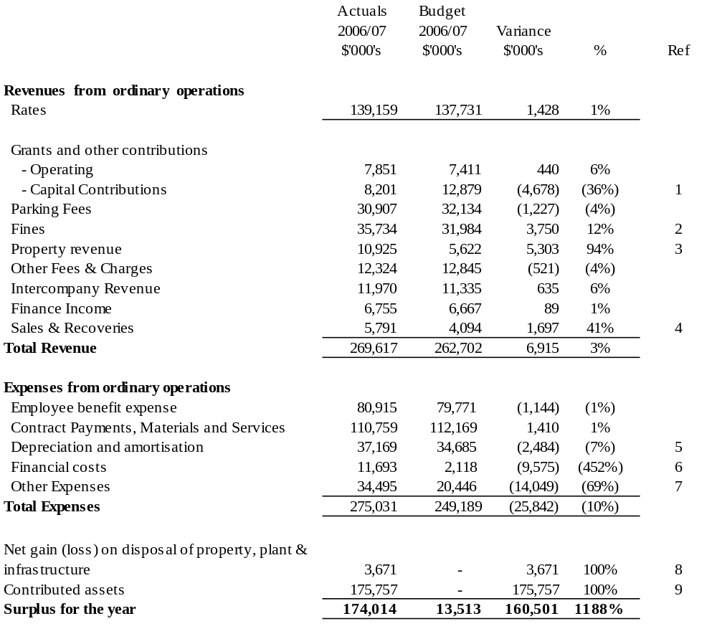

Standard statement of income – comparison report

Ref. | Item | Commentary
1 | Grants and other contributions(revenue) –capital | Unfavourable variance largely due to external capital contributions for recreational projects not being received ($5.5 million).
2 | Fines | The budget was net of provisions and therefore not comparable to actuals. When adjusted the variance is unfavourable $7.4 million. This is a result of lower than expected PINS revenue and a once off adjustment for PINS Debtors following a review of recoverability.
3 | Property revenue | Favourable variance results from the gain on investment revaluation of assets ($4.885 million). A-IFRS requires the reporting of gains/(losses) on revaluation of investment properties be recorded in the Income Statement.
4 | Sales and recoveries | Favourable variance largely explained by additional recoveries received for work undertaken in relation to:  - Docklands ($0.435 million);  - SRO Valuation Information ($0.241 million); and  - Major Events ($0.628 million).
5 | Depreciation and amortisation | Unfavourable variance largely due to new assets and revaluation of existing assets. Information pertaining to these items was unavailable at the time of budgeting.
6 | Finance costs | Favourable variance largely due to income for parking fines being net of provisions as described in Ref 2.  Furthermore, a provision for doubtful debts relating to Birrarung Marr and Royal Park Wetlands was reversed following settlement of the amounts owing.
7 | Other expenses | The recognition of Council’s contribution to the Melbourne Convention Centre resulted in higher expenses of $15 million.
8 | Net gain/(loss) on disposal of property, plant and infrastructure | Favourable variance resulted from the gain on disposal of two properties.
9 | Contributed assets | Recognition of a receivable for assets that will transfer to the City of Melbourne from 1st July 2007.

Standard statement of balance sheet

 | ACTUALS | BUDGET
 | 2006/07 | 2006/07 | Variance
 | $'000's | $'000's | $'000's | % | Ref
ASSETS
Current Assets
Cash and cash equivalents | 119,336 | 91,986 | 27,350 | 30% | 1
Trade and other receivables | 200,833 | 23,698 | 177,135 | 747% | 2
Other assets | 2,888 | 3,600 | (712) | (20%) | 3
Total current assets | 323,057 | 119,285 | 203,773 | 171%
Non-current assets
Other financial assets | 31,791 | 36,987 | (5,196) | (14%) | 4
Intangible assets | 3,680 | - | 3,680 | 100% | 5
Property, plant and infrastructure | 2,103,963 | 2,108,026 | (4,063) | (0%) | 5
Investment property | 63,795 | - | 63,795 | 100% | 5
Total non-current assets | 2,203,229 | 2,145,013 | 58,216 | 2.7%
TOTAL ASSETS | 2,526,286 | 2,264,297 | 261,989 | 12%
LIABILITIES
Current liabilities
Trade and other payables | 41,362 | 33,737 | (7,625) | (23%) | 6
Employee benefits | 18,753 | 9,875 | (8,878) | (90%) | 7
Provisions | 398 | 1,777 | 1,379 | 78%
Total current liabilities | 60,513 | 45,389 | (15,124) | (33%)
Non-current liabilities
Employee benefits | 3,150 | 8,795 | 5,645 | 64% | 7
Non-current payables | 18,493 | - | (18,493) | 100% | 8
Total non-current liabilities | 21,643 | 8,795 | 5,645 | 64%
TOTAL LIABILITIES | 82,156 | 54,184 | (9,479) | (17%)
NET ASSETS | 2,444,130 | 2,210,113 | 252,509 | 11%
Equity
Accumulated surplus | 1,607,029 | 1,436,149 | 170,880 | 12%
Reserves | 837,101 | 773,964 | 63,137 | 8%

Standard statement of balance sheet – comparison report

Ref. | Item | Commentary
1 | Cash and cash equivalents | Higher cash due to proceeds from the sales of two properties and delays in the capital program.
2 | Trade and other receivables (asset) | Debtors are higher due to recognition of assets that will transfer to the City of Melbourne from 1st July 2007.
3 | Other (current) assets | Dividends and tax equivalents receivable from subsidiaries slightly lower than budgeted.
4 | Other financial assets | The dissolution of the Yarra Melbourne regional library corporation and City Library joint venture reduced Council’s financial assets.
5 | Intangible assets, property, plant, infrastructure and investment properties | A combination of found assets (drainage), contributed assets (Commonwealth Games Village) and revaluation of investment properties resulted in higher balances in property, plant and infrastructure.  The overall variation in the combined classes is less than 3%.
6 | Trade and other payables | Higher Trade and Other Payable mainly due to recognition of amounts payable as part of the Docklands transition.
7 | Employee benefits | Impacts of the Enterprise Bargaining increases on the provision for annual leave and long service leave resulted in higher employee benefits.
8 | Non-current payables | Payables relating to the Melbourne Convention Centre, Docklands and Centre for Adult Education resulted in higher balances.

Standard statement of cash flows (reconciliation)

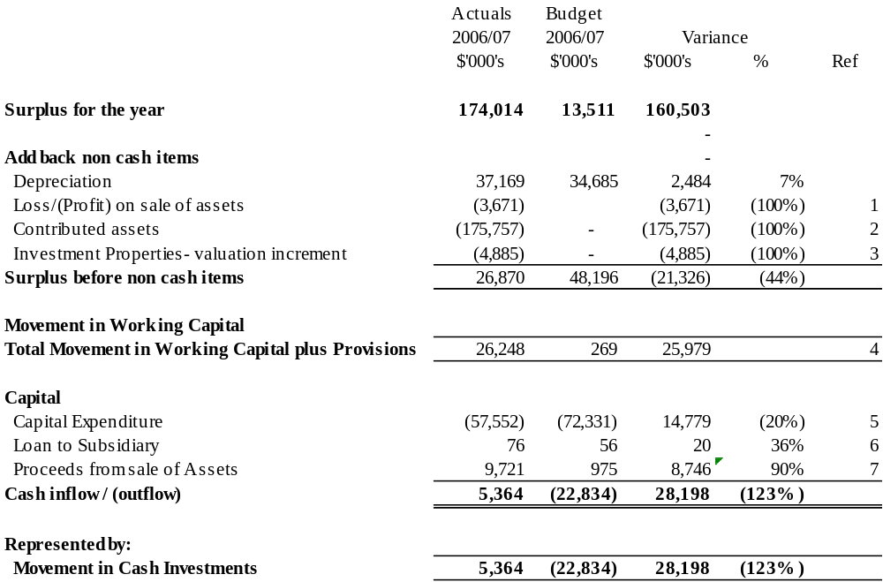

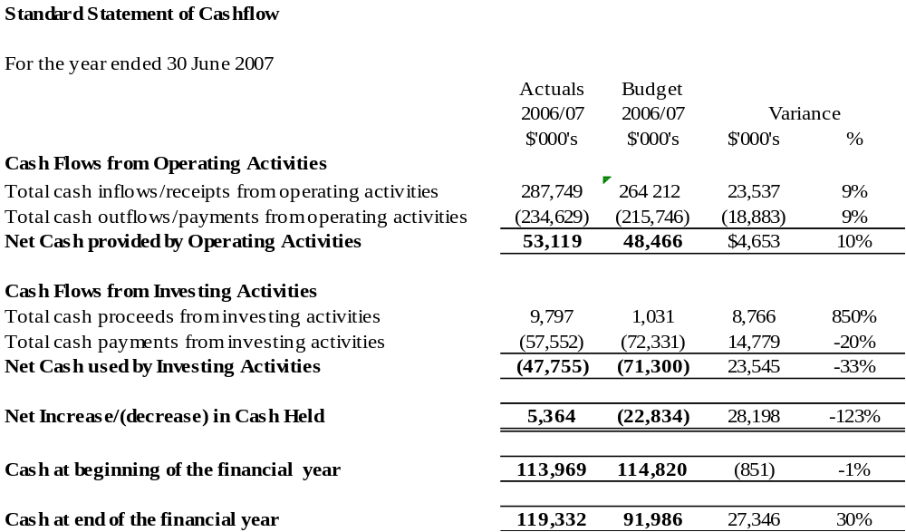
Standard statement of cash flows – comparison report

Ref. | Item | Commentary
1 | Loss/(profit) on sale of assets | A gain on the sale of two properties resulted in a favourable variance.
2 | Contributed assets | Council received contributed assets from the Commonwealth Games Village and recognised a receivable for the transfer of Docklands assets.
3 | Investment properties – revaluation increment | Accounting standards require the increments/(decrements) in the valuation of investment properties to be reported in the Income Statement. This was not budgeted.
4 | Movement in working capital | Reflects the recognition of the liability as part of the Docklands migration to the City of Melbourne and the Melbourne Convention Centre payable.
5 | Capital expenditure | Delays in the capital works program resulted in lower cash outlay for capital expenditure.
6 | Loan to subsidies | The cash inflow relates to repayments by CityWide on a loan made in 2004/05.
7 | Proceeds from sale of assets | The inflow of funds was a result of proceeds from the sale of 2 properties. These proceeds were unbudgeted.

Standard statement of Council works

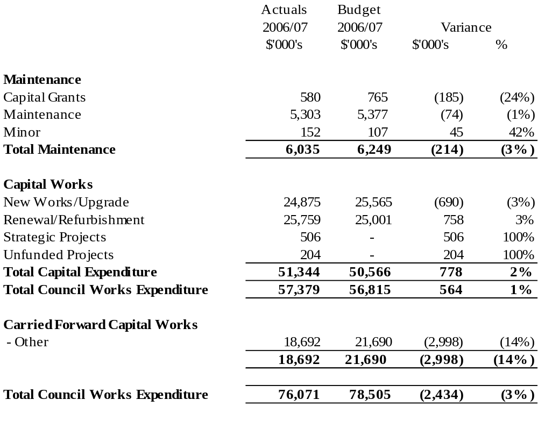
Financial Report

Income statement
For the year ended 30 June 2007

 | Consolidated |  |  |  |  | Council
 | 2007 | 2006 |  |  | 2007 |  | 2006
 | $'000 | $'000 | Note |  | $'000 |  | $'000
Revenues from ordinary operations
Rates | 139,159 | 127,766 | 1(d),3(a) |  | 139,159 |  | 127,769
Grants and other contributions | 16,104 | 24,423 | 1(d),3(d) |  | 16,052 |  | 24,806
Parking fees | 34,090 | 30,732 | 3(b) |  | 30,907 |  | 27,668
Fines | 35,734 | 37,657 | 1(d) |  | 35,734 |  | 37,657
Property revenue | 25,055 | 24,319 |  |  | 10,925 |  | 10,506
Other fees and charges | 93,648 | 67,110 |  |  | 12,324 |  | 11,675
Inter-company revenue | - | - |  |  | 11,970 |  | 11,085
Finance Income | 7,673 | 8,891 | 3(c) |  | 6,755 |  | 8,156
Sales and recoveries | 10,245 | 9,286 |  |  | 5,791 |  | 4,819
 | 222,550 | 202,418 |  |  | 130,458 |  | 136,372
Total revenue | 361,709 | 330,184 |  |  | 269,617 |  | 264,140
Expenses from ordinary operations
Employee benefit expense | 122,225 | 106,069 | 4(a) |  | 80,915 |  | 76,962
Contract payments, materials and services | 146,292 | 137,117 | 4(b) |  | 110,759 |  | 111,242
Depreciation and amortisation | 43,782 | 36,944 | 4(c) |  | 37,169 |  | 32,036
Finance costs | 13,782 | 14,051 | 4(d) |  | 11,693 |  | 12,619
Other expenses | 34,824 | 14,568 | 4(e) |  | 34,495 |  | 14,475
Total expenses | 360,904 | 308,750 |  |  | 275,031 |  | 247,334
Share of net profits/(loss) of associates and joint venture | - | (197) | 17 |  | - |  | 95
Net gain/(loss) on disposal of property, plant and infrastructure | 3,671 | (3,470) | 16 |  | 3,671 |  | (3,574)
Contributed assets | 175,757 | 1,520 | 20(b) |  | 175,757 |  | 1,520
Surplus for the year | 180,232 | 19,288 |  |  | 174,014 |  | 14,848

This income statement should be read with its accompanying notes from page 153.
The income statement is represented at Note 2(a) and (b) on the basis of functional activity. Refer to pages 162-164 for details.

Balance sheet
For the year ended 30 June 2007
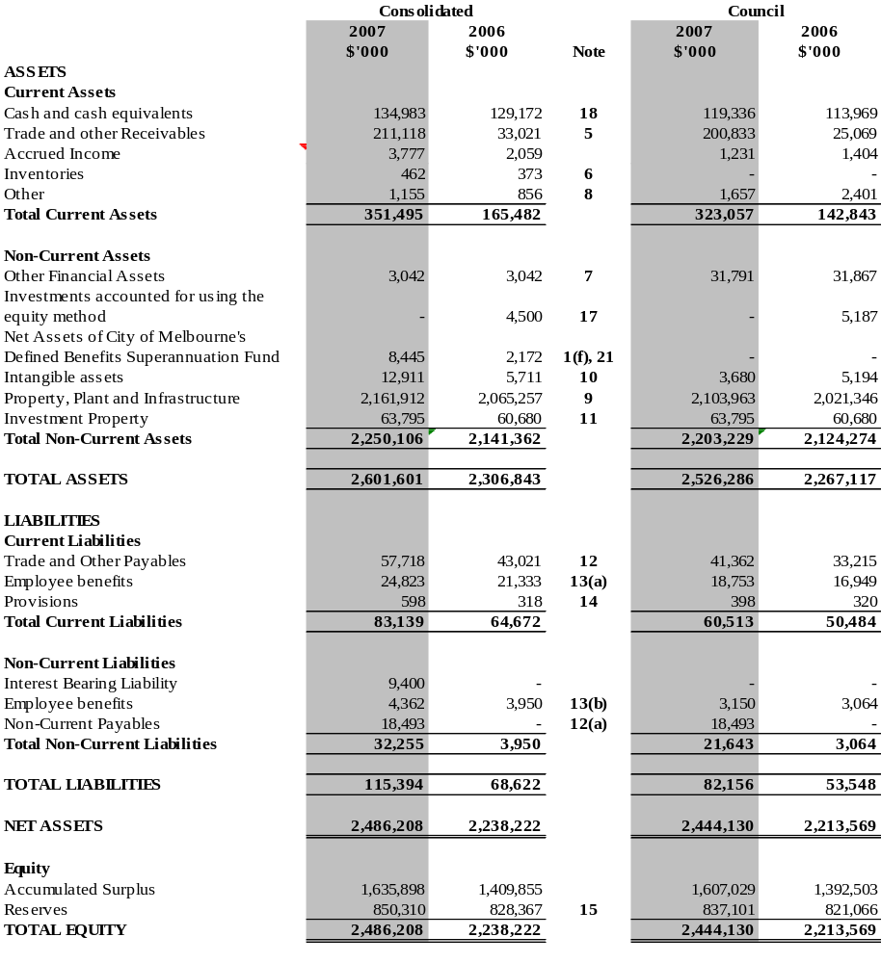

The balance sheet should be read in conjunction with its accompanying notes on from page 153.

Statement of cash flows
For the year ended 30 June 2007

 | Consolidated |  |  | Council
 | 2007 | 2006 |  | 2007 | 2006
 | $'000 | $'000 | Note | $'000 | $'000
Cash flows from operating activities
Receipts
Rates, fees and charges (inclusive of GST) | 327,477 | 289,042 |  | 240,525 | 223,586
Grants and other contributions (inclusive of GST) | 17,338 | 26,381 |  | 17,286 | 26,764
Interest | 7,670 | 8,850 |  | 6,752 | 8,115
Dividends received | 3 | 41 |  | 2,903 | 2,924
Tax equivalents | - | - |  | 3,291 | 2,329
Other (including sales and recoveries) (inclusive of GST) | 21,356 | 25,953 |  | 16,991 | 20,745
Payments
Employee benefit expense | (117,400) | (104,038) |  | (78,947) | (75,270)
Materials and services (inclusive of GST) | (167,611) | (167,302) |  | (138,297) | (143,120)
Finance costs (inclusive of GST) | (12,906) | (14,363) |  | (10,817) | (12,931)
Other (inclusive of GST) | (6,567) | (6,554) |  | (6,568) | (6,450)
Net cash provided by operating activities | 69,360 | 58,012 | 18(a) | 53,119 | 46,694
Cash flows from investing activities
Proceeds from sale of property, infrastructure, plant and equipment | 10,212 | 1,807 |  | 9,721 | 1,120
Payments for property, infrastructure, plant and equipment | (74,449) | (103,879) |  | (57,552) | (94,695)
Acquisition of business | (8,714) | - |  | - | -
Loans to subsidiaries | - | - |  | 76 | 68
Net cash used by investing activities | (72,951) | (102,072) |  | (47,755) | (93,507)
Cash flows from financing activities
Proceeds from borrowings | 9,400 | - |  | - | -
Net cash used by financing activities | 9,400
Net increase/(decrease) in cash held | 5,809 | (44,058) |  | 5,364 | (46,814)
Cash at beginning of the financial year | 129,172 | 173,230 |  | 113,969 | 160,784
Cash at end of the financial year | 134,983 | 129,172 | 18(b) | 119,336 | 113,969

The statement of cash flows should be read in conjunction with its accompanying notes on page 181
- Refer to Note 18(c) for restrictions on cash investments.
Statement of changes in equity (consolidated)
For the year ended 30 June 2007
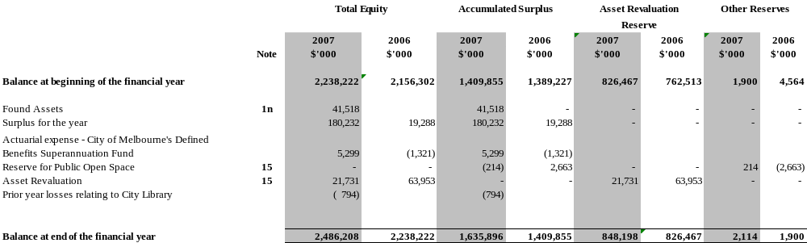
This statement of changes in equity (consolidated) should be read in conjunction with its accompanying notes from page 178.
Statement of changes in equity (Council)
For the year ended 30 June 2007
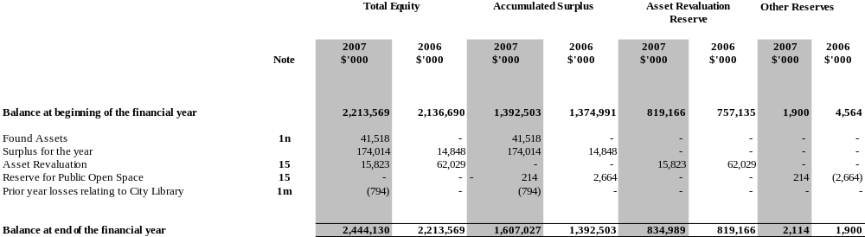
This statement of changes in equity (Council) should be read in conjunction with its accompanying notes from page 178.

Notes to and forming part of the Financial Report

- The Melbourne City Council is a body corporate constituted pursuant to the Local Government Act 1989 (Vic) to provide for the peace, order and good government of its municipal district. The Financial Report has been drawn up in accordance with that Act and related Regulations.
- This Financial Report is a general purpose financial report that consists of an income statement, balance sheet, statement of cash flows, statement of changes in equity and notes accompanying these financial statements. The general purpose Financial Report complies with Australian Accounting Standards, other authoritative pronouncements of the Australian Accounting Standards Board, Urgent Issues Group Interpretations, the Local Government Act 1989, and the Local Government (Finance and Reporting) Regulations 2004.
International Financial Reporting Standards

Australian Accounting Standards include Australian equivalents to International Financial Reporting Standards (IFRS). This Financial Report complies with the Australian equivalents to IFRS (A-IFRS).

Note 1. Significant accounting policies

The significant policies, which have been adopted in the preparation of this Financial Report, are:
(a) Basis of preparation

The Financial Report has been prepared on the going concern basis (except for the Melbourne Wholesale Fish Market, refer note 20(a)) and historical costs, except where otherwise stated, and accrual accounting principles. Unless otherwise stated, the accounting policies adopted are consistent with those of the previous year. Where appropriate, comparative figures have been amended to accord with current presentation and disclosure made of material changes to comparatives.

(b) Principles of consolidation

The consolidated results in the include all funds through which the Melbourne City Council controls resources to carry on its functions. In the process of reporting on the Melbourne City Council as a consolidated unit, all intra and inter entity balances and transactions have been eliminated.
CityWide Service Solutions Pty Ltd, Queen Victoria Market Pty Ltd and Melbourne Wholesale Fish Market Pty Ltd are all wholly owned subsidiaries of the Council incorporated in Australia and are included in the consolidated Financial Report.
The Sustainable Melbourne Fund Trust is wholly controlled trust of the Council and is included in the consolidated Financial Report.

(c) Taxation

Melbourne City Council is exempt from the payment of income tax and capital gains tax. Payments for Fringe Benefits Tax and Goods and Services Tax (GST) are made in accordance with the relevant legislation. Payments for payroll tax are only made by the trading entities controlled by the Melbourne City Council.
The wholly owned subsidiaries are subject to the Melbourne City Council’s tax equivalence policy. Where the subsidiary is exempt from certain taxes it pays an equivalence of the tax to Melbourne City Council.
Revenues, expenses and assets are recognised net of the amount of GST, except where the amount of GST incurred is not recoverable from the Australian Taxation Office. In these circumstances the GST is recognised as part of the cost of acquisition of the asset or as part of an item of the expense.
Cash flows are presented in the cash flow statement on a gross basis, except for the GST component of investing and financing activities, which are disclosed as operating cash flows.

(d) Fees, fines, charges, rates, grants, and other contributions

Fees and charges are recognised as revenue when services are provided or the cash is received, which ever occurs first.
Fines are recognised as revenue when the penalty is imposed.
Rates, grants, and other contributions are recognised as revenues when Melbourne City Council obtains control over the related assets. Control over assets acquired from rates is obtained at the commencement of the rating period or, where earlier, upon receipt of the rates. Control over granted assets is normally obtained upon their receipt or upon prior written notification that a grant has been secured.
Where contributions recognised as revenues during the financial year were obtained on the condition that they be expended in a particular manner or used over a particular year, and those conditions were undischarged as at the reporting date, the nature of any amounts pertaining to those undischarged conditions are disclosed in Note 3(d). That note also discloses the amount of contributions recognised as revenues in previous financial years, which were expended in respect of Melbourne City Council’s operations during the current financial year.
Tax equivalents and dividends from subsidiaries are recognised as income when received or amounts have been declared at the respective subsidiary companies board meeting.
Revenue arising from service contracts is recognised by reference to the stage of completion of the contract, unless the outcome of the contract cannot be reliably estimated. The stage of completion is determined by reference to the proportion that costs incurred to date bear to the estimated total costs of the contract. Administrative overheads are not included in the costs of the contract for this purpose. Where the outcome of a contract cannot be reliably estimated, contract costs are recognised as an expense as incurred, and where it is probable that the costs will be recovered, revenue is recognised to the extent of costs incurred.

(e) Intangibles

(i) Goodwill
Where an entity or operation is acquired, the identifiable net assets acquired are measured at fair value. Fair value is defined in note 1(n)(iii). The excess of the fair value of the cost of acquisition over the fair value of the identifiable net assets acquired is brought to account as goodwill. Goodwill is not amortised, but tested for impairment annually.

(ii) Licences
Licences are recorded at cost and amortised on a straight line basis over a 20 month period.

(iii) Software
Software, that is not an integral part of the related hardware, is classified as intangibles, recorded at cost and amortised on a straight line basis over a five year period.
 | Goodwill | Licences | Software
Useful lives | Indefinite | Finite | Finite
Method used | Not depreciated or  re-valued | 20 months – straight line | 5 Years – straight line
Internally generated/ acquired | Acquired | Acquired | Acquired
Impairment test/ recoverable amount test | Reviewed annually for indication of impairment | Amortised method reviewed at each financial year-end. | Amortised method reviewed at each financial year-end;  Reviewed annually for indication of impairment

(f) Employee benefits

(i) Wages, salaries, annual and long service leave
Liabilities for employees’ entitlements to wages and salaries, annual leave, and other employee benefits which are expected to be paid or settled within 12 months of balance date are accrued at nominal amounts calculated on the basis of 2006/07 wage and salary rates and payroll based oncosts in accordance with AASB 119 ‘Employee Benefits’.
Liabilities for other Employee benefits which are not expected to be paid or settled within 12 months of balance date are accrued as per AASB 119 at the present values of future amounts expected to be paid based on 4.5 per cent per annum projected weighted average increase in wage and salary rates and payroll based oncosts over an average period of five years. Present values are calculated using the government guaranteed securities rates with similar maturity terms.

(ii) Superannuation
Council has an ongoing obligation to share in the future experience of the City of Melbourne Superannuation defined benefits sub-plan. Favourable or unfavourable variations may arise should the experience of the Funds differ from the assumptions made by the Funds’ actuary in estimating the Funds’ accrued benefit liability.
An asset is recognised in the consolidated financial statements as the Council’s share of the scheme’s assets, being the difference between the present value of employees’ accrued benefits and the net market value of the scheme’s assets at balance date. The asset also includes applicable contributions tax of 15 per cent.
Superannuation expense for the reporting year is the amount of statutory contribution Melbourne City Council makes to superannuation funds, which provides benefits to employees.
Details of these arrangements are set out in Note 21.

(g) Depreciation

Depreciation measures the service potential of buildings, infrastructure assets, plant and equipment consumed during the year. Interest in trees, land and artworks are not depreciated as they are considered to have either unlimited useful lives or to be self generating assets. Depreciation is recognised on a straight-line basis over the useful lives of the assets to the economic entity. Depreciation rates are reviewed each financial year. The depreciation periods for the major classes of assets are consistent with the prior year; with the exception of drains infrastructure assets. Effective life determination of drainage assets, as completed by independent experts, has resulted in the useful life of drainage assets being extended from a maximum of 90 to 189 years. The depreciation periods for the major classes of assets are as follows:

 | 2006/07 | 2005/06
Buildings | 10 – 50 Years | 10 – 50 Years
Roads and laneways – seal | 7 – 10 Years | 7 – 10 Years
Roads and laneways – substructure | 18 – 88 Years | 18 – 88 Years
Footpaths | 3 – 50 Years | 3 - 50 Years
Kerb and channel | 15 – 50 Years | 15-50 Years
Bridges | 5 – 83 Years | 5-83 Years
Drains | 25 – 90 Years | 25-90 Years
Plant and equipment | 3 – 20 Years | 3-20 Years
Furniture and fittings | 5 Years | 5 Years
Irrigation systems | 10 – 20 Years | 10-20 Years
Parks and gardens infrastructure | 10 – 50 Years | 10-50 Years
Statues, sculptures and artworks | 0 – 100 Years | 0-100 Years
Other structures | 5 – 50 Years | 5-50 Years

Assets are depreciated from the date of acquisition or, in respect of internally constructed assets, from the time an asset is completed and held ready for use.

(h) Cash assets

For purposes of the statement of cash flows and the balance sheet, cash and cash equivalents includes short term deposits, bank bills and negotiable certificates of deposits which are readily convertible to cash on hand and are subject to an insignificant risk of changes in value, net of bank overdrafts.
Short-term deposits are stated at cost. Interest is recognised when earned. Short-term deposits, bank bills and NCDs, as at 30 June 2007, had a weighted average duration of approximately 75 days (2006:115 days) and a weighted average interest rate of 6.07 per cent (2006 : 5.77 per cent).
Fixed interest securities are valued at cost.

(i) Receivables and payables

Trade receivables are carried at nominal amounts due less any provision for doubtful debts. A provision for doubtful debts is recognised when collection of the full nominal amount is no longer probable. Receivables are generally settled within 30 days.

Trade creditors and accruals are recognised for amounts to be paid in the future for goods and services received, whether or not billed to the economic entity. The amounts are unsecured and are usually paid within 30 days of recognition.

(j) Provision for doubtful debts

The collectability of debts is assessed at balance date and specific provision is made for any doubtful accounts.
No provision is made for rate debtors because the debts are collectable against the property.

(k) Inventories

Inventories are valued at the lower of cost and net realisable value using the weighted average cost method of valuation.

(l) Investments

Investments in associate entities are accounted for using equity accounting principles.

(m) Joint venture

Melbourne City Council held a 60 per cent interest in the City Library Joint Venture with the Centre of Adult Education, who held the other 40 per cent interest. The joint venture was dissolved and ceased operations effective 31st March 2007. City of Melbourne has recognised its share of the assets and liabilities distributed on dissolution of the joint venture within its financial statements.

(n) Property, plant, equipment and infrastructure

(i) Land under roads

The Council has elected not to recognise land under roads as an asset in accordance with AASB 1045 ‘Land under Roads’ which extends the requirement to recognise and measure land under roads as an asset until 31 December 2007.

(ii) Capital and recurrent expenditure

As a general rule, material expenditure incurred in the purchase or development of assets is capital expenditure. Expenditure necessarily incurred in either maintaining the operational capacity of the non-current asset or ensuring that the original life estimate of the asset is achieved, is considered maintenance expenditure and is treated as an expense as incurred. Items of a capital nature with a total value of less than $2,000 (2006:$2,000) are treated as an expense.

(iii) Acquisition

Acquisitions of assets are initially recorded at cost. Cost is determined as the fair value of the assets given as consideration plus costs incidental to their acquisition, including architectural and engineering fees and all other establishment costs.
The Council’s policy is to capitalise and depreciate individual capital expenditure over $2,000 (2006: $2,000).
Fair value means the amount for which an asset could be exchanged between a knowledgeable willing buyer and a knowledgeable willing seller in an arm’s length transaction.

(iv) Construction work in progress

The cost of property, plant, equipment and infrastructure constructed by Melbourne City Council includes the cost of materials and direct labour and an appropriate proportion of overheads.

(v) Leases

Melbourne City Council does not currently use any finance lease arrangements. In respect of operating leases, where the lesser effectively retains substantially the entire risks and benefits incidental to ownership of the leased property, the payments are charged to expense over the lease term.

(vi) Asset revaluation

All asset values not valued at cost were reviewed and where necessary valued as at 30 June 2007. The net increase in the Asset Revaluation Reserve was $15.8 million for the Council and $21.7 million for the economic entity in 2006/07 (refer to note 15, page 178).
Revaluation increments are credited directly to the asset revaluation reserve, except that, to the extent that an increment reverses a revaluation decrement in respect of that class of asset previously recognised as an expense, the increment is recognised as revenue.
Revaluation decrements are recognised immediately as expenses, except that, to the extent that an increment balance exists in the asset revaluation reserve in respect of the same class of assets, they are debited directly to the asset revaluation reserve.
Revaluation increments and decrements are offset against one another within a class of non-current assets, but not otherwise.

(vii) Valuation

All land and buildings are valued at fair value, being market value assuming the highest and best use permitted by the relevant land use planning provisions or existing public use whichever is the greater. Freehold land reserved for public open space is valued at a discount, being 20 per cent of market value, based on legal precedents.
All improvements on Crown Land are valued on the basis of fair value, being either market value or written down replacement cost for special purpose buildings.
Infrastructure assets are valued at fair value, being replacement cost less accumulated depreciation.

(viii) Impairment

At each reporting date, the Council reviews the carrying value of its assets to determine whether there is any indication that these assets have been impaired. If such an indication exists, the recoverable amount of the asset, being the higher of the asset’s fair value less costs to sell and value in use, is compared to the assets carrying value. Any excess of the assets carrying value over its recoverable amount is expensed to the income statement.

(viv) Found assets

During 2007 the City of Melbourne, specifically the Engineering Services Group, undertook an extensive review to locate measure and identify all of the infrastructure drainage assets within the City of Melbourne and to determine the impact of asset condition on the fair value and remaining useful lives of the City’s infrastructure drainage assets.
As a result of this review a substantial additional meterage of infrastructure drainage assets were identified. Although these infrastructure drainage assets have existed for a substantial number of years they had not previously been recognised in the financial statements of the City of Melbourne. These assets have now been recognised in the financial statements of the City of Melbourne, at their written down value based on their respective effective lives, resulting in an adjustment to the closing balance of retained equity totalling $41.5 million.

(o) Non-Cash Donations

Non-cash donations in excess of $2,000 value are recognised as revenue and as non-current assets at their fair value at date of receipt. Non-cash donations of less than $2,000 are not recognised where these are immaterial in total.

(p) Rounding

Unless otherwise stated, amounts in the Financial Report are rounded to the nearest thousand dollars.

(q) Website costs

Costs in relation to web sites controlled by the Melbourne City Council are charged as expenses in the period in which they are incurred unless they relate to the acquisition of an asset, in which case they are capitalised and amortised over their period of expected benefit.

(r) Allocation between current and non-current

With the exception of employee entitlements, the determination of whether an asset or liability is current or non-current, consideration is given to the time when each asset or liability is expected to be realised or paid. The asset or liability is classified as current if it is expected to be turned over within the next twelve months, being the Council’s operational cycle.
For employee entitlements, long service leave entitlements for employees with over 10 years service and all annual leave entitlements is classified as current. Long service leave entitlements for employees with less than 10 years service is classified as non current.

(s) Investment property

Investment property is held to generate long-term rental yields. All tenant leases are on arms length basis.
Investment property is carried at fair value, being market value assuming the highest and best use permitted by the relevant land use planning provisions or existing public use whichever is the greater. Valuation of investment properties at 30 June 2007 were determined by Paul Ferguson – Senior Valuer, Rates and David Slicer, Valuer, Valuations Branch. Changes to fair value are recorded in the income statement. Investment properties are not depreciated.

(t) New accounting standards and interpretations

The following Australian Accounting Standards have been issued or amended and are applicable to the City of Melbourne but are not yet effective. They have not been adopted in the preparation of the financial statements at reporting date.

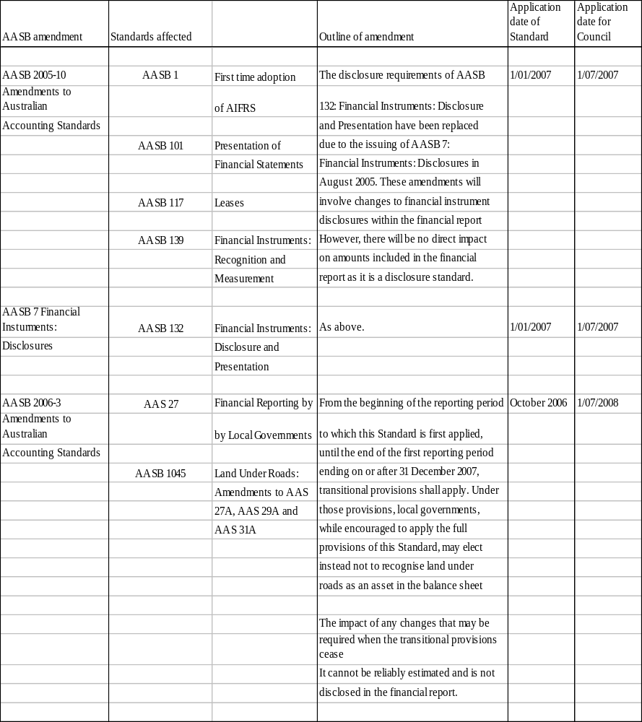
(u) Functional currency

The presentation currency of the City of Melbourne is the Australian dollar. The functional currency of each subsidiary throughout the group and the consolidated financial statements is also the Australian dollar.

Note 2. Operating result attributable to functions/activities (consolidated)

Revenues, expenses and assets have been attributed to the following functions.
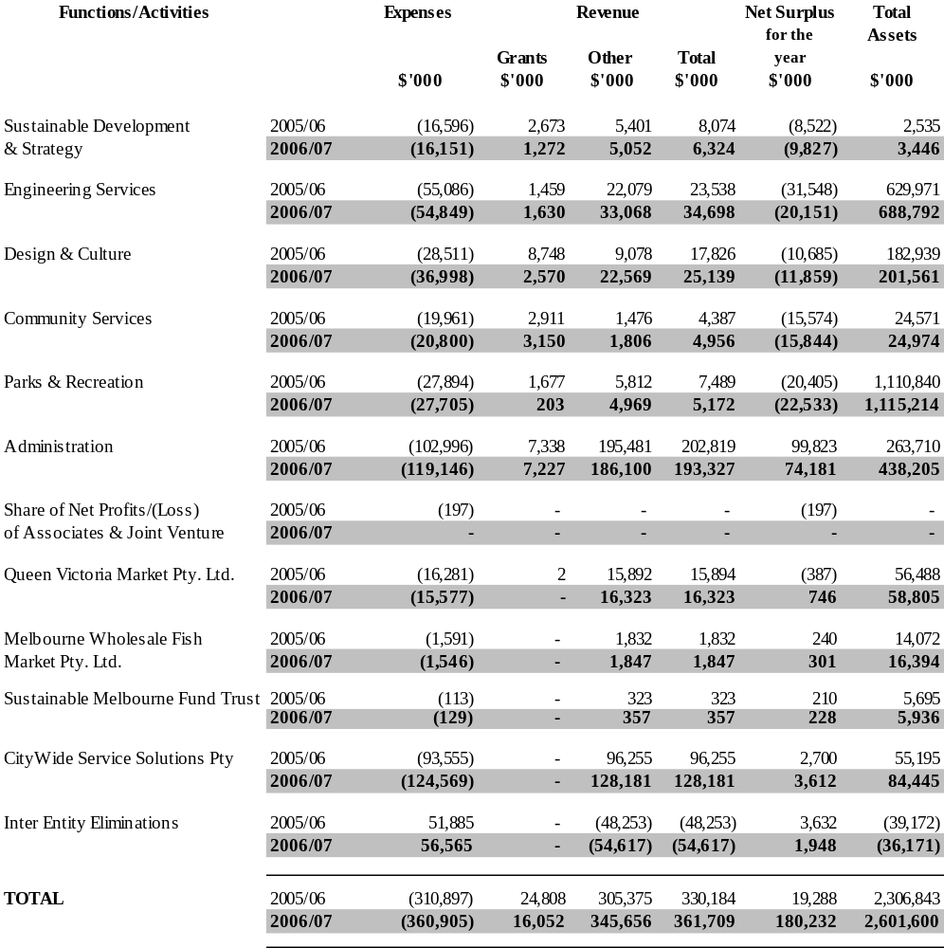

(b) A brief description of the goal of each function is as follows:

Sustainable Development and Strategy
To administer and coordinate regulations and laws in a way that enhances the sustainability and economic well being in the city and makes it more liveable. Effective liaison is sought with customers, service providers, relevant authorities and neighbourhood groups in an effort to find a balance between the need for some regulation and the need to encourage users to enjoy the city.

Engineering Services
To manage the city environment and maintain its infrastructure assets to make the city more accessible and attractive as a place to live, work, conduct business and visit, and to identify needs and provide services that contribute to the quality of life for city users.

Design and Culture
Design and Culture is responsible on behalf of the Council for providing urban design policy, advice, design, project management, property management including investment properties and real estate services. It also holds the responsibility for the delivery of a comprehensive arts and culture program.

Community Services
To identify needs and deliver a coordinated range of primary care, child care and public health services with the aim of improving the lifestyle of City of Melbourne residents, businesses and visitors while ensuring the cost-efficient management of community assets.

Parks and Recreation
To develop the City of Melbourne’s 700 hectares of gardens, parks and reserves, linked by gracious tree-lined boulevards, to become the best network of capital city gardens, parks and streetscapes in the world, and to promote the City as the sporting and leisure capital of Australia.

Administration
To provide a range of quality support functions to the Council which, in turn, assists Council in providing the highest standard of services to the community. These support functions include sound financial management, quality computing services, management of an efficient and motivated workforce and the delivery of effective communications services. Rate Revenue has been included in Administration as this revenue can not be attributed to any particular function.

CityWide Service Solutions Pty Ltd
To meet the contract service needs of local government, other governments, and private and public sector corporations by providing a comprehensive range of quality, physical services at competitive rates.

Queen Victoria Market Pty Ltd
To ensure that the market maintains and enhances an industry reputation as Australia’s foremost traditional market, whilst meeting world’s best practice standards.

Melbourne Wholesale Fish Market Pty Ltd
To ensure that the market is operated as a fully commercial business serving the needs of the fishing industry.

Sustainable Melbourne Fund Trust
The Sustainable Melbourne Fund (SMF) is a self sustaining fund set up by the City of Melbourne which invests funds in projects with environmental benefits to the city. The projects may extend beyond the boundaries of the City of Melbourne to the broader state of Victoria, reflecting the position of Melbourne as the capital city of Victoria.

Revenues from ordinary activities

Note 3. Revenues from ordinary activities

(a) Rates
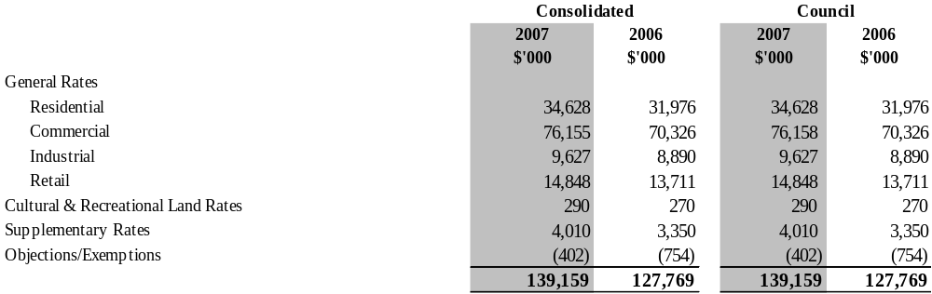
The City of Melbourne uses ‘net annual value’ as the basis of valuation of all properties within the municipal district. The net annual value of a property approximates the annual net rental for a commercial property and five per cent of the capital improved value for a residential property.
The date of the general valuation of land for rating purposes within the municipal district was 1 January 2006 and the valuation first applied to the rating period commencing 1 July 2006.

(b) Parking fees
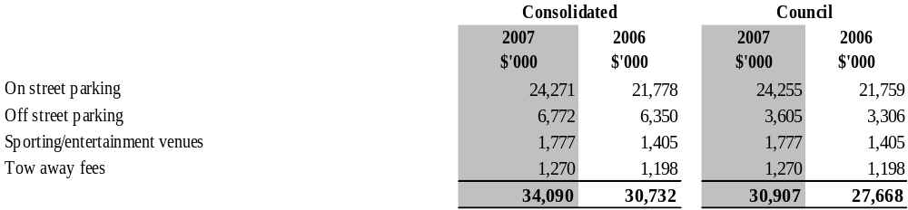

(c) Finance income
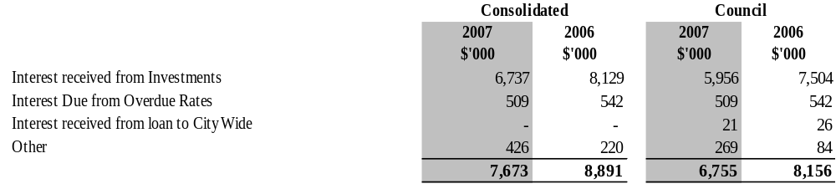
(d) Grants and other contributions were received in respect of the following:

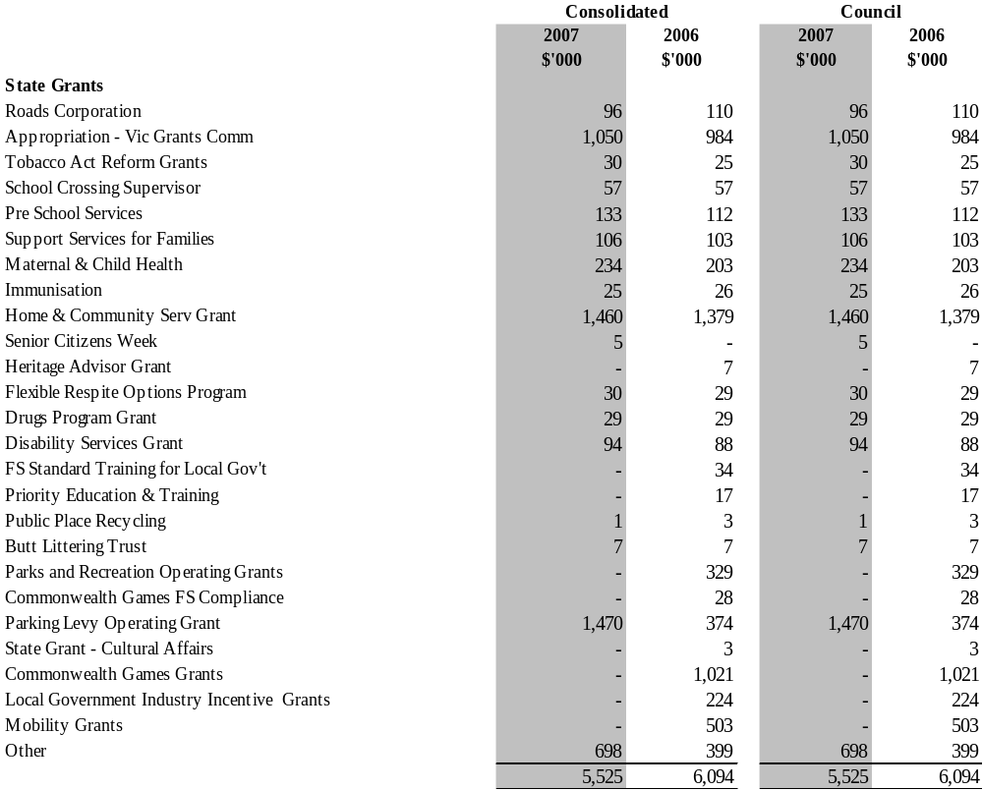

(d) Grants and other contributions were received in respect of the following: (continued)
 | Consolidated |  |  | Council
 | 2007 | 2006 |  | 2007 | 2006
 | $'000 | $'000 |  | $'000 | $'000
Federal Grants
Federal grant – aged and disability | 134 | 156 |  | 134 | 156
Federal grant – family and children | 21 | 127 |  | 21 | 127
Special needs subsidy scheme | 59 | 49 |  | 59 | 49
Federal grant – immunisation register | 15 | 14 |  | 15 | 14
Federal grant – community incentive | 7 | 16 |  | 7 | 16
Federal grant – other | 490 | 226 |  | 490 | 226
 | 726 | 588 |  | 726 | 588
Capital Grants
Capital grants | 3,335 | 9,074 |  | 3,335 | 9,522
Parking levy capital grant | 3,530 | 4,626 |  | 3,530 | 4,626
Public open space contributions | 862 | 2,265 |  | 862 | 2,265
 | 7,727 | 15,965 |  | 7,727 | 16,413
Total Other
Other contributions | 184 | 420 |  | 184 | 355
Child care benefit | 645 | 504 |  | 645 | 504
Sponsorships | 1,297 | 852 |  | 1,245 | 852
 | 2,126 | 1,776 |  | 2,074 | 1,711
Total grants and other contributions | 16,104 | 24,423 |  | 16,052 | 24,806

(e) Conditions over contributions
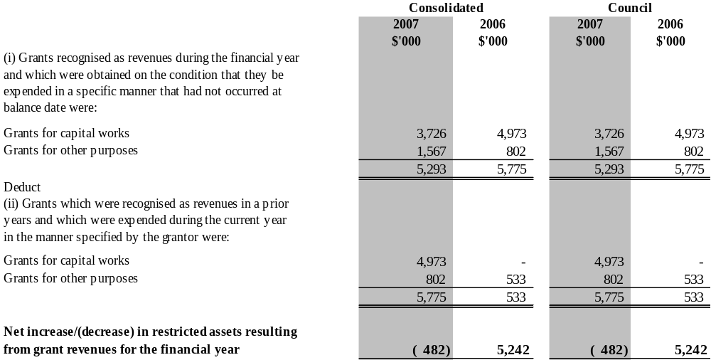

Expenses from ordinary activities

Note 4. Expenses from ordinary activities
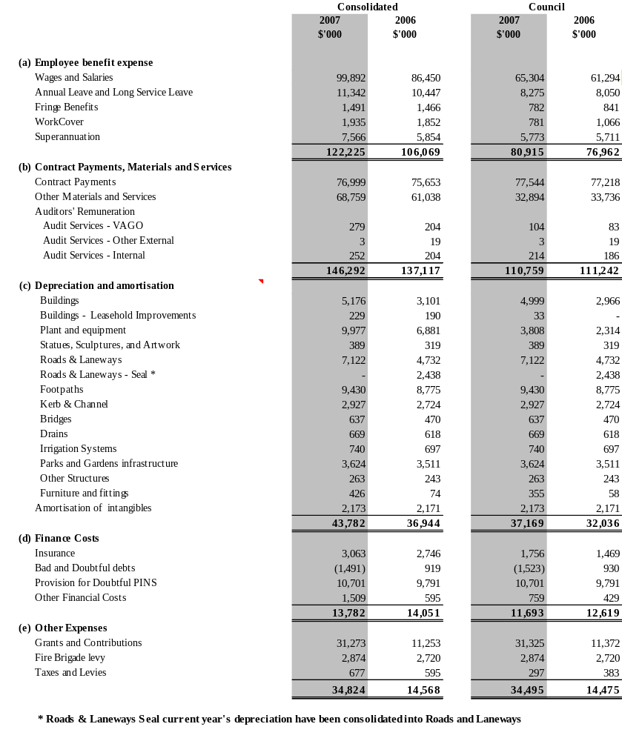

Assets
Note 5. Trade and other receivables

 | Consolidated |  |  | Council
 | 2007 | 2006 |  | 2007 | 2006
 | $'000 | $'000 |  | $'000 | $'000
Current
Rates | 1,353 | 1,317 |  | 1,353 | 1,317
Parking infringement debtors | 24,646 | 27,089 |  | 24,646 | 27,089
Provision for debts - parking infringement | (12,176) | (11,908) |  | (12,176) | (11,908)
Other debtors* | 195,493 | 15,627 |  | 184,803 | 6,733
Provision for doubtful debts - other debtors | (280) | (1,884) |  | (93) | (1,729)
GST receivable | 2,082 | 2,780 |  | 2,225 | 3,490
Loan to CityWide Solutions Pty Ltd | - | - |  | 76 | 77
 | 211 118 | 33 021 |  | 200 833 | 25 069

A receivable of $175.4 million has been recognised at 30 June 2007 representing the value of Docklands assets that will be received on 1 July 2007.

Note 6. Inventories
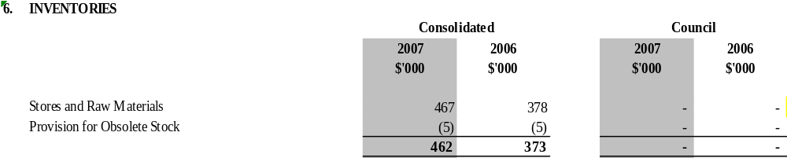
Note 7. Other financial assets

 | Consolidated |  |  | Council
 | 2007 | 2006 |  | 2007 | 2006
 | $'000 | $'000 |  | $'000 | $'000
Interests in Other Entities:

CityWide Service Solutions Pty Ltd | - | - |  | 18,406 | 18,406
Regent Management Company Pty Ltd | 2,776 | 2,776 |  | 2,776 | 2,776
MAPS Group Ltd | 250 | 250 |  | 250 | 250
Queen Victoria Market Pty Ltd | - | - |  | 200 | 200
Melbourne Wholesale Fish Market Pty Ltd | - | - |  | 5,000 | 5,000
Baycorp Advantage Limited | 16 | 16 |  | 16 | 16
Sustainable Melbourne Fund Trust | 0 | - |  | 5,000 | 5,000
Loan to CityWide Solutions Pty Ltd | - | - |  | 143 | 219
 | 3,042 | 3,042 |  | 31,791 | 31,867

Note 8. Other financial assets
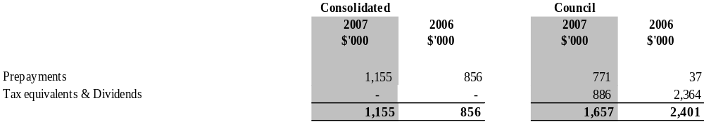

Note 9. Property, plant, equipment and infrastructure

 | Consolidated |  | Council
 | 2007 | 2006 | 2007 | 2006
 | $’000 | $’000 | $’000 | $’000
Land – freehold
At Council's valuation | 81,068 | 76,978 | 81,068 | 76,978
At independent valuation | 13,200 | 11,200 | - | -
At cost | 12,196 | 6,611 | - | -
 | 106,464 | 94,789 | 81,068 | 76,978
Land – other controlled
At Council's valuation | 993,490 | 993,490 | 993,490 | 993,490
Buildings on freehold land
At Council's valuation | 126,820 | 69,071 | 126,820 | 69,071
At cost | 3,164 | 3,015 | - | -
 | 129,984 | 72,086 | 126,820 | 69,071
Accumulated depreciation-valuation | - | - | - | -
Accumulated depreciation-cost | (655) | (478) |  | -
 | 129,329 | 71,608 | 126,820 | 69,071
Buildings on other controlled land
At Council's valuation | 39,161 | 37,440 | 39,161 | 37,440
Buildings – leasehold improvements
At cost | 4,039 | 1,721 | 2,269 | -
Accumulated depreciation | (1,064) | (835) | (33) | -
 | 2,975 | 886 | 2,236 | -
Plant and equipment
At cost | 83,911 | 60,261 | 29,955 | 18,016
Accumulated depreciation | (34,037) | (28,830) | (9,070) | (9,234)
 | 49,874 | 31,431 | 20,885 | 8,782
Furniture and fittings
At cost | 5,016 | 446 | 4,466 | 331
Accumulated depreciation | (914) | (296) | (564) | (209)
 | 4,102 | 150 | 3,901 | 122
Statues, sculptures and artworks
At cost | 43,807 | 43,328 | 43,807 | 43,328
Accumulated depreciation | (2,207) | (1,819) | (2,207) | (1,819)
 | 41,600 | 41,509 | 41,600 | 41,509
Roads and laneways
At Council's valuation | 382,635 | 363,727 | 382,635 | 363,727
Roads and laneways – seal *
At Council's valuation | - | 20,988 | - | 20,988
Footpaths
At Council's valuation | 95,811 | 92,689 | 95,811 | 92,689
Kerb and channel
At Council's valuation | 89,296 | 85,835 | 89,296 | 85,835
Bridges
At Council's valuation | 33,458 | 32,950 | 33,458 | 32,950
Drains
At Council's valuation | 65,207 | 18,865 | 65,207 | 18,865
Irrigation
At Council's valuation | 11,119 | 11,119 | 11,119 | 11,119
At cost | 3,282 | 2,750 | 3,282 | 2,750
 | 14,401 | 13,869 | 14,401 | 13,869
Accumulated depreciation-valuation | (2,879) | (2,303) | (2,879) | (2,303)
Accumulated depreciation-cost | (393) | (229) | (393) | (229)
 | (3,272) | (2,532) | (3,272) | (2,532)
 | 11,129 | 11,337 | 11,129 | 11,337
Parks and gardens infrastructure
At Council's valuation | 52,362 | 47,528 | 52,362 | 47,528
Trees
At Council's valuation | 30,093 | 29,611 | 30,093 | 29,611
Other structures
At Council's valuation | - | - | - | -
At cost | 3,395 | 3,369 | 3,395 | 3,369
Accumulated depreciation-cost | (506) | (243) | (506) | (243)
 | 2 889 | 3 126 | 2 889 | 3 126
Works in progress
At cost | 32,036 | 87,298 | 31,921 | 87,298
Total property, plant, equipment and infrastructure | 2,161,912 | 2,065,257 | 2,103,963 | 2,021,346

*Roads and laneways seal prior year's asset valuations has been consolidated into Roads and Laneways

The basis of valuation are included under note 1(n) in the Financial Report and have been conducted as follows:

(i) Valuations of Council Land and Buildings were determined by David Slicer, Valuer and Paul Ferguson, Senior Valuer, Rates and Valuations Branch, City of Melbourne.

Independent valuation of Land and Buildings were determined by Bruce Kerr, BBus (Prop), AAPI who is a certified practising valuer and member of the Australian Property Institute on behalf of Urbis JHD on the basis of a continuing use as a wholesale fish market.

(ii) Valuations of Infrastructure Assets (roads and laneways, footpaths, kerb and channel, bridges and drains) were determined by Gordon Duncan (Principal Engineer - Infrastructure, Engineering Services Group) and Bandara Rajapakse (Senior Infrastructure Engineer, Engineering Services Branch), City of Melbourne.

(iii) Valuation of Irrigation Assets was determined by Paul Newbold (Contracts Administrator) and Chris Adams (Projects Officer) Parks and Recreation Branch, City of Melbourne.

(iv) Valuation of Parks and Gardens Infrastructure were determined by Francis Khoo (Group Manager, Parks and Recreation Branch) and Chris Adams (Projects Officer) Parks and Recreation Branch, Paul Ferguson (Senior Valuer, Rates and Valuations Branch), City of Melbourne.

(v) Valuations of Trees were determined by Ian Shears - Senior Tree Planner, M.Appl.Sci (Hort) of Parks and Recreation, City of Melbourne.

All the above valuations were completed as at 30 June 2007, except for irrigation assets which was done in June 2002.Valuations for 30 June 2007 are at fair value. Unless otherwise stated the carrying value of each class of asset measured at fair value at balance date materially reflects their fair value at that date.

A review of future asset sales has been undertaken. However, at this stage there are no unconditional contracts of sale in place. Consequently the assets remain classified as non-current assets.

(a) Consolidated
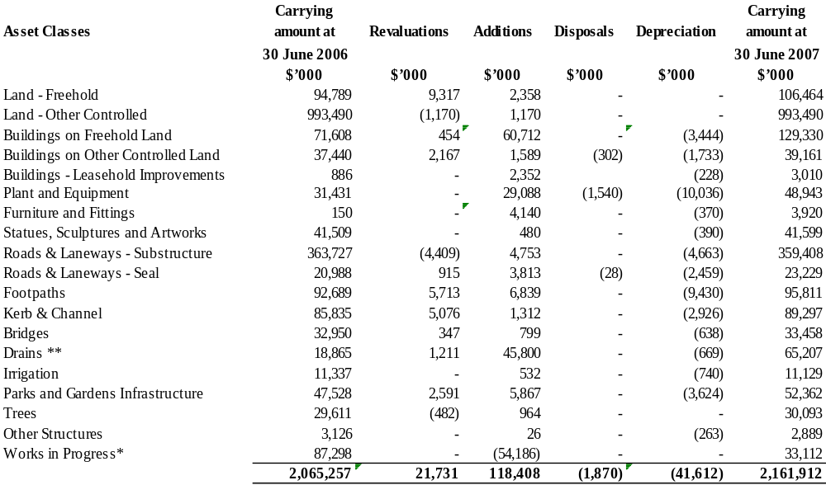

* Works in progress addition figure is a net amount consisting of $52.5million additional works in progress and $106.7million of assets capitalised during the financial year 2006/07.

** Additions to drains during 2006/07 also includes $41.5 million in found assets. Refer to note 1n (viv).
Asset Classes | Carrying amount at 30 June 2006 | Re-valuations | Additions | Disposals | Depreciation | Carrying amount at 30 June 2006
 | $’000 | $’000 | $’000 | $’000 | $’000 | $’000
Land - freehold | 76,978 | 3,411 | 679 | - | - | 81,068
Land - other controlled | 993,490 | (1,170) | 1,170 | - | - | 993,490
Buildings on freehold land | 69,071 | 454 | 60,563 | - | (3,267) | 126,821
Buildings on other controlled land | 37,440 | 2,167 | 1,589 | (302) | (1,733) | 39,161
Buildings - leasehold Improvements | - | - | 2,269 | - | (33) | 2,236
Plant and equipment | 8,782 | - | 16,951 | (1,042) | (3,806) | 20,885
Furniture and fittings | 122 | - | 4,134 | - | (356) | 3,900
Statues, sculptures and artworks | 41,509 | - | 480 | - | (390) | 41,599
Roads and laneways - substructure | 363,727 | (4,409) | 4,753 | - | (4,663) | 359,408
Roads and laneways - seal | 20,988 | 915 | 3,813 | (28) | (2,459) | 23,229
Footpaths | 92,689 | 5,713 | 6,839 | - | (9,430) | 95,811
Kerb and channel | 85,835 | 5,076 | 1,312 | - | (2,926) | 89,297
Bridges | 32,950 | 347 | 799 | - | (638) | 33,458
Drains ** | 18,865 | 1,211 | 45,800 | - | (669) | 65,207
Irrigation | 11,337 | - | 532 | - | (740) | 11,129
Parks and gardens infrastructure | 47,528 | 2,591 | 5,867 | - | (3,624) | 52,362
Trees | 29,611 | (482) | 964 | - | - | 30,093
Other structures | 3,126 | - | 26 | - | (263) | 2,889
Works in progress* | 87,298 | - | (55,379) | - | - | 31,919
 | 2,021,346 | 15,824 | 103,161 | (1,372) | (34,997) | 2,103,962
(b) Council

* Works in progress additions figure is a net amount consisting of $51.3 million additional works in progress and $106.7million of assets capitalised during the financial year 2006/07.

** Additions to drains during 2006/07 also includes $41.5 million in found assets. Refer to note 1n (viv).

Note 10. Intangible assets

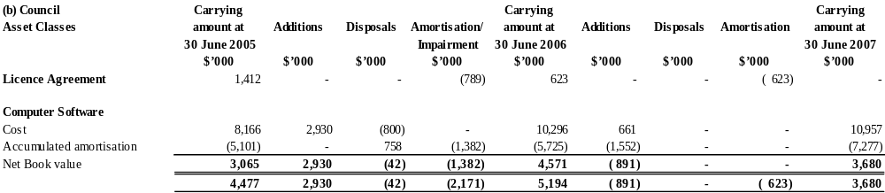

Note 11. Investment property

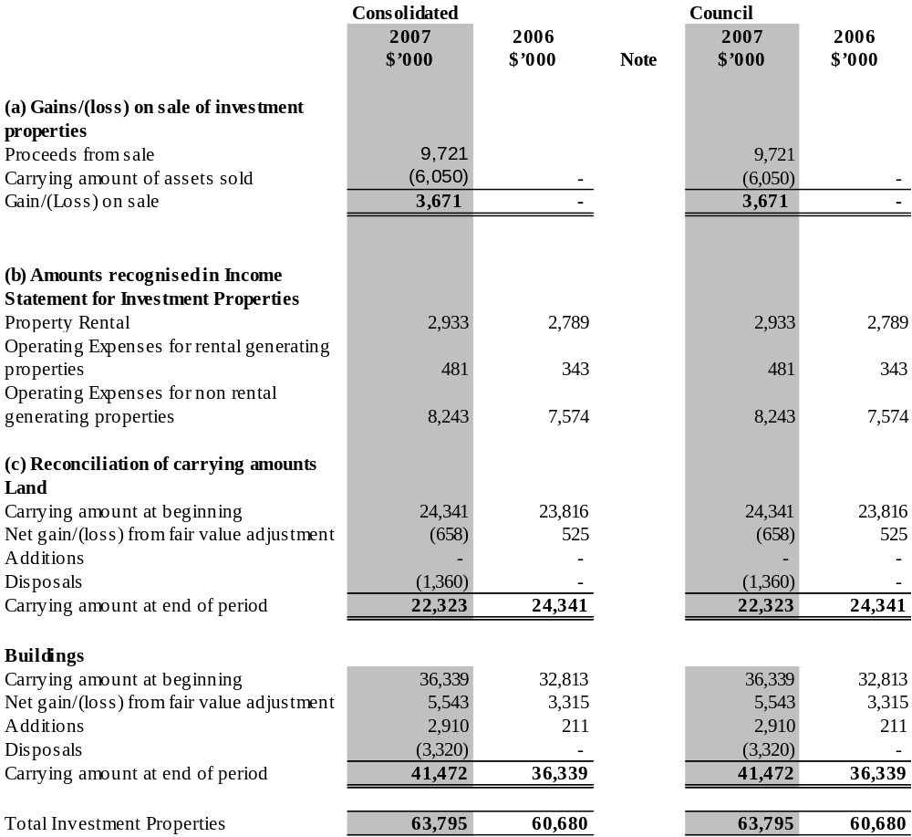

Liabilities
Note 12. Trade and other payables
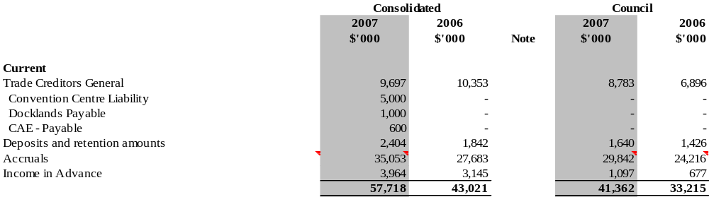

Note 12(a). Non-Current. Trade and other payables

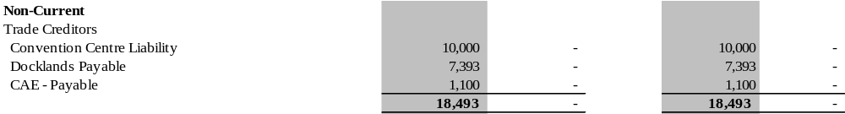

Note 13. Employee benefits

 | Consolidated |  |  | Council
 | 2007 | 2006 | Note | 2007 | 2006
 | $'000 | $'000 |  | $'000 | $'000
(a) Current
Long service leave | 11,959 | 10,371 | 1(f)(i) | 9,801 | 8,902
Annual leave | 11,462 | 10,183 |  | 7,551 | 7,327
Other | 1,401 | 777 |  | 1,401 | 720
 | 24,823 | 21,333 |  | 18,753 | 16,949
(b) Non-Current
Long service leave | 4,362 | 3,950 | 1(f)(i) | 3,150 | 3,064
 | 4,362 | 3,950 | 1(f)(i) | 3,150 | 3,064
Total employee benefits | 29,185 | 25,283 |  | 21,902 | 20,013
(c) Reconciliation of movements
Annual leave
Balance at the beginning of the financial year | 10,183 | 7518 |  | 7,327 | 6,783
Additional provisions | 9,640 | 10,123 |  | 6,269 | 5,673
Amounts used | (8,324) | (7,421) |  | (6,018) | (5,115)
Increase in the discounted amount because of time and the effect of any change in the discount rate | (37) | (37) |  | (27) | (14)
Balance at the end of the financial year | 11,462 | 10,183 |  | 7,551 | 7,327

Long service leave
Balance at the beginning of the financial year | 14,321 | 14,045 |  | 11,966 | 10,351
Additional provisions | 2,851 | 657 |  | 1,786 | 1,947
Amounts used | (769) | (299) |  | (746) | (276)
Increase in the discounted amount because of time and the effect of any change in the discount rate | (82) | (82) |  | (56) | (56)
Balance at the end of the financial year | 16,321 | 14,321 |  | 12,950 | 11,966
(d) Current employee benefits disclosure
Employee benefits entitlements
- that fall due within 12 months after the end of the period measured at nominal value | 12,872 | 11,062 |  | 8,989 | 8,147
- that do not fall due within 12 months after the end of the period measured at present value | 11,951 | 10,271 |  | 9,764 | 8,802
 | 24,823 | 21,333 |  | 18,753 | 16,949

Note 14. Provisions
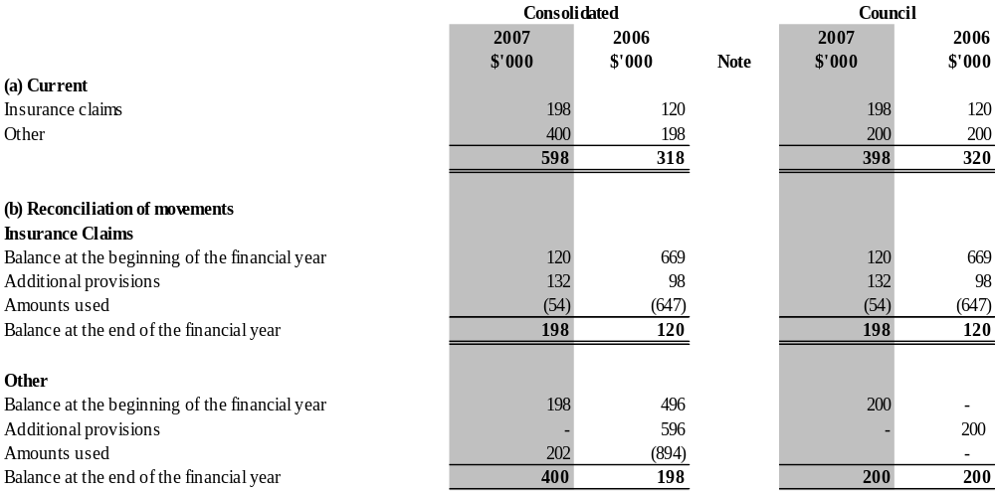

Equity
Note 15. Reserves

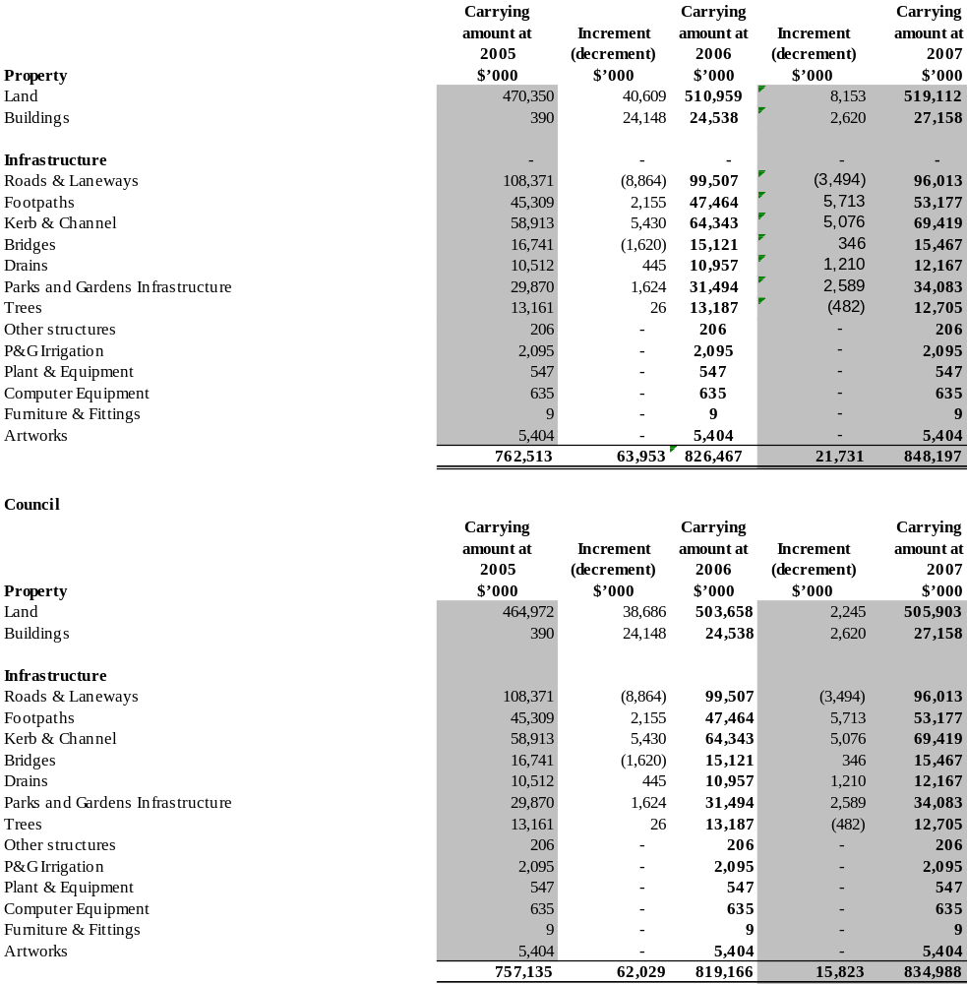

Other disclosures
Note 16. Gains/(loss) on sale of fixed and intangible assets

 | Consolidated |  |  | Council
 | 2007 | 2006 |  | 2007 | 2006
 | $'000 | $'000 |  | $'000 | $'000
Land and buildings
Proceeds from sales | 8,740 | - |  | 8,740 | -
Carrying amount of assets sold | (4,982) | (140) |  | (4,982) | (140)
Gain/(loss) on sale | 3,759 | (140) |  | 3,759 | (140)
Plant, equipment and infrastructure
Proceeds from sales | 981 | 1,807 |  | 981 | 1,120
Carrying amount of assets sold/disposed | (1,068) | (5,095) |  | (1,068) | (4,512)
Gain/(Loss) on sale | (88) | (3,288) |  | (88) | (3,392)
Computer software
Proceeds from sales | - | - |  | - | -
Carrying amount of assets sold/disposed | - | (42) |  | - | (42)
Gain/(loss) on sale | - | (42) |  | - | (42)
Total proceeds from sale of assets | 9,721 | 1,807 |  | 9,721 | 1,120
Total carrying amount of assets sold | (6,050) | (5,277) |  | (6,050) | (4,694)
Total gain/(loss) on sale | 3,671 | (3,470) |  | 3,671 | (3,574)

Note 17. Investments accounted for using the equity method

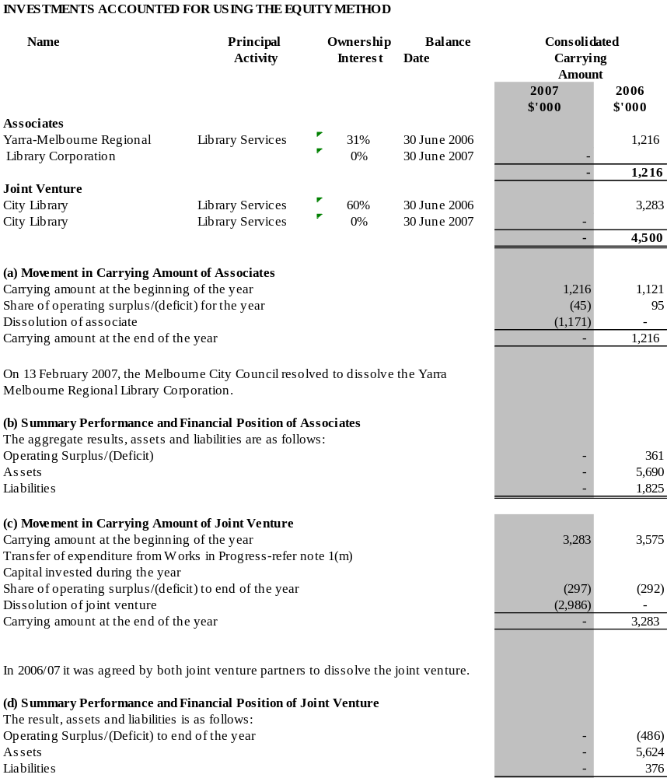

Note 18. Cash flow information
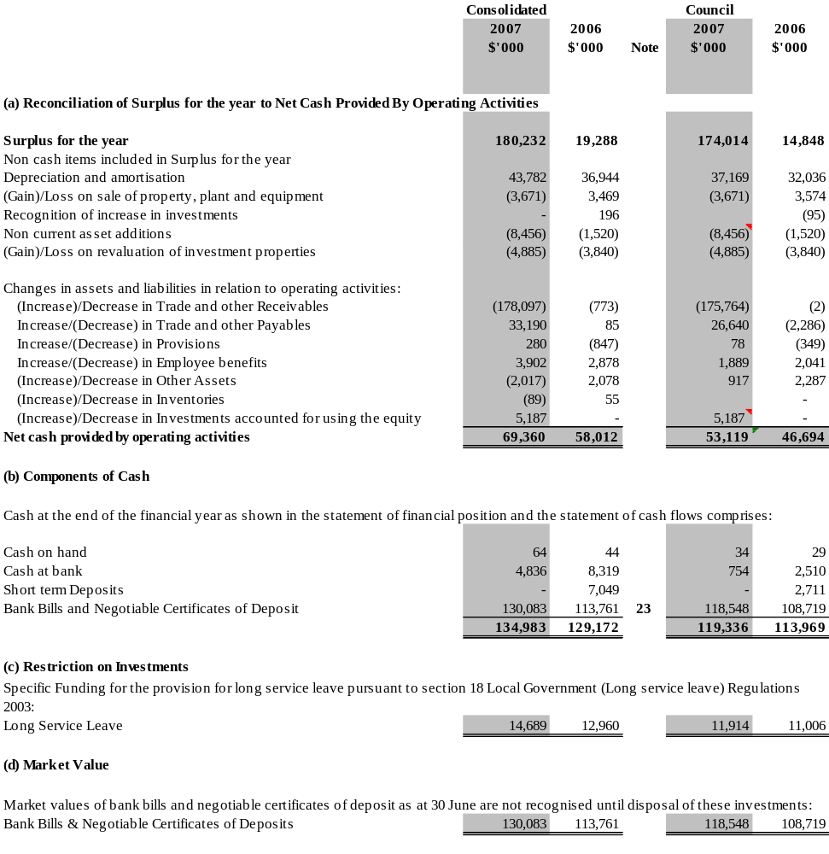

Note 19. Leases and commitments
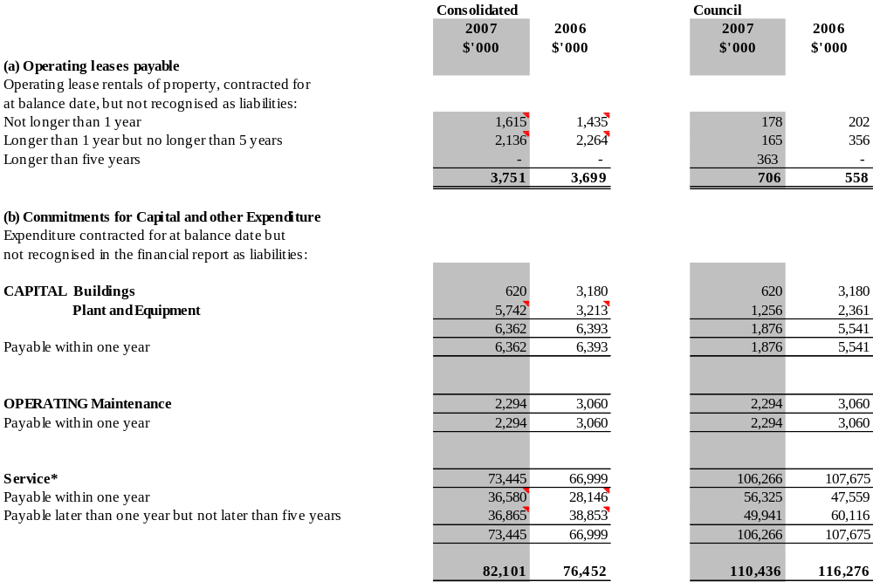

* Service contracts are for a maximum period of five years.

Note 20. Contingent assets and liabilities

(a) Guarantees

Melbourne City Council and the State Government of Victoria have indemnified, in equal shares, Regent Management Company Pty Ltd against any liability, loss or expense incurred or suffered by the Company. Over the financial year, no calls on this indemnity were made.

At 30 June 2007 there are no outstanding Melbourne City Council bank guarantees.

Note 20A. Melbourne Wholesale Fish Market

The Melbourne Wholesale Fish Market Pty Ltd had offered the business for sale through a tender process from the short listed Expression of Interest Registrants. The tender process has now been terminated. The Council has formally resolved that, in the event that alternative solutions for the market do not come to fruition, that the market will be wound up and that market closed no later than 31 March 2009. Accordingly the financial statements of the Melbourne Wholesale Fish Market will not be prepared on a ‘going concern’ basis in forward years.

Note 20B. Docklands

Legislation to transfer the municipal responsibility for the Docklands precinct to the City of Melbourne received Royal Assent on the 10th October 2006. The transfer will occur on 1st July 2007. A receivable of $175.4 million has been recognised at 30 June 2007 representing the value of assets that will be received on that date.

In addition, the Council entered into an agreement with the State of Victoria to fund the estimated cash deficit of $8.393 arising from this transfer. The $8.393 million has been recognised as a liability as at 30 June 2007. The Council intends to pay this liability over the next five years using cashflows generated form the Dockland precinct.

An amount of $167.0 million as also been taken to account in the profit and loss as contributed assets in relation to the transfer.

As part of the transition, the City of Melbourne will also take over City of Docklands Precinct Debtors in relation to Rates, Marina Berthing Charges and Parking Infringement Notices in existence at 30th June 2007. The City of Melbourne will pay fair value to VicUrban for these debtor balances.

Note 21. Superannuation

Melbourne City Council makes employer superannuation contributions in respect of its employees to the Local Authorities Superannuation Fund (the Fund) and employee nominated approved accumulation superannuation funds. Obligations for contributions are recognised as an expense in the Income Statement when they are due.
Most contributions are to the Local Authorities Superannuation Fund. The Fund has three categories of membership, each of which is funded differently.

Accumulation members

The Fund’s accumulation category, Vision Super Saver, receives both employer and employee contributions on a progressive basis. Employer contributions are normally based on a fixed percentage of employee earnings (nine per cent required under the Superannuation Guarantee Legislation). No further liability accrues to the employer as the superannuation benefits accruing to employees are represented by their share of the net assets of the Fund.

Defined benefits members

The Fund's Defined Benefit Plan is a multi-employer sponsored plan. As the Fund's assets and liabilities are pooled and are not allocated by employer, the Actuary is unable to reliably allocate benefit liabilities, assets and costs between employers. As provided under Paragraph 32 (b) of AASB 119, Melbourne City Council does not use defined benefit accounting for these contributions.
Melbourne City Council makes employer contributions to the defined benefit category of the Fund at rates determined by the Trustee on the advice of the Fund's Actuary. On the basis of the results of the most recent full actuarial investigation conducted by the Fund's actuary as at 31 December 2005, the Trustee has determined that the current funding arrangements are adequate for the expected Defined Benefit Plan liabilities. Melbourne City Council makes the following contributions:

- 9.25 per cent of members’ salaries (same as previous year); and

- the difference between resignation and retrenchment benefits paid to its retrenched employees plus contributions tax (same as previous year).

The Fund's liability for accrued benefits was determined in the 30 June 2006 actuarial review pursuant to the requirements of Australian Accounting Standard AAS25 as follows:
30-June-2006
$ million
Net market value of assets | 3,443.6
Accrued benefits (per accounting standards) | 3,319.6
Difference between assets and accrued benefits | 124.0
Vested benefits | 3,040.4

The financial assumptions used to calculate the Accrued Benefits for the defined benefit category of the Fund were:

Net investment return | 8.0% p.a.
Salary inflation | 5.5% p.a.
Price Inflation | 3.0% p.a.

City of Melbourne Superannuation Sub Plan (CMSSP) Members

A separate plan is operated for City of Melbourne defined benefit members. The CMSSP was closed to new members on 23 December 1993.
The CMSSP is a multi-employer sponsored plan. As the Fund's assets and liabilities are pooled and are not allocated by employer, the Actuary is unable to reliably allocate benefit liabilities, assets and costs between employers. As provided under Paragraph 32 (b) of AASB 119, Council does not use the defined benefit accounting for these contributions, but as the majority of the members of the fund are employees of the Melbourne City Council group, the surplus or deficit of the fund is recorded in accordance to AASB119 at the consolidated level for reporting purposes. Member profiles will be reviewed periodically to determine if and when reporting at the individual entity level became appropriate.

The Melbourne City Council makes employer contributions to the defined benefits category of the Fund at rates determined by the Fund’s Trustee on advice of the actuary. On the basis of the results of the most recent update of the full actuarial investigation conducted by the Fund’s actuary as at 30 June 2006, the Trustee has determined that the funding arrangements were adequate for the expected CMSSP liabilities and Melbourne City Council makes the following contributions:

- eight per cent of members’ salaries (up until 30th November 2006), and four per cent thereafter; and
- the difference between resignation and retrenchment benefits paid to its retrenched employees (same as previous year).

The CMSSP Fund’s liability was determined in the 31 December 2006 actuarial investigation pursuant to the requirements of the Australian Accounting Standard AAS 25 as follows:

30-June 2006
$ million
Net market value of assets | 65.6
Accrued benefits (per accounting standards) | 51.7
Difference between assets and accrued benefits | 13.9
Vested benefits | 54.9
Vested befits index | 119%

An asset of $8.445 million is recognised in the consolidated financial statements as the Council’s share of the scheme’s assets, being the difference between the present value of employees’ accrued benefits and the net market value of the scheme’s assets at balance date.

The total amount of superannuation contributions paid by Melbourne City Council (inclusive of its wholly owned subsidiaries Queen Victoria Market Pty Ltd and Melbourne Wholesale, Fish, Market Pty Ltd.) during the year was $6,126,377 (2006: $5,888,007).

Council has an ongoing obligation to share in the future experience of the Local Authorities Superannuation Fund Defined Benefits sub-plan and the City of Melbourne Superannuation sub-plan. Favourable or unfavourable variations may arise should the experience of the Funds differ from the assumptions made by the Funds’ actuary in estimating the Funds’ accrued benefit liability.

CityWide Services Solutions Pty Ltd contributes in respect of its employees to the following sub-plans of the Local Authorities Superannuation Fund:

- The City of Melbourne sub-plan;
- The Defined Benefits sub-plan; and
- The Accumulation sub-plan.

The amount of superannuation contributions paid by CityWide Service Solutions Pty Ltd during the year was $2,413,663 (2006: $1,766,940).

The consolidated amount of superannuation contributions paid during the year was $8,540,040 (2006: $7,654,947).
Note 22. Related party transactions

(a) Names of persons holding the position of a Responsible Person at the Melbourne City Council during the financial year were:
Councillors
John So |  |  | Gary Singer |  | David R. Wilson |  |  |  |  | Catherine Ng
Carl Jetter |  |  | Fraser Brindley |  | Brian Shanahan |  |  |  |  | Peter Clarke
Fiona Snedden
Chief Executive Officer |  |  | David Pitchford
(b) Remuneration of Responsible Persons in bands of $ 20,000
 |  |  |  |  |  |  | 2007 |  | 2006
Remuneration Range |  |  |  |  |  |  | No. |  | No.
$20,000 - $39,999 |  |  |  |  |  |  | 7 |  | 7
$40,000 - $59,999 |  |  |  |  |  |  | - |  | -
$60,000 - $79,999 |  |  |  |  |  |  | 1 |  | 1
$120,000 - $139,999 |  |  |  |  |  |  | 1 |  | 1
$300,000 - $319,999 |  |  |  |  |  |  | - |  | 1
$340,000 - $359,999 |  |  |  |  |  |  | 1 |  | -
 |  |  |  |  |  |  | 10 |  | 10
 |  |  |  |  |  |  | 2007 |  | 2006
 |  |  |  |  |  |  | $'000 |  | $'000
Total Remuneration for the financial year for Responsible Persons included above, amounted to: |  |  |  |  |  |  | 765 |  | 675
(c) Senior Officers' Remuneration
The number of Senior Officers, other than the Responsible Persons, whose total remuneration including separation payments exceeded $100,000 during the financial year, are shown below in their relevant income bands:
 |  |  |  |  |  |  |  | 2007 |  |  | 2006
 | Remuneration Range |  |  |  |  |  |  | No. |  |  | No.
 | $100,000 - $119,999* |  |  |  |  |  |  | 61 |  |  | 31
 | $120,000 - $139,999^* |  |  |  |  |  |  | 21 |  |  | 26
 | $140,000 - $159,999^ |  |  |  |  |  |  | 19 |  |  | 9
 | $160,000 - $179,999^* |  |  |  |  |  |  | 5 |  |  | 11
 | $180,000 - $199,999 |  |  |  |  |  |  | 6 |  |  | 2
 | $200,000 - $219,999^ |  |  |  |  |  |  | 3 |  |  | -
 | $220,000 - $239,999 |  |  |  |  |  |  |  |  |  | 2
 | $240,000 - $259,999 |  |  |  |  |  |  | 2 |  |  | 3
 | $260,000 - $279,999 |  |  |  |  |  |  | 2 |  |  | 1
 | $280,000 - $299,999^ |  |  |  |  |  |  | 1 |  |  | -
 | $300,000 - $319,999^ |  |  |  |  |  |  | 2 |  |  | -
 | $440,000 - $459,999^ |  |  |  |  |  |  | 1 |  |  | -
 | $560,000 - $579,999^ |  |  |  |  |  |  | 1 |  |  | -
 |  |  |  |  |  |  |  | 124 |  |  | 85
 |  |  |  |  |  |  |  | 2007 |  |  | 2006
 |  |  |  |  |  |  |  | $'000 |  |  | $'000
Total Remuneration for the financial year for Senior Officers included above, amounted to: |  |  |  |  |  |  |  | 17,374 |  |  | 11,634

The higher Senior Officer’s remuneration during 2006/07 was primarily attributable to separation payments for staff who departed as a result of an organisational efficiency review conducted by the City of Melbourne and an additional 42 staff who moved into the >$100,000 band as a result of “Bracket Creep”.
^ includes separation payments for 2006/07.
* includes separation payments for 2005/06.

- No retirement benefits were paid by the Council in connection with the retirement of Responsible Persons during the financial year or in the previous financial year.

- Other Transactions
Other related party transactions requiring disclosure this financial year have been considered and there are no matters to report. There were no matters to report in the previous financial year.

- Wholly-Owned Group
Melbourne City Council is the ultimate parent entity in the wholly-owned group. Transactions with the controlled entities, CityWide Service Solutions Pty Ltd, Queen Victoria Market Pty Ltd and Melbourne Wholesale Fish Market Pty Ltd during the year comprised of the following: car rental services, provision of accounting and administration services, property rental, contract sales, purchases of raw materials and plant and equipment and in accordance with the Tax Equivalence Policy, the receipt of payments which included tax equivalents for income tax, and payroll tax where applicable. These transactions were made on normal commercial terms and conditions and at market rates.

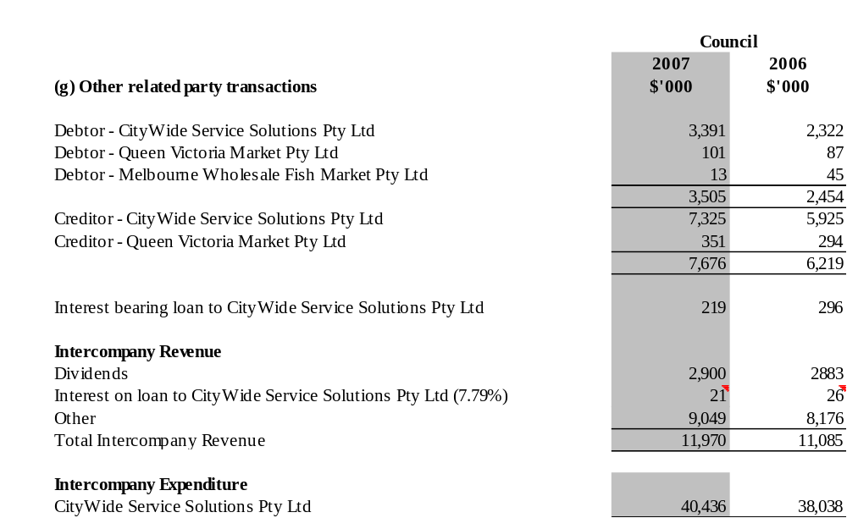

Note 23. Financial instruments
Accounting Policy, terms and conditions

Financial instruments | Note | Accounting Policy | Terms and Conditions
Financial assets
Cash and cash equivalents | 18 | Cash on hand and at bank and money market call account are valued at face value. | Council: On call deposits returned a floating interest rate of 5.92% (5.28% in 2005/2006).
Bank bills and negotiable certificates of deposits | 18 | Interest is recognised as it accrues.  Investments and bills are valued at cost.  Investments are held to maximise interest returns of surplus cash.  Fixed interest securities are valued at cost. | Council: Managed fund provided return of 6.07% (5.78%in 2005/2006) excluding unrealised gains/losses
Trade and other receivables
Rate debtors | 5 | Rates are carried at nominal amounts due plus interest. Rate debts are a charge attached to the rateable land and are recoverable on sale, therefore, no provision for doubtful debts is made. Interest rates are reviewed annually. | Rates are payable by four instalments during the year. Arrears, including deferred rates, attract interest. The interest rate was 11% (11.0% in 2005/2006) at balance date for general rates.
Parking infringement debtors | 5 | PINs/PERIN Court debtors are measured at nominal amounts due less any provision for doubtful debts. A provision for doubtful debts is recognised when collection in full is no longer probable.  Collectability of overdue accounts is assessed on an ongoing basis. | Parking infringements are unsecured.  The provision for parking infringement doubtful debts is calculated as a percentage of total parking infringement revenue and has been evaluated and recognised based on previous payment and collection history.
Other debtors | 5 | Receivables are carried at nominal amounts due less any provision for doubtful debts. A provision for doubtful debts is recognised when collection in full is no longer probable.  Collectability of overdue accounts is assessed on an ongoing basis. | General debtors are unsecured.  Credit terms are based on 30 days from date of invoice.
Investments | 7 | Investments for the Council include all wholly owned subsidiaries, wholly controlled trust of the Council and associated entities.  Investments the consolidated entity includes interests in other entities and associated entities. | Investments in other entities are valued at historical cost.  Investments in associate entities are accounted for using equity accounting principles.
Financial liabilities
Trade and other payables | 12 | Liabilities are recognised for amounts to be paid in the future for goods and services provided to Council as at balance date whether or not invoices have been received. | General Creditors are unsecured, not subject to interest charges and are normally settled within 30 days from date of invoice.

(a) Interest rate risk

The consolidated entity's exposure to interest rate risk, repricing maturities and effective weighted average interest rates on financial instruments at balance date is set out below:

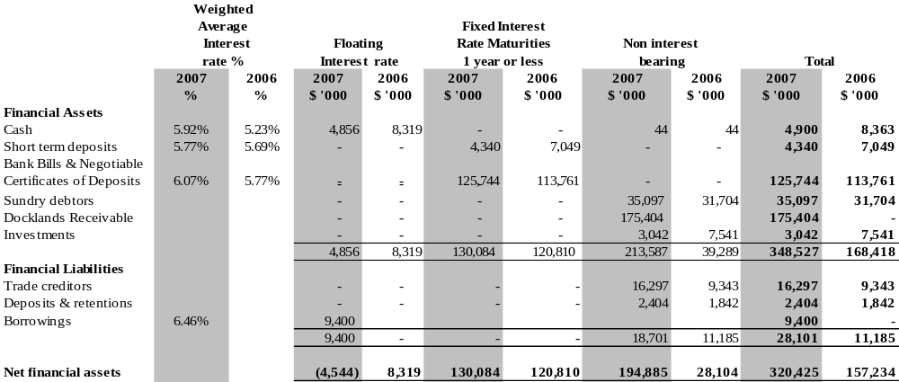

The Council’s exposure to interest rate risk, repricing maturities and effective weighted average interest rates on financial instruments at balance date is set out below:

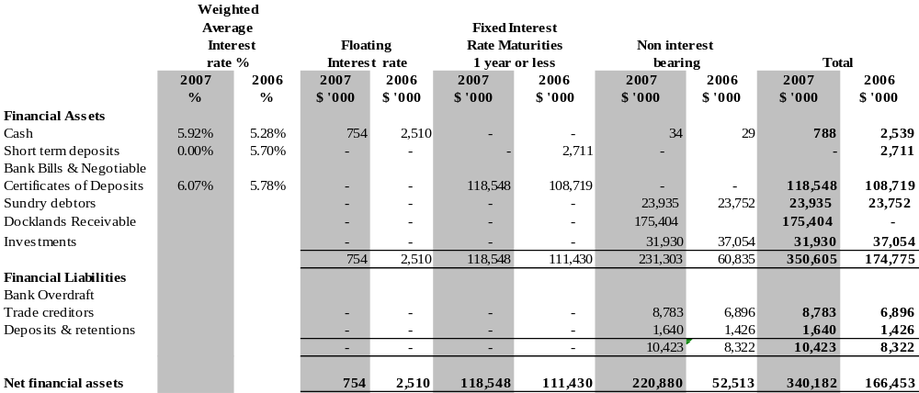

(b) Reconciliation of net financial assets to net assets

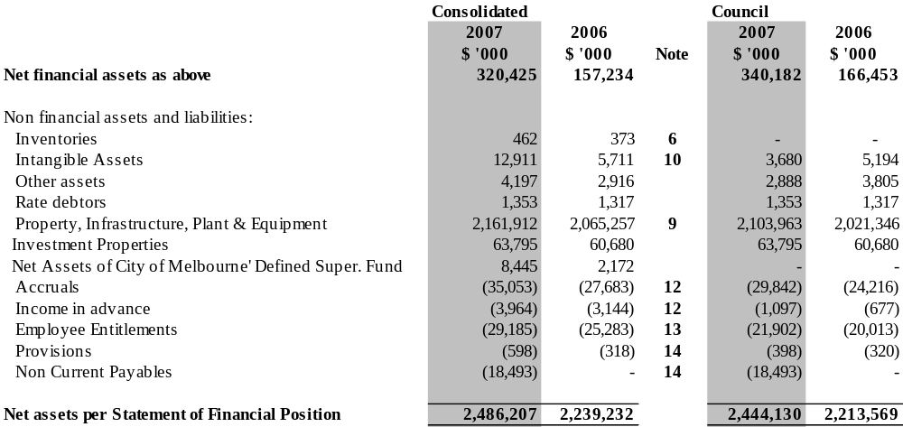
(c) Net fair values
The aggregate net fair value of financial assets and financial liabilities, both recognised and unrecognised at balance date are as follows:

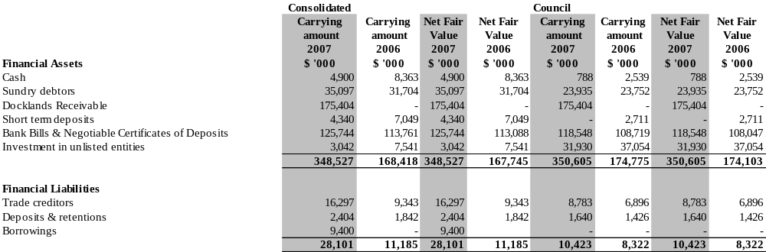

The following methods and assumptions are used to determine the net fair values of financial assets and liabilities:

- Cash, cash equivalents and short-term deposits - the carrying amount approximates fair value because of their short term to maturity.
- Trade debtors and creditors - the carrying amount approximates fair value.
- Bank bills and negotiable certificates of deposits - there are market prices quoted daily for securities issued by any of the major four banks.
- For any other securities, a reasonable estimate of the fair value has been determined by reference to the current market value of a quoted security, and adding a credit risk margin, which is determined by reference to historical data.
- Fixed interest securities are valued at cost.
(d) Credit risk exposures
The credit risk on financial assets of the economic entity which have been recognised in the Balance Sheet is generally the carrying amount, net of any provisions for doubtful debts.

Note 24. Financial rations
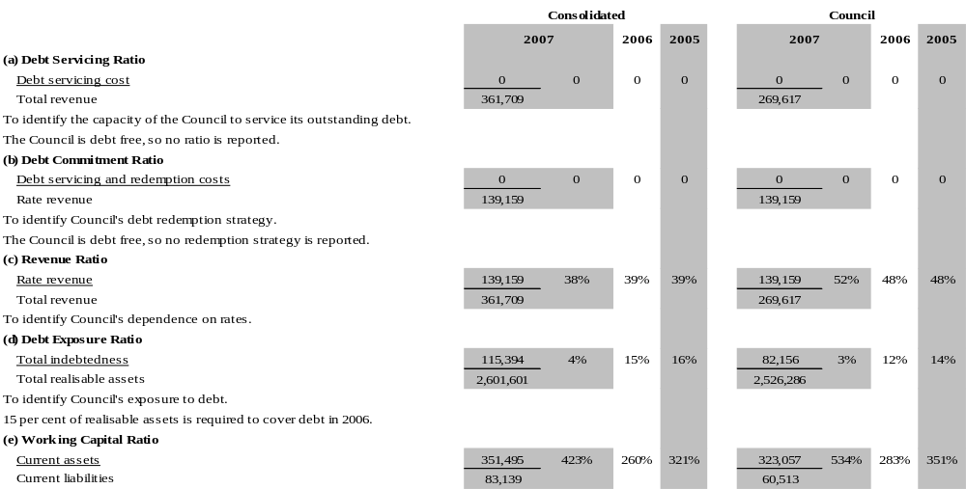
To assess Council's ability to meet current commitments.
For every dollar of current liabilities, Council has $4.23 of current assets in 2007.

Definitions

Current assets | Total current assets as shown in the balance sheet.
Current liabilities | Total current liabilities as shown in the balance sheet.
Debt redemption | Includes the principal component of repayments on loans and financial leases and capital items purchased on vendor terms.
Debt servicing costs | Includes interest and charges on loans, overdrafts and interest on payments for capital items purchased on vendor terms.
Rate revenue | Includes revenue from general rates, municipal charges, special rates, special charges, service rates and service charges.
Total indebtedness | Total liabilities, both current and non-current, as shown in the balance sheet.
Total realisable assets | Total current assets and total realisable non-current assets.
Total revenue | Total revenue as shown in the income statement.

Statement by Councillors, Chief Executive and Principal Accounting Officer on the Financial Report

For the year ended 30 June 2007

In my opinion the accompanying Financial Report and Standard Statements have been prepared in accordance with the Local Government Act 1989, the Local Government (Finance and Reporting) Regulations 2004, Australian Accounting Standards and other mandatory professional reporting requirements.

Martin Cutter (FCA)
Principal Accounting Officer

In our opinion the accompanying Financial Report presents fairly the financial transactions of the Melbourne City Council Group and the Melbourne City Council for the year ended 30 June 2007 and the financial position of the Melbourne City Council Group and Melbourne City Council as at that date.

As at the date of signing, we are not aware of any circumstance, which would render any particulars in the Financial Report to be misleading or inaccurate.

We were authorised by the Council on 28 August 2007 to certify the Financial Report in its final form.

John So Brian Shanahan
Lord Mayor Councillor

David Pitchford
Chief Executive

Melbourne
29 August, 2007

Auditor-General’s Report on the Financial Report

Melbourne City Council

To the Councillors

Matters Relating to the Electronic Presentation of the Audited Financial Report and Standard Statements

This auditor’s report for the financial year ended 30 June 2007 relates to the financial report of Melbourne City Council included on its website. The Councillors of the City of Melbourne are responsible for the integrity of the website. I have not been engaged to report on the integrity of the website. The Auditor’s report refers only to the statements named below. An opinion is not provided on any other information which may have been hyperlinked to or from these statements. If users of this report are concerned with the inherent risks arising from electronic data communications, they are advised to refer to the hardcopy of the audited financial report to confirm the information included in the audited financial report presented on this website.

The Financial Report and Standard Statements

The accompanying financial report for the year ended 30 June 2007 of Melbourne City Council which comprises of income statement, balance sheet, statement of cash flows, statement of changes in equity, a summary of significant accounting policies and other explanatory notes to and forming part of the financial report, and the statement by Councillors, Chief Executive and Principal Accounting Officer on the financial report has been audited.

The accompanying standard statements for the year ended 30 June 2007 of Melbourne City Council which comprises of standard statement of income, standard statement of balance sheet, standard statement of cash flows (reconciliation), standard statement of cash flows and standard statement of council works, the related notes and the statement by Councillors, Chief Executive and Principal Accounting Officer on the financial report have been audited.

The Responsibility of the Councillors for the Financial Report and Standard Statements

The Councillors of Melbourne City Council are responsible for the preparation and the fair presentation of:

- the financial report in accordance with Australian Accounting Standards (including the Australian Accounting Interpretations) and the financial reporting requirements of the Local Government Act 1989 (Vic).
- the standard statements in accordance with the basis of preparation as described in note 1 of the statements and the requirements of the Local Government Act 1989 (Vic).

This responsibility includes:

- establishing and maintaining internal controls relevant to the preparation and fair presentation of the financial report and standard statements that are free from material misstatement, whether due to fraud or error
- selecting and applying appropriate accounting policies
- making accounting estimates that are reasonable in the circumstances.

Auditor’s Responsibility

As required by the Audit Act 1994, my responsibility is to express an opinion on the financial report and standard statements based on the audit, which has been conducted in accordance with Australian Auditing Standards. These standards require compliance with relevant ethical requirements relating to audit engagements and that the audit be planned and performed to obtain reasonable assurance whether the financial report and standard statements are free from material misstatement.

An audit involves performing procedures to obtain audit evidence about the amounts and disclosures in the financial report and standard statements. The audit procedures selected depend on judgement, including the assessment of the risks of material misstatement of the financial report and standard statements, whether due to fraud or error. In making those risk assessments, consideration is given to internal control relevant to the Councillors preparation and fair presentation of the financial report and standard statements in order to design audit procedures that are appropriate in the circumstances, but not for the purpose of expressing an opinion on the effectiveness if the Council internal control. An audit also includes evaluating the appropriateness of the accounting policies used,and the reasonableness of accounting estimates made by the Councillors as well as evaluating the overall presentation of the financial report and standard statements.

I believe that the audit evidence obtained is sufficient and appropriate to provide a basis for my audit opinion.

Independence

The Auditor-General’s independence is established by the Constitution Act 1975. The Auditor-General is not subject to direction by any person about the way in which his powers and responsibilities are to be exercised. The Auditor-General, his staff and delegates comply with all applicable independence requirements of the Australian accounting profession.

Auditor’s Opinion

In my opinion:

- the financial report presents fairly, in all material respects, the financial position of Melbourne City Council as at 30 June 2007 and its financial performance and cash flows for the year then ended in accordance with applicable Australian Accounting Standards (including the Australian Accounting Interpretations), and the financial reporting requirements of the Local Government Act 1989 (Vic).
- the standard statements present fairly, in all material respects, in accordance with the basis of preparation as described in note 1 to the statements and comply with the requirements of the Local Government Act 1989 (Vic).

For D.D.R. Pearson
Auditor-General

Melbourne
31 August, 2007

