
City Road Master Plan
Transforming City Road into a safe
and welcoming place for everyone
2016-2023
Planning for future growth
City Road Master Plan webpage
A connected city
We manage movement in and around our growing city to help people trade, meet, participate and move about safely and easily, enabling our community to access all the services and opportunities the municipality offers.
City Road Master Plan web page
Contents
Master Plan snapshot 8
Part One: Master plan overview 12
1. Introduction 14
2. Master Plan actions 23
Part Two: What makes a great street? 33
3. A connection to the past 34
4. Meeting the needs of the future 42
5. Balancing priorities in a limited space 45
Part Three: Master Plan actions 51
Action 1. Transform City Road West into a great central city street 52
Action 2. Reimagine kings way undercroft as a community space 70
Action 3. Upgrade city road east to be safer and easier to get around 83
Action 4. Connect City Road to the Arts Centre and Yarra River 94
Action 5. Connect the gardens 106
Action 6. Expand the bicycle network within Southbank 110
Part Four: Next steps 113
6. How could the master plan be delivered? 114
Appendix: Figure descriptions 124
How to contact us 150

Issue 9 - City Road Master Plan (Incorporating minor edits following Future Melbourne Committee)
July 2016

Disclaimer
This report is provided for information and it does not purport to be complete. While care has been taken to ensure the content in the report is accurate, we cannot guarantee that the report is without flaw of any kind. There may be errors and omissions or it may not be wholly appropriate for your particular purposes. In addition, the publication is a snapshot in time based on historic information which is liable to change. The City of Melbourne accepts no responsibility and disclaims all liability for any error, loss or other consequence which may arise from you relying on any information contained in this report.
To find out how you can participate in the decision-making process for City of Melbourne’s current and future initiatives, visit the City of Melbourne’s ‘Get involved’ web page.
List of figures and images
Figure 0.1: Percentage of positive and negative experiences shared online 8
Figure 0.2: City Road Master Plan study area 9
Figure 0.3: Potential increases in journey times in minutes between Cecil Street and Linlithgow Avenue, showing the two routes most impacted by the proposals 11
Image: Artist’s impression of City Road looking west towards Balston Street, following improvements as outlined in the master plan 13
Figure 1.1: City Road Master Plan project timeline 15
Figure 1.2: City Road Master Plan study area 16
Image: Boyd Community Hub, City Road 17
Figure 1.3: City Road and related projects within the wider central city context 19
Figure 1.4: Positive and negative experiences of City Road shared online 20
Figure 1.5: Experience of City Road shared online 21
Figure 1.6: Combined feedback results for the overall draft master plan and six actions 22
Image: Pop-up event in the Kings Way Undercroft as part of the community engagement on the draft master plan, October 2015 22
Figure 1.7: Existing transport routes on City Road and Alexandra Avenue in the broader Southbank context 25
Figure 1.8: Summary of proposed actions (full details contained in part three of the master plan) 26
Figure 1.9: Proposed changes to City Road and Alexandra Avenue 28
Figure 1.10: VicRoads Traffic Volumes 2013 29
Figure 1.11: VicRoads CrashStats 2008-2012 for City Road 30
Figure 1.12: Example of the variation in travel times experienced on City Road from Cecil Street to St Kilda Road (PM peak) 31
Figure 1.13: Potential increases in journey times in minutes as a result of the actions in the master plan (between Cecil Street and Linlithgow Avenue 32
Figure 2.1: Melbourne circa 1850s facing north with the wetlands of Southbank visible in the foreground 34
Figure 2.2: Alexandra Avenue circa 1940s-1950s 35
Figure 2.3: Draffin Bros electric hot water service at 43-47 City Road (now Opera Australia) circa 1930s 36
Figure 2.4: The intersection of City Road and St Kilda Road connecting at grade prior to the lowering of City Road circa 1945 37
Figure 2.5: Arts Centre during construction with St Kilda Road to the left of image circa 1960s 37
Figure 2.6: Southbank and City Road circa 1980s 38
Image: City Road in 2015: the front door to thousands of residents and workers 39
Figure 2.7: Number of homes within the blocks fronting City Road in 2005. 40
Figure 2.8: Number of homes within the blocks fronting City Road in 2015. 40
Figure 2.9: Number of jobs within the blocks fronting City Road in 2005. 41
Figure 2.10: Number of jobs within the blocks fronting City Road in 2015. 41
Figure 2.11: The evolution of Southbank from industrial precinct to central city (2008) 43
Figure 2.12: Estimated increase in residents walking to work in Southbank 43
Figure 2.13: The evolution of Southbank into the densest suburb in Melbourne (2016) 44
Figure 2.14: Percentage of positive and negative experiences shared online 46
Image: Pedestrian walking west along City Road, crossing the tram line at the Kings Way undercroft 46
Figure 2.15: Street design elements that prioritise the efficient movement of different modes of transport 47
Figure 2.16: Street design elements that prioritise sustainability and water management 48
Figure 2.17: Street design elements that prioritise activity and street amenity 49
Figure 3.1: City Road West between Clarendon Street and Power Street 52
Image: Pedestrians crossing City Road at Queens Bridge Street, in front of Boyd Community Hub 53
Figure 3.2: Existing conditions of City Road (Clarendon Street to Queens Bridge Street) 54
Figure 3.3: The dominance of car infrastructure along City Road (between Clarendon Street and Queens Bridge Street) creates an undesirable place for pedestrians 55
Figure 3.4: The street is unattractive, creating a poor quality pedestrian environment and character 55
Figure 3.5: Proposed design of City Road (Clarendon Street to Queens Bridge Street) 56
Figure 3.6: Existing conditions of City Road looking east towards Queens Bridge Street (Section A) 57
Figure 3.7: Proposed conditions of City Road looking east towards Queens Bridge Street (Section A) 57
Figure 3.8: Existing view of City Road looking east towards Kings Way undercroft (Clarendon Street to Queens Bridge Street) 58
Figure 3.9: Artist’s impression of proposed conditions in City Road looking east towards Kings Way undercroft (Clarendon Street to Queens Bridge Street) 59
Figure 3.10: Existing conditions of City Road (Queens Bridge Street to Power Street) 60
Figure 3.11: Existing conditions along City Road resulting in a lack of pedestrian access to the Boyd Community Hub 61
Figure 3.12: Existing conditions along City Road looking east towards Power Street 61
Figure 3.13: Proposed design in City Road West between Queens Bridge Street and Power Street 62
Figure 3.14: Existing view along City Road looking south towards Boyd Community Hub (between Queens Bridge Street and Power Street) 63
Figure 3.15: Artist’s impression of proposed conditions along City Road looking south towards Boyd Community Hub (between Queens Bridge Street and Power Street) 63
Figure 3.16: Existing conditions of City Road between Queens Bridge Street and Balston Street, looking east towards Power Street (Section A) 64
Figure 3.17: Proposed conditions of City Road looking east towards Power Street (Section A) 64
Figure 3.18: Existing conditions of City Road between Queens Bridge Street and Balston Street, looking east towards Power Street (Section B) 65
Figure 3.19: Proposed conditions of City Road looking east towards Power Street (Section B) 65
Figure 3.20: Increase in journey times between Cecil Street and Power Street 67
Figure 3.21: Current view looking west along City Road between Power Street and Balston Street 68
Figure 3.22: Artist’s impression of proposed conditions looking west along City Road between Power Street and Balston Street 69
Figure 3.23: Flooding conditions surrounding the location of Kings Way Undercroft 71
Figure 3.24: Kings Way Undercroft and surrounds 72
Image: Kings Way Undercroft looking east towards the Boyd Community Hub 73
Figure 3.25: Artist’s impression of potential uses that could occur in the Kings Way Northern Undercroft space 75
Figure 3.26: Existing conditions of Kingsway Northern Undercroft 76
Figure 3.27: Existing view of City Road Park looking south towards Boyd Community Hub 77
Figure 3.28: Artist’s impression of potential changes to City Road Park looking south towards Boyd Community Hub 77
Figure 3.29: Artist’s impression of potential changes to City Road Park looking south towards Boyd Community Hub 78
Figure 3.30: Artist’s impression of potential open space upgrades looking north towards Kings Way Southern Undercroft 80
Figure 3.31: Existing view looking north towards Kings Way Southern Undercroft 81
Image: Tram passing through the Kings Way Southern Undercroft, looking north towards Crown 82
Figure 3.32: City Road East between Power Street and St Kilda Road 84
Figure 3.33: Large intersections along City Road (looking west at Southbank Boulevard) create unsafe and inconvenient crossing conditions 85
Figure 3.34: Proposed upgrade to City Road (between Power Street and Southbank Boulevard) 87
Figure 3.35: Existing view of City Road looking east towards the Arts Precinct (City Road and Southbank Boulevard) 88
Figure 3.36: Existing slip lane condition on City Road East 88
Figure 3.37: Artist’s impression of proposed conditions looking east towards the Arts Precinct (City Road and Southbank Boulevard) 89
Figure 3.38: Proposed slip lane removal in City Road East 89
Figure 3.39: Proposed upgrade to City Road (between Southgate Avenue and St Kilda Road) 90
Figure 3.40: Increase in journey times between Power Street and Linlithgow Avenue 92
Image: Closure of slip lanes can create opportunities for landscaping and improve safety by increasing space available for pedestrians waiting to cross at lights. This example shows the corner of King Street and Flinders Street. 93
Figure 3.41: Location of the Arts Centre interface with City Road 94
Figure 3.42: Arts Centre/St Kilda Road Study Area showing potential pedestrian connection improvements 95
Figure 3.43: Existing pedestrian and cycling connections are poor quality, indirect and difficult to find 97
Figure 3.44: Proposed connections that improve accessibility between the Arts Precinct, the Hoddle grid and Southbank 97
Figure 3.45: Artist’s impression of potential public realm upgrades looking east towards the Arts Centre 98
Figure 3.46: Existing view of Southgate Avenue looking east towards the Arts Centre 99
Figure 3.47: Existing view of Southgate Avenue looking south towards the Arts Centre 99
Figure 3.48: Existing connections between the Yarra River and St Kilda Road 100
Figure 3.49: Proposed connections between the Yarra River and St Kilda Road 100
Figure 3.50: Artist’s impression of potential upgrades to Southgate Avenue looking south towards the Arts Centre 101
Figure 3.51: Existing pedestrian and cycling connections are poor, indirect and difficult to find 102
Figure 3.52: Potential connections will activate frontages around City Road and provide direct access to the arts precinct 102
Figure 3.53: Artist’s impression of possible upgrades to connect City Road to the Arts Centre looking east towards Alexandra Avenue 103
Figure 3.54: Existing view of City Road underpass looking east towards Alexandra Avenue 104
Image: City Road at the corner of Fanning Street, looking east towards Testing Grounds and the existing stairs up to St Kilda Road 105
Figure 3.55: Indicative location of the proposed pedestrian crossing on Alexandra Avenue between St Kilda Road and Linlithgow Avenue 106
Image: Vehicles travelling along Alexandra Avenue, looking west towards St Kilda Road 108
Figure 3.56: Proposed upgrade to Alexandra Avenue (between Linlithgow Avenue and St Kilda Road) 109
Figure 3.57: Proposed bicycle route (orange) through Southbank with existing network (green) 110
Image: Cyclists riding west along City Road at the Kings Way undercroft 112
Image: Swanston Street creates a pleasant pedestrian environment with wide bluestone footpaths, established shady trees and central city street furniture 115
Figure 4.1: Related projects to the City Road Master Plan 116
Figure 4.2: The six actions in the master plan 119
Figure 4.3: City Road Master Plan next steps plan 122

Master Plan snapshot

Why do we need a City Road Master Plan?
The need to improve City Road is now more important than ever.
As Southbank transforms into a high density central city neighbourhood, the role of City Road needs to change to ensure that it is a pleasant place to be, as well as a street that is easy and safe to get around.
Figure 0.1: Percentage of positive and negative experiences shared online
Source: Community Engagement 2014
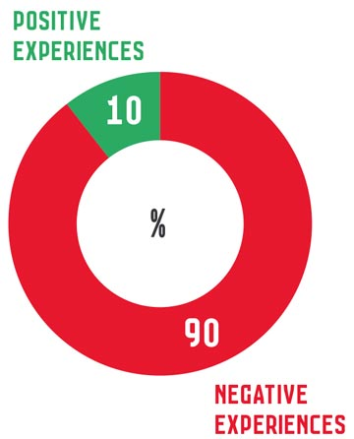
Figure 0.2: City Road Master Plan study area
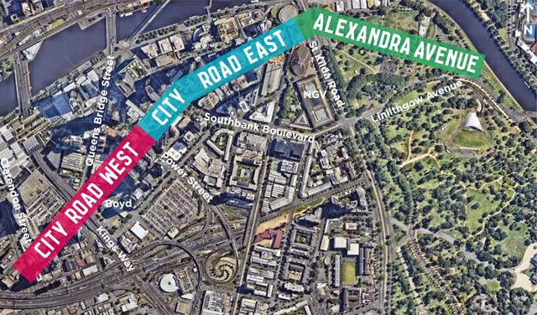
Description of figure 0.2

What does the Master Plan aim to achieve?
The City Road Master Plan aims to transform City Road into a safe and welcoming place for everyone.
It addresses ways to better balance the road’s two primary roles – as an important transport corridor for various modes, and a place that supports local street life that is people-friendly for all the residents, workers and visitors who use City Road.
It includes ways of making City Road more environmentally sustainable, contributing to a liveable and resilient city.

What does the Master Plan propose?
The master plan includes six actions to deliver improvements to the road and adjacent spaces over a seven year period.

Master Plan actions
- Transform City Road West into a great central city street.
- Reimagine Kings Way undercroft as a community space.
- Upgrade City Road East to be safer and easier to get around.
- Connect City Road to the Arts Centre and Yarra River.
- Connect the gardens.
- Expand the bicycle network within Southbank.

What will be the benefits and impacts of the proposal?
The benefits of the proposed improvements to City Road are significant and will deliver a street that is safer, enjoyable to be in, more sustainable and distinctive.
Detailed traffic modelling has been undertaken to develop and understand the impact of the actions in the master plan.
Whilst there will be some minor increases in vehicle journey times (see part one and part three for more detail) the various benefits of the proposals are considered to outweigh these impacts.

Safe and easy to get around
- 700 metres of safe separated bicycle lanes on City Road
- 6 slip lanes removed for improved safety and increased pedestrian space
- 3 upgraded bus and tram stops and improved public transport priority
- 70 metres reduced walking distance between pedestrian crossings (from 240m to 170m)

Impacts
- 1:37 minute increase to an average car journey from Cecil Street to Linlithgow Avenue in PM peak from 7:27 to 9:04 minutes
- 1:51 minute increase to an average car journey from Linlithgow Avenue to Cecil Street in AM peak from 5:29 to 7:20 minutes
- 40 on-street car parking spaces removed

Environmentally sustainable
- 98 new street trees
- 30% of public space to be water permeable surfaces
- 40% tree canopy cover target

A great place to be
- 9085 square metres of potential new public open space
- 1280 square metres of new footpath space
- 3 new signalised pedestrian crossings at Clarke Street, Balston Street and Alexandra Avenue

How has the Master Plan been prepared?
The master plan has been informed by two rounds of community engagement, detailed analysis, stakeholder discussions and ongoing involvement from key project stakeholders.
Figure 0.3: Potential increases in journey times in minutes between Cecil Street and Linlithgow Avenue, showing the two routes most impacted by the proposals
Source: GHD Traffic Modelling Report, July 2015
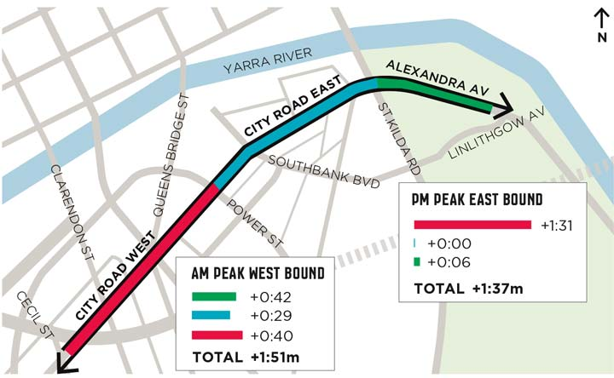
Description of figure 0.3

Part One: Master plan overview
In this part you will find out:
- Why we have produced a Master Plan
- How the community were involved
- A summary of the Master Plan actions
Image: Artist’s impression of City Road looking west towards Balston Street, following improvements as outlined in the master plan
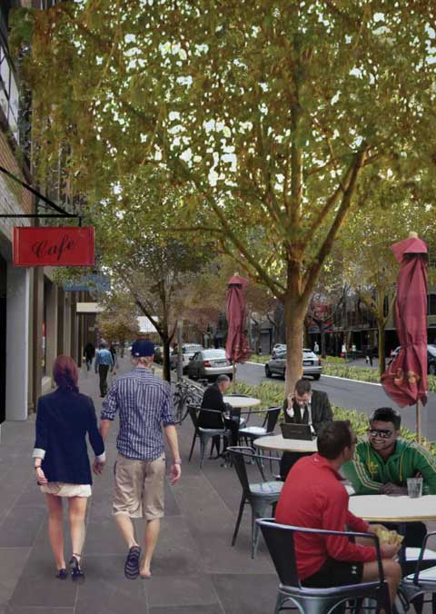
Description of image

1. Introduction

Why do we need a Master Plan for City Road?
Southbank is part of the rapidly growing central city. It has transformed since the 1980s from an industrial suburb into a thriving inner city neighbourhood. It is home to 18,250 residents, almost 900 businesses with 33,600 workers and is the centre of a globally recognised arts precinct.
City Road has been the main street of this suburb since European settlement when it was established as the original route connecting settlers to Port Phillip Bay. It is now the central spine of one of Melbourne’s most densely populated central city neighbourhoods, which continues to grow with an additional 7000 people expected to call Southbank home by 2021.
Southbank has changed dramatically, but the design of City Road has not kept up with this change and the street fails to meet the needs of the local community.
The design of the street reflects its more recent industrial past, prioritising east-west vehicular movements rather than walking and cycling throughout the Southbank neighbourhood.
It is a difficult street to cross, unsafe, noisy and poorly landscaped. While footpaths are generous in some locations, at intersections they frequently become narrow, congested and feel unsafe. There is no room for cyclists in the street and public transport stops are in poor condition.
The City Road Master Plan aims to balance the road’s two primary roles – as an important transport corridor and as a place that supports local street life, that is people-friendly and safe for all the residents, workers and visitors who use City Road. It also considers how to make central Melbourne more environmentally sustainable, contributing to a more liveable and resilient city.
This master plan aims to create a 21st century street; a street that locals can be proud of, a street that is comfortable to be in as a pedestrian, safe to cross, with welcoming and generous footpaths. A street that is characterised by beautiful trees and an active street life enabled through the provision of generous pedestrian space.
This means balancing the various transport modes and ensuring it enables people to get where they need to go whether they are walking, cycling, driving or catching public transport.
The local community are strongly in support of improving City Road. The resounding opinion of the community during our engagement activity in February to March 2014 was that City Road needs to be significantly improved to meet people’s needs and aspirations.
The road has to transform from being an unwelcoming, unsafe and unpleasant traffic corridor, into a place that people choose to be.
Community engagement on the draft master plan in September to October 2015 revealed a high level of support for proposals in the draft master plan with close to three quarters of responses being supportive of all or most of it.
This project delivers a key action from the Southbank Structure Plan 2010, and responds directly to the feedback about how the road is experienced from the initial community engagement in 2014.
Figure 1.1: City Road Master Plan project timeline
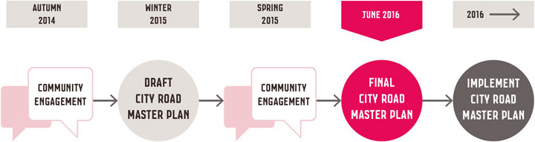
Description of figure 1.1

How has the Master Plan been prepared?
The master plan has been informed by community feedback, detailed traffic modelling throughout Southbank, as well as ongoing discussions with key stakeholders such as VicRoads, the management authority for the road carriageway and project partner.
The design proposals consider traffic capacity requirements, arterial route functions and limitations presented by the need to fit multiple functions into the 30 metre wide reserve of City Road. The master plan presents the preferred response to different parts of the road.
For further detail on background material used to inform this master plan, please refer to the following documents available online:
- City Road Draft Master Plan (September 2015)
- Transport and Access Report
- Community Engagement Summaries (phase one and phase two)
- Issues and Opportunities Report
- Traffic Modelling Report

Which parts of City Road does the Master Plan affect?
The study area extends from Clarendon Street in the west to St Kilda Road in the east and includes Alexandra Avenue to the intersection with Linlithgow Avenue. In total, the study area is approximately two kilometres long (see figure 1.2).
The master plan considers the road in three sections:
- City Road West - Clarendon Street to Power Street.
- City Road East - Power Street to the St Kilda Road.
- Alexandra Avenue - St Kilda Road to Linlithgow Avenue.
Each section of the road presents different opportunities for improvement.
The public spaces near the Boyd Community Hub have also been addressed in this study area. These include the Kings Way Undercroft and City Road Park on the corner of Queens Bridge Street and City Road.
The lowering of City Road in the 1970s severed the historic connection of City Road to St Kilda Road, making it more difficult to access the city from Southbank. The connections between City Road and St Kilda Road (at the Arts Centre) have therefore also been reviewed.
Any upgrades to City Road west of Clarendon Street will be developed in future coordination with the City of Port Phillip.
Figure 1.2: City Road Master Plan study area
Description of figure 1.2

How can we achieve improvements in City Road?
The master plan is a seven year plan for delivering improvements within the road reserve (the traffic lanes and footpaths) and some public spaces adjacent to the road.
It proposes improvements to the layout and design of the road to better balance the priorities given to different transport modes - walking, cycling, driving and public transport as well as improvements to the character and enjoyment of the street, through footpath widening, tree planting, new paving and street furniture.
In order to ensure that the master plan is grounded and deliverable in a realistic time frame, the master plan has been influenced by the following drivers:

The Master Plan can happen.
It is important to ensure that the master plan is both aspirational but realistic and deliverable, subject to potential funding decisions, within the next seven years.
City Road will continue to play an important role in Melbourne’s road transport network. In particular, City Road east of Power Street provides a bypass from the Burnley Tunnel for oversized or placarded vehicles (trucks carrying goods that are not allowed through the tunnel).
VicRoads, the management authority for the road carriageway, has confirmed that this function will remain for the foreseeable future. As this master plan is a seven year plan, it provides solutions that retain this placarded vehicle access while still improving the performance of the street.

The Master Plan is supported by the decision makers.
Proposed changes to the road need to be supported by both authorities that manage it – City of Melbourne and VicRoads. That is why the City of Melbourne has worked closely with VicRoads, the key project partner, to deliver the master plan.
The project requires partnership with other key organisations who are either responsible for the way the road is designed and functions or are directly impacted by the road design. These include:
- Public Transport Victoria
- Arts Centre Melbourne
- City of Port Phillip
- Victorian Government
- Yarra Trams and bus operators

The Master Plan is supported by the community.
The needs and aspirations of the community are intrinsic to the delivery of the master plan and is why it has been informed by two rounds of community engagement, at the beginning of the project and at the draft master plan stage.
Image: Boyd Community Hub, City Road
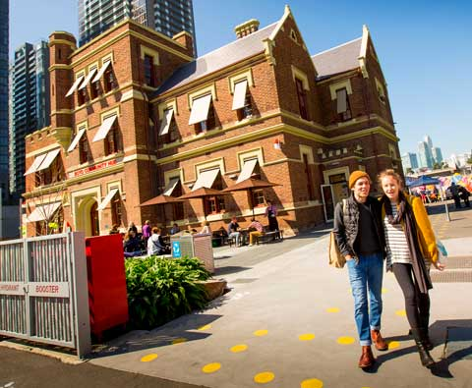

The Master Plan aligns with other projects, plans and strategies to improve Southbank.
The master plan vision aligns with other significant projects being undertaken in the vicinity of City Road, such as Transforming Southbank Boulevard, Boyd Park and the Arts Blueprint (Arts Victoria) (see figure 1.3).
The master plan also aims to deliver on the goals and objectives of existing City of Melbourne strategies and plans, including:
- Bicycle Plan 2016-2020
- Motorcycle Plan 2015-2018
- Open Space Strategy 2012
- Places for People 2015
- Total Watermark 2014
- Transport Strategy 2012-2030
- Urban Forest Strategy 2012-2032
- Walking Plan 2014-2017
- Zero Net Emissions by 2020
VicRoads is currently developing a ‘Movement and Place Transport Planning Framework’. The framework highlights the importance of roads and streets in not only providing for the efficient and safe movement of people, goods and services, but also providing great places that contribute to the look, feel and reputation of Victoria.
This master plan demonstrates principles that align with the framework, aiming to respond to the changing needs of City Road as both a movement corridor and a place for people along the different parts of the road.
Figure 1.3: City Road and related projects within the wider central city context
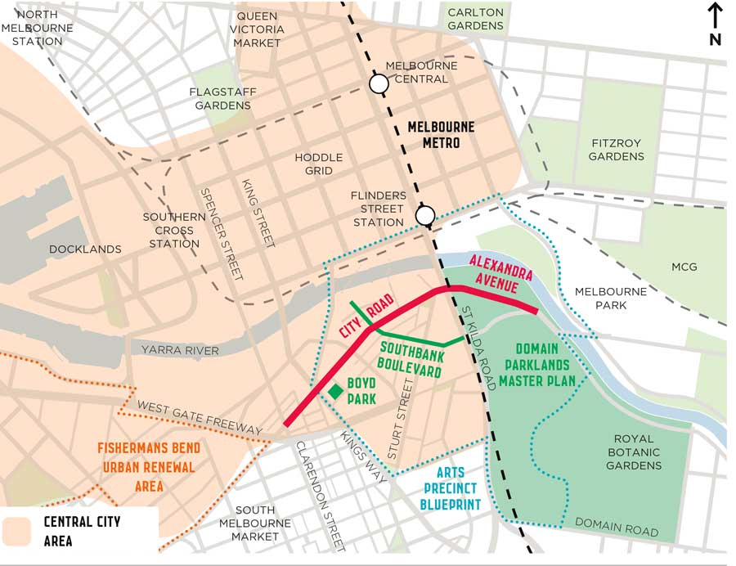
Description of figure 1.3

How did the community get involved?
Two phases of community engagement were undertaken in developing the master plan. The first phase took place at the beginning of the project before any proposals were established, to get a better understanding of the existing conditions of City Road.
A second phase of community engagement tested how supportive the community were of the draft master plan proposals. These are explained below.

Phase 1 Engagement
The first phase of community engagement was held from 17 February to 16 March 2014, when the community was asked to share their experience of City Road through an interactive map on Participate Melbourne and ‘drop-in sessions’ at the Boyd Hub (see figure 1.4).
The purpose of the community engagement was to:
- Raise awareness of the City Road Master Plan Project.
- Develop an understanding of the community’s experiences of City Road.
- Gather qualitative data to feed into the development of the draft master plan.
Nearly all of the experiences shared by the community were negative, with many feeling unsafe and frustrated (see figure 1.5).
A clear sense of the issues and concerns along the road was captured through the placement of comments on the interactive map.
Figure 1.4: Positive and negative experiences of City Road shared online
Source: Community Engagement 2014
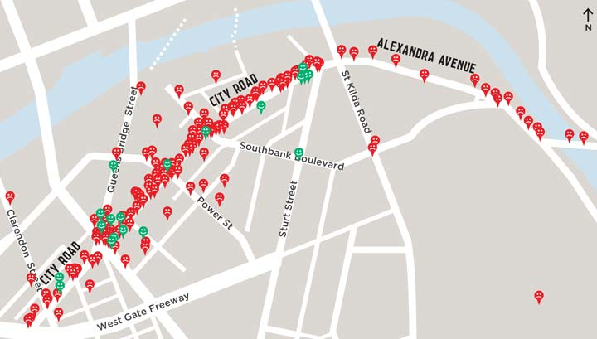
Description of figure 1.4
Figure 1.5: Experience of City Road shared online
Source: Community Engagement 2014
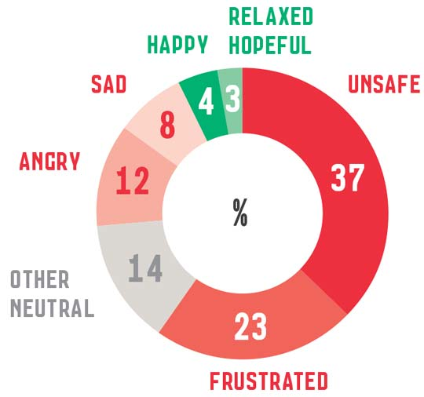
Description of figure 1.5

Phase 2 Engagement
The second phase of community engagement was held from 9 September to 21 October 2015. The community was asked how supportive they were of the proposals outlined in the draft master plan via an interactive master plan on Participate Melbourne.
Participants were able to comment on the overall master plan and/or individual actions. This was supported by a number of face to face events including walking tours, drop-in sessions at Boyd and pop-up spaces in the Kings Way undercroft.
The purpose of the community engagement was to:
- Present the draft master plan to the community and seek their feedback on the overall master plan and its six actions.
- Provide the community with an opportunity to discuss the draft master plan with City of Melbourne staff and learn more about it through face to face engagement.
- Gather qualitative and quantitative data from the community on the draft master plan to help inform the development of a final master plan.
Results revealed a high level of support for the draft master plan, with close to three quarters of the 211 responses on Participate Melbourne being supportive (see figure 1.6).
The responses captured during the community engagement helped to refine the master plan and are discussed in each action in part three.
Figure 1.6: Combined feedback results for the overall draft master plan and six actions
Source: Community Engagement 2015
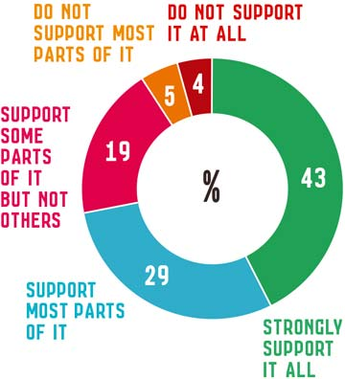
Description of figure 1.6
Image: Pop-up event in the Kings Way Undercroft as part of the community engagement on the draft master plan, October 2015
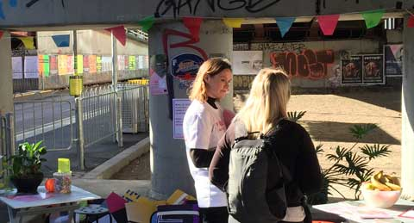

2. Master Plan actions

What are the Master Plan actions?
The master plan consists of the following six key actions to improve the road design and layout. These actions respond to the changing conditions along the length of the study area.
- Transform City Road West into a great central city street.
- Reimagine Kings Way undercroft as a community space.
- Upgrade City Road East to be safer and easier to get around.
- Connect City Road to the Arts Centre and Yarra River.
- Connect the gardens.
- Expand the bicycle network within Southbank.
A summary of these actions is provided on the following pages (see figure 1.8). The full details of each action are contained in part three of this document, followed by next steps in part four.

What are the transport priorities and requirements?
The street improvements outlined in the master plan respond to different transport requirements along City Road and Alexandra Avenue.
Due to changing conditions and space limitations along the road, not all transport modes can be accommodated in each section. Figure 1.7 shows the existing major routes for each mode, illustrating how different users of the street connect into and through City Road and Alexandra Avenue.
A summary of how transport modes are accommodated in the master plan is noted below.

Pedestrians
Walking is the predominant mode of transport for all trips in central Melbourne, in the order of 86 per cent (Walking Plan, City of Melbourne 2014).
The City of Melbourne seeks to deliver an environment in which pedestrians are prioritised and supported by a safe, attractive and engaging urban environment (Road Safety Plan 2013-2017, City of Melbourne).
Pedestrian amenity and safety is the highest priority along the full length of City Road.
Generally the footpaths are of sufficient width. Opportunities to improve access and safety for pedestrians are focused on making it safer and easier to cross City Road and Alexandra Avenue.
This includes improvements at existing intersections to minimise crossing distances as well as providing new crossing points along the road in targeted locations where there is existing or likely to be future demand.

Cyclists
The City of Melbourne is committed to becoming a cycling city with safe and connected bicycle routes. This involves delivering a connected cycling network, building high quality routes for local cycling trips, increasing participation in cycling and making cycling safer (Bicycle Plan 2016-20, City of Melbourne).
There is currently very limited bicycle access within and through Southbank other than the Yarra Promenade which is shared with pedestrians. The master plan recognises the importance of providing safe bicycle access for the Southbank community, as well as the need to connect Southbank to surrounding areas and key routes.
Due to competing transport needs, it is not possible to continue bike lanes along the full length of City Road at this time.
Instead, a bicycle route is proposed via City Road, Balston Street, Kavanagh Street and Southbank Boulevard (see Action 6 for further details).
The City of Melbourne Bicycle Plan aims to upgrade Southbank Boulevard, Kavanagh Street, Balston Street, and investigate connections on City Road and Clarendon Street in the medium term (two to five years).

Public Transport
The importance of public transport in Southbank will increase as development intensifies, resident and worker populations grow and Fishermans Bend is developed as part of the expanded central city.
By 2026, it is expected that Queens Bridge Street and Clarendon Street will have more tram routes and services to provide greater connectivity to the proposed Domain Metro station and the western section of the Hoddle Grid.
The master plan does not propose changes to the existing public transport network but aims to maintain or increase public transport priority. Pedestrian access for public transport passengers has been a focus for street improvements.

Cars
Car access will be maintained for the full length of the study area. Proposed changes aim to minimise impact to vehicle capacity and journey time. Access to all private car parks will be maintained.

Trucks
Access for placarded vehicles and over dimensional vehicles will be maintained east of Power Street as an alternative route to the Burnley Tunnel in line with VicRoads’ requirements. The master plan aims to mitigate the impact of these vehicles on other road users where possible.
Figure 1.7: Existing transport routes on City Road and Alexandra Avenue in the broader Southbank context
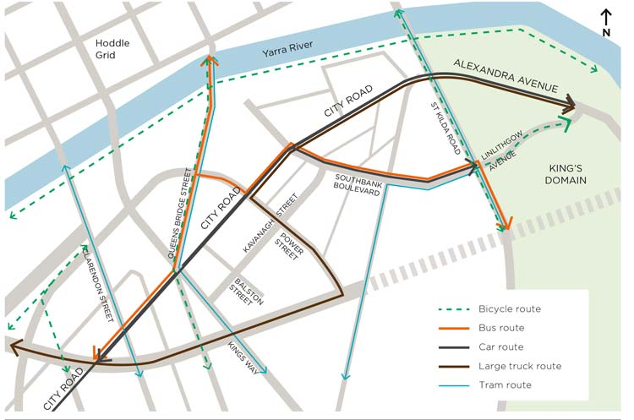
Description of figure 1.7

Master Plan actions
Purpose: To transform City Road into a safe and welcoming place for everyone
Figure 1.8: Summary of proposed actions
(full details contained in part three of the master plan)
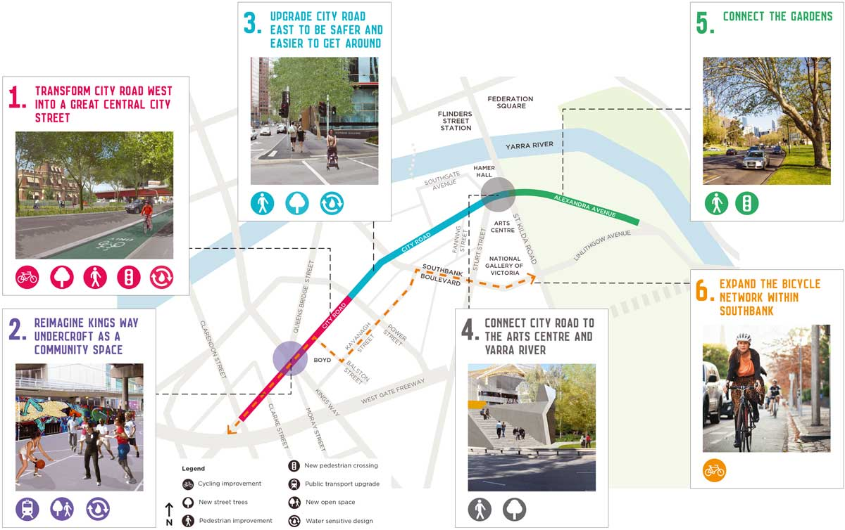

Action 1: Transform City Road West into a great central city street
Proposed improvements:
- Cycling improvement
- New street trees
- Pedestrian improvement
- New pedestrian crossing
- Water sensitive design.
Full details of Action 1 in part three

Action 2. Reimagine Kings Way Undercroft as a community space
Proposed improvements:
- Public transport upgrade
- New open space
- Water sensitive design.
Full details of Action 2 in part three

Action 3. Upgrade City Road East to be safer and easier to get around
Proposed improvements:
- Pedestrian improvement
- New street trees
- Water sensitive design.
Full details of Action 3 in part three

Action 4. Connect City Road to the Arts Centre and Yarra River
Proposed improvements:
- Pedestrian improvement
- New street trees.
Full details of Action 4 in part three

Action 5. Connect the gardens
Proposed improvements:
- Pedestrian improvement
- New pedestrian crossing.
Full details of Action 5 in part three

Action 6. Expand the bicycle network within Southbank
Proposed improvements:
- Cycling improvement.
Full details of Action 6 in part three

What are the proposed changes to City Road?
Figure 1.9 shows the changes to City Road and Alexandra Avenue proposed in the master plan. These relate to the road reserve specifically (footpaths and carriageway).
The majority of changes are concentrated in City Road West between Clarendon Street and Power Street in response to detailed analysis of existing traffic conditions (refer to Existing traffic conditions on page 29).
City Road East and Alexandra Avenue experience higher traffic volumes due to their arterial route function which is reflected in the level of changes proposed in these segments of the road.
Figure 1.9: Proposed changes to City Road and Alexandra Avenue
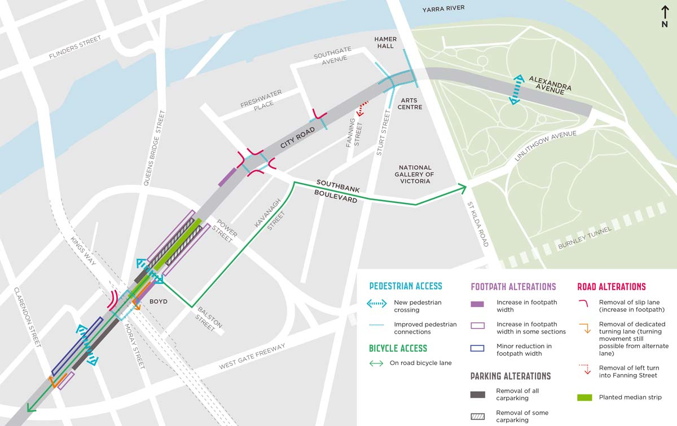
Description of figure 1.9

Existing traffic conditions

Traffic volumes
There is significant variation in traffic volumes in different segments of City Road and Alexandra Avenue, which has influenced the design proposals in the master plan.
Figure 1.10 demonstrates how City Road’s arterial route function as a bypass to the Burnley Tunnel results in far greater traffic volumes east of Power Street, compared to City Road west of Power Street. Approximately 45,600 vehicles per day travel along Alexandra Avenue, compared to 22,500 per day on City Road West.
These variations in traffic volumes along City Road highlight that there are greater opportunities for improvements west of Power Street in the shorter term.
Figure 1.10: VicRoads Traffic Volumes 2013
Source: GHD Traffic and Access Study, May 2014
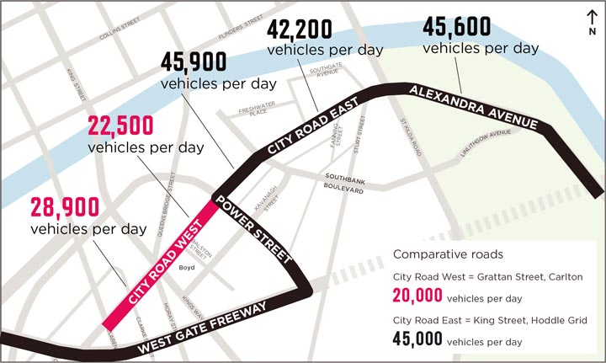
Description of figure 1.10

Crashes
There have been a number of crashes on City Road, particularly at intersections which are often very large and confusing. This includes two fatalities as shown in figure 1.11. Improved safety is a key driver for the master plan to improve safety for all users of City Road.
Figure 1.11: VicRoads CrashStats 2008-2012 for City Road
Source: GHD Traffic and Access Study, May 2014
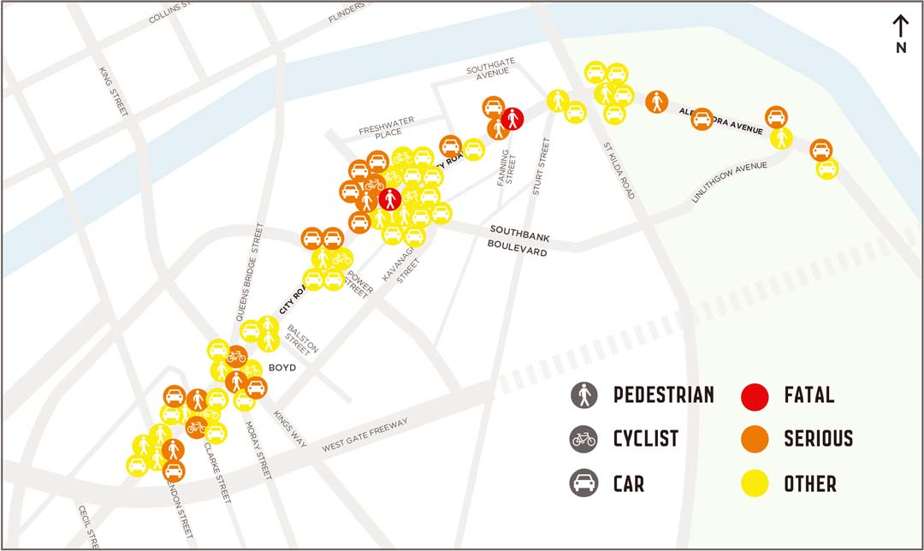
Description of figure 1.11

How will the Master Plan affect traffic?

Traffic modelling
Detailed traffic modelling has been undertaken to develop the street layout proposals presented in the master plan and to understand their impact on traffic movement. Proposals aim to minimise impacts on traffic movement where possible to retain the key arterial route from Power Street to the east.
One way of understanding the likely impact of these proposals is by measuring the increase or decrease in average (median) journey times. Variations in journey times are presented alongside the corresponding actions in part three of the master plan.

Limitations to traffic modelling
While traffic modelling can be a useful means of understanding the trade-offs involved in transforming City Road, its limitations need to be recognised. Traffic modelling does not account for other likely affects of improvements to City Road.
These may include changes in individual travel behaviour such as shifting to a different mode of transport or choosing an alternate route.
Another limitation to modelling the impacts of proposed changes is the volatility of existing conditions in Southbank. City Road, and Southbank in general, is a heavily trafficked and highly congested area where observed journey times vary significantly.
For example, two runs of the same route at the same time of day can vary in duration from three minutes to eight minutes, as demonstrated in figure 1.12.
Therefore, a modelled increase to an average (median) journey time is, in reality, likely to be absorbed within the spectrum of existing journey time variability.
Figure 1.12: Example of the variation in travel times experienced on City Road from Cecil Street to St Kilda Road (PM peak)
Source: GHD Traffic Modelling Report, July 2015
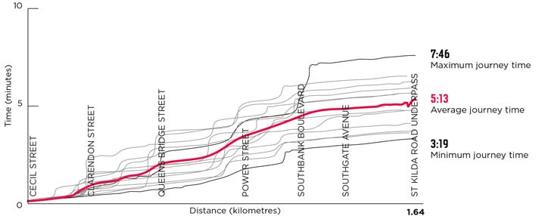
Description of figure 1.12

Potential increase in journey times
Increases in journey times will be most significant in City Road West as shown in figure 1.13.
The two routes most impacted by the proposed changes are:
- Travelling east bound in the PM peak from Cecil Street to Linlithgow Avenue which could increase the average journey time by 1:37 minutes from 7:27 to 9:04 minutes.
- Travelling west bound in the AM peak from Linlithgow Avenue to Cecil Street which could increase the average journey time by 1:51 minutes from 5:29 to 7:20 minutes.
Minor journey time increases are expected in the AM peak east bound (an additional 30 seconds to the average journey) and in the PM peak west bound (an additional 43 seconds to the average journey).
Figure 1.13: Potential increases in journey times in minutes as a result of the actions in the master plan (between Cecil Street and Linlithgow Avenue
Source: GHD Traffic Modelling Report, July 2015
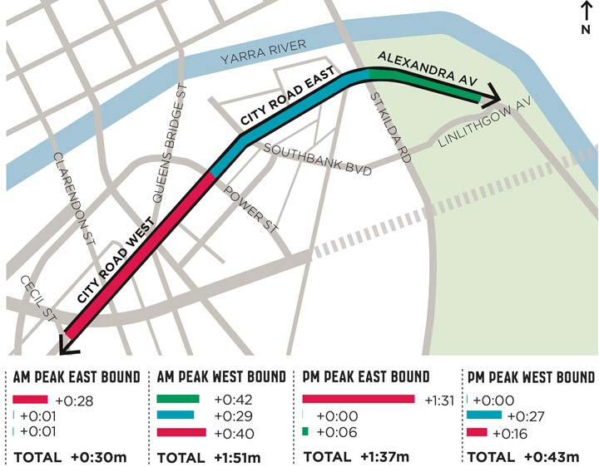
Description of figure 1.13

Part Two: What makes a great street?
In this part you will find out:
- How Southbank is changing and the story of where it has come from
- Key priorities to consider for City Road

3. A connection to the past
The public realm plays an important role in the way people experience, value and remember a city. Public spaces have their own histories and they connect the experience of the place today to its past.

Pre-European Settlement
The area that we call Southbank today was inhabited by Aboriginal people for thousands of years prior to the arrival of Europeans in 1835.
The low lying wetlands south of Birrarung (Yarra River) provided a rich source of food for the clans of the surrounding region. Due to its topography, Southbank is still prone to flooding today.

1830s - European Settlement
City Road has claims to being the first ‘street’ in Melbourne. Soon after European settlement, a walking track between Port Phillip Bay and the newly laid Hoddle grid was established along a dry creek bed, later formalised as City - Sandridge Road. The Sandridge Railway opened in 1854, moving goods to and from the port (see figure 2.1).
Figure 2.1: Melbourne circa 1850s facing north with the wetlands of Southbank visible in the foreground
Source: State Library of Victoria
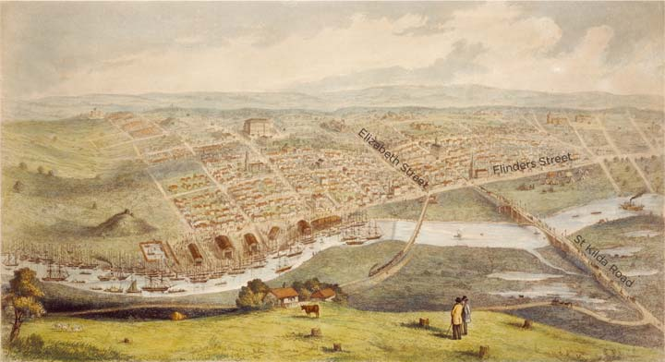

1840s - Royal Botanic Gardens
In the 1840s, land south of the Yarra overlooking Melbourne was reserved as parkland. The Royal Botanic Gardens were set aside in 1846 as parkland and work commenced to transform the Domain into a public park shortly after.

1850 - 1950 Establishment of industrial precinct
Throughout this century, Southbank (formerly South Melbourne) became an industrial precinct, with City Road providing an important connection to the central city. Land uses along City Road included warehouses, manufacturing and mechanics’ workshops (see figure 2.3)
Alexandra Avenue was constructed in 1901, a wide boulevard with four separate lanes and Alexandra Gardens were laid out shortly after.
Figure 2.2: Alexandra Avenue circa 1940s-1950s
Source: Rose Stereograph Co, State Library of Victoria
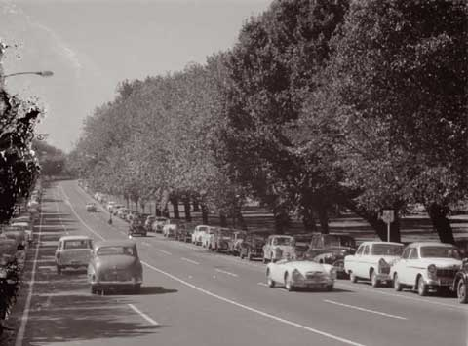
Figure 2.3: Draffin Bros electric hot water service at 43-47 City Road (now Opera Australia) circa 1930s
Source: State Library of Victoria
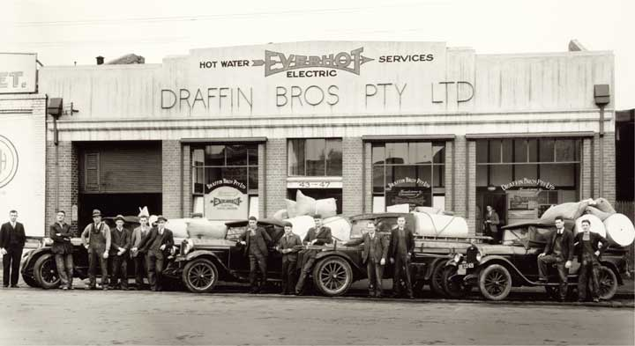

1950/60s - City Road disconnected from central city
Swan Street Bridge opened in the 1950s, connecting Alexandra Avenue to the sports precinct for the 1956 Melbourne Olympic Games.
In the 1960s, as part of the Roy Grounds’ Master Plan for the arts precinct, City Road was tunnelled below St Kilda Road. This severed its historic connection with St Kilda Road, Princes Bridge and the Hoddle grid (see figure 2.4 and figure 2.5). The Arts Centre Precinct opened in the 1980s.
In 1961 the Kings Way overpass opened, creating a new southern entrance to the city and forming a perceived barrier between Southbank and South Melbourne.
Figure 2.4: The intersection of City Road and St Kilda Road connecting at grade prior to the lowering of City Road circa 1945
Source: State Library of Victoria
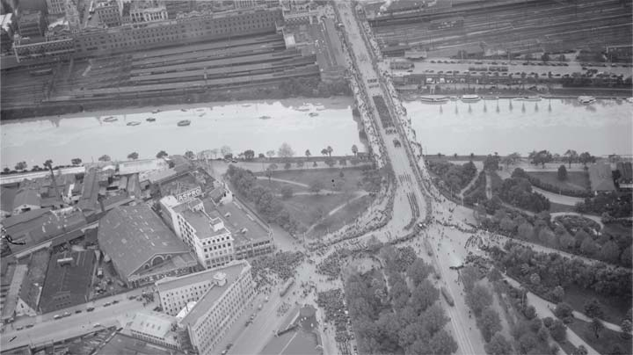
Figure 2.5: Arts Centre during construction with St Kilda Road to the left of image circa 1960s
Source: Arts Centre Melbourne Performing Arts Collection
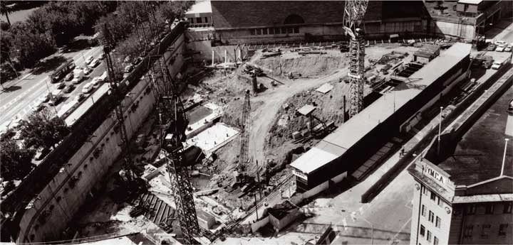

Late 20th Century - urban renewal
The urban renewal of Southbank from an industrial area into a commercial and residential precinct began in the 1980s with the opening of the Southgate Complex and high rise office towers along the Yarra River. Crown Casino opened in 1997, continuing the trend of development fronting onto the Yarra River and turning its back to City Road.
Figure 2.6: Southbank and City Road circa 1980s
Source: State Library of Victoria
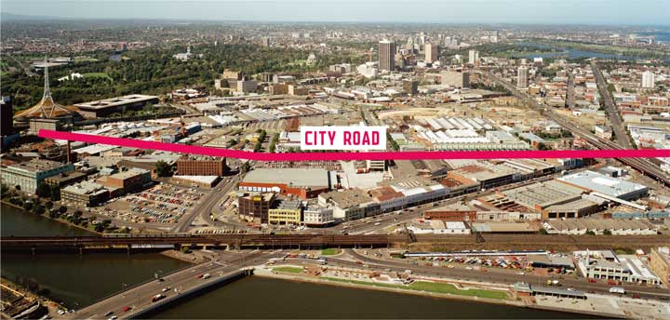

21st Century - booming suburb
CityLink and the Burnley tunnel commenced operation in 2000, establishing City Road East as the alternative route for placarded vehicles and all vehicles in times of tunnel closure.
The Southbank Structure Plan 2010 (and former Southbank Plan 2007) set a vision for the ongoing renewal of Southbank as part of Melbourne’s expanded central city which saw the rezoning of the land to Capital City Zone in 2013.
The iconic Eureka Tower, at 297 metres high was completed in 2006 and is currently the tallest building in Melbourne. The approved Australia 108 development to be built on the corner of City Road and Southbank Boulevard will soon take over this title at 319 metres high.
Image: City Road in 2015: the front door to thousands of residents and workers
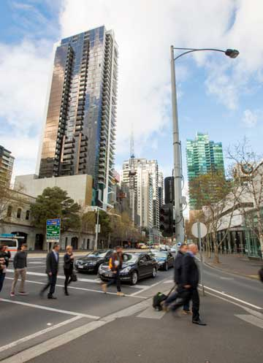

City Road as the front door to thousands of residents and workers
In the past decade the number of residents and workers in Southbank has drastically increased, particularly on the blocks fronting City Road (see figure 2.7 to figure 2.10). There are now over 6000 homes and over 20,000 jobs.
This influx of residents to the area reinforces the importance of City Road as a street that must serve the broad needs of its local population and act as a safe front door to the thousands of new homes along its length.
Improvements to City Road need to be respectful of the past and provide opportunities for today’s residents, visitors and workers to connect to the history of the city and the place.
Figure 2.7: Number of homes within the blocks fronting City Road in 2005.
Source: CLUE 2005
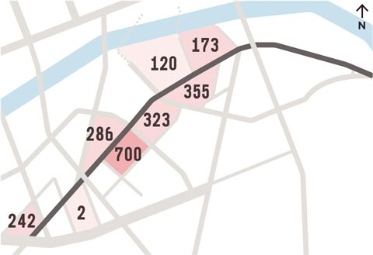
Description of figure 2.7
Figure 2.8: Number of homes within the blocks fronting City Road in 2015.
Source: CLUE 2015
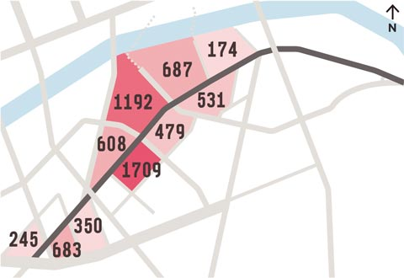
Description of figure 2.8
Figure 2.9: Number of jobs within the blocks fronting City Road in 2005.
Source: CLUE 2005
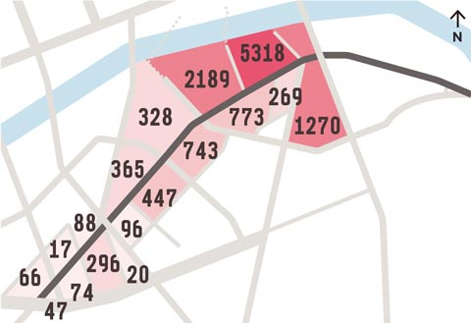
Description of figure 2.9
Figure 2.10: Number of jobs within the blocks fronting City Road in 2015.
Source: CLUE 2015
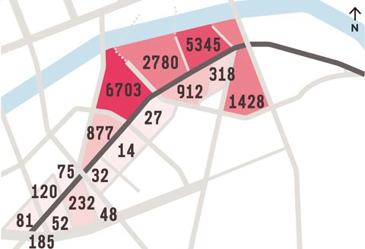
Description of figure 2.10

4. Meeting the needs of the future
Since urban renewal began in the 1980s, Southbank has become the fastest growing suburb in Melbourne. This has seen increased numbers of people living, working and visiting the area.
City Road, however, has not transformed to meet the needs of these people. It is still primarily designed to move vehicles in an east to west direction and continues to act as a significant barrier to north-south movement, effectively dividing Southbank in two.
Population growth and development is set to continue at a rapid pace with several significant potential development sites yet to come forward. This growth emphasises the need to improve the quality of the public realm and connections through Southbank and to the Hoddle Grid, which is the key destination for most residents.
The growth of Southbank cannot be looked at in isolation of the Fishermans Bend urban renewal area which is connected to Southbank through City Road. The 455 hectare site is forecast to accommodate a residential population in the order of 80,000 and approximately 40,000 jobs.
In 2011, 34 per cent of Southbank residents walked to work. A further 24 per cent walked to public transport. This means that there were approximately 4000 people walking around Southbank as their primary means of transport during peak periods.
Trends suggest that the proportion of people travelling by foot and public transport is likely to significantly increase along with a greater number of workers and visitors to the area.
By 2032, we can expect well over 20,000 people walking around Southbank and City Road every day during the peak morning and evening periods.
City Road will need to accommodate this significant increase in pedestrians in order to ensure that people can easily and safely access their jobs, homes and other services.
Figure 2.11: The evolution of Southbank from industrial precinct to central city (2008)
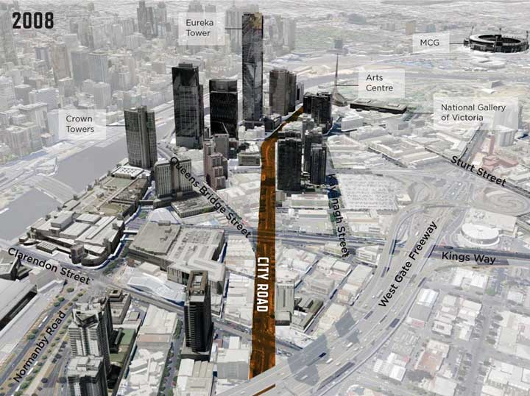
Description of figure 2.11
Figure 2.12: Estimated increase in residents walking to work in Southbank
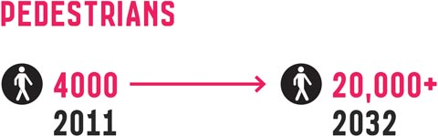
Figure 2.13: The evolution of Southbank into the densest suburb in Melbourne (2016)
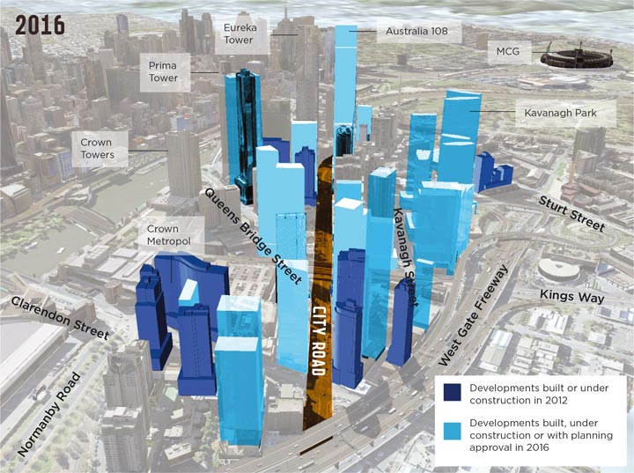
Description of figure 2.13

5. Balancing priorities in a limited space

The role of the street
Streets make up the majority of the public spaces in our city, yet we often don’t think of them in this way. Typically, streets are regarded as movement corridors, particularly for private vehicles. The reality is that streets perform a far greater role than moving vehicles.
Streets are destinations as well as journeys. They provide opportunities to gather, stroll, socialise, perform, dine, sit, relax or exercise. They provide important space for nature in the city and offer places of respite from the built environment.
They are spaces that allow for the delivery of goods and people to businesses, work places and homes.
Streets provide the interface between the public and private places in our city. They are the front door and the address that helps us to navigate and experience the city. They have their own identity, character and status.
Streets also allow us to get around, whether it be in a private vehicle, a work vehicle, on foot, by bike or public transport, pushing a stroller or walking a dog.
Cities are defined by their streets. Melbourne has some exemplary streets- Swanston Street, Lygon Street and Brunswick Street are all examples of vibrant streets, each with its own distinct character and identity.

Trade-offs
In every street a limited amount of space is allocated to different, and sometimes competing, uses and functions. Outdoor dining, street trees, vehicles and bicycle lanes all take space.
It was clearly demonstrated in our 2014 community engagement on City Road that the road is seen by all users - drivers, pedestrians, cyclists - as poorly performing and in significant need of a redesign (figure 2.14).
Trade-offs must be made in the design of any street to find the right balance for its particular context.
More space for pedestrians and cyclists may result in less space for parking. Intersections that favour cars may make it more challenging for pedestrians to cross safely and efficiently.
The Transport Strategy (2012) clearly prioritises walking, cycling and public transport as the dominant transport modes in the central city.
In order to help improve City Road we need to ensure that it can perform multiple roles. To do this it needs to be:
- Safe and easy to get around
- Environmentally sustainable
- A great place to be
These elements are explained in more detail in the following pages.
Figure 2.14: Percentage of positive and negative experiences shared online
Source: Community Engagement 2014
Image: Pedestrian walking west along City Road, crossing the tram line at the Kings Way undercroft
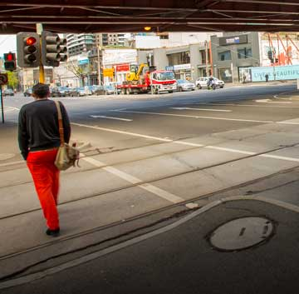

Safe and easy to get around
The following elements are evident in streets that are comfortable, connected and convenient for pedestrians, cyclists, public transport passengers and drivers.
Figure 2.15: Street design elements that prioritise the efficient movement of different modes of transport
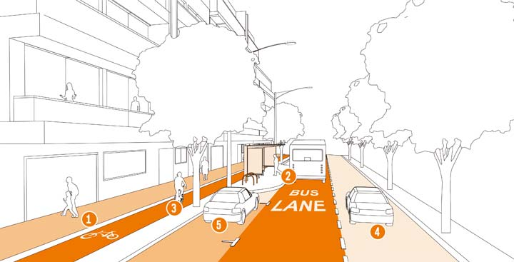

1 Pedestrian access
- Safe and direct pedestrian access encourages walking as the primary transport mode.
- Sheltered and well-lit public transport stops create a safe and comfortable place to wait.
- Adjusting traffic signals to reduce pedestrian waiting time minimises the incentive to cross illegally and unsafely.
- Medians can help to create pedestrian refuges to assist in crossing the street.

2 Public transport priority
- Bus and tram priority lanes allow for a more efficient public transport network. Encouraging public transport use can help minimise traffic congestion.

3 Bicycle infrastructure
- High quality bicycle lanes that are separated from traffic help create a safe and legible network for cyclists of different abilities.
- Improving bicycle infrastructure encourages more people to cycle and can reduce traffic congestion.
- On-street bicycle parking provides a convenient place for cyclists to access local businesses, residences and services.

4 Speed limits
- Reducing the traffic speed limit can improve safety and access for all road users.

5 On-street car parking
- On-street car parking improves access to local businesses, residences and services.
- On-street parking between cyclists and road traffic (with a sufficient buffer) can improve cyclist safety.
- Parking movements can encourage slower traffic speeds and make the street safer for pedestrians.

Environmentally sustainable
The following elements are evident in streets that address the changing climate by harnessing water, reducing urban heat, increasing vegetation and prioritising sustainable transport.
Figure 2.16: Street design elements that prioritise sustainability and water management
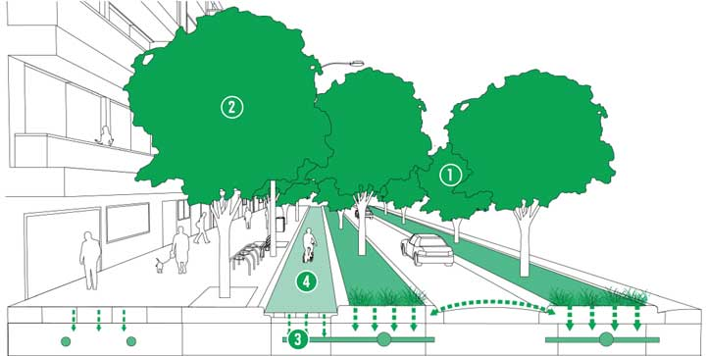

1 Increased tree canopy
- Increasing the street tree canopy helps to reduce the ‘Urban Heat Island Effect’, making the city cooler.
- An increased tree canopy increases the absorption of carbon dioxide, improving local air quality.

2 Healthy and diverse trees
- Improving tree health and increasing the diversity of species increases the ecological resilience of our urban forest.
- A healthy and diverse tree canopy provides a more diverse habitat for wildlife.

3. Water sensitive urban design (WSUD)
- Increasing permeable surfaces and decreasing the extent of asphalt helps mitigate flooding issues and storm water pollution.
- ‘Urban Heat Island Effect’ is reduced through the use of surfaces such as grass, ground planting and permeable paving.
- Natural water filtration improves soil quality and tree health and reduces overall water consumption.

4 Sustainable transport modes
- Prioritising walking, cycling and public transport improves the efficiency of transport on the street and minimises emissions.

A great place to be
The following elements are evident in streets that are lively and attractive with a variety of activities, shops, residences and services that draw people to visit and encourages them to linger.
Figure 2.17: Street design elements that prioritise activity and street amenity
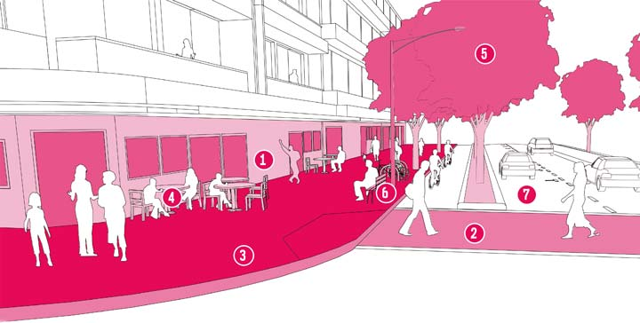

1 Active building frontages
- Visually interesting building frontages with windows and regular entrances encourage active street life.
- Fine grain development allows for a variety of retailers, hospitality and services.
- A strong connection between the street and the buildings along it encourages more ‘eyes on the street’, improving safety.
- Awnings along building frontages provide protection from sun and rain.

2 Pedestrian crossings
- More frequent crossings improve safety, walkability and connections.

3 Wide footpaths
- Wide footpaths reduce crowding and allow for a variety of activities to take place such as on-street dining.
- Perceived increase in footpath width is created by locating cycle lanes and medians adjacent to the footpath.
- Removing slip lanes will reduce crossing distances, increase pedestrian visibility and create more spaces for street greening and amenities.

4 Street activities
- Street vendors, buskers and public art add to the atmosphere and overall experience of the street.
- Different activities along the street encourage people to gather in public spaces.

5 Street trees
- A generous tree canopy provides shade in summer and creates a pleasant place to meet and socialise.

6 Street furniture
- High quality street furniture provides places to relax and experience the street life.
- Street furniture can include benches, bicycle parking hoops, drinking fountains and lighting.

7 Mitigating traffic impacts
- Reducing the speed limit can help to minimise noise pollution and improve safety and comfort for all road users.
- Slowing traffic speeds can promote on-street activity and local businesses.

Part Three: Master Plan actions
In this part you will find:
- The design proposals for each action in the Master Plan

Action 1. Transform City Road West into a great central city street

Understanding City Road West
City Road West (between Clarendon Street and Power Street) is a local street and can be enhanced significantly to make it safer, more attractive and welcoming.
The master plan proposes to transform this section of City Road into a great central city street. With an increasing number of residential apartments, Boyd Community Hub and tram and bus services in this location, this part of City Road is the centre of an evolving community (see figure 3.1).
Traffic volumes in City Road West are significantly lower than City Road East as it does not perform the same role as the bypass to the Burnley Tunnel. This means there are greater opportunities to transform City Road West into a great central city street.
Connections to the City of Port Phillip and Fishermans Bend are a key consideration for the design proposals in this section.
To make it easier to demonstrate the proposed changes in the master plan, City Road West has been shown in two sections either side of Kings Way: Clarendon Street to Queens Bridge Street and Queens Bridge Street to Power Street.
The existing conditions of City Road and changes proposed in this master plan are outlined on pages 54 to 69.
Figure 3.1: City Road West between Clarendon Street and Power Street
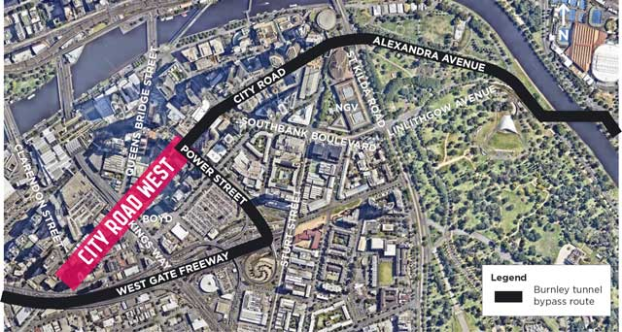
Description of figure 3.1
‘The intersection at Clarke Street is poorly marked and is in need of a crossing.’ - @gj_win, resident (20 February 2014)

What did the community say?
This action received a strong level of support during the community engagement. Close to three quarters of the responses were either strongly supported it all or most parts of it.
Participants were highly supportive of proposals to improve pedestrian and cycling conditions and streetscape upgrades that make City Road greener and more inviting.
Participants also placed high importance on ensuring that proposals prioritise safety and do not sacrifice existing footpath space along City Road.
There was some concern about the interaction of different transport users and increases in traffic volumes as a result of future development in Southbank.
‘The proposed plan will transform Southbank from an ugly duckling into a charming swan.’ - greenahtene, resident (9 September 2015)
Image: Pedestrians crossing City Road at Queens Bridge Street, in front of Boyd Community Hub
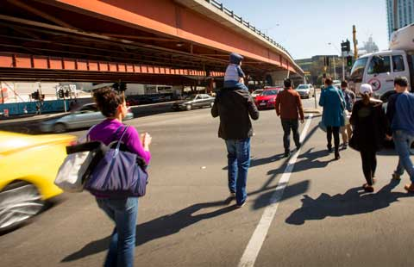

Section 1: Clarendon Street to Queens Bridge Street

Existing conditions
The existing conditions of City Road West are inadequate to meet the needs of the future. While there are wide footpaths, the street is dominated by traffic, has inconsistent tree planting and expanses of asphalt. This creates a poor street character. Some public transport priority is provided with a bus lane in the AM peak.
Figure 3.2: Existing conditions of City Road (Clarendon Street to Queens Bridge Street)
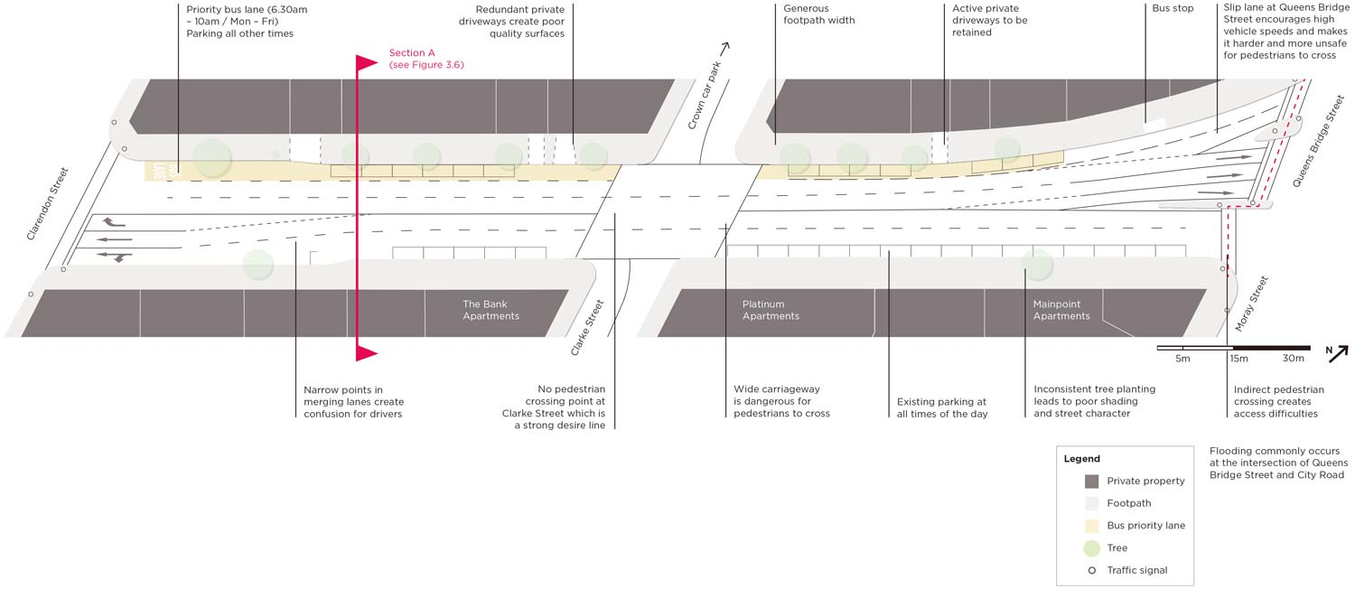
Description of figure 3.2
Figure 3.3: The dominance of car infrastructure along City Road (between Clarendon Street and Queens Bridge Street) creates an undesirable place for pedestrians
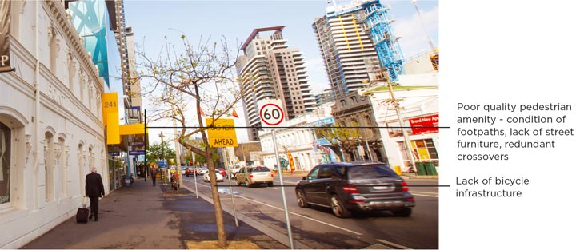
Figure 3.4: The street is unattractive, creating a poor quality pedestrian environment and character
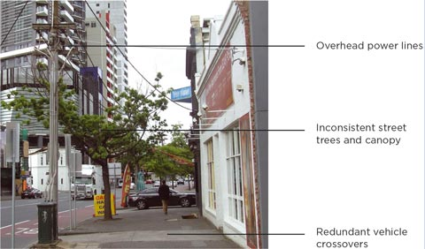

Proposed design
The proposed design introduces pedestrian crossings at Clarke Street, separated bicycle lanes, new tree planting, high quality materials and maintains bus priority.
Figure 3.5: Proposed design of City Road (Clarendon Street to Queens Bridge Street)
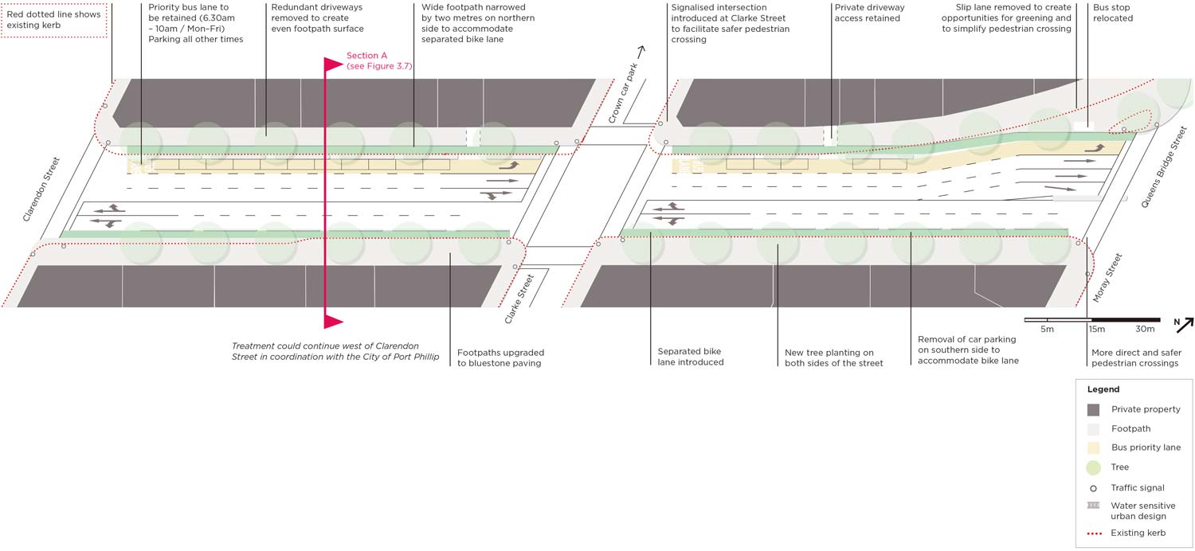
Description of figure 3.5

Existing conditions
Figure 3.6: Existing conditions of City Road looking east towards Queens Bridge Street
(Section A)
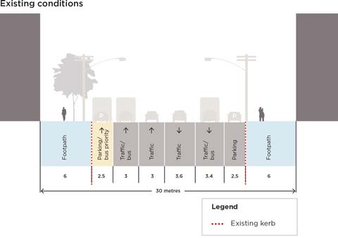
Description of figure 3.6

Proposed conditions
Figure 3.7: Proposed conditions of City Road looking east towards Queens Bridge Street (Section A)
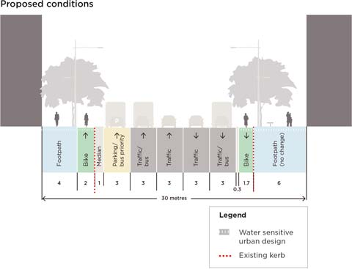
Description of figure 3.7

Proposed design
Figure 3.8: Existing view of City Road looking east towards Kings Way undercroft (Clarendon Street to Queens Bridge Street)
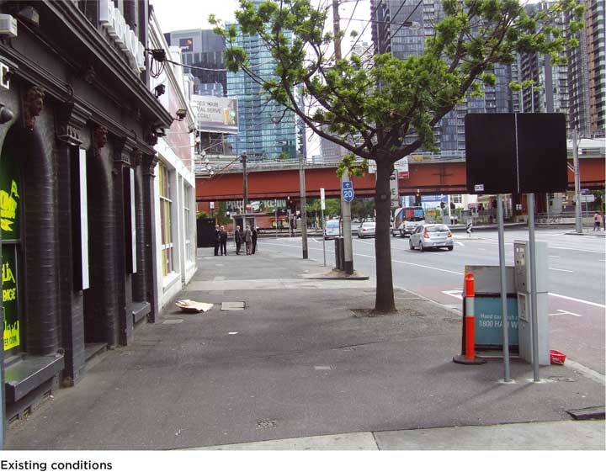
‘This section of City Road between Clarke Street and the Kings Way overpass is low-lying and has flooded badly in heavy rains.’ - Steve, resident (15 March 2014)
Figure 3.9: Artist’s impression of proposed conditions in City Road looking east towards Kings Way undercroft (Clarendon Street to Queens Bridge Street)
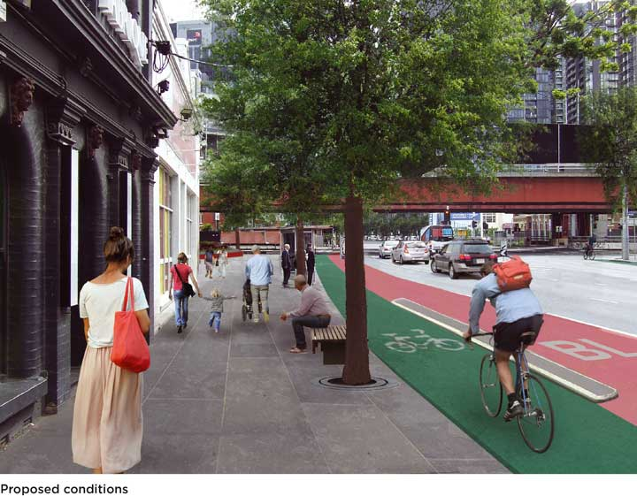
Description of figure 3.9

Section 2: Queens Bridge Street to Power Street

Existing conditions
Figure 3.10: Existing conditions of City Road (Queens Bridge Street to Power Street)
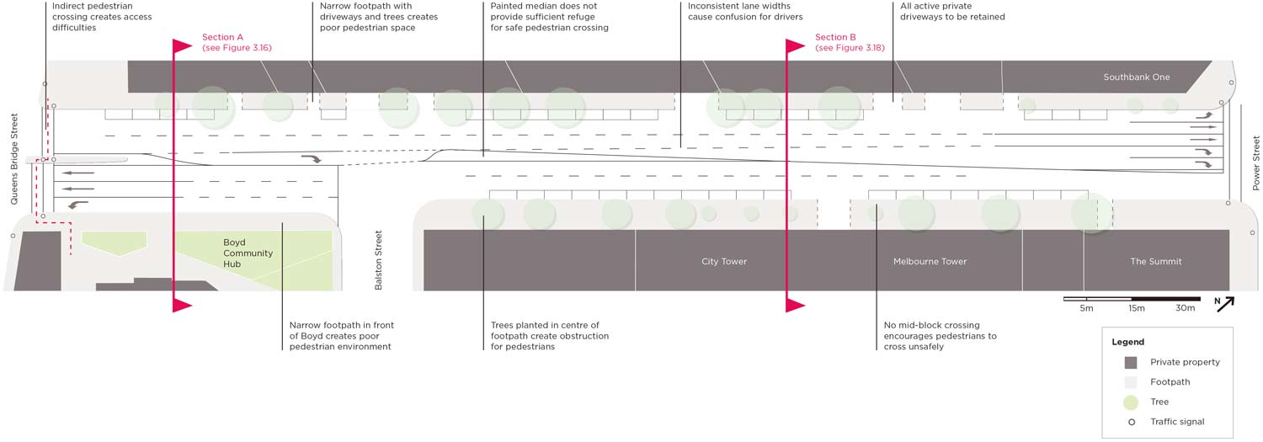
Description of figure 3.10
Figure 3.11: Existing conditions along City Road resulting in a lack of pedestrian access to the Boyd Community Hub
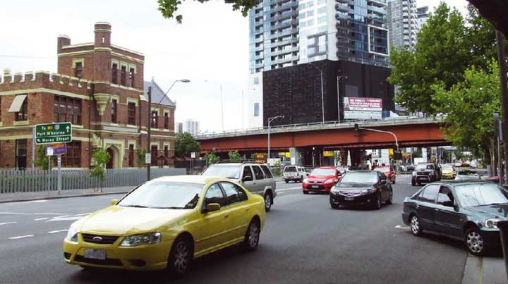
Figure 3.12: Existing conditions along City Road looking east towards Power Street
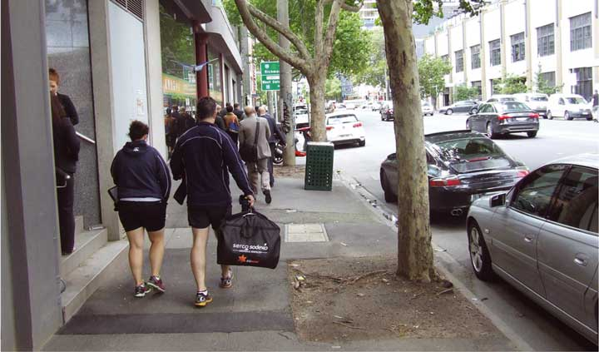

Proposed design
The proposed design introduces a tree lined median, improved pedestrian amenity around Boyd and separated bicycle lanes west of Balston Street.
Figure 3.13: Proposed design in City Road West between Queens Bridge Street and Power Street
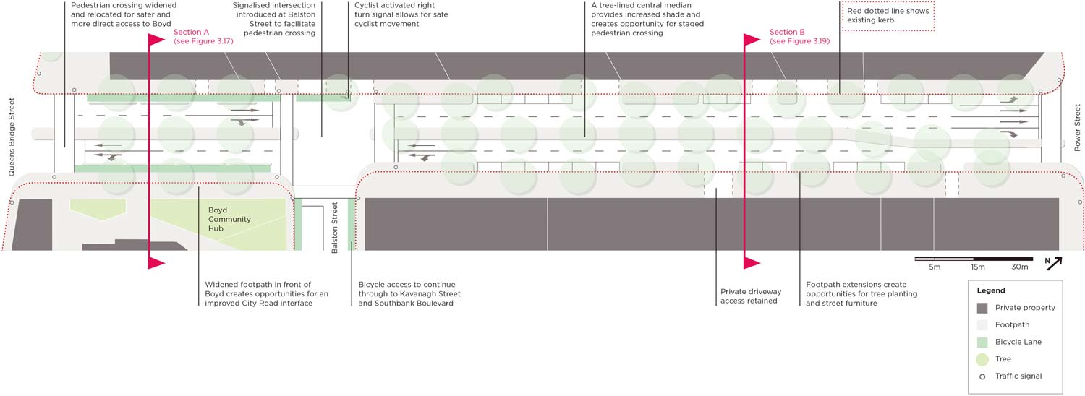
Description of figure 3.13

Existing conditions
Figure 3.14: Existing view along City Road looking south towards Boyd Community Hub (between Queens Bridge Street and Power Street)
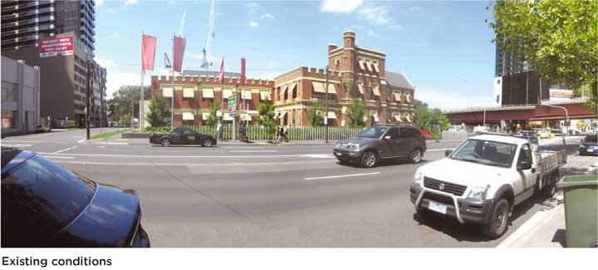

Proposed conditions
Figure 3.15: Artist’s impression of proposed conditions along City Road looking south towards Boyd Community Hub (between Queens Bridge Street and Power Street)
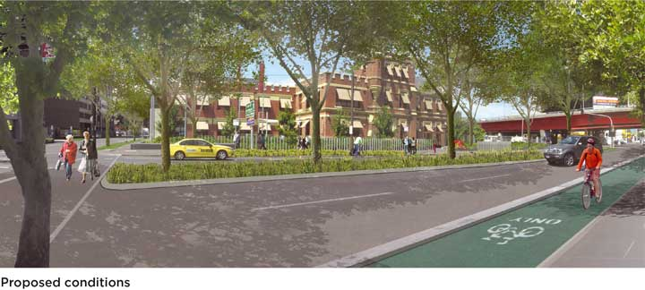
Description of figure 3.15

Existing conditions (A)
Figure 3.16: Existing conditions of City Road between Queens Bridge Street and Balston Street, looking east towards Power Street (Section A)
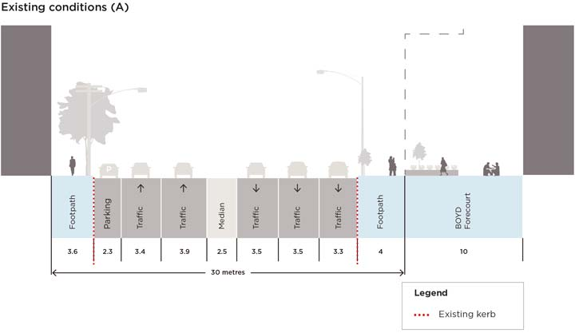
Description of figure 3.16

Proposed conditions (A)
Figure 3.17: Proposed conditions of City Road looking east towards Power Street (Section A)
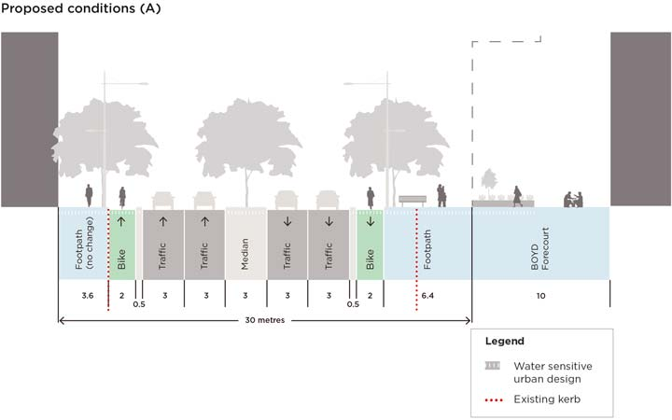
Description of figure 3.17

Existing conditions (B)
Figure 3.18: Existing conditions of City Road between Queens Bridge Street and Balston Street, looking east towards Power Street (Section B)
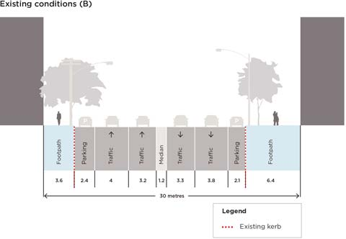
Description of figure 3.18

Proposed conditions (B)
Figure 3.19: Proposed conditions of City Road looking east towards Power Street (Section B)
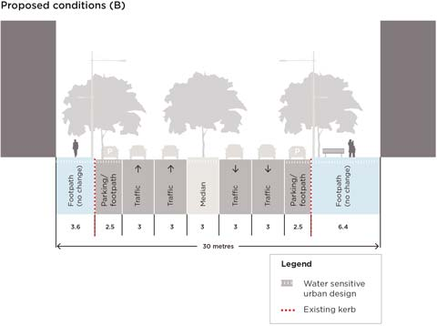
Description of figure 3.19

Action 1 Summary

Proposed improvements
The improvements proposed for City Road West will deliver the following benefits to significantly improve the safety, character and enjoyment of City Road West:
- Over 60 new street trees
- 700 metres of separated bicycle lanes
- High quality street materials, furniture and lighting
- Public transport priority from Fishermans Bend and South Melbourne
- Reduced pedestrian wait times
- New traffic signals at Clarke and Balston Streets for safer and more direct pedestrian access
- Removal of slip lanes at Queens Bridge Street

Potential impacts
The improvements to City Road West have been tested in the traffic model and are expected to lead to minor increases in journey times for vehicles travelling along City Road between Cecil Street and Power Street.
These are outlined below and are considered to be acceptable impacts that balance the need to maintain traffic flow while significantly improving the experience of the street for pedestrians, cyclists and public transport users (see figure 3.20).
- Average increase in journey time from Cecil Street to Power Street of up to:
  - 27 seconds in AM peak from 3:11 minutes to 3:38 minutes.
  - 1:31 minutes in PM peak from 3:46 minutes to 5:17 minutes.
- Average increase in journey time from Power Street to Cecil Street of up to:
  - 40 seconds in AM peak from 2:29 minutes to 3:09 minutes.
  - 16 seconds in PM peak from 2:47 minutes to 3:03 minutes.
Consequences of the proposed design include:
- Removal of around 40 on-street car parking spaces.
- Removal of some street trees in order to realign footpaths (there will be a net gain of street trees).
- Footpath narrowed between Clarke and Queens Bridge Streets.
Figure 3.20: Increase in journey times between Cecil Street and Power Street
Source: GHD Traffic Modelling Report, July 2015
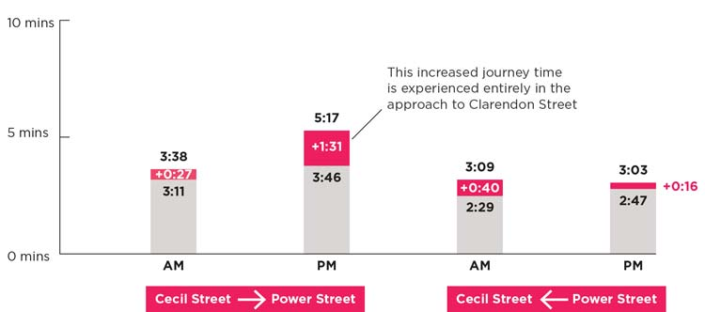
Description of figure 3.20

Next steps
Progressing this action will involve further refinement of the concept design as shown in the master plan through the detailed design phase.
This step involves producing technical drawings informed by the analysis of factors including flooding, road safety, services, landscape architecture and engineering standards.
The detailed design will need to be approved by both the City of Melbourne and VicRoads as the road authority.
The timing of construction of this action will be subject to the availability of funding and coordination with influential projects such as Melbourne Metro Rail Project.
Further information on next steps is outlined in part four.
Figure 3.21: Current view looking west along City Road between Power Street and Balston Street
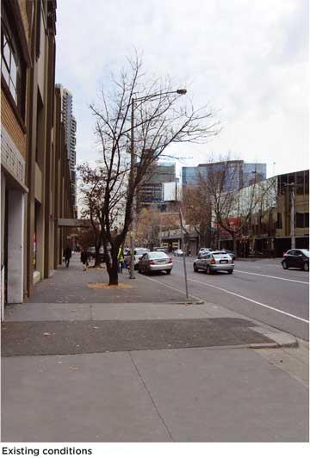
Figure 3.22: Artist’s impression of proposed conditions looking west along City Road between Power Street and Balston Street
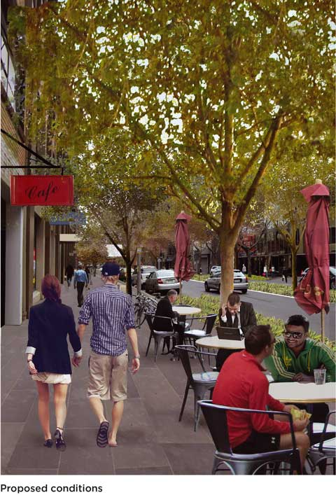
Description of figure 3.22

Action 2. Reimagine kings way undercroft as a community space

Understanding the role of Kings Way Undercroft
The Kings Way Undercroft and surrounding area presents opportunities for pedestrian and cyclist improvements as well as potential open space upgrades.
The undercroft is located adjacent to the Boyd Community Hub, which since opening in July 2012, has attracted an average of 7000 visitors per month. The Boyd Community Hub has been described as the new ‘heart’ of Southbank and offers a diverse range of community services, helping to foster civic activity in the area.
A concept for a new park, ‘Boyd Park’, on the site is currently being developed, however there is seen to be further scope for additional and complementary uses in the undercroft space that cannot be accommodated in the park.
This action looks to build on the success of the Boyd Community Hub by expanding activity into the redundant spaces of the Kings Way Undercroft (see figure 3.24). By reclaiming some road space and consolidating this with existing pedestrian spaces, three distinct areas can be formed to create a combined area of one hectare of usable public space.
Flooding is a key issue in this area and any proposals to upgrade the spaces will need to consider how to manage stormwater (see figure 3.23).
Figure 3.23: Flooding conditions surrounding the location of Kings Way Undercroft
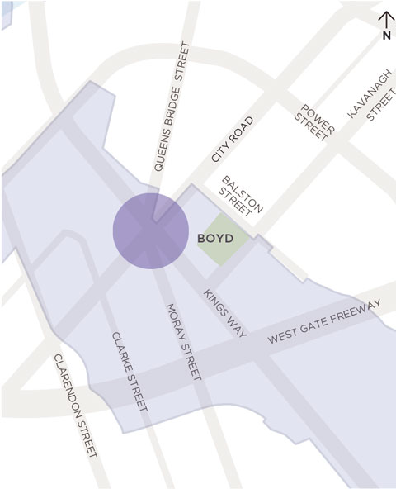
Description of figure 3.23
Figure 3.24: Kings Way Undercroft and surrounds
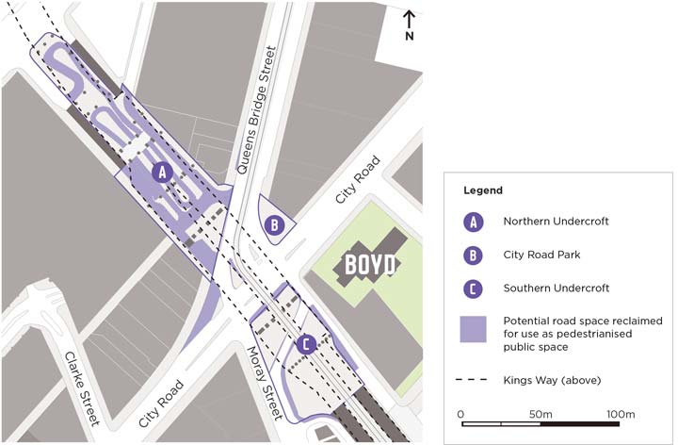
Description of figure 3.24
This project aims to:
- Incubate local community activities and local businesses.
- Further integrate the recently upgraded tram stop and bus stop with the surrounding public spaces.
- Address flooding issues and the urban heat island effect.
- Consider the role these spaces could play in complementing the existing Boyd Community Hub and upcoming Boyd Park, to better serve the local community
Design concepts on the following pages illustrate ways each of the three sites could be reimagined.
It should be noted that the proposed concept designs for the Kings Way Undercroft are situated on Crown Land. As such, any proposal will require approval from both the City of Melbourne and VicRoads, in conjunction with any relevant referral authorities (for example Melbourne Water).

What did the community say?
This action received the highest level of support out of any action in the draft master plan during the community engagement.
All responses were highly supportive of proposals to transform redundant spaces into usable and inviting public open spaces.
Community feedback also revealed a desire to see improvements to the access of these spaces (particularly the tram stop) and for the final design to address flooding and the need for improved lighting and safety of these areas.
This positive feedback confirms the desire for public space that supports the growing Southbank community.
‘This has been such a waste of space and feels unsafe (when not used as storage space by the builders!). This is a great initiative - that part of City Road has been totally ignored till now.’ - Arji, resident (21 October 2015)
Image: Kings Way Undercroft looking east towards the Boyd Community Hub
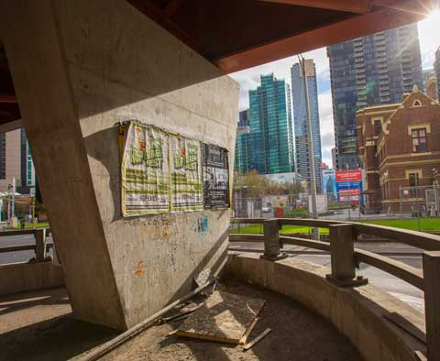

Northern Undercroft design concept
The Northern Undercroft is located under Kings Way overpass on the northern side of City Road.
It is currently occupied by a large redundant taxi rank and provides on and off ramps to the Crown Casino car parks. It connects to rear service lanes for properties facing Queens Bridge Street and City Road. Large concrete pylons support Kings Way overhead.
By consolidating redundant space, an area of approximately 5000 m2 can be created. This is equivalent in size to approximately 12 basketball courts.
Figure 3.25 presents a design concept for reimaging the Northern Undercroft as a multipurpose space that provides for a range of community activities.
Possible uses and improvements of the Northern Undercroft could include:
- Skate park/parkour
- Climbing walls
- Sports courts
- Group fitness space
- Play spaces
- Temporary art installations/events
- Pop up pavilions/studios
‘Fantastic!!! Would love to see this space brightened and activated, the provision for activities like skateboarding is awesome! Turning unused and unwanted spaces like this into vibrant community spaces is a great initiative.’ - Ryan, worker (14 September 2015)

Figure 3.25: Artist’s impression of potential uses that could occur in the Kings Way Northern Undercroft space
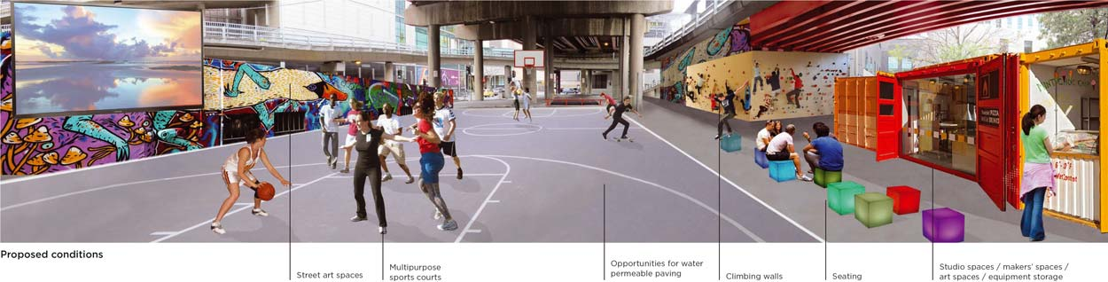
Description of figure 3.25
Figure 3.26: Existing conditions of Kingsway Northern Undercroft
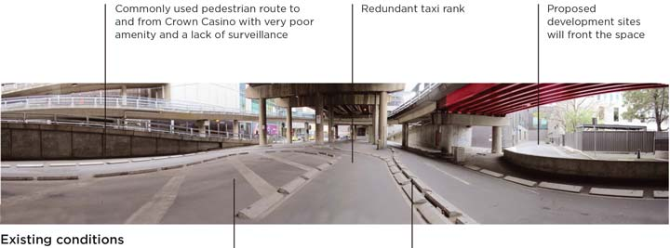
Description of figure 3.26

City Road Park design concept
City Road Park is a small park on the corner of City Road and Queens Bridge Street directly opposite the Boyd Community Hub.
The park is owned by the City of Melbourne, however currently contains two covenants that restrict the height of planting and other structures to a maximum of 1.5 metres.
City Road Park currently lacks adequate shelter, seating or protection from traffic. It is exposed to the adjacent roadways and is dominated by a large advertising billboard.
Figure 3.28 and Figure 3.29 present potential design concepts for reimagining City Road Park as an attractive, sheltered public space with opportunities to sit and gather.
The redesign of City Road Park could include features such as:
- Art and sculpture installations
- Play elements
- Water Sensitive Urban Design opportunities (for example rain gardens)
- Interactive music and sound
- Seating
- Greening
‘Adding vegetation/planting to separate pedestrians from Queens Bridge Street is an effective idea.’ - Liam, passing through (9 September 2015)
Figure 3.27: Existing view of City Road Park looking south towards Boyd Community Hub
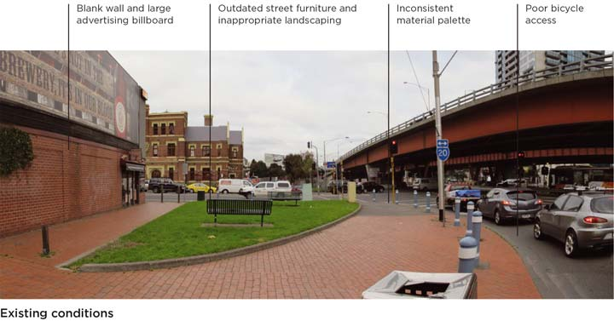
Description of figure 3.27
Figure 3.28: Artist’s impression of potential changes to City Road Park looking south towards Boyd Community Hub
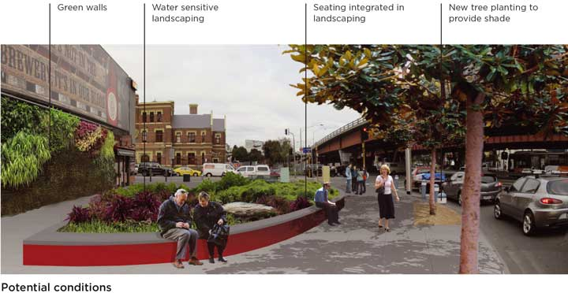
Description of figure 3.28
Figure 3.29: Artist’s impression of potential changes to City Road Park looking south towards Boyd Community Hub
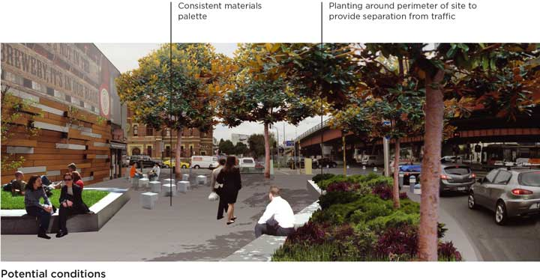
Description of figure 3.29

Southern Undercroft design concept
The Southern Undercroft is located to the south of City Road adjacent to Moray Street.
The Southern Undercroft accommodates a recently upgraded tram stop, large fenced gravel areas that cut across this space and a cut-through road and bicycle connection from Queens Bridge Street to Moray Street. This space is very difficult for pedestrians to move through. Fences, a lack of paving, flooding issues and poor signage all contribute to a feeling of a leftover and forgotten space.
Figure 3.30 presents a potential design concept for re imagining the Southern Undercroft as a green open space with trees and direct bicycle and pedestrian connections to Boyd and the tram stop.
Possible opportunities for improving the Southern Undercroft could include:
- Removing barriers to pedestrian access
- Tree planting
- Green open space
- Play elements
- Water Sensitive Urban Design
- Rain gardens
- Seating
- Further tram stop upgrades
- Lighting upgrades
‘The area around the intersection of Kings Way with City Road has lots of potential but actually looks awful. There is much potential for planting trees on the south-west corner of the intersection.’ - Angelo, resident (4 March 2014)

Figure 3.30: Artist’s impression of potential open space upgrades looking north towards Kings Way Southern Undercroft
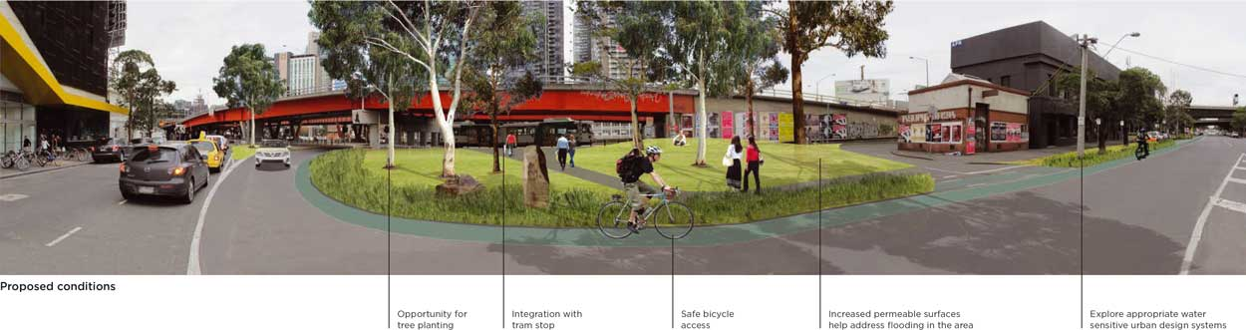
Description of figure 3.30
Figure 3.31: Existing view looking north towards Kings Way Southern Undercroft
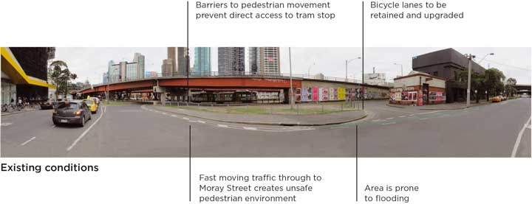
Description of figure 3.31

Action 2 Summary

Proposed improvements
The design will look to improve the existing conditions through proposals that aim to minimise the impacts of flooding and improve safety for the use and access of the three spaces identified.
The improvements proposed for the Kings Ways Undercroft will deliver the following benefits to significantly improve the functionality and use of these spaces.
- Water sensitive urban design
- New open space
- High quality street materials, furniture and lighting
- New street trees and planting
- Public transport access upgrade

Potential impacts
This action focuses on a public realm upgrade that contains minimal traffic impacts to the surrounding roads.

Next steps
Providing usable open space, minimising the impacts of flooding and improving access to the tram stop are the highest priority for this action.
The next step to progress this action is the detailed design phase. This step involves producing technical drawings informed by the analysis of factors including flooding, road safety, services, landscape architecture and engineering standards.
The three areas identified for potential upgrades in this action can be progressed separately due to the different characteristics and functions of each space.
The City of Melbourne owns City Road Park however the northern and southern undercroft spaces are Crown Land. They are managed in part by the City of Melbourne and in part by VicRoads.
Proposals to upgrade the Kings Way Undercroft will require approval from both the City of Melbourne and VicRoads, in conjunction with any relevant referral authorities (for example Melbourne Water).
Progressing Action 2 will also be influenced by the delivery of the improvements along City Road West as part of Action 1 and subject to available funding.
Further information on next steps is outlined in part four.
Image: Tram passing through the Kings Way Southern Undercroft, looking north towards Crown
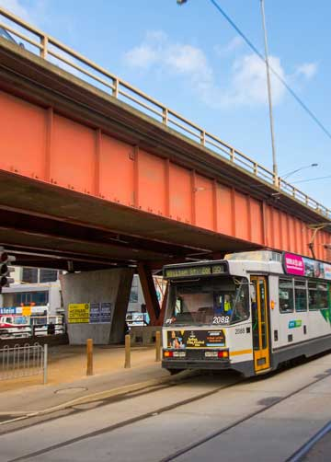

Action 3. Upgrade city road east to be safer and easier to get around

Understanding City Road East
City Road East between Power Street and St Kilda Road presents opportunities for improving safety and access, however significant changes are not currently possible due to the need to retain the road’s ongoing arterial function. City Road East carries approximately 45,000 vehicles per day, including trucks that are required to use this road as an alternate route to the Burnley Tunnel.
Significant upcoming developments such as Australia 108 will bring increasing numbers of residents and pedestrians walking along and across City Road.
City Road East impedes much of this pedestrian movement acting as a barrier that divides Southbank residences and the Arts Precinct from destinations to the north such as Southbank Promenade, Southgate and the Hoddle Grid.
Potential short term improvements include removing slip lanes and reclaiming redundant road space to allow wider footpaths and tree planting. These aim to improve the safety and amenity of the local environment as much as possible within the current traffic constraints.
Figure 3.32: City Road East between Power Street and St Kilda Road
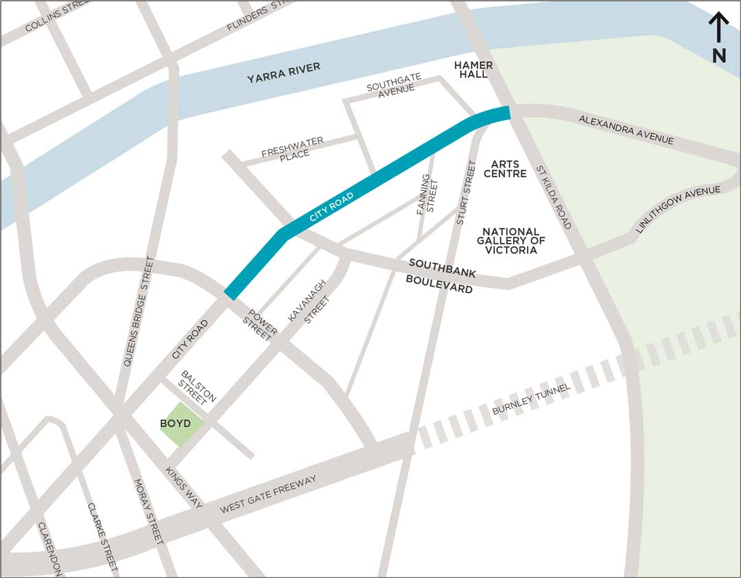
Description of figure 3.32

Existing conditions
The existing conditions of City Road East are inadequate to meet the needs of the future. Greater detail is contained on the following pages. Some of the key issues are:
- The pedestrian environment is unpleasant and unsafe due to dominance of traffic along City Road.
- Pedestrian crossings at large intersections are difficult and unsafe due to slip lanes and long wait times.
- Significant traffic flows contribute to noise and air pollution.
- Very narrow footpaths at the Power Street intersection bring pedestrians very close to large turning trucks.
- The pedestrian crossing at Fanning Street is often unseen by drivers who are moving quickly through the
St Kilda Road underpass.
To make it easier to demonstrate the proposed changes in the master plan, City Road East has been shown in two sections: Power Street to Southbank Boulevard and Southgate Avenue to St Kilda Road.
‘Left turn slip lanes have no place in a high density, high pedestrian volume urban area.’ - Garrath, resident (21 February 2014)

What did the community say?
This action received a mixed response during the community engagement. There was considerably less support for this action in comparison to other actions, predominantly due to the requirement to maintain the arterial function of City Road East.
There was some feedback that this action does not go far enough to better balance the road’s role as a place and minimise the impacts of heavy traffic.
The design proposals in Action 3 reflect the fact that the master plan is a seven year plan and it is a requirement of VicRoads to maintain traffic capacity on this section of road in this period.
The removal of slip lanes and upgrading of footpaths with new materials, furniture and trees proposed in this action will still greatly improve the amenity of City Road East. This, combined with the Transforming Southbank Boulevard Project, will change the look and feel of this part of Southbank.
Concerns about pedestrian safety will be investigated further by undertaking a road safety audit of City Road during the detailed design phase.
Figure 3.33: Large intersections along City Road (looking west at Southbank Boulevard) create unsafe and inconvenient crossing conditions
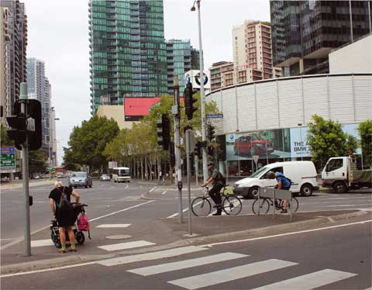
‘Greater prioritisation of pedestrians is necessary - lights should be supportive of people on foot getting around.’ - hcdr, visitor/tourist (9 September 2015)

Section 1: Power Street to Southbank Boulevard

Proposed design
Proposed street upgrades include removal of slip lanes and simplifying pedestrian crossings at Southbank Boulevard, central tree planting and some footpath extensions along City Road.
Figure 3.34: Proposed upgrade to City Road (between Power Street and Southbank Boulevard)
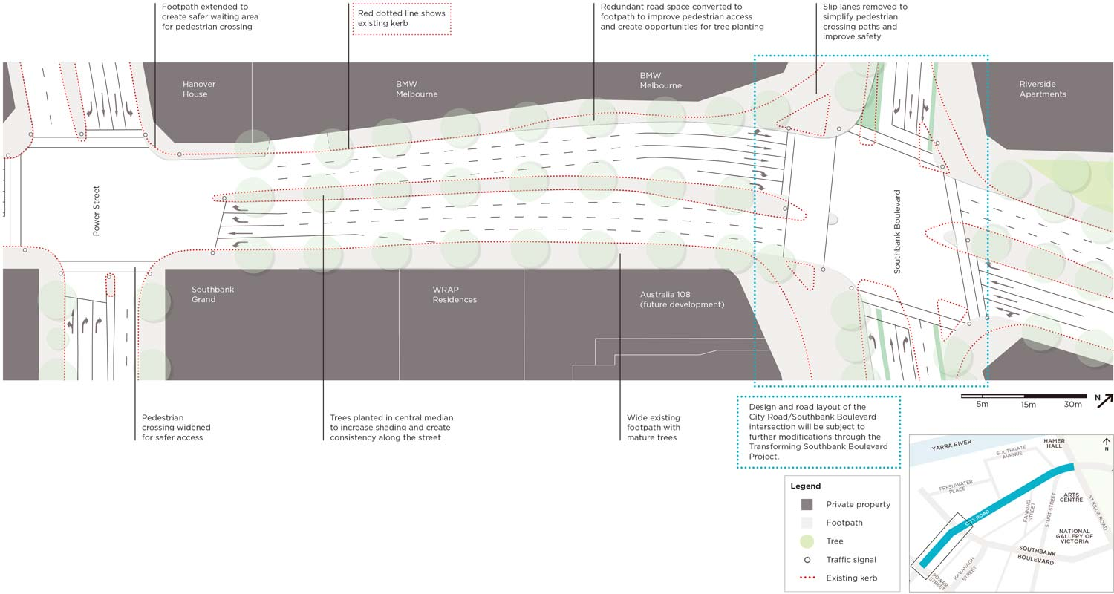
Description of figure 3.34
Figure 3.35: Existing view of City Road looking east towards the Arts Precinct (City Road and Southbank Boulevard)
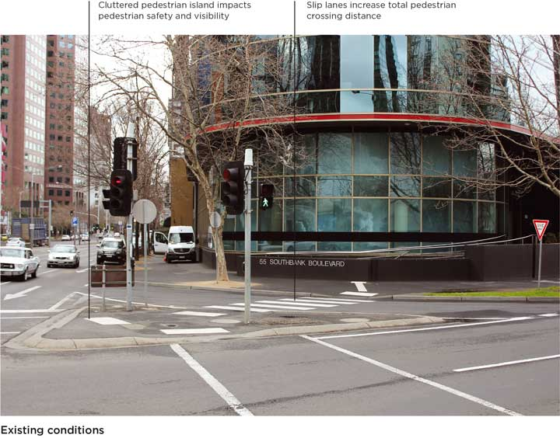
Description of figure 3.35
Figure 3.36: Existing slip lane condition on City Road East
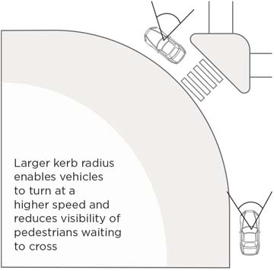
Figure 3.37: Artist’s impression of proposed conditions looking east towards the Arts Precinct (City Road and Southbank Boulevard)
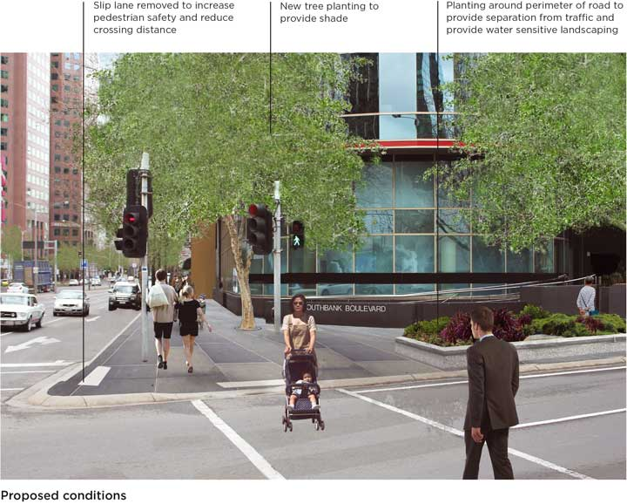
Description of figure 3.37
Figure 3.38: Proposed slip lane removal in City Road East
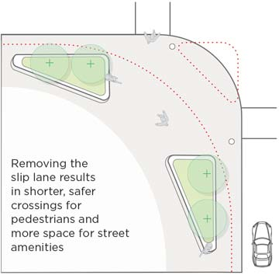

Section 2: Southgate Avenue to St Kilda Road

Proposed design
Proposed street upgrades include removal of a slip lane at Southgate Avenue (in front of IBM), simplifying pedestrian crossings, reconfiguring Fanning Street, central tree planting and some footpath extensions.
Figure 3.39: Proposed upgrade to City Road (between Southgate Avenue and St Kilda Road)
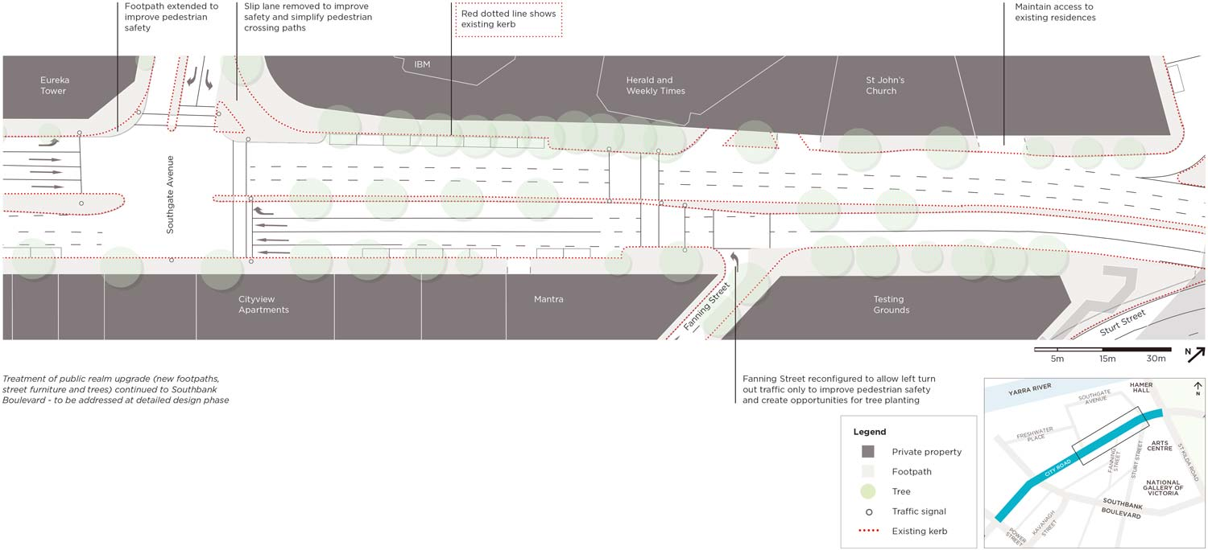
Description of figure 3.39
‘Cars just fly through too fast as they don’t know that there is a crossing (at Fanning Street).’ - Denise, resident (27 February 2014)

Action 3 Summary

Proposed improvements
In order to upgrade City Road East to be safer and easier to get around, this action will result in the following improvements:
- Removal of five slip lanes at Southbank Boulevard, Southgate Avenue and upgrade of reclaimed space
- Addition of over 45 new street trees
- Footpath upgrades and extensions outside BMW, St John’s Church and Fanning Street
- Improved bicycle access across City Road at Southbank Boulevard
- High quality street materials, furniture and lighting

Potential impacts
The improvements to City Road East have been tested in the traffic model and result in minimal journey time increases for vehicles travelling between Power Street and Linlithgow Avenue as outlined below (see figure 3.40).
- Average increase in journey time from Power Street to Linlithgow Avenue of up to:
  - 2 seconds in AM peak from 1:54 minutes to 1:56 minutes
  - 5 seconds in PM peak from 3:42 minutes to 3:47 minutes.
- Average increase in journey time from Linlithgow Avenue to Power Street of up to:
  - 1:11 minutes in AM peak from 3:00 minutes to 4:11 minutes
  - 27 seconds in PM peak from 4:03 minutes to 4:30 minutes.
Figure 3.40: Increase in journey times between Power Street and Linlithgow Avenue
Source: GHD Traffic Modelling Report, July 2015
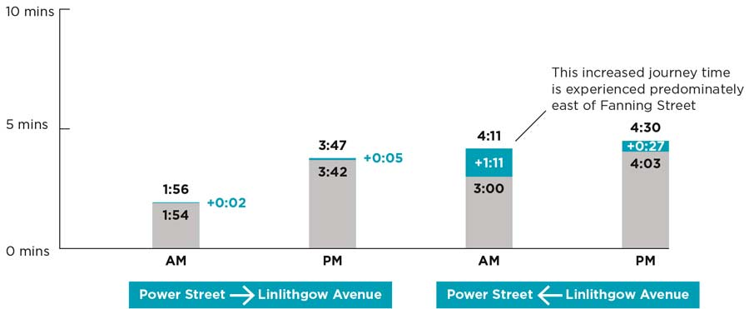
Description of figure 3.40

Next steps
Progressing this action will involve further refinement of the concept design as shown in the master plan through the detailed design phase.
This step involves producing technical drawings informed by the analysis of factors including flooding, road safety, services, landscape architecture and engineering standards.
The detailed design will need to be approved by both the City of Melbourne and VicRoads as the road authority.
The timing of construction of this action will be subject to the availability of funding and coordination with influential projects including Transforming Southbank Boulevard and Melbourne Metro Rail Project.
Further information on next steps is outlined in part four.
Image: Closure of slip lanes can create opportunities for landscaping and improve safety by increasing space available for pedestrians waiting to cross at lights. This example shows the corner of King Street and Flinders Street.
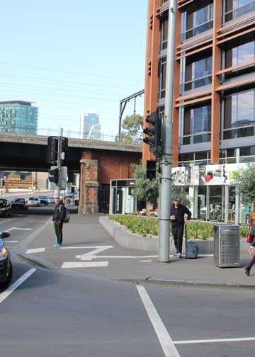

Action 4. Connect City Road to the Arts Centre and Yarra River
At St Kilda Road, City Road is lowered below grade, re-emerging eastbound from the underpass as Alexandra Avenue.
This underpass creates an inhospitable and unsafe environment bounded by traffic guard rails, concrete structural supports and theatre back-of-house loading areas.
Coupled with fast-moving heavy traffic, this is a difficult area for pedestrians to navigate and disorientating for visitors to the globally renowned Arts Precinct.
The following pages present several design concepts for significant upgrades to pedestrian access around City Road at St Kilda Road.
Figure 3.41: Location of the Arts Centre interface with City Road
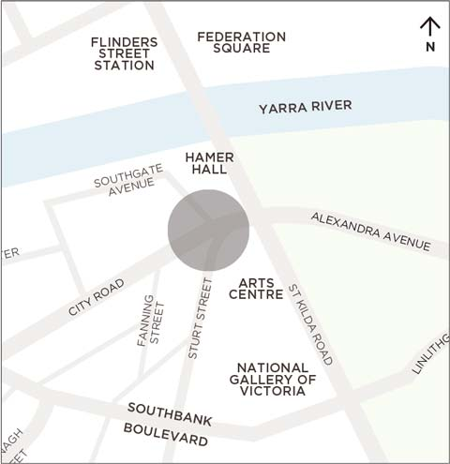
Figure 3.42: Arts Centre/St Kilda Road Study Area showing potential pedestrian connection improvements
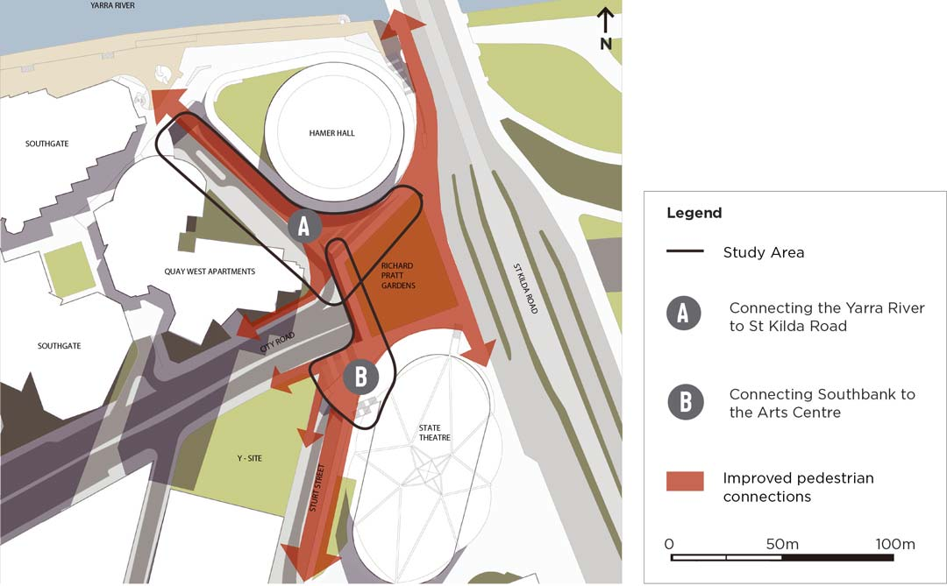
Description of figure 3.42

Arts precinct
Above City Road, the Arts Centre’s St Kilda Road frontage benefits from a prominent address and high quality pedestrian environment. Arts Victoria’s ‘Arts Precinct Blueprint’ sets a vision to expand the arts throughout Southbank to create one of the world’s leading arts and cultural districts.
The interface between City Road and St Kilda Road provides a significant opportunity for the integration of the Arts Centre, the Yarra River and the expansion of the Arts Precinct into Southbank.

Reconnecting City Road with the city
This project acknowledges and highlights the strategic importance of reconnecting City Road with the Hoddle Grid by integrating the arts precinct within Southbank. It proposes ways to transform the existing disconnected and poor quality pedestrian environment into a connected, inviting and engaging place for people.
This project aims to:
- Create a safe pedestrian environment that is easy for everyone to get around.
- Create an inviting, public ‘back door’ from City Road to the Arts Centre.
- Replace or upgrade inadequate and outdated infrastructure.
- Create direct pedestrian links between the Arts Centre, the Yarra River and Southbank.
- Provide an improved pedestrian connection over City Road.
- Deliver a flexible concept which does not limit future expansion and growth of the precinct.
The design concepts on the following pages illustrate ways this area could be reconnected to serve both the local community and deliver on the broader Arts Precinct vision.

What did the community say?
The majority of responses to this action from the community were supportive of the proposals for the Arts Precinct. It received the second highest level of support out of the six actions in the draft master plan with more than three quarters of responses being supportive of all or most parts of this action.
This action did not receive any responses that were not supportive, demonstrating a strong desire for improved connections at the rear of the Arts Centre that reconnect Southbank with the Arts Precinct.
Participants liked improvements to pedestrian and cycling connections and activating public space at the rear of the Arts Centre.
There was some desire to retain existing bicycle parking and car parking for local residents and to include mural art at the rear of Hamer Hall. These suggestions have been reflected in the concept design for this action.
‘The proposed design seeks to restore the balance with pedestrians and unify the area with St Kilda Rd in a flowing, aesthetically pleasing way.’ - Damian, interested (14 September 2015)

Section A: Connecting the Yarra River to St Kilda Road
Figure 3.45 presents a design concept for improving pedestrian connections between St Kilda Road and the Arts Centre lawn to the Yarra River. This design concept includes the upgrade of Southgate Avenue (figure 3.50 page 101) by minimising road space and through-traffic while enabling better pedestrian and cycling links.
‘Better links are required between St Kilda Road and City Road - It’s an ugly wasteland under Hamer Hall.’ - Matt, visitor (20 February 2014)
Figure 3.43: Existing pedestrian and cycling connections are poor quality, indirect and difficult to find
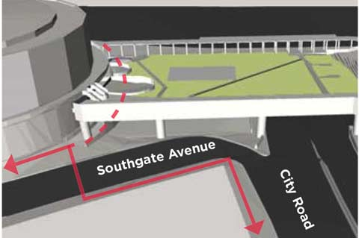
Figure 3.44: Proposed connections that improve accessibility between the Arts Precinct, the Hoddle grid and Southbank
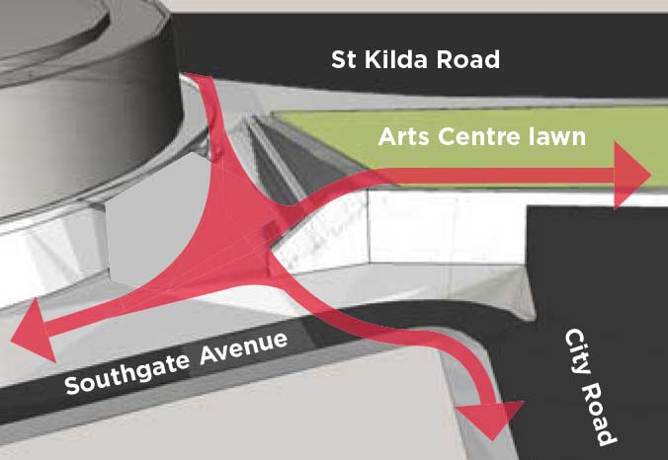

Figure 3.45: Artist’s impression of potential public realm upgrades looking east towards the Arts Centre
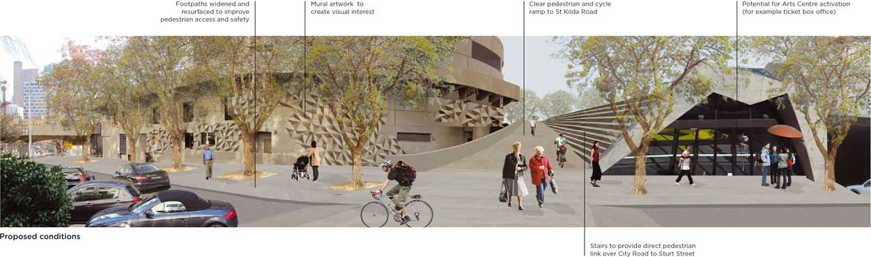
Description of figure 3.45
Figure 3.46: Existing view of Southgate Avenue looking east towards the Arts Centre
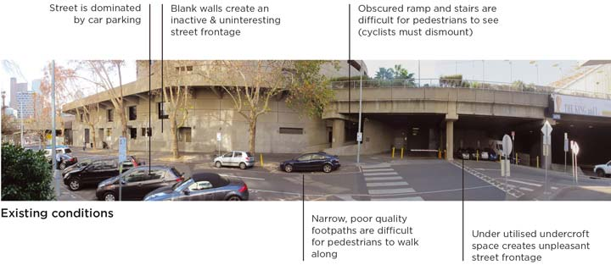
Description of figure 3.46
Figure 3.47: Existing view of Southgate Avenue looking south towards the Arts Centre
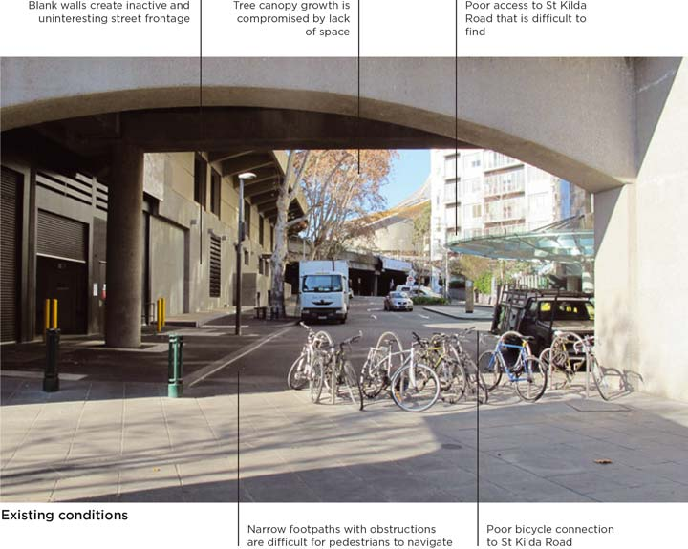
Description of figure 3.47
Figure 3.48: Existing connections between the Yarra River and St Kilda Road
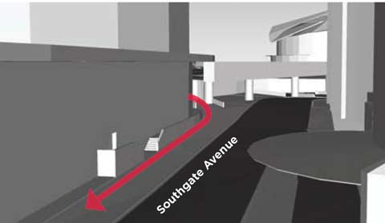
Figure 3.49: Proposed connections between the Yarra River and St Kilda Road
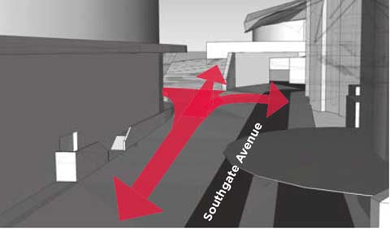
Figure 3.50: Artist’s impression of potential upgrades to Southgate Avenue looking south towards the Arts Centre
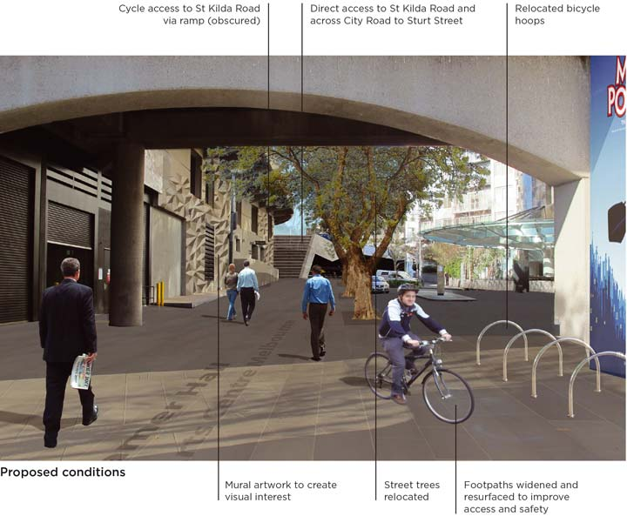
Description of figure 3.50
‘An attractive pedestrian link would help to remove the feeling that City Road splits Southbank in two.’ - Nathan, resident (1 March 2014)

Section B: Connecting Southbank to the Arts Centre
Figure 3.53 presents a potential design concept for creating an inviting entrance from City Road to the Arts Centre. A staircase and elevator would provide direct pedestrian connections between City Road and the Arts Centre and would help to integrate Southbank as part of the Arts Precinct.
‘This really should be the gateway for pedestrians from Melbourne to the whole Southbank area. Flowing the garden down to the road would be a game changer.’ - Steve, resident (25 February 2014)
Figure 3.51: Existing pedestrian and cycling connections are poor, indirect and difficult to find
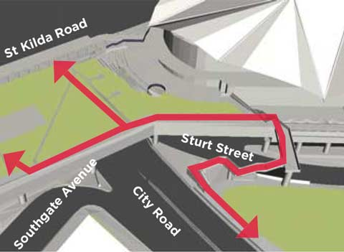
Figure 3.52: Potential connections will activate frontages around City Road and provide direct access to the arts precinct
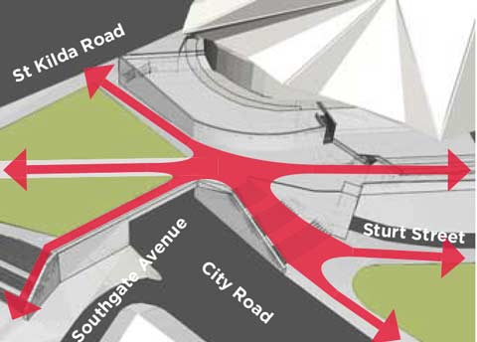

Figure 3.53: Artist’s impression of possible upgrades to connect City Road to the Arts Centre looking east towards Alexandra Avenue
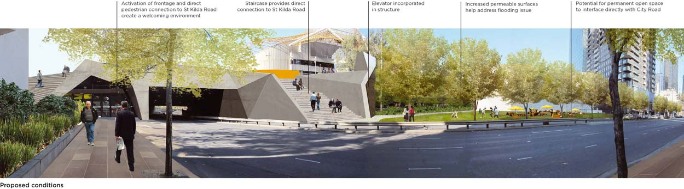
Description of figure 3.53
Figure 3.54: Existing view of City Road underpass looking east towards Alexandra Avenue
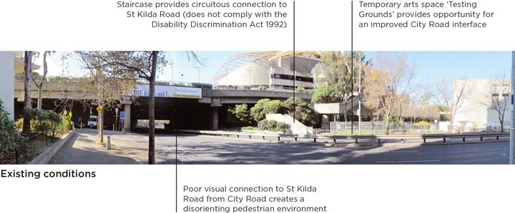
Description of figure 3.54

Action 4 Summary

Proposed improvements
The proposals outlined in this action will deliver the following benefits to improve significantly connections between City Road, the Arts Centre and the Yarra River:
- New street trees
- Improved pedestrian access and footpath upgrades
- Improved bicycle access
- High quality street materials, furniture and lighting

Potential impacts
This action focuses on a public realm upgrade that contains minimal traffic impacts to the surrounding roads.

Next steps
The proposed improvements identified in Action 4 involve the Arts Centre as the lead stakeholder and driver of changes in this area.
The Arts Centre is currently developing a master plan that will investigate ways to improve both the internal areas of its buildings and the surrounding spaces.
For the intent of the action to be realised, the City of Melbourne will work with the Arts Centre to ensure that the master planning work that is being undertaken for the Arts Centre in 2016 aligns with the highly supported proposals in this master plan.
Further information on next steps is outlined in part four.
Image: City Road at the corner of Fanning Street, looking east towards Testing Grounds and the existing stairs up to St Kilda Road
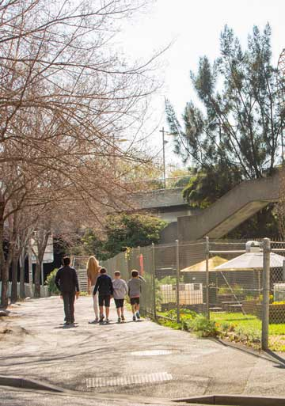

Action 5. Connect the gardens

Understanding Alexandra Avenue
Alexandra Avenue between St Kilda Road and Linlithgow Avenue runs through the Domain Parklands which are listed on the Victorian Heritage Register for their significance to the State of Victoria.
The parklands provide a range of important benefits to the city in terms of urban ecology, biodiversity, urban forest, water management, recreation and events.
In the context of the master plan, Alexandra Avenue between St Kilda Road and Linlithgow Avenue presents opportunities to improve the connection between Alexandra Gardens and Queen Victoria Gardens and calm traffic flow through this area.
The existing conditions of Alexandra Avenue encourage high vehicle speeds and do not maximise the potential of pedestrian connections between the surrounding gardens and Yarra River.
This action proposes to introduce a signalised pedestrian crossing mid-way between St Kilda Road and Linlithgow Avenue to connect to the existing path networks within the two gardens.
This will provide a direct connection between Alexandra Gardens and Queen Victoria Gardens. It will not only increase pedestrian safety, but greatly improve the usability of these gardens.
The City of Melbourne is developing the Domain Parklands Master Plan to create a shared vision for the parklands and to guide their management into the future. Other opportunities for improvements in this area will be explored as part of the Domain Parklands master plan.
Figure 3.55: Indicative location of the proposed pedestrian crossing on Alexandra Avenue between St Kilda Road and Linlithgow Avenue
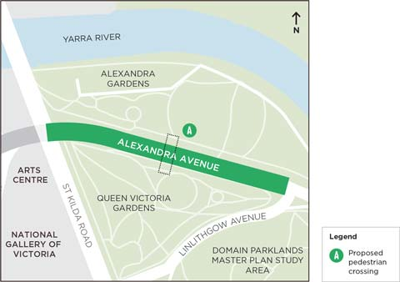
Description of figure 3.55

What did the community say?
This action received a mixed response during the community engagement. Feedback revealed support for a pedestrian connection between the two gardens and traffic calming measures.
There was some concern about the impact of congestion and driver behaviour associated with Swan Street Bridge.
These concerns are being investigated by VicRoads through the Swan Street Bridge Upgrade project which aims to ease eastbound congestion on Swan Street Bridge, reduce queue lengths and improve cycling and pedestrian access.
The draft master plan included a longer term proposal for a central tree-lined median. While only 16 responses were received specific to this action, there was less support for this idea due to the potential impact on existing trees and landscape values, loss of usable open space and cost versus benefit of the proposal.
Other considerations regarding the boulevard proposal include the potential cost (approximately $1.5 million) and benefit in comparison to other proposals in City Road and Alexandra Avenue, and the seven year time frame of the master plan.
As such, this action now focuses on the short term proposal to introduce a pedestrian crossing while any longer term opportunities for this area, such as a central median, could still be considered as part of the Domain Parklands Master Plan.

Action 5 Summary

Proposed improvements
The new pedestrian crossing proposed for Alexandra Avenue will deliver the following benefits:
- Safer and more direct pedestrian access between two significant gardens.
The proposed crossing is presented on the following pages.

Potential impacts
The introduction of a new pedestrian crossing on Alexandra Avenue has been tested in the traffic model and results in minimal traffic delays. This is due to synchronising the new set of traffic lights with the existing traffic lights at the intersection of Linlithgow Avenue.
The Swan Street Bridge upgrade aims to ease east bound congestion and reduce queue lengths on Alexandra Avenue.

Next steps
The next step to progress this action is to develop a detailed design for the pedestrian crossing, in conjunction with the Domain Parklands Master Plan.
The detailed design will need to be approved by both the City of Melbourne and VicRoads as the road authority.
Timing of construction will be subject to the availability of funding and coordination with influential projects like the Swan Street Bridge Upgrade.
Further information on next steps is outlined in part four.
‘It’s so hard to get from Alexandra Gardens to Queen Victoria Gardens. We really need a connection for better usage of both garden spaces.’ - Steve, resident (25 February 2014)
‘The new pedestrian crossing is a great idea. It must be a proper ground level crossing, not a bridge. Give priority to pedestrians in this area, not cars.’ - bodysuitman, resident (17 September 2015)
Image: Vehicles travelling along Alexandra Avenue, looking west towards St Kilda Road
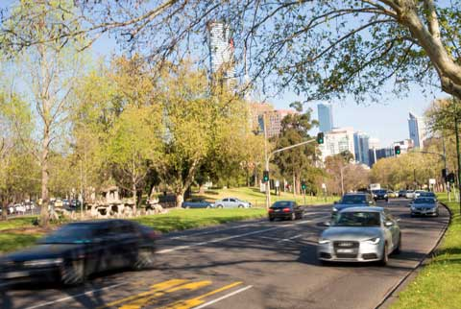

Alexandra Avenue

Proposed design
The proposed design introduces a new pedestrian crossing on Alexandra Avenue, mid-way between St Kilda Road and Linlithgow Avenue to connect into the existing path network.
Figure 3.56: Proposed upgrade to Alexandra Avenue (between Linlithgow Avenue and St Kilda Road)
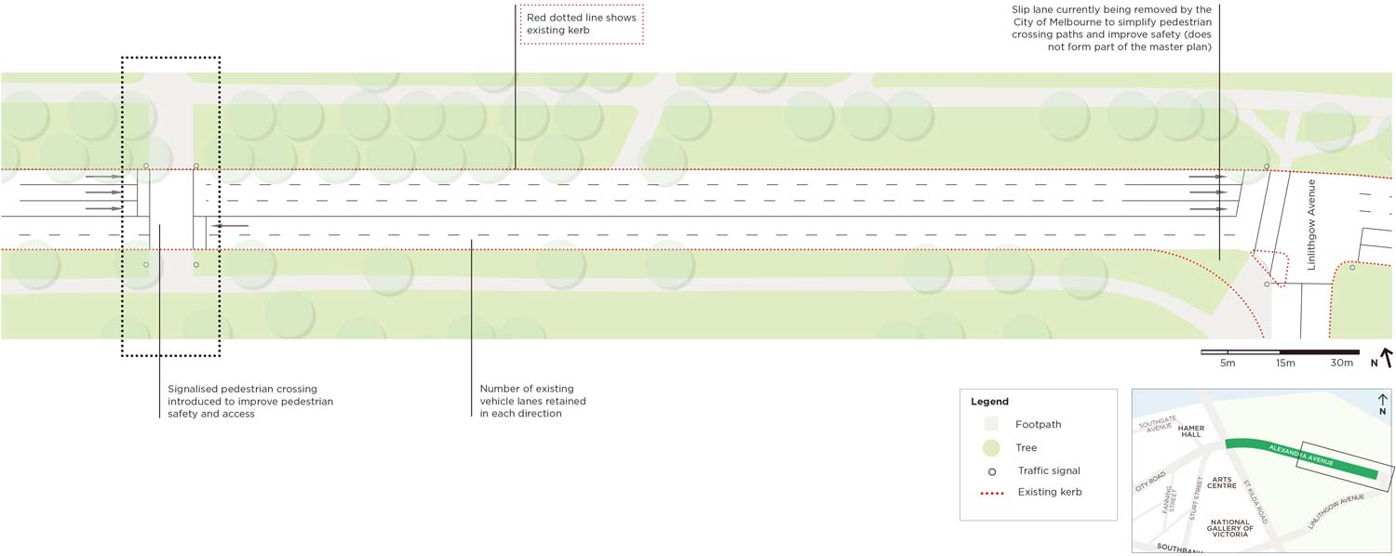
Description of figure 3.56

Action 6. Expand the bicycle network within Southbank

Understanding cycling in Southbank
The master plan proposes a new on-road bicycle route through Southbank via City Road, Balston Street, Kavanagh Street and Southbank Boulevard (see figure 3.57).
Figure 3.57: Proposed bicycle route (orange) through Southbank with existing network (green)
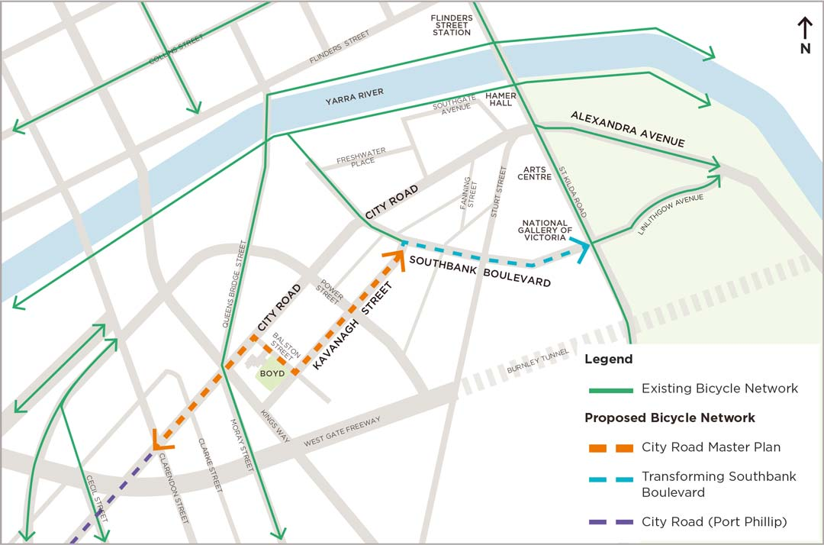
Description of figure 3.57
This route will improve cycling access within Southbank between the Boyd Community Hub and the King’s Domain and from the Yarra River trail through Southbank towards South Melbourne and Fishermans Bend.
This new bicycle route will greatly improve cycling access within Southbank and connect to the existing bicycle network, providing greater options for safe on-road cycle journeys through Southbank.
It is not considered feasible within the time scale of this master plan to accommodate safe, separated bicycle lanes in City Road East and Alexandra Avenue due to the competing space requirements of different modes requiring access to City Road between Power Street and Southbank Boulevard.
Separated bicycle lanes are proposed for City Road from Clarendon Street to Balston Street to ensure cyclist safety on this segment of the arterial road which contains both cars and buses. Further detail on the design of these bicycle lanes is included in Action 1 (see page 52).
Bicycle lanes on Southbank Boulevard will be included in the Transforming Southbank Boulevard project. This will provide important connections to the river, St Kilda Road and the Botanical Gardens.
West of the M1 Freeway, City Road in the City of Port Phillip is nominated as a proposed commuter bike route (City of Port Phillip Bike Plan 2011-2020). This route will be critical to help connect Fishermans Bend to the central city.
The City of Melbourne will support the provision of bicycle facilities at key destinations like the Boyd Community Hub.

What did the community say?
Participants of the community engagement were highly supportive of providing more cycling connections in Southbank, however emphasised the importance of safety for cyclists, particularly relating to the design of bicycle lanes and interaction with other transport modes.

Action 6 Summary

Proposed improvements
- This action will result in a new east-west bicycle link through Southbank.

Potential impacts
The introduction of new bicycle lanes on Kavanagh and Balston Streets will require the reallocation of some road space to accommodate the bike lanes.
There may be some traffic delays associated with the proposed signalisation of the intersection of City Road and Balston Street as described in Action 1.

Next steps
This action will be progressed through the implementation of the City of Melbourne Bicycle Plan 2016-2020, which includes the local bike connection on Balston and Kavanagh Streets. The connecting bike link on City Road West will be progressed as part of Action 1.
The City of Melbourne will continue to work with all relevant stakeholders including City of Port Phillip, PTV, Yarra Trams, VicRoads and Melbourne Convention and Exhibition Centre, to ensure a cohesive, connected and safe cycling network.
Further information on next steps is outlined in part four.
‘Anything that improves conditions for cycling is good for the city, the people, health and the environment.’ - Dianemdunn, passing through (1 October 2015)
‘Cycling access to Port Melbourne via City Road is scary.’ - Jackie, resident (26 February 2014)
Image: Cyclists riding west along City Road at the Kings Way undercroft
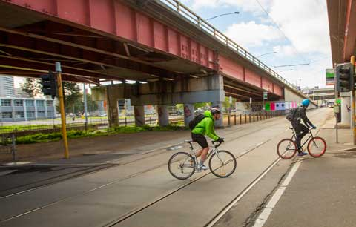

Part Four: Next steps
In this part you will find:
- The next steps to deliver the master plan

6. How could the master plan be delivered?
There are a number of steps required to take the proposals in the master plan forward to deliver changes in Southbank.
The typical stages of design from the master plan (also known as ‘concept design’) through to construction are described below.

Concept design (master plan)
The concept design stage typically involves establishing design proposals that reflect an agreed vision and project objectives and have been informed by analysis and engagement with key stakeholders and the community.
This master plan constitutes the concept design stage for City Road.

Detailed design
Following on from the concept design is the detailed design stage. Detailed design is broken down into two key steps: draft functional layout and functional layout.
The draft functional layout requires further site analysis to be undertaken that will assist with the refinement of the detailed design. This stage is likely to take around 12 months and include the following key analysis:
- Civil Engineering drawings (technical drawings) that show information about grading, landscaping, site details and the proposals drawn to scale.
- Digital feature survey that identifies all the land features including trees, street furniture, services, buildings and ground levels.
- Flooding survey/analysis to determine the extent of flooding incidents and types of treatments to manage stormwater and reduce impacts of flooding.
- Geotechnical survey to obtain information about the physical properties of soil and rock in and around the study area.
- Landscape architecture to assess and design the landscaping including identification of specific materials, plant species and water sensitive urban design infrastructure.
- Road safety audit to identify road safety issues and determine measures to improve safety for all road users (for example speed limits, kerb radii).
- Service checks to determine the age, location and condition of services and whether they need upgrading.
The functional layout process will finalise the design detail and construction drawings required to progress a specific proposal and is likely to take about six months to complete.
Some of the master plan actions can be progressed sooner than others. Actions 1, 2, 3, 5 and 6 are ready to progress to the detailed design stage, whereas Action 4 is still at the concept design (master plan) stage and is being led by the Arts Centre.

Construction works
Construction works will involve building the physical improvements to the road and public spaces. Construction is subject to approval from both the City of Melbourne and VicRoads as the road authority and any other relevant referral authority (for example Melbourne Water). Construction is also dependent on the availability of funding and prioritisation of the project. Construction works are usually timed to minimise disruption to the surrounding areas.
Image: Swanston Street creates a pleasant pedestrian environment with wide bluestone footpaths, established shady trees and central city street furniture
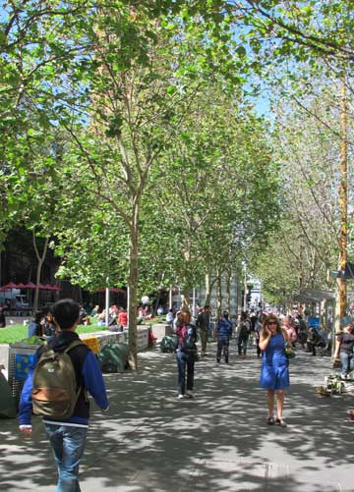

What other projects will influence the delivery of the Master Plan?
There are a number of other projects being developed in the vicinity of City Road that will influence the delivery of the master plan (see figure 4.1). These projects are described below.
Figure 4.1: Related projects to the City Road Master Plan
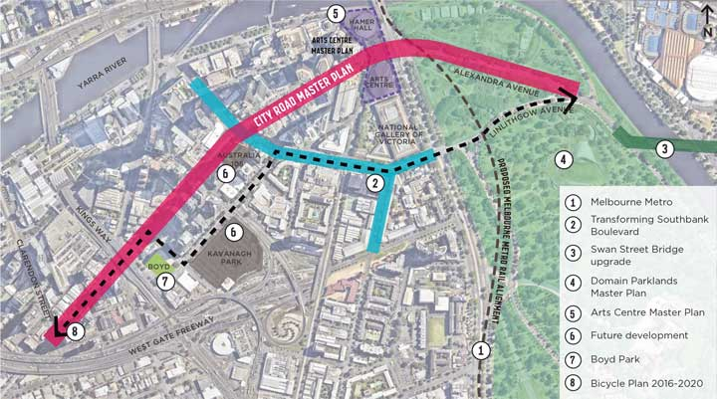
Description of figure 4.1

1 Melbourne Metro Rail Project
The Melbourne Metro Rail Project will create a new end to end rail line from Sunbury to Cranbourne-Pakenham with high capacity trains and five new underground stations in the City of Melbourne.
The construction of the Melbourne Metro Rail tunnel and stations at Domain and Federation Square/Flinders Street will temporarily impact on traffic conditions in and around the city, including Southbank.
Temporary road closures to accommodate construction work is likely to increase traffic flow on City Road and Alexandra Avenue for a specific period.
Construction of some of the actions in the master plan will be coordinated with Melbourne Metro and the indicative timelines may be impacted as a result.

2 Transforming Southbank Boulevard
The City of Melbourne has identified an opportunity to create more public open space for the growing Southbank community through the transformation of Southbank Boulevard and Dodds Street.
Southbank Boulevard no longer carries the volume of traffic it was designed for, so the project will reconfigure the road to create new open space between St Kilda Road and the Yarra River.
The master plan for Transforming Southbank Boulevard and Dodds Street is expected to be completed in late 2016 with construction to commence in 2017 and phased to align with surrounding major developments.

3 Swan Street Bridge upgrade
In the 2015 Victorian State Budget, the Government committed $30 million to address a range of issues on Swan Street Bridge including queuing and traffic congestion, particularly during peak times and east-west connectivity for cyclists between Alexandra Avenue and Batman Avenue.
VicRoads is currently developing an integrated solution for the bridge which increases its capacity, eases congestion, improves traffic flow and balances the needs of drivers, cyclists and pedestrians.

4 Domain Parklands Master Plan
The City of Melbourne is developing a master plan to guide the management of the Domain Parklands, now and into the future.
The aim is to create a strong, shared vision for the whole parkland that will consider factors like climate change, water restrictions, urban ecology, increases in visitation, major events and changing community uses.
The Domain Parklands Master Plan is expected to be completed by mid 2017.

5 Arts Centre Master Plan
Arts Centre Melbourne has engaged a project team to commence a master plan process to address the many challenges facing the precinct including both internal and external upgrades.
Arts Centre Melbourne and the City of Melbourne agree on the broad objectives of improving the area in Action 4 of the City Road Master Plan and will work in close collaboration to address the challenges to deliver its master plan to the State Government in December 2016.

6 Future development in Southbank
As development in Southbank continues to occur at a rapid rate, future developments such as Australia 108, Kavanagh Park and Queensbridge Tower (Crown) are important to consider as we plan for Southbank’s community.
The scale of these developments present an opportunity for development contributions to be utilised to progress some of the master plan proposals.
There is also an opportunity to ensure construction works are complementary and aim to reduce disturbances as much as possible.

7 Boyd Park
In 2007 the City of Melbourne purchased the Boyd School site. In consultation with the community, it was determined the site should be divided into three areas: the community hub featuring the heritage listed school buildings, a portion of the site sold for a private development and the remainder of the site to be transformed into the new park.
A first round of community consultation on the park was undertaken in 2014 to inform the design of a draft concept for the park which will be released for community consultation. The timing and construction of the park is contingent on construction of the private development.

8 Bicycle Plan 2016-2020
The Bicycle Plan is the City of Melbourne’s action plan for a connected bicycle network, improving links to existing routes and making cycling more accessible for people of all ages and abilities. It was endorsed by Council in March 2016.
The Bicycle Plan aims to upgrade Southbank Boulevard, Kavanagh Street and Balston Street and investigate connections on City Road and Clarendon Street in the medium term (two to five years).

Next steps
The City Road Master Plan is a seven year plan for delivering improvements to the road and surrounding public realm.
A plan that shows potential next steps has been established for the actions in the master plan. It contains indicative timelines, costings, the stages of development from design through to construction and the lead agencies driving the delivery of each action (see figure 4.3).
The timelines contained in the plan are indicative only and subject to modification.
An approximate cost for each action has been included in the plan.
These initial costings were produced by a quantity surveyor and are based on unit rates from other similar projects and approximate quantities calculated from the concept drawings in the master plan.
The costings will be subject to review as the project progresses through the detailed design and construction stages.
The delivery of the actions will be influenced by project priority, availability of funding, approval by lead agencies and responsible authorities and coordination with related projects.
A summary of the next steps for each of the six actions is provided below (see figure 4.2).
Figure 4.2: The six actions in the master plan
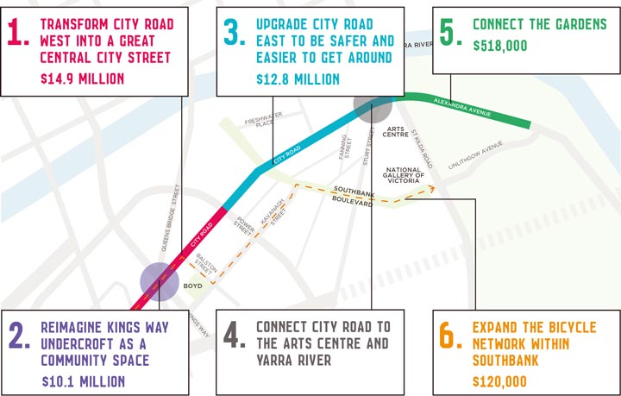
Description of figure 4.2

Action 1. Transform City Road West into a great central city street
Progressing Action 1 will involve further refinement of the concept design through the detailed design stage, which will need to be approved by both the City of Melbourne and VicRoads as the road authority.
The timing of construction will be subject to the availability of funding and coordination with influential projects such as Melbourne Metro Rail Project.
Approximate cost: $14.9 million

Action 2. Reimagine Kings Way Undercroft as a community space
Providing usable open space, minimising the impacts of flooding and improving access to the tram stop are the highest priority for Action 2.
The next step to progress this action is the detailed design stage. This process will involve further analysis of site conditions to inform the refinement of the design.
The three areas identified for potential upgrades in this action can be progressed separately due to the different characteristics and functions of each space.
The City of Melbourne owns City Road Park however the northern and southern undercroft spaces are Crown Land. They are managed in part by the City of Melbourne and VicRoads.
Proposals to upgrade the Kings Way Undercroft will require approval from both the City of Melbourne and VicRoads, in conjunction with any relevant referral authorities (for example Melbourne Water).
Progressing this action will influenced by the delivery of the improvements along City Road West as part of Action 1 and subject to available funding.
Approximate cost:
- Kings Way Northern Undercroft: $5.9 million
- City Road Park: $422,000
- Kings Way Southern Undercroft: $3.7 million
Total approximate cost: $10.1 million

Action 3. Upgrade City Road East to be safer and easier to get around
Progressing Action 3 will involve further refinement of the concept design through the detailed design stage, which will need to be approved by both the City of Melbourne and VicRoads as the road authority.
The timing of construction will be subject to the availability of funding and coordination with influential projects including Transforming Southbank Boulevard and Melbourne Metro Rail Project.
Approximate cost: $12.8 million

Action 4. Connect City Road to the Arts Centre and Yarra River
The proposed improvements identified in Action 4 involve the Arts Centre as the lead stakeholder and driver of changes in this area.
The Arts Centre is currently developing a master plan that will investigate ways to improve both the internal areas of its buildings and the surrounding spaces.
For the intent of the action to be realised, the City of Melbourne will work with the Arts Centre to ensure that the master planning work that is being undertaken for the Arts Centre in 2016 aligns with the highly supported proposals in this master plan.
Approximate cost: n/a

Action 5. Connect the gardens
The first step to progress Action 5 is to develop a design for the pedestrian crossing that is in line with the Domain Parklands Master Plan.
The detailed design will need to be approved by both the City of Melbourne and VicRoads as the Road Authority.
Timing of construction will be subject to the availability of funding and coordination with influential projects like the Swan Street Bridge Upgrade.
Approximate cost: $518,000

Action 6. Expand the bicycle network within Southbank
Action 6 will be progressed through the implementation of the City of Melbourne Bike Plan 2016-2020, which includes the local bike connection on Balston and Kavanagh Streets. The connecting bike link on City Road West will be progressed as part of Action 1.
The City of Melbourne will continue to work with the City of Port Phillip, PTV, Yarra Trams, VicRoads and Melbourne Convention and Exhibition Centre to ensure a cohesive and connected cycling network across the two municipalities.
Approximate cost: $120,000

Indicative proposed implementation plan
Figure 4.3: City Road Master Plan next steps plan
Note: Timelines are indicative only and subject to modification. Factors influencing timing and delivery include available funding, annual budget and service delivery priorities, outcomes of the draft functional layout and key influencing projects
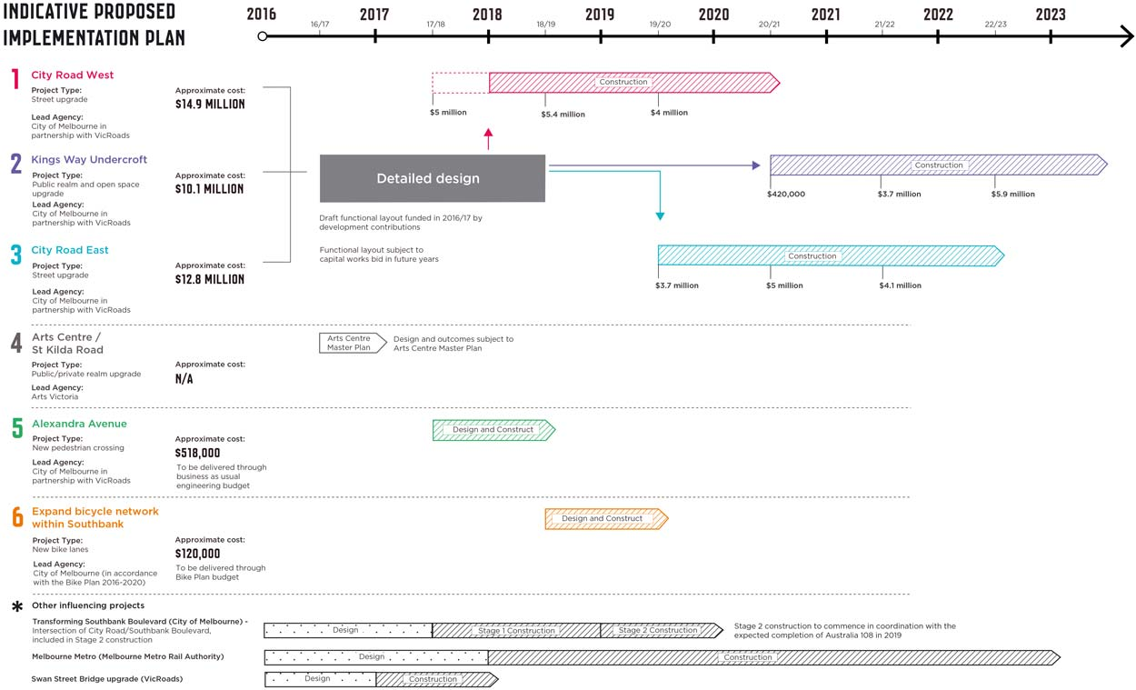
Description of figure 4.3

How will the actions be funded?
Funding sources for each action will vary depending on the nature of the proposal.
Within each action it might be possible to fund specific parts using a range of funding sources.
Potential funding sources currently being considered for the six actions include:
- Capital works budget (City of Melbourne)
- Bike Plan budget (City of Melbourne)
- Development contributions
- Public Open Space contributions
- Some actions (Action 5 and Action 6) to be delivered through regular annual budgets (business as usual at City of Melbourne)
- Parking levy (Victorian Government levy to be used for the purpose of funding transport initiatives in line with the Transport Strategy)
The detailed design work to commence in 2016/17 will inform the future timing, funding and sequencing of the individual master plan actions. Implementation of these actions will be subject to annual budget and service delivery priorities.

Appendix: Figure descriptions
In this accessible version of the master plan, all figures and images include alternative text (figure descriptions).
Where the figure descriptions are short (one or two sentences), they are included with the image and are not repeated in this appendix. Where the descriptions are longer, they are provided in this appendix, and the alternative text included with the image indicates there is a link below the image to the description here.
The figure descriptions reflect the visible content of each figure and do not include additional information.

Figure 0.2: City Road Master Plan study area
The study area comprises three sections:
- City Road West - between Clarendon Street and Power Street
- City Road East - between Power Street and St Kilda Road
- Alexandra Avenue - between St Kilda Road and Linlithgow Avenue.
Return to text following Figure 0.2

Figure 0.3: Potential increases in journey times in minutes between Cecil Street and Linlithgow Avenue, showing the two routes most impacted by the proposals
The table below shows the potential increases in journey time for AM west bound peak travel by section.
Road section | AM peak west bound  (minutes, seconds)
City Road West | +0:40
City Road East | +0:29
Alexandra Avenue | +0:42
Total | +1:51
The table below shows the potential increases in journey time for PM east bound peak travel by section.
Road section | PM peak east bound  (minutes, seconds)
Alexandra Avenue | +1:31
City Road East | +0:00
City Road West | +0:06
Total | +1:37
Return to text following Figure 0.3

Image: Artist’s impression of City Road looking west towards Balston Street, following improvements as outlined in the master plan
Digitally altered photo of proposed conditions described in figure 3.13. The image shows:
- bluestone paving on footpath
- new tree-lined central median
- new kerbside cafe seating
- additional trees and shade
- ground planting on the kerbside and median.
Return to text following image

Figure 1.1: City Road Master Plan project timeline
The phases of the timeline are:
- Autumn 2014: Community engagement
- Winter 2015: City Road Draft Master Plan
- Spring 2015: Community engagement
- June 2016: Final City Road Master Plan (this document)
- 2016 on: Implement City Road Master Plan.
Return to text following Figure 1.1

Figure 1.2: City Road Master Plan study area
The study area comprises three segments:
- City Road West - between Clarendon Street and Power Street
- City Road East - between Power Street and St Kilda Road
- Alexandra Avenue between St Kilda Road and Linlithgow Avenue.
Return to text following Figure 1.2

Figure 1.3: City Road and related projects within the wider central city context
City Road and Alexandra Avenue are located at the southern end of the Expanded Central City Area of Melbourne, south of the Yarra River and northeast of Fishermans Bend Urban Renewal Area.
Related projects that intersect with the City Road Master Plan study area include:
- Boyd Park
- Southbank Boulevard
- Domain Parklands Master Plan area
- Arts Precinct Blueprint area.
Return to text following Figure 1.3

Figure 1.4: Positive and negative experiences of City Road shared online
Shared negative experiences outnumber positive experiences, with 90 per cent negative and 10 per cent positive. Many sections of road have negative experiences only. Positive experiences are mostly isolated, and there are just two clusters of positive experiences: between Moray Street and Queens Bridge Street and Balston Street; and between Fanning Street and Sturt Street.
Return to text following Figure 1.4

Figure 1.5: Experience of City Road shared online
Doughnut chart of the following data, collected during community engagement in 2014:
- Unsafe: 37%
- Frustrated: 23%
- Other, neutral: 14%
- Angry:12%
- Sad: 8%
- Happy: 4%
- Relaxed, hopeful: 3%.
Return to text following Figure 1.5

Figure 1.6: Combined feedback results for the overall draft master plan and six actions
Doughnut chart of the following data, collected during community engagement in 2015:
- Strongly support it all: 43%
- Support most parts of it: 29%
- Support some parts of it but not others: 19%
- Do not support most parts of it: 5%
- Do not support it at all: 4%.
Return to text following Figure 1.6

Figure 1.7: Existing transport routes on City Road and Alexandra Avenue in the broader Southbank context
Existing transport routes in the broader Southbank context comprise bicycle, bus, car, large truck and tram routes.
Bicycle routes are located along:
- the south side of the Yarra river
- St Kilda Rd (crossing City Road)
- Linlithgow Avenue east of St Kilda Road
- Queens Bridge Street and Moray Street (crossing City Road).
Bus routes run along parts of:
- City Road
- Queens Bridge Street
- Power Street
- Southbank Boulevard
- St Kilda Road.
Major car routes are:
- City Road
- Alexandra Avenue
- Southbank Boulevard.
A large truck route operates through Alexandra Avenue, City Road East, Power Street and the West Gate Freeway.
Tram routes run along:
- Clarendon Street
- Kings Way
- Queens Bridge Street
- Sturt Street
- Southbank Boulevard
- St Kilda Road.
Return to text following Figure 1.7

Figure 1.9: Proposed changes to City Road and Alexandra Avenue
Proposed changes are:

Pedestrian access
New signalised pedestrian crossings:
- Intersection of City Road and Clarke Street
- Intersection of City Road and Balston Street
- Alexandra Avenue, halfway between St Kilda Road and Linlithgow Avenue.
Improved pedestrian connections:
- Intersection of City Road and Queens Bridge Street and Moray Street
- Intersection of City Road and Southbank Boulevard
- Intersection of City Road and Southgate Avenue (western end)
- The area around Southgate Avenue (eastern end), Sturt Street and St Kilda Road.

Bicycle access
- On road bicycle lane along City Road (between Clarendon Street and Balston Street), Balston Street, Kavanagh Street and Southbank Boulevard.

Footpath alterations
Increase in footpath width in the following areas:
- south side of City Road between Moray Street and Balston Street
- north side of City Road near west side of Southbank Boulevard.
Increase in footpath width in some sections:
- south side of City Road near east side of Clarendon Street
- both sides of City Road between Balston Street and Power Street.
Minor reduction in footpath width:
- north side of City Road between Clarendon Street and Moray Street.

Parking alterations
Removal of all carparking:
- most of the south side of City Road between Clarendon Street and Moray Street
- north side of City Road between Queens Bridge Street and Balston Street.
Removal of some carparking:
- both sides of City Road between Balston Street and Power Street.

Road alterations
Removal of slip lane (increase in footpath):
- travelling east along City Road, left turn into Queens Bridge Street (two lanes)
- four corners at intersection of City Road and Southbank Boulevard
- left turn from west end of Southgate Avenue into City Road.
Removal of dedicated turning lane (turning movement still possible from alternate lane):
- travelling west along City Road, right turn into Clarendon Street
- travelling west along City Road, left turn into Kings Way Undercroft.
Removal of left turn into Fanning Street:
- travelling west along City Road East.
Planted median strip:
- City Road between Moray Street/Queens Bridge Street and Power Street.
Return to text following Figure 1.9

Figure 1.10: VicRoads Traffic Volumes 2013
In 2013, traffic volumes were recorded as the following:
- City Road between Clarendon Street and Moray/Queens Bridge Street: 28,900 vehicles per day
- City Road between Queens Bridge Street and Power Street: 22,500 vehicles per day
- City Road between Power Street and Southbank Boulevard: 45,900 vehicles per day
- City Road between Southbank Boulevard and St Kilda Road: 42,200 vehicles per day
- Alexandra Avenue between St Kilda Road and Linlithgow Avenue: 45,600 vehicles per day.
A comparative road to City Road West is Grattan Street, Carlton, which had a traffic volume of 20,000 vehicles per day.
A comparative road to City Road East is King Street, Hoddle Grid, which had a traffic volume of 45,000 vehicles per day.
Return to text following Figure 1.10

Figure 1.11: VicRoads CrashStats 2008-2012 for City Road
A map of the study area showing a marker for each pedestrian, cyclist or car involved in a CrashStats incident. Each marker identifies whether the incident was fatal, serious or other.
There were two fatal incidents, both involving pedestrians: at the corner of Southbank Boulevard and at the corner of Fanning Street.
The largest number of incidents occurred at intersections along City Road West and City Road East, especially at the intersection of City Road and Southbank Boulevard.
Return to text following Figure 1.11

Figure 1.12: Example of the variation in travel times experienced on City Road from Cecil Street to St Kilda Road (PM peak)
This graph shows several example journeys along the 1.64 kilometre route. The horizontal access shows the distance travelled in kilometres, and the vertical axis shows time taken in minutes. The average journey time was 5:13 minutes. The minimum journey time was 3:19 minutes, and the maximum journey time was 7:46 minutes.
The longer journeys show more and longer stops at and around the major intersections.
Return to text following Figure 1.12

Figure 1.13: Potential increases in journey times in minutes as a result of the actions in the master plan (between Cecil Street and Linlithgow Avenue)
The following table shows the potential increases in journey time for peak travel east bound by section.
Road section | AM peak  east bound  (minutes, seconds) | PM peak  east bound  (minutes, seconds)
City Road West | +0:28 | +1:31
City Road East | +0:01 | +0:00
Alexandra Avenue | +0:01 | +0:06
Total | +0:30 | 1:37
The following table shows the potential increases in journey time for peak travel west bound by section.
Road section | AM peak  west bound  (minutes, seconds) | PM peak  west bound  (minutes, seconds)
Alexandra Avenue | +0:42 | +0.00
City Road East | +0:29 | +0:27
City Road West | +0:40 | +0:16
Total | +1:51 | +0:43
Return to text following Figure 1.13

Figure 2.7: Number of homes within the blocks fronting City Road in 2005

North of City Road
- Between West Gate Freeway and Clarendon Street: 242
- Between Queens Bridge Street and Power Street: 286
- Between Southbank Boulevard and Southgate Avenue (west end): 120
- Between Southgate Avenue (west end) and Southgate Avenue (east end): 173

South of City Road
- Between Clarke Street and Moray Street: 2
- Between Power Street and Balston Street: 700
- Between Power Street and Southbank Boulevard: 323
- Between Southbank Boulevard and Fanning Street: 355
Return to text following Figure 2.7

Figure 2.8: Number of homes within the blocks fronting City Road in 2015

North of City Road
- Between West Gate Freeway and Clarendon Street: 245
- Between Queens Bridge Street and Power Street: 608
- Between Power Street and Southbank Boulevard: 1192
- Between Southbank Boulevard and Southgate Avenue (west end): 687
- Between Southgate Avenue (west end) and Southgate Avenue (east end): 174

South of City Road
- Between Clarendon Street and Clarke Street: 683
- Between Clarke Street and Moray Street: 350
- Between Balston Street and Power Street: 1709
- Between Power Street and Southbank Boulevard: 479
- Between Southbank Boulevard and Fanning Street: 531
Return to text following Figure 2.8

Figure 2.9: Number of jobs within the blocks fronting City Road in 2005

North of City Road
- Between West Gate Freeway and Clarendon Street: 66
- Between Clarendon Street and Clarke Street: 17
- Between Clarke Street and Queens Bridge Street: 88
- Between Queens Bridge Street and Power Street: 365
- Between Power Street and Southbank Boulevard: 328
- Between Southbank Boulevard and Southgate Avenue (west end): 2189
- Between Southgate Avenue (west end) and Southgate Avenue (east end): 5318

South of City Road
- Between West Gate Freeway and Clarendon Street: 47
- Between Clarendon Street and Clarke Street: 74
- Between Clarke Street and Moray Street: 296
- Between Moray Street and Kings Way: 20
- Between Kings Way and Balston Street: 96
- Between Balston Street and Power Street: 447
- Between Power Street and Southbank Boulevard: 743
- Between Southbank Boulevard and Fanning Street: 773
- Between Fanning Street and Sturt Street: 269

Arts Centre precinct (both sides of City Road)
- Between Sturt Street, Southgate Avenue (east end), Yarra River and St Kilda Road: 1270
Return to text following Figure 2.9

Figure 2.10: Number of jobs within the blocks City Road in 2015

North of City Road
- Between West Gate Freeway and Clarendon Street: 81
- Between Clarendon Street and Clarke Street: 120
- Between Clarke Street and Queens Bridge Street: 75
- Between Queens Bridge Street and Power Street: 877
- Between Power Street and Southbank Boulevard: 6703
- Between Southbank Boulevard and Southgate Avenue (west end): 2780
- Between Southgate Avenue (west end) and Southgate Avenue (east end): 5345

South of City Road
- Between West Gate Freeway and Clarendon Street: 185
- Between Clarendon Street and Clarke Street: 52
- Between Clarke Street and Moray Street: 232
- Between Moray Street and Kings Way: 48
- Between Kings Way and Balston Street: 32
- Between Balston Street and Power Street: 14
- Between Kings Way and Southbank Boulevard: 27
- Between Southbank Boulevard and Fanning Street: 912
- Between Fanning Street and Sturt Street: 318

Arts Centre precinct (both sides of City Road)
- Between Sturt Street, Southgate Avenue (east end), Yarra River and St Kilda Road: 1428
Return to text following Figure 2.10

Figure 2.11: The evolution of Southbank from industrial precinct to central city (2008)
Aerial photo looking east over City Road and Southbank. There are around 20 high-rise buildings visible in the Master Plan area.
Labelled buildings and venues are:
- Crown Towers
- Eureka Tower
- Arts Centre
- National Gallery of Victoria
- MCG.
Return to text following Figure 2.11

Figure 2.13: The evolution of Southbank into the densest suburb in Melbourne (2016)
Aerial photo of the same view as figure 2.11. looking east over City Road and Southbank, and including graphic overlays.
In addition to the high-rise building that were present in 2008, the image highlights:
- approximately 10 developments that were built or under construction in 2012
- approximately 20 developments that were built, under construction or with planning approval in 2016.
Labelled buildings and venues are:
- Crown Metropol
- Crown Towers
- Prima Tower
- Eureka Tower
- Australia 108
- MCG
- Kavanagh Park (proposal for six towers and open space).
Return to text following Figure 2.13

Figure 3.1: City Road West between Clarendon Street and Power Street
Aerial photo of the master plan area. City Road West, the section between West Gate Freeway and Power Street, is highlighted.
The Burnley tunnel bypass route is also highlighted, which comprises:
- West Gate Freeway
- Power Street
- City Road East
- Alexandra Avenue
- Swan Street Bridge
- Batman Avenue south of Swan Street Bridge.
Return to text following Figure 3.1

Figure 3.2: Existing conditions of City Road (Clarendon Street to Queens Bridge Street)
Plan showing traffic lanes, private property, footpaths, bus priority lane, on-street car parking, trees and traffic signals. Significant buildings are The Bank Apartments (located on the southwest corner of City Road West and Clarke Street), Platinum Apartments and Mainpoint Apartments (both located between Clarke Street and Moray Street).
The plan includes annotations that highlight relevant existing conditions.
Highlighted items on the north side of City Road are:
- Priority bus lane (6.30am - 10am / Mon - Fri), parking all other times
- Redundant private driveways create poor quality surfaces
- Access to Crown car park via Clarke Street
- Generous footpath width (this also applies to south side)
- Active private driveways to be retained
- Bus stop (in slip lane at Queens Bridge Street)
- Slip lane at Queens Bridge Street encourages high vehicle speeds and makes it harder and more unsafe for pedestrians to cross.
Highlighted items on the south side of City Road are:
- Narrow points in merging lanes create confusion for drivers
- No pedestrian crossing point at Clarke Street, which is a strong desire line
- Wide carriageway is dangerous for pedestrians to cross
- Existing parking at all times of the day
- Inconsistent tree planting leads to poor shading and street character
- Indirect pedestrian crossing at the intersection of City Road with Moray Street and Queens Bridge Street creates access difficulties.
An additional annotation states that flooding commonly occurs at the intersection of Queens Bridge Street and City Road.
The plan also shows a cross-section of City Road half way between Clarendon Street and Clarke Street that is labelled Section A. Detailed dimensions for the existing conditions at Section A are provided in figure 3.6.
Return to text following Figure 3.2

Figure 3.5: Proposed design of City Road (Clarendon Street to Queens Bridge Street)
Plan showing traffic lanes, private property, footpaths (with lines showing existing kerbs), bike lanes, bus priority lane, trees, traffic signals and water sensitive urban design infrastructure.
The plan includes annotations that highlight features of the proposed design.
Highlighted items on the north side of City Road are:
- Priority bus lane to be retained (6.30am - 10am / Mon - Fri), parking all other times
- Redundant driveways removed to create even footpath surface
- Wide footpath narrowed by two metres on northern side to accommodate separated bike lane
- Signalised intersection introduced at Clarke Street to facilitate safer pedestrian crossing
- Private driveway access retained
- Slip lane removed (at the corner of Queens Bridge Street) to create opportunities for greening and simplify pedestrian crossing
- Bus stop relocated near the corner of Queens Bridge Street.
Highlighted items on the south side of City Road are:
- Footpaths upgraded to bluestone paving
- Separated bike lanes introduced (on both sides of the street)
- New tree planting on both sides of the street
- Removal of car parking on southern side to accommodate bike lane
- More direct and safer pedestrian crossings (at the corner with Queens Bridge Street and Moray Street).
The plan notes that the treatment in this section of City Road could continue west of Clarendon Street in co-ordination with the City of Port Phillip.
The plan also shows a cross-section of City Road half way between Clarendon Street and Clarke Street that is labelled Section A. Width data for the proposed conditions at Section A are provided in figure 3.7.
Return to text following Figure 3.5

Figure 3.6: Existing conditions of City Road looking east towards Queens Bridge Street (Section A)
Looking east towards Queens Bridge Street, the existing conditions at Section A in figure 3.2 are, from left to right:
- Footpath:6 metres
- Parking/bus priority, eastbound: 2.5 metres
- Traffic/bus lane, eastbound: 3 metres
- Traffic lane, eastbound: 3 metres.
- Traffic lane, westbound: 3.6 metres
- Traffic/bus lane, westbound: 3.4 metres
- Parking: 2.5 metres
- Footpath: 6 metres.
The total road width is 30 metres.
Return to text following Figure 3.6

Figure 3.7: Proposed conditions of City Road (Section A)
Looking east towards Queens Bridge Street, the proposed conditions at Section A in figure 3.5 are, from left to right:
- Footpath:4 metres
- Bike: 2 metres (new)
- Median: 1 metre (new)
- Parking/bus priority, eastbound: 3 metres
- Traffic/bus lane, eastbound: 3 metres
- Traffic, eastbound: 3 metres.
- Traffic, westbound: 3 metres
- Traffic/bus, westbound: 3 metres
- Median: 0.3 metre (new)
- Bike: 1.7 metres (new)
- Footpath:6 metres (no change).
The total width is 30 metres.
Footpaths and bike lanes have water sensitive urban design infrastructure.
Return to text following Figure 3.7

Figure 3.9: Artist’s impression of proposed conditions in City Road looking east towards Kings Way undercroft (Clarendon Street to Queens Bridge Street)
Digitally altered photo and notes of proposed conditions for City Road West described in figure 3.5. The image shows:
- bluestone paving on footpath
- pedestrian seating
- additional trees and shade
- new painted bike lane
- new median beside bike lane
- painted bus priority lane.
Return to text following Figure 3.9

Figure 3.10: Existing conditions of City Road (Queens Bridge Street to Power Street)
Plan showing traffic lanes, private property, footpaths, on road car parking spaces, trees and traffic signals.
Significant buildings and locations are:
- Southbank One, on the northwest corner of City Road and Power Street
- Boyd Community Hub, on the south side of City Road, between Queens Bridge Street and Balston Street
- City Tower, Melbourne Tower and The Summit, on the south side of City Road between Balston Street and Power Street.
The plan includes annotations that highlight relevant existing conditions.
Highlighted items on the north side of City Road are:
- Indirect pedestrian crossing on the corner of Queens Bridge Street creates access difficulties
- Narrow footpath with driveways and trees creates poor pedestrian space
- Painted median does not provide sufficient refuge for safe pedestrian crossing
- Inconsistent lane widths cause confusion for drivers
- All active private driveways to be retained.
Highlighted items on the south side of City Road are:
- Narrow footpath in front of Boyd creates poor pedestrian environment
- Trees planted in centre of footpath create obstruction for pedestrians
- No mid-block crossing encourages pedestrians to cross unsafely.
The plan shows two cross-sections of City Road:
- Section A is located half-way between Queens Bridge Street and Balston Street. Detailed dimensions of the existing conditions at Section A are provided in figure 3.16.
- Section B is located half-way between Balston Street and Power Street. Detailed dimensions of the existing conditions at Section B are provided in figure 3.18.
Return to text following Figure 3.10

Figure 3.13: Proposed design in City Road West between Queens Bridge Street and Power Street
Plan showing traffic lanes, private property, footpaths (with lines showing existing kerbs), bicycle lanes, trees and traffic signals. The Boyd Community Hub is located on the south side of City Road, between Queens Bridge Street and Balston Street.
The plan includes annotations that highlight features of the proposed design.
Highlighted items on the north side of City Road are:
- Pedestrian crossing at the corner of Queens Bridge Street widened and relocated for safer and more direct access to Boyd
- Signalised intersection introduced at Balston Street to facilitate pedestrian crossing
- Cyclist activated right turn signal at Balston Street allows for safe cyclist movement
- A tree-lined central median provides increased shade and creates opportunity for staged pedestrian crossing
- Sections of footpath are widened beyond the existing kerb
- Separated bicycle lanes on both sides of the road between Queens Bridge Street and Balston Street.
Highlighted items on the south side of City Road are:
- Widened footpath in front of Boyd creates opportunities for an improved City Road interface
- Boyd Community Hub
- Bicycle access to continue through to Kavanagh Street and Southbank Boulevard
- Private driveway access retained
- Footpath extensions create opportunities for tree planting and street furniture.
The plan shows two cross-sections of City Road.
- Section A is located half-way between Queens Bridge Street and Balston Street. Detailed dimensions for the existing conditions at Section A are provided in figure 3.17.
- Section B is located half-way between Balston Street and Power Street. Detailed dimensions for the existing conditions at Section B are provided in figure 3.19.
Return to text following Figure 3.13

Figure 3.15: Artist’s impression of proposed conditions in City Road looking south towards Boyd Community Hub (between Queens Bridge Street and Power Street)
Digitally altered photo and notes of proposed conditions described in figure 3.13. The image shows:
- bluestone paving on footpath
- new tree-lined central median, including ground planting
- new painted bike lane
- new median between bike lane and traffic lane
- pedestrian crossing on the corner of Balston Street and City Road.
Return to text following Figure 3.15

Figure 3.16: Existing conditions of City Road between Queens Bridge Street and Balston Street, looking east towards Power Street (Section A)
Looking east towards Balston Street, the existing conditions at Section A in figure 3.10 are, from left to right:
- Footpath:3.6 metres
- Parking: 2.3 metres
- Traffic lane, eastbound: 3.4 metres.
- Traffic lane, eastbound: 3.9 metres
- Median: 2.5 metres
- Traffic lane, westbound: 3.5 metres
- Traffic lane, westbound: 3.5 metres
- Traffic lane, westbound: 3.3 metres
- Footpath: 4 metres
- Boyd Forecourt: 10 metres.
The total width, excluding the Boyd Forecourt, is 30 metres.
Return to text following Figure 3.16

Figure 3.17: Proposed conditions of City Road looking east towards Power Street (Section A)
Looking east towards Balston Street, the proposed conditions at Section A in figure 3.13 are, from left to right:
- Footpath: 3.6 metres
- Bike lane: 2 metres (new)
- Median: 0.5 metres (new)
- Traffic lane, eastbound: 3 metres
- Traffic lane, eastbound: 3 metres
- Median: 3 metres
- Traffic lane, westbound: 3 metres
- Traffic lane, westbound: 3 metres
- Median: 0.5 metres (new)
- Bike lane: 2 metres (new)
- Footpath: 6.4 metres (widened from 4 metres)
- Boyd Forecourt: 10 metres.
The total width, excluding the Boyd Forecourt, is 30 metres.
Footpaths, bike lanes, medians and the Boyd Forecourt have water sensitive urban design infrastructure.
Westbound traffic lanes have been reduced from three lanes to two lanes.
Return to text following Figure 3.17

Figure 3.18: Existing conditions of City Road between Queens Bridge Street and Balston Street, looking east towards Power Street (Section B)
Looking east towards Power Street, the existing conditions at Section B in figure 3.10 are, from left to right:
- Footpath:3.6 metres
- Parking: 2.4 metres
- Traffic lane, eastbound: 4 metres
- Traffic lane, eastbound: 3.2 metres
- Median: 1.2 metres
- Traffic lane, westbound: 3.3 metres
- Traffic lane, westbound: 3.8 metres
- Parking: 2.1 metres
- Footpath: 6.4 metres.
The total width is 30 metres.
Return to text following Figure 3.18

Figure 3.19: Proposed conditions of City Road looking east towards Power Street (Section B)
Looking east towards Power Street, the proposed conditions at Section B in figure 3.13 are, from left to right:
- Footpath:3.6 metres (no change)
- Parking/footpath: 2.5 metres
- Traffic lane, eastbound: 3 metres
- Traffic lane, eastbound: 3 metres
- Median: 3 metres
- Traffic lane, westbound: 3 metres
- Traffic lane, westbound: 3 metres
- Parking/footpath: 2.5 metres
- Footpath: 6.4 metres (no change).
The total width is 30 metres.
Footpaths, parking lanes and medians have water sensitive urban design infrastructure.
Return to text following Figure 3.19

Figure 3.20: Increase in journey times between Cecil Street and Power Street
The increase in journey times, in minutes and seconds, will be:
- travelling east from Cecil Street to Power Street:
  - AM: +0:27 - from 3:11 to 3:38
  - PM: +1:31 - from 3:46 to 5:17 (this increased journey time is experienced entirely in the approach to Clarendon Street)
- travelling west from Power Street to Cecil Street:
  - AM: +0:40 - from 2:29 to 3:09
  - PM: +0:16 - from 2:47 to 3:03.
Return to text following Figure 3.20

Figure 3.22: Artist’s impression of proposed conditions looking west along City Road between Power Street and Balston Street
Digitally altered photo and notes of proposed conditions described in figure 3.13. The image shows:
- bluestone paving on footpath
- new tree-lined central median
- new kerbside cafe seating
- additional trees and shade
- ground planting on the kerbside and median.
Return to text following Figure 3.22

Figure 3.23: Flooding conditions surrounding the location of Kings Way Undercroft
Map of the area surrounding Kings Way Undercroft. An overlay shows that this area is subject to inundation and can be affected by flooding. The overlay extends from the undercroft:
- to Clarendon Street to the west
- to Whiteman Street to the north, including the east side of Kings Way and the approach to the undercroft from Queens Bridge Street
- to Balston Street to the east
- through most of the area south of City Road bounded by Clarendon Street and Balston Street - this area extends to just south of the West Gate Freeway west of Kings Way and significantly further south of the West Gate Freeway along Kings Way and the area east of Kings Way.
Return to text following Figure 3.23

Figure 3.24: Kings Way Undercroft and surrounds
Plan of the undercroft area showing:
- Label A: The Northern Undercroft below Kings Way, with large areas of potential road space reclaimed for use as pedestrianised public space
- Label B: City Road Park, on the northeast corner of the City Road intersection with Queens Bridge Street
- Label C: The Southern Undercroft below Kings Way, with strips of potential road space reclaimed for use as pedestrianised public space.
Return to text following Figure 3.24

Figure 3.25: Artist’s impression of potential uses that could occur in the Kings Way Northern Undercroft space
Digitally altered photo and notes of potential conditions:
- Street art spaces
- Multipurpose sports courts
- Opportunities for water permeable paving
- Climbing walls
- Seating
- Studio spaces / makers’ spaces / art spaces / equipment storage.
Return to text following Figure 3.25

Figure 3.26: Existing conditions of Kings Way Northern Undercroft
Photo and notes of existing conditions:
- Commonly used pedestrian route to and from Crown Casino with very poor amenity and a lack of surveillance
- Redundant taxi rank
- Proposed development sites will front the space
- Poorly lit and unsafe space
- Large, poorly maintained spaces prone to flooding.
Return to text following Figure 3.26

Figure 3.27: Existing conditions of City Road Park looking south towards Boyd Community Hub
Photo and notes of existing conditions:
- Blank wall and large advertising billboard
- Outdated street furniture and Inappropriate landscaping
- Seating that lacks shelter and protection from traffic
- Inconsistent material palette
- Poor bicycle access.
Return to text following Figure 3.27

Figure 3.28: Artist’s impression of potential changes to City Road Park looking south towards Boyd Community Hub
Digitally altered photo and notes of potential conditions:
- Green walls
- Water sensitive landscaping
- Seating integrated in landscaping
- New tree planting to provide shade and a buffer between pedestrians and traffic.
Return to text following Figure 3.28

Figure 3.29: Artist’s impression of potential changes to City Road Park looking south towards Boyd Community Hub
Digitally altered photo and notes of potential conditions:
- Consistent materials palette
- Planting around perimeter of site to provide separation from traffic.
Return to text following Figure 3.29

Figure 3.30: Artist’s impression of potential open space upgrades looking north towards Kings Way Southern Undercroft
Digitally altered photo and notes of proposed conditions:
- Opportunity for tree planting
- Integration with tram stop
- Safe bicycle access
- Increased permeable surfaces help address flooding in the area
- Explore appropriate water sensitive urban design systems.
Return to text following Figure 3.30

Figure 3.31: Existing view looking north towards Kings Way Southern Undercroft
Photo and notes of existing conditions:
- Physical barriers to pedestrian movement prevent direct access to tram stop
- Bicycle lanes to be retained and upgraded
- Fast moving traffic through to Moray Street creates an unsafe pedestrian environment
- Area is prone to flooding.
Return to text following Figure 3.31

Figure 3.32: City Road East between Power Street and St Kilda Road
Street map of the master plan area. City Road East, the section between Power Street and St Kilda Road, is highlighted.
Highlighted major roads and venues in the vicinity of City Road East are:
- Southbank Boulevard
- Hamer Hall
- Arts Centre
- National Gallery of Victoria.
Return to text following Figure 3.32

Figure 3.34: Proposed upgrade to City Road (between Power Street and Southbank Boulevard)
Plan showing traffic lanes, private property, proposed footpaths (with lines showing existing kerbs), trees and traffic signals. Significant buildings on the north side of City Road are Hanover House and BMW Melbourne west of Southbank Boulevard, and Riverside Apartments on the east side of Southbank Boulevard. Significant buildings on the south side of City Road, all west of Southbank Boulevard, are Southbank Grand, WRAP Residences and Australia 108 (future development).
The plan includes annotations that highlight proposed street upgrades.
Highlighted items on the north side of City Road are:
- Footpath extended to create safer waiting area for pedestrian crossing
- Redundant road space converted to footpath to improve pedestrian access and create opportunities for tree planting
- Slip lanes removed on all four corners at Southbank Boulevard to simplify pedestrian crossing paths and improve safety.
Highlighted items on the south side of City Road are:
- Pedestrian crossing widened across Power Street for safer access
- Trees planted in central median to increase shading and create consistency along the street
- Wide existing footpath with mature trees.
Design and road layout of the City Road/Southbank Boulevard intersection will be subject to further modifications through the Transforming Southbank Boulevard Project.
Return to text following Figure 3.34

Figure 3.35: Existing view of City Road looking east towards the Arts Precinct (City Road and Southbank Boulevard)
Photo and notes of existing conditions:
- Cluttered pedestrian island impacts pedestrian safety and visibility
- Slip lanes increase total pedestrian crossing distance.
Return to text following Figure 3.35

Figure 3.37: Artist’s impression of proposed conditions looking east towards the Arts Precinct (City Road and Southbank Boulevard)
Photo and notes of proposed conditions:
- Slip lane removed to increase pedestrian safety and reduce crossing distance
- New tree planting to provide shade
- Planting around perimeter of road to provide separation from traffic and provide water sensitive landscaping.
Return to text following Figure 3.37

Figure 3.39: Proposed upgrade to City Road (between Southgate Avenue and St Kilda Road)
Plan showing traffic lanes, private property, footpaths (with lines showing existing kerbs), trees and traffic signals. Significant buildings on the north side of City Road are Eureka Tower west of Southgate Avenue (west end); and IBM, Herald and Weekly Times and St John’s Church east of Southgate Avenue (west end). Significant buildings and venues on the south side of City Road are Cityview Apartments and Mantra, west of Fanning Street, and Testing Grounds, east of Fanning Street.
The plan includes annotations that highlight the proposed street upgrades.
Highlighted items on the north side of City Road are:
- Footpath extended at the northwest corner of Southgate Avenue (west end) to improve pedestrian safety
- Slip lane removed at the northeast corner of Southgate Avenue (west end) to improve safety and simplify pedestrian crossing paths
- Maintain access to existing residences.
Highlighted items on the south side of City Road are:
- Treatment of public realm upgrade (new footpaths, street furniture and trees) continued to Southbank Boulevard - to be addressed at detailed design phase
- Fanning Street reconfigured to allow left turn out traffic only to improve pedestrian safety and create opportunities for tree planting.
Return to text following Figure 3.39

Figure 3.40: Increase in journey times between Power Street and Linlithgow Avenue
The increase in journey times, in minutes and seconds, will be:
- travelling east from Power Street to Linlithgow Avenue:
  - AM: +0:02 - from 1:54 to 1:56
  - PM: +0:05 - from 3:42 to 3:47
- travelling west from Linlithgow Avenue to Power Street:
  - AM: +1:11 - from 3:00 to 4:11 (this increased journey time is experienced predominately east of Fanning Street)
  - PM: +0:27 - from 4:03 to 4:30.
Return to text following Figure 3.40

Figure 3.42: Arts Centre/St Kilda Road Study Area showing potential pedestrian connection improvements
The Study Area comprises:
- Label A: Connecting the Yarra River to St Kilda Road - from the Yarra River, along Southgate Avenue (east end), and through Richard Pratt Gardens to St Kilda Road
- Label B: Connecting Southbank to the Arts Centre - Over the Arts Centre overpass to the north end of Sturt Street.
Improved pedestrian connections radiate in multiple directions from Richard Pratt gardens:
- along the west side of St Kilda Road, from Princess Bridge and past the Arts Centre
- between Richard Pratt Gardens and the Yarra River
- across the Arts Centre overpass
- on both sides of City Road
- on both sides of Sturt Street.
Return to text following Figure 3.42

Figure 3.45: Artist’s impression of potential public realm upgrades looking east towards the Arts Centre
Digital image and notes of proposed conditions:
- Footpaths widened and resurfaced to improve pedestrian access and safety
- Mural artwork to create visual interest
- Clear pedestrian and cycle ramp to St Kilda Road
- Potential for Arts Centre activation (for example ticket box office)
- Stairs to provide direct pedestrian link over City Road to Sturt Street.
Return to text following Figure 3.45

Figure 3.46: Existing view of Southgate Avenue looking east towards the Arts Centre
Photo and notes of existing conditions:
- Street is dominated by car parking
- Blank walls create an inactive & uninteresting street frontage
- Obscured ramp and stairs are difficult for pedestrians to see (cyclists must dismount)
- Narrow, poor quality footpaths are difficult for pedestrians to walk along
- Under utilised undercroft space creates unpleasant street frontage.
Return to text following Figure 3.46

Figure 3.47: Existing view of Southgate Avenue looking south towards the Arts Centre
Photo and notes of existing conditions:
- Blank walls create inactive and uninteresting street frontage
- Tree canopy growth is compromised by lack of space
- Poor access to St Kilda Road that is difficult to find
- Narrow footpaths with obstructions are difficult for pedestrians to navigate
- Poor cycle connection to St Kilda Road.
Return to text following Figure 3.47

Figure 3.50: Artist’s impression of potential upgrades to Southgate Avenue looking south to the Arts Centre
Digital image and notes of proposed conditions:
- Cycle access to St Kilda Road via ramp (obscured)
- Direct access to St Kilda Road and across City Road to Sturt Street
- Relocated bicycle hoops
- Mural artwork to create visual interest
- Street trees relocated
- Footpaths widened and resurfaced to improve access and safety.
Return to text following Figure 3.50

Figure 3.53: Artist’s impression of possible upgrades to connect City Road to the Arts Centre looking east towards Alexandra Avenue
Digital image and notes of proposed conditions:
- Activation of frontage and direct pedestrian connection to St Kilda Road create a welcoming environment
- Staircase provides direct connection to St Kilda Road
- Elevator incorporated in structure
- Increased permeable surfaces help address flooding issue
- Potential for permanent open space to interface directly with City Road.
Return to text following Figure 3.53

Figure 3.54: Existing view of City Road underpass looking east towards Alexandra Avenue
Photo and notes of existing conditions:
- Staircase provides circuitous connection to St Kilda Road (does not comply with the Disability Discrimination Act 1992)
- Temporary arts space ‘Testing Grounds’ provides opportunity for an improved City Road interface
- Poor visual connection to St Kilda Road from City Road creates a disorienting pedestrian environment.
Return to text following Figure 3.54

Figure 3.55: Indicative location of the proposed pedestrian crossing on Alexandra Avenue between St Kilda Road and Linlithgow Avenue
Street map of the Alexandra Avenue area, between St Kilda Road and Linlithgow Avenue.
Highlighted amenities and venues in the vicinity are:
- Yarra River
- Arts Centre
- National Gallery of Victoria
- Alexandra Gardens
- Queen Victoria Gardens
- Domain Parklands (the subject of its own Master Plan Study Area).
The map shows (as Label A) the proposed pedestrian crossing half-way between St Kilda Road and Linlithgow Avenue.
Return to text following Figure 3.55

Figure 3.56: Proposed upgrades to Alexandra Avenue (between Linlithgow Avenue and St Kilda Road)
Plan of Alexandra Avenue from less than half-way beyond St Kilda Road through to Linlithgow Avenue.
The plan shows traffic lanes, footpaths (including a line that shows the existing kerb at the corner of Linlithgow Avenue), trees and traffic signals.
The plan includes annotations that highlight features of the proposed design:
- Signalised pedestrian crossing introduced to improve pedestrian safety and access - located equidistant from St Kilda Road and Linlithgow Avenue
- Slip lane for left turn from Linlithgow into Alexandra Avenue westbound currently being removed by the City of Melbourne to simplify pedestrian crossing paths and improve safety (does not form part of the master plan)
- Number of existing vehicle lanes are retained in each direction.
Return to text following Figure 3.56

Figure 3.57: Proposed bicycle route (orange) through Southbank with existing network (green)
Street map of the master plan and surrounding areas.
The map shows the existing bicycle network and the proposed bicycle network in the area.
Bike paths exist on:
- North bank of the Yarra River, east of Elizabeth Street
- South bank of the Yarra River
- Collins Street
- William Street
- Normanby Street
- Whiteman Street
- Cecil Street
- Queens Bridge Street
- Moray Street
- Southbank Boulevard (from the Yarra River to Kavanagh Street - not beyond)
- St Kilda Road
- Shared path in Alexandra Gardens
- Linlithgow Avenue.
The proposed bicycle network will add bike paths:
- As part of the City Road Master Plan:
  - from the corner of City Road and Clarendon Street to the corner of City Road and Balston Street
  - from there, to the corner of Balston Street and Kavanagh Street
  - from there, to the corner of Kavanagh Street and Southbank Boulevard
- As part of the Transforming Southbank Boulevard project:
  - from the corner of Kavanagh Street and Southbank Boulevard to the corner of Southbank Boulevard and St Kilda Road (this proposed section connects, via existing and proposed networks, City Road, the Yarra River, St Kilda Road and Linlithgow Avenue)
- As part of City Road within the City of Port Phillip:
  - continuing along City Road west of Clarendon Street.
Return to text following Figure 3.57

Figure 4.1: Related projects to the City Road Master Plan
Aerial photo of the master plan area with overlays showing the following related projects:
- Melbourne Metro
- Transforming Southbank Boulevard
- Swan Street Bridge upgrade
- Domain Parklands Master Plan
- Arts Centre Master Plan
- Future development at Kavanagh Park
- Boyd Park
- Bicycle Plan 2016-2020.
The projects are described in the text following the figure.
Return to text following Figure 4.1

Figure 4.2: The six actions in the master plan
Map of the master plan area showing the six actions, and the approximate cost of each action, are:
- Action 1: Transform City Road West into a great central city street: $14.9 million
- Action 2. Reimagine Kings Way Undercroft as a community space: $10.1 million
- Action 3. Upgrade City Road East to be safer and easier to get around: $12.8 million
- Action 4. Connect City Road to the Arts Centre and Yarra River: Cost not available (see details in text below)
- Action 5. Connect the gardens: $518,000
- Action 6. Expand the bicycle network within Southbank: $120,000
Return to text following Figure 4.2

Figure 4.3: City Road Master Plan next steps plan
Actions / other influencing projects | Approximate cost | Timelines (calendar years)
Actions
Detailed design for  actions 1 to 3  Draft functional layout funded in 2016/17 by development contributions  Functional layout subject to capital works bid in future years | See each action below | Mid-2016 to mid-2018
1 City Road West  Project Type: Street upgrade.  Lead Agency: City of Melbourne in partnership with VicRoads | $14.9 million  2017-18: $5 million  2018-19: $5.4 million  2019-20: $4 million | Construction: Early 2018 to mid-2020
2 Kings Way Undercroft  Project Type: Public realm and open space upgrade  Lead Agency: City of Melbourne in partnership with VicRoads | $10.1 million  2020-21: $420,000  2021-22: $3.7 million  2022-23: $5.9 million | Construction: Mid-2020 to mid-2023
3 City Road East  Project Type: Street upgrade  Lead Agency: City of Melbourne in partnership with VicRoads | $12.8 million  2019-20: $3.7 million  2020-21: $5 million  2021-22: $4.1 million | Construction: Mid-2019 to mid-2022
4 Arts Centre / St Kilda Road  Project Type: Public/private realm upgrade  Lead Agency: Arts Victoria | Not available | Arts Centre Master Plan: Mid-2016 to early 2017  Design and outcomes subject to Arts Centre Master Plan
5 Alexandra Avenue  Project Type: New pedestrian crossing  Lead Agency: City of Melbourne in partnership with VicRoads | $518,000  To be delivered through business as usual engineering budget | Design and Construct: Mid-2017 to mid-2018
6 Expand bicycle network within Southbank  Project Type: New bike lanes  Lead Agency: City of Melbourne (in accordance with the Bike Plan 2016-2020) | $120,000  To be delivered through Bike Plan budget | Design and Construct: Mid-2018 to mid-2019
Other influencing projects
Transforming Southbank Boulevard (City of Melbourne)  Intersection of City Road/Southbank Boulevard, included in Stage 2 construction |  | Design: Early 2016 to mid-2017  Stage 1 Construction and Stage 2 Construction: Mid-2017 early 2020 (Stage 2 construction to commence in coordination with the expected completion of Australia 108 in 2019)
Melbourne Metro (Melbourne Metro Rail Authority) |  | Design: Early 2016 to late 2017  Construction: Early 2018 onwards
Swan Street Bridge upgrade (VicRoads) |  | Design: 2016 calendar year  Construction: 2017 calendar year (expected completion end 2017)
Return to text following Figure 4.3

How to contact us

Online
City of Melbourne website

In person
Melbourne Town Hall - Administration Building
120 Swanston Street, Melbourne
7.30am to 5pm, Monday to Friday
(Public holidays excluded)

Telephone
03 9658 9658
7.30am to 6pm, Monday to Friday
(Public holidays excluded)

In writing
City of Melbourne
GPO Box 1603
Melbourne VIC 3001
Australia

Fax
03 9654 4854

Translation services
Language | Telephone
Cambodian | 03 9280 0716
Cantonese | 03 9280 0717
Greek | 03 9280 0718
Indonesian | 03 9280 0719
Italian | 03 9280 0720
Mandarin | 03 9280 0721
Somali | 03 9280 0722
Spanish | 03 9280 0723
Turkish | 03 9280 0724
Vietnamese | 03 9280 0725
All other languages | 03 9280 0726

National Relay Service
If you are deaf, hearing impaired or speech-impaired, call us via the National Relay Service: Teletypewriter (TTY) users phone 1300 555 727 then ask for 03 9658 9658. 9am to 5pm, Monday to Friday (public holidays excluded).

melbourne.vic.gov.au/cityroad
melbourne.vic.gov.au/cityroad
melbourne.vic.gov.au/getinvolved
melbourne.vic.gov.au

