August 2022
Heritage Shed Restoration

Stage 4 Works to Sheds E, F and C
Three quarters of the market’s historic sheds have now been restored, including Sheds A to D and J to M. This major $30 million restoration project will see all 12 sheds restored by mid-2023, securing them as the unique backdrop of the market experience.
The project now moves to Stage 4 and the restoration of Sheds E and F. The traders in Shed E will be relocated within Sheds J to L and Shed F traders will temporarily close while works are underway.
Stage 4 works also includes the installation of trader essential services in Shed C, which includes power, running water and organic waste infrastructure, that will connect to the future waste and recycling hub in Queen Street.
The works are authorised under Heritage Victoria Permit Number P318866.
Thanks for your patience as we undertake these important works to ensure the market’s iconic sheds will be a part of Melbourne’s heritage long into the future.
Stage 4 works include:
Sheds E and F restoration – August to early 2023
Repair and strengthening of structural elements such as trusses
Repair of timber elements
Repair of verandahs
Painting
New insulated roofing to improve the temperature under Shed E
Upgrade of common area services, including power and lighting.
Shed C essential services – August to end 2022
The installation of power and running water for Shed C traders will enable compliant services to be connected to each trader stall. Works include:
Concrete cutting
Excavation of trenches
Installation of services
Asphalting and line marking.
Work area
Stage 4 includes Sheds E, F and C (see map below), with works occurring Monday to Saturday. Restoration works to Sheds E and F are scheduled from August to early 2023. Works to install essential trader services to Shed C will occur from August to the end of the year.
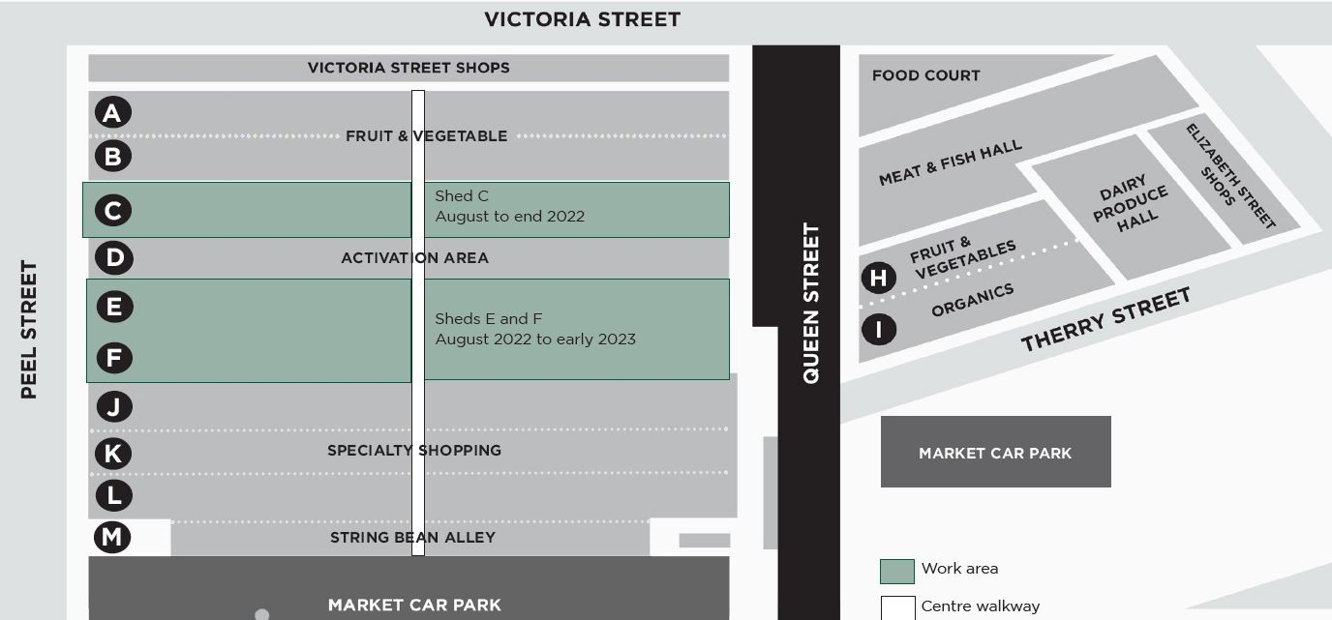
Pedestrian access
The work area will be fenced off, with pedestrian access to the centre walkway open on market days. However, there may be times when access to the centre walkway will be temporarily restricted to allow for works to be carried out safely. The upper and lower walkways will be closed for the duration of works. Please take care and be mindful of changed conditions.
Noise
Works are being undertaken in accordance with WorkSafe and EPA guidelines and are expected to generate low to medium levels of noise. Traders and customers in close proximity to the work area may experience some inconvenience.
Like to know more?
To find out more about the new Food Hall and the Queen Victoria Market Precinct Renewal program, please contact 9658 9658, or visit melbourne.vic.gov.au/qvmrenewal

https://www.melbourne.vic.gov.au/building-and-development/urban-planning/local-area-planning/queen-victoria-market-precinct-renewal-plan/Pages/queen-victoria-market-precinct-renewal-plan.aspx

