Navigate the port and unlock the city

Melbourne City Marina
Melbourne City Marina is your gateway to experiencing the best of Melbourne. Surrounded by the entertainment hub of Docklands, just off Docklands Drive, you’ll enjoy a captivating view of the city, day and night. Venture into the city or explore the best of Melbourne by the water.

Yarra’s Edge
Yarra’s Edge is nestled on the southern banks of the Yarra River between Bolte Bridge and Crown Casino. An enviable location on the edge of the city, Yarra’s Edge is surrounded by a host of shopping, dining and entertainment facilities including South Wharf, South Bank and the Yarra River.

Make yourself at home
Our marinas provide fully serviced berths for long-term and visitor berthing at Docklands and Yarra’s Edge. With 5 Gold Anchor accreditation, we offer personalised customer service and luxury facilities. Enjoy the convenience of an on-site marina manager seven days per week, as well as 24-hour security and CCTV.

Day visitors
Day visitors to Melbourne City Marina and Yarra’s Edge can berth for free for up to four hours before 4pm. You’ll have limited access to the marina facilities and will need to register with the marina office so we can provide you with an available berth. If you want to venture out to explore Melbourne, the city is just a short tram ride away.

A quick guide to navigating the port
Navigating the Port of Melbourne sounds like a complicated task with lots to look out for, but for those in the know, it can be the easiest and most relaxing part of the trip with plenty to see. This guide will break down accessing the city by navigating the port so you can unlock the city.

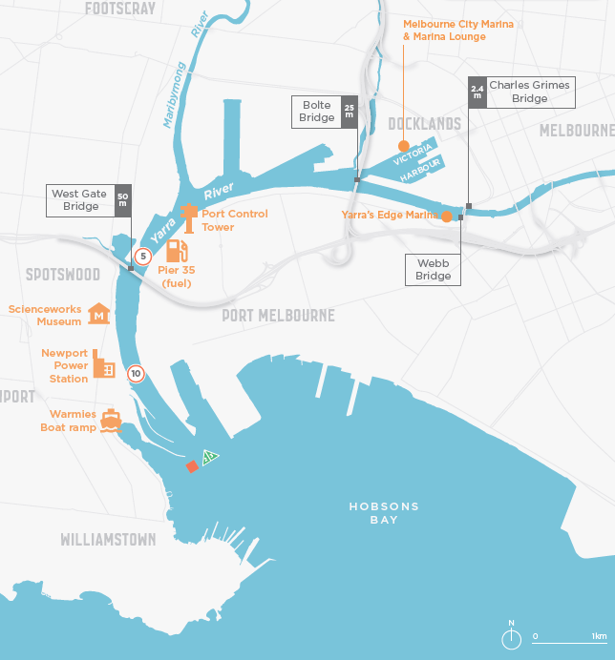
Please note, this map is not for navigation use. Navigation aids are shown for information only. For navigation of the Yarra and Maribyrnong Rivers, chart AUS 154 and AUS 155 should be consulted. Notices to mariners issued by Parks Victoria are published at Parks Victoria
- Before you depart, conduct a safety check
- Wherever you’re departing from in the bay, safely set course for lateral starboard marker 21.
- Continue on course for lateral starboard marker 23
- Contact Melbourne VTS on VHF-Ch 12 for a river traffic update prior to approaching the Yarra.
- At marker 23 continue towards the Newport Power station chimney. You are now in the entrance to the Yarra River.
- When cruising under the Westgate Bridge, stick to the right hand side.
- You will pass through two swing basins on your way to the city. Stick to the right, follow the green markers and enjoy the view. Melbourne VTS on VHF-Ch 12 will keep you updated if required.
- At the Bolte Bridge, stay to the right for Yarra’s Edge Marina or head left into Victoria Harbour for Melbourne City Marina.

Frequently asked questions

Will I know if a ship is moving through the port?
The Harbour Master can provide you a traffic update and advice from Melbourne VTS on VHF-Ch 12 or by calling 03 9644 9700.

What happens if a ship is in the channel either navigating or turning?
The port has approximately ten ship movements per day. The first response is to steer clear of big ships. Make clear and early turns to do so. Stay to the starboard side of the river and if the vessel is turning or manoeuvring, just stop and wait.

Will I get under the Westgate and Bolte bridges?
The Bolte is smaller than the Westgate at twenty-five metres. Unless you are a Navy ship or an ocean racing yacht, you shouldn’t have any problems.

What should I do if a ship is passing?
You must maintain a clear distance from a ship. You should only feel a slight roll from the ship’s wake.

Do I need to contact the Harbour Master?
Recreational vessels don’t need to contact the Harbour Master, however we recommend you get a traffic update and advice from Melbourne VTS on VHF-Ch 12 or by calling 03 9644 9700.

Can I sail up the river?
Sailing without the motor running is not permitting, but you can motor sail to ensure your ability to manoeuvre at all time.

Further information
Recreational Boating Safety Handbook | Transport Safety Victoria
Safety around ships | Transport Safety Victoria
Boating on the bay | Victorian Ports Corporation (Melbourne) (vicports.vic.gov.au)

Contact details

Address
City of Melbourne Waterways
120, 439 Docklands Drive
Docklands VIC 3008

Phone
03 9658 8738

Email
berthing@melbourne.vic.gov.au

Office hours
- Monday to Saturday 9am to 5pm
- Sunday 9am to 3pm

https://www.parks.vic.gov.au
https://transportsafety.vic.gov.au/maritime-safety/recreational-boating/licensing/victorian-recreational-boating-safety-handbook
https://transportsafety.vic.gov.au/maritime-safety/recreational-boating/safe-operation/operating-rules/safety-around-ships
https://www.vicports.vic.gov.au/community-and-bay-users/recreational-boating/Pages/boating-on-the-bay.aspx

