City of Melbourne – Melbourne Economy Snapshot
July 2023
DISCLAIMER: We’ve taken every care to ensure this information is correct at the time of publication. The City of Melbourne assumes no responsibility or liability for any errors, omissions or changes to information over time. The City of Melbourne does not accept liability whatsoever for any direct or indirect loss, damage or injury as a result of reliance on this information.

Business confidence grows with new city rhythm 3
Table 1 – Approved monthly alterations to shops and restaurants in April and May, City of Melourne 3
Hotel room boom 4
Table 2 – Average daily accommodation supply and demand, City of Melourne 4
Melbourne heats up during winter 6
Table 3 – Average daily activity for June at Town Hall (West) 6
Table 4 – Average daily activity at Town Hall (West) during June events 7
A wealth of experiences 7
Table 5 – Average adjusted daily spend by quarter, City of Melbourne 8
Table 6 – Percentage change Q2 2019 to Q2 2023, City of Melbourne 8
Appendix 1: Data Sources 10

Business confidence grows with new city rhythm
Business owners are demonstrating confidence in the new and improved rhythm of the city and investing in upgrades to revamp their premises. Permit approvals for alterations to shops and restaurants are on the rise with 89% more than this time last year. Melbourne is the number one place to do business, with the most permit approvals of this type in Victoria.
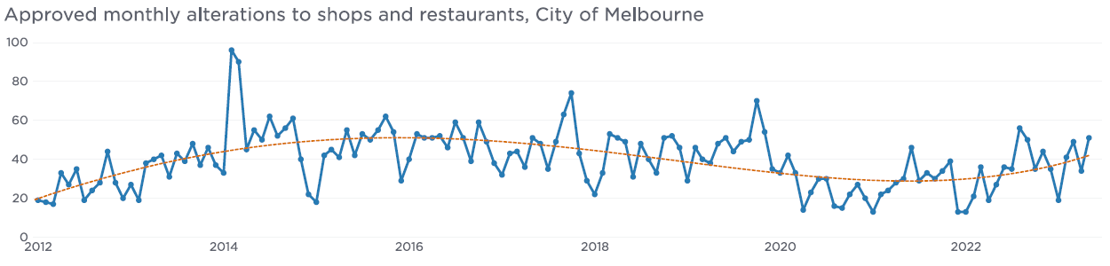
The chart above shows the monthly permit approvals for alterations to shops and restaurants in the City of Melbourne from January 2012 to May 2023. It shows that permit approvals started in January 2012 at around 20 per month before increasing to between 40 and 60 per month in 2014. Permit approvals stayed at this level until the end of 2019 before decreasing back to around 20 per month during 2020 and 2021. Permit approvals began to increase in 2022 and 2023. In May 2023, the most recent available data, there were 51 approvals.
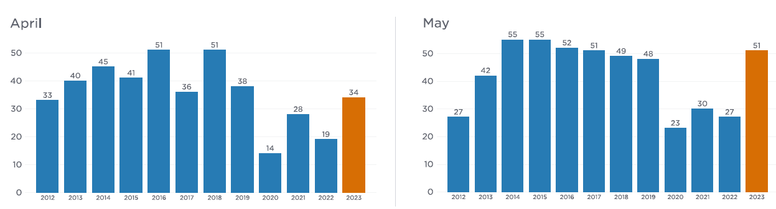

Table 1 – Approved monthly alterations to shops and restaurants in April and May, City of Melbourne
Year | April | May
2012 | 33 | 27
2013 | 40 | 42
2014 | 45 | 55
2015 | 41 | 55
2016 | 51 | 52
2017 | 36 | 51
2018 | 51 | 49
2019 | 38 | 48
2020 | 14 | 23
2021 | 28 | 30
2022 | 19 | 27
2023 | 34 | 51

The table above shows the number of monthly permit approvals for alterations to shops and restaurants for April and May from 2012 to 2023. This shows that in 2023, permit approvals were higher than they were in 2020, 2021, and 2023, and similar to years prior to 2019.
In April 2022, there were 19 approved permits for alterations to shops and restaurants compared to 34 in April 2023. In May 2022, there were 27 approved permits for alterations to shops and restaurants compared to 51 in May 2023.

Hotel room boom
The build of hotel rooms reflects a reinvigorated confidence in Melbourne’s economy with an extra 10,000 rooms becoming available in the last four years; there are also more than 1200 new hotel rooms coming through the pipeline. Separately, bookings are also up by 23% since May 2019 – all providing a strong basis to welcome Melbourne’s visitors.
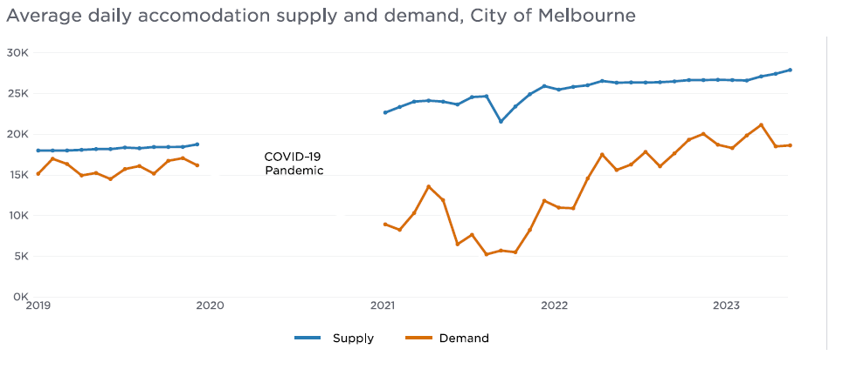

Table 2 – Average daily accommodation supply and demand, City of Melbourne
Year | Month | Supply | Demand
2019 | January | 18068 | 14665.5
2019 | February | 18066 | 16527.3
2019 | March | 18071 | 15875.3
2019 | April | 18143 | 14458.1
2019 | May | 18235 | 14760.8
2019 | June | 18237 | 14012.1
2019 | July | 18424 | 15249.3
2019 | August | 18335 | 15626.7
2019 | September | 18488 | 14677.9
2019 | October | 18489 | 16277.6
2019 | November | 18497 | 16606.1
2019 | December | 18802 | 15713.3
2021 | January | 22588 | 8377.2
2021 | February | 23257 | 7692.0
2021 | March | 23897 | 9787.2
2021 | April | 24018 | 13067.7
2021 | May | 23894 | 11382.7
2021 | June | 23554 | 5904.5
2021 | July | 24438 | 7079.6
2021 | August | 24535 | 4645.0
2021 | September | 21513 | 5116.7
2021 | October | 23314 | 4912.0
2021 | November | 24774 | 7672.0
2021 | December | 25747 | 11306.6
2022 | January | 25325 | 10459.5
2022 | February | 25654 | 10372.2
2022 | March | 25850 | 14084.1
2022 | April | 26359 | 17051.5
2022 | May | 26150 | 15131.6
2022 | June | 26188 | 15814.6
2022 | July | 26176 | 17385.2
2022 | August | 26208 | 15588.5
2022 | September | 26307 | 17196.7
2022 | October | 26465 | 18898.9
2022 | November | 26465 | 19619.4
2022 | December | 26501 | 18276.5
2023 | January | 26464 | 17857.8
2023 | February | 26412 | 19424.4
2023 | March | 26904 | 20740.5
2023 | April | 27215 | 18069.1
2023 | May | 27668 | 18191.3

The chart and table above show the average daily supply of hotel rooms for the month from January 2019 to May 2023 and the average daily demand of hotel rooms for the month from January 2019 to May 2023, noting that data was not collected during 2020 due to the COVID-19 Pandemic. The supply of hotel rooms is shown to be steadily increasing over time and is at its highest level in May 2023 at around 28,000 rooms per day after starting at around 18,000 rooms per day in January 2019. The demand for hotel rooms was at around 15,000 rooms per day in January 2019. This number decreased during 2021 to as low as 8,000 rooms per day before increasing during 2022 and 2023 to around 18,000 rooms in May 2023. Demand for hotel rooms was highest in March 2023 at around 21,000 rooms per day.
During May 2023, the average daily supply of hotel rooms was around 28,000 and demand was around 18,000.

Melbourne heats up during winter
Melbourne is the place to be in winter – day and night – with visitor activity steadily increasing in 2023 and surpassing previous years. A new pattern has emerged that shows popular night-time events like the QVM Winter Night Market, RISING, and Firelight now entice crowds into the city during the day to explore and enjoy all that’s on offer, then head to the main event at night. And that’s great news for traders and the economy.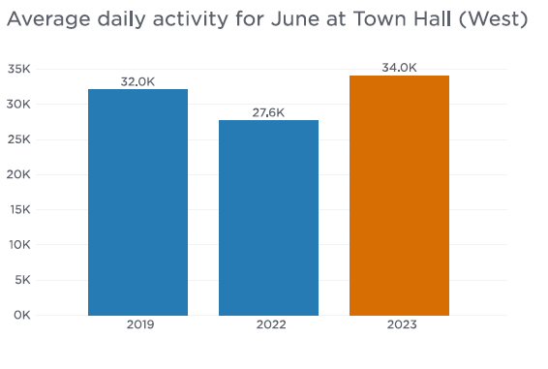

Table 3 – Average daily activity for June at Town Hall (West)
Year | Average daily activity
2019 | 32027.0
2022 | 27637.5
2023 | 34041.3

The chart and table above show the average daily activity for June at the Town Hall (West) pedestrian sensor for 2019, 2022, and 2023. Activity is shown to be higher during June 2023 than June 2022 and June 2019.
Activity at Town Hall (West) during June 2023 was 3% higher compared to June 2019 and 23% higher than June 2022.
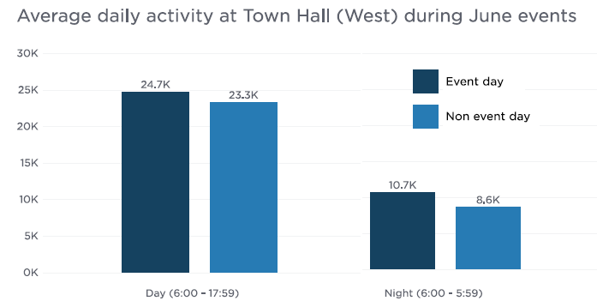

Table 4 – Average daily activity at Town Hall (West) during June events
Time of day | Event day | Non event day
Day (6:00am – 5:59 pm | 24739.1 | 23301.9
Night (6:00pm – 5:59am) | 10687.3 | 8628.6

The chart and table above show the average daily activity during daytime and nighttime at the Town Hall (West) pedestrian sensor during events in June 2023. Activity is shown to be higher during the day and at night when events are on compared to days without events. The event days include the QVM Winter Night Market, RISING, and Firelight.
During events, activity at Town Hall (West) was 6% higher than non event days during daytime and 24% higher than non event days during nighttime.
Upcoming events in the City of Melbourne include Melbourne International Film Festival (3 to 20 Aug), Now or Never (17 Aug to 2 Sep), Electric Kingdom (7 to 17 Sep) and Melbourne Fashion Week (23 to 29 Oct).

A wealth of experiences
Despite many feeling the pinch of inflation and interest rate rises, Melbourne’s economy is steady, strong and resilient. Spending in the city continues to grow and is 1.4% higher than last quarter. Residents and visitors are embracing all the city has to offer with a renewed focus on experiences including dining, bars, events, clubs and accommodation.
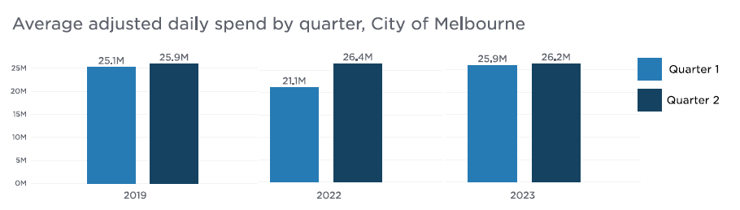

Table 5 – Average adjusted daily spend by quarter, City of Melbourne
Year | Quarter 1 | Quarter 2
2019 | $25142748 | $25857089
2022 | $21064572 | $26404205
2023 | $25880954 | $26236326

The chart and table above show the average daily spend within the City of Melbourne for Quarter 1 (January, February and March) and Quarter 2 (April, May and June) adjusted for inflation for 2019, 2022 and 2023. Across all three years spend is shown to be lower in Quarter 1 than Quarter 2, with Quarter 2 spend slightly higher in 2019 and 2023, and much higher in 2022. Quarter 2 spend is very similar across all three years with 2023 Quarter 2 spend slightly higher than Quarter 2 spend in 2019 and slightly lower than Quarter 2 spend in 2023.

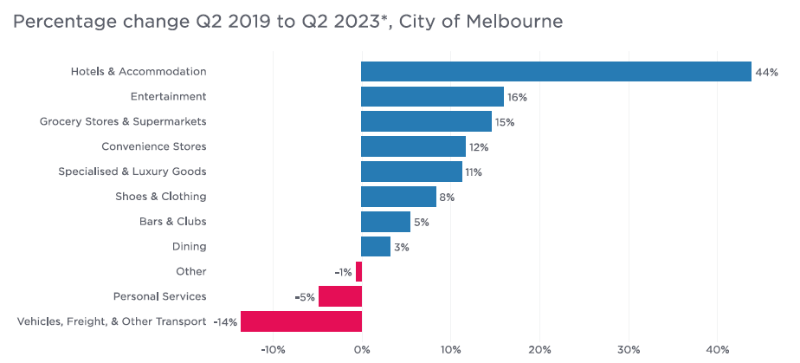Table 6 – Percentage change Q2 2019 to Q2 2023*, City of Melbourne
Spending Category | Percentage Change
Hotels & Accommodation | 44%
Entertainment | 16%
Grocery Stores & Supermarkets | 15%
Convenience Stores | 12%
Specialised & Luxury Goods | 11%
Shoes & Clothing | 8%
Bars & Clubs | 5%
Dining | 3%
Other | -1%
Personal Services | -5%
Vehicles, Freight, & Other Transport | -14%

The chart and table above show the percentage change in average daily spend adjusted for inflation within the City of Melbourne between Quarter 2 in 2019 and Quarter 2 in 2023 for different spending categories. The categories Hotels & Accommodation is shown to have the largest increase compared to all others and is 44% higher in Quarter 2 2023 than Quarter 2 2019. The categories Entertainment, Grocery Stores & Supermarkets, Convenience Stores and Specialised & Luxury Goods are all up between 11% and 16%. The categories Shoes & Clothing, Bars & Clubs and Dining are up between 3% and 8%. The categories Other, Personal Services and Vehicles, Freight, & Other Transport are down.
During Quarter 2 2023, average daily spend adjusted for inflation was around $1.6 million for Hotels & Accommodation, $8.8 million for Dining, $1.6 million for Bars & Clubs and totaled $2.4 billion for the quarter.

Appendix 1: Data Sources
Pedestrian activity data current as of 01/07/2023. Source: City of Melbourne Pedestrian Counting System.
Spend data current as of 10/07/2023 and is subject to revisions. Data source: Spendmapp by Geografia (2023). All dollar figures have been adjusted for inflation to June 2019 prices.
Permit data current as of 11/07/2023. Data source: Victorian Building Authority (VBA).
Hotel data current as of 20/06/2023. Data source: STR Global.
*Selected spend categories. The Vehicles, Freight, & Other Transport category predominantly includes the sale of automotive vehicles, transportation costs (not including fuel), and parking.

