City of Melbourne – Melbourne Economy Snapshot
April 2023
DISCLAIMER: We’ve taken every care to ensure this information is correct at the time of publication. The City of Melbourne assumes no responsibility or liability for any errors, omissions or changes to information over time. The City of Melbourne does not accept liability whatsoever for any direct or indirect loss, damage or injury as a result of reliance on this information.

New commuter patterns offer new opportunities 3
More hospitality businesses opening on the weekend 4
Percentage of Cafes and Restaurants Open 5
Table 2 - Melbourne CBD 5
Table 3 – Carlton 5
Table 4 – Docklands 5
Table 5 – Southbank 5
International students are back and spend is up 6
Night-time economy thrives as big events draw people to the City 7
Appendix 1: Data Sources 9

New commuter patterns offer new opportunities
The continued popularity of flexible working has seen a shift in traditional commuter patterns. Tuesday to Thursday is now the city's busiest time in the morning. Across the week, afternoons are having an increased share of activity. Thursday evenings are the new Friday night for city workers looking to dine out and enjoy drinks with friends.
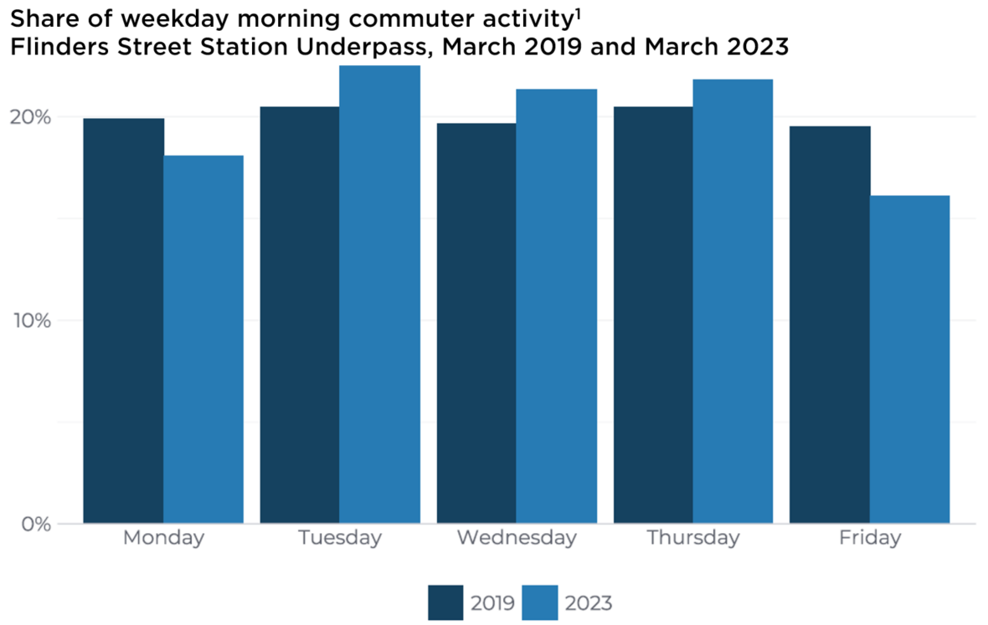

Table 1 - Share of Weekday Morning Pedestrian Activity at Flinders St Station Underpass, 6am – 9am
Day | March 2019 | March 2023 | Change
Monday | 20% | 18% | -2
Tuesday | 20.5% | 22.5% | +2
Wednesday | 19.5% | 21% | +1.5
Thursday | 20.5% | 22% | +1.5
Friday | 19.5% | 16% | -3.5

The table above shows that 66% of all morning pedestrian activity at Flinders Street Station Underpass occurred between Tuesday and Thursday from 6am to 9am in March 2023.
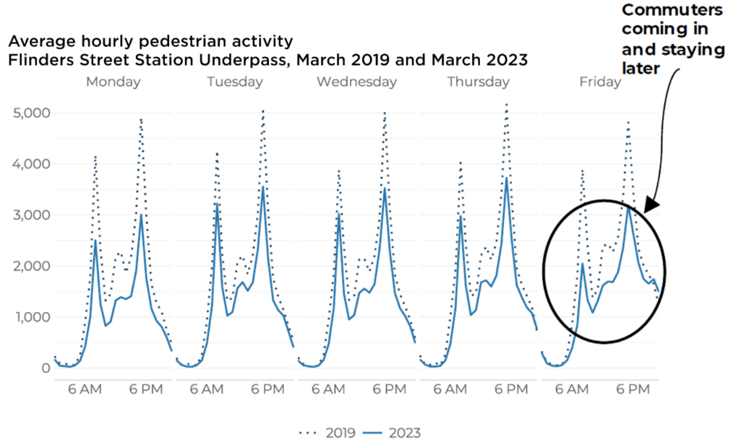
The chart above shows that commuter activity in 2019 followed a standard pattern, with a morning peak at 8am around 4,000, and a larger afternoon peak at 6pm at around 5,000. In 2023, the commuter volume was lower than in 2019 but followed a similar pattern for Tuesdays, Wednesdays and Thursdays, with the morning peak reaching around 3,000, and the afternoon peak around 3,500. Mondays in 2023 also followed the same pattern but lower in both morning and afternoon by around 500. However, Fridays in 2023 show a different pattern, with a very low morning peak at 2,000, then gradually building to a short, wide peak at 7pm indicating that commuters are continuing to flow into the city throughout the day, and to stay later into the evening.
In March 2023, the weekday activity at Flinders Street Station underpass was at 72% of 2019 levels and 152% of 2022 levels.

More hospitality businesses opening on the weekend
Café and restaurant trading days have changed between 2019 and 2022. In response to the city's changing rhythm, a higher percentage of businesses were opening over the weekend, with Sunday becoming a more prominent trading day. A lower percentage of businesses were opening on Monday and Tuesday, with Tuesday an emerging day for commuters in 2023. Cafés and restaurants are an important part of the city economy. In 2022, there were over 1,500 cafes and restaurants in the City of Melbourne. Over half of these were located in the CBD, followed by Docklands (11%), Carlton (11%) and Southbank (8%).
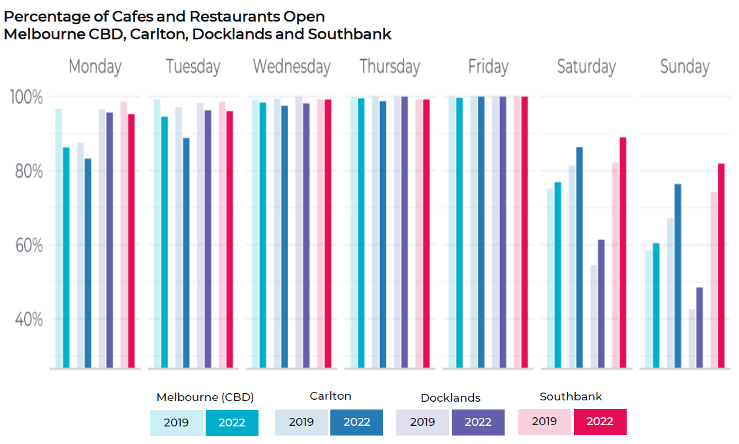

Percentage of Cafes and Restaurants Open

Table 2 - Melbourne CBD
Day | Monday | Tuesday | Wednesday | Thursday | Friday | Saturday | Sunday
2019 | 97% | 99% | 99% | 100% | 100% | 75% | 58%
2022 | 86% | 95% | 98% | 99% | 99% | 77% | 60%

Table 3 – Carlton
Day | Monday | Tuesday | Wednesday | Thursday | Friday | Saturday | Sunday
2019 | 88% | 97% | 99% | 100% | 100% | 81% | 67%
2022 | 83% | 89% | 98% | 99% | 100% | 86% | 76%

Table 4 – Docklands
Day | Monday | Tuesday | Wednesday | Thursday | Friday | Saturday | Sunday
2019 | 97% | 98% | 100% | 100% | 100% | 55% | 43%
2022 | 96% | 96% | 98% | 100% | 100% | 61% | 48%

Table 5 – Southbank
Day | Monday | Tuesday | Wednesday | Thursday | Friday | Saturday | Sunday
2019 | 99% | 99% | 99% | 99% | 100% | 82% | 74%
2022 | 95% | 96% | 99% | 99% | 100% | 89% | 82%

The chart and tables above show that close to 100% of cafes and restaurants in all districts were open on Wednesdays, Thursdays and Fridays in both 2019 and 2022. However, the chart shows that there are fewer cafes and restaurants trading on Mondays and Tuesdays in 2022 than there were in 2019 across all districts, with the biggest drops being in the CBD and Carlton. In contrast, there are more cafes and restaurants trading on the weekends in 2022 than there were in 2019, across all districts.
During 2019 the percentage of businesses open on the weekend was 65%. In 2022 that increased by 3% with 68% of businesses opening on the weekends.

International students are back and spend is up
International students are flocking to Melbourne and enjoying everything the city has to offer, with over 138,000 international student visa holders studying at Victorian tertiary education institutions. Average activity near Melbourne University more than doubled during O-Week celebrations compared to the week prior and surpassed O-week 2019 levels. This coincided with a 21% uplift in international student visa holders, and a more than 5% bump in spending across the city. The uplift in activity and spend is greater than it has been in the past. Student activity is highest on Wednesdays and lowest on Friday with the usual peak between 11am and 6pm.
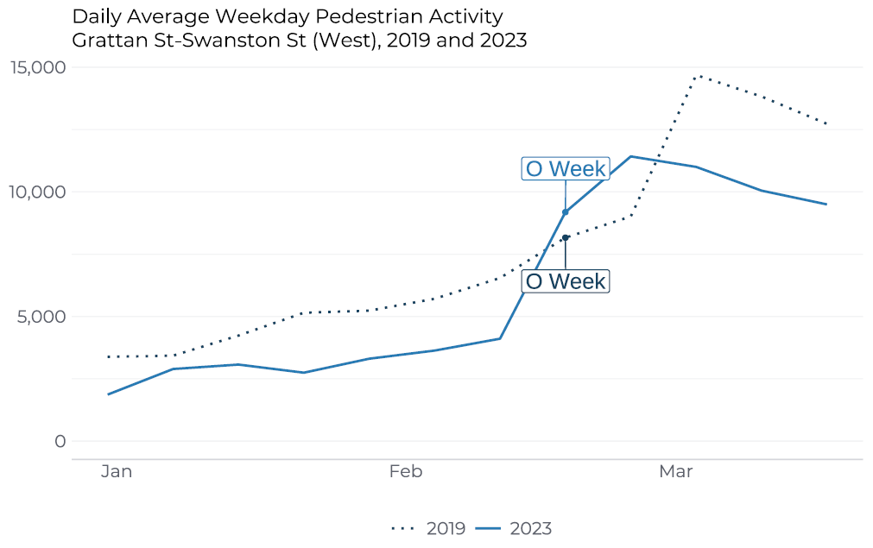
Activity at Grattan Street – Swanston Street (West) on weekdays was at 75% of 2019 levels and 136% off 2022 levels.
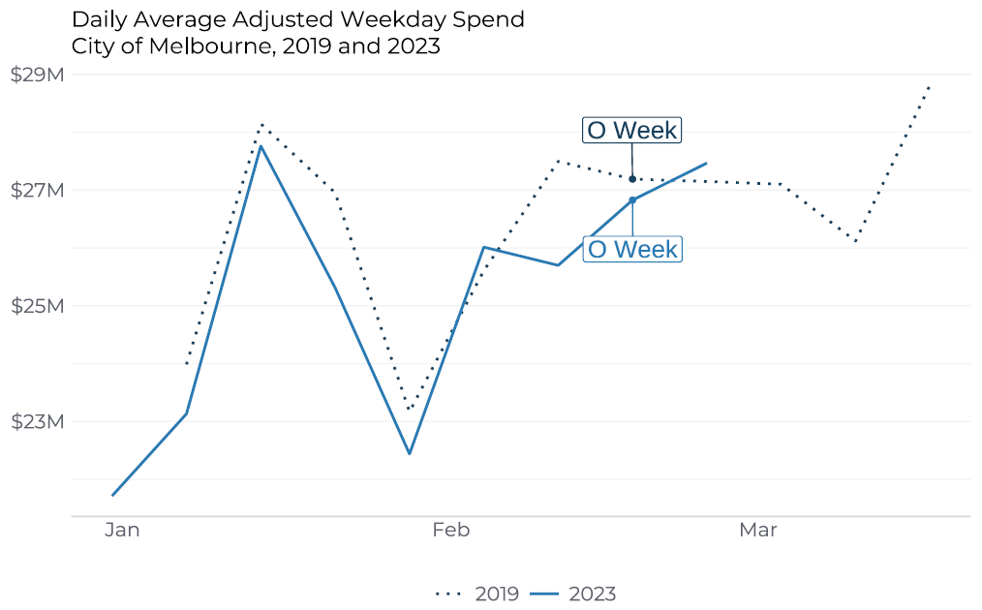
As of 27 March 2023, Victorian international student visas were at 91% of 2019 levels and 170% of 2022 levels.

Night-time economy thrives as big events draw people to the City
Night-time spend continues to grow and offers exciting opportunities for businesses to take advantage of the city's new rhythm. It surpassed the 2019 pre-COVID benchmark in both February and March. Adjusting for inflation, night-time spend in February was 109% of the benchmark, and 111% of the benchmark in March. Periods of increased night-time spending across the city coincide with major events such as concerts and festivals.
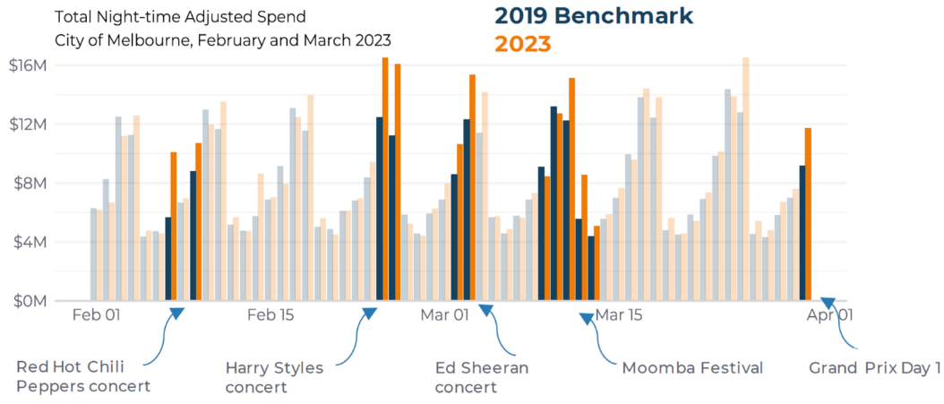
This chart highlights the impact of major events on spending in Melbourne. Night-time spending increased on the nights of the Red Hot Chilli Peppers concert (7 and 9 February) by an average of 44% above the 2019 benchmark. Across the two nights for the Harry Styles concert (24 and 25 February) night-time spend increased by an average of 38% above the 2019 benchmark. The Ed Sheeran concert (2 and 3 March) saw an increase of night-time spend by an average of 24%. Moomba Festival (9-13 March) saw an increase of night-time spend by an average of 12% above the 2019 benchmark, and day one of the Grand Prix (30 March) saw an increase of night-time spend up 28% on the 2019 benchmark.
Upcoming events in the City of Melbourne include YIRRAMBOI Festival (4 to 14 May), Shop the City (5 to 7 May) and Rising Festival (7 to 18 June).

Appendix 1: Data Sources
Pedestrian activity data current as of 01/04/2023. Source: City of Melbourne Pedestrian Counting System.
Spend data current as of 18/04/2023. Data source: Spendmapp by Geografia (2023). All dollar figures have been adjusted for inflation to June 2019 prices.
Hospitality data current as of 06/04/2023. Source: Census of City Land Use and Employment (CLUE).
Student visa data current as of 287/03/2023. Data source: Department of Home Affairs (2023).
1. Morning commuter activity refers to 6am to 9am, Monday to Friday.

