
Health and Wellbeing Profile 2020
Contents
Acronyms and abbreviations 6
Health and Wellbeing Profile 2020 – Summary 7
Key health and wellbeing issues across the lifespan 7
Key lifestyle and behaviour issues 7
Key environmental conditions 7
Summary of vulnerable population groups 8
Summary of COVID-19 impacts 8
Introduction 9
Policy context 9
How can I use this profile? 10
How was this profile developed? 10
The impact of COVID-19 10
Rapid evidence review 10
Analysis of data sets from City of Melbourne 10
Analysis of secondary data sets 11
Profile Structure 11
Our community 12
Population and growth 12
Age structure 13
Aboriginal people 13
Disability 13
Cultural and linguistic diversity 15
Household structure 15
LGBTIQ 16
Understanding child and adolescent health and wellbeing 17
Summary of key health and wellbeing issues from this section 17
Areas tracking well 18
Smoking during pregnancy 18
Birthweight 18
Breastfeeding 18
Maternal and child health consultations 19
Developmental vulnerability 20
Areas not tracking well 21
Kindergarten participation 21
Immunisation rates 22
Adolescent health and wellbeing 23
Spotlight on: Adolescent mental health 24
Understanding adult health and wellbeing 25
Summary of key health and wellbeing issues from this section 25
Areas tracking well 26
Life expectancy 26
Self-reported health 26
Dental health 26
Anxiety and depression (this is an Area to Watch due to COVID-19) 27
Suicide rate (this is an Area to Watch due to COVID-19) 27
Areas not tracking well 28
Subjective wellbeing 28
Chronic diseases 29
Sexual health 31
Infectious diseases (non-sexually transmitted) (this is an Area to Watch due to COVID-19) 31
Psychological distress (this is an Area to Watch due to COVID-19) 32
Sought help for a mental health issue 32
Spotlight on: Mental health 33
Understanding older adult health and wellbeing 34
Summary of key health and wellbeing issues for this section 34
Areas tracking well 35
Need for assistance 35
Volunteering 35
Internet access and digital literacy (this is an Area to Watch due to COVID-19) 36
Areas not tracking well 36
Chronic disease (dementia) 36
Spotlight on: Age pension 36
Loneliness and social isolation (this is an Area to Watch due to COVID-19) 38
Elder abuse (this is an Area to Watch due to COVID-19) 38
Focus on lifestyle and behaviour 40
Summary of key health and wellbeing issues from this section 40
Areas tracking well 41
Smoking 41
Areas not tracking well 42
Alcohol and drug related harm (this is an Area to Watch due to COVID-19) 42
Spotlight on: Alcohol culture 44
Gambling (this is an Area to Watch due to COVID-19) 45
Healthy eating 46
Physical activity (this is an Area to Watch due to COVID-19) 47
Sedentary lifestyle (this is an Area to Watch due to COVID-19) 48
Preventative screening tests (this is an Area to Watch due to COVID-19) 49
Focus on social, cultural and economic conditions 49
Summary of key health and wellbeing issues from this section 50
Areas tracking well 51
Tolerance of diversity (this is an Area to Watch due to COVID-19) 51
Crime rates 52
Internet access and digital literacy (this is an Area to Watch due to COVID-19) 53
Areas not tracking well 54
Unemployment (this is an Area to Watch due to COVID-19) 54
Income inequality and poverty (this is an Area to Watch due to COVID-19) 55
Food security (this is an Area to Watch due to COVID-19) 56
Housing stress (this is an Area to Watch due to COVID-19) 57
People sleeping rough and people who are homeless (this is an Area to Watch due to COVID-19) 59
Perceptions of safety 60
Violence against women (this is an Area to Watch due to COVID-19) 61
Family violence (this is an Area to Watch due to COVID-19) 62
Spotlight on: Aboriginal and Torres Strait Islander Health 63
Feeling part of the community (this is an Area to Watch due to COVID-19) 64
Community engagement and participation (this is an Area to Watch due to COVID-19) 64
Focus on the built and natural environment 65
Summary of key health and wellbeing issues from this section 65
Areas tracking well 66
Public open space 66
Active Transport (this is an Area to Watch due to COVID-19) 67
Vehicle ownership 69
Spotlight on: Climate Change 69
Heatwaves and extreme heat 71
Tree canopy cover 72
Flooding and storm events 74
Drought and reduced rainfall 74
Air quality 74
Thunderstorm asthma 75
Greenhouse gas emissions 76
Food system resilience 77
Integrated water management 78
Spotlight on: Access to blue space 78
Areas not tracking well 78
Noise complaints (this is an Area to Watch due to COVID-19) 78
Overcrowding in rooming houses (this is an Area to Watch due to COVID-19) 79
Appendix 80
Health and Wellbeing Profile 2020 - at a glance 80
Our community 80
Health and wellbeing status 80
Lifestyle and behaviours 80
Environmental determinants of health and wellbeing 81
Social and cultural 81
Disclaimer 82

Acknowledgement of Traditional Custodians
The City of Melbourne respectfully acknowledges the Traditional Custodians of the land, the Bunurong Boon Wurrung and Wurundjeri Woi Wurrung peoples of the Eastern Kulin Nation and pays respect to their Elders past, present and emerging. We are committed to our reconciliation journey, because at its heart, reconciliation is about strengthening relationships between Aboriginal and non-Aboriginal peoples, for the benefit of all Victorians.
The contents of this report have been developed by Urbis, on behalf of City of Melbourne.
Disclaimer
This report is provided for information and it does not purport to be complete. While care has been taken to ensure the content in the report is accurate, we cannot guarantee it is without flaw of any kind. There may be errors and omissions or it may not be wholly appropriate for your particular purposes. In addition, the publication is a snapshot in time based on historic information which is liable to change. The City of Melbourne accepts no responsibility and disclaims all liability for any error, loss or other consequence which may arise from you relying on any information contained in this report.
To find out how you can participate in the decision-making process for City of Melbourne’s current and future initiatives, visit our website.

Acronyms and abbreviations
Term | Definition
ABS | Australian Bureau of Statistics
ADHD | Attention deficit hyperactivity disorder
AIHW | Australian Institute of Health and Welfare
AIR | Australian Immunisation Register
AoD | Alcohol and other drugs
CBD | Central business district
CoMSIS | City of Melbourne Social Indicators Survey
COVID-19 | Coronavirus Disease 2019
CSIRO | Commonwealth Scientific and Industrial Research Organisation
DoT | Department of Transport
EGM | Electronic gaming machine
EPA | Environment Protection Authority
GP | General practitioner
HILDA | Household, Income and Labour Dynamics in Australia
HIV | Human immunodeficiency viruses
HVI | Heat vulnerability index
LGA | Local government area
LGBTIQ | Lesbian, gay, bisexual, trans and gender diverse, intersex and queer
MCH | Maternal and child health
MPHWP | Municipal Public Health and Wellbeing Plan
NATSEM | National Centre for Social and Economic Modelling
NCIS | National Coronial Information System
NO₂ | Nitrogen dioxide
O₃ | Ground-level ozone
PHIDU | Public Health Information Development Unit
PreP | Pre-exposure prophylaxis
SIDS | Sudden Infant Death Syndrome
SO₂ | Sulfur dioxide
UHI | Urban heat island
VCAMS | Victorian Child and Adolescent Monitoring System
VCGLR | Victorian Commission for Gambling and Liquor Regulation
VISTA | Victorian Integrated Survey of Travel and Activity
VPA | Victorian Planning Authority
VPHS | Victorian Population Health Survey
Areas throughout this report have a text marking to indicate they are an area to watch due to COVID-19.

Health and Wellbeing Profile 2020 – Summary
The following provides a summary of the key health and wellbeing issues in the City of Melbourne based on the data highlighted from this profile. Inclusion as a key health and wellbeing issue for the municipality was determined by indicators which are either not tracking well over time or in comparison with Victorian data, or indicators as areas to watch due to COVID-19. A summary of health and wellbeing impacts of COVID-19 is provided on the following page.

Key health and wellbeing issues across the lifespan
- Child and adolescent health and wellbeing
  - Declining kindergarten participation rates
  - Low immunisation rates
  - Adolescent mental health
- Adult health and wellbeing
  - Mental health (psychological distress, depression and anxiety, suicide risk)
  - Declining subjective wellbeing
  - Leading chronic diseases (overweight/obesity, hypertension, type 2 diabetes and asthma)
  - Sexually Transmitted Infections
  - Increasing infectious diseases (influenza, COVID-19)
- Older adults
  - Low levels of digital literacy
  - Leading chronic disease (dementia)
  - Social isolation and loneliness
  - Elder abuse

Key lifestyle and behaviour issues
- Exposure to second-hand smoke in the central city
- Alcohol and drug related harm
- Unhealthy diet
- Physical inactivity
- Gambling
- Delayed preventative screening tests due to COVID-19

Key environmental conditions
- Social and cultural
  - Declining perceptions of safety
  - Increasing family violence and violence against women
  - Declining social cohesion (racism, feeling part of the community, community engagement)
- Economic
  - Widening digital divide
  - Increasing financial insecurity
  - Increasing food insecurity
  - Increasing housing stress
  - People sleeping rough and homelessness
- Built and natural
  - Active transport infrastructure
  - Health impacts of climate change (climate anxiety, heatwaves and extreme heat, flooding and storm events, drought and reduced rainfall, air quality, thunderstorm asthma, greenhouse gas emissions, food system resilience, integrated water management)
  - Health impacts of urban densification (noise complaints, overcrowded housing)

Summary of vulnerable population groups
Evidence from this profile shows that some population groups in the municipality experience significant disparities in health and wellbeing outcomes and are also expected to be disproportionately affected by COVID-19. These groups include:
- Women
- Children
- Young people
- Older adults (especially those who are socially isolated and/or have low levels of digital literacy)
- People with a disability
- International students
- People who identify as LGBTIQ
- Aboriginal people
- Culturally and linguistically diverse populations (especially migrants and refugees)
- People with pre -existing physical and mental health conditions
- Low income households
- People who live in low socio economic areas (including Carlton, Kensington and Flemington)
- The unemployed or people on government payments
- People living alone
- People living in public housing, rooming or overcrowded housing
- People who are homeless or at risk of homelessness
- People with low digital literacy or access to technology

Summary of COVID-19 impacts
This profile was developed as the world lives through the impacts of the COVID-19 pandemic. It is expected that the economic, health and social impacts of the COVID-19 pandemic will be felt by our community for decades to come, especially for those who are already vulnerable. Where there is early evidence the data is expected to be amplified by COVID-19, it is indicated throughout the profile that it is an Area to Watch due to COVID-19. The following provides a summary of the health and wellbeing impacts of the pandemic highlighted in this profile:
- Mental health (social isolation and loneliness, psychological distress, anxiety and depression)
- Social cohesion (racism)
- Increasing family violence including elder abuse
- Increasing alcohol and drug use
- Physical activity (shift from organised sport to walking and cycling in local spaces)
- Steep rise in food insecurity
- Increasing financial hardship (unemployment, housing stress)
- Increasing risk of homelessness
- Impacts of urban living (more noise complaints due to conflicts with working from home and continued construction in the city, higher risks for people living in high density housing)
- Drop in participation in community engagement activities (shift to online)
- Widening digital divide as COVID-9 fast tracks the digitisation of our lives

Introduction
“The definitive factors in determining whether someone is in good health extend significantly beyond access to care and include the conditions in their life and the conditions of their neighbourhoods and communities.”
John Auerbach, Centers for Disease Control and Prevention

Policy context
Responsibility for the health and wellbeing of Australians spans all levels of government, and also involves non-government, community and private sectors. Under the Victorian Public Health and Wellbeing Act 2008 (The Act), the City of Melbourne, alongside the Victorian Government and all local governments across the state, has specific responsibilities to contribute to protecting and enhancing the health and wellbeing of communities. The Act requires the development of a state-wide Victorian public health and wellbeing plan and local municipal public health and wellbeing plans every four years. The plans are used by state and local governments to make evidence-based strategic planning decisions relating to their community’s health and wellbeing needs. They are designed to inform each other, laying the foundation for an integrated approach to planning across Victoria.
Municipal public health and wellbeing plans are guided by the Environments for Health framework– a systems approach to public health planning. Under the approach, a holistic concept of health and wellbeing is framed through the consideration of four key dimensions that lie within the built, social, economic and natural environments.
The framework recognises the complexity of community health and the many determinants, or factors, that shape people’s health and wellbeing. It utilises a social model of health that examines how connection to place, community participation and a sense of empowerment can contribute to good or ill health.
Importantly, the framework emphasises the central role local governments play in shaping healthy communities. Councils are uniquely positioned to address some of the key determinants of health by directly influencing and delivering community health and recreational services, land-use planning and community events.
Figure 1: Determinants of health and wellbeing. Adapted from City of Melbourne 2017-2021 Council Plan
Build environment:
Adequate housing, transport infrastructure, recreational facilities
Social environment:
Community connection, belonging, sense of safety, access to art and culture
Economic environment:
Employment, income equality, access to basic necessities
Natural environment:
Access to public spaces, air and water quality, climate resilience

How can I use this profile?
The City of Melbourne Health and Wellbeing Profile 2020 has been developed to:
- provide an overview of the health and wellbeing status of people in the City of Melbourne municipality as well as the lifestyle behaviours and environmental conditions (social and cultural, economic, built and natural) which determine health and wellbeing outcomes in the municipality, as required under the Act.
- use the data presented to recommend key community health and wellbeing priority areas to inform City of Melbourne’s next Municipal Public Health and Wellbeing Plan (to be embedded in the Council Plan 2021-25).
- provide an evidence-based resource for use by City of Melbourne and community stakeholders to inform ongoing strategic planning and activity that aims to improve the health and wellbeing of the local community.
It can be used by policymakers, community groups, health professionals, researchers and residents to guide policy and program decisions, as well as encourage community engagement and action.

How was this profile developed?

The impact of COVID-19
This Health and Wellbeing Profile was developed as the world lives through the impacts of the COVID-19 pandemic. It is expected that the economic, health and social impacts of the COVID-19 pandemic will be felt by our community for decades to come, especially for those who are already vulnerable. Evidence and observations from our communities have been used to highlight some of the health and wellbeing impacts of the pandemic in this report. It should be noted however, that new evidence is becoming available on an ongoing basis and therefore the data referenced in this report may not be the latest information available. As such, results should be interpreted with caution (note: this is an area to watch due to COVID-19.)
The development of this profile was informed by several key research activities, including:

Rapid evidence review
A highly focussed and targeted review of national and international, peer-reviewed and grey literature to provide a baseline understanding of the social determinants of health. A review of evidence and commentary on the health and wellbeing impacts of the COVID-19 pandemic was also undertaken as they emerged.

Analysis of data sets from City of Melbourne
An examination of City of Melbourne’s own primary research at the municipality level including:
- City of Melbourne Social Indicators Survey (CoMSIS)
- ISO 37120 Indicators for Quality of Life (World Council on City Data)
- City of Melbourne population and household forecasts
- City of Melbourne Daily Population Estimates and Forecasts 2026
- City of Melbourne Street Count
- City of Melbourne Resident Profiles
- City of Melbourne Maternal Child Health Reports
- City of Melbourne Parks and Greening Team tree Canopy data 2020
- City of Melbourne Health and Wellbeing Branch Noise Complaints and Rooming Houses data 2019
- City of Melbourne, Climate Change and City Resilience Team data 2020

Analysis of secondary data sets
We analysed available data sets relevant to public health in the municipality. Where municipality-level data was not available, inner Melbourne, Victorian or Australian population-level data was analysed if appropriate. These datasets included:
- Australian Early Development Census (AEDC)
- Australian Immunisation Register (AIR)
- Victorian Population Health Survey (VPHS)
- Australian Bureau of Statistics (ABS), Census of Population and Housing
- Crime Statistics Agency (CSA)
- Victorian Child and Adolescent Monitoring System (VCAMS)
- Victorian Department of Environment, Land, Water and Planning (DELWP), Mapping and analysis of vegetation, heat and land use
- Victorian Department of Health and Human Services (DHHS), Infectious disease reports
- Victorian Department of Justice and Community Safety (DJCS), Victorian wholesale liquor sales
- Victorian Department of Transport (DoT), Victorian Integrated Survey of Travel and Activity (VISTA)
- Australian Institute of Health and Welfare (AIHW)
- Victorian Commission for Gambling and Liquor Regulation (VCGLR)
- Public Health Information Development Unit (PHIDU)
- AoDStats Turning Point
- Dementia Victoria
- Department of Social Services, Municipality of Melbourne Older People Demographic Profile
- National Centre for Social and Economic Modelling (NATSEM)
- Environmental Protection Authority Victoria (EPA Vic)
- Victorian Planning Authority (VPA)
- National Coronial Information System (NCIS)
We have reported on trends where comparable data is available across multiple years. Where data is available for Victoria, we have also made comparisons.

Profile Structure
Informed by a Determinants of Health Framework and Lifestage approach to health, the profile is structured as follows:
- Our Community
- Understanding Child and Adolescent Health and Wellbeing
- Understanding Adult Health and Wellbeing
- Understanding Older Adults Health and Wellbeing
- Focus on Lifestyle and Behaviour
- Focus on Social, Cultural and Economic Conditions
- Focus on the Built and Natural Environment
In each section, indicators or health areas which are tracking favourably over time or favourable relative to Victoria are discussed under Areas Tracking Well. Indicators which are tracking unfavourably over time or when compared with Victoria are discussed under Areas not tracking well.
In some instances, there is early evidence the data is expected to be amplified by COVID-19. In these instances, we have indicated that it is an area to watch due to COVID-19.
Spotlights provide additional insights on health and wellbeing indicators and areas that are particularly relevant to the municipality.

Our community
The City of Melbourne municipality covers an area of 37.7 km² and is located at the heart of Greater Melbourne. It is made up of the city centre and 16 inner suburbs, each with its own distinctive character and with different businesses, dwellings and communities living and working there.

Population and growth
As at 30 June 2020, an estimated 178,955 people live in the City of Melbourne. Approximately half are female and half are male. As Victoria’s capital city and main business, administrative, cultural and recreational hub, the city centre also attracted 403,000 workers, 85,000 students and 288,000 visitors on an average day in 2019.
The municipality’s resident population is expected to grow over the coming years. From 2016 to 2026, the number is expected to increase from approximately 146,000 to 247,000 residents – an increase of 69 per cent. The central business district (CBD) (34,361 residents), Southbank (18,545 residents) and Docklands (16,436 residents) are suburbs forecast to experience the highest increase in residents over this period.
These projections were calculated pre-COVID-19 pandemic, so this is likely to influence resident population growth in some way.
Municipality map
Figure 2: City of Melbourne local government area and suburbs
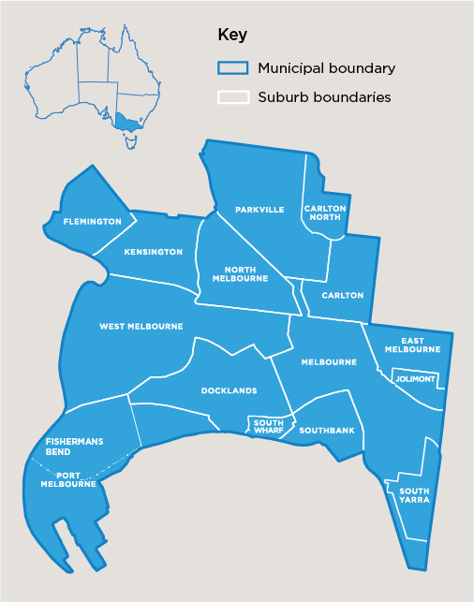

Age structure
The City of Melbourne has the youngest age profile of residents in Victoria with a median age of 28 (compared with 37 for Victoria). In 2016, people aged between 18 and 34 years made up over 60 per cent of all residents, while people aged 65 years and over made up 6.5 per cent (compared with 15.6 per cent for Victoria).
The proportion of residents aged 65 years is forecast to increase slightly from 6.7 per cent in 2016, to 7.6 per cent by 2026. While the municipality’s demographic will remain relatively young, it will be important to ensure that the needs of this growing older population are not overlooked in the future.

Aboriginal people
The City of Melbourne is home to the Bunurong Boon Wurrung and Wurundjeri Woi Wurrung peoples of the Eastern Kulin Nation. In 2016, it was estimated that Aboriginal people made up 0.3 per cent (470 residents) of the municipality’s resident population. Reflecting the wider population, approximately half were female, and half were male. The median age of Aboriginal residents in the municipality is 28.
The municipality has a lower proportion of Aboriginal residents than in Greater Melbourne (0.5 per cent) and Victoria (0.8 per cent). However, for the Kulin Nation, Melbourne has always been an important meeting place for events of social, educational, sporting and cultural significance. Today Melbourne is a significant gathering place for all Aboriginal and Torres Strait Islander peoples.

Disability
The Australian Bureau of Statistics Core Activity Need for Assistance indicator measures the number of people with a profound or severe disability. This includes people needing help in the three core activity areas of self-care, mobility and communication as a result of a long-term (more than 6 months) health condition, disability, or old age.
In 2016, 2369 residents in the City of Melbourne reported needing assistance with core activities, which represented 1.7 per cent of the population. This is lower compared with 4.9 per cent for Greater Melbourne.
The data shows that need for assistance increases with age. For example, 5 per cent of City of Melbourne residents aged 65-69 years indicated they needed assistance with core activities, increasing to 32 per cent of residents aged 85-89 years.
Figure 3: City of Melbourne age profiles, 2016 and 2026 (forecasted)
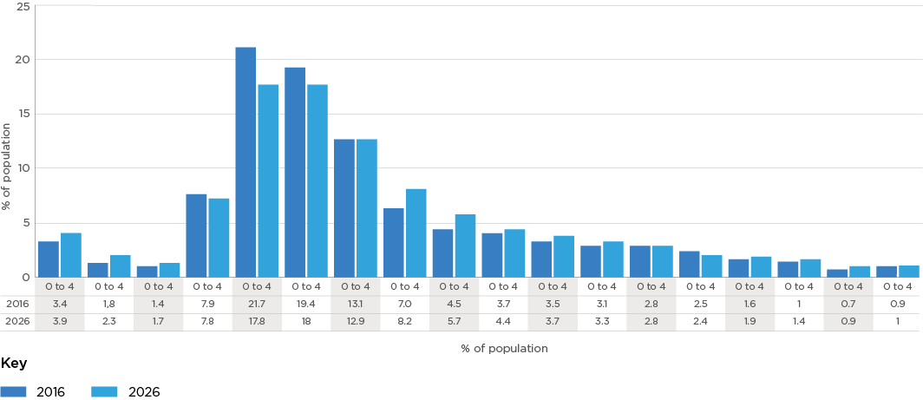
Source: .id (2020), City of Melbourne Population and Age Structure
Age group (years) | 2016  Number | 2016 % of population | 2026  Number | 2026 % of population
0 to 4 | 4,902 | 3.4 | 9,559 | 3.9
5 to 9 | 2,688 | 1.8 | 5,795 | 2.3
10 to 14 | 2,018 | 1.4 | 4,301 | 1.7
15 to 19 | 11,593 | 7.9 | 19,173 | 7.8
20 to 24 | 31,755 | 21.7 | 43,924 | 17.8
25 to 29 | 28,314 | 19.4 | 44,592 | 18.0
30 to 34 | 19,085 | 13.1 | 31,920 | 12.9
35 to 39 | 10,210 | 7.0 | 20,393 | 8.2
40 to 44 | 6,639 | 4.5 | 13,985 | 5.7
45 to 49 | 5,474 | 3.7 | 10,785 | 4.4
50 to 54 | 5,071 | 3.5 | 9,227 | 3.7
55 to 59 | 4,594 | 3.1 | 8,088 | 3.3
60 to 64 | 4,046 | 2.8 | 6,965 | 2.8
65 to 69 | 3,580 | 2.5 | 5,958 | 2.4
70 to 74 | 2,366 | 1.6 | 4,723 | 1.9
75 to 79 | 1,492 | 1.0 | 3,486 | 1.4
80 to 84 | 977 | 0.7 | 2,160 | 0.9
85 and over | 1,294 | 0.9 | 2,362 | 1.0
Total persons | 146,096 | 100.0 | 247,395 | 10

Cultural and linguistic diversity
The City of Melbourne has an incredibly diverse population culturally and linguistically. In 2016, more than half (56 per cent) of residents were born overseas, substantially higher than Greater Melbourne (34 per cent). The most common countries of birth outside Australia for residents were China (16 per cent), Malaysia (5 per cent) and India (4 per cent).
Just under half (48 per cent) of all residents speak a language other than English at home, compared with 40 per cent for Greater Melbourne. Other than English, the most commonly spoken languages in City of Melbourne households were Mandarin (19 per cent), Cantonese (4 per cent) and Indonesian (2 per cent). Overseas students are likely to make up a large proportion of residents who speak a language other than English, with many large universities located in the municipality.
The proportion of residents who agree that it is a good thing for society to be made up of different cultures is trending upwards, increasing from 93 per cent in 2018 to 96 per cent in 2020. These positive results suggest that our residents increasingly recognise the value of multiculturalism in the community, which is especially important amid growing reports of racist attacks and racism within the community during the COVID-19 period.

Household structure
The number of dwellings within the City of Melbourne is anticipated to grow from 75,913 in 2016 to 129,611 in 2026 alongside the expected population growth in the municipality. Reflecting the relatively young and diverse demographic of the municipality, lone households make up more than a third (37 per cent) and group households a fifth (20 per cent) of households. Just over a quarter (26 per cent) are reported to live with a partner and no children. Family households made up less than half (43 per cent) of all households, substantially less than Greater Melbourne (71.7 per cent).
Figure 4: City of Melbourne household types, 2016 and 2026 (forecasted)
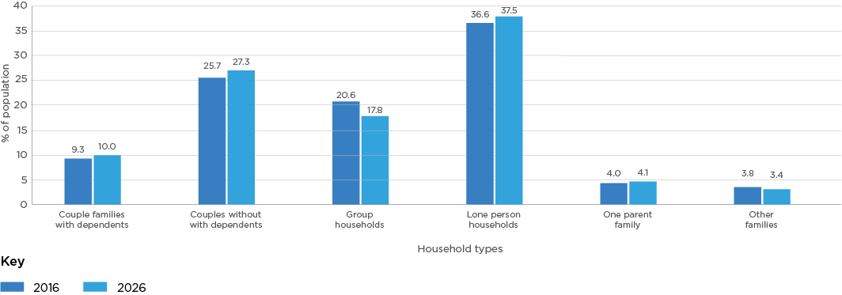
Source: forecast.id
Household type | 2016  Number | 2016 % of population | 2026  Number | 2026 % of population
Couple families with dependents | 6,245 | 9.3 | 11,250 | 10.0
Couples without dependents | 17,284 | 25.7 | 30,749 | 27.3
Group households | 13,868 | 20.6 | 20,007 | 17.8
Lone person households | 24,577 | 36.6 | 42,219 | 37.5
One parent family | 2,693 | 4.0 | 4,646 | 4.1
Other families | 2,544 | 3.8 | 3,822 | 3.4

LGBTIQ
With the absence of Census data on the LGBTIQ population, we do not have reliable and comprehensive national data on LGBTIQ people: where they live, what they do for work, their health and wellbeing, and their care needs.
Available data is limited to the reported number of same-sex couples from the Census. According to the 2016 Census, there were 1653 same sex couples in the City of Melbourne, made up of 1123 male same-sex couples and 530 female same-sex couples.

Understanding child and adolescent health and wellbeing
The early years of a child’s physical, cognitive and psychosocial development provide the foundation for their long-term health, development and wellbeing. In the first few years of life, more than one million new neural connections form every second, developing sensory pathways for vision, early language skills and high cognitive functions. Infants rely on adults for essential care, so it is critical that caregivers provide safe and secure shelter, adequate nutrition, responsive caregiving, and opportunities for early learning and relationship development. Early childhood development can be compromised by unhealthy pre-natal behaviours such as smoking and alcohol consumption, socio-economic factors such as poverty, and environmental factors such as insecure housing and access to parks. While most children in Australia are healthy, safe and developing well, around 20 per cent are developmentally vulnerable. Improving maternal and infant health, promoting healthy behaviours and protecting children from harm are key to ensuring young people are set up for success as they transition into adolescence and adulthood.
Second to early childhood, adolescence is the most important period for a person’s psychological and biological development. During adolescence, many health problems and lifestyle risk factors for disease emerge including mental health conditions, smoking and substance use, unsafe sex, poor nutrition and physical inactivity. Promoting female participation in sport during adolescence is particularly important, with a recent study indicating that 46 per cent of girls aged 15-17 years decreased their participation in sport in the past 12 months, compared with 30 per cent of boys the same age. Key protective factors for adolescent health are safe and supportive families, schools and peers, including the supportive social environments.
Children and adolescents (aged 0 to 17) make up 9 per cent of City of Melbourne’s total population. The COVID-19 pandemic has presented unprecedented challenges – for families, directly impacting their health and wellbeing. Young people are particularly vulnerable to challenges at home. General practitioners have reported an increase in levels of dysfunction among children in high-risk groups, including those with developmental issues and special needs. It is critical that support is given to families as they transition in and out of social distancing (as required) to ensure young people and their families build resilience to navigate the COVID-19 crisis.

Summary of key health and wellbeing issues from this section
- Declining kindergarten participation rates. Kindergarten participation rates in the City of Melbourne have declined 9 per cent from 83.5 per cent in 2016, to 74.5 per cent 2018. Promoting participation in kindergarten will help ensure children can develop the critical social, intellectual, and physical skills prior to joining compulsory school settings.
- Low immunisations rates. The proportion of fully immunised young children in the municipality has generally increased from the years 2017 to 2019 for ages 12 to 15 months, 24 to 27 months, and 60 to 63 months. While this increase is encouraging, the rate is still lower than for Victoria and below the 95 per cent target required for herd immunity.
- Adolescent mental health. While there is limited data at the municipality level, the Australian Child and Adolescent Survey of Mental Health and Wellbeing found that approximately one in seven (13.9 per cent) respondents aged four to seventeen years old experienced a mental-disorder, highlighting adolescent mental health as a key health and wellbeing issue in the community. Younger males (16.3 per cent) were more likely than females (11.5 per cent) to experience mental ill-health.

Areas tracking well

Smoking during pregnancy
Tobacco use during pregnancy is associated with poorer perinatal outcomes including pre-term birth, placental complications, stillbirth and low birth weight. Smoking cessation plays an important role in reducing the risk of complications during pregnancy and birth. Where cessation is not possible, reducing smoking or quitting at later stages of the pregnancy may provide some level of protection for the mother and baby.
Among City of Melbourne residents, rates of smoking during pregnancy have declined from 4.1 per cent in 2015, to 3.6 per cent in 2017. The municipality tracks favourably compared to Greater Melbourne, where 6.9 per cent of women reported smoking tobacco during the first 20 weeks of pregnancy.

Birthweight
Low birthweight is used to describe babies that are born weighing 2500 grams or less. Factors influencing low birthweight include: extremes of maternal age, chronic maternal conditions, and tobacco and drug use during pregnancy. Low birthweight is associated with a greater risk of illness and death in infancy and future health impacts such as developmental difficulties and chronic disease. Among City of Melbourne residents, 7.1 per cent of births are recorded as low birthweight. This is higher than the average of 6.3 per cent in Greater Melbourne.

Breastfeeding
Breastfeeding promotes the healthy development of infants and children. Breast milk contains all the nutrients needed during the first six months of life and is the most important part of a baby’s diet until around 12 months. Breastfeeding is associated with improved cognitive development and a reduced risk of Sudden Infant Death Syndrome (SIDS), infectious diseases and diabetes. Breastfeeding also has health benefits for mothers, promoting faster childbirth recovery and reducing risks of breast cancer, ovarian cancer and maternal depression.
Australia’s infants feeding guidelines recommend exclusive breastfeeding to infants up to 6 months. Thereafter, to meet their evolving nutritional requirements, infants should receive nutritionally adequate and safe foods to supplement breastfeeding. In the last four years, City of Melbourne data shows the proportion of mothers within the municipality reported to be ‘fully breastfeeding at 3 months’ has fluctuated between 60 per cent and 64 per cent. The data revealed a 10 per cent drop in the proportion of mothers fully breastfeeding at 6 months relative to the 3-month mark.
Mothers in the City of Melbourne (50 per cent) are more than twice as likely to fully breastfeed their children at 6 months compared to the average across Victoria (22 per cent). However, a higher proportion of mothers across Victoria partially breastfeed their children at 6 months (24.7 per cent compared to 12.7 per cent in the city of Melbourne).
Figure 5: Breastfeeding rates across the city of Melbourne and Victoria, 2018
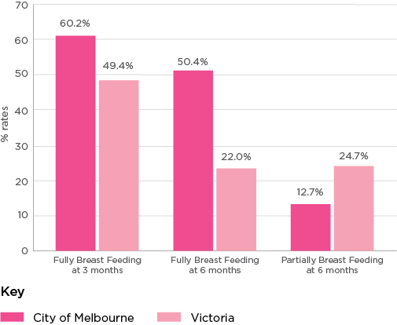
Source: City of Melbourne
Breast feeding status | City of Melbourne | Victoria
Fully Breast Feeding at 3 months | 60.2% | 49.4%
Fully Breast Feeding at 6 months | 50.4% | 22.0%
Partially Breast Feeding at 6 months | 12.7% | 24.7%
While breastfeeding rates within the municipality are higher than the Victorian average, there is an opportunity to increase community awareness about the importance of fully breastfeeding between the ages of three and six months. Greater uptake of fully breastfeeding during this period will contribute to significant health gains for both children and mothers.

Maternal and child health consultations
The Victorian Maternal and Child Health (MCH) Service is a free universal service which works with families to care for infants and young children. Consultations with maternal and child health nurses focus on optimising child and family health, wellbeing, safety, learning and development. The service involves 10 key age and stage visits from birth to three and a half years.
The proportion of children attending the 3.5 years and final stage visit within the City of Melbourne increased from 47.1 per cent in 2014, to 64.1 per cent in 2017 – slightly higher than the Victorian average (62.9 per cent). Improvements in health consultation attendance indicate improved access to professional health screening at a critical development period.
Figure 6: City of Melbourne rate of children attending the 3.5 years Maternal and Child Health visit
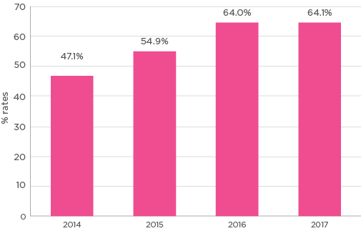
Source: Victorian Child and Adolescent Monitoring System
Year | Percentage attending
2014 | 47.1%
2015 | 54.9%
2016 | 64.0%
2017 | 64.1%
From July 2019 to May 2020, the most frequently reported red flags from maternal child health services in the municipality were those relating to family/parental mental health problems (22 per cent), child disability (11 per cent), low birthweight (12 per cent), and high parental stress (8 per cent).

Developmental vulnerability
Developmental vulnerability means a child is in the lowest 10 per cent in one or more of the following domains:
- physical health and wellbeing
- social competence
- emotional maturity
- language and cognitive skills (school-based)
- communication skills and general knowledge.
There have been significant improvements in childhood development in the City of Melbourne. The proportion of children recorded as developmentally vulnerable in one or more domains dropped significantly from 23.5 per cent in 2015, to 21.7 per cent in 2017. However, changes in the proportion of vulnerable children vary across development domains. While there was a significant decrease in the proportion of children recorded as developmentally vulnerable in the emotional maturity (11.7 per cent to 8.7 per cent) and physical health and wellbeing (10.4 per cent to 7.8 per cent) domains, there was a significant increase in the proportion of children reported as developmentally vulnerable in the language and cognitive skills domain (4.7 per cent to 5.1 per cent).
Figure 7: Proportion of children in the City of Melbourne who are developmentally vulnerable by domain
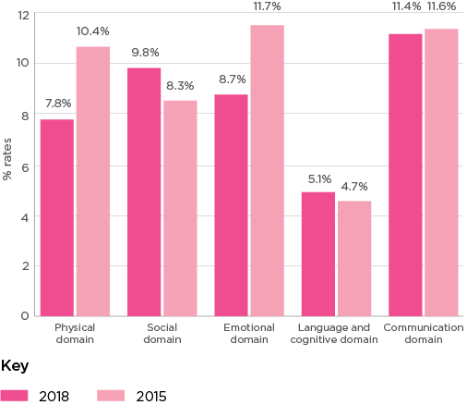
Source: Australian Early Development Census
Domain | %  Developmentally Vulnerable  2018 | %  Developmentally Vulnerable  2015
Physical domain | 7.8% | 10.4%
Social domain | 9.8% | 8.3%
Emotional domain | 8.7% | 11.7%
Language and cognitive domain | 5.1% | 4.7%
Communication domain | 11.4% | 11.6%

Areas not tracking well

Kindergarten participation
Kindergarten helps to promote children’s development by providing opportunities to learn, play and socialise in a safe and structured environment. Participation in kindergarten is a strong indicator of future wellbeing, behaviour and academic performance.
Kindergarten participation rates in the city of Melbourne have gradually fallen from 83.5 per cent in 2016, to 74.5 per cent in 2018. This decrease reflects a broader trend across the state, with average kindergarten participation rates decreasing from 96.2 to 92.1 per cent in Victoria over the same period. The introduction of Victorian Government’s ‘No jab, no play’ legislation, requiring all children to be fully vaccinated to enrol in early childhood education and care service, may have contributed to lower participation rates, particularly amongst families opposed to vaccination.
Figure 8: Kindergarten participation rates in the city of Melbourne
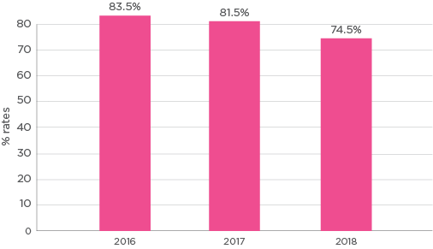
Source: Victorian Child and Adolescent Monitoring System
Year | Percentage attending kindergarten
2016 | 83.5%
2017 | 81.5%
2018 | 74.5%
Declining kindergarten participation is likely to impact the development of critical social, cognitive and physical skills among younger children across the municipality. Promoting the importance of kindergarten and addressing access barriers for families in the community is therefore considered a key health and wellbeing issue for the city of Melbourne.

Immunisation rates
Immunisations help to protect the community by reducing the spread of communicable diseases. Immunisations are most effective when a high proportion of the population have been immunised. Routine vaccinations begin at birth and are an effective way of protecting children’s immune systems while they develop.
The proportion of fully immunised young children in the municipality has generally increased from the years 2017 to 2019 for ages 12 to 15 months, 24 to 27 months, and 60 to 63 months. While this increase is encouraging, the rate is lower than for Victoria and below the 95 per cent target required for herd immunity.
Figure 9: Proportion of children in the city of Melbourne who are fully immunised
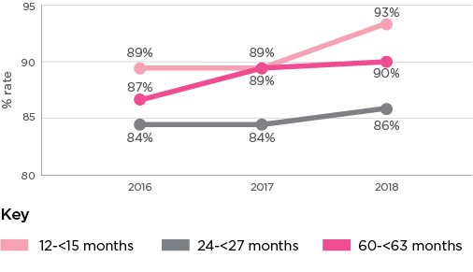
Source: Australian Immunisation Register
Year | % immunised  12 months to  under 15 months | % immunised  24 months to  under 27 months | % immunised  60 months to  under 63 months
2016 | 89% | 84% | 87%
2017 | 89% | 84% | 89%
2018 | 93% | 86% | 90%

Adolescent health and wellbeing
While there is a lack of data for the adolescent group at the municipality level, Victorian data highlight several unique health and wellbeing issues and needs for this cohort. Key statistics from the VicHealth Strategy to promote young people’s health and wellbeing 2017-19 include:
- Mental health: Fourteen per cent of adolescents aged 12-17 years have a mental health condition, rising to 27 per cent among adults aged 18 – 24 years.
- Loneliness: One in eight Victorians aged 16 – 25 years have high intensity of loneliness, which is linked to decreased mental wellbeing.
- Overweight and obesity: Almost a third of 10 – 14 year olds, and over half of 18 – 24 year olds are overweight or obese.
- Physical activity and sports participation: while 67 per cent of 10 – 14 year olds participate in sport, this drops dramatically at age 15, with only 29 per cent of 15 – 19 year olds playing sport.
- Diet and nutrition: Australians aged 14 – 18 years consume more than 40 per cent of their total daily energy intake through junk food and sugar drinks.
These statistics highlight some of the key adolescent health and wellbeing issues to be considered by the City of Melbourne.

Spotlight on: Adolescent mental health
Adolescence can be a time of immense change for young people, potentially leading to a range of emotional, social and schooling challenges. While there is limited data focussed on the City of Melbourne, national data suggests that mental ill-health is a major health issue for adolescents. The Australian Child and Adolescent Survey of Mental Health and Wellbeing found that approximately one in seven (13.9 per cent) respondents aged four to seventeen years old experienced a mental disorder. Younger males (16.3 per cent) were more likely than females (11.5 per cent) to experience mental ill-health. The most common mental conditions reported were attention deficit hyperactivity disorder (ADHD) (7.4 per cent), anxiety (6.9 per cent) and major depressive disorder (2.8 per cent).
Tackling mental health during adolescence is critical to improving health and wellbeing outcomes in later life. Almost half of all lifetime mental health disorders first emerge at age fourteen, and three quarters by age twenty-four. This highlights the need for mental health interventions during adolescence to reduce the risk and severity of mental ill-health in adulthood. For young people most at risk, protective factors also include improving family connection, social supports and social inclusion initiatives developing a sense of belonging with peers.

Understanding adult health and wellbeing
Around 87 per cent of City of Melbourne residents are aged between 18 and 69. This life stage is typically characterised by a large number of significant life events including: career establishment, formation of long-term relationships and family units, and retirement. Health conditions and levels of engagement in positive health behaviours (e.g. healthy eating, exercise) emerge during this period. As these behavioural lifestyle factors largely influence the rate of health decline in later years, health promotion efforts targeted at this age group have traditionally focused on increasing individual-level healthy behaviours and decreasing unhealthy behaviours (e.g. smoking, alcohol consumption, poor nutrition and physical inactivity). Working-age adults – those aged 25 to 64 years – make up the largest proportion of the working population and often support their children and older relatives. Reduced earning capacity due to poorer health during this life stage can therefore significantly impact the health and wellbeing of not only the individual but also their families and broader society.
There is little doubt that the COVID-19 pandemic has and will continue to impact the health and wellbeing outcomes for adults residing in Melbourne, and across Australia more broadly. Evidence is showing that economic uncertainty is contributing to increased rates of high mental stress, especially amongst unemployed people. The Taking the Pulse of the Nation Tracker surveyed 2842 working-age Australians (aged 18 to 64 years) during the COVID-19 period and found that 19 per cent of respondents experienced high mental distress – double the reported figure from the 2017 Household, Income and Labour Dynamics in Australia (HILDA) survey. Similarly, a recent CSIRO study found that almost 60 per cent of its 4000 Australian respondents reported a negative change in their self-reported satisfaction with life during COVID-19 restrictions. While these studies have focussed on the Australian population, findings that the pandemic has been detrimental to respondents’ health and wellbeing reflects the experiences of the City of Melbourne community.

Summary of key health and wellbeing issues from this section
- Mental health (psychological distress, depression and anxiety, suicide risk)
Collective evidence outlined in this section suggests that anxiety and depression, psychological distress and risk of suicide is an emerging health issue for the community, especially in light of COVID-19.
- Declining subjective wellbeing
Our residents’ subjective wellbeing scores have trended downards over the past few years, decreasing from an average of 73.2 (out of 100) in 2018 to 71.9 in 2020. This score is also lower than the Australian average of 75.3.
- Leading chronic diseases (overweight/obesity, hypertension, type 2 diabetes and asthma)
While rates of some chronic diseases in the municipality have declined, there has been an upwards trend in the prevalence of obesity and overweight, hypertension, asthma and type 2 diabetes. This highlights chronic diseases as a continuing health issue that would benefit from increased focus.
- Sexually Transmissible Infections (STIs)
Despite a drop in chlamydia transmission rates from 2018 to 2019, rates of syphilis and gonorrhoea transmissions continue to grow in the City of Melbourne, highlighting STIs as a growing health issue in the community.
- Increasing infectious diseases (influenza and COVID-19) (non-sexually transmitted) From 2016 to 2019, the rate of infectious disease events in the City of Melbourne increased from 2162 events per 100,000 residents to 2450 per 100,000 residents. Although the 2019 figure is lower than the Victorian average (2715 per 100,000), this increase and the COVID-19 pandemic highlight infectious diseases as a key health issue in the community.

Areas tracking well

Life expectancy
City of Melbourne residents have an average life expectancy of 84.4 years, higher than the average of 84 years for Greater Melbourne. Even so, discrepancies exist across population groups. Based on state-wide data, Victorian Aboriginal people are expected to live on average seven years less than non-Aboriginal Victorians.

Self-reported health
More than half of the municipality’s residents consider themselves to be healthy, with 61 per cent rating their health as excellent or very good in 2020; an increase from 53 per cent in 2019, and 51 per cent 2018.
Figure 10: Self-reported health among City of Melbourne residents: excellent or very good rating
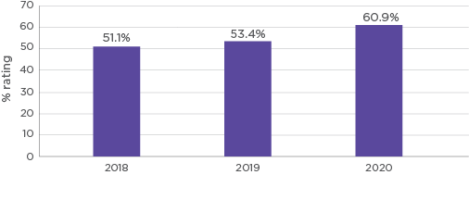
Source: City of Melbourne Social Indicators Survey
Year | Self-Reported Health Rating
2018 | 51.1%
2019 | 53.4%
2020 | 60.9%
While our residents have one of the highest life expectancies in the world and generally consider their health as excellent or good, there are opportunities to improve the health of the community by reducing rates of chronic diseases and sexually transmissible infections, and improving mental health and wellbeing.

Dental health
Maintaining a healthy mouth, teeth and gums is fundamental to a person’s ability to eat, speak and socialise, and therefore has the potential to significantly impact their overall health and wellbeing. In 2017, more than two-fifths (41.6 per cent) of all City of Melbourne adult residents rated their dental health as either excellent or very good, compared to just over one third (37.2 per cent) for the Victorian population.
In addition, just over one fifth (22.8 per cent) of adults reported avoiding or delaying visiting a dentist because of cost. While this figure is significantly lower than the 34 per cent for Victoria, it nevertheless highlights cost as a key barrier for around one quarter of our community in accessing dental services.

Anxiety and depression (this is an Area to Watch due to COVID-19)
Many people will experience a mental illness during their lifetime. Clinical depression and anxiety disorder are the most common types of mental illness and can have a significant impact on individuals, families and society more broadly. Mental illness is closely associated with suicide and is the third leading cause of overall disease burden in Australia.
In 2017, around one fifth (22.1 per cent) of our adult population reported having ever been diagnosed with anxiety or depression. This reflects a decrease since 2014 (27.1 per cent) and is lower than the average reported for Victoria (27.4 per cent). Although there has been a decrease, it is important to note that the figure is likely to be an underestimate as it only captures those who have been diagnosed. Women in the municipality were more likely to report having anxiety or depression compared to men (24 per cent compared to 20 per cent). Some of this disparity may be attributed to gender stereotypes which prevent men from seeking help and disclosing mental health problems to their doctors, leading to under diagnosis.
While the current data places anxiety and depression under areas tracking well, it is anticipated that rates of both will increase over time due to the impacts of COVID-19. Surveys by Monash University are already indicating elevated levels of anxiety and depression being experienced by Australians. As such, mental health is considered a key health and wellbeing issue for the City of Melbourne.

Suicide rate (this is an Area to Watch due to COVID-19)
Suicide is linked to mental illnesses such as depression, psychosis and substance abuse. At 8.9 deaths per 100,000 people, the 2016 suicide rate in the municipality has decreased since 2013 and is lower than the Victorian rate of 9.9 per 100,000 people. Based on national data, rates of suicide are generally higher amongst men: men aged 85 years and older are most likely to die by suicide (33 per 100,000), while the 35–44 years age group (8.3 per 100,000) has the highest rate amongst women.
Disparities in suicide rates also exist between different population groups. While there is limited data at the municipal level, the nationwide suicide rate of Aboriginal and Torres Strait Islander people is reported to be twice that of the non-Indigenous Australians. In 2018, the standardised rate of suicide amongst non-Indigenous people was 12.1 per 100,000 people and 24.1 per 100,000 for Aboriginal and Torres Strait Islander people. Suicide is also the fifth leading cause of death for Aboriginal and Torres Strait Islander people. The lesbian, gay, bisexual, transgender and gender diverse, queer and intersex (LGBTIQ) population is also at elevated risk of death by suicide, with LGBTIQ people aged 16 to 27 years five times more likely to attempt suicide than the general population.
Although the current data places suicide rate under areas tracking well, rates of suicide are predicted to increase due to the impacts of COVID-19. Suicide modelling from the University of Sydney’s Brain and Mind Centre has predicted a potential 25-50 per cent increase in the number of people dying by suicide in Australia over the next five years. The researchers expect this projected increase to disproportionately affect younger people. As such, mental health is considered a key health and wellbeing issue for the city of Melbourne.

Areas not tracking well

Subjective wellbeing
People who report higher subjective wellbeing tend to live longer, are healthier, and recover more quickly from illness and injury relative to those who report lower subjective wellbeing.
In 2020, our residents gave their overall wellbeing an average score of 71.9 (out of 100), lower than the Australian average of 75.3. This reflects a decrease from 72.6 in 2019 and 73.2 in 2018. The overall wellbeing score is based on respondents’ reported satisfaction with:
- their standard of living
- their health
- what they are currently achieving in life
- personal relationships
- how safe they feel
- feeling part of their community
- satisfaction with their future security.
The overall wellbeing score is also an indicator of resilience, which relates to a person’s system of attitudes and behaviours when adapting to stressful situations.
Self-reported levels of wellbeing varies across population groups, socio-economic status and with age within the municipality. In 2020, students rated their overall wellbeing an average score of 64.5 (out of 100), down from 68.1 in 2019, and lower than reported in 2018 (67.3). The average score for international students was also lower than for local students (67.7 compared with 70.7).
Socio-economic factors such as employment status and income level are also positively associated with self-reported subject wellbeing. Survey respondents who were employed full-time rated on average their subjective wellbeing 74.11, substantially higher than respondents who were unemployed (68.1) and/or students (67.9). Similarly, average wellbeing scores declined with income levels, with highest income respondents ($130,000+ annually) giving their overall wellbeing an average score of 77.5 and lowest income respondents (<$33,799 annually) reporting a substantially lower average score of 68.8.
This relationship is also reflected in the municipality’s geography, with average wellbeing scores lowest in Carlton (68.7) and Melbourne (70.1) – typically low socio-economic suburbs with high student populations. Those in public housing also had much lower average wellbeing scores (68.5). By contrast, the high socio-economic status suburbs of East Melbourne (75.8) and Docklands (75.3) had the highest average wellbeing scores. These findings are consistent with the past research which highlights a relationship between income and subjective wellbeing. 84 The evidence suggests that individuals with higher incomes are better resourced to respond to stressors and shocks from negative life events or conditions, such as injury, and to engage in enjoyable activities which promote subjective wellbeing.
Subjective wellbeing also increases with age. In 2020, respondents aged 18-24 years reported the lowest scores (70.1), increasing to 74.0 for those aged 45–54 years. The highest average score was given by those aged 65 years and over (82 out of 100).

Chronic diseases
Chronic diseases are currently the underlying cause of 87 per cent of deaths in Australia, with around 50 per cent of all Australians living with one or more chronic conditions. The growing prevalence of chronic diseases has not only diminished the health and wellbeing of individuals, but is also placing considerable strain on the health system. These challenges are further compounded by Australia’s ageing population, with research suggesting that the prevalence of chronic diseases and rates of comorbidity increase with age. While chronic diseases are generally not curable, many can be managed through early intervention or prevented through positive health behaviours (e.g. regular exercise and healthy eating).
Similar to other Victorians, common chronic conditions amongst city of Melbourne residents are overweight and obesity (30.8 per cent), hypertension (27 per cent), asthma (15.2 per cent) and arthritis (11.8 per cent).
Analysis of chronic disease trends uncovers a mixed picture for the municipality. From the year 2014 to 2017, rates of arthritis, cancer, heart disease, osteoporosis and stroke decreased, while rates of obesity and overweight, hypertension, and type 2 diabetes rose. In particular, the rate of hypertension has increased by almost 10 per cent, highlighting this chronic disease as a growing health issue for the community.
The proportion of City of Melbourne residents reporting that they live with asthma (ever diagnosed) has increased from 9.6 per cent in 2012, to 15.2 per cent in 2017.
Rates of obesity and overweight, hypertension, and type 2 diabetes are increasing in the community and are emerging key health issues. Addressing major behavioural risk factors such as smoking, alcohol abuse, physical inactivity and unhealthy diets are critical to tackling this community health issue.
Figure 11: Prevalence of selected chronic diseases in the City of Melbourne and Victoria, 2017
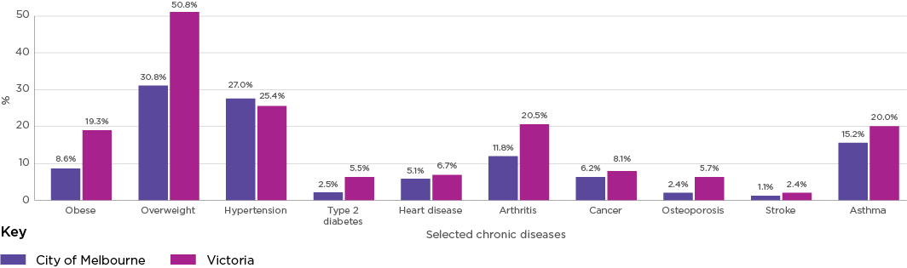
Source: Victorian Population Health Survey
Chronic disease | City of Melbourne | Victoria
Obese | 8.6% | 19.3%
Overweight | 30.8% | 50.8%
Hypertension | 27.0% | 25.4%
Type 2 diabetes | 2.5% | 5.5%
Heart disease | 5.1% | 6.7%
Arthritis | 11.8% | 20.5%
Cancer | 6.2% | 8.1%
Osteoporosis | 2.4% | 5.7%
Stroke | 1.1% | 2.4%
Asthma | 15.2% | 20.0%
Figure 12: Prevalence of common chronic diseases in the city of Melbourne 2014 and 2017, and asthma 2012 and 2017 (asthma data not available for 2014)
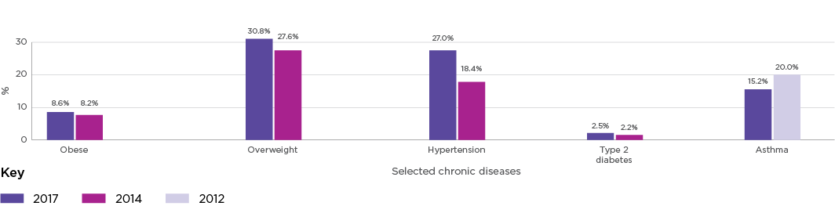
Source: Victorian Population Health Survey
Chronic disease | 2017 | 2014 | 2012
Obese | 8.6% | 8.2% | N/A
Overweight | 30.8% | 27.6% | N/A
Hypertension | 27.0% | 18.4% | N/A
Type 2 diabetes | 2.5% | 2.2% | N/A
Asthma | 15.2% | N/A | 20.0%

Sexual health
Sexual health is an important part of health and wellbeing for adults. Achieving and maintaining good sexual health means, at minimum:
- understanding how to have positive sexual relationships
- understanding how to obtain contraception
- engaging in regular testing and treatment for sexually transmissible infections (STIs) and blood-borne viruses.
Significant progress has been made in reducing hepatitis and HIV amongst our residents. The rate of hepatitis notifications decreased from 79.4 per 100,000 residents in 2016, to 62.8 per 100,000 in 2019, while HIV notifications fell from 28.10 per 100,000 people to 15.60 per 100,000 residents over the same period. Increased awareness, availability and uptake of testing and pre-exposure prophylaxis (PreP) have made significant contributions to HIV prevention in recent years.
Although chlamydia notifications have trended upwards between 2016 and 2018, there was a 23 per cent decrease in notifications in 2019 compared with 2018. Chlamydia infections still account for the highest number of STI notifications in the City of Melbourne with 1465 in 2019. This highlights the need to continue efforts to reduce the infection risk within the community.
Transmission rates of other STIs in the City of Melbourne are growing. Reflecting broader trends across Victoria, the rate of syphilis transmissions in the municipality increased from 77 per 100,000 residents to 82 per 100,000 residents. Over the same period, the rate of gonorrhoea increased from 359 per 100,000 residents to 428 per 100,000 residents, highlighting STIs as a key health issue for the community. Rates of Hepatitis B in the municipality are higher than the state and metro west average in males and females. Rates of Hepatitis B were more than triple the state average for females and males.
Efforts aimed at increasing awareness, screening and treatment, especially amongst high-risk populations, could assist with addressing STIs as a growing health problem.
Gender inequality is also one of the most significant factors that determine sexual and reproductive health outcomes. Women and girls are significantly more likely to experience sexual violence and take the main responsibility in contraceptive decision-making and pregnancy. As a result, women and girls bear the overwhelming burden of sexual and reproductive health morbidity in our community. Lesbian, gay, bisexual and transgender, intersex and queer (LGBTIQ) communities also experience stigma and discrimination that results in poor sexual and reproductive health outcomes., International students are also at increased risk of poor SRH outcomes due to low levels of sexual and reproductive health literacy as well as adjusting to new cultural norms, poor access to services, reproductive coercion, sexual assault and social isolation.

Infectious diseases (non-sexually transmitted) (this is an Area to Watch due to COVID-19)
Infectious diseases, also known as communicable diseases, are caused by the spread of microorganisms, and can be passed from one person or animal to another. Over the past century, prevention strategies such as vaccinations and improved sanitation have drastically reduced the incidence and severity of many of these diseases. Although the total burden of infectious diseases is relatively small in Australia, some have the potential to cause serious illness and outbreaks, as demonstrated by the COVID-19 pandemic.
The rate of infectious disease events in the City of Melbourne increased from 2162 events per 100,000 residents in 2016, to 2450 per 100,000 residents in 2019. While the 2019 figure is lower than the Victorian average (2715 per 100,000), this increase highlights infectious diseases as an emerging health issue. In 2019, the top five infectious diseases within the municipality were influenza, varicella zoster, campylobacter infection, hepatitis C and salmonellosis.
The COVID-19 pandemic highlights the widespread harmful impact that infectious diseases can have on the community. In addition to the immediate health impacts on those experiencing the virus, emerging evidence suggests the long-term and ongoing side effects of the virus in recovered patients could include chronic lung and heart conditions, and post-viral fatigue.

Psychological distress (this is an Area to Watch due to COVID-19)
Rates of psychological distress among City of Melbourne residents are increasing. The proportion of our residents who reported experiencing high or very high levels of psychological distress via the K10 scale increased from 11 per cent in 2014, to 18 per cent in 2017. This is higher than the Victorian rate of 15 per cent, highlighting psychological distress as an emerging health issue for our community.
There is likely to be an increase in demand for mental health services both now and in the future due to the growing rate of psychological distress and the impacts of COVID-19 on mental health.

Sought help for a mental health issue
In 2017, 15 per cent of City of Melbourne adult residents sought help for a mental health issue in the previous year. While this reflects no change since 2014, it is slightly higher than across Victoria more broadly (14 per cent).
Men in the municipality (14.7 per cent) were slightly more likely to seek help for a mental health problem compared to men across Victoria (14.1 per cent). Conversely, the proportion of women seeking help for a mental health problem in the municipality (15.1 per cent) was substantially less the proportion of women across the state (21.2 per cent).
Figure 13: Proportion of adults in the city of Melbourne who sought professional help for a mental health issue in the previous year by gender, 2017
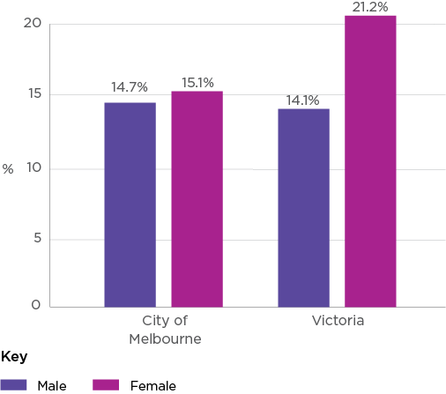
Source: Victorian Population Health Survey
Rating | Male | Female
City of Melbourne | 14.7% | 15.1%
Victoria | 14.1% | 21.2%

Spotlight on: Mental health
The World Health Organisation defines mental health as “a state of well-being in which every individual realises his or her own potential, can cope with the normal stresses of life, can work productively and fruitfully, and is able to make a contribution to her or his community”. Mental health is therefore not merely the absence of mental illness but about how people feel, think, behave and relate to others, and can significantly affect people’s ability to function effectively. Therefore while eliminating all mental illness remains an aspirational goal, there are significant population health gains to be made by focussing on policies that improve population mental health.
As shown by the evidence in this report, mental health is a significant health and wellbeing issue for municipality, across all age groups. More than one fifth (22 per cent) of our adult population have reported having ever been diagnosed with anxiety or depression and one in seven (14 per cent) of adolescents aged 12-17 years old in Victoria experience a mental health condition. A large proportion of older adults in the municipality live alone, putting them at increased risk of experiencing loneliness and social isolation – risk factors for mental ill-health. There is growing concern about the community’s mental health as the world is confronted with major issues such as such as climate change and pandemics. As such, it is critical that local governments are more active in supporting people at risk-of and experiencing mental-ill health.

Understanding older adult health and wellbeing
Ageing affects people in different ways: many older people enjoy good health and cognitive function into very old age, while others experience declines in physical and mental capacities and require significant help from others. A range of factors influence older adult health, including behavioural and biomedical risk factors, as well as mental and social wellbeing.
While the City of Melbourne is home to the youngest local government population in Victoria, older adult health and wellbeing is of growing importance. The number of residents in the municipality aged 65 and over is expected to more than double by 2030 and more than triple by 2041, highlighting the need for a stronger focus on older health in the coming years.
The COVID-19 pandemic has placed an additional spotlight on the health vulnerabilities specific to older populations, many of whom face heightened risks of severe disease, hospitalisation and death in the absence of effective treatment options. Domestic and international experiences highlight how residential and aged care facilities can become particularly vulnerable settings, putting high-risk residents in even more harm. While Victorians utilise social distancing to limit rates of virus transmission, these public health policies can also heighten risk factors related to isolation and loneliness among the elderly, and subsequently lead to depression, anxiety and cognitive decline.

Summary of key health and wellbeing issues for this section
- Low levels of digital literacy
While Australian aged 50-69 years are generally digitally engaged, more than half of those (57 per cent) aged 70 years and over having no digital literacy. Almost two-thirds (62 per cent) of older Australians have never tried making a video call, while more than half (58 per cent) have never tried messaging or using social media. Many older adults will have less face to face contact with their support networks due to COVID-19 restrictions, putting them at greater risk of social isolation and loneliness.
- Leading chronic disease (dementia)
The number of residents living with dementia in the City of Melbourne is expected to exponentially rise in the coming decades. There are opportunities to increase awareness, reduce stigma and enhance supports for people living with dementia and their families.
- Social isolation and loneliness
A high proportion of older people within the City of Melbourne live alone. With the number of older people within the municipality expected to exponentially grow, issues of loneliness and isolation will become increasingly relevant. Impacted by mobility constraints, chronic ailments or dementia, it is important that older people receive adequate social support and care to prevent the possible physical and mental health impacts of being alone.
- Elder abuse
Elder abuse remains under-recognised and underreported as a public health issue. Elder abuse can have stark emotional and physical health consequences for the victims, highlighting that it is important for council to enhance prevention and response interventions.

Areas tracking well

Need for assistance
Many older Australians living at home require assistance with a range of day-to-day activities. Providing such assistance can support older people to stay in their homes for longer, maintaining independence and connection to family, friends and the community.
The Australian Bureau of Statistics Core Activity Need for Assistance indicator is used to measure the number of people with a profound or severe disability. This includes people needing help in the three core activity areas of self-care, mobility, and communication as a result of a long-term (more than 6 months) health condition, disability or old age. In 2016, Census data showed that 1347 adults aged over 65 within the city of Melbourne needed assistance with a core activity, representing approximately 18 per cent of the older adult population. This is lower than the 28 per cent for the Greater Melbourne region.
Carlton (26 per cent), Kensington (24 per cent) and Parkville (18 per cent) are home to the highest number of older adults requiring assistance relative to their population.
Table 1: Number and proportion of people aged over 65 with profound or severe disability
Suburb | Number of people 65+ who need assistance | Proportion of total 65+ population in the suburb
Carlton | 283 | 26%
Docklands | 30 | 5%
East Melbourne | 140 | 16%
Kensington | 214 | 24%
Melbourne | 64 | 7%
North Melbourne | 195 | 15%
Parkville | 168 | 18%
Southbank | 54 | 6%
South Yarra West | 179 | 15%
Source: 2016 Census of Population and Housing - ASSNP Core Activity Need for Assistance by AGE5P

Volunteering
A significant proportion of Australia’s volunteer workforce is aged over 65. Volunteering is an important way for older people to participate in social and community activities. This can help to reduce social isolation and increase physical and mental activity.
Census data in 2016 revealed that 1690 City of Melbourne residents aged 65 years and over undertook voluntary or unpaid work for an organisation in the 12 months prior to the census. This makes up approximately 19.1 per cent of the total over 65 population – a higher proportion relative to residents living in the Greater Melbourne region (15.7 per cent). Volunteering rates among city of Melbourne residents were found to be approximately equal by gender (19.4 per cent male compared to 18.9 per cent female).

Internet access and digital literacy (this is an Area to Watch due to COVID-19)
Reliable internet access can play an important role in the health and wellbeing for older Australians. It enables users to stay connected to family and friends and to source accurate health information and community news, which helps older people remain in their homes for longer.
According to census data, the City of Melbourne compares favourably to the metropolitan Melbourne region for internet accessibility at home for residents aged over 65 (92 per cent compared to 88 per cent).
However, digital literacy can decline with age. While Australian aged 50-69 years are generally digitally engaged, more than half of those (57 per cent) aged 70 years and over report having low to no digital literacy. Research also indicates that older Australians are missing out on basic ways to remain connected. Almost two-thirds (62 per cent) have never tried making a video call, while more than half (58 per cent) have never tried messaging or using social media. This is especially concerning as many older adults will have less face to face contact with their support networks due to COVID-19 restrictions, putting them at greater risk of social isolation and loneliness.

Areas not tracking well

Chronic disease (dementia)
Dementia is a term for a group of conditions characterised by impairment of brain function. It is a major cause of disability and dependency among people aged over 65. The most common form of dementia is Alzheimer’s disease, with symptoms including memory loss, and changes to speech, cognition, behaviour and mobility.
A study commissioned by Dementia Victoria in 2017 showed that 971 City of Melbourne residents were living with dementia. The study projected that this figure would increase five-fold to 5775 residents living with dementia by 2050.
The number of residents living with dementia in the City of Melbourne is expected to exponentially rise in the coming decades. There are opportunities to increase awareness, reduce stigma and enhance supports for people living with dementia and their families. These opportunities include supporting public awareness campaigns and finding ways to link residents to established government, not-for-profit and private supports.

Spotlight on: Age pension
The Age Pension is an income support payment for Australians aged 66 and over. The age pension is means tested and designed to support older Australians who require financial assistance.
Figure 14: Number of age pensioners per suburb, December 2019
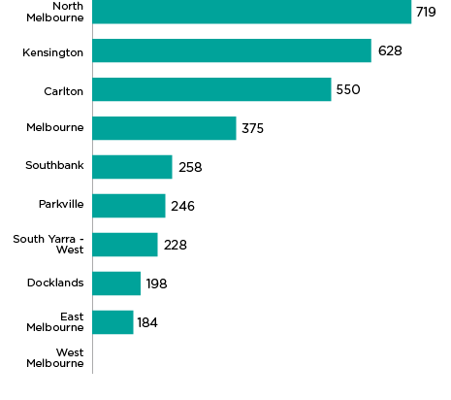
Source: Department of Social Services, DSS Payment Demographic Data
Suburb | Number of age pensioners
North Melbourne | 719
Kensington | 628
Carlton | 550
Melbourne | 375
Southbank | 258
Parkville | 246
South Yarra – West | 228
Docklands | 198
East Melbourne | 184
West Melbourne | N/A
As of March 2019, 3386 city of Melbourne residents are receiving the age pension. The data reveals that the suburbs of North Melbourne, Kensington, Carlton and Melbourne have the highest number of age pensioners in the municipality.
The maximum fortnightly age pension rate is equal to $944.30 for a single person and $1423.60 when combined for a couple. Across Victoria, this means the maximum age pension allowance is approximately only 30 per cent higher than the poverty rate for a single person household.
While the Age Pension is a primary source of income for almost two thirds of this cohort postretirement, relying entirely on its income can lead to a poor standard of living and housing insecurity.

Loneliness and social isolation (this is an Area to Watch due to COVID-19)
Social isolation and loneliness from living alone is common and can be harmful to both mental and physical health. Social isolation and loneliness is linked to poor health outcomes and conditions including high blood pressure, cardiovascular disease, weakened immune system, depression, anxiety and poor cognitive function. Older adults may experience the impacts of loneliness and social isolation more acutely due to mobility constraints, chronic ailments, caring responsibilities or dementia.
According to census data, around one-fifth (19 per cent) of all adults aged over 65 in the city of Melbourne live alone. This is particularly pronounced among older residents, with a quarter of residents aged between 80 to 84 and 22 per cent of adults aged 85 to 89 in lone households.
As life expectancy increases, older residents in the municipality are expected to live alone for longer. Impacts of loneliness are likely compounded by social trends such as declining fertility and increased immigration, which limit the extent of informal care available to an ageing population.
During the COVID-19 pandemic, there have been reports of older people cancelling their in-home support services and assessments, and giving up their usual recreational activities in the community, feeling too scared to leave their homes for fear of contracting the virus, isolating them further.
Table 2: Proportion of residents aged 65+ living alone in the city of Melbourne
Age group | Number of people aged 65+ who live alone | Proportion of total population
65-69 | 789 | 17%
70-74 | 531 | 19%
75-79 | 356 | 19%
80-84 | 266 | 24%
85-89 | 186 | 22%
90-94 | 75 | 17%
95-99 | 22 | 14%
100 and over | 3 | 10%
Source: Australian Bureau of Statistics

Elder abuse (this is an Area to Watch due to COVID-19)
Elder abuse is any behaviour or act that causes harm or distress to an older person and includes financial, physical, sexual, social and emotional abuse and neglect. Perpetrators of elder abuse are most commonly family members. Risk factors are largely related to increased vulnerability associated with ageing, such as cognitive decline, poor physical health, disability and social isolation. Elder abuse is a form of family violence as recognised by the Victorian Royal Commission into Family Violence.
It is generally noted that elder abuse is under-recognised and under-reported, making predictions of its prevalence difficult. While there is not yet solid evidence of the prevalence of elder abuse in Australia, it is recognised that it will likely increase as Australians continue to age.
The National Ageing Research Institute in its profile of elder abuse in Victoria, found that financial abuse and psychological/emotional abuse together are the most common forms of abuse reported by older Victorians (81.8 per cent). Victims are most likely to be female (72.5 per cent), and the perpetrators are 60 per cent male and 40 per cent female. The research also found that almost all (92.3 per cent) of abuse is perpetrated by persons related to the older person or in a de facto relationship. Around two thirds (66.8 per cent) of abuse is perpetrated by a child of the older person.
While there is limited data on the prevalence of elder abuse, there have already been reports that elder abuse has increased due to the economic impacts of COVID-19. For example, adult children returning to live with their parents or pressuring parents for financial support after losing their jobs. Perpetrators of family violence who have returned to live with their parents after family violence incidents with their intimate partner may also continue controlling behaviours with their parents. Social isolation means many older adults will have less contact with their usual support networks to disclose the abuse they may be experiencing. Less contact also means fewer people in the community noticing the signs of abuse leading to many cases being under-reported. As such, there is a need for informal support networks and organisations to continue reaching out to older adults in the community, especially those who are less digitally engaged.
As the demographic profile of our community gets older, the extent of elder abuse reported within the community is expected to rise. This will heighten the importance of raising awareness of elder abuse and implementing safe supports for those at risk and experiencing harm.

Focus on lifestyle and behaviour
Lifestyle and behaviour can both undermine or promote health and wellbeing. A healthy lifestyle is determined by day-to-day behaviours and functions of people in their employment, living environment, recreation and diet which promote health and reduce the risk of poor health outcomes. Lifestyles and behaviours are also known as modifiable risk factors. Unlike non-modifiable risk factors such as age or genetic composition which are beyond the control of an individual, modifiable risk factors can be changed or adjusted. For example, individual behaviours such as smoking, alcohol consumption and drug use, physical inactivity, and poor nutrition increases the risk of obesity and chronic diseases such as coronary heart disease, diabetes and cancer. In 2016, nearly nine in ten deaths in Australia were associated with chronic diseases, highlighting the significant health burden of chronic diseases.
The COVID-19 pandemic is changing how people socialise, work, exercise and eat. Evidence shows that more people are engaging in outdoor activities (such as cycling and running) as a means of socialising while maintaining physical distance. Conversely, the pandemic has also led to a rise in unhealthy lifestyle choices and behaviours: there have been reports of fewer people attending general practitioners for health screening for cancer, diabetes and asthma, while a recent study by the Foundation for Alcohol Research and Education found that more than 70 per cent of Australians were consuming more alcohol than usual during COVID-19.

Summary of key health and wellbeing issues from this section
- Exposure to second-hand smoke in the central city
While smoking rates in the City of Melbourne have been trending downward over the past few years, the central city attracts people who smoke from all over Melbourne and is concentrated in a highly populated area. As such, smoking remains a key health and wellbeing issue for the city of Melbourne in order to help curtail the health impacts of passive smoking in the city.
- Alcohol and drug related harm
Rates of ambulance attendance for alcohol and drug misuse within the municipality have increased from 2110 attendances per 100,000 residents in 2016, to 2171 attendances per 100,000 residents in 2019, highlighting alcohol and drug related harm as a priority health and wellbeing issue for the City of Melbourne.
- Gambling
Total expenditure on pokies in the municipality has trended upwards. In the four years to June 2019, spending on pokies within the City of Melbourne grew at an annual rate of 1.96 per cent, exceeding annual expenditure increases across Victoria during the same period (1.05 per cent). Interactive gambling is also on the rise, with over one-third (34.1 per cent) of Australians using the internet to make a bet in 2018, more than double the comparable figure (15.7 per cent) in 2012.
- Unhealthy diet
Healthy eating is an area of concern for the municipality. Around 93 per cent of residents do not meet the recommended daily intake of fruit and vegetables, while consumption of soft drink and take away food is relatively high compared with Victoria.
- Physical inactivity
More than half of City of Melbourne residents (52.7 per cent) do not engage in the recommended amount of physical activity and around one fifth (22 per cent) spend more than eight hours sitting on an average weekday, highlighting physical activity as a significant health issue for the city of Melbourne.
- Delayed preventative screening tests due to COVID-19
There are growing concerns that people are delaying medical tests due to COVID-19 which could have critical consequences for early detection and management of diseases.

Areas tracking well

Smoking
Tobacco smoking is one of the leading causes of preventable illness and death in Australia. It contributes more than one fifth of the total cancer burden and is linked to increased risk of heart disease, stroke, reduced lung functioning, and complications during pregnancy and childbirth.
In relation to smoking status, the proportion of City of Melbourne residents who identify as current smokers has remained steady from 9.5 per cent in 2012, to 9.1 per cent in 2017. This is significantly lower than the proportion of current smoked in Victoria (16.7 per cent). Encouragingly, the proportion of non-smokers has also increased from just under two-thirds (65.4 per cent) to three-quarters (74.6 per cent) of the resident population over the same period. With the decline in the proportion of ex-smokers, these results suggest fewer residents in the municipality are taking up smoking.
Table 3: Smoking status of city of Melbourne residents, 2012, 2014 and 2017
Smoking status | 2012 | 2014 | 2017
Current smokers | 9.5% (15.7% Victoria) | 8.0% (13.1% Victoria) | 9.1% (16.7% Victoria)
Ex-smokers | 24.3% (25.2% Victoria) | 22.6% (24.8% Victoria) | 16% (24.4% Victoria)
Non-Smokers | 65.4% (58.6%) | 69.1% (61.5% Victoria) | 74.6% (58.1% Victoria)
Source: Victorian Population Health Survey
In 2017, just 4.3 per cent of City of Melbourne residents reported being daily smokers in 2017, lower than 7.1 per cent reported for the municipality in 2014, and 5.2 per cent reported in 2012. The 2017 rate for the city of Melbourne is also significantly lower than reported for Victoria (12.4 per cent). However, the proportion of residents who smoke occasionally has increased from 4.3 per cent in 2012, to 4.8 per cent in 2017 – higher than rate of 4.3 per cent across Victoria.
Fewer people taking up smoking and more existing smokers successfully quitting is reported to be driving lower smoking prevalence across Victoria. Legislative changes in 2017 which banned smoking in all commercial outdoor areas in Victorian combined with the expansion of smoke-free areas across the municipality will further help by curtailing the health impacts of passive smoking in the municipality.
Table 4: Smoking frequency of city of Melbourne residents who smoke, 2012, 2014 and 2017
Smoking status | 2012 | 2014 | 2017
Daily smokers | 5.2% (11.9% Vic) | 7.1% (9.8% Vic) | 4.3% (12.4% Vic)
Occasional smokers | 4.3% (3.8% Vic) | 0.9% (3.4% Vic) | 4.8% (4.3%Vic)
Source: Victorian Population Health Survey
Electronic cigarettes or e-cigarettes (commonly known as vaping) is fast becoming a popular habit and not just as a smoking cessation strategy. There are possible links from vaping to serious lung disease and respiratory conditions from the chemicals used and growing evidence that e-cigarettes can lead young people to start smoking regular cigarettes. E-cigarettes are becoming more popular with young people, with one in five students aged 16 to 17 having tried e-cigarettes. Approximately 9 percent of the population has vaped and around one-fifth (19.2 per cent) of young adults aged between 18 and 24 use e-cigarettes, with use decreasing with age. According to the latest National Drug Strategy Household Survey (2016), around 1 per cent of the Australian population smoke e-cigarettes daily.

Areas not tracking well

Alcohol and drug related harm (this is an Area to Watch due to COVID-19)
The National Health and Medical Research Council (NHMRC) recommends that healthy individuals should drink no more than 10 standard drinks per week and no more than four per day, to reduce the risk of harm from alcohol-related disease or injury. While many consume alcohol responsibly, harmful alcohol consumption can directly and indirectly cause injury, illness and death. The total burden of disease and injury attributable to alcohol and drug use is almost 7 per cent. Excessive or dangerous consumption is also a known risk factor for mental ill health, violence, risky sexual behaviours and long-term dependence.
The rate of alcohol related hospitalisations in the City of Melbourne has fluctuated between 463 and 522 hospitalisations per 100,000 residents over the past few years. The rate of drug hospitalisations in the municipality has followed a similar trend, fluctuating between 194 and 270 hospitalisations per 100,000 residents, over the same period.
Figure 15: Rate of alcohol and drug related hospitalisations among City of Melbourne residents per 100,000 population, 2015 to 2018
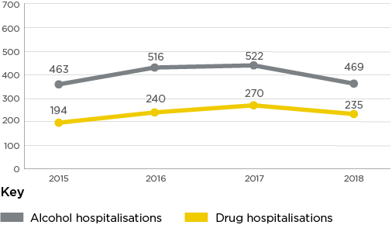
Source: AOD stats
Year | Alcohol hospitalisations | Drug hospitalisations
2015 | 463 | 194
2016 | 516 | 240
2017 | 522 | 270
2018 | 469 | 235
In 2018, the proportion of City of Melbourne residents admitted to hospital for drug or alcohol related reasons was less than half of that reported for Victoria (469 per 100,000 compared to 720 per 100,000 population). The rate of drug related hospitalisations in the city of Melbourne was 27 per cent lower when compared to Victoria (235 per 100,000 compared to 298 per 100,000 population).
While the downward trend in hospitalisations is positive, rates of ambulance attendance for alcohol and drug misuse within the municipality has increased from 2110 attendances per 100,000 residents in 2016, to 2171 attendance per 100,000 residents in 2019. These figures however, are based on the location of ambulance attendances and therefore include workers and visitors to the municipality, in addition to residents. As the centre of Victoria’s business, administrative, cultural and recreational activities, these relatively high figures for the municipality are not unexpected.
Alcohol related assaults refer to cases of physical or verbal abuse where the perpetrator or victim reports that alcohol use contributed to violence. In 2018, the rate of alcohol related assaults during daytime periods (between 6am and 8pm) was 752 incidents per 100,000 residents, an increase from 627 incidents per 100,000 in 2015. Meanwhile, alcohol related assaults during weekend nights (Friday and Saturday between 8pm and 6am) remained relatively steady from 2015 to 2018 (427 to 438 assaults per 100,000 residents).
Figure 16: Rate of alcohol related assault within the City of Melbourne by time of day, per 100,000 residents, 2015 to 2018
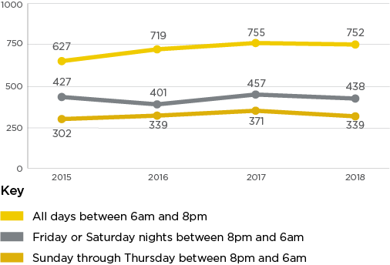
Source: AOD stats
Year | All days between 6am and 8pm | Friday or Saturday nights between  8pm and 6am | Sunday through Thursday between 8pm and 6am
2015 | 627 | 427 | 302
2016 | 719 | 401 | 339
2017 | 755 | 457 | 371
2018 | 752 | 438 | 339

Spotlight on: Alcohol culture
Alcohol culture is a term used to describe how drinking behaviours are influenced by the norms, rules, practices and values that govern how social circles interact around alcohol.
Research has found that Victorians broadly accept alcohol in most social situations including funerals, birthday parties, weddings, and sporting events. Social drinking is found to be most entrenched among young Victorians aged 16 to 29 years. A VicHealth study found two thirds of young Victorian’s reported drinking at levels that put them at risk of injury from a single drinking occasion. Alcohol culture can be harmful to physical and mental health. Regular alcohol consumption can impact concentration, judgment, mood and memory, increasing the risk of stroke and dementia. It increases the risk of heart damage as well as liver, stomach and bowl cancer.
The latest data from the Victorian Commission for Gambling and Liquor Regulation (VCGLR) shows the volume of alcohol sales within the City of Melbourne has decreased from 4,156,226 litres in 2016-17 to 3,041,393 litres in 2017-18. While this nominally reflects a 27 per cent decrease, the movement in data must be interpreted with caution due to changes in data collection processes in 2017-18.
The City of Melbourne has a relatively young demographic profile including large numbers of students and visitors. Continuing to promote responsible consumption of alcohol, particularly among those most at risk of alcohol-related harm is important in keeping the community healthy and safe.

Gambling (this is an Area to Watch due to COVID-19)
Gambling across Victoria is widespread with 69 per cent of all adults estimated to participate in some form of gambling. While gambling provides recreational and entertainment benefits to some users, there are an estimated 35,600 people in Victoria who experience problem gambling. Problem gambling is linked to poorer health and wellbeing outcomes for gamblers and their families, including increased risk of depression and anxiety, tobacco smoking and alcohol consumption.
In Victoria there are five main gambling products:
- electronic gaming machine (EGM) or ‘pokies’
- casino
- lotteries
- race betting
- sports betting
While pokies account for roughly 47 per cent of total gambling expenditure, they make up roughly 75 to 80 per cent of problem gamblers.
Overall, total expenditure on pokies in the municipality has trended upwards. In the four years to June 2019, spending on pokies within the City of Melbourne grew at an annual rate of 1.96 per cent, exceeding annual expenditure increases across Victoria during the same period (1.05 per cent). While the growth rate within the City of Melbourne is higher than across Victoria, these figures do not likely represent total losses among municipal residents.
Figure 17: Electronic Gaming Machine expenditure within the city of Melbourne, July 2015 to June 2019
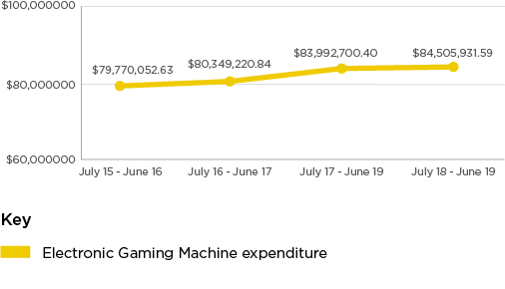
Source: Victorian Commission for Gambling and Liquor Regulation
Period | Expenditure
July 2015 – June 2016 | $79,770,052.63
July 2016 – June 2017 | $80,349,220.84
July 2017 – June 2019 | $83,992,700.40
July 2018 – June 2019 | $84,505,931.59
Interactive gambling, also known as internet, remote and online gambling, is also on the rise. In 2018, over one-third (34.1 per cent) of Australians used the internet to make a bet, more than double the comparable figure (15.7 per cent) in 2012. Most of this growth has been driven by the use of mobile phones to place bets. Features of interactive gambling such as privacy and anonymity, continual and convenient access and the ability to use electronic funds may increase the risk of problem gambling. Moreover, there are growing concerns that interactive gambling is becoming increasingly normalised in Australian media culture with research showing that over two-thirds of children aged 8 to 16 years can recall at least one sports betting brand.
The closure of electronic gaming machine venues due to COVID-19 pandemic is estimated to have saved Victorian consumers approximately $421 million. While the short-term closure of pokies venues will likely have resulted in exposure reductions, these gains may have been either fully or partially offset by increased expenditure in online or other forms of gambling. Recent analysis undertaken by NAB found spending on gambling activity to be 50.7 per cent higher in June 2020 than at the beginning of the year, most likely due to an increase in online gambling during the COVID-19 period.

Healthy eating
Eating a variety of healthy foods is essential to improving overall health and wellbeing, reducing the risk of nutrition-related chronic disease and improving nutrition-related health outcomes, particularly for vulnerable populations. Suboptimal diets are a major risk factor for heart disease, stroke, high blood pressure, some cancers and type 2 diabetes.
Australian daily dietary guidelines recommend the average adult consume 5 serves of vegetables and legumes and 2 serves of fruit a day. In 2020, only seven per cent of adults in the municipality consumed the recommended two serves of fruit and three serves of vegetables each day. While this is an improvement on 4 per cent in 2019 and higher than reported for Victoria (3.7 per cent in 2017), healthy eating could be further promoted within the municipality given 93 per cent of residents are still not meeting the recommended daily intake of fruit and vegetables.
By comparison, consumption of soft drink and take-away food in the municipality is relatively high compared with Victoria. In 2017, 17 per cent of City of Melbourne residents reported eating take-away food more than once a week, compared with 15 per cent for Victoria. City of Melbourne residents were also more likely to consume soft drinks daily (11.5 per cent) compared to the Victorian population (11.3 per cent). This higher rate of takeaway consumption in the municipality is likely due to the vast range of takeaway and fast food options available in the central business district.
Figure 18: Consumption of take-away food and soft drink in the City of Melbourne and Victoria, 2017
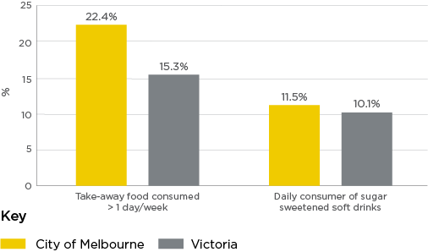
Source: Victorian Population Health Survey
Item | City of Melbourne | Victoria
Take-away food consumed more than 1 day/week | 22.4% | 15.3%
Daily consumer of sugar sweetened soft drinks | 11.5% | 10.1%

Physical activity (this is an Area to Watch due to COVID-19)
Regular physical activity can contribute to positive health and wellbeing outcomes across a person’s lifespan. It can assist with weight management, reduce the risk of chronic diseases, prevent musculoskeletal conditions and improve mental wellness. In large urban centres such as the City of Melbourne, the level of engagement in physical activity can be impacted by factors such as availability of green space, access to public transport, the range of facilities offering health and fitness services, and perceptions of safety.
In 2020, just under half of City of Melbourne adult residents surveyed (47.3 per cent) engaged in the recommended amount of physical activity (30 minutes or more, 4 days a week) compared to 47.5 per cent in 2019, and 52.3 per cent in 2018. The 2020 figure is also lower than the latest reported figures (2017) for Victoria (50.9 per cent) and neighbouring local government areas such as Port Phillip (59.9 per cent), Yarra (54.9 per cent) and Stonnington (54.1 per cent).
As shown in Figure 19 below, the proportion of City of Melbourne residents who participated in organised physical activities (e.g. use of fitness/leisure/sports centre or participation in a sporting club) has also declined over recent years. The proportion of residents participating in any organised physical activity has dropped from 28.8 per cent in 2018, to only 20.2 per cent – almost a 10 per cent decrease. Over the same period, participation in physical activity by a sports club or association has fallen from 11.9 per cent to only 6.8 per cent – a drop of over 5 per cent.
Figure 19: Proportion of City of Melbourne residents who participated in organised physical activity, 2018 to 2020.
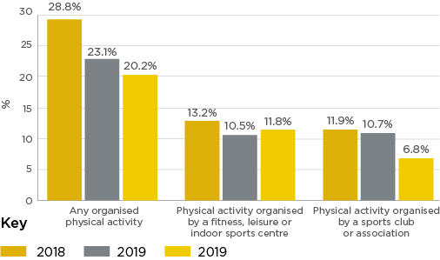
Source: City of Melbourne Social Indicators Survey
Year | 2018 | 2019 | 2020
Any organised physical activity | 28.8% | 23.1% | 20.2%
Physical activity organised by a fitness, leisure or indoor sports centre | 13.2% | 10.5% | 11.8%
Physical activity organised by a sports club or association | 11.9% | 10.7% | 6.8%
Although overall reported levels of physical activity in the city of Melbourne have fallen over the past few years, there is evidence that the COVID-19 pandemic has impacted the levels and types of physical activity undertaken within the City of Melbourne. Evidence suggests the closure of recreational facilities such as pools and gyms has diverted users to other forms of active recreation such as cycling, walking, running and scootering. More people are also reported to be using local paths, streets and parks, highlighting the importance of public open spaces which encourage physical activity.

Sedentary lifestyle (this is an Area to Watch due to COVID-19)
A sedentary lifestyle involves little to no physical activity. Insufficient physical activity can increase the risk of cardiovascular disease, type 2 diabetes, high blood pressure, some cancers, and depression and anxiety. On an average weekday, around one fifth (22 per cent) of adults residing in City of Melbourne spend more than eight hours sitting. This is consistent with Victoria as a whole. On an average weekend day, just under one quarter of adults (23 per cent) spend between two and four hours sitting, a result which is significantly lower than the Victorian population more broadly (34 per cent).
Levels of inactivity (participate in 0 days of physical activity per week) amongst the municipality’s residents vary across the lifespan. Reflecting past research showing that levels of physical activity decline with age, pensioners (63.3 per cent) are more likely to be inactive compared to the general City of Melbourne population. Young people living alone (22.9 per cent) were also more likely to be inactive. Less economically advantaged groups such as low income households (21.7 per cent) and people living in public housing (32.3 per cent) were more likely to be inactive compared with the general population, while residents who spoke a language other than English were more likely to be inactive compared to residents who spoke only English (26.5 per cent compared with 13.9 per cent).

Preventative screening tests (this is an Area to Watch due to COVID-19)
Preventative screening tests help detect and prevent a range of health conditions. Screening generally involves testing or checking a target group before symptoms develop to reduce morbidity and mortality associated with some cancers, cardiovascular disease, high blood pressure and other health conditions.
Victorian Population Health Survey data shows mixed results for health screening behaviours of residents in the City of Melbourne. In 2017, 40 per cent of residents reported having a bowel exam to detect cancer in the five years prior to completing the survey, an 8 per cent decrease from 2014 (48.0 per cent). However, the proportion of adults who reported having a blood lipids (52.5 per cent), blood pressure (79.4 per cent) and blood glucose (44.2 per cent) test in the two years prior to the survey remained relatively constant over the same period. Figures reported for 2017 were also comparable with testing rates for Victoria. Encouragingly, the proportion of residents who reported having a mammogram in the last two years increased significantly from 73 per cent in 2014, to 90 per cent in 2017. This figure is also higher than the 79.2 per cent reported for Victoria.
There are growing concerns that people are delaying medical tests due to COVID-19 as the community are advised to stay at home to prevent the spread of the virus. In May 2020, the Prostate Cancer Foundation reported a 60 per cent reduction in the number of prostate-specific antigen tests compared to 12 month prior, while general practitioners reported fewer people attending regular checks ups for conditions such as diabetes and asthma. Ensuring the community continue to have regular health screening tests during the COVID-19 period is critical for early detection and management of diseases.

Focus on social, cultural and economic conditions
Social, cultural and economic determinants of health extend beyond conventional socio-economic factors of employment, income and education. These determinants also examine how aspects of diversity, safety, community connection, and civic engagement influence the wellbeing of our residents.
The City of Melbourne is Victoria’s centre for business, tourism and the arts, attracting a diverse residential, visitor and worker population. While the municipality has experienced tremendous economic growth and continuous high employment, the community is also facing growing economic inequality, high rates of relative poverty, housing stress and food insecurity. Communities from poorer social and economic circumstances are at greater risk of poor health outcomes as they have fewer means to access health care, nutritious food, transport and adequate housing.
The COVID-19 pandemic has placed unique social and economic challenges on the municipality. Most of the city’s vibrant nightlife businesses have been negatively impacted by the need to close completely or provide a reduced service due to imposed restrictions. Even those that have been able to trade have still been greatly affected by a loss of tourism and foot traffic from office buildings across the city. There has also been a reported spike in incidents of racism and racist attacks directed at Melbourne’s international student community, and increased levels of family violence during this period.

Summary of key health and wellbeing issues from this section
- Widening digital divide
While there is a relatively high level of digital inclusion in the municipality, evidence suggest there are many groups who have significantly less ability and opportunity to use online technologies effectively. These groups include low-income people, people aged over 65, Aboriginal and Torres Strait Islander people, and people with disability. As the community is expected to undertake more day-to day activities online due to COVID-19, it is predicted that this digital divide will only widen.
- Financial insecurity
Pre COVID-19 25 per cent of City of Melbourne residents lived below the relative poverty line, approximately double the rate of Greater Melbourne (13 per cent) and Victoria (12 per cent). Economists predict a steep downturn in employment particularity for young workers and workers in industries such as accommodation and food services, arts and recreation, education and training and retail trade. This is expected to have far reaching impacts on the health and wellbeing of the community, including elevated rates of mental health issues, homelessness and food insecurity.
- Increasing food insecurity
Food security is a significant and rapidly growing health issue for the community, with the proportion of residents who reported experiencing food insecurity increasing from 26 per cent in 2019, to 33 per cent in 2020. It is anticipated that rates of food insecurity will surge even more in the near future due to the impacts of the COVID-19 pandemic, with reports in May 2020 indicating that demand for food relief from charities has already doubled. COVID-19 has demonstrated the fragility of the current food system and the need for a more coordinated and localised approach to food in our city.
- Increasing housing stress
Melbourne remains one of the least affordable housing markets in the world. Thirty per cent of the municipality’s residents are experiencing housing stress– the highest of any inner Melbourne municipality. Housing stress can be a source of chronic stress, impacting the mental health and wellbeing of families.
- People sleeping rough and homelessness
There is a homelessness crisis in the City of Melbourne. The number of people sleeping rough in the municipality has increased by 250 per cent - from 112 in 2008, to 279 in 2018. The health of people experiencing homelessness is vulnerable and likely to be further compromised by the impacts of climate change and COVID-19.
- Declining perceptions of safety
In 2020, 86 per cent of residents reported feeling safe during the day, compared with 89 per cent in 2018. Over the same period, the proportion of residents reported feeling safe on public transport during the day dropped from 87 per cent to 81.3 per cent, while just over half (54.2 per cent) reported feeling safe on public transport at night. Improving perceptions of safety within the community is therefore a key health and wellbeing issue for the city of Melbourne.
- Increasing family violence and violence against women
Concerningly, recent data indicates that the rate of reported family violence incidents are at 929 cases per 100,000 residents, a sharp increase from 875 cases per 100,000 residents in 2019. This spike combined with reports of an increase in the number of incidents of family violence during the COVID-19 lockdown highlights family violence as a key health and wellbeing issue that requires focussed and immediate attention.
- Declining social cohesion (racism)
Our residents understand and appreciate the value of culturally diverse communities and relationships with Aboriginal and Torres Strait Islander people. However, there has been a reported spike in racism and racist attacks particularly aimed at Asian cultures during the COVID-19 pandemic. Indeed, there has been a particularly sharp decline in students feelings of connection to their community dropping from 64.6 in 2019 to 59.9 to 2020. There has also been a gradual decline in community engagement and participation levels amongst residents. The impacts of COVID-19 pandemic may have contributed to this sharp decline in 2020. The widespread closure of theatre, music venues, museums and galleries during periods of lockdown has limited opportunities to participate in arts and cultural activities, while social distancing has led to fewer face-to-face volunteering opportunities. The shift towards more digitised forms of communication due to COVID-19 may also have implications for how Council involves residents in future decision-making.

Areas tracking well

Tolerance of diversity (this is an Area to Watch due to COVID-19)
Evidence suggests there is a connection between culture-based discrimination and intolerance and poor health and wellbeing, with those who experience discrimination having an increased risk of anxiety, depression, low infant birth rate, and drug and alcohol misuse. Discrimination can also restrict access to critical social determinants of health and wellbeing, including employment, education, health care and social supports.
City of Melbourne residents recognise the importance of living in socially and culturally diverse communities, with the proportion of survey residents who agreed that “it is a good thing for society to be made up of different cultures” increasing from 93.3 per cent in 2018, to 96.2 per cent in 2020. Over the same period, the proportion of surveyed residents who recognised the importance of the relationship between Aboriginal and Torres Strait Islander people and other Australians remained relatively constant (93.8 per cent in 2018, to 94.5 per cent in 2020).
Figure 20: Proportion of City of Melbourne residents who agree that it is a good thing for society to be made up of different cultures, 2018 to 2020
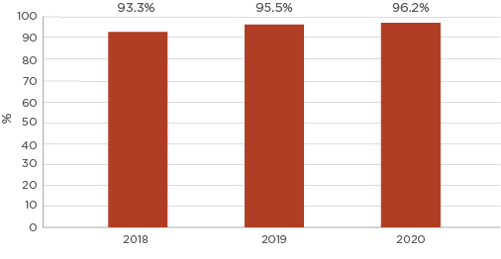
Source: City of Melbourne Social Indicators Survey
Year | Percentage
2018 | 93.3%
2019 | 95.5%
2020 | 96.2%
Figure 21: Proportion of City of Melbourne residents who recognise the importance of the relationship between Aboriginal and Torres Strait Islander people and other Australians 2018 – 2020
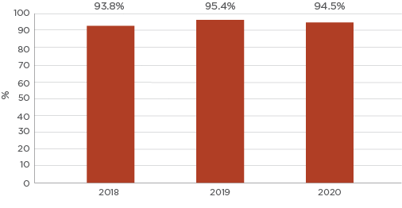
Source: City of Melbourne Social Indicators Survey
Year | Percentage
2018 | 93.8%
2019 | 95.4%
2020 | 94.5%
Although these figures place tolerance of diversity under areas tracking well, there have been growing reports of racism and racist attacks towards people from Asian backgrounds during the COVID-19 pandemic. The Australian Human Rights Commission recently reported that around a quarter of racial discrimination complaints in February and March 2020 were reported to be due to the pandemic. Similarly, a reporting database for anti-Asian racism in Australia during the COVID-19 pandemic had received more than 300 reports from Chinese and east Asian backgrounds by early May 2020. It is anticipated that these issues will continue in the immediate and long-term and therefore need to be considered as an upcoming health and wellbeing issue for the City of Melbourne. Given the large multicultural and international student population in the municipality, promoting anti-racism messaging and supporting those experiencing racism is particularly important to address this emerging health and wellbeing issue.

Crime rates
The extent to which people feel safe in their community can positively impact on social cohesion, levels of trust, and experiences with crime. Crime, and the fear of crime, in turn, is noted to have impacts on mental and physical health outcomes, as well as engagement in health behaviour such as physical activity.
In the year ending March 2020, there were 36,275 offences recorded by Victoria Police in the City of Melbourne municipality. This resulted in an offence rate of 19,347 incidents per 100,000 population in the municipality – the lowest rate in the last five years.
Overall crime rates in the City of Melbourne are declining among almost all offence divisions from the year 2017 to 2020. The exception was drug offences which saw a 2.1 per cent increase over this period.
Table 5: Offence rate per 100,000 population by offence type in the City of Melbourne, year ending March 2017 to 2020.
Offence Division | 2017 | 2018 | 2019 | 2020 | % Change 2017-2020
Crimes against the person | 3050 | 3007 | 2641 | 2674 | -14.1%
Property and deception offences | 14,017 | 12,298 | 10,739 | 11,330 | -23.7%
Drug offences | 1419 | 1427 | 1583 | 1449 | +2.1%
Public order and security offences | 2508 | 2535 | 2594 | 1923 | -30.4%
Justice procedures offences | 2313 | 1995 | 2082 | 1908 | -21.2%
Source: Crime Statistics Agency
As shown in Table 6, there has also been a substantial decrease in total offences committed by younger people between the years 2017 to 2020. The number of total offences committed by children aged 10 to 17 declined almost 28 per cent, while the number of offences committed by adolescents aged between 18 and 24 years also fell 16 per cent. This contrasts with the 10.6 per cent increase in alleged youth offender incidents reported in the last year across Victoria.
Table 6: Alleged offender incidents in the City of Melbourne, 2017 to 2020
Age | 2017 | 2018 | 2019 | 2020 | % Change 2017-2020
10 to 17 | 1325 | 1142 | 992 | 959 | -27.6%
18 to 24 | 3282 | 2936 | 2905 | 2760 | -15.9%
Source: Crime Statistics Agency

Internet access and digital literacy (this is an Area to Watch due to COVID-19)
People increasingly rely on the internet to access critical information and service provision, such that those with very limited or no access at all are likely to experience disadvantage. According to the 2016 Census, 89.5 per cent of households within the municipality had at least one person access the internet from their dwelling, higher than the Victorian average (83.7 per cent).
While these figures indicate relatively high levels of digital inclusion in the municipality, evidence suggests there are many groups who have significantly less ability and opportunity to use online technologies effectively. These groups include low-income people, people aged over 65 (as noted above), Aboriginal and Torres Strait Islander people, and people with disability.
The COVID-19 pandemic is fast tracking the digitisation of our world. Banking, medical and psychology appointments, grocery shopping, socialising and even school and cultural activities have all moved online during lockdown periods. This has significant implications for widening digital inequalities in our community. Research from the Mitchell Institute suggests that missing two terms of classroom teaching could lead to students from disadvantaged backgrounds falling six weeks behind on numeracy and four weeks on reading, compounding the existing educational disadvantage these students face. Gaps in internet access are highlighted as one of the key challenges faced by students learning remotely. Many older Australians with low or no digital literacy will also face challenges adapting to the fast-tracked creation and digitisation of online services as a result of COVID-19, such as medical appointments, banking, paying bills, ordering groceries and even socialising. Supporting community members to be ‘digitally included’ by helping them to access and use the internet will have significant benefits to the individual and the community. As such, addressing the digital divide is considered a key health and wellbeing issue for the City of Melbourne.

Areas not tracking well

Unemployment (this is an Area to Watch due to COVID-19)
Those who lose employment or are unemployed long-term tend to experience poorer physical and mental health outcomes. Unemployed people have a higher risk of death and have more illness and disability, and are more likely to experience loneliness, social isolation and mental illness.
As shown in Figure 22 below, the unemployment rate in the City of Melbourne has fluctuated between 3.5 per cent and 4.2 per cent over the past four years.
Figure 22: Quarterly unemployment rate, March 2016 to November 2019
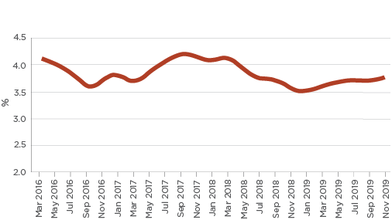
Source: Australian Government Department of Education, Skills and Employment, Small Area Labour Markets (local government area level)
While unemployment levels have remained low up until the end of 2019, economists predict a severe downturn in economic activity during and following the COVID-19 pandemic. The municipality is likely to bear a significant brunt of this downturn, with forecasts predicting a steep decline in employment for younger workers and workers in industries such as accommodation and food services (60.5 per cent), arts and recreation (55 per cent), education and training (35.9 per cent) and retail trade (33 per cent).
According to weekly payroll data released by the Australian Bureau of Statistics, as of 30th May 2020 unemployment in inner Melbourne is 10.6 per cent, higher than the total unemployment rate across Victoria of 9 per cent. While unemployment impacts are already widespread, it is predicted that employment levels will continue to fall, the extent to which will likely be influenced by a range of factors including COVID-19 case outcomes, global economic performance, and federal stimulus. Growing unemployment is also expected to have significant and far reaching impacts on the health and wellbeing of the community, including elevated rates of mental health issues, homelessness, and food insecurity.

Income inequality and poverty (this is an Area to Watch due to COVID-19)
Income inequality generates health inequality: those with lower incomes have reduced access to the resources needed to maintain and improve overall health and wellbeing such as education, employment, adequate housing, healthy food, and health and community service infrastructure.
While employment levels remained high between 2016 and 2019, growing disparities have emerged in the distribution of income. Using the P80/P20 measure of income inequality, the distribution of income has widened approximately 21 per cent from 2014 to 2017. The P80/20 measure is also 50 per cent higher in the City of Melbourne (7.29) compared the Greater Melbourne region (4.86).
Figure 23: Income inequality in the City of Melbourne, 2014 to 2017
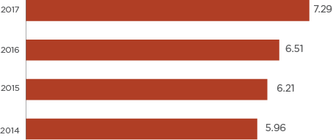
Source: Australian Bureau of Statistics
Year | Number
2017 | 7.29
2016 | 6.51
2015 | 6.21
2014 | 5.96
Income variances are likely influenced by the high student population residing within the City of Melbourne, however, growing income inequality may reflect increasing disparity in the level of access to social, economic and health-based opportunities and resources among different population groups within the municipality.
Concerningly, high income inequality also coincides with high rates of relative poverty. The National Centre for Social and Economic Modelling (NATSEM) estimated that 25 per cent of City of Melbourne residents lived below the relative poverty line, approximately double the rate of Greater Melbourne (13 per cent) and Victoria (12 per cent). Relative to all municipalities within Victoria, the City of Melbourne has the highest proportion of its population living below the poverty line, followed by the City of Hume (22 per cent). People living in poverty are at far greater risk of experiencing the adverse health, economic and social impacts of the COVID-19 pandemic.

Food security (this is an Area to Watch due to COVID-19)
Food security exists when everyone has physical, social and economic access to sufficient, safe and nutritious food to meet their dietary needs and food preferences for an active and healthy lifestyle at all times. Access to sufficient, safe, nutritious and culturally appropriate food is a human right, as recognised under the International Covenants on Economic, Social and Cultural Rights (ICESR).
Food insecurity occurs when a person cannot access food due to material, financial and environmental barriers. Apart from poorer general health, food insecurity is linked to an increased risk of anaemia, malnutrition, diabetes, and mental health issues such as depression and anxiety. Some groups of people are at particular risk of food insecurity including people seeking asylum, Aboriginal and Torres Strait Islander people, unemployed people, and those with little to no income. It is estimated that approximately 4 per cent of Australians cannot access sufficient, nutritious and safe food.
The latest City of Melbourne Social Indicators Survey data reveals a high proportion of City of Melbourne residents experienced challenges accessing adequate food in the previous year.
In 2020, 32.9 per cent of survey respondents reported having experienced food insecurity within the last 12 months, up from 26 per cent in the previous year.
Figure 24: Issues relating to the food security in the previous 12 months, 2018 to 2020.
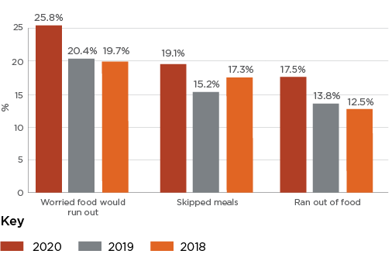
Source: City of Melbourne Community Indicators Survey
Issue | 2020 | 2019 | 2018
Worried food would run out | 25.8% | 20.4% | 19.7%
Skipped meals | 19.1% | 15.2% | 17.3%
Ran out of food | 17.5% | 13.8% | 12.5%
Similarly, the proportion of respondents who reported worrying that food would run out increased from 20 per cent in 2019 to 26 per cent in 2020.
Residents who spoke a language other than English are more likely to be food insecure compared to residents who spoke only English (41.8 per cent compared with 22.3 per cent). The most food insecure suburbs are Carlton (42.7 per cent) and Melbourne (38.8 per cent).
It is predicted that rates of food insecurity will surge in coming months and years due to the economic shock from the COVID-19 pandemic, with evidence suggesting that demand for food relief from charities has already doubled. In addition, many charities offering food relief have been forced to close during the pandemic, putting further pressure on food relief organisations. The pandemic has also exposed the vulnerability of supply chains, as demonstrated by widespread emptying of supermarket shelves and subsequent ‘panic buying’ across Australia.
A closer look at the 2020 City of Melbourne Social Indicators Survey results indicates that certain population groups are at greater risk of experiencing food insecurity compared to the general City of Melbourne population. These groups included:
- Younger adults aged 18–24 years (51.8 per cent), especially those who lived alone (43.6 per cent)
- Students (43,5 per cent), carers (44.4 per cent) and pensioners (33.3 per cent)
- People who were unemployed (41.8 per cent) or employed on a part-time or casual basis (44.3 per cent)
- Less economically advantaged groups such as low-income households (less than $$33,799)
- People living in public housing (48.4 per cent) and renters (39.4 per cent)

Housing stress (this is an Area to Watch due to COVID-19)
Having access to safe, secure and affordable housing is a crucial determinant of health and wellbeing and an important precondition for participation in employment, education and the community. The housing crisis within Melbourne is now well recognised. Melbourne’s housing market ranks ‘severe unaffordable’; the fourth least-affordable housing market in the world. As a result, those on modest incomes can struggle to find stable housing without making overburdening economic sacrifices.
The latest census data shows that housing and housing affordability are key issues within the municipality. Five and a half per cent of residents within the municipality live in social housing, more than double the Greater Melbourne average (2.7 per cent). The proportion of residents living in overcrowded dwellings has almost tripled from 483 per 100,000 residents in 2011, to 1350 per 100,000 residents in 2016.
Figure 25: Housing stress in the inner metropolitan Melbourne municipalities, 2016
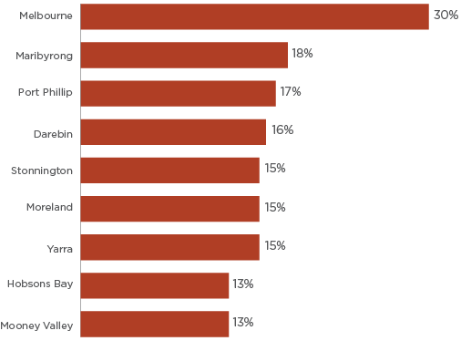
Source: Allen, G. (2019)
Inner metropolitan Melbourne municipality | Percentage
Melbourne | 30%
Maribyrong | 18%
Port Phillip | 17%
Darebin | 16%
Stonnington | 15%
Moreland | 15%
Yarra | 15%
Hobsons Bay | 13%
Mooney Valley | 13%
Thirty per cent of City of Melbourne residents experience housing stress, the highest rate of all inner-city municipalities, and this figure is expected to only increase as the economic impacts of the COVID-19 pandemic unfold. A recent survey from the Australian National University found that the proportion of Australians unable to meet their regular housing payments has more than doubled from 6.9 per cent in April 2020, to 15.1 per cent in May 2020. Young Australians were most likely to be experiencing housing stress, with the almost half (44 per cent) of respondents aged 18–24 years reporting they are unable to pay their rent on time.

People sleeping rough and people who are homeless (this is an Area to Watch due to COVID-19)
The City Melbourne defines homelessness as a lack of one or more elements that represent home. This may include a sense of security, stability, privacy, safety and the ability to control their living space. Extreme homelessness is identified as rough sleeping, where people without access to conventional dwellings are forced to resort to parks, tents, cars and other forms of impoverished shelter.
According to the 2016 Census, the City of Melbourne had 1721 homeless people, second only to the city of Greater Dandenong (2103). This includes people:
- living in improvised dwellings, tents or sleeping out (sleeping rough)
- in supported accommodation specifically for homeless people
- staying temporarily with other households
- living in boarding houses
- in other temporary lodgings
- severely crowded dwellings.
Population growth and limited affordable housing options combined with the impact of family violence, poor mental health and unemployment have contributed to growing rates of homelessness. In addition, the lack of support services (such as counselling and medical support) available to rough sleepers once accommodation is found for them means people often leave housing options and return to the streets.
The latest StreetCount data (2018) suggests the number of people sleeping rough in the municipality increased by approximately 250 per cent over the past 10 years or so, from 112 in 2008 to 279 in 2018.
Of the 297 people reported to be sleeping rough in 2018, 79 per cent were male and 21 per cent female. Seventy-seven per cent were born in Australia, while 9 per cent identified as being Aboriginal and Torres Strait Islander. The majority of people sleeping rough were middle aged; 58 per cent were aged between 26 and 40 years, while 27 per cent were aged between ages 41 and 60 years.
Data from the City of Melbourne Homeless Service Coordination Project indicates that mental health and alcohol and other drugs (AoD) are key issues for people experiencing homelessness in the municipality. A total of 111 individuals were referred to the project in the 12 months to June 2019. Of those, 81 identified as having symptoms of mental illness – both diagnosed and undiagnosed. The lack of assertive drug and alcohol outreach support for individuals was also identified as a significant gap in needs. This is consistent with past research which showed in 2018 to 2019, one in ten clients presenting to specialist homeless services reported having problematic drug or alcohol use.
The impacts of COVID-19 will be disproportionately felt by people who are currently homeless or at risk of homelessness. Those with existing health conditions at the greatest risk of developing severe COVID-19 symptoms and research has consistently shown that people who are sleeping rough have very high prevalence of chronic health conditions. People who are sleeping rough are also at increased risk of exposure to COVID-19 as they are not able to self-isolate. Moreover, the economic impact of COVID-19 also places an enormous number of Australians at risk of homelessness.
The Coronavirus pandemic has disproportionately impacted Aboriginal people in the City of Melbourne compared to the general population. While non-Aboriginal people over 70 years of age are recommended to self-isolate, for non-Aboriginal people it is over 50 years as a designated vulnerable group.
The impacts are most acutely felt by Aboriginal people experiencing homelessness. Aboriginal people sleeping rough are probably one of the most vulnerable groups affected by COVID-19 given their pre-existing risk factors and health conditions The risk of contracting and transmitting COVID-19 in this group is very high and the consequences potentially devastating. There is a significant risk for cross-transmission of COVID-19 into the broader Aboriginal Communities within Victoria given the interactions Aboriginal people sleeping rough have with broader family, kinship and Community networks – this risk has not abated, and at least 2 of the current Council “hotspots” have high populations of Aboriginal residents.

Perceptions of safety
Overall, there has been a decline in residents’ perceptions of safety over the past few years. In 2020, 85.7 per cent of residents reported feeling safe during the day, compared with 89 per cent in 2018. Over the same period, the proportion of residents reported feeling safe on public transport during the day dropped from 86.5 per cent to 81.3 per cent. There was little difference between men’s and women’s perceptions of safety during the day.
As expected, residents’ perceptions of safety are much lower at night-time. In 2020, just under two-thirds (64 per cent) reported feeling safe at night-time and just over half (54.2 per cent) reporting feeling safe on public transport at night. Women were much less likely to report feeling safe at night-time (58 per cent) compared with men (71.5 per cent). Similarly, less than half (48.1 per cent) of female residents reported feeling safe around public transport hubs, compared with 61.1 per cent of male residents.
When considered together, these figures suggest that safety, especially around public transport hubs, is a growing issue for the community. Lower levels of perceived safety can create barriers to healthy behaviours and protective factors such as physical activity, community participation and social cohesion. Strategies developed to help address perceptions of safety should be underpinned by consideration of the groups most affected (women) and areas where fear is highest (public transport hubs at night-time).
Figure 26: Perceptions of safety, city of Melbourne residents, 2018 to 2020
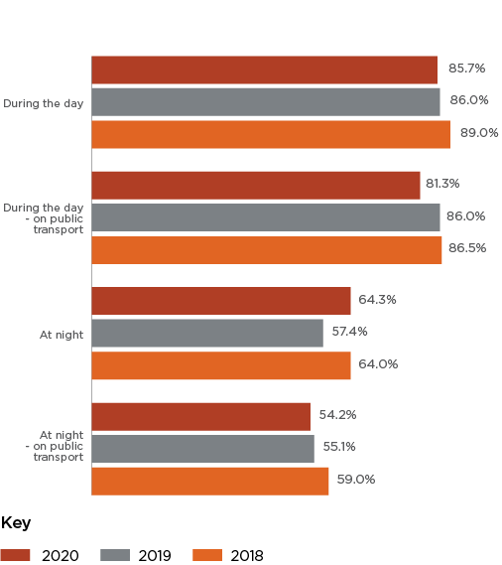
Source: City of Melbourne Social Indicators Survey
Perception of safety | 2020 | 2019 | 2018
During the day | 85.7% | 86.0% | 89.0%
During the day – on public transport | 81.3% | 86.0% | 86.5%
At night | 64.3% | 57.4% | 64.0%
At night – on public transport | 54.2% | 55.1% | 59.0%

Violence against women (this is an Area to Watch due to COVID-19)
Violence against women is the act of gender-based violence that results in, or is likely to result in, physical, sexual or psychological harm or suffering to women, including threats of such acts, coercion or arbitrary deprivation of liberty, whether occurring in public or private life. It is often characterised by acts of physical violence, sexual violence, psychological abuse, coercive control, stalking and harmful cultural practice.
There has been a general increase in assaults and sexual offences against women across Victoria in the four years to March 2020. Sexual offences against women have increased from 6413 reports in 2017, to 7403 reports in 2020 – an increase of almost 15 per cent. Similarly, assaults against women have risen 6 per cent over the same period (21,010 reports in April 2017 compared with 22,271 in March 2020).
The City of Melbourne is experiencing similar trends to Victoria in sexual assault offences. In 2020, rates of sexual assault offences reached 521.6 per 100,000 residents, close to the 10-year high of 524.3 offences per 100,000 residents reported in 2018. While data broken down by gender is not publicly available at the municipality level, the majority of sexual assault victims in Victoria are female (approximately 84 per cent in 2020). Conversely, rates of stalking, harassment and threatening behaviour have steadily declined over recent years, decreasing from 316.7 offences per 100,000 residents in 2016-17, to 242.7 offences per 100,000 residents in 2019-20.
Figure 27: Rate of offences recorded per 100,000 population, City of Melbourne
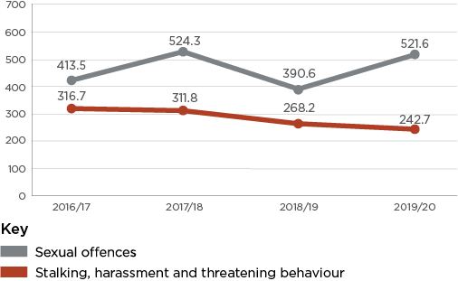
Source: Crime Statistics Agency
Offence | 2016/17 | 2017/18 | 2018/19 | 2019/20
Sexual offences | 413.5 | 524.3 | 390.6 | 521.6
Stalking, harassment and threatening behaviour | 316.7 | 311.8 | 268.2 | 242.7

Family violence (this is an Area to Watch due to COVID-19)
Family violence is any behaviour or act perpetrated against a family member that causes harm or distress and includes financial, physical, emotional and sexual abuse and neglect. Family violence encompasses other commonly used terms such as domestic violence, intimate partner violence and elder abuse. Family violence is predominantly, but not exclusively, perpetrated by men against women and children. Violence can occur in any kind of relationship including, LGBTIQ relationships and against older people and people with a disability. As noted above, family violence perpetrated against older people is referred to as elder abuse. Violence can cause significant short- and long-term health issues for victims including death, serious injury, disability, complications during pregnancy and birth, and mental health issues.
From 2016-17 to 2019-20, family violence incident rates within the City of Melbourne have fluctuated between approximately 875 and 950 cases per 100,000 population. It is concerning that most recent data shows that the rate of reported family violence incidents are at 929 cases per 100,000 residents, a sharp increase from 875 cases per 100,000 residents in 2019.
While rates of family violence incidents have remained relatively steady in recent years, the impacts of the COVID-19 pandemic and its isolating effects have led to warnings from Australian general practitioners and health advocates of an impending increase in the number of incidents of family violence during periods of ‘lockdown’.
A recent Monash University survey of 166 family violence practitioners suggests an increase in both the incidence and severity of family violence in Victoria during the pandemic. Most respondents (59 per cent) reported that the pandemic had increased the frequency of violence against women, while half (50 per cent) reported an increase in the severity of violence. Alarmingly, the number of first-time family violence reports had gone up for 42 per cent of practitioners surveyed. Surveyed practitioners also reported that perpetrators were using the pandemic to inflict new forms of violence and control.
Figure 28: Family violence incidents recorded in the City of Melbourne, 2016-17 to 2019-20
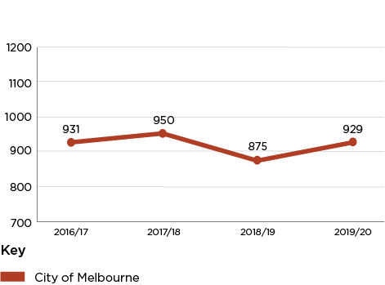
Source: Crime Statistics Agency
Period | Number of incidents in the City of Melbourne
2016/17 | 931
2017/18 | 950
2018/19 | 875
2019/20 | 929

Spotlight on: Aboriginal and Torres Strait Islander Health
“Aboriginal health does not mean the physical wellbeing of an individual, but refers to the social, emotional and cultural wellbeing of the whole Community. For Aboriginal people this is seen in terms of the whole-of-life view” - Gee, G., et al
The Aboriginal understanding of health encompasses social, emotional, spiritual, cultural and community domains. One’s individual health is far less important to an Aboriginal person than the health of their family, Community and their Country. This requires culturally appropriate approaches to healthcare and services that embody the principle of self-determination.
To understand and respond to Aboriginal health and wellbeing a deeper understanding of the issues faced by Aboriginal and Torres Strait Islander people is key. Aboriginal people continue to address historical and contemporary issues that impact their communities. These include dispossession, dislocation and the continued impacts of colonisation, racism and discrimination, inter-generational trauma, lower levels of education and employment and higher rates of incarceration, chronic diseases, homelessness, alcohol and other drug issues and self-harm.
The limited availability of culturally appropriate research and data on Aboriginal communities is something that needs to be addressed in the development of any health interventions for Aboriginal people in the City of Melbourne.
Nationally, Aboriginal people die younger than non-Aboriginal people with 81% dying before the age of 75 years compared with only 34% of non-Aboriginal people. The leading causes of mortality are cardio-vascular disease, cancer, injury and suicide, endocrine diseases such as diabetes and respiratory disease.
When compared to the overall Australian population, Aboriginal and Torres Strait Islander peoples also have a substantially higher prevalence of smoking. In Victoria, the proportion of Aboriginal persons in 2018-19 over 18 who were daily smokers was 36% compared with 12.4% in the Victorian population.
City of Melbourne’s is aiming to reshape Melbourne to become a city with an Aboriginal focus through our Reconciliation Action Plan 2020-23 (RAP). By implementing self-determining, culturally appropriate programs, co-designed with Aboriginal people, we will take the first important steps to addressing some of the social determinants outlined above that can adversely impact on Aboriginal people’s health and wellbeing.

Feeling part of the community (this is an Area to Watch due to COVID-19)
A strong sense of community belonging is an important part of social functioning and is positively linked to wellbeing and mental health.
In 2020, City of Melbourne residents were less satisfied with feeling part of the community (65.53 out of 100) compared with the average for Australia (71 out of 100). The average score for residents, workers and students varied across different age groups. Respondents aged 25 to 34 years were the least satisfied with feeling part of the community (62.6 out of 100), while respondents aged 65 years and over were the most satisfied with feeling part of the community (78.3 out of 100).
While average satisfaction scores remained relatively constant for residents and workers, the average satisfaction score from students saw a sharp decline from 64.6 in 2019 to 59.9 to 2020. Data for 2020 was collected in the midst of the COVID-19 pandemic, during which there were increased reports of racist attacks, especially towards people from Asian backgrounds. This is likely to have contributed to the decline in the score, including among the municipality’s large international student cohort.

Community engagement and participation (this is an Area to Watch due to COVID-19)
Civic engagement involves participation in collective or individual activities that reflect an interest in society and democracy. Civic engagement is a sign of social cohesion and a person’s overall wellbeing. Greater engagement helps to limit disconnection from community and the health issues associated with social isolation and loneliness.
Overall, there has been a gradual decline in community engagement and participation levels amongst City of Melbourne residents. In 2020, 37.1 per cent of residents reported volunteering decreased from 43.3 per cent in 2018. Over the same period, residents’ participation in arts and cultural activities decreased from 23.1 per cent to 17.5 per cent, while the proportion of residents participating in activities that influenced government decision-making decreased from 56.4 per cent to 52.3 per cent.
The impacts of COVID-19 pandemic may have contributed to this sharp decline in resident engagement and participation in 2020. The widespread closure of theatre, music venues, museums and galleries during periods of lockdown has limited opportunities to participate in arts and cultural activities, while social distancing has led to fewer face-to-face volunteering opportunities. The shift towards more digitised forms of communication due to COVID-19 may also have implications for how Council involves residents in future decision-making.

Focus on the built and natural environment
Researchers and policy makers are increasingly recognising the potential positive impacts of the built and natural environment on population safety, health and wellbeing. For example, highly connected street networks and diverse land-uses have all been linked to increased levels of physical activity and lower rates of obesity and morbidity of chronic disease such as heart disease and type-2 diabetes. Similarly, public parks and gardens and frequent and accessible public transport options can promote better mental health by reducing stress, facilitating more opportunities for social interactions, and improving access to essential services and employment opportunities, while the design of the built environment including open spaces can influence crime and perceptions of safety.
Leading medical journal The Lancet has declared climate change as ‘the biggest global health threat of the 21st century’. Resulting heatwaves can increase the risk of heat exhaustion and stroke, with studies showing higher mortality rates in major Australian capital cities during heatwaves. This is exacerbated for city dwellers by the urban heat island (UHI) effect, whereby cities can be 5–11 degrees Celsius hotter than surrounding areas. As shown by the 2020 summer bushfires, extreme weather events influenced by changed climate can also result in physical harm, respiratory problems and death. Further, air pollution from fossil fuels has been linked to respiratory issues and exacerbation of chronic diseases such as heart disease, chronic obstructive pulmonary disease and asthma. Increasingly severe and frequent flooding and extreme weather can cause injury, harm and loss of life, disrupt agricultural food production leading to changes in food security. Urban green spaces such as parks, street trees and green roofs have been found to mitigate the urban heat island (UHI) effect and reduce the risk of flooding.

Summary of key health and wellbeing issues from this section
- Health impacts of climate change
While the City of Melbourne performs relatively well across key indicators of climate change mitigation and actions for health, climate change is considered the biggest global health threat of the 21st century. Climate change-related exposures such as higher temperatures, extreme weather events and worsening air quality will continue impact on the health of the community, especially socially and economically disadvantaged populations. Strategies that mitigate the health and wellbeing effects of climate change must be identified and prioritised.
- Active and environmentally friendly forms of transport
On measures of active transport use, the municipality performs relatively well. In 2018, more than two-fifths (41 per cent) of all trips in the municipality were by walking or cycling, compared with 18.2 per cent for Greater Melbourne. However, amid ongoing concerns about the impacts of climate change, a growing population, and rising traffic congestion, supporting active transport should remain a key health and wellbeing issue for the municipality due to its significant health and environmental benefits.
- Health impacts of urban densification
A growing population, transition towards a 24-hour city, and the effects of climate change are placing significant pressure on the City of Melbourne’s built and natural environment. Increasing noise, air pollution, and impacts of the urban heat island will continue to grow as a health and wellbeing issue for the City of Melbourne unless action is taken.

Areas tracking well

Public open space
There are several health and social benefits associated with access to walkable and attractive open public spaces. Urban green spaces provide places for exercise, relaxation and shade which can contribute to improved mental health outcomes, lower rates of chronic diseases, and obesity and overweight. They also enable social interaction which is critical for creating and maintaining community cohesion and building social capital.
Compared to neighbouring municipalities, the City of Melbourne has the highest amount of public space (21 per cent) as a proportion of its total area. While this figure provides an indication of the availability of open public space, accessibility provides a better indicator of usage therefore the potential benefits to the community.
Figure 29: Public space as a proportion of the City of Melbourne area
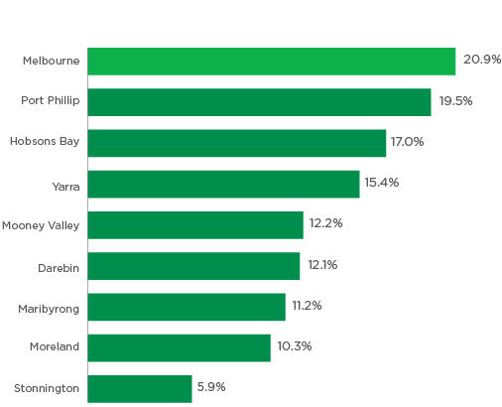
Source: Victorian Planning Authority
Area | Percentage
Melbourne | 20.9%
Port Phillip | 19.5%
Hobsons Bay | 17.0%
Yarra | 15.4%
Mooney Valley | 12.2%
Darebin | 12.1%
Maribyrong | 11.2%
Moreland | 10.3%
Stonnington | 5.9%
On measures of accessibility, the City of Melbourne also compares favourably with other inner-city municipalities. Almost the entire City of Melbourne’s population (93.5 per cent) is within 400 metres of public open space.
Although these results appear positive, a number of public open spaces are also areas where residents and visitors feel unsafe. This is primarily due to impacts of anti-social behaviours, the presence of rough sleepers, and in some cases unwelcoming or poorly designed landscapes. In the evenings and at night, open spaces are often uninviting and felt to be unsafe with poor lighting. This can include extreme lighting, that is so stark it is alarming. Lighting can also create areas of bright light and contrast areas of comparative darkness. The quality of design of open spaces and whether people feel safe and welcome to use parks and gardens are key factors in determining if, when and how that space is used. Proximity to open space is only a positive if that open space welcomes people to use it at all times of day. Continuing to meet the community’s open space needs is an emerging challenge in the context of the City of Melbourne’s growing population, the emerging impacts of climate change, and an observed increase in open space usage during the COVID-19 pandemic.
Figure 30: Population within the City of Melbourne within 400m walkable distance of public open space
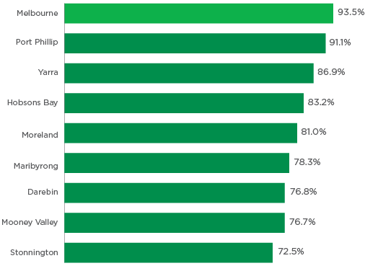
Source: Victorian Planning Authority
Area | Percentage
Melbourne | 93.5%
Port Phillip | 91.1%
Yarra | 86.9%
Hobsons Bay | 83.2%
Moreland | 81.0%
Maribyrong | 78.3%
Darebin | 76.8%
Mooney Valley | 76.7%
Stonnington | 72.5%

Active Transport (this is an Area to Watch due to COVID-19)
Active transport can have significant physical and mental health benefits. Walking and cycling can assist with weight management, reduce the risk of chronic diseases, prevent musculoskeletal conditions, and improve mental wellness. Replacing motorised forms of transport with active transport also has significant co-benefits, including reduced air pollution, less traffic congestion and fewer vehicle-related deaths and injuries. Built environment characteristics such as land use mix, street connectivity, open space and high quality pedestrian and cycling infrastructure can help promote active transport.
In 2018, walking made up more than one third (37 per cent) of all trips in the municipality, while cycling made up around 3 per cent. These proportions are slightly lower than in 2016, but are higher compared with Greater Melbourne (18 per cent for walking and cycling combined). The municipality’s relatively high density, public open spaces, and availability of public transport options could all enable more active modes of transport. The design of our streets – including tree planting, water sensitive urban design, permeable pavement, shade, lighter surface materials – all create a safer, aesthetically pleasing and more comfortable public realm. This is especially important with increasing temperatures, heavy rainfall events (and flooding), and will promote increased use and therefore active travel (both walking and cycling).
While higher than reported for Greater Melbourne, these proportions are slightly lower than reported for the municipality in 2016. However, evidence suggests that the COVID-19 pandemic has led to increased uptake in recreational cycling across Melbourne, with weekend cycling numbers increasing by over 50 per cent from February to May 2020.
COVID-19 has also led to a resurgence in ‘local living’ as more people are working and learning from home, and using local parks streets and parks for walking, cycling and exercise. Preliminary results from a national survey conducted by Deakin University in May 2020 showed an increase in the proportion of adult respondents reporting walking as a family compared to February. There was also a reported increase in the amount of time spent walking as a family, especially among respondents with a child aged 5–17 years.
It will be important to support this shift towards more active forms of transport in the community and retain the associated health benefits.
Figure 31: Proportion of all trips made in the City of Melbourne, 2016 and 2018
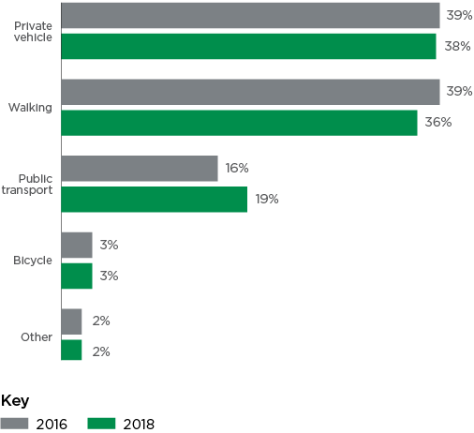
Source: Victorian Integrated Survey of Travel and Activity (VISTA)
Mode of transport | 2016 | 2018
Private vehicle | 39% | 38%
Walking | 39% | 36%
Public transport | 16% | 19%
Bicycle | 3% | 3%
Other | 2% | 2%

Vehicle ownership
The number of registered vehicles in the City of Melbourne is trending downwards (65,647 vehicles in 2015 to 56,419 in 2018). Vehicles classified as using petrol or LPG/dual/other had the sharpest decline (45,800 to 38,805, and 2159 to 1021 respectively). The increase in uptake of fuel efficient and electric vehicles may be due to growing awareness and concern of the impacts of climate change amongst residents. It is anticipated that the market transition to electric vehicles will accelerate in the next five years. While this will reduce air pollution in the municipality, greenhouse gas emissions will continue to rise if the electricity grid does not transition to renewable energy over the same period.
Table 7: Number of registered motor vehicles by fuel type in the City of Melbourne, 2015-2018
Registered Vehicle Type | 2015 | 2016 | 2017 | 2018
Registered motor vehicles – type of fuel – petrol | 45,800 | 42,304 | 40,085 | 38,805
Registered motor vehicles – type of fuel – diesel | 17,632 | 14,103 | 14,650 | 16,487
Registered motor vehicles – type of fuel – LPG/dual/other | 2159 | 1520 | 1261 | 1021
Registered motor vehicles – type of fuel – electric | 56 | 55 | 86 | 106
All registered motor vehicles | 65,647 | 57,982 | 56,082 | 56,419
Source: Australian Bureau of Statistics

Spotlight on: Climate Change
Rising temperatures, extreme weather events (such as extreme heat and heatwaves, floods, and bushfires), drought and air pollution have been linked to increased risk of heat exhaustion and stroke, respiratory problems, the spread of infectious diseases, and challenges to food security. People in our community with existing health conditions, older people, families with infants and those on low-incomes, are particularly vulnerable, as they have fewer resources to take actions that reduce their exposure to these risks (e.g. use of air conditioning during heatwaves).
Climate change can also undermine people’s mental health directly and indirectly. In addition to the trauma caused by experiencing extreme weather events, there are growing concerns about the impacts of eco-anxiety (also described as climate anxiety) – a chronic fear of environmental doom, especially amongst younger people. These concerns are reflected in research by Sustainability Victoria which found that 78 per cent of Victorians are concerned about climate change, with 38 per cent concerned about its impact on health and quality of life. Young Victorians aged 15–24 years were more likely to place climate change among the top three important issues facing the state (44 per cent) than the general population (30 per cent).
Climate change is increasing the intensity and severity of such extreme weather events. Many people experience serious health problems due to heat waves with 374 additional deaths occurring in the heatwave leading up to the 2009 Black Saturday bushfires. Melbourne currently averages 11 days with extreme temperatures hotter than 35°C. By 2050 under a high emissions scenario, our municipality is projected to experience between 13 and 21 days hotter than 35°C on average. This trend will also increase the severity of bushfire smoke haze and thunderstorm asthma which can severely impact the health of our community. These projections highlight the needs for mitigation and adaptation strategies to minimise the impacts of climate change on human health within the City of Melbourne.
Protecting our natural environment helps maintain clean air and water and improves physical and mental wellbeing. Retaining water in the urban environment, expanding our green spaces, installing temporary shade spaces, and increasing our tree canopy all help to cool our municipality. Many of these initiatives also help reduce flash flooding risks and the impacts of drought.
A resilient built environment is essential to a good quality of life. Providing reliable, well integrated, services such as transport, water and energy in the face of a changing climate, will allow Melbourne to become a city that is always ready for the future. The way we build our city also contributes to how well it responds to climate events. As we experience more days of extreme heat, the thermal comfort of accommodation including high-rise apartments is imperative. During extreme heat we can face periods of power outages, which means lifts in apartment buildings or air conditioning will not function and this can greatly impact human health and wellbeing.
A focus on the thermal performance of buildings can support better health outcomes during summer heatwaves as well as the cold weather in winter. This is particularly important for older people, families with young infants and vulnerable people with existing health conditions. Energy efficient buildings can also reduce greenhouse gas emissions and fuel poverty, particularly for low-income renters experiencing housing stress.
The following pages provide an overview of climate change indicator data available including:
- Heat waves and extreme heat
- Tree canopy cover
- Flooding and storm events
- Drought and reduced rainfall
- Air quality
- Thunderstorm asthma
- Greenhouse gas emissions
- Integrated water management
- Food system resilience

Heatwaves and extreme heat
The Victorian government has a heat health alert system which notifies organisations including local government about extreme heat or heatwaves that are likely to negatively impact human health. Heat health alerts are issued for the Central District, which includes the City of Melbourne when the forecast average temperature reaches or exceeds 30 degrees Celsius. Eight heat health alerts were issued for the Central District over the summer season 2018-2019 and five over the summer season 2019-20.
During the 2009 heatwave there was a 46 per cent increase in ambulance callouts and a 12 per cent increase in emergency department presentations. In addition, there were 374 excess deaths recorded during the heatwave period. The 2014 heatwave also led to a significant increase in demand for health services, with a 25 per cent increase in ambulance callouts and an estimated 167 excess deaths.
The heat vulnerability index (HVI) indicates how vulnerable populations are to extreme heat event. The heat vulnerability index rating is determined by three factors:
- Heat exposure
- Sensitivity to heat
- Adaptive capacity
The index ranges from 1 (low vulnerability) to 5 (high vulnerability). In 2018, the municipality was rated 2 on the index, indicting relatively low vulnerability. Within the City of Melbourne, people living in South Yarra – west are least vulnerable to extreme heat (rating of 1), while people in Carlton and North Melbourne and most vulnerable (rating of 3).
Table 8: Heat Vulnerability Index (HVI) by suburb in the City of Melbourne, 2018
Heat Vulnerability Index rating (2018) | Suburb
1 | South Yarra – west
2 | Docklands, East Melbourne, Kensington, Melbourne (central business district), Melbourne (remainder), Parkville, Southbank, West Melbourne, Carlton North
3 | Carlton, North Melbourne
Source: Victorian Department of Environment, Land, Water and Planning (2018), Cooling and Greening Melbourne Interactive Map
Socially disadvantaged communities (e.g. those on lower incomes) and people with existing physical (e.g. heart disease, obesity, multiple sclerosis) or mental illness, the very old and the very young, and those living alone are most at risk of negative health impacts from extreme heat.
During the 2009 heatwave, in addition to the devastating bushfires that claimed 173 lives in Victoria, the city experienced a blackout, which led to closures of the city’s rail and tram networks. The total economic costs of the heatwave were estimated to be $800 million. There was increased demand on health services including a 46 per cent increase in ambulance callouts and a 12 per cent increase in emergency department presentations. In addition, there was a significant impact on mortality with 374 excess deaths recorded during the heatwave period. Research undertaken on the 2014 heatwave showed businesses in the City of Melbourne lost an estimated $37 million in revenue over the four days of the heatwave.

Tree canopy cover
Tree canopy cover has been linked to lower odds of developing psychological distress and higher odds of maintaining good general health. The presence of canopy trees within public and private spaces can provide sensory relief in urban areas characterised by hard materials and surfaces (e.g. concrete and glass), has restorative effects on mental fatigue, provides shade and reduces ambient temperatures, creating more comfortable walking environment. Increasing tree canopy cover is also considered to be one of the most cost efficient and effective ways to combat the urban heat island effects and adapt to climate change.
Figure 32: Tree canopy cover by inner city municipalities
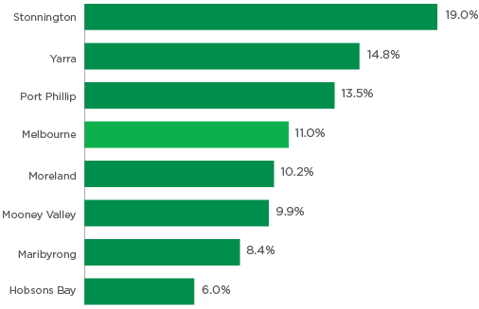
Source: Victorian Department of Environment, Land, Water and Planning (2018), Cooling and Greening Melbourne Interactive Map
Inner city municipality | Percentage
Stonnington | 19.0%
Yarra | 14.8%
Port Phillip | 13.5%
Melbourne | 11.0%
Moreland | 10.2%
Mooney Valley | 9.9%
Maribyrong | 8.4%
Hobsons Bay | 6.0%
It is estimated that canopy cover across the municipality’s public and private realm is 11 per cent, placing mid-range when compared with other inner-city municipalities. As shown in Figure 32 below, neighbouring municipalities Stonnington (19 per cent) and Yarra (14.8 per cent) have the highest percentage of overall tree canopy coverage, while Hobsons Bay (6 per cent ) and Maribyrnong (8.4 per cent) have the lowest of inner city municipalities.
The City of Melbourne’s public realm fares well with almost a quarter (23.7 per cent) of its area having tree canopy cover. The City of Melbourne plants at least 3000 trees each year as part of its Urban Forest Strategy. It is estimated that the Inner Regional which includes the municipalities of Melbourne, Yarra and Port Phillip has 13 per cent canopy cover in the private realm.
As shown in Figure 33 below, overall tree canopy coverage (public and private realm) varies significantly between suburbs in the City of Melbourne. East Melbourne is estimated to have the highest tree coverage, with almost a quarter (23.6 per cent) of the suburb with tree coverage, followed by Parkville (20.7 per cent) and Melbourne (15.6 per cent). At the other end of the scale is Docklands and West Melbourne with 2.8 per cent 3.1 per cent tree coverage, respectively.
Figure 33: Proportion of tree coverage by suburb in the City of Melbourne, 2018
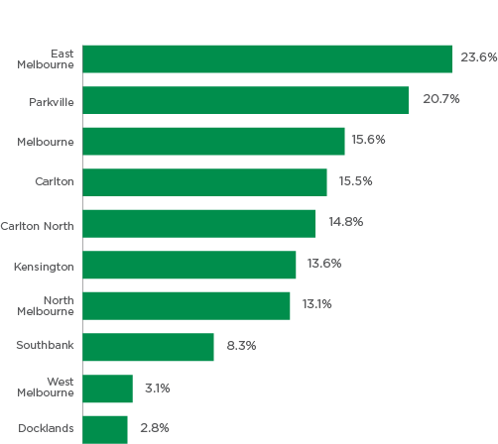
Source: Victorian Department of Environment, Land, Water and Planning (2018), Cooling and Greening Melbourne Interactive Map
Suburb | Percentage
East Melbourne | 23.6%
Parkville | 20.7%
Melbourne | 15.6%
Carlton | 15.5%
Carlton North | 14.8%
Kensington | 13.6%
North Melbourne | 13.1%
Southbank | 8.3%
West Melbourne | 3.1%
Docklands | 2.8%

Flooding and storm events
The potential for storm drain inundation and flash flooding will likely increase with more intense rainfall events accompanied by sea level rise. These events have numerous flow-on effects, for example to business, transportation systems and health and safety.
Flash flooding is known to cause the most deaths or injuries of all natural disaster weather events. Increased wind speeds have an exponential effect on building damages, which results in more debris flying through the air. Depending on the cause and location, the risk of public injury or death during a storm event is significant for the community.
The City of Melbourne 2009 Climate Change Adaptation Strategy identified floods and storm events as one of the four main climate change risks for Melbourne. As part of the Strategy refresh in 2017, Council reviewed the risks to assess whether they were still accurate and identified that floods and storms remain a priority for action and focus.

Drought and reduced rainfall
Drought and insufficient water supply as a priority for action and focus for the City of Melbourne. Critical risks identified for extreme drought and reduced rain fall for the City of Melbourne are:
- Insufficient urban water supply
- Biodiversity impacts in stressed waterways
- Injury due to hard sporting grounds
- Loss of social cohesion due to inability to fully optimise the use of sporting grounds in drought period.
Additionally, insufficient water supply can impact on how the community responds to heat, for example, watering of trees and parks. Drought can also lead to water restrictions and increased water prices which may lead to mental or emotional stress, especially for the most vulnerable in the community.
At current rates of growth Melbourne will become Australia’s largest city by 2030. Should very low rainfall conditions continue in the short to medium term, there is a risk of Melbourne experiencing serious water shortages from its centralised mains water supply. Adapting to the impacts of drought and low rainfall therefore remains a priority for the City of Melbourne.

Air quality
Poor air quality is harmful to human health. Health impacts of pollutants include irritation of the nose, airways and lungs, resulting in respiratory problems. Long-term exposure increases the risk of morbidity and mortality from cardiovascular disease and respiratory diseases such as asthma. Common air pollutants include:
- Nitrogen dioxide – the major source of this pollutant in Australia is the burning of fossil fuels such as coal, oil and gas. About 80 per cent of all nitrogen dioxide in cities comes from motor vehicle exhaust.
- Ground-level ozone – ozone gas is formed when nitrogen oxides react with air pollutants known as ‘reactive organic substances’ in the presence of sunlight. Sources of the chemicals that react to form ozone include motor vehicle exhaust, oil refinery, printing, petrochemicals, lawn mowing, aviation, bushfires and burning off.
- Sulfur dioxide – about 99 per cent of the sulfur dioxide in air comes from human sources. The main source of sulfur dioxide in the air is industrial activity that processes material that contain sulfur e.g. electricity generation from coal, oil or gas that contains sulfur.
- Particulate matter (PM2.5 and PM10) – particulate matter describes a mix of tiny solid particles and droplets found in the air. Particulate matter mainly comes from motor vehicle exhaust, wood burning heaters and industry.
The latest data on air pollution shows mixed results for the City of Melbourne. From 2015 to 2017, levels of PM2.5 and nitrogen dioxide concentration have increased (7.9 to 8.3 micrograms per cubic metre and 18.8 to 19.9 micrograms per cubic metre, respectively), while levels of ground-level ozone and sulfur dioxide decreased slightly (30.1 to 29.6 micrograms, and 1.5 to 1.1 micrograms per cubic metre, respectively). After a slight decrease in 2016, PM10 concentration in 2017 jumped back up to 2015 levels (16.2 micrograms per cubic metre).
When considered together, these results suggest air quality in the City of Melbourne remains relatively consistent. However, the 2019/20 bushfires in Australia’s eastern states highlight the threat of climate change on exacerbating air-quality-related health issues. During the fires, authorities reported Melbourne’s air quality to be the worst in the world. A recent study estimated that smoke from the bushfires was linked to over 400 deaths and 3000 hospitalisations in Australia relating to cardiovascular and respiratory problems, and asthma.

Thunderstorm asthma
The size, severity and impact of the 2016 thunderstorm asthma event in Victoria was unprecedented. Thousands of people developed breathing issues, with many experiencing an asthma attack for the first time in their lives. During the event, almost 13,000 people presented at hospital emergency departments – 44 per cent more than the three-year average, and a 73 per cent increase in ambulance call outs. An estimated 9 excess deaths occurred in people with asthma as a result of the event.
Figure 34: Concentration (micrograms per cubic metre) of common pollutants in the City of Melbourne
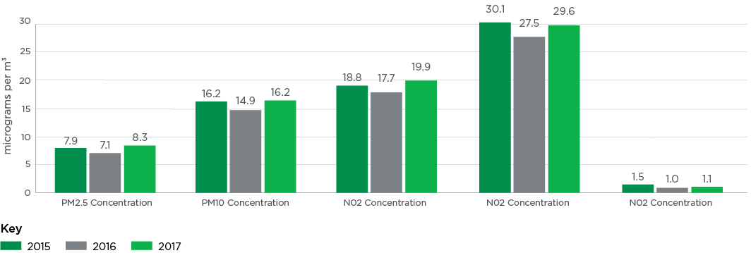
Source: Environmental Protection Agency Victoria
Item | 2015 – micrograms per cubic metre | 2016 – micrograms per cubic metre | 2017 – micrograms per cubic metre
PM2.5 Concentration | 7.9 | 7.1 | 8.3
PM10 Concentration | 16.2 | 14.9 | 16.2
Nitrogen dioxide concentration | 18.8 | 17.7 | 19.9
Nitrogen dioxide concentration | 30.1 | 27.5 | 29.6
Nitrogen dioxide concentration | 1.5 | 1.0 | 1.1

Greenhouse gas emissions
The City of Melbourne is committed to net zero emissions by 2040 as part of its response to the Climate and Biodiversity Emergency Declaration.
The majority of the municipality’s greenhouse gas emissions come from the burning of coal, oil and gas for energy use in buildings (66 per cent) and transport fuel (19 per cent). These emissions need to be reduced because they are causing the climate change impacts that exacerbate health issues in our municipality. Furthermore, the actions needed to transition away from fossil fuels provide opportunities to improve public health through active transport and improvements in air quality as well as the thermal performance of buildings.
As shown in Figure 35 below, the City of Melbourne has made progress in reducing per capita greenhouse gas emissions. In 2014, the municipality’s emissions were 41.2 tonnes of greenhouse gases per capita, decreasing to an average of 27.2 tonnes per capita in 2019.
This was largely due to the closure of the Hazelwood power station and an increase in renewable energy supplying the electricity grid. Compared with fossil fuels, electricity generation from renewable energy sources such as solar and wind has lower pollution related impacts on human health particularly in the regions where generation occurs. It is anticipated that further closures of ageing coal-fired power plants will occur in the next few years – an important transition away from fossil fuels.
From the financial years 2013-14 to 2019, the percentage of electricity from renewable energy sources as a proportion of total energy consumption has steadily increased from one eighth (12.5 per cent) to more than one fifth (21.8 per cent). The City of Melbourne is also powering its facilities with 100 per cent renewable energy and we are committed to 100 per cent renewable energy for the municipality.
While significant progress has been made, the municipality still has one of the highest emissions in the world on a per capita basis. This is attributed to the municipality’s large number of office buildings powered by coal-fired power stations relative to its low residential population.
When considered together, the City of Melbourne performs relatively well across key indicators of climate change and actions for health. Significant progress has been made in reducing greenhouse gas emissions, increasing energy from renewable sources, and reducing the risks from impacts such as extreme heat, flooding, drought, and storm events. A substantially larger proportion of trips in the municipality are also being made by more active forms of transport (walking and cycling) compared with Greater Melbourne, and this is likely to increase due to the impacts of COVID-19. Nonetheless, climate change-related exposures such as higher temperatures, extreme weather events and worsening air quality will continually impact on the health of the community, especially socially and economically disadvantaged populations. Strategies that mitigate and adapt to the health and wellbeing effects of climate change should be identified and prioritised.
Figure 35: Per capita greenhouse gas emissions in the City of Melbourne
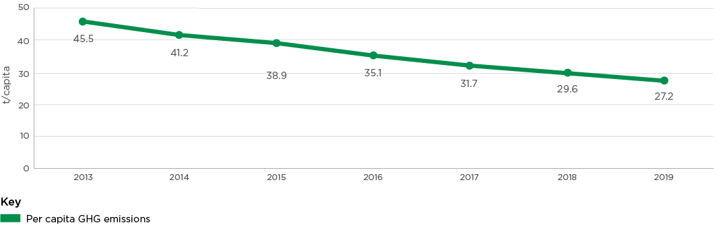
Source: City of Melbourne Climate Change and City Resilience branch
Year | Per capita GHG emissions (t/capita)
2013 | 45.5
2014 | 41.2
2015 | 38.9
2016 | 35.1
2017 | 31.7
2018 | 29.6
2019 | 27.2

Food system resilience
Our food systems will face unprecedented risks from future pandemics, economic crises, climate change, fuel shocks and other events. A resilient food system can withstand and recover from the shocks and stresses in a way that ensures a sufficient supply of acceptable and accessible food for all. Resilient food systems are characterised by diversity in:
- food source (local and global supply chains)
- the length of supply changes (short and long)
- production scale (small and large); who produces food (community and commercial production)
- the foods we consume.
Almost two thirds of City of Melbourne residents (65 per cent) produce and consume their own food in some form. This includes all aspects of production from entry level herb growing in pots (28 per cent) to larger garden projects such as growing vegetables and fruits at home (15 per cent) or street/community gardens (3 per cent), preserving or pickling produce (15.5 per cent) and making jams and conserves (14.5 per cent). Reports of a spike in demand for vegetable seeds and seedlings, suggests growing interest in backyard vegetable production during the COVID-19 pandemic.

Integrated water management
Water is fundamental to the liveability of the city and the health and wellbeing of our community. The role that water plays in our municipality is continuously evolving, particularly in the context of climate change. The way we manage water in our city will underpin how we can mitigate the impacts of extreme heat, heat waves, drought, flooding and sea level rise. Integrated water management (IWM), which is the coordinated management of the city’s water sources, is a critical enabler in mitigating these climate change risks. IWM is achieved through the implementation of water sensitive urban design (WSUD), which aims to secure fit-for-purpose water supplies for the needs of our growing city, increase permeability across our highly urbanised catchments, enhance resilience of our parks and gardens, and reduce the potential impact of pollutants within these water sources on our environment. Permeable surfaces allow our city to act as a sponge for rainfall, hydrating and cooling the landscape. WSUD, permeable paving and park expansions increase permeability across the city. In 2017/18 and 2018/19, 3520m² of new permeable surfaces were created in the municipality.
Water sourced from stormwater harvesting schemes can be used for irrigation of parks, gardens and ovals, improving soil moisture levels and growing conditions for mature trees. Passively watered trees can access a significant proportion of annual irrigation requirements from stormwater ensuring optimal growing conditions which provide a large canopy. Irrigating City of Melbourne urban landscapes will improve the cooling effect these areas can provide to our communities, combatting the urban heat island effect through evaporation and shade. Capturing and slowing down stormwater has multiple benefits including flood mitigation, drought resilience and water pollution reduction.

Spotlight on: Access to blue space
There is growing evidence that access to outdoor water features such as rivers, ponds and lakes, also known as ’blue space’, can promote health and wellbeing. Studies have shown that contact with blue spaces promotes mental health and wellbeing, and physical exercise.
Although encouraging, the health impact of blue spaces is a recently emerging research field with relatively few studies to date. Moreover, there is limited data on the availability and access of blue spaces within the City of Melbourne. Nonetheless, the evidence highlights the use of blue spaces as a potential strategy to promote health and wellbeing in the municipality.

Areas not tracking well

Noise complaints (this is an Area to Watch due to COVID-19)
There is growing evidence that long-term or dangerous levels of exposure to environmental noise can adversely affect human health, including through an increased risk of sleep disturbance, cardiovascular disease, and reduced cognitive performance.
The number of noise complaints made in the City of Melbourne has generally trended upwards over the past four years. In the 2019/20 financial year there were a total of 2741 noise complaints made, an increase of more than 20 per cent on the number in 2015/2016 (2272 noise complaints made). As shown in Table 9 below, the largest number of noise complaints received by Council related to building works or construction (915), followed by roadworks (452 complaints) and request for on-call building office noise or nuisance (294 requests). The number of noise complaints relating to building works or construction and road works has doubled since the 2018/19 financial year with the COVID-19 pandemic forcing more people to work from home, and a large number of major infrastructure and construction projects such as the Metro Tunnel continuing to operate during this period.
Table 9: Number of noise complaints reported in the City of Melbourne, 2015/16 to 2019/20
Noise complaint type | FY 15/16 | FY 16/17 | FY 17/18 | FY 18/19 | FY 19/20
Building-works or construction | 290 | 451 | 472 | 414 | 915
Roadworks related issues | 130 | 165 | 143 | 250 | 452
Request on-call Building Officer noise/nuisance | 512 | 461 | 503 | 589 | 294
Street Trading – busking noise | 491 | 620 | 320 | 476 | 203
Entertainment venues (music) | 160 | 159 | 192 | 201 | 176
Source: City of Melbourne

Overcrowding in rooming houses (this is an Area to Watch due to COVID-19)
A rooming house is a building where one or more rooms are available to rent, and four or more people in total can occupy those rooms. In most, residents share bathrooms, laundries and other common areas. There are currently 58 registered rooming houses in the City of Melbourne; however, the growing number of unregistered rooming houses is of growing concern for the municipality. The number of complaints relating to unregistered rooming houses to Council has escalated from 29 complaints in 2016 to 162 complaints in 2019. The City of Melbourne environmental health team suggests tenants are more likely to be foreign students and workers, who are low-income, vulnerable, and socially disadvantaged. Overcrowding and poor housing conditions are reported to expose tenants to significant health risks, such as fire, passive smoking, infectious diseases, and mental health issues. Tenants also have increased risk of exposure to COVID-19 as they are unable to self-isolate.

Appendix

Health and Wellbeing Profile 2020 - at a glance
The City of Melbourne municipality covers an area of 37.7 km² and is located at the heart of Greater Melbourne. It is made up of the city centre and 16 inner suburbs, each with its own distinctive character and with different businesses, dwellings and communities living and working there.

Our community
- Population: 178,955 people live in the municipality. Pre-COVID-19, the city centre attracted 403,000 workers, 85,000 students and 288,000 visitors on an average day.
- Young demographic: 28 year old median age (compared to 37 for greater Melbourne).
- Living with a disability: 1.7% residents have a disability.
- Living alone and high density living: 37% lone person households, 19% elderly residents live alone, 4% single parent family households, 83% of occupied private dwellings are flats/apartments.
- Diverse community: 0.3% or 468 people are Aboriginal, 56% born overseas (China 16%, Malaysia 5%, India 4%), 48% speak a language other than English (Mandarin 19%, Cantonese 4%, Indonesian 2%), 79,230 overseas students.
- Gender and LGBTIQ community: 49% males, 51% females and unknown per cent intersex or trans and gender diverse (data unavailable). 1653 same sex couples (1123 male same-sex couples and 530 female same-sex couples).

Health and wellbeing status
- Preventable diseases are the leading cause of ill health with 31% are overweight or obese and 27% hypertensive.
- 15%: rates of asthma increasing.
- 72%: decreasing levels of self-reported wellbeing.
- Sexual and reproductive health are growing issues including chlamydia, syphilis, gonorrhoea and Hepatitis B.
- Infectious disease rates increasing (from 2162 events per 100,000 residents to 2450 per 100,000 residents).
- 22%: have been diagnosed with depression and/or anxiety.
- Only 15% Have sought professional help for a mental health issue (14% Vic).
- 18% experience high-very high levels of psychological distress in their day-to-day lives (15% Vic).
- 8.9 deaths per 100,000 (9.9 Vic) is the suicide rate.

Lifestyle and behaviours
- 93% do not eat enough fruit or vegetables.
- 52.7% do not do enough exercise.
- High rate of ambulance attendances for alcohol and drug misuse in metro Melbourne.
- 11.5% drink soft drink daily.
- 22% sit for 8+hours on an average weekday.
- Alcohol related assaults during the day increasing.
- 17% eat takeaway food more than once a week.
- Delayed health screening and tests due to COVID-19.
- 4.3% are daily smokers. Increasing density increases exposure to second-hand smoke in the central city.

Environmental determinants of health and wellbeing

Social and cultural
- Increasing reports of family violence
- 96% agree it is good for society to be made up of different cultures. Despite this, there have been increasing reports of racism during COVID-19
- Widening digital divide as our world becomes increasingly digitised, especially for low income households and those with low levels of digital illiteracy
- Declining crime rates
- Declining perceptions of safety, especially at night around public transport hubs
- Decrease in sense of community belonging (66% City of Melbourne, 71% Australia)
- Decrease in community engagement and participation (volunteering, arts and cultural activities, civic participation).

Built
- 21% of the municipality is open space – higher compared to neighbouring municipalities
- 93.5% of people live within 400 metres of public open space
- Health impacts related to urban densification (noise, air pollution, urban heat island effect)
- Community infrastructure to meet growing and diverse population is required (public open space, active transport)
- 41% of all trips in the municipality walking and cycling (18.2% Greater Melbourne)
- Resurgence in ‘local’ living during COVID-19 – learning and working from home, using local streets and open spaces for walking, cycling and socialising.

Economic
- 30% experiencing housing stress
- 5.5% live in social housing, double metro Melbourne at 2.5%
- Overcrowded dwellings on the rise
- 279 people are homeless (sleeping rough)
- 32.9% are food insecure and demand for food relief is growing
- 10.6% unemployment and rising (as of May 2020)
- Pre-COVID, 25% residents live below the poverty line - the highest percentage in Victoria.

Natural
- Health impacts of climate change - including drought, air pollution, rising temperatures and extreme weather events such as extreme heat and heatwaves, floods, and bushfires),
- Impacts of climate change on mental health (ecoanxiety)
- 11% tree canopy coverage (public and private realm), this varies significantly between suburbs
- 65% of residents produce and consume their own food
- Planning and design challenges such as integrated water management, energy efficient buildings, resilient food systems, access to green and blue spaces.

Disclaimer
This report is dated 17 August 2020 and incorporates information and events up to that date only and excludes any information arising, or event occurring, after that date which may affect the validity of Urbis Pty Ltd (Urbis) opinion in this report. Urbis prepared this report on the instructions, and for the benefit only, of City of Melbourne (Instructing Party) for the purpose of Draft (Purpose) and not for any other purpose or use. To the extent permitted by applicable law, Urbis expressly disclaims all liability, whether direct or indirect, to the Instructing Party which relies or purports to rely on this report for any purpose other than the Purpose, and to any other person which relies or purports to rely on this report for any purpose whatsoever (including the Purpose).
In preparing this report, Urbis was required to make judgements which may be affected by unforeseen future events, the likelihood and effects of which are not capable of precise assessment.
All surveys, forecasts, projections and recommendations contained in or associated with this report are made in good faith and on the basis of information supplied to Urbis at the date of this report, and upon which Urbis relied. Achievement of the projections and budgets set out in this report will depend, among other things, on the actions of others over which Urbis has no control.
In preparing this report, Urbis may rely on or refer to documents in a language other than English, which Urbis may arrange to be translated. Urbis is not responsible for the accuracy or completeness of such translations and disclaims any liability for any statement or opinion made in this report being inaccurate or incomplete arising from such translations.
Whilst Urbis has made all reasonable inquiries it believes necessary in preparing this report, it is not responsible for determining the completeness or accuracy of information provided to it. Urbis (including its officers and personnel) is not liable for any errors or omissions, including in information provided by the Instructing Party or another person or upon which Urbis relies, provided that such errors or omissions are not made by Urbis recklessly or in bad faith.
This report has been prepared with due care and diligence by Urbis and the statements and opinions given by Urbis in this report are given in good faith and in the reasonable belief that they are correct and not misleading, subject to the limitations above.

https://participate.melbourne.vic.gov.au
Department of Health and Human Services (2001), Environments for Health, https://www.healthyplaces.org.au/userfiles/file/Environments%20for%20Health%20Victoria.pdf (PDF 560KB)
ABS (ERP)
City of Melbourne (2020), Daily Population Estimates and Forecasts, https://www.melbourne.vic.gov.au/about-melbourne/research-and-statistics/city-population/Pages/daily-population-estimates-and-forecasts.aspx
.id (2020), City of Melbourne Population Summary, https://forecast.id.com.au/melbourne/population-summary
ibid
Australian Bureau of Statistics (ABS) (2016), Census of Population and Housing
.id (2020), City of Melbourne Population and Age Structure, https://forecast.id.com.au/melbourne/population-age-structure?Year1=2016&Year2=2026&Year3=2041&AgeTypeKey=2
ibid
ABS (2016), Census of Population and Housing
Whilst the terms ‘Koorie’ or ‘Koori’ are commonly used to describe Aboriginal people of southeast Australia, we have used the term ‘Aboriginal’ to include all people of Aboriginal and Torres Strait Islander descent who are living in Victoria.
ibid
ibid
ibid
City of Melbourne (2020), Resident Profiles, https://www.melbourne.vic.gov.au/about-melbourne/research-and-statistics/city-population/Pages/residents-profiles.aspx
Ibid
City of Melbourne Social Indicators Survey (CoMSIS)
Schneiders and Lucas (2020), Asian-Australian groups report surge in racist abuse, assaults during pandemic, The Age
City of Melbourne Social Indicators Survey
.id (2020), City of Melbourne: Population, households and dwellings, https://forecast.id.com.au/melbourne/population-households-dwellings?
ibid
ABS (2016), Census of Population and Housing
ABS (2016), Census of Population and Housing
WHO (2020), Early childhood development, https://www.who.int/topics/early-child-development/en
Centre on the Developing Child (2007), The science of early childhood development, https://46y5eh11fhgw3ve3ytpwxt9r-wpengine.netdna-ssl.com/wp-content/uploads/2007/03/InBrief-The-Science-of-Early-Childhood-Development2.pdf (PDF 666KB)
Moore et al (2015), Early childhood development the social determinants of health inequities, https://www.rch.org.au/uploadedFiles/Main/Content/ccch/151014_Evidence-review-early-childhood-development-and-the-social-determinants-of-health-inequities_Sept2015.pdf (PDF 1MB)
Australian Early Development Census (AEDC) (2018), 2018 AEDC Results, https://www.aedc.gov.au/?doc_id=13051
WHO (2020), Maternal, newborn, child and adolescent health, https://www.who.int/maternal_child_adolescent/topics/child/development/10facts/en
Viner et al (2012), Adolescence and the social determinants of health, https://www.thelancet.com/journals/lancet/article/PIIS0140-6736(12)601494/fulltext
Suncorp (2019), Australian Youth Confidence Report
Ibid
RACGP (2020), Mental health ‘most important’ thing for children during COVID-19, https://www1.racgp.org.au/newsgp/clinical/mental-health-most-important-thing-for-children-du
Australian Immunisation Register (AIR)
WHO (2013), Tobacco use and second-hand smoke exposure in pregnancy, https://apps.who.int/iris/bitstream/handle/10665/94555/9789241506076_eng.pdf (PDF 1.3MB)
Department of Health (2019), Pregnancy Care Guidelines: Tobacco smoking, https://www.health.gov.au/resources/pregnancy-care-guidelines/part-c-lifestyle-considerations/tobacco-smoking
Australian Institute of Health and Welfare (2018). Children’s Headline Indicators, https://www.aihw.gov.au/reports/children-youth/childrens-headline-indicators/contents/3-low-birthweight
AIHW (2018), Australia’s Children, https://www.aihw.gov.au/reports/children-youth/australias-children/contents/health/birthweight
WHO (2019), Exclusive breastfeeding for optimal growth, development and health of infants, https://www.who.int/elena/titles/exclusive_breastfeeding/en/
Ibid
Department of Health (2019), Breastfeeding, https://www1.health.gov.au/internet/main/publishing.nsf/Content/health-pubhlth-strateg- brfeed-index.htm
Ibid
Better Health (2019), Maternal and child health services, https://www.betterhealth.vic.gov.au/health/healthyliving/maternal-and-child-health-services
Victorian Child and Adolescent Monitoring System (VCAMS), https://discover.data.vic.gov.au/dataset/vcams-children-attending-the-3-5-years-ages-and-stages-visit
City of Melbourne (2020), Community and City Services
AEDC (2018), Findings from the AEDC, https://www.aedc.gov.au/early-childhood/findings-from-the-aedc
Ibid
AIHW (2018), Australia’s Children, https://www.aihw.gov.au/reports/children-youth/australias-children/contents/education/child-learning-development
Victorian Government 2017-20. No Jab, No Play, https://www2.health.vic.gov.au/public-health/immunisation/vaccination-children/no-jab-no-play
AIHW (2018), Immunisation and vaccination, https://www.aihw.gov.au/getmedia/31858178-69f7-47de-b9d1-e3329d774d9e/aihw-aus-221chapter-7-2.pdf.aspx
Department of Health (2020), Immunisation for children, https://www.health.gov.au/health-topics/immunisation/immunisation-throughout-life/immunisation-for-children
Australian Immunisation Register (AIR)
Department of Health (2020), Current coverage data tables for all children, https://www.health.gov.au/health-topics/immunisation/childhoodimmunisation-coverage/current-coverage-data-tables-for-all-children
When enough people are vaccinated against a disease to prevent it from spreading
VicHealth (2017), Young people, health and wellbeing strategy, VicHealth’s Strategy to promote young people’s health and wellbeing, https://www.vichealth.vic.gov.au/-/media/ResourceCentre/PublicationsandResources/Mental-health/Young-people-health-and-wellbeing-strategy.pdf (PDF 402KB)
Australian Government (2015), The Mental Health of Children and Adolescents, https://www1.health.gov.au/internet/main/publishing.nsf/Content/9DA8CA21306FE6EDCA257E2700016945/$File/child2.pdf (PDF 1.9MB)
Kessler et al (2005), Lifetime Prevalence and Age-of-Onset Distributions of DSM-IV Disorders in the National Comorbidity Survey Replication
.id (2020), City of Melbourne Population and Age Structure, https://forecast.id.com.au/melbourne/population-age-structure?AgeTypeKey=3&Year1=2016&Year2=2020&Year3=2041
World Health Organisation (WHO) (2000), https://www.who.int/ageing/publications/lifecourse/alc_lifecourse_training_en.pdf (PDF 271KB)
Australian Institute of Health and Welfare (AIHW) (2014). https://www.aihw.gov.au/getmedia/441ec0d5-6185-42e4-92be-bc0ebc8be328/6_8health-working-population.pdf.aspx (PDF 305KB)
Melbourne Institute (2020), How to protect mental health through the Covid-19 crisis?, https://melbourneinstitute.unimelb.edu.au/__data/assets/pdf_file/0004/3369973/ri2020n06.pdf (PDF 232KB)
The HILDA survey is a household longitudinal panel study that collects information about economic and personal wellbeing, labour market dynamics and family life from more than 17,000 Australians each year.
Commonwealth Scientific and Industrial Research Organisation (CSIRO) (2020), A wellbeing survey of the CSIRO Total Wellbeing Diet database during the Covid-19 pandemic, https://www.csiro.au/en/News/News-releases/2020/CSIRO-study-reveals-COVID-19s-impact-on-weight-and-emotional-wellbeing
AIHW (2017), Trends in Indigenous mortality and life expectancy, 20012015, https://www.aihw.gov.au/reports/indigenous-australians/trends-in-indigenous-mortality-and-life-expectancy/contents/table-of-contents
Self-reported health is based on a person’s own assessment of how they feel about their health, their state of mind and their life in general
AIHW (2019), Oral health and dental care in Australia, https://www.aihw.gov.au/reports/den/231/oral-health-and-dental-care-in-australia/contents/summary
Victorian Population Health Survey (VPHS)
AIHW (2018), Mental health, https://www.aihw.gov.au/getmedia/1838295a-5588-4747-9515-b826a5ab3d5a/aihw-aus-221-chapter-3-12.pdf.aspx (PDF 430KB)
ibid
Victorian Population Health Survey
Victorian Population Health Survey
WHO (2020), Gender disparities and mental health: the facts, https://www.who.int/mental_health/prevention/genderwomen/en/
Monash University (2020), Survey to track long-term mental, brain health impacts of COVID-19, https://www.monash.edu/news/articles/survey-to-track-long-term-mental,-brain-health-impacts-of-covid-19
AIHW (2015), Suicide, https://www.aihw.gov.au/getmedia/de29fe77-427e-451c-8f71-c7d55118c5c7/phe193-suicide.pdf.aspx (PDF 700KB)
City of Melbourne ISO 37120 Indicators for Quality of Life
ABS (2019), 3303.0 – Cause of Death, Australia 2018
ibid
ibid
Ansara (2016), Making The Count: Addressing Data Integrity Gaps in Australian Standards for Collecting Sex and Gender Information
University of Sydney Brain and Mind Centre (2020), Modelling shows path to suicide prevention in covid-recovery, https://www.sydney.edu.au/news-opinion/news/2020/05/13/modelling-shows-path-to-suicide-prevention-in-covid-recovery.html
Subjective wellbeing relates to a person’s evaluations of their own life.
Health Victoria (2015), The Victorian happiness report: The subjective wellbeing of Victorians, https://www2.health.vic.gov.au/public-health/population-health-systems/health-status-of-victorians/survey-data-and-reports/victorian-happiness-report
City of Melbourne Social Indicators Survey
City of Melbourne (2020), Liveability and quality of life, https://www.melbourne.vic.gov.au/about-melbourne/research-and-statistics/Pages/Liveability.aspx
ibid
Tay et al (2018), Income and subjective wellbeing: review, synthesis and future research, https://www.nobascholar.com/chapters/34/download.pdf (PDF 208KB)
ibid
City of Melbourne Social Indicators Survey
AIHW (2019), Chronic disease, https://www.aihw.gov.au/reports-data/health-conditions-disability-deaths/chronic-disease/overview
AIHW (2018), Chronic conditions, https://www.aihw.gov.au/getmedia/6bc8a4f7-c251-4ac4-9c05-140a473efd7b/aihw-aus-221chapter-3-3.pdf.aspx (PDF 540KB)
AIHW (2012), Risk factors contributing to chronic disease, https://www.aihw.gov.au/getmedia/74121d1b-69ca-4a34-a08a-51b741ea26b2/12724.pdf.aspx?inline=true (PDF 3.1MB)
Victorian Population Health Survey
Victorian Population Health Survey
WHO (2020), Sexual health, https://www.who.int/topics/sexual_health/en/
Health Victoria (2020), Sexual health, https://www2.health.vic.gov.au/public-health/preventive-health/sexual-health
HIV and Hepatitis B notification data incorporates ‘unspecified and ‘newly acquired cases’.
Grulich et al (2018), https://www.thelancet.com/journals/lanhiv/article/PIIS2352-3018(18)30215-7/fulltext
Only “infectious” syphilis notifications included in data. Infectious includes all cases less than 2 years in duration.
Gender Equity in the City of Melbourne (2020), Women’s Health in the North.
AIHW (2018), Communicable diseases, https://www.aihw.gov.au/getmedia/c831d34e-c0df-44af-8600-7e04fc872192/aihw-aus-221-chapter-3-19.pdf.aspx (PDF 472KB)
ibid
Lewin (2020), What are the long-term health risks following COVID-19?, https://www1.racgp.org.au/newsgp/clinical/what-are-the-long-term-health-risks-post-covid-19
Victorian Population Health Survey
The Kessler Psychological Distress Scale (K10) is used to measure psychological distress amongst a population. It asks individuals about symptoms of anxiety and depression experienced in the past four weeks.
WHO (2014), Mental health: a state of wellbeing, https://www.who.int/news-room/facts-in-pictures/detail/mental-health
Huppert (2009), Psychological wellbeing: evidence regarding its causes and consequences
WHO (2020), Ageing and health, https://www.who.int/news-room/fact-sheets/detail/ageing-and-health
Ibid
Department of Health (2020), Coronavirus advice for older people, https://www.health.gov.au/news/health-alerts/novel-coronavirus-2019-ncov-healthalert/advice-for-people-at-risk-of-coronavirus-covid-19/coronavirus-covid-19advice-for-older-people
Russell (2020), Nursing homes at the centre of the coronavirus pandemic, USSC, https://www.ussc.edu.au/analysis/nursing-homes-at-the-centre-of-the-coronavirus-pandemic
AIHW (2019), Social isolation and loneliness, https://www.aihw.gov.au/reports/australias-welfare/social-isolation-and-loneliness
Seniors Online Victoria (2018), Help at home, https://www.seniorsonline.vic.gov.au/services-information/support-services/help-at-home
AIHW (2018), Older Australia at a glance, https://www.aihw.gov.au/reports/older-people/older-australia-at-a-glance/contents/social-and-economic-engagement/civic-and-social-participation
Volunteering rates were equal to 19.4% males and 18.9% females.
VicHealth (2013), Technology and older people, https://www.vichealth.vic.gov.au/~/media/ResourceCentre/PublicationsandResources/Research/Technology-older-people-research-summary-Oct2013.pdf?la=en (PDF 243KB)
Office of the eSafety Commissioner (2017), Older Australians and digital confidence, https://www.esafety.gov.au/about-us/research/digitalbehaviours-older-australians/digital-confidence
AIHW (2019), Dementia, https://www.aihw.gov.au/reports-data/health-conditions-disability-deaths/dementia/about
National Centre for Social and Economic Modelling (NATSEM), University
Services Australia (2020), Payments for older Australians, https://www.servicesaustralia.gov.au/individuals/subjects/payments-older-australians
Pension data for West Melbourne not available
Age pension rates calculated as at March to September 2020. Maximum figures derived from the base rate, pension supplement and energy supplement.
Parliament of Australia (2016), Housing and economic security in retirement, https://www.aph.gov.au/Parliamentary_Business/Committees/Senate/Economics/Economic_security_for_women_in_retirement/Report/c09
AIHW (2019), Social isolation and loneliness, https://www.aihw.gov.au/reports/australias-welfare/social-isolation-and-loneliness
Cacioppo and Cacioppo (2014), Older adults reporting social isolation or loneliness show poorer cognitive function 4 years later.
Pate (2014), Social Isolation: Its impact on the mental health of older Victorians
CareSearch (2018), Living Alone, https://www.caresearch.com.au/caresearch/ClinicalPractice/SpecificPopulations/LivingAlone/tabid/1417/Default.aspx
City of Melbourne aged care services
Seniors Rights Victoria (2020), Roundtable considers the impacts of COVID-19, https://seniorsrights.org.au/roundtable-considers-the-impacts-of-covid-19/
WHO (2020), Elder abuse – what is elder abuse?, https://www.who.int/ageing/projects/elder_abuse/en/
AIHW (2019), Elder Abuse, https://www.aihw.gov.au/getmedia/affc65d3-22fd-41a9-9564-6d42e948e195/Australias-Welfare-Chapter-7summary-18Sept2019.pdf.aspx#:~:text=Analysis%20of%202%20years%20of,2015).&text=Elder%20abuse%20also%20occurs%20in,to%20abuse%20(Cooper%20et%20al (PDF 159KB).
State of Victoria (2014-16), Royal Commission into Family Violence: Summary and recommendations
Kaspiew et al (2016), Elder abuse – understanding issues, frameworks and responses, https://aifs.gov.au/sites/default/files/publication-documents/rr35-elder-abuse-nov18.pdf (PDF 1.4MB)
Ibid
Joosten et al (2015), Profile of elder abuse in Victoria, Summary Report, https://seniorsrights.org.au/wp-content/uploads/2014/03/Summary-Report_Profile-of-Elder-Abuse-in-Victoria_Final.pdf (PDF 1.2MB)
Seniors Rights Victoria (2020), Roundtable considers the impacts of COVID-19, https://seniorsrights.org.au/roundtable-considers-the-impacts-of-covid-19/
WHO (1998), Healthy Living – What is Healthy Living?, https://apps.who.int/iris/handle/10665/108180
AIHW (2017), Behaviours and risk factors, https://www.aihw.gov.au/reports-data/behaviours-risk-factors
AIHW (2016), How lifestyle choices affect our health, in Australia’s Health 2016, https://www.aihw.gov.au/getmedia/0ea3cb23-34c3-4e3b-8a20-8c1c0cde6586/ah16-factsheet-lifestylechoices.pdf.aspx (PDF 708KB)
AIHW (2019), Chronic disease, https://www.aihw.gov.au/reports-data/health-conditions-disability-deaths/chronic-disease/overview
Call to fast-track bike lanes to boost jobs and take advantage of lockdown-induced bicycle sales,
Scott (2020), Experts worries people delaying medical tests due to coronavirus will create ‘tidal wave’ of diagnoses, https://www.abc.net.au/news/2020-05-14/coronavirus-medical-testingdelays-could-lead-to-future-sickness/12241812
Foundation for Alcohol and Research and Education (2020), Alcohol sales & use during COVID-19, prepared by YouGov Galaxy, http://fare.org.au/wp-content/uploads/COVID-19-POLL.pdf (PDF 633KB)
Cancer Council (2019), Smoking and tobacco control, https://www.cancer.org.au/policy-and-advocacy/position-statements/smoking-and-tobacco-control/#:~:text=Tobacco%20smoking%20remains%20the%20leading,of%2015%2C500%20Australians%20every%20year
AIHW (2020), Alcohol, tobacco & other drugs in Australia, https://www.aihw.gov.au/reports/alcohol/alcohol-tobacco-other-drugs-australia/contents/introduction
QUIT, Deaths & disease from smoking,
VicHealth (2019), Smoking prevalence reaches landmark 10 per cent figure in Victoria. https://www.vichealth.vic.gov.au/media-and-resources/media-releases/smoking-prevalence-reaches-landmark-ten-percent-figure-in-victoria
State of Victoria (2017-2020), Outdoor dining – smoke-free, https://www2.health.vic.gov.au/public-health/tobacco-reform/smoke-free-areas/outdoor-dining#:~:text=From%201%20August%202017%2C%20smoking,at%20least%202.1%20metres%20high.
City of Melbourne (2020), Smoking and Tobacco, https://www.melbourne.vic.gov.au/community/health-support-services/health-services/Pages/smoking-and-tobacco.aspx#:~:text=The%20City%20of%20Melbourne%20has,between%20William%20and%20King%20streets)
Australian Government (2019), Electronic cigarettes https://www.tga.gov.au/community-qa/electronic-cigarettes
The Cancer Council (2019), Extent of Use. In: Tobacco in Australia: Facts and issues, https://www.tobaccoinaustralia.org.au/chapter-18-harm-reduction/indepth-18b-e-cigarettes/18b-3-extent
The Cancer Council (2019), Trends in use of e-cigarettes in Australia, https://www.tobaccoinaustralia.org.au/chapter-18-harm-reduction/indepth-18b-e-cigarettes/18b-3-extent
National Health and Medical Research Council (NHMRC) (2020), Australian guidelines to reduce health risks from drinking alcohol, https://www.nhmrc.gov.au/health-advice/alcohol
AIHW (2020), Alcohol, tobacco & other drugs in Australia, https://www.aihw.gov.au/reports/alcohol/alcohol-tobacco-other-drugs-australia/contents/introduction
https://www.aihw.gov.au/reports/burden-of-disease/impact-alcohol-illicit-drug-use-on-burden-disease/contents/summary
https://www.cdc.gov/alcohol/fact-sheets/alcohol-use.htm
AIHW (2016), 2016 National Drug Strategy Household Survey
VicHealth, Centre for Alcohol Policy Research and Alcohol and Drug Foundation (2019), Alcohol Cultures Framework background paper – A framework to guide public health action on risky drinking cultures
VicHealth (2013), Drinking-related lifestyles: Exploring the role of alcohol in Victorians’ lives, Victorian Health Promotion Foundation, Melbourne.
VicHealth (2014). A snapshot of Victoria’s alcohol culture, https://www.vichealth.vic.gov.au/~/media/ResourceCentre/PublicationsandResources/alcohol%20misuse/A-snapshot-of-Victorias-alcohol-culture_selected%20findings.ashx (PDF 210KB)
Ibid
Healthdirect (2020), How alcohol affects your health, https://www.healthdirect.gov.au/how-alcohol-affects-your-health
State of Victoria (2020), Victorian wholesale liquor sales data, https://www.justice.vic.gov.au/data-and-research/victorian-wholesale-liquor-sales-data
Victorian Responsible Gambling Foundation (VRGF) (2020). Victorian population gambling and health study 2018-2019, https://responsiblegambling.vic.gov.au/resources/publications/victorian-population-gambling-and-healthstudy-20182019-759/
VRGF (2018), https://responsiblegambling.vic.gov.au/resources/gambling-victoria/how-gambling-victoria-changing-over-time/. Low risk gamblers accounted for an estimated 8.9 per cent of the Victorian population, moderate risk gamblers 2.8 per cent. The study found .81 per cent of Victorians experienced problem gambling in 2014.
VRGF (2020), Victorian population gambling and health study 2018-2019, https://responsiblegambling.vic.gov.au/resources/publications/victorianpopulation-gambling-and-health-study-20182019-759/
VRGF (2020), Expenditure on gambling in Victoria and Australia, https://responsiblegambling.vic.gov.au/resources/gambling-victoria/expenditure-on-gambling-victoria-and-australia/
Queensland Treasury (2020), Australian gambling statistics, prepared by the Queensland Government Statistician’s office, https://www.qgso.qld.gov.au/statistics/theme/society/gambling/australian-gambling-statistics#currentrelease-australian-gambling-statistics
ABC (2011), Key facts: Gambling in Australia, https://www.abc.net.au/news/2011-05-25/key-facts-gambling-in-australia/2730414
Roy Morgan (2018), Mobile betting drives growth in online wagering, http://www.roymorgan.com/findings/7624-mobile-betting-users-march-2018-201806172313
Gainsbury (2014), Interactive Gambling, https://aifs.gov.au/agrc/publications/interactive-gambling/export
VRGF (2017), Gen Bet: Has gambling gatcrashed our teens?, https://responsiblegambling.vic.gov.au/resources/publications/gen-bet-has-gambling-gatecrashed-our-teens-16/
Crawford (2020), The pokies are switched off. Don’t turn them back on, https://www.theage.com.au/national/victoria/the-pokies-are-switched-off-don-t-turn-them-back-on-20200518-p54u2s.html
National Australia Bank (NAB) (2020), Impacts of Coronavirus on consumption based spending and business payment inflows, prepared by NAB economic data insights, https://business.nab.com.au/wp-content/uploads/2020/06/nab-economics-data-insights-6-june-2020.pdf (PDF 407KB)
Department of Health (2016), Nutrition and Healthy Eating, https://www1.health.gov.au/internet/main/publishing.nsf/Content/health-pubhlth-strateg-food-index.htm
Ibid
Nutrition Australia (n.d), Australian Dietary Guidelines: Recommended daily intakes, https://nutritionaustralia.org/fact-sheets/australian-dietary-guidelines-recommended-daily-intakes/
Australian Government Department of Health (2019), Physical activity
Dollman, J. (2018). https://www.ncbi.nlm.nih.gov/pmc/articles/PMC5800268/
City of Melbourne Social Indicators Survey
Victorian Population Health Survey
Timperio and Giles-Corti (2020), Streets for people – Lessons from a return to local living, https://www.vichealth.vic.gov.au/-/media/Life-and-Health-Re-imagined---Streets-for-peopleJune2020.pdf?la=en&hash=BF9381511051764AE40F0E4E77CE1F92875AB750 (PDF 1.3MB)
Department of Health (2019), Physical activity and sedentary behaviour, https://www1.health.gov.au/internet/main/publishing.nsf/Content/pasb
AIHW (2018), Australia’s health 2018, https://www.aihw.gov.au/reports/australias-health/australias-health-2018/contents/indicators-of-australias-health/physical-inactivity
Victorian Population Health Survey
AIHW (2018), Australia’s health 2018, https://www.aihw.gov.au/reports/australias-health/australias-health-2018/contents/indicators-of-australias-health/physical-inactivity
City of Melbourne Social Indicators Survey
Department of Health and Human Services (2020), Population screening, https://www2.health.vic.gov.au/public-health/population-screening
ABC (2020), Experts worried delaying medical tests due to coronavirus will create ‘tidal wave’ of diagnoses, https://www.abc.net.au/news/2020-05-14/coronavirus-medical-testing-delays-could-lead-to-future-sickness/12241812
AIHW (2016), Social determinants of health, https://www.aihw.gov.au/getmedia/11ada76c-0572-4d01-93f4-d96ac6008a95/ah16-4-1-socialdeterminants-health.pdf.aspx (PDF 751KB)
Ibid
Sojo and Bapuki (2020), The toxic spread o COVID-19 racism, https://pursuit.unimelb.edu.au/articles/the-toxic-spread-of-covid-19-racism
Hegarty and Tarzia (2020), Domestic violence, isolation and COVID-19, https://pursuit.unimelb.edu.au/articles/domestic-violence-isolation-and-covid-19
VicHealth (2006), More than tolerance: Embracing diversity for health, https://www.vichealth.vic.gov.au/~/media/resourcecentre/publicationsandresources/discrimination/morethantolerance/more_tolerance_media_%20summary.pdf?la=en (PDF 518KB)
Ibid
Fang et al (2020), Australians urged to ‘show kindness’ amid reports of COVID-19 racial discrimination complaints, ABC news
Schneiders and Lucas (2020), Asian-Australian groups report surge in racist abuse, assaults during pandemic, The Age
ABS (2010) Feeling of safety, https://www.abs.gov.au/ausstats/abs@.nsf/Lookup/by%20Subject/1370.0~2010~Chapter~Feelings%20of%20safety%20(4.4.4)196
Lorenc et al (2014), Crime, fear of crime and mental health: synthesis of theory and systemic reviews of interventions and qualitative evidence https://www.ncbi.nlm.nih.gov/books/NBK262831/#:~:text=Crime%20and%20fear%20of%20crime,in%20a%20range%20of%20ways.&text=Crime%20and%20the%20fear%20of,outcomes%20(e.g.%20social%20cohesion).
Australian Human Rights Commission (2020), 8A A right to access to Internet, https://humanrights.gov.au/our-work/8-right-access-internet
Thomas et al (2018), Measuring Australia’s Digital Divide: the Australian Digital Inclusion Index 2018
Mitchell Institute (2020), Impact of learning from home on educational outcomes for disadvantaged children, https://www.vu.edu.au/mitchell-institute/schooling/new-research-shows-the-impact-of-online-classroom-on-learning
AIHW (2016), Social determinants of health, in Australia’s health 2016, https://www.aihw.gov.au/getmedia/11ada76c-0572-4d01-93f4-d96ac6008a95/ah16-4-1-social-determinants-health.pdf.aspx (PDF 751KB)
AIHW (2019), Social Isolation and loneliness, https://www.aihw.gov.au/reports/australias-welfare/social-isolation-and-loneliness
30.5% of people aged 20-29 are forecasted to lose their jobs
Coates et al (2020), Shutdown: estimating the COVID-19 employment shock. Grattan Institute, https://grattan.edu.au/wp-content/uploads/2020/04/Shutdown-estimating-the-COVID-19-employment-shock-Grattan-Institute.pdf (PDF 3.1MB)
Unemployment change calculated from the time of the 100th COVID-19 case (14 of March) to the 30th of May.
VicHealth (2019), Health Equity: Strategy 2019-2023, https://www.vichealth.vic.gov.au/-/media/ResourceCentre/PublicationsandResources/Action-Agenda/Health-Equity-Strategy-2019.pdf?la=en&hash=0918D7FA06E08BAF8AE06A3FC32552B64EEC9CEC (PDF 101KB)
P80/P20 measure of income inequality calculates the difference in income value at the 80th income percentile against the income value of the 20th income percentile. A ratio of 7.29 indicates that individuals at the top of the 80th percentile of income received 7.29 times more income than those at the top of the 20th percentile.
Poverty line is calculated at $353.45 per week. Poverty is calculated by reporting the percentage people in an area who live in households who fall below this line. The report uses the half-median after-housing equivalised disposable income poverty line. See Tanton, R., Peel, D., Vidyattama, Y.(2018). Every suburb Every town – Poverty in Victoria, https://vcoss.org.au/wp-content/uploads/2018/11/Every-suburb-Every-town-Poverty-in-Victoria-VCOSS.pdf (PDF 2.1MB)
City of Melbourne. Food City – City of Melbourne Food Policy.
Office of the High Commissioner Human Rights (1996-2020), International Covenant on Economic, Social and Cultural Rights, https://www.ohchr.org/en/professionalinterest/pages/cescr.aspx
Lindberg et al (2015), Food insecurity in Australia: Implications for general practitioners
Gundersen and Seligman (2017), Food insecurity and health outcomes.
Victorian Agency for Health Information (2017), Challenges to healthy eating – food insecurity in Victoria: findings from the 2014 Victorian population health survey.
Lindberg et al (2015), Food insecurity in Australia: Implications for general practitioners
Ibid
ABC (2020), A thousand lose their jobs due to coronavirus, demand for Foodbank doubles.
Ibid
Carey et al (2020), Good food for all – Resetting our food system for health, equity, sustainability and resilience
AIHW (2016), Social determinants of health, in Australia’s health 2016, https://www.aihw.gov.au/getmedia/11ada76c-0572-4d01-93f4-d96ac6008a95/ah16-4-1-social-determinants-health.pdf.aspx (PDF 751KB)
McKeown, R (2020), Australia’s Housing Market ‘Severely Unaffordable’, https://theurbandeveloper.com/articles/australias-housing-market-severely-unaffordable-
The sum of persons living in ‘severely’ crowded dwellings and ‘other crowded dwellings’ according to the ABS Census. A ‘severely’ crowded dwelling is one which needs four or more extra bedrooms to house the people living there. ‘Other crowded dwellings’ are dwellings requiring three extra bedrooms to accommodate the people living there.
Housing stress is typically described as lower-income households that spend more than 30% of gross income on housing costs (ABS 2019)
In Melbourne housing stress applied to all people who earn below 120% of the median income spend more than 30% of gross weekly income on housing costs. Data available from, Allen, G. (2019). Map: which local government areas in our fastest-growing state show the highest rates of housing stress? https://blog.id.com.au/2019/housing-analysis/map-which-lgas-in-our-fastest-growing-states-show-the-highest-rates-of-housing-stress/
Biddle et al (2020), COVID-19 and mortgage and rental payments: May 2020, https://csrm.cass.anu.edu.au/research/publications/covid-19-andmortgage-and-rental-payments-may-2020
City of Melbourne (2020), What is homelessness, https://www.melbourne.vic.gov.au/community/health-support-services/social-support/about-homelessness/Pages/about-homelessness.aspx
Department of Health and Human Services (2018), Victoria’s homelessness and rough sleeping action plan. https://www.dhhs.vic.gov.au/sites/default/files/documents/201802/Rough%20Sleeping%20Action%20Plan_20180207.pdf#:~:text=Escalating%20issues%20have%20driven%20the,income%20support%2C%20and%20family%20violence (PDF 2.4MB).
AIHW (2019), Homelessness and homelessness services, https://www.aihw.gov.au/reports/australias-welfare/homelessness-and-homelessness-services#why
ibid
Note that this is likely to be an undercount due to methodological limitations in identifying Aboriginal people sleeping rough.
AIHW (2020), Alcohol, tobacco & other drugs in Australia, https://www.aihw.gov.au/reports/alcohol/alcohol-tobacco-other-drugs-australia/contents/priority-populations/homeless-people
United Nations (1993), Declaration on the elimination of violence against women, United Nations General Assembly, www.un.org/documents/ga/res/48/a48r104 (PDF 67KB)
VicHealth (2017), Violence against women in Australia. An overview of research and approaches to primary prevention, https://www.vichealth.vic.gov.au/-/media/ResourceCentre/PublicationsandResources/PVAW/Violence-Against-Women-Research-Overview.pdf (PDF 1.4MB)
Crime Statistics Agency (2020), Person victim reports by sex and principle offence, https://www.crimestatistics.vic.gov.au/crime-statistics/historical-crime-data/victim-reports-0
ibid
Department of Health and Human Services (2018), What is family violence?, https://services.dhhs.vic.gov.au/what-family-violence
Domestic Violence Victoria (2020), About Family Violence, http://dvvic.org.au/understand/about-family-violence/
Pfitzner et al (2020), Responding to the ‘shadow pandemic’: practitioner views on the nature of and responses to violence against women in Victoria, Australia during the COVID-19, Monash University restrictions https://bridges.monash.edu/articles/Responding_to_the_shadow_pandemic_practitioner_views_on_the_nature_of_and_responses_to_violence_against_women_in_Victoria_Australia_during_the_COVID-19_restrictions/12433517
Hegarty and Tarzia (2020), Domestic violence, isolation and COVID-19, https://pursuit.unimelb.edu.au/articles/domestic-violence-isolation-and-covid-19
ibid
Hagert et al (1992), Sense of belonging: a vital mental health concept.
City of Melbourne Social Indicators Survey
Schneiders and Lucas (2020), Asian-Australian groups report surge in racist abuse, assaults during pandemic, The Age
ABS (2010), Measures of Australia’s Progress, 2010, https://www.abs.gov.au/ausstats/abs@.nsf/Lookup/by%20Subject/1370.0~2010~Chapter~Civic%20participation%20%284.6.7.2%29
AIHW (2019), Understanding welfare and wellbeing, https://www.aihw.gov.au/reports/australias-welfare/understanding-welfare-and-wellbeing
AIHW (2019), Social isolation and loneliness, https://www.aihw.gov.au/reports/australias-welfare/social-isolation-and-loneliness
Sallis et al (2016), Use of science to guide city planning policy and practice: how to achieve healthy and sustainable future cities.
Ewing and Cervero (2010), Travel and the built environment: a meta-analysis
Brown et al (2009), Mixed land-use and walkability: variations in land use measures and relationships with BMI, overweight and obesity.
Guite et al (2006), The impact of the physical and urban environment on mental well-being.
Hong and Chen (2014), The role of the built environment on perceived safety from crime and walking: examining direct and indirect impacts.
Costello et al (2009), Managing the health effects of climate change: Lancet and University College London Institute for Global Health Commission.
ibid
Zhang et al (2018), The MJA-Lancet Countdown on health and climate change: Australian policy inaction threatens lives
Arriagada et al (2020), Unprecedented smoke-related health burden associated with the 2019-20 bushfires in eastern Australia.
Rao et al (2013), Better air for better health: forging synergies in policies for energy access, climate change and air pollution.
Lake et al (2012), Climate change and food security: health impacts in developed countries.
Shisegar (2014), The impact of green areas on mitigating the urban heat island effect: a review.
WHO (2016), Urban green spaces and health, https://www.euro.who.int/__data/assets/pdf_file/0005/321971/Urban-green-spaces-and-health-review-evidence.pdf (PDF 4.1MB)
Victorian Planning Authority (2017), Metropolitan Open Space Network, http://vpa.vic.gov.au/wp-content/uploads/2018/02/Open-Space-Network-Provision-and-Distribution-Reduced-Size.pdf (PDF 1.2MB)
ibid
State of Victoria (2017-2020), Transport, https://www2.health.vic.gov.au/hospitals-and-health-services/planning-infrastructure/sustainability/transport
Smith et al (2017), Systematic literature effects on physical activity and active transport.
Ibid
VicRoads (2020), Bike profile volume trend analysis.
Timeperio and Giles-Corti (2020), Life and Health Re-imagine: Streets for people, lessons from a return to local living, https://www.vichealth.vic.gov.au/-/media/ResourceCentre/Life-and-Health-Re-imagined---Streets-for-people.pdf?la=en&hash=3F37BA41CD5F4A19603A5D62A0D7541DC92C9F86 (PDF 1.7MB)
Fagliano and Roux (2018), Climate change, urban health, and the promotion of health equity, https://www.ncbi.nlm.nih.gov/pmc/articles/PMC6057639/
Taylor and Murray (2020), Overwhelming and terrifying: the rise of climate anxiety, https://www.theguardian.com/environment/2020/feb/10/overwhelming-and-terrifying-impact-of-climate-crisis-on-mental-health
Sustainability Victoria (2016/17), Victorians’ perceptions of climate change
Steffen et al (2019), Weather gone wild: climate change-fuelled extreme weather in 2018.
Department of Human Services (2009), January 2009 Heatwave in Victoria: an Assessment of Health Impacts
Clarke et al (2019), Greater Melbourne Climate Projections 2019. CSIRO, Melbourne Australia
State of Victoria (2017-2020), Heat Health Alerts, https://www2.health.vic.gov.au/public-health/environmental-health/climate-weather-and-public-health/heatwaves-and-extreme-heat/heat-health-alerts
State of Victoria (2009), January 2009 Heatwave in Victoria: an Assessment of Health Impacts, https://www2.health.vic.gov.au/about/publications/researchandreports/January-2009-Heatwave-in-Victoria-an-Assessment-of-Health-Impacts
State of Victoria (2014), The health impacts of the January 2014 heatwave in Victoria, https://www2.health.vic.gov.au/about/publications/researchandreports/health-impacts-january-2014-heatwave
Armstrong (2018), Review of Health and Climate Change Literature to inform City of Melbourne Zero Net Emissions Strategy
Astell-Burt et al (2019), Association of urban green space with mental health and general health among adults in Australia, https://jamanetwork.com/journals/jamanetworkopen/fullarticle/2739050?utm_source=For_The_Media&utm_medium=referral&utm_campaign=ftm_links&utm_term=072619
ibid
Block et al (2012), Responding to the Urban Heat Island: A Review of the Potential of Green Infrastructure, http://www.vcccar.org.au/sites/default/files/publications/VCCCAR%20Urban%20Heat%20Island%20-WEB.pdf (PDF 1.4MB)
Victorian Department of Environment, Land, Water and Planning (2018), Cooling and Greening Melbourne Interactive Map, http://mapshare.maps.vic.gov.au/coolinggreening/
City of Melbourne (2020), Parks and City Greening Team
The Nature Conservancy and Resilient Melbourne (2019), Living Melbourne: Our Metropolitan Urban Forest, https://resilientmelbourne.com.au/wp-content/uploads/2019/09/LivingMelbourne_Strategy_online3.pdf (PDF 46.5MB)
City of Melbourne (2009), Climate Change Adaptation Strategy
Australian Government (2007), Natural Hazards in Australia – Identifying Risk Analysis requirements.
ibid
City of Melbourne (2017), Climate Adaptation Strategy Refresh 2017
ibid
City of Melbourne (2009), Climate Change Adaptation Strategy
ibid
Australian Government Department of Agriculture, Water and the Environment (2005), Air quality Fact Sheets on Nitrogen dioxide (NO₂); Ground-level ozone (O₃); Sulfur Dioxide (SO₂).
Environment Protection Agency Victoria (EPA) (no date), PM2.5 particles in the air
Environment Protection Authority (no date), PM10 particles in the air
AIHW (2018), Impacts of the natural environment in health, in Australia’s Health 2018, https://www.aihw.gov.au/getmedia/cfd6abd4-32fb-4995-835f-5e94dac7a827/aihw-aus-221-chapter-4-1.pdf.aspx (PDF 543KB)
Webb and McMillan (2020), Smoke haze makes Melbourne’s air quality the world’s worst, for a time, The Age.
Arriagada et al (2020), Unprecedent smoke-related health burden associated with the 2019-20 bushfires in eastern Australia.
State of Victoria (2017), The November 2016 Victorian epidemic thunderstorm asthma event: an assessment of the health impacts, https://www2.health.vic.gov.au/Api/downloadmedia/%7B459A8B36-7C70-4C0E-861E-C648BBF4C818%7D (PDF 4.2MB)
City of Melbourne (2018), Climate Change Mitigation Strategy to 2050.
Climate and Health Alliance (2018), Climate Change and Health Literature Review. Prepared for the City of Melbourne.
City of Melbourne (2019), Council now powered by 100 per cent renewable energy, https://www.melbourne.vic.gov.au/news-and-media/Pages/Council-now-powered-by-100-per-cent-renewable-energy.aspx
C40. (2020), City Emissions Comparison, https://www.c40knowledgehub.org/s/article/C40-cities-greenhouse-gas-emissions-interactive-dashboard?language=en_US
City of Melbourne (2018), Climate Change Mitigation Strategy to 2050
VicHealth (2020), Good food for all – resetting our food systems for health, equity, sustainability and resilience, https://www.vichealth.vic.gov.au/-/media/ResourceCentre/Life-and-Health-Re-imagined---Paper-2---Good-food-for-all.pdf?la=en&hash=491F0BB6D951980C818CC05F3250A43754D44976 (PDF 1.2MB)
City of Melbourne Social Indicators Survey
Briscoe and Carbonell (2020), Coronavirus panic buying takes root at nurseries selling fruit and vegetable plants and seeds, https://www.abc.net.au/news/2020-03-24/coronavirus-panic-buying-of-edible-plants-at-nurseries/12082988
E2Designlab for CRC for Water Sensitive Cities (2020), Designing for a cool city: Guidelines for passively irrigated landscapes
Britton et al (2020), Blue Care: a systematic review of blue space interventions for health and wellbeing, https://academic.oup.com/heapro/article/35/1/50/5252008
Cascon et al (2017), Outdoor blue spaces, human health and well-being: a systematic review of quantitative studies, https://pubmed.ncbi.nlm.nih.gov/28843736/
ibid
Department of Health (2018), The health effects of environmental noise, https://www1.health.gov.au/internet/main/publishing.nsf/Content/A12B57E41EC9F326CA257BF0001F9E7D/$File/health-effects-Environmental-Noise-2018.pdf (PDF 2.1MB)
Consumer Affairs Victoria (2020), What is a rooming house?, https://www.consumer.vic.gov.au/housing/renting/types-of-rental-agreements/sharing-in-a-rooming-house

