

Electric Line Clearance Management Plan

Contents

Definitions 3

Management Plan — General 4

Regulation 9 — Preparation and submission of this Electric Line Clearance Management Plan 4

Management plan particulars 6

Regulation 9(4) — Preparation of a Management Plan 6

Management procedures for maintaining line clearance 10

Exemptions, exceptions and alternative compliance mechanisms 14

Monitoring and auditing 15

Training, qualifications and experience 17

Notification, consultation and dispute resolution 18

Publishing information Regulations 10(1)–(6) — Obligations relating to this Plan 21

Regulations 10(1)–(4) — Requests from Energy Safe Victoria 21

Regulation 10(5) — Plan compliance 21

Regulation 10(6) — Plan publication 21

Regulations 11(1) and (2) — Exemptions 21

Schedule 1 — Code of Practice for Electric Line Clearance 21

Part 2 — Clearance responsibilities 21

Part 3 — Minimum clearance spaces 28

Division 1 — Standard minimum clearance spaces 28

Appendices 30

Appendix 1 — Map of declared area and electrical distribution boundaries within City of Melbourne 30

Appendix 2 — Trees of Indigenous, Heritage or Cultural Significance 32

Appendix 3 — Tree maintenance zones and programmed maintenance schedule 43

Appendix 4 — Applicable distance for middle two thirds of a span of an LBRA electric line 46

Appendix 5 — Required training for personnel working near power lines 50

Appendix 6 — Sample of Notification Letter 52

# Definitions

|  |  |
| --- | --- |
| ABC | Aerial Bundled Conductor (overhead powerlines) |
| Code | Code of Practice for Electric Line Clearance as defined in the Schedule of the Electricity Safety (Electric Line Clearance) Regulations 2020 |
| Conductor | Overhead powerline |
| DB | Distribution Business |
| Declared area | The area of the municipality where vegetation management around powerlines is the responsibility of City of Melbourne |
| DEECA | Department of Energy, Environment, and Climate Action |
| ELCMP | Electric Line Clearance Management Plan (the Plan) |
| ESI | Electricity Supply Industry |
| ESV | Energy Safe Victoria |
| HV | High Voltage (22,000 volts – 66,000 volts) |
| KPI | Key Performance Indicator |
| LBRA | Low Bushfire Risk Area – An area that a fire control authority has assigned a fire hazard rating of “low” under section 80 of the Act; or an urban area |
| LV | Low Voltage (Less than 1,000 volts alternating current or 1500 volts direct current) |
| Plan | City of Melbourne Electric Line Clearance Management Plan |
| Regulations | Electricity Safety (Electric Line Clearance) Regulations 2020 |
| Suitably qualified arborist | An arborist who holds at a minimum, a Certificate III in Arboriculture including the ‘Perform a ground-based tree defect evaluation’ unit or equivalent, and at least three years of experience in assessing trees |
| The Act | *Electricity Safety Act 1998* (Vic) |

# Management Plan — General

## Regulation 9 — Preparation and submission of this Electric Line Clearance Management Plan

This Plan was prepared in accordance with Energy Safe Victoria’s (ESV’s) Electricity Safety (Electric Line Clearance) Regulations 2020 – Regulation 9 Preparation and submission of management plans.

This Plan also includes the City of Melbourne’s obligations under Regulations 10 and 11, and is structured in order of the specified regulations, using the same numbering to enable direct cross referencing.

This Plan is applicable for the financial year from 1 July 2023 until 30 June 2024. The Plan is stored in Council’s document management system and will be available for review on Council’s [website](http://www.melbourne.vic.gov.au/community/parks-open-spaces/tree-protection-management/Pages/tree-maintenance-electrical-line-clearance-management-plan.aspx)[1].

City of Melbourne, Manager Parks Services and Senior Parks Operations Officer or delegated authority reviews and amends this Plan annually. The amended document is submitted to the Director Parks and City Greening for review and authorisation prior to 31 March each year.

Preparation of this document is scheduled in the Parks Services calendar for the first week in January every year. The preparation of this document includes a review of all processes and procedures and their effectiveness in meeting the plan objectives.

Specifically, the following information will be reviewed annually as a minimum:

| Regulation | Annual action | Notes and references |
| --- | --- | --- |
| 9(1–3) | All references to the Act, Regulations, and Code are relevant and up to date | Check the date applicable to the Plan. Put most recent Plan on [Council’s website](https://www.greaterdandenong.vic.gov.au/biodiversity-nature-and-wildlife/trees) |
| 9(4)(a)–(d) | Update management details, if required | Check internal records and staff changes |
| 9(4)(f) | Check for updates to declared areas and zoning for general tree maintenance | Include any changes or additions to the annual tree maintenance cycle |
| 9(4)(g) | Check for updates to the municipality’s fire hazard zone rating | <https://discover.data.vic.gov.au/dataset/low-bushfire-rating-areas1> |
| 9(4)(g) | Request updated GIS layers from Distribution Businesses for the distribution network | Refer to the contact details in section [Regulations 9(4)(j)(ii)(B)](#_Regulations_9(4)(j)(ii)(B):_Provisi) |
| 9(4)(h)(i) | Check the threatened species list | <https://www.environment.vic.gov.au/conserving-threatened-species/threatened-list> |
| 9(4)(h)(ii) | Check for updates to the Environment and Landscape Planning Overlays and add to the tree database | <https://mapshare.vic.gov.au/Vicplan/index.html?RunWorkflow=LgaSelect&lga=Greater%20Melbourne> |
| 9(4)(h)(ii) | Check for updates to the Heritage Overlay schedule and add to the tree database | https://planning-schemes.app.planning.vic.gov.au/melbourne/ordinance/43.01-s |
| 9(4)(h)(iii) | Check for updates of culturally or environmentally significant trees and update to the tree database | <https://achris.vic.gov.au>/  www.trusttrees.org.au |
| 9(4)(i) | Confirm contractor is aware of and is implementing the process to identify indigenous or significant trees | Review Tree Maintenance Contract requirements |
| 9(4)(j)(i) | Check that the most recent Regulations are part of the tree maintenance contract | Check that the Tree Maintenance Contract includes allowance for any changes and update Contractors with any changes (e.g. additional zone maintenance) |
| 9(4)(j)(i) | Update the tree maintenance schedule for the relevant year  Update pruning clearance zones and include as maps | Forward plan the dates for pruning zone work and input the updated timeframes into a work schedule in Appendix 3. Advertise the most recent schedule on Council’s website |
| 9(4)(j)(i) | Request and review the qualifications of contractors | Qualifications need to match description of job role as per Appendix 5 |
| 9(4)(j)(ii)(B) | Liaise with the relevant DB to get latest clearance requirements for spans >100 m LBRA | Refer to the contact details in section [Regulations 9(4)(j)(ii)(B)](#_Regulations_9(4)(j)(ii)(B):_Provisi) |
| 9(4)(l) | Review any applications for alternative compliance mechanisms | Ensure the tree database is updated with this information |
| 9(4)(p) | Check the latest units of competency for the Certificate II in ESI – Powerline Vegetation Control | [Training.gov: Certificate II in ESI – Powerline Vegetation Control](https://training.gov.au/Search?id=ktknjzzzde0ryihwncrob1ci&SearchType=Nrt&searchTitleOrCode=Certificate+II+in+ESI+-+Powerline+Vegetation+Control&searchTgaSubmit=Search&anzsco=&asced=&ScopeNationalCode=)  Update the site audit form to reflect the most recent training units |
| 9(4)(s) | Exceptions – review, assess, and update | Include this as an agenda item in monthly tree maintenance contract meetings and update the tree database |

The new document is submitted to the Director Parks and City Greening for review and authorisation prior to 31 March each year. The superseded document is removed from circulation on 30 June of each year and replaced with the new approved document.

City of Melbourne, Senior Parks Operations Officer will submit the Plan within 14 days of a request from ESV.

# Management plan particulars

## Regulation 9(4) — Preparation of a Management Plan

The following sections are as per Regulation 9(4) of the Electricity Safety (Electric Line Clearance) Regulations 2020

### (a) Name, address and telephone number of the responsible person

|  |  |
| --- | --- |
| Organisation: | City of Melbourne |
| Address: | 120 Swanston Street, Melbourne |
| Telephone No: | 9658 9658 |
| Email: | [parkservices@melbourne.vic.gov.au](mailto:parkservices@melbourne.vic.gov.au) |
| Name of Chief Executive Officer: | Alison Leighton |

### (b) Name, position, address and telephone number of the individual who was responsible for the preparation of the management plan

|  |  |
| --- | --- |
| Name: | David Callow |
| Position: | Director Parks and City Greening |
| Address: | 120 Swanston Street, Melbourne |
| Telephone No: | 9658 9658 |
| Email: | [parkservices@melbourne.vic.gov.au](mailto:parkservices@melbourne.vic.gov.au) |

### (c) Name, position, address and telephone number of the persons who are responsible for carrying out the management plan

|  |  |
| --- | --- |
| Name: | Dan Thomas |
| Position: | Manager Parks Services |
| Address: | 120 Swanston Street, Melbourne |
| Telephone No: | 9658 9658 |
| Email Address: | [parkservices@melbourne.vic.gov.au](mailto:parkservices@melbourne.vic.gov.au) |

And

|  |  |
| --- | --- |
| Name: | Natasha Stoikos |
| Position: | Senior Parks Operations Officer Open Space |
| Address: | 120 Swanston Street, Melbourne |
| Telephone No: | 9658 9658 |
| Email Address: | [parkservices@melbourne.vic.gov.au](mailto:parkservices@melbourne.vic.gov.au) |

### (d) The telephone number of a person who can be contacted in an emergency that requires clearance of an electric line that the responsible person is required to keep clear of trees

**Business Hours**

|  |  |
| --- | --- |
| Name and affiliation | Nic Gillingham – Citywide Service Solutions (Citywide Tree Services) |
| Emergency Telephone No: | 0474 333 163 |

**After Hours**

|  |  |
| --- | --- |
| Name: | City of Melbourne Security |
| Emergency Telephone No: | 9658 9774 |

### (e) The objectives of this management plan

* To maintain public safety
* To comply with the Regulations and Code, whilst protecting areas of important vegetation as identified in the Plan
* To minimise fire starts that may occur due to contact between vegetation and the electricity network
* To assist in the provision of reliable electrical supply
* To support workplace safety
* To manage vegetation in a manner that maximises amenity and environmental benefits
* To protect areas of important vegetation which may be deemed as such on the basis of those areas listed in a planning scheme to be of ecological, historical or aesthetic significance or trees of cultural or environmental significance
* To maintain community satisfaction with the manner in which the necessary works are carried out
* To continuously improve the Plan and its implementation through the use of measurable Key Performance Indicators as defined in clause 9(4)(n).

City of Melbourne will meet these objectives by:

* Maintaining open dialogue with the vegetation management group of the relevant Distribution Businesses and contractors so that all parties have a clear and mutual understanding of each other’s priorities
* Continue to provide notification and education to the public regarding the importance of public tree assets and their management
* Continue to improve City of Melbourne’s electronic tree database to allow users to efficiently locate tree assets and record information regarding adjacent electric lines and the condition, size, species, structure, significance, and management requirements for tree assets
* Undertake pruning in accordance with industry best practice and continue City of Melbourne’s careful and considered approach to tree species selection for planting near electrical infrastructure
* Ensure employees are appropriately trained and qualified, and are working to industry best practice (Appendix 5)
* Continue auditing and monitoring contract performance via measurable KPIs and monthly meetings and reporting.

### (f) (g) The land to which the management plan applies and hazardous bushfire risk areas

The Plan applies to the entire City of Melbourne municipality, approximately 36 square kilometres. The entire municipality is a declared area and is designated Low Bushfire Risk Area (Appendix 1).

The Bushfire Risk Area Boundary information is retrieved annually from the CFA Fire Hazard Ratings for Electric Lines. The bushfire risk area boundary information is updated annually using the Electric Line Vegetation Clearance page on the CFA’s website, as part of the preparation of this plan. This information is stored in City of Melbourne's document management system.

The City of Melbourne municipality contains spans of both low and high voltage conductors.

Pruning in the City of Melbourne occurs in zones, which are shown on the map in Appendix 3.

### (h) The location of areas containing trees which may need to be cut or removed to ensure compliance with the Code and that are:

The City of Melbourne maintains a tree management database, used by contractors, that identifies the location and species of each tree, as well as data relating to tree significance and management (i.e. last date of inspection or cutting).

As part of the preparation of the Plan, Council annually reviews the resources noted below to identify trees indigenous to Victoria or significant trees specified in Regulations 9(4)(h)(i), (ii) and (iii) and updates the tree database accordingly. All trees that are included in the sub clauses below are identifiable in Council’s tree database by the category labelled ‘significant’.

Work crews access this information in the field on mobile devices before undertaking works on trees managed by City of Melbourne.

1. Indigenous to Victoria

To ensure the trees are identified correctly, the City of Melbourne utilises suitably qualified arborists for inspections who are trained and able to identify the relevant species using reputable resources such as the *Flora of Melbourne* (2014).

The lists of species indigenous to Melbourne and native to Victoria, which are in the tree management database, are provided in Appendix 2.1.

1. Listed in a planning scheme to be of ecological, historical or aesthetic significance.

The City of Melbourne planning scheme lists trees of heritage and aesthetic significance.

The Heritage Overlay (clause 43.01) within the City of Melbourne Planning Scheme lists the sites where tree controls apply and a permit is required to remove, destroy or lop a tree. The list of trees/sites is provided in Appendix 2.2, and is provided to relevant contractors through City of Melbourne’s tree management database.

A Heritage Overlay permit exemption is listed for any action which is necessary to keep the whole or any part of a tree clear of an electric line provided the action is carried out in accordance with a code of practice prepared under Section 86 of the Act.

Trees that are protected pursuant to Environmental Significance Overlay (42.01) within the City of Melbourne Planning Scheme, but are on private landare not managed under this Plan. The list of protected trees/sites is available at [Melbourne Planning Scheme](http://planningschemes.dpcd.vic.gov.au/schemes/melbourne)[2].

1. Trees of cultural or environmental significance

All culturally and environmentally significant trees and tree avenues in the municipality are recorded as significant within the tree management database. The annual review of ‘significance’ status in preparation of this plan is based on information sourced from the [Aboriginal Cultural Heritage Register and Information System (ACHRIS[3])](https://achris.vic.gov.au) and the [National Trusts of Australia Register of Significant Trees](https://www.trusttrees.org.au/)[[4]](http://www.trusttrees.org.au) (Appendix 2.3).

As information regarding specific trees on the Aboriginal Cultural Heritage Register is not publicly available, a request is made annually via ACHRIS to obtain the most up-to-date information. This information is recorded within the tree database as a ‘significant’ tree.

### (i) The means that the responsible person is required to use to identify a tree specified in paragraph ([g](#_(g)_The_location))

As noted in clause (h) above, Council’s electronic tree management database is reviewed annually as part of its preparation of this Plan.

All contractors implementing line clearance works are required to consult this database to ascertain the origin and significance of trees before commencing work in each pruning precinct.

Trees assessed as having cultural or environmental significance at local, state, and national levels are listed in Council’s tree database as ‘significant’. Before pruning in an area, the Contractor must check Council’s tree database to determine if any trees adjacent to the powerlines are listed as significant.

City of Melbourne also seeks specialist advice (where necessary) to determine whether works to prune or remove trees could endanger any species (or habitat thereof), or communities on the threatened flora or fauna advisory lists, or that are recorded on the [*Flora and Fauna Guarantee Act 1998* Threatened Lis](https://www.environment.vic.gov.au/__data/assets/pdf_file/0031/536089/FFG-Threatened-List-September-2022.pdf)t[[5]](https://www.environment.vic.gov.au/conserving-threatened-species/threatened-list).

No pruning or removal of a significant tree shall occur without authorisation by Council’s Parks and City Greening Branch, who will arrange an inspection/assessment and provide recommendations prior to any works.

Pursuant to Clauses 11 and 12 of the Code, Council will, as far as practicable:

* Restrict cutting or removal of indigenous or significant trees to the minimum extent necessary to ensure compliance with the requirements of a schedule to the Code, or to make an unsafe situation safe
* Avoid cutting or removing a tree that is habitat for threatened fauna during the breeding season, unless it is necessary to mitigate a high-risk hazard. Where it is not practicable to avoid tree pruning or removal during the breeding season, Council will translocate the breeding threatened fauna before undertaking the tree works.

The City of Melbourne will also continue to work with relevant agencies to ensure the aesthetics and viability of significant trees are not compromised by line clearance works.

As part of the preparation for the Plan, City of Melbourne consults with all relevant bodies and standards to ensure all organisational procedures are current.

# Management procedures for maintaining line clearance

### (j)(i)—(ii)(A) and (B) The management procedures that the responsible person is required to adopt to ensure compliance with the Code

Under the City of Melbourne’s services contract 3742, the Contractor is required to conform to the Electric Line Clearance Regulations, the Electrical Safety Act, AS 4373–2007 *Pruning of amenity trees* (see 9(4)(k) below), and this plan. The Contractor is required to prune trees to maintain the minimum clearance space (Part 3 of this Plan).

This contract makes provision for any changes in clearance space requirements resulting from the annual review of this Plan and/or changes in the regulations.

Council’s successful contractor is required to employ suitably qualified and experienced arborists ((4)(p) and Appendix 5)).

City of Melbourne manages the trees through a combination of the programmed maintenance schedule, reactive maintenance works, proactive tree removals and the [Urban Forest Strategy[6]](https://www.melbourne.vic.gov.au/sitecollectiondocuments/urban-forest-strategy.pdf).

The Programmed Maintenance Schedule divides the municipality into 43 maintenance zones as illustrated and detailed in Appendix 3. The program is undertaken by Council’s current contractor Citywide Service Solutions with the following requirements:

* All zones are completed within a 24-month pruning cycle (Appendix 3). The programmed zone work for each month is detailed in Appendix 3
* All trees under or adjacent to power lines are to be inspected as part of the Programmed Maintenance Schedule and works are to be completed within 4 weeks of inspection
* Where pruning is required, the extent of pruning will maintain minimum clearances and provide additional clearance, as necessary, to prevent regrowth from entering the clearance space between pruning cycles and manage the sag and sway of electrical conductors for spans as great as 45 meters in length (Appendix 4)
* Works are initially focussed on achieving HV clearances and additional contractor resources are engaged to undertake live line pruning where required
* Each tree within the zone program is inspected and pruned at a frequency where regrowth can be easily maintained, therefore it is unnecessary to record regrowth data
* All works are recorded in City of Melbourne’s and the Contractor’s tree management database
* A quality audit is undertaken by a Council officer for completed works to ensure compliance with the Electric Safety (Electric Line Clearance) Regulations 2020 and AS 4373–2007. The completion audit includes assessing an allowance for regrowth for the length of the pruning cycle
* An ELC update, including program performance, is provided quarterly by the Contract Manager to Councillors and senior management through established Urban Forest briefings.

Reactive maintenance works occur where trees are identified as being non-compliant outside the normal maintenance regime. These trees can be reported to Council customer service on 9658 9658 or Melbourne City Council Security on 9658 9774, and then referred to the Senior Parks Operations Officer for assessment of work requirements and allocation to Council’s current contractor Citywide Service Solutions. The requirements for this process are:

* Non-urgent reactive works are to be completed within 20 business days of the works being allocated, unless another timeframe is determined by the Tree Contract Officer at the time of allocation
* In situations of high priority, the primary aim is to make the site safe within 24 hours of notification. Additional works will be scheduled as required
* All works are recorded in City of Melbourne’s tree management database
* Where practically possible, trees will be pruned to the minimum clearances outlined in the Electric Safety (Electric Line Clearance) Regulations 2020. All pruning should conform to AS 4373–2007 *Pruning of amenity trees*.

Proactive removal of unsuitable tree species will occur when a suitably qualified and experienced arborist has determined that a tree cannot be managed to comply with the Code, is not eligible for an exemption, and the appropriate tree removal protocols have been applied. The process for proactive tree removal is:

* Contractor identifies a tree that cannot be managed by pruning and refers the tree to the City of Melbourne for consideration via the Tree Evaluation Form.
* The tree is assessed by a qualified arborist to determine whether:
* The tree cannot be managed through pruning
* Is not eligible for an exception
* Does not meet the criteria for engineering solutions.
* An assessment recommending removal is provided to Parks and City Greening for approval
* Notification is provided to the community regarding the removal of the tree (Appendix 6)
* Works are programmed as per the reactive works process
* Removal of tree and stump completed within 20 business days, or in accordance with timelines required by the Distribution Business if a shutdown is required for safety
* Actions are recorded in the document management system
* If the site location is suitable, tree replacement is programmed for the following planting season
* Formative pruning to assist with maintaining clearances conducted during establishment period
* Inspect and prune in accordance with this Plan
* City of Melbourne audits all trees that have been pruned for powerline clearance (4)(o).

Species selection for tree planting is informed by the Urban Forest Precinct Plans. These plans provide a variety of species for each precinct that are suitable for planting near powerlines. Community consultation will be undertaken to determine the final species selection.

City of Melbourne will consult with adjoining Councils, relevant Distribution Business’s (Jemena and CitiPower) and other key stakeholders as required to facilitate compliance with the Code. The boundaries for Jemena and CitiPower are shown in Appendix 1.

#### A. Specify the method for determining an additional distance that allows for cable sag and sway.

Minimum clearances for sag and sway for spans below 100 m in length will be maintained in compliance with the distances in the clearance graphs in Schedule 2 of the Code. Graphs 1, 2, 3 and 4 of Schedule 2 of the Regulations will inform allowance for sag and sway in the municipality which is a Low Bushfire Risk Area (Appendix 4).

#### B. Provide for determining different additional distances for different parts of an electric line span

For spans greater than 100 m in length, City of Melbourne will consult with the relevant Distribution Business to provide the required clearance distance to allow for sag and sway. This information will be recorded in the City of Melbourne tree management database against the affected tree, and will be available to operators in the field via electronic tablets for a minimum of five years.

### (k) The procedures to be adopted if it is not practicable to comply with the requirements of AS 4373 while cutting a tree in accordance with the Code.

The City of Melbourne requires all staff and contractors pruning trees within the municipality to comply with AS 4373 *Pruning of amenity trees* (AS 4373) as far as is reasonably practicable.

Reasonably practicable in relation to AS 4373 means that, at a particular time, the pruning is, or was, reasonably able to be done in a manner that continues acceptable tree health and structure, considering all relevant matters including:

* Whether the action could create a defect, hazard, or a loss of tree health, canopy cover or aesthetic value in the present or future
* Whether the action could affect the future safety of the public
* What the person concerned knows, or ought reasonably to know, about:
* The hazard or the risk – must have adequate knowledge to determine the hazards and risks
* Ways of eliminating or minimising the risk – must have adequate knowledge in relation to alternative measures
* Whether other resources or techniques are available to complete works to the standard required
* Whether the cost required to complete the works to the standard grossly outweighs the value of the tree.

Where pruning to AS 4373 standard is not practicable, the site or trees are to be referred to the Senior Parks Operations Officer, or a nominated Council Officer who holds a Certificate Level V or above in Arboriculture. That officer will make an assessment on whether it is reasonably practicable to deviate from AS 4373.

City of Melbourne ensures its contractors are appropriately trained and aware of the principles of AS 4373 by:

* Referencing the standard in all of its internal pruning procedures
* Referencing the standard in tender documents and contracts
* Ensuring that internal staff and contractors undertaking electric line clearance work have, at a minimum, the qualifications listed in Appendix 5.

Where pruning to achieve clearance will not comply with AS 4373, City of Melbourne may elect to:

* Increase the pruning frequency to minimise the area of pruning required
* Remove scaffold/ primary limbs to minimise future pruning requirements
* Investigate the potential for engineering solutions to facilitate compliance or an exemption, or
* Remove trees where the resulting pruning would leave trees unsuitable for retention.

Where trees are to be removed, residents in the affected area are contacted in person or by a written notification card as per City of Melbourne’s adopted practice (Appendix 6).

The process for selecting the most appropriate (best fit) plant and equipment considers each of the following:

* Access to site
* Voltage of overhead conductors – equipment suitably insulated and tested
* Configuration of equipment
* Reach/height of equipment
* Cutting tools proportional to material to be cut.

Availability may also be a defining factor: where the best fit is not available, other options may be considered; however, the alternative option must still be able to achieve acceptable pruning standards in a safe manner.

City of Melbourne conducts zone audits, by suitably qualified and experienced arborists, throughout the programmed maintenance schedule to ensure compliance with AS 4373–2007 and electric line clearance regulations.

* Audits are conducted within 30 days of zone completion and assess over 30% of trees within each zone
* Quality of cuts, appropriateness of pruning, clearance requirements, and post-work site clean-up are reviewed
* Feedback via the audit results is provided to teams
* Any non-compliance identified through the post-work audit process is reported to the Trees Contract Officer within 3 days of identification
* Remedial pruning will be required within 14 days of identification to achieve compliance
* Where trees are irreversibly damaged by a service provider through negligent pruning, City of Melbourne will pursue costs to recover removal and replacement, including the loss of amenity.

### Long-term management strategies

City of Melbourne has several long-term strategies with a view to mitigating ELC risks, which include: the Urban Forest Strategy, the Formative Pruning Program, the Precinct planting plans that select appropriate species to plant near powerlines, and Budget Bids for bundling cables (e.g. Queensberry Street and Fogarty Street).

# Exemptions, exceptions and alternative compliance mechanisms

### (l) A description of each alternative compliance mechanism in respect of which the responsible person has applied, or proposed to apply, for approval under clause 31 of the Code.

City of Melbourne has not applied for, and currently does not plan to apply for, any alternative compliance mechanism under clause 31 of the Code.

If an exemption is required, based on a risk assessment, City of Melbourne would make an application in writing to ESV and would include the:

* Applicant’s name and contact details
* Reasons for the proposed exemption
* Details of the proposed exemption
* Details of the vegetation risk assessment and management procedures that would be used under the exemption
* Technical details explaining how the exemption would not increase electricity safety risks, including published technical standards that will be complied with when commissioning, installing, operating, maintaining and decommissioning any alternative compliance mechanism
* Location or class of the span to which any alternative would be applied
* Specification for the proposed minimum clearance space in relation to the span, or class of spans.

The application will also include a copy of:

* The formal safety assessment prepared under Clause 32 of the regulations
* Written agreement from the owner or operator of the span; or
* Written agreement from the owner or operator of the class of spans.

If, and as requested by Energy Safe Victoria, City of Melbourne would provide further information or material about the application within a mutually agreed timeframe.

### (m) The details of each approval for an alternative compliance mechanism that:

1. The responsible person holds: Not applicable
2. Is in effect: Not applicable

Contractors are required to report to City of Melbourne any trees that cannot be pruned in compliance with AS 4373. These trees will be identified accordingly in the tree management database and actioned as necessary as outlined in 9(4)(l).

At the time of this plan’s preparation, all trees have been pruned in compliance with AS 4373. Therefore, City of Melbourne does not hold an approval for an alternative compliance mechanism, and none is in effect.

# Monitoring and auditing

### (n) A description of the measures that must be used to assess the performance of the responsible person under the management plan.

City of Melbourne and the Senior Parks Operations Officer have defined Key Performance Indicators (KPIs) to assist in measuring the implementation of the Plan:

* Preparation of the Electric Line Clearance Management Plan prior to 31 March of each year
* Completion of the proactive program for pruning as per the Programmed Maintenance Schedule (Appendix 3)
* A minimum 95% compliance in monthly zone audits for electric line clearance
* A minimum 90% compliance in biannual HV audits for electric line clearance
* 100% of non-compliance rectified within 14 business days of notification
* 100% of hazards identified in workplace OHS inspections addressed in a timely manner
* Less than 20 requests for electric line clearance received from the public or Distribution Business each month
* Less than 10 requests for emergency clearances received from Distribution Business annually
* No complaints from property owners
* 100% of tree removals have corresponding approval via a Tree Escalation Form and associated process
* No fires identified as having started as a result of tree branches/foliage contacting wires
* No outages caused by vegetation as reported by the Distribution Business and total Service Target Performance Incentive Scheme (STPIS) value.

Key Performance Indicators are monitored via:

* Mapping the inspection and pruning program against the zone maintenance progress
* Mobile worksite safety audits
* Post-works auditing
* Customer feedback and levels of customer requests relating to powerlines
* Compliance and outage results from the Distribution Business (when supplied).

Results are reported via:

* Internal team meetings
* Monthly contract meetings
* Quarterly ELC updates to councillors and senior management (through urban forest briefings)
* Annual Service Plan.

Reporting of Key Performance Indicators is used to aid in:

* Issuing of reworks where required
* Individual performance management for internal staff
* Development of procedures and processes
* Review and development of pruning programs and Contract Specification
* Promotion of understanding throughout the organisation of ELC program performance
* Selection of suitable tree species for planting near powerlines.

### (o) Details of the audit processes that must be used to determine the responsible person’s compliance with the Code

City of Melbourne undertakes audits to verify compliance with the Code. Audits are developed and implemented by a Council Senior Arborist or delegated council officer who is a suitably qualified arborist.

A quality audit is undertaken for each completed declared area to ensure compliance with:

* The Electricity Safety (Electric Line Clearance) Regulations 2020
* The quality of arboricultural works and compliance with AS 4373.

Audits will include:

* A minimum of one random on-site Safety Audit per block by the Senior Arborist, Inspecting Arborist, or delegated Council Officers, so that appropriate OH&S and traffic/pedestrian control are implemented, and appropriate controls are in place for powerline tree trimming
* Pre-works site checks are implemented and documented for record keeping by all Council staff and contractors
* The competency and qualification of electrical line clearance workers meets the requirements of the Regulations, and accurate with records supplied by the Contractor at the monthly contract meetings.

Any identified non-compliance would be reported by the Senior Arborist and rectified within 30 working days. Confirmation of rectification would be provided in writing to the Senior Arborist and included in the monthly contract report. Contractors are required to provide a report in response to the non-compliance, identifying the cause for non-compliance and actions that will mitigate the cause in future works.

Results of audits are reported via:

* Internal team meetings
* Monthly contract meetings.

Audit results and resulting communications are stored in the City of Melbourne’s document management system.

# Training, qualifications and experience

### (p) The qualifications and experience that the responsible person must require of the persons who are to carry out the cutting or removal of trees

When staff and contractors are undertaking electric line clearance works for the City of Melbourne, they are working as qualified persons as defined Under Regulation 616(2) of the Electricity Safety (General) Regulations 2019, as “a person who holds a current certificate that is approved by Energy Safe Victoria, specifying satisfactory completion of a training course in tree clearing”.

As defined in the Regulations, a “suitably qualified arborist” has:

* As a minimum, a Certificate III in Arboriculture including the ‘Perform a ground-based tree defect evaluation’ unit or equivalent
* At least three years of experience assessing trees.

To ensure only appropriately qualified and experienced contractor personnel are employed on the City of Melbourne’s services contract 3472, Council conducts annual desk-top audits of Contractors’ training records received initially via tender submissions, and via ongoing contractor reporting and regular reviews.

The training records must include:

* job role for each employee
* most recent date of each qualification
* qualifications that are soon to expire
* where training is scheduled.

The relevant training and qualifications for each employee must meet the minimum requirement for their job role, as specified in Appendix 5.

As units of competency can change to reflect current industry best practice, the minimum required units under the current Certificate II in ESI – Powerline Vegetation Control are specified in Appendix 5, and are included in the checklist for the Senior Arborist when auditing contractors.

Any employees found to be on site without the required training and qualifications will be instructed to cease work immediately and requested to leave site until the required training and qualification records can be provided.

# Notification, consultation and dispute resolution

### (q) Notification and consultation procedures

The tree maintenance schedule is available to all residents on City of Melbourne’s website. This is reviewed monthly to reflect the progress of tree work, including any unforeseen changes to the schedule.

Pursuant to Clause 16(3) of Division 3 of the Code, prior to cutting or removing a tree identified under Regulation 9(4)(h)(ii) or (iii) of this Plan, unless cutting or removal is required urgently, written notice will be given if:

* the tree is within the boundary of private property
* the tree is on land that is managed by a Council that is not the responsible person; or
* the tree is on land that is contiguous to private property and the use of that property may be affected during the cutting or removal.

Within 14–60 days prior to the commencement of electrical line clearance works, Council will provide notification to affected persons.

Notifications are also included quarterly on Council Briefing notes.

### (r) Dispute resolution procedures

If a dispute arises during the process of consultation/negotiation between affected landowners and City of Melbourne regarding proposed clearing/pruning/alternative construction activities, the complaint shall be resolved at the lowest management level possible. If resolution is not possible, the complaint shall be escalated to the next level of management, following the process outlined in Figure 1.

The person responsible for resolving official disputes between Council and members of the public relating to the issues discussed in the Plan is:

|  |  |
| --- | --- |
| Name: | Natasha Stoikos |
| Title: | Senior Parks Operations Officer, Trees and Open Space |
| Telephone No: | 9658 8658 |
| Email: | [parkservices@melbourne.vic.gov.au](mailto:parkservices@melbourne.vic.gov.au) |

If the dispute cannot be resolved directly with City of Melbourne, the person making the complaint will be referred to the Energy and Water Ombudsman Victoria.

If a dispute arises between City of Melbourne and a DB, then the unresolved issue would be escalated to a higher level of management. Failing resolution, clarification would be sought from ESV regarding the statutory requirements.

### Figure 1: Dispute Resolution Flowchart

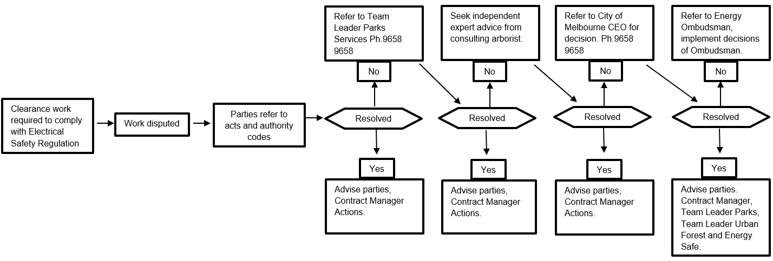

### (s) If ESV has granted an exemption under regulation 11 relating to a requirement of the Code, details of the exemption or a copy of the exemption

Under Clause (11) of the Regulations, City of Melbourne has no exemptions from any of the requirements of the Regulations subject to any conditions specified by Energy Safe Victoria.

# Publishing information Regulations 10(1)–(6) — Obligations relating to this Plan

## Regulations 10(1)–(4) — Requests from Energy Safe Victoria

If requested in writing by Energy Safe Victoria, City of Melbourne, within 14 days, or as otherwise specified, the responsible person for this ELCMP, prepared under Regulation 9, will:

* Provide a copy of this Plan to ESV
* Supply further information or material relating to this Plan
* Amend the Plan if instructed to do so.

## Regulation 10(5) — Plan compliance

City of Melbourne will comply with all requirements of this Plan, pending approval by ESV.

## Regulation 10(6) — Plan publication

The currently approved Plan is available on [City of Melbourne](https://www.melbourne.vic.gov.au/community/greening-the-city/tree-protection-management/Pages/tree-maintenance-electrical-line-clearance-management-plan.aspx)[7]. A copy of the approved plan will be made available on [City of Melbourne](https://www.melbourne.vic.gov.au/community/greening-the-city/tree-protection-management/Pages/tree-maintenance-electrical-line-clearance-management-plan.aspx)6 by 30 June.

## Regulations 11(1) and (2) — Exemptions

City of Melbourne does not have an active exemption at this time. If an exemption is sought and approved from ESV, City of Melbourne will comply with the associated conditions (if any).

# Schedule 1 — Code of Practice for Electric Line Clearance

## Part 2 — Clearance responsibilities

### Division 1 — Roles of Responsible Persons (clauses 4–7)

Part 2, Division 1, Clauses 4–7 of the Code, allow for exceptions to the Code as per the conditions in the table below.

| Clause | Applicable area | Line type | Tree part | Condition for exception |
| --- | --- | --- | --- | --- |
| 4* | All areas | Insulated, low voltage | Structural branches around lines | The branch is > 130 mm wide at the point it enters the minimum clearance space;  **and**  the branch is:  • > 150 mm from the line if the span distance is ≤ 40 m  **or**  • > 300 mm from the line if the span is > 40 m;  **and**  In the last 14 months:  • a [suitably qualified](#_Regulation_9_(4)(p):) arborist (Regulation 9(4)(p)) has inspected the tree and advised that it has no visible defects that could cause the branch to fail and contact the electric line, and  • Council has completed a risk assessment of the branch and implemented mitigation measures for any identified risks. |
| 5 | All areas | Insulated, low voltage | Small branches around lines | The branch:  • is less than 10 mm wide at the point at which it enters the minimum clearance space;  **and**  • has been removed from the minimum clearance space within the past 12 months. |
| 6* | LBRA | Uninsulated, low voltage | Small branches under lines | The branch is less than 10 mm wide at the minimum clearance space entry point and is no more than 500 mm inside the minimum clearance space**;**  **and**  the branch originates at a point below the height of the electric line;  **and**  if the branch is within the minimum clearance space around the middle two-thirds of the span, the span is fitted with:  • 1 conductor spreader if the span is ≤ 45 m  **or**  • 2 conductor spreaders if the span is > 45 m.  *Spreader not required if the branch comes within the minimum clearance space around the first or last sixth of the span.  **and**  In the last 14 months:  • a [suitably qualified](#_Regulation_9_(4)(p):) arborist (Regulation 9(4)(p)) has inspected the tree, and  • Council has completed a risk assessment of the branch and implemented mitigation measures for any identified risks. |
| 7* | LBRA | Uninsulated, low voltage | Structural branches around lines | if the branch is within the minimum clearance space around the middle two-thirds of the span, the span is fitted with:  • 1 conductor spreader if the span is ≤ 45 m  **or**  • 2 conductor spreaders if the span is > 45 m.  *Spreader not required if the branch comes within the minimum clearance space around the first or last sixth of the span.  **and**  the branch is > 130 mm wide at the point it enters the minimum clearance space  **and**  The branch is no more than 500 mm inside the minimum clearance space  **and**  In the last 14 months:  • a [suitably qualified](#_Regulation_9_(4)(p):) arborist (Regulation 9(4)(p)) has inspected the tree and advised that it has no visible defects that could cause the branch to fail and contact the electric line, and  • Council has completed a risk assessment of the branch and implemented mitigation measures for any identified risks. |

* If City of Melbourne leaves a branch within the minimum clearance space for an electric line under Clauses 4, 6, and 7, it will:

* Conduct a risk assessment of the tree and branch in accordance with ANSI A300 Tree Risk Assessment
* Mitigate any identified risks.

The Arborist:

* registers this information in the tree data base
* ensures the tree is noted in the proactive inspection program.

This process is managed by the Senior Parks Operations Officer.

Council retains records in its tree database and GIS systems for at least five years on:

* Each inspection
* All advice referred to regarding the branch identified as having no structural defects
* Each risk assessment on any risks posed by the branch
* The mitigation measures to effectively mitigate any identified risks posed by the branch.

Any trees registered as an exception would be re-assessed annually and inspected by a City of Melbourne senior arborist following pruning.

### 9 Responsible person may cut or remove hazard tree

If a City of Melbourne employee or contractor identifies a tree as likely to fall onto, or otherwise come into contact with an electric line, or has regrowth that will enter the clearance space before the next scheduled visit, the tree may be pruned or removed provided that:

* The tree has been assessed by a suitably qualified arborist who must consider:
* the likelihood of contact with electric line
* tree health, defects, size of failure, target potential
* whether the tree qualifies for an exception to the minimum clearance space as per Clauses 4–7 of the Code
* local environmental and safety factors, as per current Job Safety Analysis requirements
* history and significance of the tree, and
* the presence of habitat or fauna.
* the tree has been assessed and approved for removal through the City of Melbourne’s Tree Removal Process
* the assessment is recorded in the tree data base
* works are undertaken with regard to Regulation 9(4)(i) and (j) of the Plan
* affected persons are notified as per the City of Melbourne’s adopted practice.

As the asset owner of the trees covered under this plan, the City of Melbourne reserves the right to prune further than 1 metre from the minimum clearance space or remove hazard trees where they cannot be made safe or be retained as useful assets.

### Division 2 — Manner of cutting and removing trees

### 10 Cutting of tree to comply with Standard

A responsible person cutting a tree under Division 1 must, as far as practicable, cut the tree in accordance with AS 4373 as published or amended from time to time 9(4)(j).

### 11 Cutting or removal of indigenous or significant trees must be minimised

Through its tree management database, City of Melbourne provides contractors and staff with a list of ‘significant’ trees; that is, those designated as having indigenous, cultural or environmental significance and those that are listed within a planning scheme within the municipality (9(4)(h)(i)–(iii).)

City of Melbourne’s arborists are trained in species identification and can correctly identify the significant trees to species level.

Before pruning in an area, the contractor is required to:

* Have a comprehensive understanding of the significant tree locations
* Have the ability to identify the trees and cross-reference them with Council’s tree database to ensure records are accurate.

City of Melbourne’s arborists are notified and engaged in the appropriate decision-making process if these trees require cutting or removal (see regulations 9(4)(j)).

### (3)(a) Indigenous trees

City of Melbourne has a mix of exotic and indigenous tree species. Indigenous trees are spread throughout the municipality. There are no native/indigenous trees (remnant or forest vegetation) that may need to be cut or removed to ensure compliance to the extent practicable with the 2020 Regulations.

All tree works conducted on Council-owned and -managed trees is required to be carried out by suitably qualified and experienced arboricultural staff to meet the minimum standard required to comply with this Plan.

If the removal of any tree identified under Regulation 9(4)(h) is required, an inspection and advice will be provided by a suitably qualified arborist prior to removal.

A list of species is provided to contractors and staff through the tree management database (also see Appendix 2.1).

City of Melbourne will also seek specialist advice (where necessary) to determine whether any species (or habitat thereof) or communities on the [Flora and Fauna Guarantee Act Threatened List](https://www.environment.vic.gov.au/conserving-threatened-species/threatened-list)[8] are endangered by works to prune or remove trees.

### (3)(b) Trees listed in a planning scheme to be of ecological, historical or aesthetic significance

As noted in clause 9(4)(h), trees identified with ecological, historical and aesthetic importance are recorded in Council’s tree management database, which includes each tree’s species, location (address) and reviewed annually. The City of Melbourne Planning Scheme is reviewed annually in preparation of this Plan. After each review the City of Melbourne updates the tree database accordingly. Before tree maintenance works commence in an area, the contractor is required to check Council’s tree database for any significant trees in that area.

Any works undertaken in relation to City of Melbourne trees contained within any of the overlays of the City of Melbourne Planning Scheme will comply to the extent practicable with this Plan.

All tree works conducted on Council-owned and -managed trees are required to be carried out by suitably qualified and experienced arboricultural staff and to meet the minimum standard required to comply with this Plan, as detailed in Clauses 4–7 of the Code.

If the removal of any tree identified under Regulation 9(3)(h) is required, an inspection and advice from will be provided by a suitably qualified arborist prior to removal.

As part of the preparation for the Plan, City of Melbourne will consult with all relevant bodies and standards to ensure all organisational procedures are current.

### (3)(c) Trees of cultural or environmental significance

City of Melbourne reviews the advice provided by the Aboriginal Cultural Heritage Register and Information System ([ACHRIS](https://achris.vic.gov.au/)[9]) as part of the annual preparation of this Plan.

A request is made annually via ACHRIS to obtain the most up-to-date information because information regarding specific trees on the Aboriginal Cultural Heritage Register is not publicly available. This information is recorded within the tree database as a ‘significant’ tree and decisions regarding the need to cut or remove any of these trees by a suitably qualified arborist follows the processes outlined in clauses 9(4)(j) and (k).

### 12 Cutting or removal of habitat for threatened fauna

As per regulation 9(4)(h)(iii) of the Plan, City of Melbourne is not currently aware of any threatened fauna which may be affected by the implementation of this Plan. Should threatened fauna be identified, the following process shall be followed:

* Location of threatened fauna and associated habitat mapped and tree maintenance and inspection teams notified
* Tree assessment conducted by a suitably qualified arborist and results recorded in the tree data base. The assessment:
* considers tree health, structure and potential risk
* considers the history, location and foreseeable local conditions
* aims to identify whether the fauna using the tree is a threatened species.
* Once identified, the breeding season for the fauna using the tree will be determined. Resources such as [Threatened plants and animals[10]](https://www.ari.vic.gov.au/research/threatened-plants-and-animals) or [State Wide Integrated Flora and Fauna Teams (SWIFFT) website](http://www.swifft.net.au/)[[11]](https://www.swifft.net.au/) may be used in the first instance
* Specialist advice may be sought to identify fauna, determine breeding season if required or to translocate fauna
* Assessment results and information regarding management of the fauna will be referred to the Senior Parks Operations Officer for approval prior to commencing works
* Where practicable works will be undertaken outside the breeding season
* Relocation of the fauna can be considered to make safe an unsafe situation as identified in Clause 9, or if it is not practical to undertake works outside of the breeding season.

As part of the preparation for the Plan, City of Melbourne will consult with all relevant bodies and standards to ensure all organisational procedures are current.

### 13 Restriction on timing of cutting or removal if notification is required

City of Melbourne will not commence tree pruning or removal prior to any specified date or period required by Clause 16(6) or 17(4)(b).

### 14 Restriction on urgent cutting of trees

If urgent cutting is required under a relevant clause, City of Melbourne will not cut a tree further than one metre from the minimum clearance space for an electric line span.

### 15 Restriction on urgent removal of trees

If urgent removal is required under a relevant clause, City of Melbourne will only do so once the requirements of Clause 15(2) are satisfied.

### Division 3—Notification, consultation and dispute resolution

### 16 Responsible person must provide notification before cutting or removing certain trees

Before cutting or removing certain trees listed at Clause 16(1), the City of Melbourne will give written notice as per Clauses 16(2)–(7).

### 17 Responsible person must publish notification before cutting or removing certain trees

City of Melbourne will provide notification to persons affected by electric line clearance works at least 14 days, and no more than 60 days, before the intended pruning or removal is to occur. If pruning does not commence within these timeframes, then affected residents will be re-notified.

Notification methods will include:

* Monthly updates and maps of the areas currently being worked in the Public Notices section of City of Melbourne’s website[[12]](https://www.melbourne.vic.gov.au/community/greening-the-city/tree-protection-management/Pages/tree-maintenance-electrical-line-clearance-management-plan.aspx).

### 18 Responsible person must consult with occupier or owner of private property before cutting or removing certain trees

If cutting or removing a tree on private property is required under any clause, City of Melbourne will consult with the relevant property owner or occupier as per Clause 18.

### 19 Notification and record keeping requirements for urgent cutting or removal

If urgent tree cutting or removal is required as a result of conditions listed at Clause 19(1), City of Melbourne will give notice to the relevant property owner or occupier, or Council, as per Clauses 19(2) and 19(3) and will keep a record of the written notice for 5 years.

### Division 4—Additional duties of responsible persons

### 20 Duty relating to the safety of cutting or removal of trees close to an electric line.

City of Melbourne requires all staff and contractors to hold the qualification of Cert II ESI – Powerline Vegetation Control and comply with the guidelines and limits set within either ESV – Electrical Safety Rules for Vegetation Work near Overhead Powerlines by Non-electrical workers (Electrical Safety Rules) or rules set by the asset owner, whichever is greater.

If staff or contractors have concerns about the safety of cutting or removal of a tree for which the Council has clearance responsibilities, the Council will consult:

| Business | Contact | Phone | Email |
| --- | --- | --- | --- |
| Metrotrains/VicTrack | Peter Kinsella | 0458-764-854 | [Peter.Kinsella@metrotrains](mailto:Peter.Kinsella@metrotrains).com.au |
| Yarra Trams | Tobias Meyer | 0410-473-749 | [Tobias.Meyer@yarratrams](mailto:Tobias.Meyer@yarratrams).com.au |
| Powercor/Citipower | Leo Hourigan | 0408-304-984 | [Lhourigan@powercor.com.au](mailto:LHourigan@powercor.com.au) |
| Jemena | Will Few | 0438-322-079 | [William.few@zinfra.com.au](mailto:William.few@zinfra.com.au) |

### 21 Duty relating to assisting to determine the allowance for cable sag and sway.

At least once per year, prior to updating this Plan, City of Melbourne liaises with the Distribution Businesses to: i) obtain confirmation that all span lengths are less than 100 m long; ii) obtain relevant information for effective tree management around electric lines; and, iii) maintain communication links.

### 22 Duties relating to management procedures to minimise danger

Not applicable to councils.

## Part 3 — Minimum clearance spaces

## Division 1 — Standard minimum clearance spaces

| Clause | Line type | Area type | Minimum clearance space | Applicable distance (AD) |
| --- | --- | --- | --- | --- |
| 24 | Insulated | All | The space extending away from the line in all directions perpendicular to its axis for the applicable distance (Figures 1, 2 & 3 of the Code) | For the first & last sixths of the span:  • 300 mm  For the middle 2 thirds of the span (Graph 1 of the Code):  • if the span is ≤ 40 m: 300 mm  • if the span is > 40 m & ≤ 100 m: 300 mm + ((span distance – 40) x 10) = AD  • if the span is > 100 m: 900 mm |
| 25 | Uninsulated, low voltage | LBRA | The space extending away from the line in all directions perpendicular to its axis for the applicable distance and if the span is greater than 100 m, additional distance to allow for sag & sway (Figures 1 & 4 of the Code). | For the first & last sixths of the span:  • 1000 mm  For the middle 2 thirds of the span (Graph 2 of the Code):  • if the span is > 45 m & ≤ 100 m:  1000 mm + (span distance – 45) x (1500 ÷ 55)  • if the span is >100 m: 2500 mm |
| 26 | Uninsulated, High voltage (other than 66 000 V line) | LBRA | The space extending away from the line in all directions perpendicular to its axis for the applicable distance and if the span is greater than 100 m, additional distance to allow for sag & sway (Figures 1 & 3 of the Code). | For the first & last sixths of the span:  • 1500 mm  For the middle 2 thirds of the span (Graph 3 of the Code):  • if the span is > 45 m & ≤100 m:  1500 mm + (span distance – 45) x (1000 ÷ 55)  • if the span is > 100 m: 2500 mm |
| 27 | Uninsulated, 66 000 V | LBRA | The space extending away from the line in all directions perpendicular to its axis for the applicable distance and if the span is greater than 100 m, additional distance to allow for sag & sway (Figures 1 & 5).  The space above these spaces must also remain clear. | For the first & last sixths of the span:  • 2250 mm  For the middle 2 thirds of the span (Graph 4 of the Code):  • if the span is ≤ 45 m: 2250 mm  • if the span is > 45 m & ≤ 100 m:  (2500 mm + (span distance – 45) x (1250 ÷ 55)  • if the span distance is > 100 m: 3500 mm |
| 28 | Uninsulated, low & high voltage (other than 66 000 V) | HBRA | The space extending away from the line in all directions perpendicular to its axis for the applicable distance and additional distance that allows for conductor sag and sway (Figures 1 & 5 of the Code).  The space above these spaces must also remain clear. | For the first & last sixths of the span:  • 1500 mm  For the middle 2 thirds of the span (Graph 5 of the Code):  • if the span is ≤ 45 m: 1500 mm  • if the span is > 45 m & ≤ 500 m: (1500 mm + (span distance – 45) x (500 ÷ 303)  • if the span is > 500 m: 2250 mm |
| 29 | Uninsulated 66 000 V | HBRA | The space extending away from the line in all directions perpendicular to its axis for the applicable distance and an additional distance that allows for conductor sag and sway (Figures 1 & 5 of the Code).  The space above these spaces must also remain clear. | For the first & last sixths of the span:  • 2250 mm  For the middle 2 thirds of the span (Graph 6 of the Code):  • if the span is ≤ 45 m: 2250 mm  • if the span is > 45 m & ≤ 350 m:  (2250 mm + (span distance – 45) x (750 ÷ 305)  • if the span is > 350 m: 3000 mm |

Signed _____________________________

Dan Thomas – Manager Parks Services

Date: 25th March 2024

Signed _____________________________

David Callow – Director Parks and City Greening

Date: 25th March 2024

# Appendices

## Appendix 1 — Map of declared area and electrical distribution boundaries within City of Melbourne

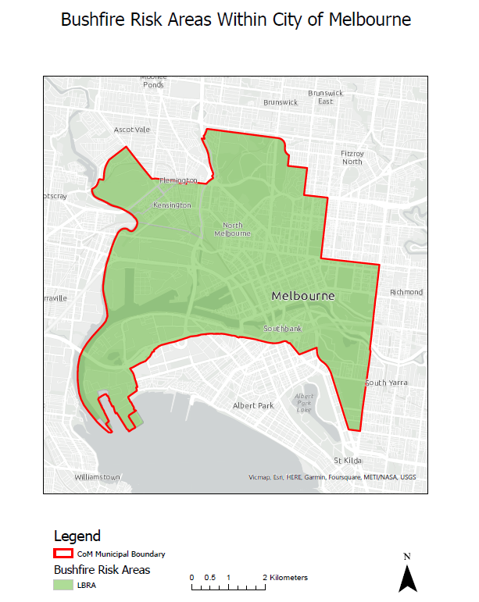

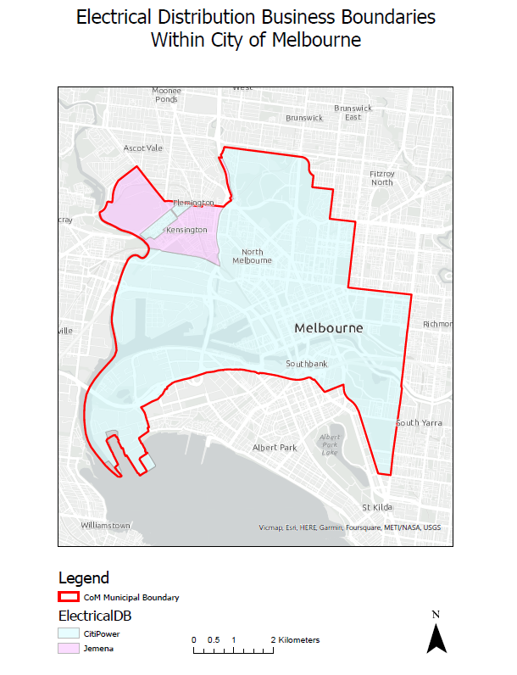

## Appendix 2 — Trees of Indigenous, Heritage or Cultural Significance

### Appendix 2.1 – List of indigenous trees in the City of Melbourne (CoM) and native to Victoria (Vic)

|  |  |
| --- | --- |
| Species | Status |
| *Acacia acinacea* | CoM Indigenous |
| *Acacia dealbata* | CoM Indigenous |
| *Acacia implexa* | CoM Indigenous |
| *Acacia longifolia* | CoM Indigenous |
| *Acacia mearnsii* | CoM Indigenous |
| *Acacia melanoxylon* | CoM Indigenous |
| *Acacia paradoxa* | CoM Indigenous |
| *Acacia pycnantha* | CoM Indigenous |
| *Acacia verticillata* | CoM Indigenous |
| *Allocasuarina littoralis* | CoM Indigenous |
| *Allocasuarina verticillata* | CoM Indigenous |
| *Banksia integrifolia* | CoM Indigenous |
| *Banksia marginata* | CoM Indigenous |
| *Bursaria spinosa* | CoM Indigenous |
| *Eucalyptus camaldulensis* | CoM Indigenous |
| *Eucalyptus leucoxylon* | CoM Indigenous |
| *Eucalyptus leucoxylon* subsp*. connata* | CoM Indigenous |
| *Eucalyptus melliodora* | CoM Indigenous |
| *Eucalyptus ovata* | CoM Indigenous |
| *Eucalyptus viminalis* | CoM Indigenous |
| *Eucalyptus viminalis* subsp. *pryoriana* | CoM Indigenous |
| *Leptospermum laevigatum* | CoM Indigenous |
| *Melaleuca ericifolia* | CoM Indigenous |
| *Melaleuca squarrosa* | CoM Indigenous |
| *Myoporum insulare* | CoM Indigenous |
| *Viminaria juncea* | CoM Indigenous |

| Species | Status |
| --- | --- |
| *Acacia floribunda* | Vic Native |
| *Acacia howittii* | Vic Native |
| *Acacia maidenii* | Vic Native |
| *Acacia pravissima* | Vic Native |
| *Acacia verniciflua* | Vic Native |
| *Angophora floribunda* | Vic Native |
| *Banksia serrata* | Vic Native |
| *Brachychiton populneus* | Vic Native |
| *Callistemon rugulosus* | Vic Native |
| *Callitris endlicheri* | Vic Native |
| *Callitris rhomboidea* | Vic Native |
| *Corymbia gummifera* | Vic Native |
| *Corymbia maculata* | Vic Native |
| *Elaeocarpus reticulatus* | Vic Native |
| *Eucalyptus botryoides* | Vic Native |
| *Eucalyptus brookeriana* | Vic Native |
| *Eucalyptus elata* | Vic Native |
| *Eucalyptus globulus* | Vic Native |
| *Eucalyptus globulus* subsp*. maidenii* | Vic Native |
| *Eucalyptus kitsoniana* | Vic Native |
| *Eucalyptus mannifera* | Vic Native |
| *Eucalyptus muelleriana* | Vic Native |
| *Eucalyptus obliqua* | Vic Native |
| *Eucalyptus pauciflora* | Vic Native |
| *Eucalyptus pauciflora* subsp. *pauciflora* | Vic Native |
| *Eucalyptus polyanthemos* | Vic Native |
| *Eucalyptus radiata* | Vic Native |
| *Eucalyptus sideroxylon* | Vic Native |
| *Eucalyptus tricarpa* | Vic Native |
| *Eucalyptus yarraensis* | Vic Native |
| *Ficus coronata* | Vic Native |
| *Geijera parviflora* | Vic Native |
| *Livistona australis* | Vic Native |
| *Melaleuca armillaris* | Vic Native |
| *Melaleuca lanceolata* | Vic Native |
| *Melaleuca parvistaminea* | Vic Native |
| *Myrsine howittiana* | Vic Native |
| *Nothofagus cunninghamii* | Vic Native |
| *Pittosporum undulatum* | Vic Native |
| *Tristaniopsis laurina* | Vic Native |

### Appendix 2.2 – Trees Listed in Heritage Overlay

| PS Map Ref | Heritage Place |
| --- | --- |
| HO6 | South Yarra Precinct – 120W Toorak Rd: 2 *Phoenix canariensis* (Canary Island Date Palm) & Row of 11 *Cupressus torulosa* (Italian Bhutan Cypress) |
| HO1092 | Moonee Ponds Creek and Infrastructure Precinct: The heritage place consists of the Racecourse Road, Macaulay Road, Arden Street and Dynon Road Bridges (plus 3m from the bridge perimeter), Pumping stations 1–5, the water course with vegetated banks and existing channel widths and creek reserve including bluestone pitcher lining and the brick pipe bridge piers. |
| HO10 | Aboriginal Scarred Tree Fitzroy Gardens |
| HO11 | Aboriginal Scarred Tree Royal Zoological Gardens |
| HO512 | *Gleditsia sinensis* (Chinese Honey Locusts), King Street, Melbourne |
| HO514 | *Olea europaea* (Common Olive Tree), Little Lonsdale Street, Melbourne |
| HO1095 | *Schinus molle* (Mature Peppercorn Tree) row Part 208–292 Arden Street, North Melbourne. The heritage place is the peppercorn tree row and land within the Tree Protection Zone which is calculated as being twelve times the measured trunk diameter |
| HO1096 | Clayton Reserve, 201–241 Macaulay Road, North Melbourne. *Platanus* x *acerifolia* trees (London Plane), which includes land within the Tree Protection Zone that is calculated as being twelve times the measured trunk diameter |
| HO1182 | Two Elm (*Ulmus* sp.) street trees near 80, 86 Capel Street, West Melbourne. |
| HO1185 | Six Elm (*Ulmus* sp.) street trees near 81–141 Jeffcott Street, West Melbourne |
| HO1098 | Two *Phoenix canariensis* palms (Canary Island Palm), which includes land within the Tree Protection Zone that is calculated as being twelve times the measured trunk diameter. East side of Bellair Street, Kensington. |
| HO1100 | Victorian Railways Kensington *Schinus molle* (Peppercorn Tree), which includes land within the Tree Protection Zone that is calculated as being twelve times the measured trunk diameter. Bellair Street |
| HO1388 Interim control Expiry Date: 31/07/23 | Harris Street Plane Tree Avenue Harris Street (between Errol and Curzon Streets), Plane Tree Way (between Dryburgh and Abbotsford Streets)  Part 302–326 Abbotsford Street, Part 50–56, 58–64, 66–72, 74–80, 92–132 O’Shanassy Street and Part 141–157 Curzon Street, North Melbourne |
| HO1387 Interim control Expiry Date: 31/07/23 | Hotham Gardens Stage 1: 55–61, 63–69, 71–77, 79–85, 87–93 and 95–101  O’Shanassy Street, North Melbourne Peppercorn Tree (*Schinus molle*), Melia (*Melia azedarach*), Cedar (*Cedrus* sp.), English Oak (*Quercus robur*), Liquidambar (*Liquidambar styraciflua*) x 5, Spotted Gum (*Corymbia*  *maculata*), Liquidambar (*Liquidambar styraciflua*) x 5, Jacaranda (*Jacaranda mimosifolia*), Liquidambar (*Liquidambar styraciflua*) x 2, Spotted Gum (*Corymbia maculata*), Eucalypt (*Eucalyptus* sp.), Lemon-scented Gum (*Corymbia citriodora*), Lemon-scented Gum (*Corymbia citriodora*), Spotted Gum (*Corymbia maculata*) |
| HO364 | Melbourne Zoo (all land except for places included within the Victorian Heritage Register). *Eucalyptus camaldulensis* River Red Gum (North East of Main Entrance) |
| HO1184 | Elm (*Ulmus* sp.) Hawk and Curzon Street Reserve, 2A Hawke Street, West Melbourne  (West Melbourne Heritage Review 2016: Statements of Significance February 2020 (Amended March 2022)) |
| HO1186 | Elm, Hawke Street and King Street Reserve, near 446 King Street, West Melbourne  (West Melbourne Heritage Review 2016: Statements of Significance February 2020 (Amended March 2022)) |
| HO844 | Canary Island Palms (*Phoenix canariensis*) x 2, 171–179 Roden Street, West Melbourne  (West Melbourne Heritage Review 2016: Statements of Significance February 2020 (Amended March 2022)) |
| HO1180 | Canary Island Pines (*Pinus canariensis*) x 2, Howard Street and William Street Reserve, West Melbourne  (West Melbourne Heritage Review 2016: Statements of Significance February 2020 (Amended March 2022)) |

### Appendix 2.3 – Trees listed in National Trust Register applicable to this Plan

| Asset ID | Species | Common name | Street number and name | Suburb |
| --- | --- | --- | --- | --- |
| 1055595 | *Ulmus glabra* 'Lutescens' | Golden Wych Elm | 1 Gatehouse Street | PARKVILLE |
|  | *Jubaea chilensis* | Chilean Wine Palm | 156-292 Grattan Street | PARKVILLE |
| 1028612 | *Ulmus glabra* 'Lutescens' | Golden Wych Elm | Alexandra Ave and Punt Road | SOUTH YARRA |
| 1032415, 1032416, 1032417 | *Schinus terebinthifolius* | Brazilian Pepper Tree | Birdwood Avenue | MELBOURNE |
|  | *Quercus robur* | English Oak | Brunton Avenue | EAST MELBOURNE |
| 1036981, 1037000, 1037001, 1037002, 1037003, 1037004, 1037005, 1037006, 1037007, 1037008, 1037009, 1037010, 1037011, 1037012, 1037013, 1037014, 1037015, 1037016, 1037017, 1037018, 1037019, 1037020, 1037021, 1037022, 1037023, 1037024, 1037025, 1037026, 1037027, 1037028, 1037029, 1037030, 1037031, 1037033, 1037034, 1037035 | *Platanus* x *acerifolia* | London Plane | Carlton Gardens, Rathdowne Street | CARLTON |
| 1037194, 1037195 | *Chamaecyparis funebris* | Funeral Cypress | Carlton Gardens, Rathdowne Street | CARLTON |
| 1037419 | *Quercus acutissima* | Japanese Chestnut Oak | Darling Square, Cnr. Gipps and Darling Streets | EAST MELBOURNE |
| 1032661 | *Eucalyptus cornuta* | Yate Gum | Domain Parklands, Birdwood Avenue | MELBOURNE |
| 1031775 | *Ulmus parvifolia* | Chinese Elm | Domain Parklands, Domain Road | MELBOURNE |
| 1032406 | *Ficus macrophylla* | Moreton Bay Fig | Domain Parklands, Domain Road | MELBOURNE |
| 1040301, 1040302, 1040303, 1040304, 1040305, 1040308, 1040319, 1040320, 1040321, 1040322, 1040342, 1040344, 1040345, 1040346, 1040347, 1040348, 1040349, 1040351, 1040353, 1040354, 1040355, 1040361, 1040362, 1040363, 1040364, 1040365, 1040366, 1040367, 1040368, 1040369, 1040371, 1040373, 1040374, 1040375, 1040376, 1040432, 1040433, 1040434, 1040447, 1040448, 1040449, 1040450, 1040451, 1040452, 1040453, 1040454, 1040455, 1040457, 1040458, 1040460, 1040461, 1040462, 1040463, 1040474, 1040504, 1040533, 1040534, 1040535, 1040536, 1040537, 1040539, 1040545, 1040546, 1040548, 1040549, 1040550, 1040552, 1040553, 1040554, 1040555, 1040556, 1040571, 1040572, 1040573, 1040629, 1040631, 1040632, 1040633, 1040634, 1040642, 1040643, 1040644, 1040645, 1040646, 1040647, 1040649, 1040650, 1040651, 1040652, 1040653, 1040654, 1040660, 1040661, 1040662, 1040663, 1040664, 1040665, 1040666, 1040669, 1040670, 1040671, 1040672, 1040673, 1040674, 1040675, 1040676, 1040688, 1040689, 1040691, 1040693, 1040694, 1040696, 1040697, 1040698, 1040700, 1040701, 1040702, 1057982, 1057983, 1057984, 1057985, 1057986, 1057987, 1057988, 1057989, 1057990, 1058052, 1058053, 1058057, 1058058, 1058059, 1058100, 1058101, 1058102, 1058103, 1058104, 1058105, 1058106, 1058107, 1058108, 1058110, 1058111, 1058112, 1058113, 1058114, 1058115, 1058125, 1058126, 1058128, 1058129, 1058130, 1058131, 1058132, 1058133, 1058134, 1058137, 1058165, 1058166, 1058168, 1058169, 1058182, 1058183, 1058184, 1058185, 1058186, 1058187, 1058188, 1058208, 1058209, 1058210, 1058211, 1058213, 1058214, 1058215, 1058216, 1058217, 1058218, 1058219, 1058247, 1058250, 1058252, 1058264, 1058271, 1058272, 1058273, 1058282, 1058290, 1058297, 1058298, 1058299, 1058300, 1058474, 1058515, 1059021, 1060747, 1061832, 1061835, 1288548, 1288578, 1288579, 1288580, 1288581, 1288582, 1288583, 1288584, 1288585, 1288586, 1288587, 1288588, 1288589, 1288590, 1288591, 1288599, 1288602, 1288605, 1289343, 1289347, 1503672, 1546533, 1583139, 1583140, 1583192, 1662772, 1663881, 1663882, 1663883, 1663884, 1663885, 1663886, 1663887, 1663888, 1663889, 1663890, 1663891, 1663892, 1663893, 1663894, 1663895, 1749086, 1784956, 1784957, 1784960, 1784961, 1784962, 1784963, 1784964, 1784967, 1784968, 1784969, 1801397, 1801398, 1801399, 1801400, 1801401, 1801402, 1801403, 1801404, 1801405, 1801406, 1801407, 1801408, 1801409, 1801410, 1801411, 1801412, 1801413, 1801414 | *Ulmus procera* | English Elm (Avenue) | Fitzroy Gardens, Clarendon Street | EAST MELBOURNE |
| 1058305 | *Waterhousea floribunda* | Weeping Lilly Pilly Or Weeping Myrtle | Fitzroy Gardens, Clarendon Street | EAST MELBOURNE |
| 1039927 | *Ginkgo biloba* | Maidenhair | Flagstaff Gardens, William Street | WEST MELBOURNE |
| 1022036, 1022037 | *Corymbia citriodora* | Lemon-Scented Gum | Intersection Swanston Streets and College Crescent | CARLTON |
| 1019367, 1019369, 1019370, 1019371, 1019372, 1019373, 1019374, 1019375, 1019376, 1019377, 1019378, 1019379, 1019380, 1019381, 1019382, 1019383, 1019384, 1019385, 1019386, 1019387, 1019388, 1019389, 1019390, 1019391, 1019392, 1019393, 1019394, 1019395, 1019396, 1019397, 1019398, 1019399, 1019400, 1019401, 1019402, 1019404, 1019405, 1019406, 1019407, 1019408, 1019409, 1019410, 1019411, 1019413, 1019414, 1019415, 1019416, 1019417, 1019418, 1019419, 1019420, 1019422, 1019423, 1019424, 1019425, 1019427, 1019429, 1019431, 1019432, 1019433, 1019435, 1019436, 1019437, 1019446, 1019447, 1019448, 1019449, 1019451, 1019452, 1019453, 1019454, 1019455, 1019456, 1019457, 1019458, 1019459, 1019460, 1019461, 1019462, 1019463, 1019464, 1019465, 1019466, 1019467, 1019468, 1019469, 1019470, 1019471, 1019472, 1019473, 1019474, 1019475, 1019476, 1019477, 1019479, 1019480, 1019481, 1019482, 1019483, 1019484, 1019485, 1019486, 1019487, 1019488, 1019489, 1019490, 1019491, 1019492, 1019493, 1019494, 1019495, 1019496, 1019497, 1019498, 1019499, 1019500, 1019501, 1019502, 1019503, 1019504, 1019505, 1019506, 1019507, 1019508, 1019509, 1019510, 1019512, 1019513, 1019516, 1019561, 1020006, 1020007, 1020008, 1020009, 1020010, 1020011, 1020012, 1020013, 1020015, 1020016, 1020017, 1020018, 1020019, 1020020, 1020021, 1020022, 1020023, 1020024, 1020025, 1020026, 1020027, 1020028, 1020029, 1020030, 1020031, 1020032, 1020033, 1020034, 1020035, 1020036, 1020037, 1020038, 1020039, 1020040, 1020042, 1020043, 1020044, 1020045, 1020046, 1020047, 1020048, 1020049, 1020050, 1020051, 1020052, 1020053, 1020054, 1020055, 1020056, 1020059, 1020060, 1020061, 1020062, 1020063, 1020064, 1020065, 1020066, 1020067, 1020068, 1020069, 1020070, 1020071, 1020072, 1020073, 1020074, 1020075, 1020076, 1020077, 1020078, 1020080, 1020082, 1020083, 1020084, 1020086, 1020087, 1020088, 1020090, 1020091, 1020092, 1020093, 1020094, 1020095, 1020096, 1020097, 1020099, 1020100, 1020101, 1020102, 1020103, 1020104, 1020105, 1020106, 1020107, 1020108, 1020109, 1020110, 1020111, 1020112, 1020113, 1020114, 1020115, 1020116, 1020117, 1020118, 1020119, 1020121, 1020123, 1020124, 1020125, 1020126, 1020127, 1020128, 1020129, 1020130, 1020146, 1020147, 1020148, 1020149, 1020151, 1020152, 1020153, 1020155, 1020156, 1020157, 1020158, 1020160, 1020161, 1020162, 1020163, 1020164, 1020165, 1020166, 1020167, 1020168, 1020169, 1020170, 1020171, 1020173, 1020174, 1020175, 1020176, 1020177, 1020178, 1020179, 1020180, 1020181, 1020182, 1020183, 1020184, 1020185, 1020186, 1020187, 1020189, 1020190, 1020191, 1020192, 1020193, 1020194, 1020195, 1020196, 1020197, 1020199, 1020200, 1020201, 1020202, 1020203, 1020204, 1020205, 1020206, 1020207, 1020208, 1020209, 1020210, 1020211, 1020212, 1020213, 1020214, 1020215, 1020216, 1020218, 1020219, 1020220, 1020221, 1020222, 1020223, 1020224, 1020225, 1020226, 1020227, 1020228, 1020229, 1020230, 1020232, 1020233, 1020234, 1020235, 1020236, 1020237, 1020238, 1020239, 1020240, 1020241, 1020242, 1020243, 1020244, 1020246, 1020247, 1020248, 1020249, 1020250, 1020251, 1020252, 1020253, 1020254, 1020255, 1020256, 1020257, 1020258, 1020259, 1020260, 1020262, 1020263, 1020264, 1020265, 1020266, 1020267, 1020268, 1020269, 1020271, 1020272, 1020273, 1020274, 1020275, 1020276, 1020277, 1020278, 1020279, 1022258, 1062022, 1529525, 1546535, 1549695, 1570438, 1583141, 1583142, 1583143, 1640186, 1640187, 1675640, 1746339, 1749154, 1749155, 1784971 | *Ulmus procera* | English Elm | Royal Parade | PARKVILLE |
| 1032021 | *Eucalyptus chapmaniana* | Bogong Gum | The Domain, Birdwood Avenue | MELBOURNE |
| 1031719 | *Corymbia maculata* | Spotted Gum | The Domain, Birdwood Avenue | MELBOURNE |
| 1032105 | *Pinus roxburghii* | Long-Leaved Indian Pine | The Domain, Birdwood Avenue | MELBOURNE |
| 1031816 | *Eucalyptus grandis* | Rose Or Flood Gum | The Domain, Birdwood Avenue and Dallas Brooks Drive | MELBOURNE |
| 1025721, 1025722, 1025723, 1025724, 1025725, 1025726, 1025745, 1025748, 1025750, 1025752, 1025754, 1025755, 1025758, 1025968, 1025969, 1025970, 1025971, 1025972, 1025973, 1025974, 1025975, 1025977, 1025978, 1025979, 1025980, 1025981, 1025982, 1025983, 1025984, 1025985, 1025986, 1025987, 1025988, 1025989, 1025990, 1025991, 1025992, 1025993, 1025995, 1025997, 1025998, 1025999, 1026000, 1026001, 1026002, 1026003, 1026004, 1026005, 1026006, 1026007, 1060855, 1060856, 1060857, 1067351, 1285769, 1285770 | *Ulmus procera* | English Elm | Victoria Parade between Hoddle Street and Nicholson Street | EAST MELBOURNE |
| 1034616 | *Eucalyptus cladocalyx* | Sugar Gum | Weedon Reserve between Wellington Parade and Punt Road | EAST MELBOURNE |
| 1439325 | *Jacaranda mimosifolia* | Jacaranda | Kensington Town Hall, 22-40 Bellair Street | KENSINGTON |

## Appendix 3 — Tree maintenance zones and programmed maintenance schedule

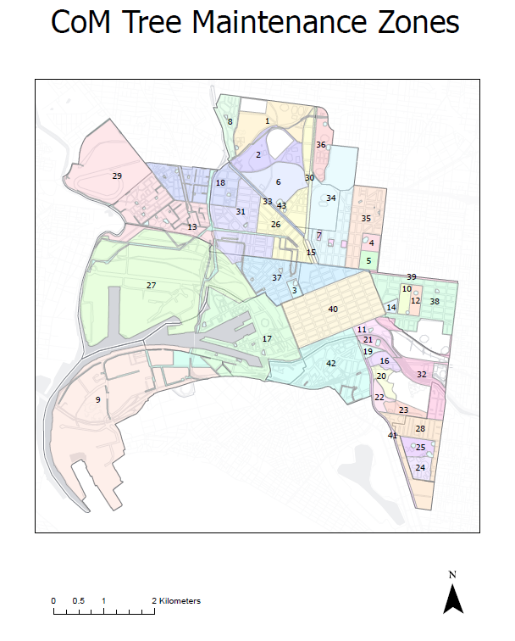

### Annual and biennial tree maintenance and monitoring schedule for November 2022 to March 2024

City of Melbourne’s pruning schedule is also available on [City of Melbourne[13].](https://www.melbourne.vic.gov.au/community/greening-the-city/tree-protection-management/Pages/tree-maintenance-electrical-line-clearance-management-plan.aspx)

A table detailing when tree maintenance will take place based on the 41 zones within the municipality. 

## Appendix 4 — Applicable distance for middle two thirds of a span of an LBRA electric line

### Graph 1 – Insulated Electric Lines in all Areas

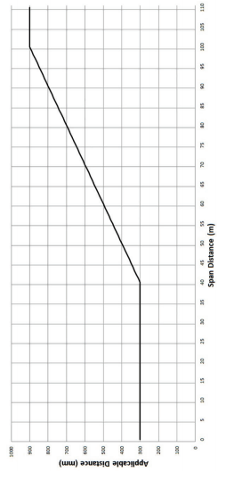

The formula by which the applicable distance for the middle two thirds of a span of an insulated electric lines in all areas is calculated is as follows:

The applicable distance for the middle two thirds of the span is:

A. if the span distance is less than or equal to 40 metres the applicable distance equals 300 millimetres; or

B. if the span distance is greater than 40 metres and less than or equal to 100 metres — the applicable distance is calculated in accordance with the following expression —   
300 + ((span distance minus 40) multiplied by 10); or

C. if the span distance is greater than 100 metres the applicable distance equals 900 millimetres.

### Graph 2 – Uninsulated Low Voltage Electric Line in Low Bushfire Risk Area

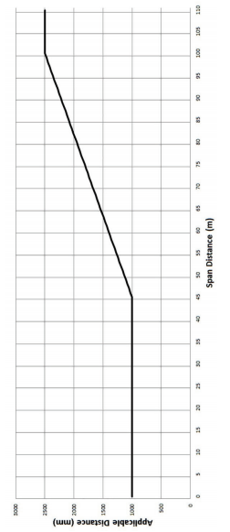

The formula by which the applicable distance for the middle two thirds of a span of uninsulated low voltage electric line in a low bushfire risk area is calculated is as follows:

A. if the span distance is less than or equal to 45 metres the applicable distance equals 1000 millimetres; or

B. If the span distance is greater than 45 metres and less than or equal to 100 metres the applicable distance is calculated in accordance with the following expression:   
1000 + ((span distance minus 45) multiplied by (1500 divided by 55)); or

C. if the span distance is greater than 100 metres the applicable distance equals 2500 millimetres.

### Graph 3 – Uninsulated High Voltage Electric Line (other than a 66,000 volt electric line) in Low Bushfire Risk Area

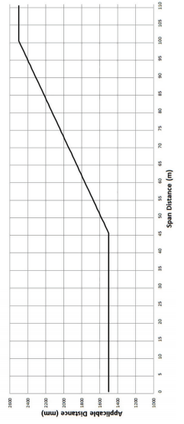

The formula by which the applicable distance for the middle two thirds of a span of uninsulated high voltage electric line (other than a 66,000 volt electric line) in a low bushfire risk area is calculated is as follows:

A. if the span distance is less than or equal to 45 metres the applicable distance equals 1500 millimetres; or

B. if the span distance is greater than 45 metres and less than or equal to 100 metres, the applicable distance is calculated in accordance with the following expression:  
1500 + ((span distance minus 45) multiplied by (1000 divided by 55)); or

C. if the span distance is greater than 100 metres the applicable distance equals 2500 millimetres.

### Graph 4 – Uninsulated 66,000 Volt Electric Line in Low Bushfire Risk Area

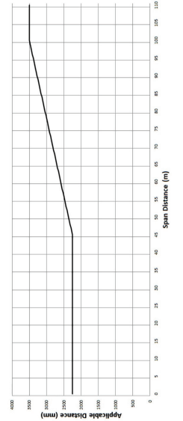

The formula by which the applicable distance for the middle two thirds of a span of uninsulated 66,000 volt electric line in a low bushfire risk area is calculated is as follows:

A. if the span distance is less than or equal to 45 metres the applicable distance equals 2250 millimetres; or

B. if the span distance is greater than 45 metres and less than or equal to 100 metres the distance calculated in accordance with the following expression:  
2250 + ((span distance minus 45) multiplied by (1250 divided by 55)); or

C. if the span distance is greater than 100 metres the applicable distance equals 3500 millimetres.

## Appendix 5 — Required training for personnel working near power lines

Under contract 3472, all training, certification and competency must be current, including all required refresher training. Training must be delivered and assessed by a trainer and organisation authorised and competent to undertake the training and assessment as outlined in the training matrix below.

All personnel must also have at least 3 years industry experience that demonstrates an understanding of AS 4373.

All contractors and employees undertaking work on an electric line clearance site will be inducted and have the current training qualification of Certificate II in ESI – Powerline Vegetation Control (UET20321) or equivalent. The most recent training package for this qualification is updated from the [National Training Register Enhancement Project](https://training.gov.au/)[14] and reviewed annually, in preparation for this Plan.

All job roles will have the following five core units:

|  |  |
| --- | --- |
| Core units | |
| AHCMOM213 | Operate and maintain chainsaws |
| UETDREL002 | Comply with environmental requirements |
| UETDREL006 | Work safely in the vicinity of live electrical apparatus as a non-electrical worker |
| UETDRVC001 | Apply work health and safety requirements for powerline vegetation control |
| UETDRVC009 | Monitor vegetation control work in the vicinity of live electrical apparatus |

Electives of the qualification will vary, depending on the specific job role. City of Melbourne requires the following units of competencies for each of the job roles:

### Inspecting Arborist:

Minimum Certificate III in Arboriculture plus the ‘Perform a ground-based tree defect evaluation’ (AHCARB408) module, and a minimum of 3 years industry experience.

### EWP Operator and Safety Observer:

|  |  |
| --- | --- |
| UETDRVC004 | Control vegetation in the vicinity of live electrical apparatus from an elevated work platform |
| UETDRVC007 | Control vegetation using pruning techniques |
| Worksafe  TLILIC0005 | High Risk Work Licence (WP)  Licence to operate a boom-type elevating work platform (boom length 11 metres or more) |

### Climbing Arborist and Safety Observer:

|  |  |
| --- | --- |
| UETDRVC006 | Control vegetation in the vicinity of live electrical apparatus from within the tree |
| UETDRVC007 | Control vegetation using pruning techniques |
| UETDRVC010 | Perform rescue from within a tree in the vicinity of live electrical apparatus |

Other staff involved in implementing this plan will have the following qualifications.

### Manager of Services

|  |  |
| --- | --- |
| Qualifications | Experience |
| Tertiary qualifications in Arboriculture or Business Management at a minimum Australian Qualification Framework (AQF) Level 6 | 15 Year’s experience in management of similar services. Demonstrated skills and experience in tree maintenance management and customer service. |

### Supervisors

|  |  |
| --- | --- |
| Qualifications | Experience |
| Tertiary qualification in Arboriculture or Horticulture to a minimum AQF level 5 | 5 years' experience in supervision of similar services  At least one supervisor for each of tree pruning and tree planting |

### Tree assessors

|  |  |
| --- | --- |
| Qualifications | Experience |
| Tertiary qualification in Arboriculture or Horticulture to a minimum AQF level 5 | 5 years arboriculture experience |

### Other staff

| Qualifications | Experience |
| --- | --- |
| Arboricultural staff, minimum AQF 4 | Required for:   * Maintenance work to trees * Tree felling * Tree planting |
| A range of qualifications, including Arboricultural and Horticultural tradespersons | Demonstrated experience in:   * Maintenance of tree assets similar in nature to that required by the Specification * Identifying, monitoring and treating pests and diseases of trees * EWP competency certificate |
| Electrical Line Clearance | Trained, authorised and certified by Energy Safe Victoria in compliance to Electrical Safety Regulations |
| Working on environmentally significant sites | Approved bush management training, certificates and experience |
| One operator on every site | Current and suitable  First Aid Certificate Level 2  Road Safety and Signage Certificate |
| Applying horticultural chemicals | Ensure applicators have the following licences:   * DPI Commercial Operator Licence (COL) * Department of Health Licence to Use Pesticides (LTUP) required by pest control operators Experienced in application of chemicals in a public place. |

## Appendix 6 — Sample of Notification Letter

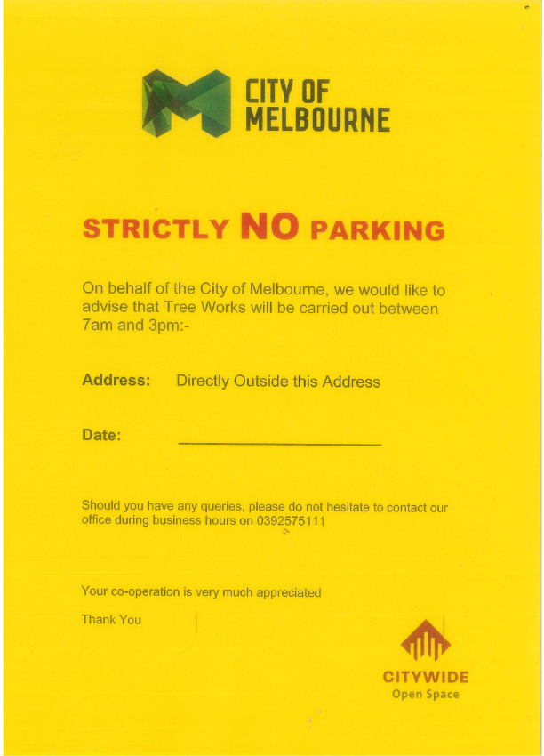

1. http://www.melbourne.vic.gov.au/community/parks-open-spaces/tree-protection-management/Pages/tree-maintenance-electrical-line-clearance-management-plan.aspx
2. <http://planningschemes.dpcd.vic.gov.au/schemes/melbourne>
3. https://achris.vic.gov.au
4. http://www.trusttrees.org.au
5. https://www.environment.vic.gov.au/__data/assets/pdf_file/0031/536089/FFG-Threatened-List-September-2022.pdf
6. https://www.melbourne.vic.gov.au/sitecollectiondocuments/urban-forest-strategy.pdf
7. https://www.melbourne.vic.gov.au/community/greening-the-city/tree-protection-management/Pages/tree-maintenance-electrical-line-clearance-management-plan.aspx
8. https://www.environment.vic.gov.au/conserving-threatened-species/threatened-list
9. https://achris.vic.gov.au/#/dashboard
10. <https://www.ari.vic.gov.au/research/threatened-plants-and-animals>

    9 https://www.swifft.net.au/
11.
12. https://www.melbourne.vic.gov.au/community/greening-the-city/tree-protection-management/Pages/tree-maintenance-electrical-line-clearance-management-plan.aspx
13. https://www.melbourne.vic.gov.au/community/greening-the-city/tree-protection-management/Pages/tree-maintenance-electrical-line-clearance-management-plan.aspx
14. Training.gov.au