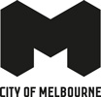

Creative Funding Framework 2024–30

Acknowledgement of Traditional Owners
The City of Melbourne respectfully acknowledges the Traditional Owners of the land we govern, the Wurundjeri Woi-wurrung and Bunurong / Boon Wurrung peoples of the Kulin Nation and pays respect to their Elders past and present. We acknowledge and honour the unbroken spiritual, cultural and political connection they have maintained to this unique place for more than 2000 generations.
We accept the invitation in the Uluru Statement from the Heart and are committed to walking together to build a better future.
Contents
Creative Funding Framework 2024–30 1
Acknowledgement of Traditional Owners 1
Disclaimer 2
Foreword from the Lord Mayor of Melbourne and Councillor 3
Introduction 4
Strategic context 5
Council’s commitment 7
Principles 8
Arts funding programs 9
Application assessments and timelines 10
Measures of success 11
How to contact us 12

Disclaimer
This report is provided for information and it does not purport to be complete. While care has been taken to ensure the content in the report is accurate, we cannot guarantee it is without flaw of any kind. There may be errors and omissions or it may not be wholly appropriate for your particular purposes. In addition, the publication is a snapshot in time based on historic information which is liable to change. The City of Melbourne accepts no responsibility and disclaims all liability for any error loss or other consequence which may arise from you relying on any information contained in this report.
To find out how you can participate in the decision-making process for the City of Melbourne’s current and future initiatives, visit Participate Melbourne

Foreword from the Lord Mayor of Melbourne and Councillor
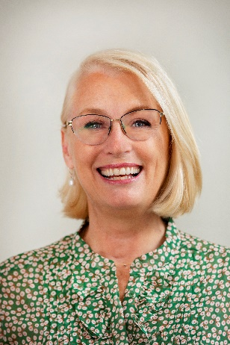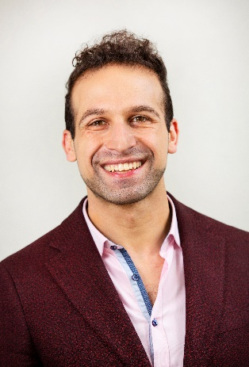
As the nation’s undisputed arts capital, the City of Melbourne is committed to nurturing its independent artists and arts organisations through a diverse offering of grants and partnerships.
We distribute more than $4 million in funding each year to foster an ever-growing, ever-inspiring suite of creative works and projects that ensure Melbourne remains one of the most exciting cities to live, work, play and visit.
In the years since this framework was first devised, the arts community has pirouetted through a number of transformations, and we wanted to ensure these guidelines reflected the needs of the community they were put in place to serve.
In developing this refreshed framework, we went back to the creative community – including artists, arts organisations, peak bodies and all tiers of government – to seek feedback and better understand the current role of our funding programs.
This new iteration re-affirms our responsibility to cultivating Melbourne’s cultural identity, responds to what the sector needs most now and ensures support throughout the creative ecosystem.
For instance, it allows us to better nurture our individual artists and small-to-medium arts organisations who are often left behind in other funding programs. This fosters a more inclusive and equitable arts sector and enables a variety of artistic experiences and expressions.
As our city continues to flourish with renewed creative vigour, this new framework will guide how funding is allocated, give emerging artists and organisations a leg up and cement our reputation as a city that values the arts.
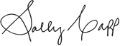
Sally Capp AO
Lord Mayor
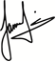
Jamal Hakim
Councillor
Creative Melbourne Portfolio Lead

Introduction
Melbourne has long been renowned as a culturally diverse metropolis with dynamic artistic energy. The history of the city and the land it stands on is interwoven with the vibrant tapestry of creative communities that have flourished and evolved here over many generations.
Acknowledging and respecting the ongoing presence and contributions of Melbourne's Aboriginal people is an essential part of recognising the city's true history and identity. Reconciliation and truth-telling efforts aim to foster a deeper understanding and respect for the Wurundjeri Woi-wurrung and Bunurong / Boon Wurrung people and their enduring connection to Melbourne’s past, present and future.
This Creative Funding Framework places a strong emphasis on inclusivity, ensuring that a diverse range of voices and perspectives can thrive within Melbourne's creative community. This inclusivity enriches the city's cultural landscape, as it encourages a broader exploration of artistic expressions and a deeper understanding of its multicultural communities.
Melbourne's creative communities have left an indelible mark on both the city's identity and the global cultural landscape. Through the city’s funding commitment, we hope to contribute to the continuation of this legacy.

Strategic context
The Creative Funding Framework 2024–30 is informed by a number of key strategy documents.
Future Melbourne 2026 is the second 10-year community plan developed by the people of Melbourne through an extensive engagement process. Goal 3 – A Creative City describes Melbourne as encouraging innovation and initiative. It describes Melbourne as a place that fosters and values its creative community, and a place that invests in the creativity of people of all backgrounds and ability, in all pursuits.
The Council Plan 2021–25 outlines Council’s four-year objectives to achieve its vision. Objective 1 – Economy of the Future describes Council’s goal to harness and enhance the creative energy of the municipality, to define Melbourne’s unique character and contribute to the city’s ongoing economic resilience and viability.
Council may soon agree to create a First Nations Strategy to sit alongside the Council Plan. Aboriginal culture and heritage is more than reconciliation, which is why the new strategy will include initiatives that promote truth-telling and celebrate Aboriginal Peoples’ unique heritage and culture within the municipality.
Key to any creative city is a commitment to being inclusive, accessible and embracing of the diversity of our communities – as outlined in Inclusive Melbourne Strategy 2022–23.
Also, while the benefits of creatives to a city are well documented in both economic and non-economic terms, our Economic Development Strategy 2031 articulates the commercial value of a creative resurgence to the city.
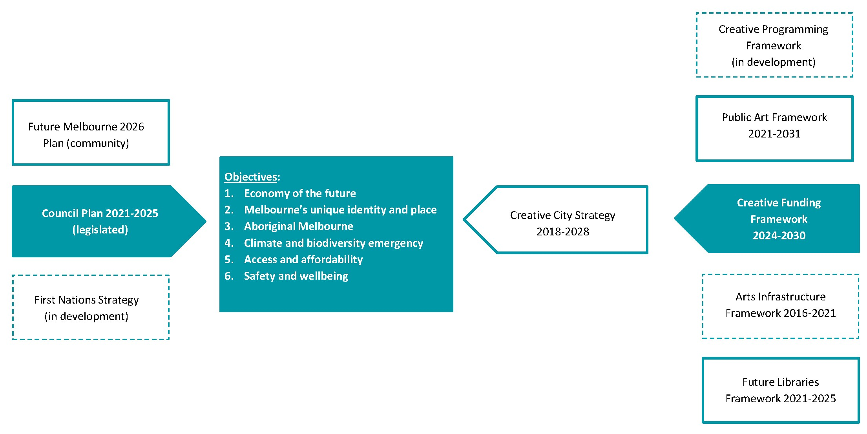

Our Creative City Strategy 2018–28 takes a 10-year view on how we integrate creativity into everything we do – not as an “add-on” but planned from the start of a project, development or activity.
Cities that have creativity at their core are more likely to prosper. So we’re applying creative practice on a civic scale and initiating art at the outset of city projects to draw on the full potential of our extraordinary creative community.
In addition to this Creative Funding Framework, the Creative City Strategy informs a number of other key frameworks that contribute to arts in our city:
- Creative Programming Framework (in development)
- Public Art Framework 2021–31
- Arts Infrastructure Framework 2016–21
- Future Libraries Framework 2021–25

Council’s commitment
The City of Melbourne is dedicated to the principles of good governance, transparency and accountability. We understand the importance of serving our residents, businesses, workers and visitors and upholding their trust.
We affirm our commitment to the following values when delivering creative funding:
- Accountability
As stewards of public funds, we are responsible and answerable for every decision made, ensuring that ratepayer interests are always at the forefront of our actions.
- Good governance
Our decisions will be guided by fairness, impartiality, and the long-term sustainability of our community.
- Transparency
We build and maintain trust by providing comprehensive and accessible information about our decisions, initiatives, and financial matters.
- Arm’s length peer assessment
We acknowledge the importance of impartial evaluation and external perspectives to ensure expert insights when allocating grants.
- Continuous improvement
We are committed to a culture of continuous improvement and will regularly evaluate our practices, seek feedback from our community, and adapt to changing needs and circumstances.

Principles
Our guiding principles for creative funding have been developed in response to our extensive sector consultation process. Our principles will guide decision making and reinforce our commitment to the creative sector. These principles will guide the strategic choices we make about who and what we fund.
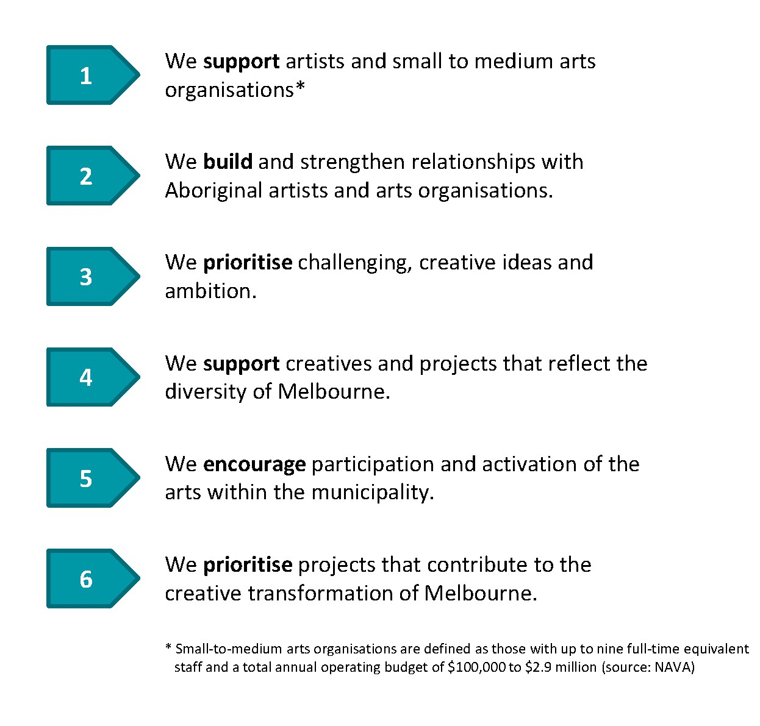

Appendix 1

Arts funding programs
The City of Melbourne’s arts funding programs are informed by guiding principles that reflect our role in the arts eco-system and extensive sector consultation. Our funding programs are designed to focus support on individual artists and small-to-medium arts organisations. Through the selection process, we will prioritise challenging, creative ideas and ambition. Funded arts projects will reflect the diversity of Melbourne and encourage participation and activation. Council’s budget allocation is shown in the below table.
Our arts funding programs include:
- Annual Arts Grants
Grants for one off arts projects to occur in the following calendar year.
- Annual Aboriginal Arts Grants
Grants for Aboriginal artists for one off arts projects to occur in the following calendar year.
- Quick Response Arts Grants
Small grants for one off arts projects or creative development.
- Arts Residency Funding
Grants and in-kind venue support for artists to develop and test their practice.
- Multi-year Arts Grants
- Three year funding to small, medium and larger arts organisations.
- Access Funding for Artists with Disabilities
Funding to assist artists with disabilities to deliver funded arts projects (additional to grant funding).
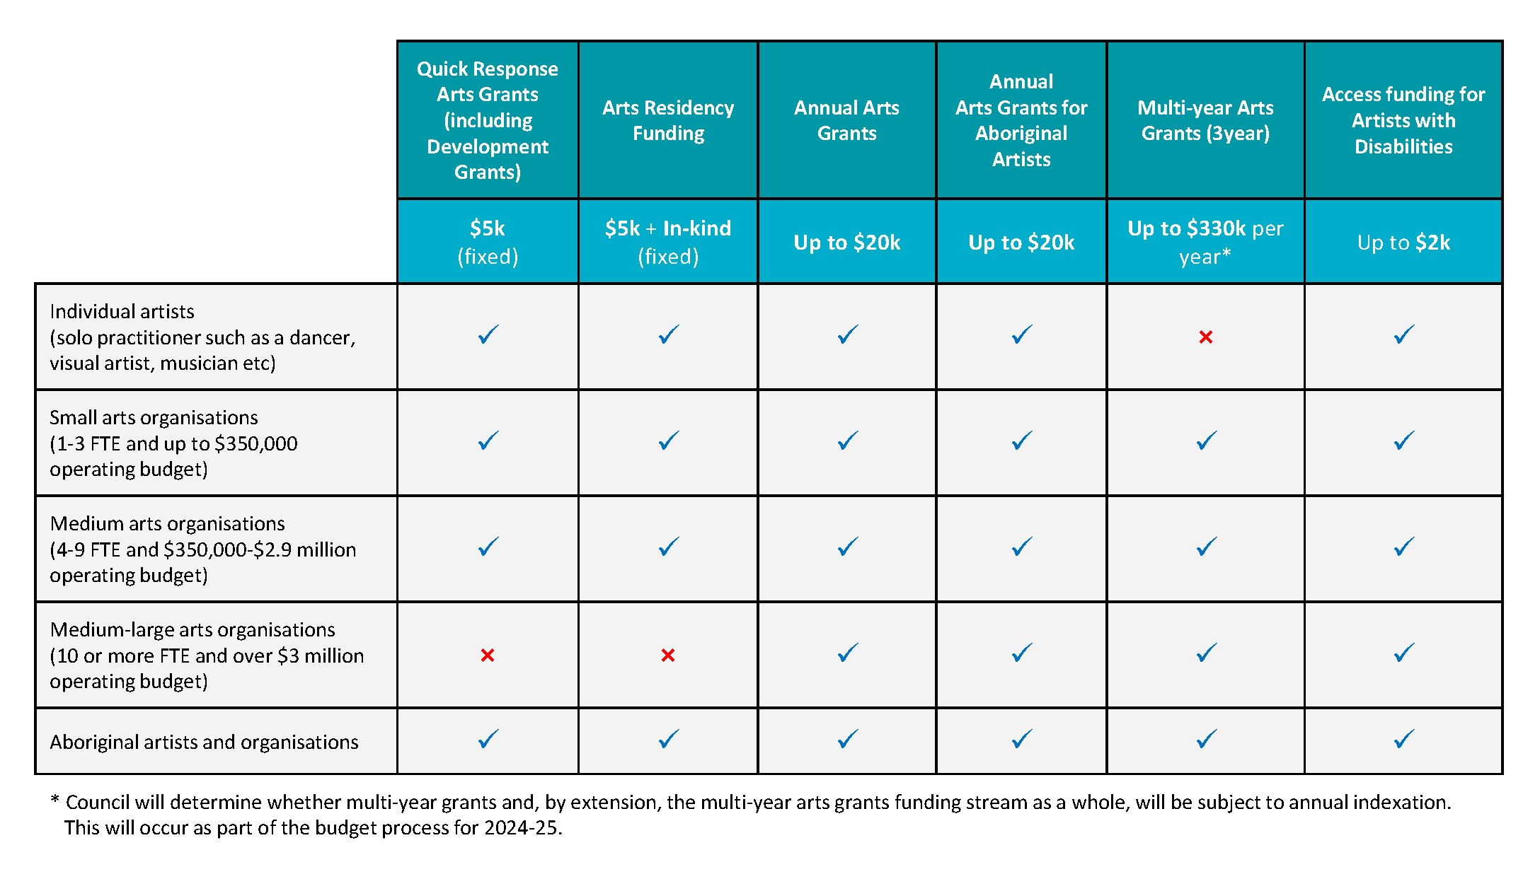

Appendix 2

Application assessments and timelines
The assessment of all arts grant applications will be conducted by a panel of independent peer-assessors. Budgets submitted may be queried or amended during the application and assessment process and partial funding may occur.
The assessment process for Quick Response Arts Grants applications will be completed within 20 business days, while for other grant programs, notification will occur within three months of application.
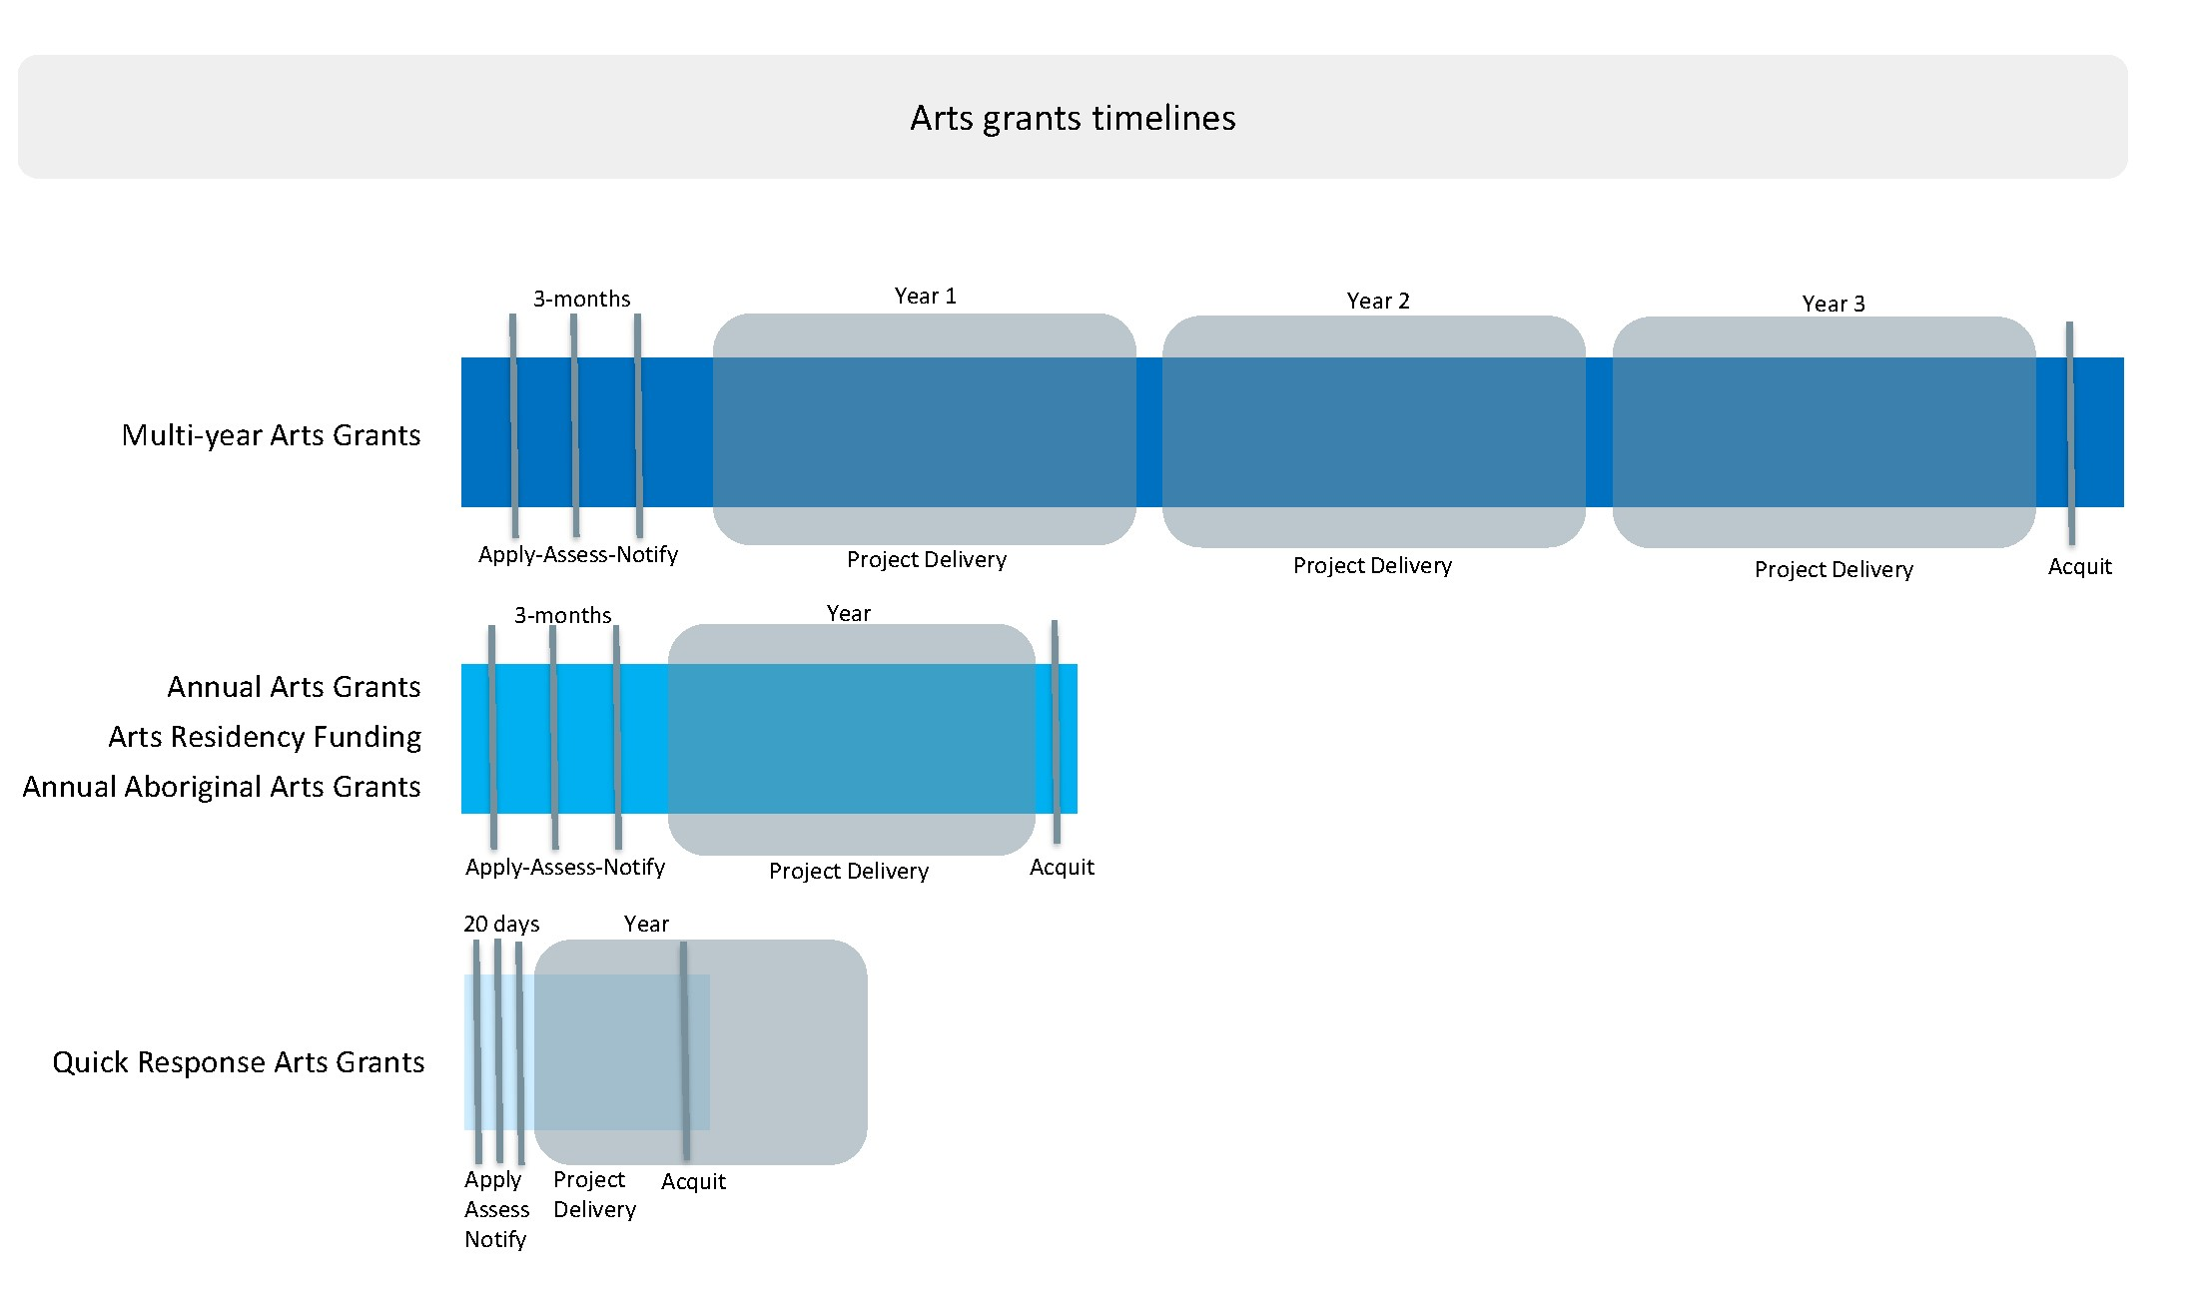

Appendix 3

Measures of success
We will know we have been successful when we see benefits created for Melbourne’s creatives and the city via the funding programs. This includes income generation, career progression among diverse emerging artists and locally-developed works reaching national and international audiences.
Melbourne is renowned for the diversity and boldness of its creative community, whose work reveals, reimagines and enriches our city. Whether emerging or established, creative people find many opportunities to develop and apply their talents in Melbourne. Diversity of artists and art forms will remain a cornerstone of successful applications.
Through our consultation process, we heard that the creative community would like to see more new grant recipients, so we will monitor the number of recipients receiving City of Melbourne funding for the first time.
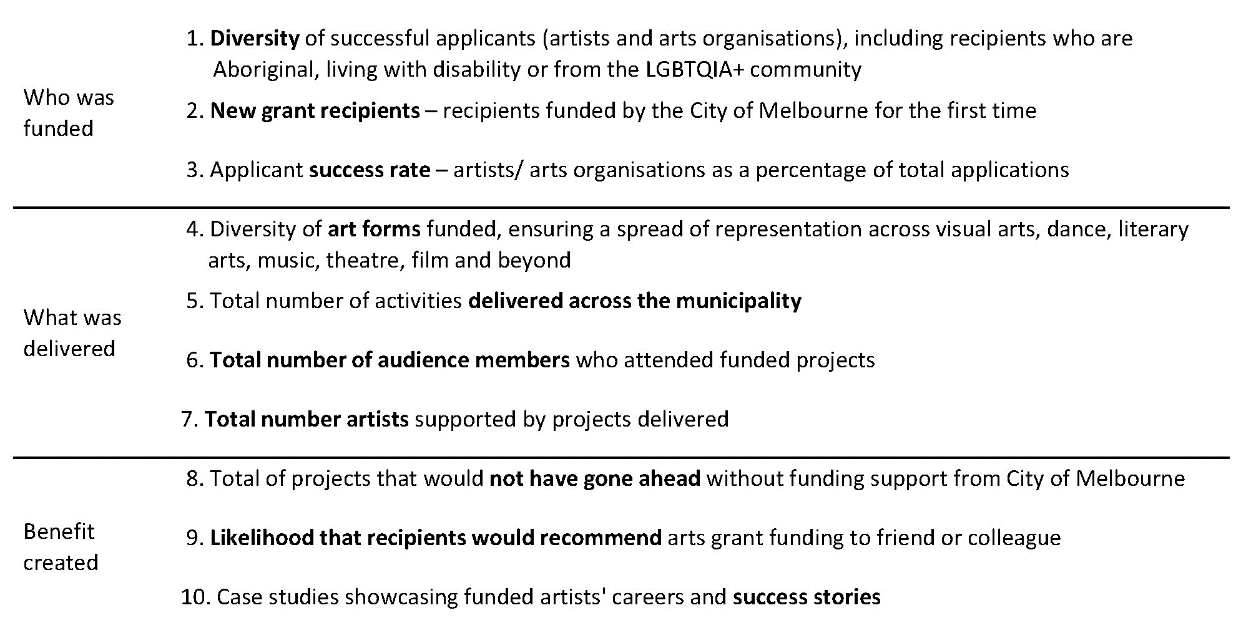

Appendix 4

How to contact us
Online
Go to City of Melbourne website
melbourne.vic.gov.au

In person
Melbourne Town Hall – Administration Building
120 Swanston Street, Melbourne
Business hours, Monday to Friday (Public holidays excluded)

Telephone
03 9658 9658
Business hours, Monday to Friday (Public holidays excluded)

Fax
03 9654 4854
In writing
City of Melbourne
GPO Box 1603
Melbourne VIC 3001
Australia

Interpreter services
We cater for people of all backgrounds
Please call 03 9280 0726

National Relay Service
If you are deaf, hearing impaired or speech-impaired, call us via the National Relay Service: Teletypewriter (TTY) users phone 1300 555 727 then ask for 03 9658 9658 9am to 5pm, Monday to Friday (Public holidays excluded)

Appendix

Appendix 1: Principles
- We support artist and small to medium arts organisations.*
- We build and strengthen relationships with Aboriginal artists and arts organisations.
- We priorities challenging creative ideas and ambition.
- We support creatives and projects that reflect the diversity of Melbourne.
- We encourage participation and activation of the arts within the municipality.
- We prioritise projects that contribute to the creative transformation of Melbourne.
* Small-to medium arts organisations are defined as those with up to nine full-time equivalent staff and a total annual operating budget of $100,000 to $2.9 million (source: NAVA)

Appendix 2: Arts funding programs
Quick Response Arts Grants (including development grants) available funding is a fixed amount of $5,000.
These grants are open to:
- individual artists (solo practitioner such as a dancer, visual artist, musician etc)
- small arts organisations (1-3 full time equivalent staff and up to a $350,000 operating budget)
- medium arts organisations (4-9 full time equivalent staff and up to a $350,000 to $2.9 million operating budget)
- Aboriginal artists and organisations.
Quick Response Arts Grants are not open to medium-large arts organisations (10 or more full time equivalent staff and over $3 million operating budget).
Arts Residency available funding is a fixed amount of $5,000 plus use of a studio space in-kind.
Residencies are open to:
- individual artists (solo practitioner such as a dancer, visual artist, musician etc)
- small arts organisations (1-3 full time equivalent staff and up to a $350,000 operating budget)
- medium arts organisations (4-9 full time equivalent staff and up to a $350,000 to $2.9 million operating budget)
- Aboriginal artists and organisations.
This program is not open to medium-large arts organisations (10 or more full time equivalent staff and over $3 million operating budget).
Annual Arts Grants available funding is up to $20,000.
These grants are open to:
- individual artists (solo practitioner such as a dancer, visual artist, musician etc)
- small arts organisations (1-3 full time equivalent staff and up to a $350,000 operating budget)
- medium arts organisations (4-9 full time equivalent staff and up to a $350,000 to $2.9 million operating budget)
- medium-large arts organisations (10 or more full time equivalent staff and over $3 million operating budget)
- Aboriginal artists and organisations.
Multi-Year Arts Grants (3 year) available funding is up $330,000 per year*.
These grants are open to:
- small arts organisations (1-3 full time equivalent staff and up to a $350,000 operating budget)
- medium arts organisations (4-9 full time equivalent staff and up to a $350,000 to $2.9 million operating budget)
- medium-large arts organisations (10 or more full time equivalent staff and over $3 million operating budget)
- Aboriginal organisations.
Multi-year Arts Grants are not open to individual artists (solo practitioner such as a dancer, visual artist, musician etc).
* Council will determine whether multi-year grants and, by extension, the multi-year arts grants funding stream as a whole, will be subject to annual indexation. This will occur as part of the budget process for 2024-25.

Appendix 3: Application assessments and timelines
- Multi-year arts grants has a three-month application, assessment and notification period. The funding is for three years and project deliveries are expecting every year for those three years. An acquittal is required for each year of the three year funding period.
- Annual arts grants has a three month application, assessment and notification period. The funding is for one year a delivery of project is expected within the year. At the end of the project delivery the project is to be acquitted.
- Arts residency funding has a three month application, assessment and notification period. The funding is for one year a delivery of project is expected within the year. At the end of the project delivery the project is to be acquitted.
- Annual Aboriginal arts grants has a three month application, assessment and notification period. The funding is for one year a delivery of project is expected within the year. At the end of the project delivery the project is to be acquitted.
- Quick response arts grants has 20 day application, assessment and notification period. The funding is for a six month period and the delivery of the project is expected within that six months. At the end of the project delivery the projected is to be acquitted.

Appendix 4: Measures of success
We will measure our success by:
Who was funded:
- Diversity of successful applicants (artist and arts organisations), including recipients who are Aboriginal, living with disability or from the LGBTQIA+ community.
- New grant recipients – recipients funded by the City of Melbourne for the first time.
- Applicant success rate – artists/arts organisations as a percentage of total applications
What was delivered:
- Diversity of art forms funded, ensuring a spread of representation across visual arts, dance, literary arts, music, theatre, film and beyond
- Total number of activities delivered across the municipality
- Total number of audience members who attended funded projects
- Total number artist supported by projects delivered
Benefit created:
- Total of projects that would not have gone ahead without funding support from City of Melbourne
- Likelihood that recipients would recommend arts grant funding to friend or colleague
- Case studies showcasing funded artists’ careers and success stories

https://participate.melbourne.vic.gov.au/
https://www.melbourne.vic.gov.au/arts-and-culture/strategies-support/Pages/creative-strategy-2018-28.aspx
https://www.melbourne.vic.gov.au/Pages/home.aspx

