6. Energy Harvesting – economic use and efficiency
This paper is an examination of the world class energy performance of the City of Melbourne’s new Council House Two (CH₂) building. The paper documents the energy harvesting systems within the building and relates these to international best practice. CH₂ is of particular interest to the expanding Ecologically Sustainable Development (ESD) market, due to the design process integration of conventionally independent systems and relevant innovations. This approach has resulted in significant energy savings, minimisation of environmental impacts and enhanced working conditions for building occupants, with the potential to lead to greater wellbeing and productivity. CH₂ establishes a precedent for effective implementation of ESD principles, and leads the way for the construction industry. This paper also introduces the new concept of ‘energy harvesting’, which is defined as energy derived from potential squander, waste and nature.
Energy is consumed in office buildings to create comfortable work conditions and power office equipment. Most energy is consumed in the process of providing comfortable indoor conditions, via heating, cooling and ventilation. This accounts for 63 per cent of Australia’s greenhouse gas emissions from commercial buildings. Lighting also draws a significant amount of energy, and office equipment itself contributes 12 per cent of the nation’s greenhouse gas emissions.
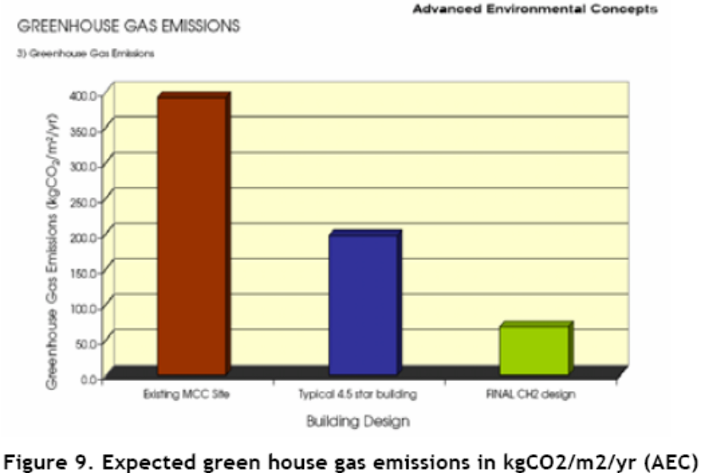
Figure 1 Expected greenhouse gas emissions in kgCO₂/m²/annum (AEC)
Energy Benchmarks
Energy benchmarks for buildings have become a common means for governments and the private sector to evaluate energy use and improve efficiency, both in Australia and worldwide. A building’s energy benchmark is a representative value of its energy consumption. Owners or operators may use it to rate a building’s actual performance, and manage energy use. Benchmarks fulfil two objectives. Building users can use them to monitor their building’s energy consumption against that of their respective sector, and designers or building managers can use them to set energy targets for design or performance improvement. This study shows that the predicted energy performance rates of CH₂ compare favourably against other operating ESD buildings in Melbourne.
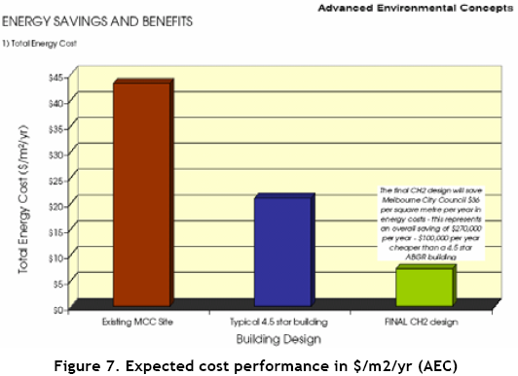
Figure 2 Expected cost performance in $/m2/annum (AEC)
Energy Harvesting System
CH₂ has been designed to include an energy harvesting system. The system converts energy potential available on site, into energy services required for the building to function. Energy harvesting is divided into three main categories: harvesting from squander, which is based on reducing energy consumption by improving efficiency; harvesting from waste, which is based on the recovery of energy otherwise lost to the environment; and harvesting from nature, which is the collection of energy from the ambient environment, and delivering it for use by the building’s occupants.

Innovative Lighting Scheme
The energy consumption of CH₂ has been reduced by harvesting from squander, improving the efficiency of the lighting and thermal comfort services. Departing from conventional office lighting strategy, where uniform task lighting is available across an entire office space and results in up to 85 per cent over-illumination, an alternate approach has been taken. The energy efficient lighting scheme in CH₂ separates task lighting from ambient lighting requirements. General lighting provides ambient light levels of 150 lux, while individually controlled task lighting for each work station provides 320 lux, adjustable to higher levels if required.
Maximising Daylight
Artificial lighting accounts for 21 per cent of the greenhouse gas emissions for commercial buildings in Australia. Introducing daylight into the office environment has been shown to increase wellbeing while reducing artificial lighting requirements. The CH₂ site posed a challenge to the design team in terms of natural light, due to overshadowing from surrounding buildings, the deep floor plan and the lesser daylight at lower levels of the building. The team compensated for these challenges by designing progressively wider windows from the top to the bottom of the building, on the north and south facades. Glazing provides visible light transmittance above 50 per cent, and solar transmittance below 35 per cent. Daylight sensors fitted to the north and south perimeter rows of lighting automatically adjust to complement daylight.
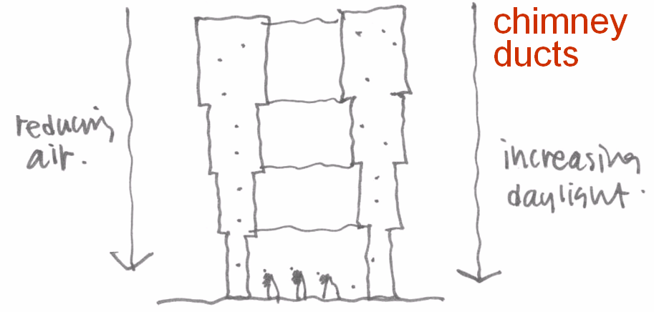
Figure 3 Image from the initial workshop of the stack and window concept

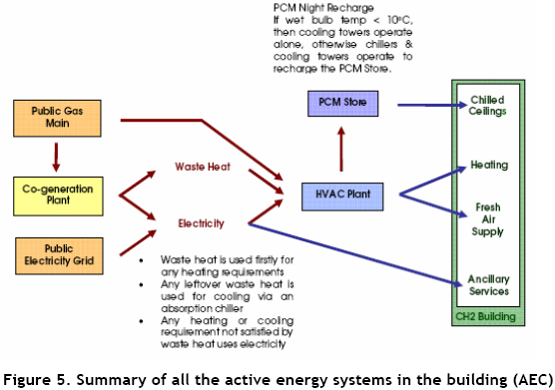
Figure 4 Summary of all active energy systems in the CH₂ building (AEC)

Thermal Comfort
In recent years, design for indoor thermal requirements has been influenced by the belief that people cannot work without air conditioning. However, thermal comfort may be defined as a sense of wellbeing with respect to thermal conditions and is influenced by six factors: dry-bulb temperature, humidity, air speed, mean radiant temperature, clothing and metabolic rate. Furthermore, much energy is wasted by the standard practice of a rigidly fixed set-point temperature control of 22.5C inside buildings. In the CH₂ building, the thermal condition has been set to a reasonable comfort band that will operate between a resultant temperature of 21 to 23C. Energy-efficient methods such as chilled ceilings and an underfloor air supply ventilation system for space conditioning have also been employed, to reduce energy consumption and deliver superior indoor environment quality.
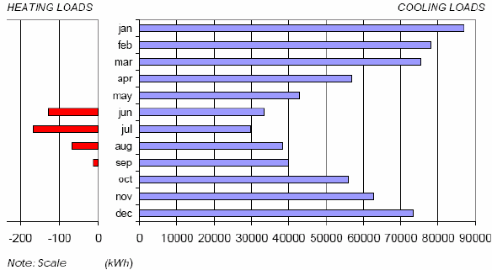
Figure 5 Predicted monthly heating and cooling loads (AEC report SFT30503)
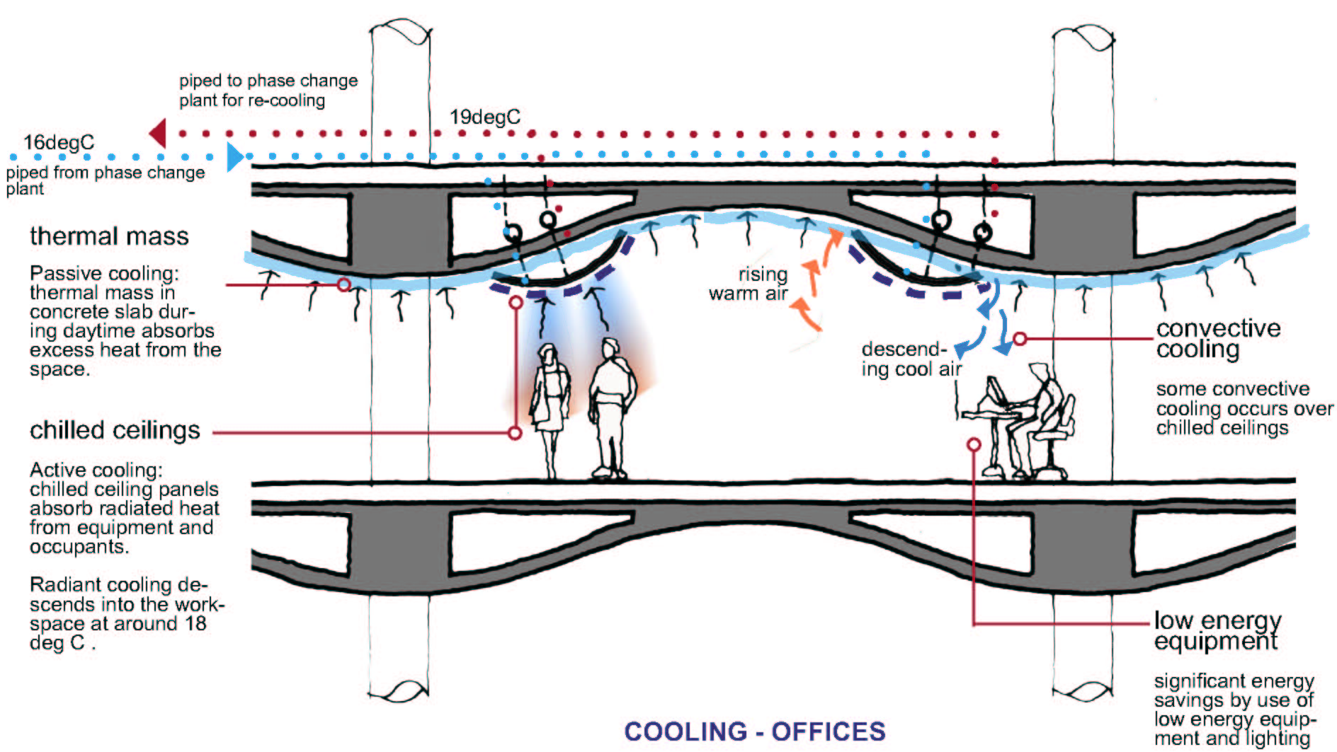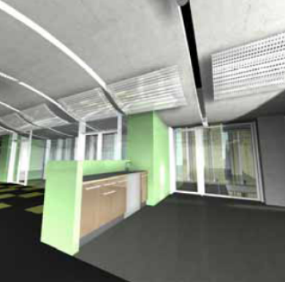
Figure 6 Chilled ceiling provides cooling Figure 7 High thermal mass pre-cast concrete ceiling panel (DesignInc)
Natural Heating and Cooling
The design of CH₂ includes shower towers that draw exterior air from 14m or more above street level and channel air down through 1.4m lightweight fabric tubes on the south side of the building. Retail spaces at the bottom of the CH₂ building are provided with air cooled by evaporation of water droplets. The resultant cool water is piped to the phase change holding tank, and is used to cool the phase change material (PCM) and contribute to satisfying the daytime cooling loads in the office floors of the building. Phase change material (PCM) is material that has the ability to change its phase and in the process absorb a large amount of heat. PCMs can be formulated so their phase change occurs at specific temperatures. In CH₂, the PCM storage tank acts as a heat sink, or storage of cooling potential, depending on the thermodynamic perspective. Viewed as a heat sink the PCMs will absorb heat from the building during the day and release it to the environment at night, via the cooling towers, shower towers or the chillers, depending on operational configuration.
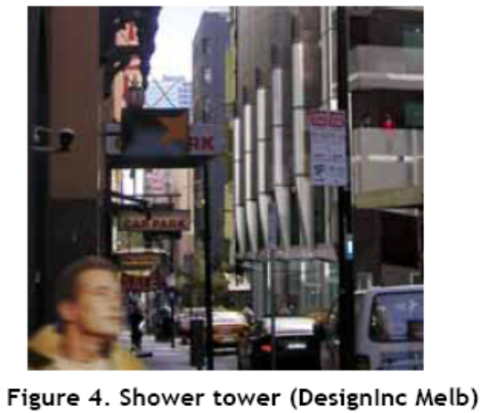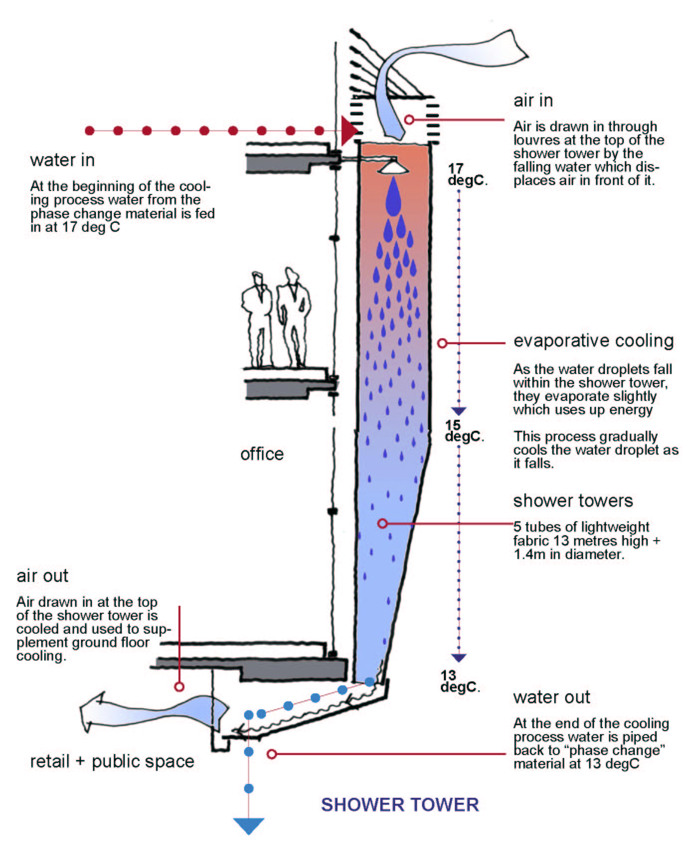
Figure 3 Shower towers (DesignInc Melbourne) Figure 4 Diagram of shower towers
Six solar assisted ventilation stacks on the building’s north façade improve ventilation and are further enhanced by wind turbine ventilators topping the stacks. The stacks are conduits for the ventilation air warmed by heat sources inside the building, assisted by heat absorbed from the sun’s radiation on the surface of the stack, which encourages the natural upward flow of air by thermal buoyancy effects. The six wind turbines primarily assist night purge operations and will also generate power during the day.
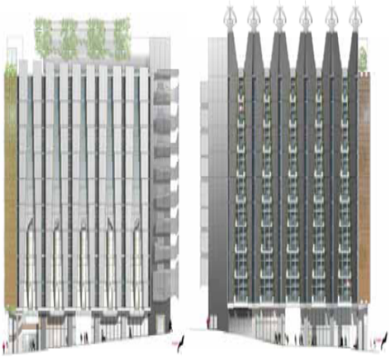
Figure 5 South and north facades (DesignInc)
Modelling shows the rising exhaust ducts are an important part of the CH₂ design. During the daytime they allow a negative pressure air relief while the floors are under positive pressure.. At night they allow a stack to be generated as the building cools. This stack would not occur without the exhaust ducts. It is further shown that designing the top of the shafts to create a negative pressure zone will also enhance the flow of air up the exhaust duct.
Quote from Advanced Environmental Concepts (AEC) report on passive design
The reduction of the temperature of the internal thermal mass in CH₂ is achieved with cool night air via a purging process. This is based on the difference in temperature between the concrete ceiling and the outside ambient temperature, which in Melbourne’s climate is significantly cooler at night. On both the north and south facades, windows are opened automatically at night, allowing cool air to flush into the building and rise out through the north façade stacks. Sensors are programmed to close the windows on the affected side of the building when strong wind and rain is detected, or the ambient temperature is higher than the temperature of the concrete ceilings. The process of night purging cools the thermal mass of the building’s concrete ceilings, which can then act as a heat sink during the day by absorbing heat generated by occupants and equipment. The system is predicted to reduce cooling loads by approximately 14 per cent on a typical summer day.

Design Lessons
One of the most valuable lessons of the CH₂ project is the importance of an integrated approach to energy-efficient building design. Building services can be seen as one interlinked whole, each impacting on and assisting the others. In this way each service becomes a dependent component, part of a chain reaction which can combine to reduce energy consumption across the whole system.

