

Urban Health Profile 2012
INTRODUCTION

All Victorian local governments are required under Section 28 of the Public Health and Wellbeing Act 2008 (the Act) to develop Municipal Public Health and Wellbeing Plans (MPHWP) which guide activity to prevent disease, prolong life and promote public health and wellbeing. To inform the development of this plan, the legislation requires each local government to examine data about the health status and its determinants in the municipality.

The purpose of this Urban Health Profile is to present a snapshot of data on health issues as they relate to the local population of the City of Melbourne, as required under the Act. The profile covers the areas of:

- The City of Melbourne people
- The City of Melbourne environments
- The City of Melbourne health and wellbeing

The information provided in this profile, along with findings from consultations with staff, the local community and health and welfare organisations will provide the basis for the content of the City of Melbourne’s Municipal Public Health and Wellbeing Plan for 2013-2017, which will be integrated with the Council Plan 2013-2017. It is also intended as an ongoing resource and planning tool for Council and health and community agencies within the Melbourne municipality.

NOTES:

This profile is based on the data available at the Local Government Area (LGA) level. As LGA level data can be limited, this document is intended to provide a snapshot of health and wellbeing needs within the City of Melbourne.

Data is based on residents of the City of Melbourne, unless otherwise stated.

Data sources and references are located in a separate document. Link: http://www.melbourne.vic.gov.au/AboutCouncil/PlansandPublications/strategies/Pages/PublicHealthandWellbeingPlan.aspx

THE CITY OFMELBOURNE PEOPLE

The City of Melbourne , as a local government area within Melbourne, comprises Melbourne’s Central Business District and several inner suburbs: Carlton, Carlton North, Docklands, East Melbourne, Flemington, Kensington, Melbourne (the city’s Central Business District), North Melbourne, Parkville, Port Melbourne, South Yarra, Southbank and West Melbourne.

There is a total resident population of 100,611 in the municipality. However, there is also a large transient population with more than 800,000 people coming through the municipality throughout the day to work, study or play. As a consequence, this makes it a hub for work and cultural activity, in addition to a residential city.

In the coming years, the municipality’s population is expected to grow fast at a rate of 4.5% reaching a forecast population of over 121,000 by 2016.

Nearly 75% of the population are aged 15 to 44 years. Older adults (aged over 60 years) comprise around 9.4% of the population. While the municipality’s population will continue to grow, it will remain relatively young with the average age of 28.

The resident population is culturally diverse with 54% of residents born overseas. In recent years, large numbers of international students have contributed to the multicultural fabric of the municipality.

QUICK STATS
Population | CoM
Estimated resident population | 100, 611³ [Male 50%, Female 50%]¹
Average age | 28 years¹
Cultural diversity
Residents born overseas | 54%¹
Speak a language other than English | 38.2%¹
Indigenous | 0.3%¹
Poor English proficiency (speaks English: not well or not at all) | 8.8% of people born overseas¹
Most common language spoken, other than English | Mandarin 10.3%¹
New settler arrivals per 100,000 population | 1,312.2 (rank 1)
International tertiary student enrolments | 24,500

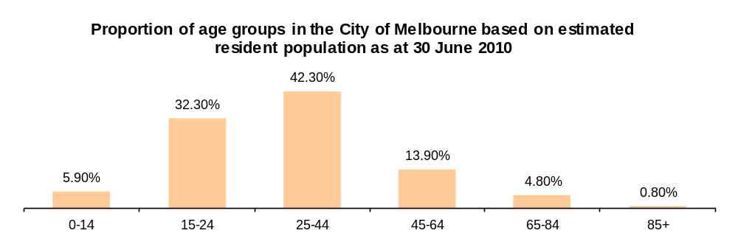

THE CITY OF MELBOURNE ENVIRONMENTS

The unique social, economic, built and natural environmental characteristics that make up the City of Melbourne all influence the opportunities and resources the community has to lead healthy and fulfilling lives. These factors are known as ‘determinants of health’.

ECONOMIC environment – includes secure employment, socio-economic status, income levels and being able to afford necessities like food and shelter.  - While The City of Melbourne is ranked 13th most socio-economic advantaged municipality in metro Melbourne, there are pockets of socio-economic disadvantage in North Melbourne, Carlton and Kensington. These areas are primarily public housing estate areas and families.  - Almost 56.5% of employed residents in the municipality work in highly skilled occupations.  - 4.3% of the 15 + population are unemployed.  - Average personal weekly income is $711.20.  - More than a third of the population (36%) are low income earners, earning less than $399 per week.  - 5.1% experience food insecurity where they had run out of food and have not been able to afford more.  - 6.5% of home purchasers and 29.5% of renters experience housing stress paying 30% or more of their household income on rent or mortgages.  - The cost of living is rising including housing, petrol, food, utilities.  - 101 people are rough sleepers/homeless.  - 41% households have no car. 39.9% say this is due to rising petrol prices.  - 54.2% have private health insurance. | SOCIAL environment – includes: our connections to the community; education choices and pathways; a sense of belonging and acceptance; community support services; feelings of safety; access to arts; culture and diversity; quality of relationships, and recreation and leisure choices.  - 42.5% of residents are attending an educational institution.  - 90% of households have Internet access (90% use broadband).  - 47.1% report using social networking to organise spending time with friends and family, significantly higher than the state average (35.1%).  - 41% of residents feel they have a say on important issues.  - The majority of people live alone (38%). There are 26% couple with no children households, 16.6% group/share households, 10.3% two parent households and 4.8% single parent households. Overall, the average household size is 2.  - Residents report feeling less safe at night, particularly on Friday and Saturday nights.  - One in three city users consume fast food when they’re in the city.  - 80% of residents had attended arts activities or events in the previous 3 months, significantly higher than the state average (63.6%).
BUILT environment – includes access to housing, shops, playgrounds, recreation facilities, roads and footpaths, community facilities and transport infrastructure.  - 67% of dwellings are flats, units or apartments.  - 15.7% of households own their houses, 19% are being purchased and 55.7% rented privately.  - 5.7% of households live in public housing.  - People living in the inner city have better access to public transport, supermarkets and the Queen Victoria Market, the municipality’s key source of fresh food.  - 85.7% believe there are good facilities and services in the municipality. | NATURAL environment – includes access to open spaces including parks, reserves and gardens, clean air and water and protection from climate change impacts.  - The 148 sites in Melbourne’s public open space network total approximately 555 hectares and represents almost 15% of the total area of the municipality.  - Compared to the state average (50.7%), residents were significantly more likely to have visited green space at least weekly in the past three months, with 66.5% reporting this.  - There are 10 community gardens.  - Climate change impacts such as the urban heat island effect are strongest in built up areas.
THE CITY OF MELBOURNE HEALTH AND WELLBEING

The following provides a snapshot of the health and wellbeing of the City of Melbourne residents covering the areas of:

  - Physical health
  - Mental health
  - Physical activity
  - Food and nutrition
  - Alcohol and other drugs
  - Health checks
  - Social inclusion
  - Safety
  - Environmental health
  - Life stages

It is important to note that these health issues and environmental conditions will hit our most disadvantaged the hardest. There is a substantial body of evidence that shows that people of lower socio-economic status have worse health than others. This evidence shows that those living in areas of greater socio-economic disadvantage rate their own health more negatively, have higher rates of some illnesses, have less healthy lifestyles than those in more advantaged areas and are less likely to get health checks. In addition, a lack of economic resources can influence people’s ability to access basic essentials such as food, housing, transport and health care. It can also impact on people’s ability to participate in their community leading to higher levels of anxiety, social isolation and marginalisation. Please consider socio-economic and social equality issues as you read through the next section.

PHYSICAL HEALTH

PHYSICAL HEALTH IN THE CITY OF MELBOURNE: KEY STATISTICS

Life expectancy
INTERESTING NOTE
While females are still outliving males, the life expectancy gap between men and women is narrowing with a decrease from a 7.6 year gap in 1999 to a 5.9 year gap in 2006.

The life expectancy at birth for both males and females born in the municipality has continued to grow over the past decade. Between 1999 and 2006, life expectancy for males increased by 3.9 years and females 2.2 years. Both male and female residents have a higher life expectancy (82 and 87.9 respectively) than the Victorian averages for males and females (79.3 and 84 respectively). This has potential implications for the areas aged and disability related services.

Self-reported health

Just over half of population self-report their health as excellent or very good (58.6%), similar to the Victorian average of 54.3%. Males in the municipality are more likely to rate their health as being fair or poor.
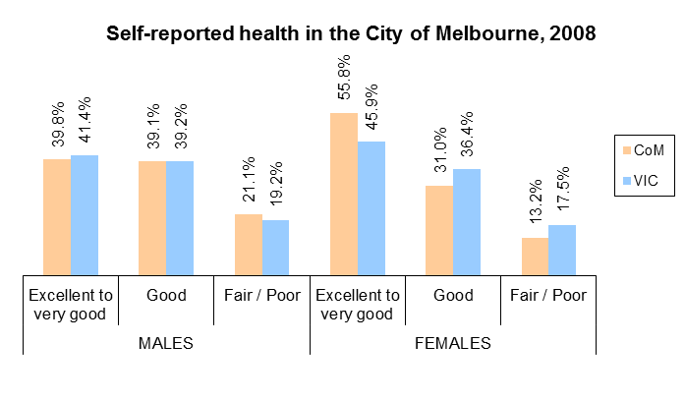
Disability

The proportion of residents with a profound or severe disability was 1.6% in 2006 and 2% of the municipality’s population in 2011. More than 1,800 residents (up by 600 people since 2006) in this municipality live with a profound or severe disability and are considered as needing help or assistance in areas of: self-care; mobility and communication; disability; long term health condition or more or old age. On a daily basis, there are likely to be even more people with disabilities in the municipality and all their needs must be considered. 1.3% have a severe and profound disability, and live in the community rather than in long-term residential care (Victoria – 3.5%).

Of the 1,800 disabled people in the municipality in 2011, around 72% were older people (aged over 54 years). Women and older people aged over 84 years were most likely to have a need for assistance.

Sexual and reproductive health

The municipality of Melbourne has the highest rate of chlamydia notifications of all local government areas in Victoria, with a rate of 9.3 per 100,000 population. Chlamydia is a bacterial sexually transmissible infection and is the most commonly reported notifiable disease in Australia. Most chlamydia infections do not show symptoms. If left undiagnosed and/or untreated, chlamydia can cause pelvic inflammatory disease (PID) which may lead to ectopic pregnancy and infertility.
Body weight status

Obese and overweight people have a higher risk of ill health, including heart disease, stroke, diabetes, colon cancer and osteoarthritis. Obesity is often accompanied by lifestyle risk factors such as physical inactivity and insufficient intake of fruit and vegetables, as well as physiological risk factors such as high blood pressure and high blood cholesterol levels. It is typically measured by calculating a person’s Body Mass Index (BMI), which is their weight in relation to their height.

In the City of Melbourne, males have similar rates of overweight to the Victorian averages, although a lower rate of obesity. Females on the other hand, are significantly less likely to be overweight than their Victorian counterparts, and have similar levels of obesity.
INTERESTING NOTES
The municipality has the lowest proportion of overweight females in Victoria.
Males are more likely to be overweight compared to females in.

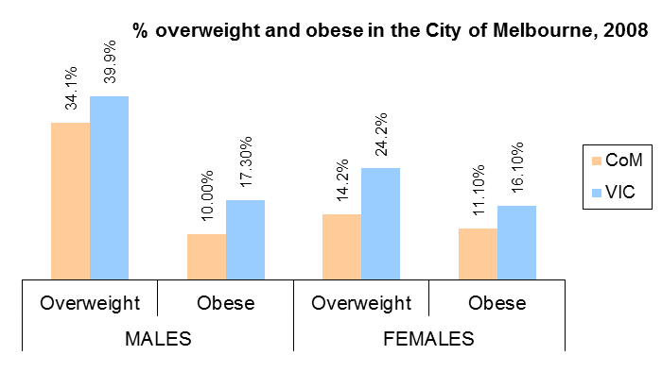
Chronic disease
FAST FACTS
The City of Melbourne has the lowest prevalence of type 2 diabetes in Victoria.
Males in have significantly higher prevalence of cancer than males in Victoria.
Females have significantly higher prevalence of heart disease and osteoporosis than females in Victoria.

The City of Melbourne has a significantly low prevalence of type 2 diabetes compared to the Victorian average (1.6% and 4.8% respectively). However, compared to Victoria there are higher rates of cancer (8.5% and 6.6% respectively). Males in particular have a significantly higher prevalence of cancer (11% compared to 6.1% for Victorian males), whereas females have similar prevalence (6.2%) to females in Victoria (7.1%).

There is also a higher prevalence of heart disease (7.8%) than the Victorian average (6.7%). Females in particular have a significantly higher prevalence of heart disease than females in Victoria (8.6% and 5.2% respectively), whereas males have a similar prevalence to males in Victoria (7.3%* and 8.3% respectively). Females also have a higher prevalence of osteoporosis compared with all Victorian females.

Osteoarthritis rates (10.7%) are similar to state levels, as are rates of asthma (9.4%).

WHAT DOES THIS MEAN FOR THE CITY OF MELBOURNE?

Data on the physical health of people in the municipality shows that there are a number of positives. Life expectancy continues to rise, rates of disability are low (although this is still a significant health issue for our older adults) overweight and obesity rates are average, and we have the lowest prevalence of type 2 diabetes in Victoria.

However, there are also a number of physical health concerns. The City of Melbourne has the highest rates of chlamydia in Victoria, indicating sexual and reproductive health is a key health issue for the municipality, and high rates of some chronic diseases.
Physical health issues are different for males and females within the municipality. Males are more likely to report their health as being fair/poor and are more likely to be overweight and have higher rates of cancer. Females, on the other hand, are more likely to rate their health as excellent to very good. They have low overweight and obesity rates when compared to the Victorian averages and high rates of heart disease and osteoporosis.
MENTAL HEALTH

MENTAL HEALTH IN THE CITY OF MELBOURNE: KEY STATISTICS

Depression and anxiety

Around 12,500 adults in the municipality (12.5%) report high to very high levels of psychological distress (depression and anxiety). This rate is similar to the rest of Victoria (11.4%). There are no differences in depression and anxiety between males and females in the municipality, with 58.1% of males and 65.7% of females were classified as having a low level of psychological distress, similar to Victorian males and females (65.3% and 59.7%).
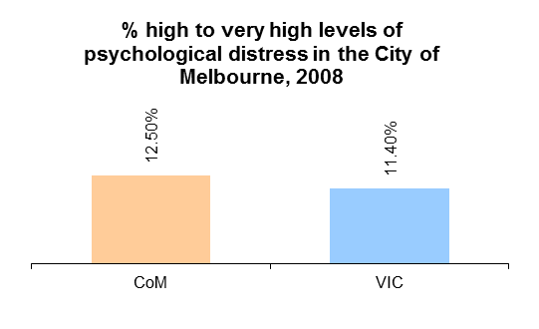
FAST FACT
There are no differences in depression and anxiety between the City of Melbourne and Victoria overall or between males and females in the municipality.
Seeking professional help

In 2008, the proportion of people who have sought professional help for a mental health problem in the last 12 months was 13% in the municipality, similar to the Victorian average (11.4%). State wide data indicates that people typically seek help from their General Practitioner (60.7%), followed by a private counsellor or psychologist (38.1%) or private psychiatrist (18.9%).

Work-life balance

Work-life balance is the maintenance of a balance between responsibilities at work and at home. When work-life balance is achieved, people feel that they have attained the best possible quality of life. In the City of Melbourne, 28.3% of residents report getting inadequate sleep (<7 hours per weekday), 25.7% report a lack of time for friends and family and 42.8% say they feel time pressure. Overall, 57.3% of the employed population report that work and family life don’t interfere with each other, which is higher than the Victorian average of 53%. Females were more likely than males to say work and family commitments clashed (62.4% males; 51.8%).

WHAT DOES THIS MEAN FOR THE CITY OF MELBOURNE?

Good mental health is fundamental to the wellbeing of individuals, their families and the population as a whole. Mental health problems and mental illness are a major cause of poor health in Victoria and it is estimated that they will affect more than one in five adults in their lifetime.

Mental health issues within the municipality for mild psychological disorders such as depression and anxiety are on par with the rest of Victoria. The data indicates that around 40% of males and 35% of females experience some degree of depression and anxiety, and around 12-13% experience high to very high levels, which suggests that mental health is an issue within the municipality. There are a number of factors that can trigger depression and anxiety including social isolation, poor work/life balance, and socio-economic disadvantage. Data around work/life balance indicates that around 40% of the population feel that their work and family lives interfere with each other, with females most likely to say they have trouble balancing these commitments.

There is no data available at the local government area level around rates of self-harm and suicide at this time.
PHYSICAL ACTIVITY

PHYSICAL ACTIVITY IN THE CITY OF MELBOURNE: KEY STATISTICS

Physical activity levels

Whether it is a walk in the local park, going to the gym or participating in a local sporting club, the National Physical Activity Guidelines recommend at least: 30 minutes of accumulated moderate physical activity for adults each day; around 3 hours for toddlers; 60 minutes for youth and at least 30 minutes of moderate activity for older adults for health and wellbeing benefits and reduced risk of disease. The benefits of regular physical activity from the early years, right through to older age are an important factor in achieving good health and wellbeing.

Around two thirds of the adult population (69.3%) are engaging in sufficient levels of physical activity, which is significantly higher than the Victorian average of 60.3%. However, 23.9% of the population are not engaging in any physical activity (3.5% are sedentary and 20.47% are doing insufficient amounts for health benefits). While the percentage of males meeting the physical activity guidelines in the municipality were similar to Victorian males (62.5% and 61% respectively), a higher proportion of females were engaging in sufficient exercise compared to Victorian females (70.9% and 59.7% respectively).
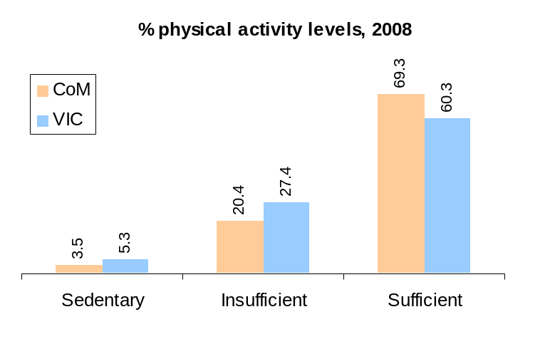
INTERESTING NOTES
The City of Melbourne is one of only 5 metropolitan areas where the proportion of persons undertaking sufficient physical activity levels was above the average for Victoria. The others were Bayside, Boroondara, Port Phillip and Stonnington.

Females in were also more likely to be physically active than males.
Incidental physical activity
FAST FACTS
People in the municipality have the highest rates of walking or cycling to get from place to place (e.g. to school, work, the shops or train station) than any other area across Victoria (68.1% compared to 38.3%)
51.5% travel to work by public transport and 63% travel to study by public transport.
Walking or cycling for transport, especially for short trips, provides an opportunity to reduce or break up sitting time. Walking, in particular, is regarded as a form of physical activity that most people can do, no matter what their age, weight, health problems or abilities, as part of everyday life. In addition, people who use public transport also spend an average of 41 minutes walking or cycling as part of their transport, compared to 8 minutes for people using private transport.

Opportunities for incidental physical activity are particularly important, as data shows that the majority of workers in the municipality aged 18 years and over (84.1%) describe their work-based activity as mainly sitting or standing, which is significantly more than the Victorian average of 64.2%.

WHAT DOES THIS MEAN FOR THE CITY OF MELBOURNE?

Physical activity rates are some of the highest in the state, with around two thirds of the population getting sufficient levels of exercise. In addition, the municipality has the highest rates of incidental physical activity. This may be due to the low car ownership rates in the municipality so people are more likely to incorporate walking and cycling as part of their everyday lives. This is particularly important given that the majority sit or stand all day at work. However, despite this, there is still a quarter of the population (24%) who are not engaging in any or enough physical activity for health benefits, particularly for males. This may be contributing to their higher rates of overweight and obesity. Levels of inactivity may also be contributors to the higher levels of heart disease, cancer and depression and anxiety within the municipality.
FOOD

FOOD IN THE CITY OF MELBOURNE: KEY STATISTICS

Fruit and vegetable intake

All Australians are encouraged to eat two serves of fruit and five serves of vegetables each day to improve energy levels, sleep patterns and concentration and help prevent obesity and a range of chronic diseases including diabetes, heart disease, osteoporosis and some cancers. It is also important for healthy teeth.

In the City of Melbourne, almost half the population (42.7%) are not eating sufficient fruit and vegetables to meet their dietary requirements with 92.4% not eating enough vegetables and 44.3% not eating enough fruit. Only 7.9% of females and 4.1% of males in met the dietary guidelines for vegetable consumption, similar to Victoria (10.7% and 5.0%).

More than half of females (60.6%) and 46.1% males met the dietary guidelines for fruit consumption, also similar to Victoria (53.5% and 41.0%). Females were more likely to meet the dietary guidelines for consumption of fruit compared to males.

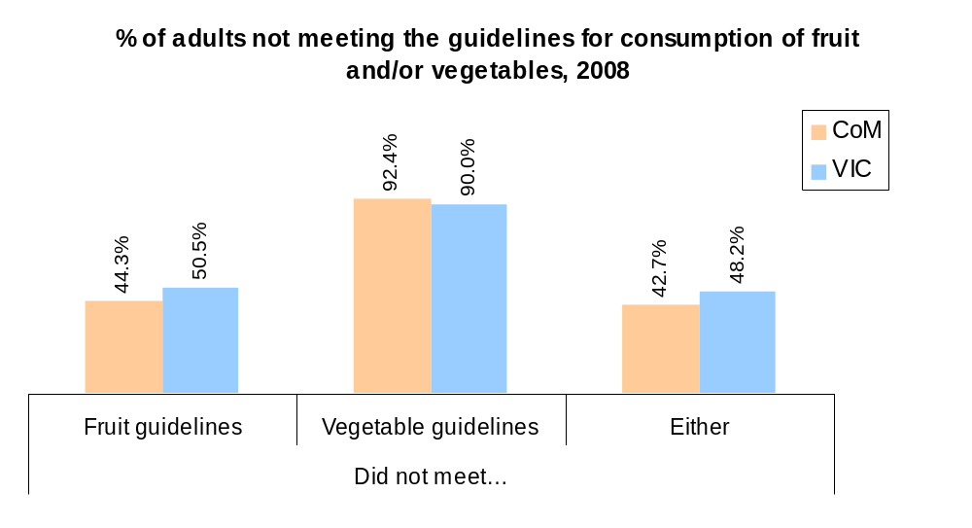
INTERESTING NOTE
People report that busy lifestyles are impacting on people’s time, motivation and energy to cook healthy meals at home.

FAST FACT
Compared to the Victorian average, adults within the City of Melbourne have a higher fruit intake. However, intake levels are still below the recommended dietary guidelines of two pieces of fruit per day.
Breastfeeding

Breastfeeding has a positive impact on the growth, development and health of an infant. In 2010-11, the City of Melbourne’s breastfeeding (fully breastfed) rate for mothers on discharge from the hospital was 75.5%, above the regional average of 68.3%. Three months later, 64% of infants were still fully breastfeeding their child, compared to 46.3% for the region. And at 6 months later, 54.2% were still fully breastfeeding, higher than the regional average of 33.2%.

Access to food (food security)

5.1% of residents in the municipality reported that, within the last 12 months, they could not afford to buy more food when they ran out and families with one or two children receiving Centrelink payments spend around half of their weekly incomes (43 to 46% respectively) to purchase enough food to meet their nutritional needs. This is significantly higher than the recommended benchmark of 30% of income spent on food.

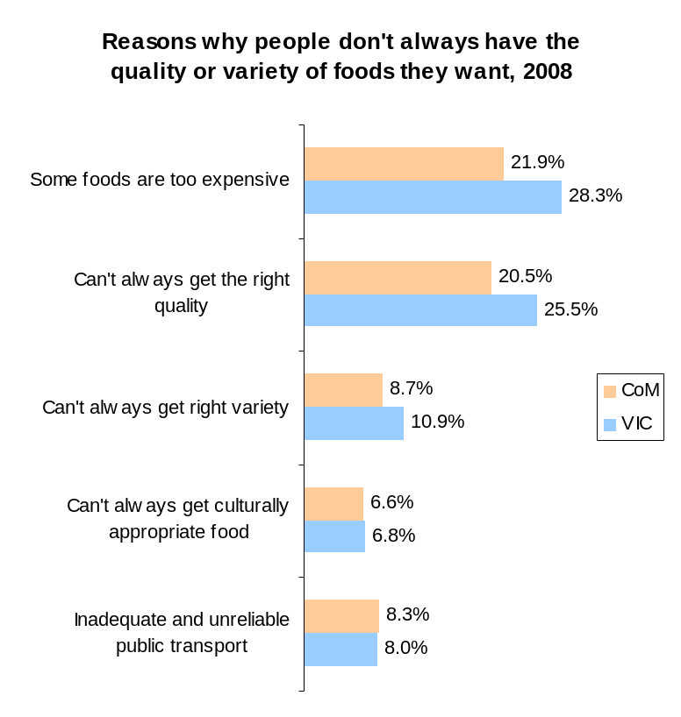
Carlton, North Melbourne, Melbourne (3000), Kensington and Parkville are the suburbs with the highest prevalence of food insecurity. Population groups or individuals who are most vulnerable include:
- People with a weekly household income less than $399
- Single parent, sole person and/or student households
- People who are unemployed
- People with poor English proficiency, particularly newly arrived migrants and refugees
- People with a disability who require assistance
- People who are homeless or at risk of homelessness

Residents in Kensington, East Melbourne, Jolimont, Parkville, Melbourne (postcode 3004), South Yarra, West Melbourne, Fisherman’s Bend and Port Melbourne are also considered vulnerable areas as they are identified as ‘food deserts’. This means that the people who reside in these areas are beyond walking distance (400 metres) to their closest healthy food source.

WHAT DOES THIS MEAN FOR THE CITY OF MELBOURNE?
FAST FACT
60.2% of residents report that they share a meal with family more than five days per week.

Safe, good quality and nutritious food is essential for good health. High quality food provides good fuel for our bodies and without it our health and wellbeing can suffer.
INTERESTING NOTE
Food, especially healthy food, is considered by people who live, work and study in the municipally to be too expensive and less convenient to access that unhealthy food.
Food and nutrition have long been recognised as important contributors to physical and mental health. While people in the municipality have a higher intake of fruit than the Victorian average, fruit and vegetable intake is still lower than the recommended daily intake for health benefits. Not eating enough fruits and vegetables can lead to poor nutrition and diet-related diseases such as heart disease, stroke and cancer.

Eating healthy food also relies on physical and economic access to food. 5.1% of the population are experiencing food insecurity, this equates to approximately 5000 adults in the municipality and this figure is likely to be higher when children and other dependents within the household are taken into account. The ability of residents to access nutritious food depends on their social and economic circumstances, and therefore it will disproportionately impact those who are already experiencing disadvantage within the municipality. Not being able to acquire and consume enough food impacts on people’s physical, mental and social wellbeing. In the short term, it can lead to anxiety, hunger and lack of energy due to poor nutrition. In the long term, it is linked with higher rates of obesity and other diet-related illnesses such as cardiovascular disease and diabetes mellitus. Food insecurity can also impact on mental wellbeing, by creating a sense of powerlessness and social exclusion as the buying, preparing and eating of food is also part of everyday life and a focus for social interactions with family and friends.
ALCOHOL AND OTHER DRUGS

ALCOHOL AND OTHER DRUGS IN THE CITY OF MELBOURNE: KEY STATISTICS

Alcohol consumption and harms

The 2001 National Health and Medical Research Council (NHMRC) guidelines for alcohol consumption indicate that males who drink more than six standard drinks and females who drink more than four standard drinks per drinking occasion are at risk of alcohol-related harm in the short-term. The percentage of males who consume alcohol at low risk levels and are at short-term risk of alcohol-related harm (41%) is higher than Victoria (33.3%). The patterns of alcohol consumption were similar between the City of Melbourne and Victoria for females.

10.1% of residents consume alcohol at risky or high risk levels at least once per week, similar to the Victorian average of 10.2%. Heavy, regular use of alcohol places people at increased risk of chronic ill health and premature death.
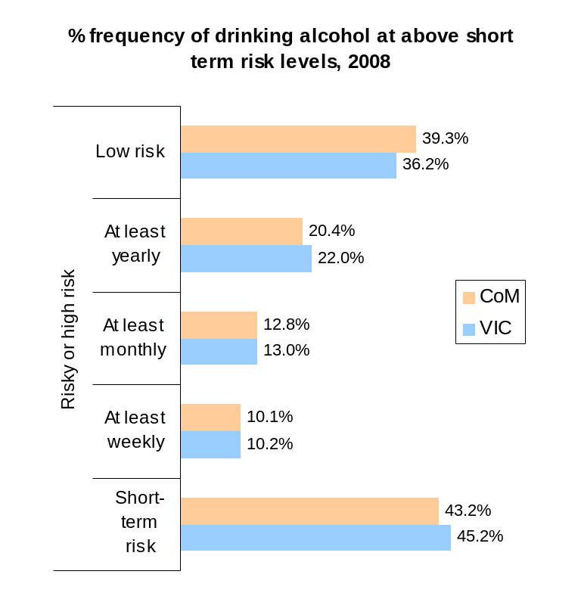
INTERESTING NOTE
Highest density of liquor licenses than all other areas in Victoria. There were 1436 liquor licenses in 2006.

The City of Melbourne has the highest proportion of alcohol-related attendances in metropolitan Melbourne (16%), with three times the number of ambulance attendances as the next highest local government area, Port Phillip (7%). Patients were more likely to be female and younger.

- The City of Melbourne and Yarra are the only two local government areas with alcohol-related assault rates higher than the State rates.
- On the increase are alcohol related hospital admission rates, assaults, ambulance attendances, treatment service utilisation.
- On the decrease are alcohol related serious road injury and liquor licensing, although rates are still higher than the state rates.

Drug use and harms

The City of Melbourne has the highest proportion of drug-related ambulance attendances of any local government area in metropolitan Melbourne. The common drugs involved are cannabis, ecstasy, amphetamines (including crystal methamphetamine), inhalant, gamma-hydroxybutyrate (GHB) and cocaine.

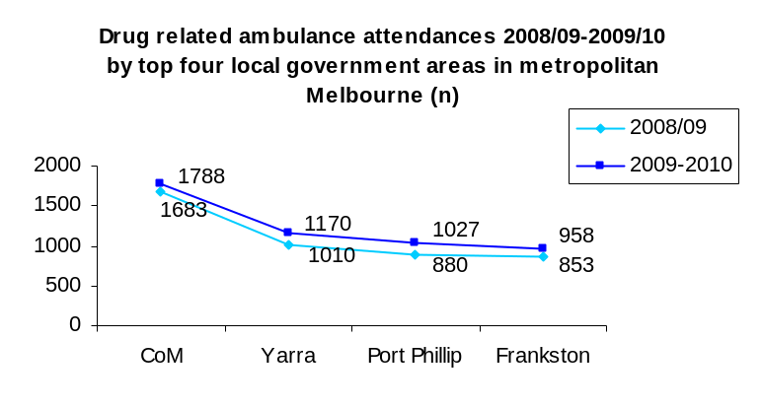
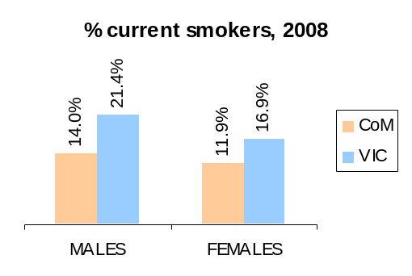
Some drug related ambulance attendances have been decreasing over time including cannabis, amphetamines, inhalants, heroin, opioid analgesics (prescription medication). However, there are increases in ambulance attendances for ecstasy, GHB and cocaine related in the municipality. In the case GHB related ambulance attendances, this accounts for around 40% of attendances occurring in metropolitan Melbourne in 2009/10. Overall, prescription drug related ambulance attendances are low (anti-depressants, antipsychotic and opioid analgesics), despite the general upward trend in metropolitan Melbourne.

Tobacco

Smoking is the single greatest cause of preventable death globally. Current smokers are defined as those persons who report smoking on a daily or occasional basis. In the City of Melbourne, 12.3% of adults are current smokers, which is significantly lower than the Victorian average of 19.1%. Males are more likely to smoke than females (14% compared to 11.9%), although this is still lower than Victorian males (21.4%).

Another key issue is the uptake of cigarette smoking by young people. Tests of retailers show that in 2011/12, out of 61 test purchases, 14 sold cigarettes to minors, a non-compliance rate of 23%. This is a decrease from previous years. However, this may reflect the fact that tobacco education visits were conducted a month prior.
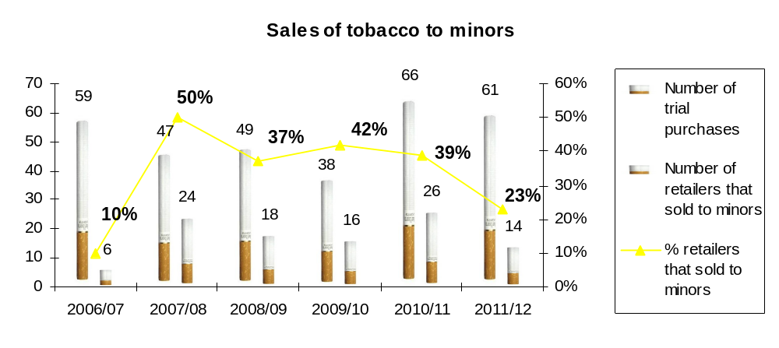

WHAT DOES THIS MEAN FOR CITY OF MELBOURNE?

Alcohol misuse, illicit drug use and tobacco smoking are the biggest contributors to early mortality and morbidity. While smoking rates in the municipality is low, alcohol and other drug use and its associated harms are very high. The nature of the municipality housing the central business district means that the city attracts people from all over greater Melbourne to socialise. The significant health and safety consequences that arise from such patterns of drinking affect not only the individuals concerned but also their families and the wider community.

HEALTH CHECKS

HEALTH CHECKS IN THE CITY OF MELBOURNE: KEY STATISTICS

Sun protection

Sun protection is poor in the City of Melbourne There were three LGAs, all in the metropolitan area, where the proportion of persons who did not wear either a hat or sunglasses was higher than the average for Victoria (14.1 per cent): Brimbank (22.6 per cent), Greater Dandenong (22.5 per cent) and Melbourne (22.4 per cent).
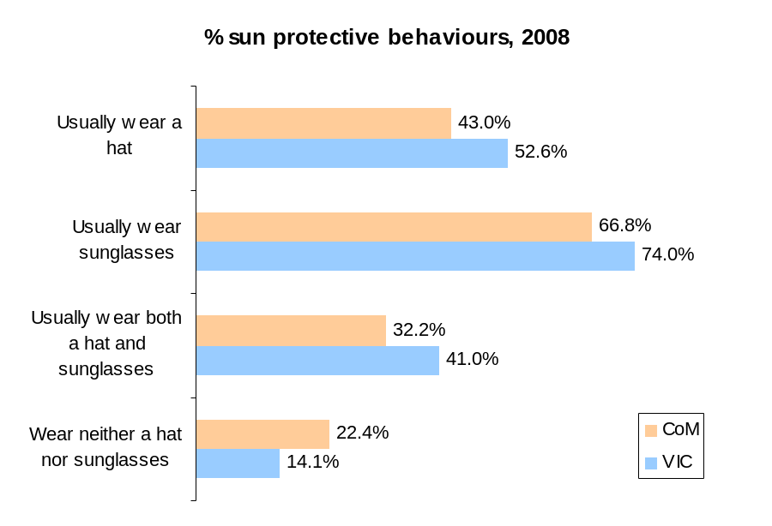
Check-ups

The proportions of people who have had check-ups for eyes, blood pressure, cholesterol, diabetes or high blood sugar (glucose) and cancer screening in the past two years:
- 76.1% have consulted an eye care specialist or attended an eye clinic. 27.2% had been within the last 6 months, which was significantly higher than the state average (21.1%), and 18.8% had been within the past year.
- The proportion of persons aged 50 years and over who had had their blood pressure checked (85.5%) was below the average for Victoria (93.1 per cent).
- Blood tests for cholesterol in the City of Melbourne (54.3%) were similar to rates for Victoria (56.5%).
- Testing for diabetes (blood glucose check) was significantly lower (46.1%) than in Victoria (52.2%). However, the fact that the municipality has the lowest prevalence of type 2 diabetes in Victoria may influence these figures.
- 30% had taken a test to detect bowel cancer, similar to the Victorian rate of 29.4%.
- 69.2% of females had undertaken a pap smear, similar to the Victorian rate of 71.1%.
- 79.3% of females had a mammogram to detect breast cancer, similar to the Victorian rate of 75.9%.

WHAT DOES THIS MEAN FOR CITY OF MELBOURNE?

While the rates of eye care checks, pap smears and mammograms were between 70 and 80%, there are low check-up rates for blood pressure, cholesterol, diabetes and bowel cancer were low ranging from 30 and 50%.

Sun protective behaviours are particularly poor in the municipality, with the majority of people reporting that they do not wear a hat or sunglasses. This may enhance risk of skin cancer. There is no data at the local government area level to check the prevalence of skin cancer in the municipality.

SOCIAL INCLUSION

SOCIAL INCLUSION IN THE CITY OF MELBOURNE: KEY STATISTICS

Feeling of belonging

65.1% of the adult population are satisfied with feeling part of the community, lower than the 70.7% for Victoria. Males are less satisfied with feeling part of their community (63.2%) than females (67.2%). There are no age differences in feeling part of the community.

Community participation

- 65.2% are members of organised groups such as sport, church, community groups or professional associations, compared to 60.7% for Victoria.
- 39.9% of parents are involved in activities at their children’s school, lower than the 48.8% for Victoria.
- 73.4% report that they have enough opportunities to participate in arts and related activities in the local area, similar to Victoria (73%).
- 25.7% help out as volunteers, lower than the Victorian average of 40.8%.
- 46.7% report participating in citizen engagement activities in the past 12 months, lower than the Victorian rate of 53.8%. There was no difference between males and females, however civic engagement participation increased with age.
- 41% feel they have a say on important issues, similar to the Victorian rate of 45.8%.
- 24.9% are members of a local community organisation decision making board or committee, similar to Victoria (22.7%).
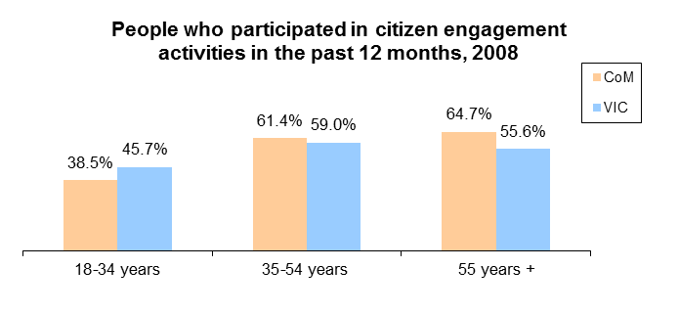
Ability to get help

A large percentage of the adult population (86.4%) say they can get help from friends, family or neighbours when needed. However, this percentage is lower than the rate for Victoria at 91.7%. The majority of the adult population (89.3%) also say they could raise $2000 in two days in an emergency, compared to 85.6% in Victoria.

WHAT DOES THIS MEAN FOR CITY OF MELBOURNE?

Social inclusion is about participation in the community, as employees, students, volunteers, teachers, carers, parents, advisors, residents – as active citizens. Close personal networks can be sources of benefits such as confidence, emotional support, practical help, contacts, resources and other forms of assistance. A lack of social connections is a significant risk factor for mental health problems. The data for the City of Melbourne indicates that social isolation may be of concern with 35% of the community dissatisfied with feeling part of the community (higher than the Victorian rate) and lower than average rates of community participation and civic engagement.
SAFETY

SAFETY IN THE CITY OF MELBOURNE: KEY STATISTICS

Crime rates

Overall, crime in the municipality has increased by 3.5% from 2010 to 2012 (from 26,712 to 27,643 recorded offences). In that period, crime against the person showed a decrease of 1.8%. All the other major categories of crime (crime against property, drug offences and other crime) increased. Other crime (which includes going equipment to steal, justice procedures, related public order, weapons/explosives, harassment, behaviour in public and other) had the greatest reported increase (14.8%). Regulated public order, theft from motor vehicles, arson and rape showed the greatest reported decrease.
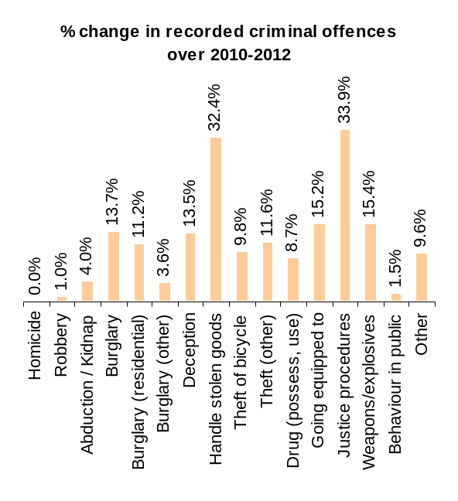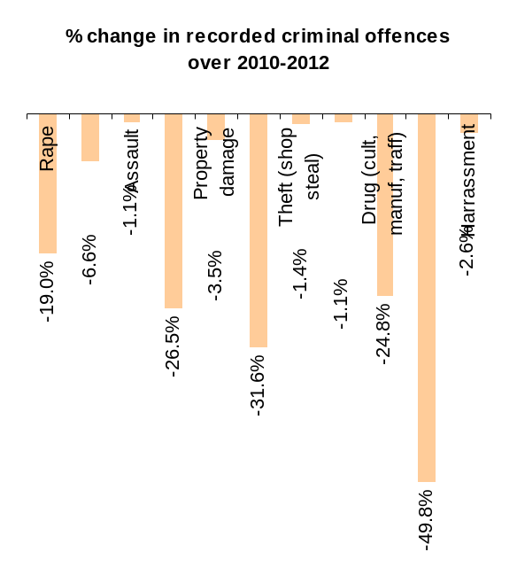
Family violence

For the Melbourne local government area, the number of family incidents reported to Victoria Police has increased in the last year by 20% from 673 incidents in 2010/11 to 841 in 2011/12. The number of Intervention Orders applied for (29%) and Safety notices issued (7.7%) has significantly increased over the last 12 months. The majority of victims experienced violence from their intimate partner (including current and former domestic partner) and victims of family violence incidents were most likely to be between 25-35 years of age, followed closely by 18-24 years.

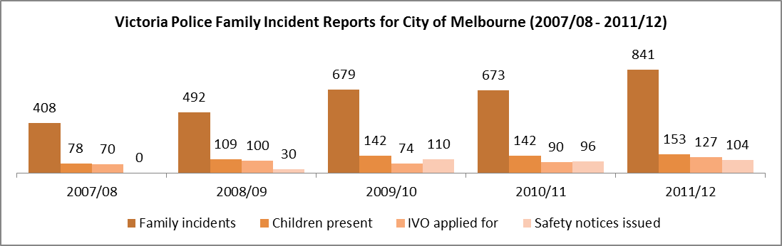
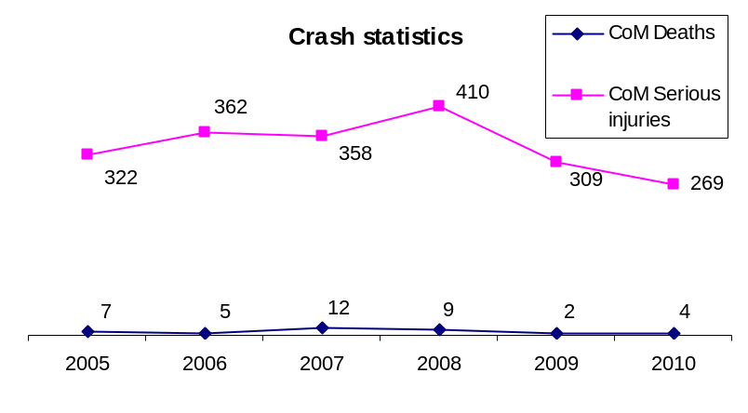
Accidental injury

The number of serious injuries and deaths in the municipality cause by road accidents has shown a decline over 2006 and 2010.

According to the 2009 Perceptions of Safety Survey, residents and businesses perceive the key reasons for risk of accidental injury in the municipality are uneven or damaged footpaths (54%), conflicts between cyclists and drivers (47%) and cyclists and pedestrians (32%), too much traffic (26%), reckless and irresponsible driving (24%) , motorists speed (15%).

Perceptions of safety

In 2009, 84% of residents and businesses stated that they either feel safe always (30%) or feel safe more often than unsafe (54%). This has declined from 92% in 2006. 84% feel the central city area (CBD, Southbank and Docklands) is very safe (17%) or safe (64%) for families. The main reasons for people feeling unsafe in the central city area in 2009 were public drunkenness, groups of people hanging around and threatening behaviour/fights. These issues are of increased concern since 2006. People report that they feel the most unsafe on Friday and Saturday nights, especially after midnight. The major safety concerns over the next five years included public drunkenness (43%), assault/physical violence (25.6%), traffic flow (17.4%), drug use (15.7%) and managing growth/increased population (13.8%).
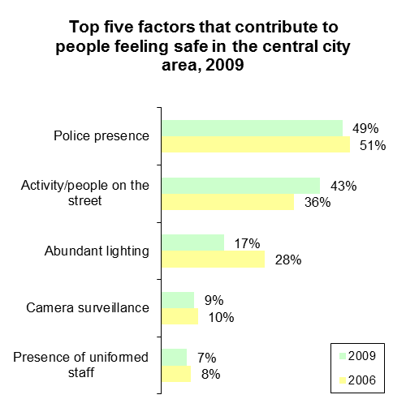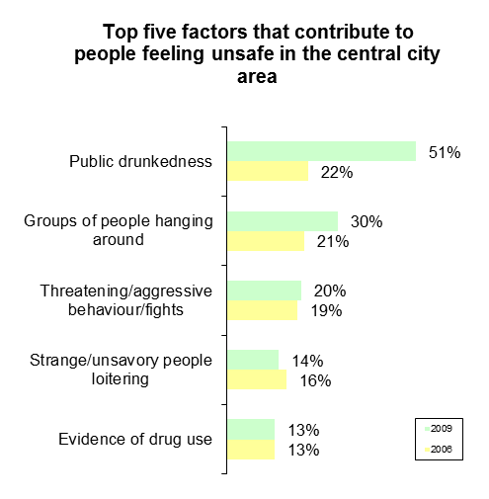

WHAT DOES THIS MEAN FOR CITY OF MELBOURNE?

Family violence is an emerging area of need within the municipality and crime is up by 3.5%. The largest increases seen in justice procedures followed by handling stolen goods, weapons/explosives, burglary, deception, theft and drug possession and use. Offences against justice procedures can include escaping custody offences or breaching bail, parole, a domestic violence or other restraining order.

These issues can be related to people’s feelings of safety in the central city area, with people reporting that they feel most unsafe on Friday and Saturday nights from public drunkenness, groups of people hanging around and threatening behaviour/fights. These fears are said to escalate over the next few years with people fearing further issues around alcohol, assault and physical violence, drug use and managing the increasing amount of people in the city. Neighbourhoods that are perceived as unsafe can foster social isolation and a lack of community connectedness between local residents and visitors.
ENVIRONMENTAL HEALTH

ENVIRONMENTAL HEALTH IN THE CITY OF MELBOURNE: KEY STATISTICS

Food safety
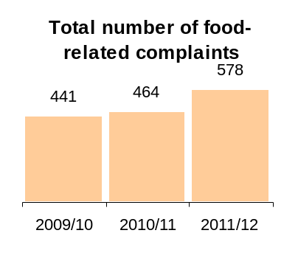
The total number of food related complaints in the municipality has increased over 2009 to 2012 from 441 in 2009/10 to 578 in 2011/12. Complaints relate to selling unsafe/unsuitable food, alleged food poisoning, the condition of the food premises and their food safety practices and hygiene.

The majority of cases of food poisoning were from café and restaurants, followed by take away and fast food outlets (which make up the largest category of food establishments in the municipality). Complaints from these food outlets have all increased since 2009, and complaints from supermarkets and catering businesses have decreased.

Melbourne City Council must obtain at least 916 food samples for analysis each year as required under the Food Act. An annual food sampling program is developed which consists of a number of sampling activities such as surveys on foods of concern, sampling at large events and festivals and participation in regional and statewide surveys. The 'sampling year' operates from 1 March to 28 February and 1148 food samples were obtained for analysis by the City of Melbourne in the sampling year ending 28 February 2012. Results of analysis for the samples obtained in this period returned a 92% compliance rate. Surveys conducted throughout the year targeted sushi, the use of raw egg in mayonnaise, dairy products and food from bain-maries. The City of Melbourne also participated in the state-wide survey on the microbiological quality of sprouts.

Noise

Elevated noise has been shown to cause hearing impairment, hypertension, heart disease, annoyance, sleep disturbance and decreased work/school performance. It can also cause stress, increase workplace accident rates, and stimulate aggression and other anti-social behaviours. The number of noise complaints received by Melbourne City Council over 2008 and 2012 has increased each year. Overall, the most significant causes of noise in the municipality are from building and construction, buskers, machinery and air-conditioning from commercial businesses, music from entertainment venues followed by barking dogs. In 2011/12 there has been a particular increase in noise complaints from building works and construction.
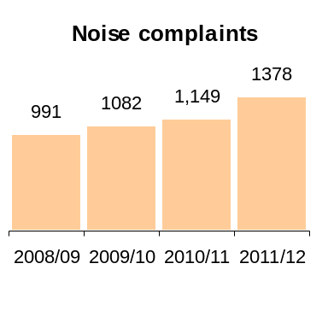
Climate change

Climate change affects our health in a number of ways, some of which are direct and others than flow on from other changes. Direct risks include:
INTERESTING NOTE
Cities are going to be even hotter because of what is known as the ‘urban heat island effect’. This term describes how urban areas can generate and store more heat than nearby rural areas.
- More frequent and intense extreme weather events resulting in more injuries, deaths and post-traumatic stress
- More frequent and intense heat waves resulting in more heart attacks, strokes, accidents, heat exhaustion and death
- More fires increasing the number of causes of smoke induced asthma attacks, burns and death

Risks of flow on effects include:

- The over-heating of urban environments can pose various indirect risks to health via threats to infrastructure including curtailed rail services, over extended emergency services, and failures of girded electricity supply.
- More exposure to some air pollutants and air-borne allergens such as pollens and moulds, exacerbating respiratory illnesses such as asthma, hay fever and longer-term heart and lung disease
- Changed rain fall patterns and hotter temperatures increasing the spread and activity of disease-transmitting mosquitoes and increasing the changes of food-borne infections as well as leading and leading to reduced food supply and increased prices of some foods resulting in reduced nutrition
- Increased pressure on the health system

In the City of Melbourne, people who are most likely to be the most vulnerable to these health impacts include:

- those with existing illnesses
- city dwellers
- low income households
- outdoor/emergency workers
- older adults
- indigenous communities
- tourists
- obese and overweight people
- children
- coastal communities

WHAT DOES THIS MEAN FOR CITY OF MELBOURNE?

While there are rising food and noise related complaints received by Melbourne City Council, these are to be somewhat expected as the city grows and moves more towards a 24-hour city. The number of food premises in the municipality has increased in parallel, especially those that are considered more high risk for food safety issues such as cafes/restaurants and take away and fast food outlets. Despite this, food safety compliance will need to remain a key priority.
Noise management will also be an increasing issue. Development is set to continue and with the city open 24 hours, there will be more people filling the streets. There will be a need to find ways to build and manage the city to resolve potential conflicts between different uses and users of the city such as visitors, workers and residents.

In addition, in an urban environment there will be increasing challenges with managing the changing climate especially around the health impacts of extreme heat. Indirectly, climate change will also have broader effects on the supply of food, particularly fresh healthy foods, increasing their cost and availability to the community. Increased energy and petrol costs are also expected to increase significantly due to changing climate and peak oil conditions. This will impact residents who are already disadvantaged further.
LIFESTAGES

LIFESTAGES IN THE CITY OF MELBOURNE: KEY STATISTICS

The majority of the population are adults aged between 21-50 years, with the median age of 28. Children aged 0 to 10 make up 6% of the population, youth from age 11 to 21 years make up 12% and older adults aged 51 years and older make up 16%. The percentage of children aged 0 to 5 and older adults aged 61 to 70 have increased the most since 2006. 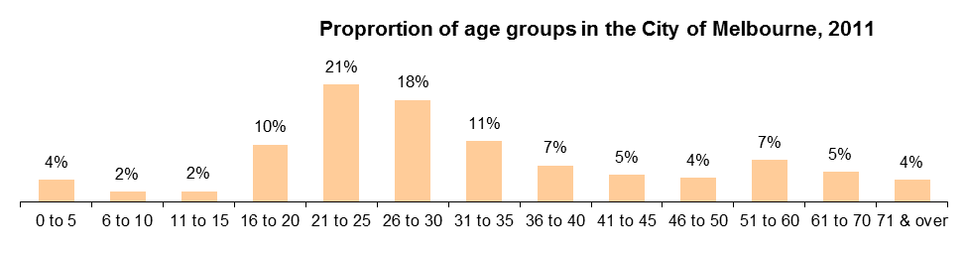
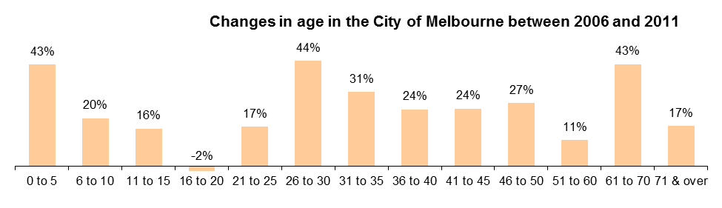
Children/early years

Immunisation

Proper and timely immunisation effectively protects children from a host of debilitating and sometimes deadly childhood diseases and is most effective when a high proportion of the population has been immunised. In 2011, 89.2% of children in the municipality are fully immunised at 24-27 months of age, compared to 93.1% for Victoria.

Health Assessments

Child health assessments evaluate children’s development at particular ages, including growth, physical movements, behaviour, play, physical examinations, hearing and eye screenings and behavioural interactions with family members and peers. In 2008-2009, 53.3% of children attended the 3.5 year key ages and stages visit, less than Victoria at 58.3%.
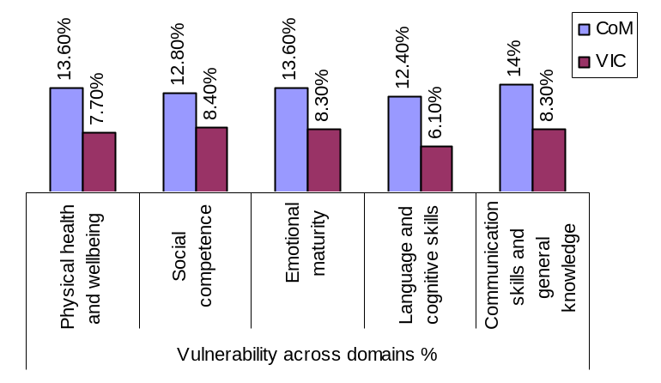
Child Development

The Australian Early Development Index (AEDI) encompasses five domains of child development including: physical health and wellbeing, social competence, emotional maturity, language and cognitive skills and communication skills and general knowledge. 52.5% of children are ‘on track’ on all five AEDI domains, similar to Victoria (55.3%). However, 27.9% children are developmentally vulnerable on one or more domains (Victoria – 20.3%), and 18.2% of children are developmentally vulnerable on two or more of the domains, higher than the 10% for Victoria.

Other health related issues for our children include:
- There were 65 children aged 0 to 8 with a need for assistance with core activities, representing 1.9% of all children in this age group. 27.3% of couple families with children aged 0 to 8 years were renting their dwellings from a state housing authority, greater than the percentage in Victoria (12.3%).
- Single parent families with children aged 0 to 8 years have a gross median weekly income of $435, less than the same income levels for Victoria ($551).
- 8.9% of prep children were reported to have asthma, lower than Victoria (14.4%). Although the City of Melbourne has a greater number of hospital separations for asthma per 1,000 children aged 0 to 8 (16.2) than Victoria (8.1).

Youth

Young people and young adults (12 to 35 years of age) comprise the largest proportion of the residential population at over 60% and this is forecast to maintain the same proportion in 2016. Young people aged 20 to 24 years make up one of the largest overseas born population groups in the municipality. The top ten birth places for those aged 12 to 25 are Malaysia, China, Indonesia, England, New Zealand, Singapore, Hong Kong, India, Korea and Vietnam. The age structure and ethnic and cultural profiles of the municipality’s young people are heavily influenced by the large, young, student population (especially the young international students). Of the 18,000 (approximate) international students residing in the City of Melbourne, over 15,000 are under the age of 25 years.

Young people face unique challenges which can impact their health and wellbeing including:
- Most young people live alone or in group households.
- There are a relatively large proportion of young people in households paying high rent and a proportion of them may be living in households experiencing housing stress.
- Approximately 39% of young people living in the municipality were not in the labour force. Overseas born students were more disadvantaged than average, in terms of employment outcomes.
- Young people generally earned lower incomes than the municipal average. Young people who earned incomes below $399 per week were most highly clustered in Melbourne CBD, Southbank, Carlton, Parkville, and North Melbourne.

Older adults

Almost two thirds of people who were severely or profoundly disabled (over 760 or 62%) were older people. Older people aged over 84 years were most likely to have a need for assistance, due to severe or profound disability (they were 30% of older people and 18% of the total population). Almost 700 older residents provided unpaid care for a person with a disability (9.5% of older people). While older people comprised 9.5% of the population they made up 17% of the carers for people with disabilities, meaning older generations shouldered the greater role in caring for a person with a disability.

With life expectancy rates increasing in the municipality (refer to page 5), there is likely to be more older adults aged in their 80’s and 90’s. As a result, there is likely to an increasing in demand for people who require aged and health support services and care.

Other health and wellbeing issues for older adults may include:
- 80% of older people live alone or in a couple household without children. This has implications for older resident’s experience of social isolation and mental health, especially if coupled with limited mobility or other health issues which make getting out and about difficult.
- The older population in the City of Melbourne are more likely to be living in public housing than the remainder of the population, many of whom earn less than $399 per week highlighting an at risk population group.
- A large proportion of older adults earn relatively low and fixed incomes.
- Older adults who experience socio-economic disadvantage are placed at risk of food insecurity, poor nutrition, social isolation and poor mental health.

WHAT DOES THIS MEAN FOR CITY OF MELBOURNE?

As people transition through different life stages, their health and wellbeing needs will differ. As the population grows, there will be increased demand for support services for these population groups.

Overview

In many aspects, the City of Melbourne presents a healthy picture. Our life expectancy at birth continues to rise, we have average rates of overweight and obesity, the lowest prevalence of type 2 diabetes in Victoria and a large majority of people are getting sufficient exercise and are eating enough fruit for health benefits.

But our health isn’t perfect. Cancer and heart disease are our leading chronic diseases, we have the highest rates of chlamydia notifications in Victoria, overweight and obesity is a problem for our men, mental health issues are experienced to various degrees and family violence is a significant issue. In addition, many people are not engaging in healthy behaviours with a low intake of vegetables, high levels of alcohol and drug misuse and harms, poor health check-up and sun protection rates and low community and civic participation.

The social, economic, built and natural environmental characteristics that make up the municipality strongly influence the opportunities and resources the community has to lead healthy and fulfilling lives. Some of the key factors which impacts on people’s health and wellbeing include:
- Inner city living costs are high. Housing prices will continue to be unaffordable for many lower and middle income households. Already the cost of housing is particularly significant to people on lower incomes with 6.5% of home purchasers and 29.5% of renters in the municipality experiencing housing stress.
- The cost of essential items such as food, petrol, housing and transport are rising, meaning people experiencing disadvantage will face increasing pressures over time.
- There is a large number of people living alone as the city attracts students and young professionals which may have implications for social inclusion.
- The city attracts people to come and socialise which is linked with problems around personal and community safety as we’re seeing alcohol and other drug use and related harms becoming an increasing problem. Similarly, it becomes a hot spot for crime with increases in people with weapons, theft and drug possession and use.
- Increasing urban density and moving towards a 24-hour city will lead to more congestion, noise and pollution.
- As the climate changes there will be impacts e.g. effects of heat especially in built up areas that can trap heat.
- The inner city will always be an attractor for people who are homeless as most support services such as emergency food and housing relief are located in the central city area.

It is important to note that these health issues and environmental conditions will hit our most disadvantaged the hardest. There is a substantial body of evidence that shows that people of lower socio-economic status have worse health than others. This evidence shows that those living in areas of greater socio-economic disadvantage:
- Self-report their health more negatively.
- They are more likely to have chronic health issues such as arthritis, asthma, bronchitis/emphysema, ulcers, diabetes, dental problems and women are more likely to be overweight or obese.
- They are more likely to die of bronchitis/emphysema, pneumonia/influenza, lung cancer, diabetes, cerebrovascular disease (mostly strokes), suicide and traffic accidents.
- They are more likely to engage in unhealthy behaviours such as smoking and males are more likely to consume alcohol at medium to high risk levels.
- They are less likely to have taken preventative health actions such as immunising children against contagious diseases, or having certain cancer screening tests.
- Least likely to have private health insurance.
- In addition, a lack of economic resources can influence people’s ability to access basic essentials such as food, housing, transport and health care.
- It can also impact on people’s ability to participate in their community leading to higher levels of anxiety, social isolation and marginalisation.

This has significant implications for our disadvantaged in the municipality. While we are ranked 13th most socio-economic advantaged municipality in metro Melbourne, there are clear pockets of socio-economic disadvantage found in North Melbourne, Carlton and Kensington. These areas have high proportions of vulnerable population groups including:
- Low income earners (earning less than $399 per week)
- Unemployed
- Families with children under 0 to 12 years, particularly single parent households
- People with low English proficiency
- Students
- Older adults, particularly those who have a disability, live alone/in public housing
- People who are severely or profoundly disabled who need assistance with core activities
- People who are sleeping rough or homeless

It is also important to note that there will be different health issues experienced by people of different ages. The health issues of children will be different to older adults and therefore what they need in terms of support and services will differ.

The City of Melbourne health and wellbeing issues

An examination of the data highlights the following areas of health and wellbeing that the City of Melbourne needs to prioritise as part of the Municipal Public Health and Wellbeing Plan for 2013-17.

Areas where the City of Melbourne is doing well or on par with the rest of the state:
- Life expectancy
- Type 2 diabetes prevalence
- Fruit intake
- Physical activity levels, especially incidental activity such as walking and cycling
- Breastfeeding rates
- Overweight and obesity levels, particularly for women
- Smoking rates
- Getting health check ups for eye care, pap smears and mammograms

Areas where the City of Melbourne is doing poorly:
- Socio-economic disadvantage particularly in North Melbourne, Carlton and Kensington
- Housing stress and homelessness
- Males are more overweight compared to females
- Prevention of chronic illness including cancer (men) and heart disease and osteoporosis (females)
- High rates of chlamydia (sexually transmitted infection)
- Mental health, including depression and anxiety
- Physical activity, especially for males
- Predominately sitting or standing at work
- Vegetable intake
- Poor access to food (food insecurity)
- Males who consume alcohol at low risk levels and are at short-term risk of alcohol-related harm
- Alcohol-related ambulance attendances
- Drug-related ambulance attendances particularly for ecstasy, GHB and cocaine
- Sun protection – not wearing either a hat or sunglasses
- Getting health checks for blood pressure check aged 50 +, bowel cancer, cholesterol and diabetes
- Community participation
- Crime rates
- Perceptions of safety at night
- Family violence
- Food safety
- Noise management
- Climate change impacts, especially heat stress

Overall, the data highlights the following as broad key health issues for the municipality (not in order of importance):
- Chronic disease prevention (cancer, heart disease, osteoporosis)
- Sexual and reproductive health, particularly around sexually transmitted diseases such as chlamydia
- Mental health
- Physical activity
- Healthy eating, especially vegetable intake
- Food security
- Alcohol and other drugs
- Social inclusion
- Safety including crime, perceptions of safety at night and family violence
- Environmental health including food safety, noise management and heat wave management

Estimate has a relative standard error of between 25 and 50 per cent and should be interpreted with caution.
A serve is half a cup of cooked vegetables or a cup of salad vegetables.
Developmentally vulnerable children score in the lowest 10% of the National AEDI population. These children demonstrate a much lower than average ability in the developmental competencies measured in that domain.

