URBAN FOREST TREE PROTECTION
Tree protection information for service providers and contractors within the City of Melbourne
Updated January 2022
Contents
Tree Protection 3
Tree Protection Requirements 3
Tree Root Sympathetic Excavation Methods 5
Tree Pruning 5
Tree Removal 5
Hording and Gantry 5
Tree Protection Management Plans 5
Contact Details 6

Tree Protection
The protection of trees is vital to retaining our city’s character and environment. Trees grow in a delicate balance with their environment and any changes to that balance must be minimized if the tree is to remain healthy state and fulfil its potential. It is rarely possible to repair stressed and injured trees, so damage needs to be avoided during all stages of development and construction.
This document guides tree protection requirements for any activity that may occur in the vicinity of City of Melbourne owned or managed trees to ensure their long-term protection, integrity and overall health.
All activities that may occur near public trees must abide by the protection requirements outlined below, in accordance with Council’s Tree Policy 2021.

Tree Protection Requirements
Tree Protection Zones
A Tree Protection Zone (TPZ) shall be established for the duration of any works near a Council tree.
The method outlined in the current Australian Standard AS-4970-2009 Protection of trees on development sites will be used for the allocation of TPZ’s. The TPZ for individual trees is calculated based on the diameter at breast height (DBH) measured at 1.4 meters above ground level. The radius of the TPZ is calculated by multiplying the tree’s DBH by 12.
For example; a tree with a 40cm DBH requires a TPZ of 4.8 metres. This method provides a TPZ that addresses both tree stability and growth requirements. TPZ distances are measured as a radius from the centre of the trunk at ground level. Should the tree canopy extend past the calculated radius then the TPZ will be extended to include all above-ground components of the tree. A TPZ shall be no less than 2m.
In some cases, the TPZ will be modified or reduced due to other factors, such as hard surfacing or impediments to root growth. Council’s arborist must approve any modification to a TPZ.
The following activities are not permitted within a TPZ:
• Excavation other than root sympathetic excavation methods
• Stockpiling of building materials, debris or soil
• Storage of equipment or tools
• Vehicular traffic except on existing paved surfaces
• Installation of service pits or hatches
• Permanent or temporary vehicular crossings
• Severing of tree roots with a diameter greater than 30mm
• Alteration of soil levels and structure
• Refuelling

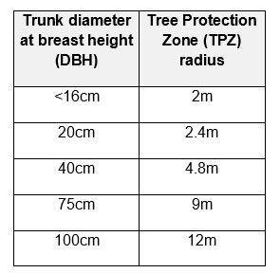

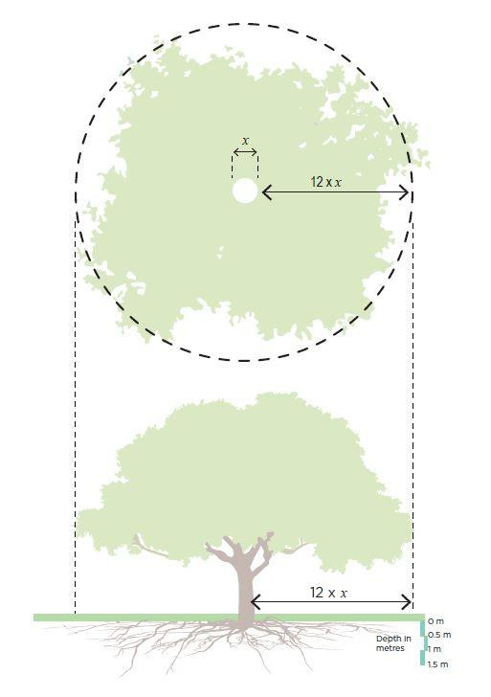

Tree Root Sympathetic Excavation Methods
Boring is the preferred method for service installation within TPZ’s. When boring is not possible, excavation shall be by hand or non-destructive digging at low pressure with approval from Council’s arborist.
Boring entry and exit pits must be positioned outside the designated TPZ of each tree. This requirement should apply unless root sympathetic exploratory investigations have been undertaken and it has been determined by an Arborist that access within the TPZ will not significantly impact the tree.
The extent or length of boring in the vicinity of trees will be determined by the TPZ.
The depth of the boring will depend on the size of the tree.
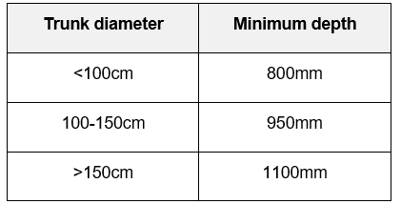

Tree Pruning
No City of Melbourne tree may be pruned or branches removed by anyone other than those authorised by City of Melbourne Parks and City Greening.

Tree Removal
Removal of trees will not occur unless approved by City of Melbourne Arborists.
Where a City of Melbourne tree is approved in relation to a project, the associated cost of the tree and its removal shall be paid by the project or representative prior to removal.

Hording and Gantry
Where a gantry or hoarding is to be constructed over a footpath the placement of the footings and gantry structure must not adversely impact trees. Structures must be placed more than 0.5m away from tree trunks, branches or roots. Footings must not be located within tree plots.
If a tree is enclosed within the hoarding or gantry space, the owner and/or builder are responsible for implementing a maintenance program for affected trees as approved by Council.

Tree Protection Management Plans
A Tree Protection Management Plan (TPMP) is required for any works that do not comply with the above measures.
The TPMP must be endorsed by Council’s Urban Forest and Ecology team prior to the commencement of works.
A TPMP must be developed to minimize impacts on Council trees and to manage tree protection during the works. The plan must be developed in accordance with Australian Standard AS 4970- 2009, Protection of Trees on Development Sites. It must be prepared by a suitably qualified and experienced Arborist and include an assessment of impacts on public trees, recommendations to manage any potential impacts on public trees and identify construction guidelines to be followed through all phases of construction.
A Project Arborist may be requested to be appointed to oversee all works near Council trees for the duration of works.

Contact Details
For further information please contact the City of Melbourne on 03 9658 9658 or email: trees@melbourne.vic.gov.au

