

Transforming Southbank Boulevard and Dodds Street - Construction Bulletin 12

July 2019
Significant progress has been made on the project in recent months, with the reopening of Southbank Boulevard between St Kilda Road and Sturt Street to vehicles and cyclists.
Key roadway works have now commenced on the section of Southbank Boulevard between Moore and Sturt Street, and will continue on to Fawkner Street in the coming weeks.

Current works

St Kilda Road to Sturt Street

All pavement works on both sides of Sturt Street are now complete and the footpaths have been reopened to pedestrians.

Southbank Boulevard and Sturt Street are looking greener with the planting of an additional 35 trees now complete.
Sturt Street to Moore Street
The majority of construction activities have now moved to the section between Sturt Street and Moore Street which include:
- utility installation works
- traffic signal infrastructure
- re-asphalting.

Kavanagh Street to Fawkner Street
Construction activity will commence on the northern side of the section of roadway between Kavanagh Street and Fawkner Street in the week commencing 22 July.
There will be changes to traffic conditions, with detours in place to facilitate east-west vehicle movements on the southern side of Southbank Boulevard.

Landscape works

The new public open space in front of the Melbourne Recital Centre and Southbank Theatre is taking shape with concrete and footings complete, and bluestone works commencing.

Detours

Detours will continue to be in place around the worksite. Please be aware of changing conditions for pedestrians and vehicles as construction takes place in the area.

Cyclists are asked to dismount as they move through the construction zone for safety reasons.
Thank you for your patience.
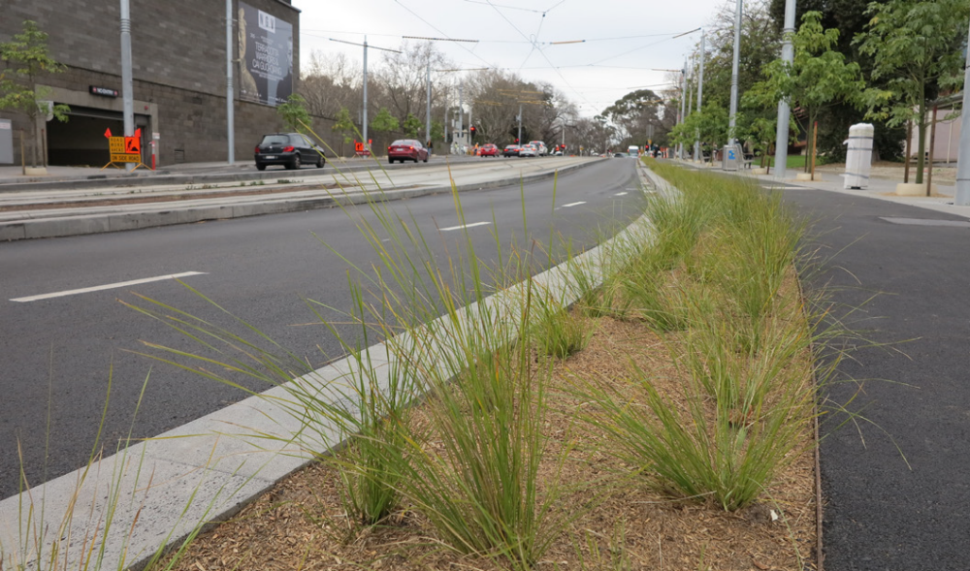
Planting along Southbank Boulevard (between St Kilda Road and Sturt Street) is now complete.
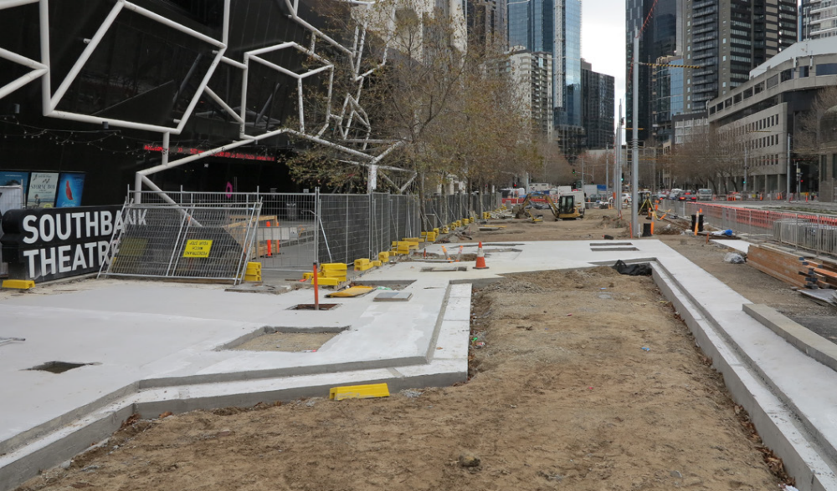
Concreting works in the landscape space to the front of the Melbourne Recital Centre are now close to complete.
To find out more, please contact 9658 9658, email southbankboulevard@melbourne.vic.gov.au, or visit melbourne.vic.gov.au/southbankboulevard

