

Transforming Southbank Boulevard and Dodds Street

Construction Bulletin 8

February 2019
Construction has recommenced on Southbank Boulevard and Dodds Street after the Christmas and New Year period.
The reopening of this section of roadway has been delayed due to unexpected circumstances, however current construction is focussed on progressing this work as quickly as possible.

Current works
Southbank Boulevard between St Kilda Road and Kavanagh Street is currently closed to vehicle traffic and detours are in place.
Construction works will continue along Southbank Boulevard between St Kilda Road and Sturt Street, with electrical and drainage infrastructure being installed. Once complete, new bluestone kerbs will be installed, footpaths will be constructed, and the asphalt roadway will be completed. These works are estimated to be completed by the end of March 2019.
Construction between Sturt Street and Moore Street will continue over the coming months and this area will remain closed to vehicles.

Sturt Street intersection
Installation of the Sturt Street signals is now complete and commissioning of the signals will be undertaken in the coming weeks. This intersection remains open to north-south vehicle movements, with pedestrian crossings in place to help people move through the area.

Detours and access
Pedestrian access around the precinct will be maintained, and cyclists should dismount as they travel along footpaths within areas which have street closures. The section of Southbank Boulevard between St Kilda Road and Moore Street remains closed, however Sturt Street is open to north-south vehicular traffic. Although Southbank Boulevard is closed, the Grant Street detour remains in place in order to facilitate access to the Arts Precinct along Sturt Street, including the Arts Centre Melbourne carpark, as per the detour maps.

Institutions in the precinct remain operational.
Image: Arts Precinct access via Grant Street for northbound traffic.
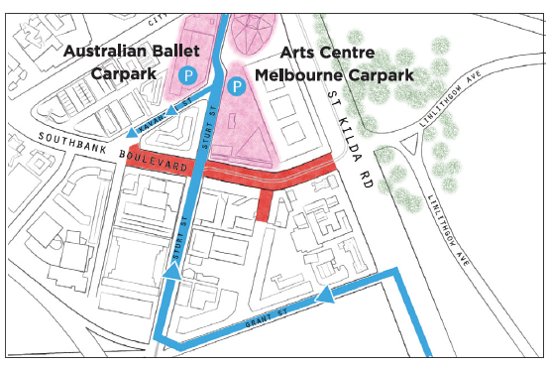
Image: Linlithgow Avenue, Alexandra Avenue and City Road detour.
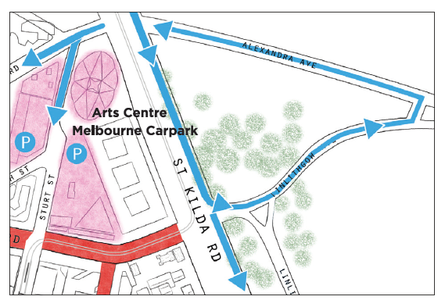

Thank you for your patience
To find out more, please contact 9658 9658, email southbank@melbourne.vic.gov.au or visit Southbank Boulevard

https://www.melbourne.vic.gov.au/southbankboulevard

