Block – Collins Street, Swanston Street, Flinders Street, Elizabeth Street
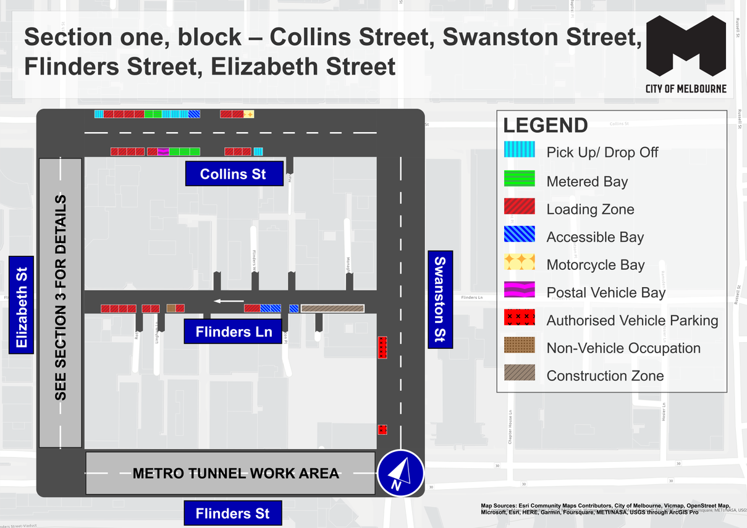
This map presents the parking conditions to be applied within this block as part of the CBD parking improvement project.

Collins Street
The north side, from west to east will include one pick up/drop off space, followed by four loading zones, two metered parking spaces, three pick up/drop off spaces, one accessible parking space, two loading zones and one motorcycle parking area.
The south side, from east to west will include one pick up/drop off space, followed by three loading zones, three metered parking spaces, one postal vehicle space and four loading zones.

Swanston Street
The west side, from south to north will include two areas of authorised vehicle parking

Flinders Lane
The south side, from east to west will include a temporary construction zone, followed by three accessible parking spaces, two loading zones, one non-vehicle occupation and six loading zones.

Flinders Street
Currently has no parking due to Metro Tunnel Project work area

Elizabeth Street
See Section 3 for details

Parking controls to be applied
Simplified and consistent parking controls will be applied across the CBD.
Pick up/drop off spaces will typically be signed ‘No Parking’ with supplementary signage indicating permitted use of the space for passenger pick up/drop off with a 2 minute limit.
Metered parking spaces will typically be signed 2P meter, 7am to 10pm, Monday to Sunday. Off-peak pricing in the CBD commenced from 3 July 2023 and includes a reduced rate of $4 per hour, Monday to Friday from 7pm and all weekend. The offer of $0 payment for short stays of up to 15 minutes in any CBD metered parking space commenced from 3 July 2023 via the EasyPark app. This allows flexibility for quick stays in any green-sign space rather than restricting them to a small number of designated bays (e.g. ¼P).
Loading Zones will typically be signed as 30 time limited spaces from 7am to 4pm Monday to Friday. Loading Zones will typically be converted to 2P meter parking spaces from 4pm to 10pm, Monday to Friday and 7am to 10pm Saturday and Sunday. Some full time Loading Zones will be placed in areas of very high demand. People making deliveries also have the option of using green-sign spaces for short stays of up to 15 minutes free via the EasyPark app.
Accessible parking spaces will typically be signed 2P, 7am to 10pm, Monday to Sunday. Blue line-marking will be applied.
Motorcycle parking will be signed as a designated motorcycle parking area with no time restrictions.
Car share spaces will typically be signed as Permit Zone for the permitted car share vehicle operator.
Postal Vehicle spaces will be signed as ‘No Parking, postal vehicles excepted’. They can be used by Australia Post vehicles and any other vehicle needing to access an adjacent postbox.
Taxi Zones will be designated in areas with high taxi demand. This includes at railway stations to support transport interchange and key tourist destinations.
Tourist coach spaces will typically be signed as ‘No Stopping, buses stopping less than 15 minutes excepted’ to facilitate passenger pick up / drop off in the CBD. Longer term tourist coach parking will be provided at key tourist destinations and in designated areas outside the CBD.
Authorised vehicle parking refers to access for permitted uses only.
Non-vehicle occupations include temporary infrastructure in place of a parking space (e.g. outdoor dining parklet).
Construction Zones will be signed as ‘Permit Zone’ to facilitate temporary use of street space for building construction.

