Block – Bourke Street, Exhibition Street, Collins Street, Russell Street
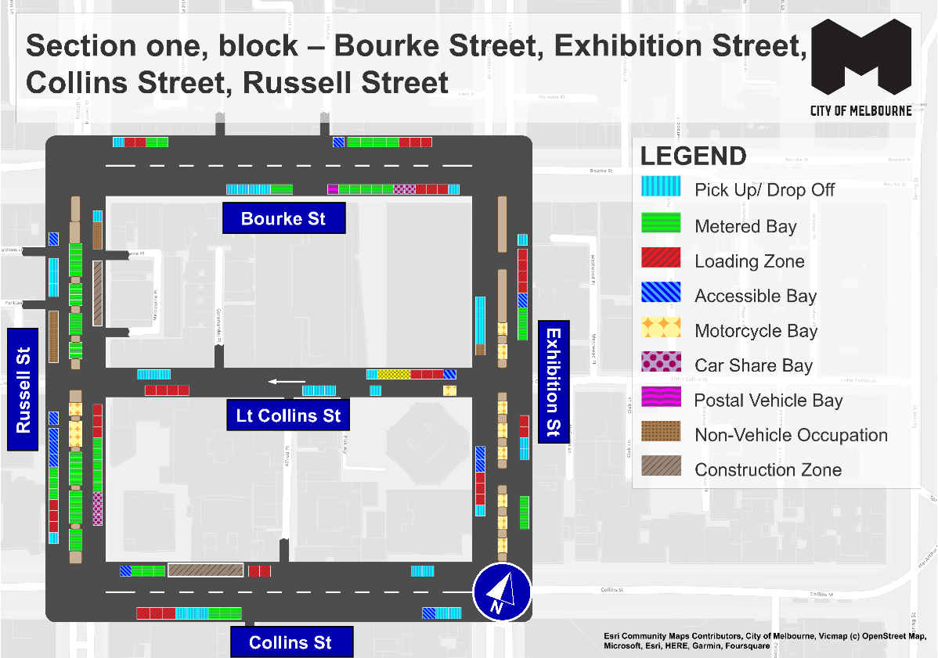
This map presents the parking conditions to be applied within this block as part of the CBD parking improvement project.

Bourke Street
The north side, from west to east includes one pick up/drop off space followed by two loading zones, two metered parking spaces, one accessible parking space, four metered parking spaces and three loading zones.
The south side, from east to west will include one pick up/drop off space, followed by three loading zones, two car share spaces, five metered parking spaces, one postal vehicle space, two metered parking spaces and four pick up/drop off spaces.

Exhibition Street
The west side, from south to north, will include one pick up/drop off space, three loading zones, two accessible parking spaces up to the intersection with Little Collins Street. This is followed by one non-vehicle occupation and four pick up/drop off spaces.
The centre of road has eight areas of motorcycle parking.
The east side, from north to south, will include one pick up/drop off space, four loading zones, one accessible parking space and three metered parking spaces to the intersection of Little Collins Street. This is followed by two loading zones, two pick up/drop off spaces and three metered parking spaces.

Collins Street
The north side, from west to east will include one accessible parking space, followed by three metered parking spaces, a construction zone area, two loading zones and two pick up/drop off spaces.
The south side, from east to west will include two pick up/drop off space, followed by one accessible parking space, three metered parking spaces, three pick up/drop off spaces and three loading zones.

Russell Street
The west side, from south to north will include one pick up/drop off space, followed by three loading zones, three metered parking spaces and four accessible parking spaces up to the intersection with Little Collins Street. This is followed by one non-vehicle occupation area, one non-vehicle occupation, three pick up/drop off spaces and one accessible parking space.
The centre of road parking, from north to south includes seventeen metered parking spaces to the intersection of Little Collins Street, followed by two motorcycle parking areas and a further sixteen metered parking spaces.
The east side, from north to south will include one pick up/drop off space, followed by one non-vehicle occupation area and a temporary construction zone area to the intersection of Flinders Lane. This is them followed by three loading zones, five metered parking spaces and three car share spaces.

Little Collins Street
The north side, from east to west will include one accessible parking spaces, three loading zones, three taxi zone spaces and four pick up/drop off spaces.
The south side, from east to west will include one motorcycle parking space, followed by four pick up/drop off spaces and four loading zones.

Parking controls to be applied
Simplified and consistent parking controls will be applied across the CBD.
Pick up/drop off spaces will typically be signed ‘No Parking’. We will add signage to explain that the space is for passenger pick up / drop off for up to 2 minutes.
Metered spaces will typically be signed ‘2P Meter, 7am – 10pm, Mon – Sun’. Off-peak pricing in the CBD started on 3 July 2023 and includes a reduced rate of $4 per hour after 7pm weekdays and all weekend. The offer of $0 payment for short stops of up to 15 minutes in any CBD metered parking space via the EasyPark app started on 3 July 2023. This allows short stops in any green-sign space rather than limiting short stops to a small number of specific bays (for example, ‘¼P’).
Loading Zones will typically be signed as ‘Loading Zone, 30-minute, 7am – 4pm, Mon – Fri’. These spaces will typically become ‘2P Meter, 4pm – 10pm, Mon – Fri’ and ‘7am – 10pm, Sat – Sun’. We will place some full time Loading Zones in areas with very high demand for deliveries. People making deliveries can also use green-sign spaces for short stays of up to 15 minutes for $0 via the EasyPark app.
Accessible (disability) parking spaces will typically be signed ‘2P, Disability Only, 7am – 10pm, Mon – Sun’. We will apply blue line-marking to these spaces.
Motorcycle parking will be signed as ‘P, Motor Cycles Only’ with no time restrictions.
Car Share spaces will typically be signed as ‘Permit Zone, Car Share Vehicles’ for the permitted car share vehicle operator.
Postal Vehicle spaces will be signed as ‘No Parking, Postal Vehicles Excepted’. They can be used by Australia Post vehicles, and by any other vehicle needing to access an adjacent postbox for up to 2 minutes.
Taxi Zones will be placed in areas with high demand for taxis. This includes at railway stations to support transport interchange and at key tourist destinations.
Tourist coach spaces will typically be signed as ‘No Stopping, Buses Stopping Less Than 15 Minutes Excepted’. This allows passenger pick up / drop off in the CBD. We will provide longer term parking for tourist coaches at key tourist destinations and in selected areas outside the CBD.
Authorised vehicle parking means access for permitted uses only (for example, Swanston Street delivery permit holders).
Non-vehicle occupation includes temporary infrastructure in a parking space (for example, an outdoor dining parklet).
Construction Zones will be signed as ‘Permit Zone, Construction Vehicles’ to allow construction vehicles with a permit to stop and park.

