Block – Franklin Street, Elizabeth Street, La Trobe Street, Queen Street
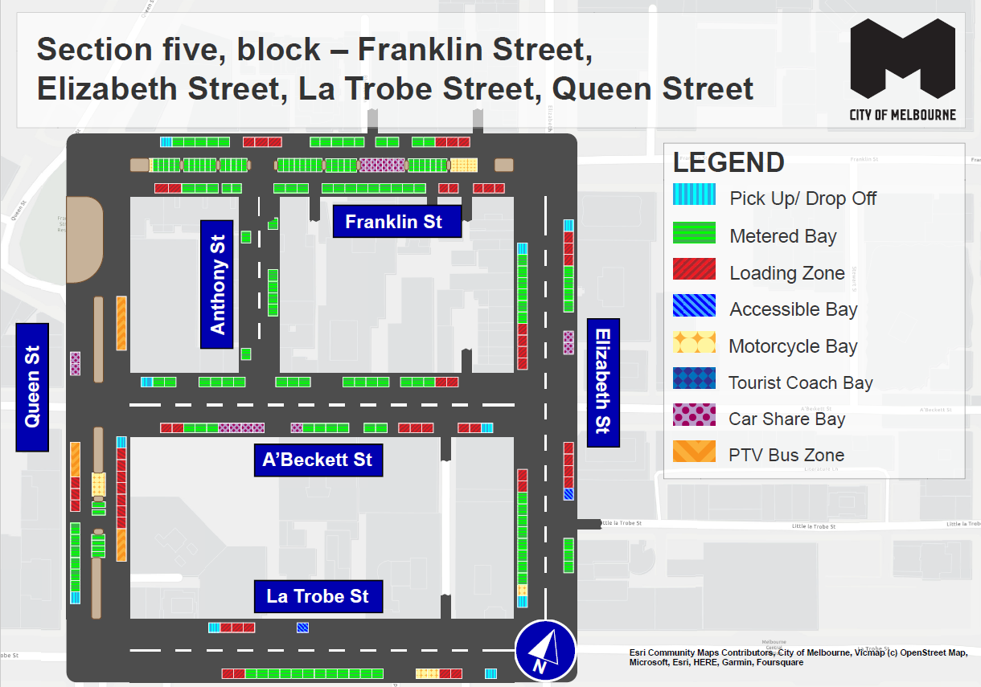
This map presents the parking conditions to be applied within this block as part of the CBD parking improvement project.

Franklin Street
The north side, from west to east, includes one pick up/drop off space followed by five metered parking spaces, three loading zones, nine metered parking spaces and a further three loading zones.
The south side, from east to west, includes five loading zones followed by 17 metered parking spaces and two additional loading zones
The centre of road parking, from west to east, includes on motorcycle parking area followed by 29 metered parking spaces, eight car share spaces, seven metered parking spaces and an additional motorcycle parking area.

Elizabeth Street
The west side, from south to north, includes one pick up/drop off space, one motorcycle parking area, eight metered parking spaces and two loading zones to the intersection of A’Beckett Street. This is followed by four loading zones, six metered parking spaces and one pick up/drop off space.
The east side, from north to south, includes one pick up/drop off space followed by three loading zones, four metered parking spaces and two car share spaces to the intersection of A’Beckett Street. This is followed by four loading zones, one accessible parking space and three metered parking spaces.

La Trobe Street
The north side, from west to east, includes one pick up/drop off space followed by three loading zones and one accessible parking space.
The south side, from east to west, includes one pick up/drop off space, two loading zones, one motorcycle parking area, 12 metered parking spaces and two loading zones.

Queen Street
The west side, from south to north, includes one pick up/drop off space, six metered parking spaces, three loading zones and one PTV bus zone to the intersection of A’Beckett Street. This is followed by two car share spaces.
The east side, from north to south, includes one PTV bus zone to the intersection of A’Beckett Street. This is followed by one pick up/drop off space, seven loading zones and one additional PTV bus zone.

A’Beckett Street
The north side, from west to east, includes one pick up/drop off space followed by 16 metered parking spaces and two loading zones.
The south side, from east to west, includes one pick up/drop off space, five loading zones, six metered parking spaces, five car share spaces, three additional metered parking spaces and two loading zones.

Anthony Street
Includes two metered parking spaces on the west side and five metered parking spaces on the east side.

Parking controls to be applied
Simplified and consistent parking controls will be applied across the CBD.
Pick up/drop off spaces will typically be signed ‘No Parking’. We will add signage to explain that the space is for passenger pick up / drop off for up to 2 minutes.
Metered spaces will typically be signed ‘2P Meter, 7am – 10pm, Mon – Sun’. Off-peak pricing in the CBD started on 3 July 2023 and includes a reduced rate of $4 per hour after 7pm weekdays and all weekend. The offer of $0 payment for short stops of up to 15 minutes in any CBD metered parking space via the EasyPark app started on 3 July 2023. This allows short stops in any green-sign space rather than limiting short stops to a small number of specific bays (for example, ‘¼P’).
Loading Zones will typically be signed as ‘Loading Zone, 30-minute, 7am – 4pm, Mon – Fri’. These spaces will typically become ‘2P Meter, 4pm – 10pm, Mon – Fri’ and ‘7am – 10pm, Sat – Sun’. We will place some full time Loading Zones in areas with very high demand for deliveries. People making deliveries can also use green-sign spaces for short stays of up to 15 minutes for $0 via the EasyPark app.
Accessible (disability) parking spaces will typically be signed ‘2P, Disability Only, 7am – 10pm, Mon – Sun’. We will apply blue line-marking to these spaces.
Motorcycle parking will be signed as ‘P, Motor Cycles Only’ with no time restrictions.
Car Share spaces will typically be signed as ‘Permit Zone, Car Share Vehicles’ for the permitted car share vehicle operator.
Postal Vehicle spaces will be signed as ‘No Parking, Postal Vehicles Excepted’. They can be used by Australia Post vehicles, and by any other vehicle needing to access an adjacent postbox for up to 2 minutes.
Taxi Zones will be placed in areas with high demand for taxis. This includes at railway stations to support transport interchange and at key tourist destinations.
Tourist coach spaces will typically be signed as ‘No Stopping, Buses Stopping Less Than 15 Minutes Excepted’. This allows passenger pick up / drop off in the CBD. We will provide longer term parking for tourist coaches at key tourist destinations and in selected areas outside the CBD.
Authorised vehicle parking means access for permitted uses only (for example, Swanston Street delivery permit holders).
Non-vehicle occupation includes temporary infrastructure in a parking space (for example, an outdoor dining parklet).
Construction Zones will be signed as ‘Permit Zone, Construction Vehicles’ to allow construction vehicles with a permit to stop and park.

