Oh

Fawkner Park upgrade

Project update

December 2021
Fawkner Park is one of Melbourne’s most popular parks with over 9,000 people enjoying the park on a daily basis. To ensure the park’s ongoing health and sustainability, the City of Melbourne has endorsed a concept plan for a number of improvements at the entrance to Fawkner Park from Pasley Street North.
Works to improve the park will commence in December 2021 and will be complete by mid-2022.

Key improvements
Tree and landscape health
- Drainage improvements to slow down water and allow it to soak into the ground during high storm water flow events.
- De-compacting soil and mulching under existing trees to improve water retention.
- The planting of 21 new trees, complementing the landscape of Fawkner Park.
- Feature seating to protect existing trees from compaction by reducing access to tree root zones.
Basketball court
- Relocation of the basketball court and re-landscaping the area with a sloping lawn to assist drainage.
- Additional line markings to allow for other informal recreation uses, making it multi-purpose.
Improved access and amenity
- Improving the overall amenity of the entrance to reflect the importance of Fawkner Park as a premier park.
- The creation of a new path to improve pedestrian safety and cyclist circulation in the area.
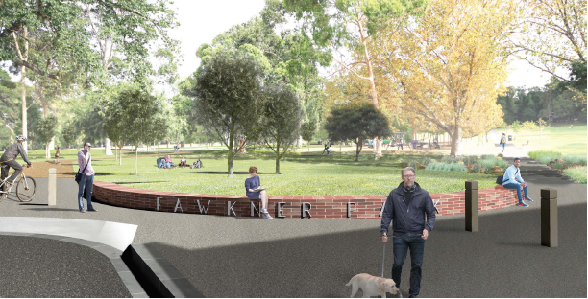
Artist impression of the new Pasley Street north entrance
Interpreter services
We cater for people of all backgrounds
Please call 03 9280 0726

To find out more, please contact 9658 9658, or visit melbourne.vic.gov.au/cityprojects

