Crafting an Accessibility
Guide

Enhance inclusivity: Your blueprint to creating an
accessibility guide

Table of Contents
Introduction 4
Accessibility 5
Understanding different types of disabilities 5
Mobility and motor disabilities 5
Blind or low vision 5
Deaf or hard-of-hearing 5
Cognitive disability 5
Psychosocial disability 6
Neurodiversity 6
Communication disability 6
Environmental sensitivities 6
Your ultimate toolkit to create an accessibility guide 7
Who uses Accessibility Guides? 7
Why are they so important? 7
Key components 8
In-practice examples of physical accessible features 9
In-practice accessible communication features 11
10 Steps to success 13
Tips and best practices 14
Sample of accessibility guide 15
Welcome 15
Contact us 15
Getting here 15
Travel by Public Transport 15
Parking 15
Arrival 16
Path to the main entrance 16
Main entrance 16
What to expect 16
Indoor dining area 16
Furniture 17
Restrooms 17
Accessible toilet 18
Communication 19
Menu 19
Sounds 19
Scents 19
Lighting 19
Disclaimer: 20

Providing an accessibility guide is not just a step towards inclusivity; it's an expression of your commitment to ensuring that every individual is afforded the same opportunity to experience, engage with, and contribute to the world around them.

Introduction
Welcome to the Online Accessibility Guide: Inclusive Digital strategies for every business, a valuable resource developed for the City of Melbourne by Flare Access. A comprehensive resource designed to empower you in building a more inclusive future for your business or organisation. In today's increasingly diverse and discerning world, crafting an accessibility guide isn't merely a good idea – it's a pivotal necessity.
The facts are clear: A lack of information about a venue or service acts as a barrier, obstructing meaningful engagement between individuals with disability and your business. Think of it as a roadblock preventing customers, visitors, and clients from accessing your offerings.
Here's where you become the architect of change. By creating an accessibility guide you aren't just breaking down barriers; you're constructing pathways to inclusion, understanding, and connection. The advantages are not only moral and social but also undeniably practical.
An accessibility guide isn't just a document; it's a powerful tool. It showcases your commitment to serving everyone, regardless of their abilities or disabilities. It instils trust and confidence, cultivating a loyal customer base.
Moreover, an accessibility guide enhances your brand reputation. It sends a resounding message that your organisation is progressive, compassionate, and deeply attentive to the diverse needs of your community.
In this toolkit, we will empower you with the knowledge, strategies, and inspiration needed to embark on the accessibility guide journey. We'll guide you through the "why" and "how" behind these invaluable resources. Together, we will take practical steps toward a world where accessibility is not just a concept; it's a reality.

Accessibility
Accessibility refers to the design and provision of products, services, environments, and information in a way that allows people with disabilities, including those with physical, sensory, cognitive, or other disability, to access and use them with the same degree of ease and effectiveness as individuals without disabilities.
It aims to eliminate barriers and ensure equal opportunities, enabling everyone to participate fully in all aspects of life, including education, employment, public spaces, transportation, technology, and communication.
Accessibility encompasses a wide range of considerations, from physical infrastructure like ramps and elevators to digital content and information that can be read by screen readers, sign language interpretation, and other features that cater to diverse needs and abilities.

Understanding different types of disabilities
Understanding different types of disabilities is crucial when creating accessibility guides because it allows for more comprehensive and effective solutions to meet the needs of diverse individuals. Here is an overview of various types of disabilities and their relevance to accessibility guides:

Mobility and motor disabilities
Mobility and motor disabilities can range from difficulty walking, to complete paralysis or reduced upper limb function. Accessibility guides should address issues such as wheelchair accessibility, fixtures and fittings, and the distance between locations.

Blind or low vision
Individuals with visual disability may be blind or have low vision. Accessibility guides should consider providing information about lighting, navigation and wayfinding, availability of alternative forms of communication such as Braille or large print and multi-sensory experiences.

Deaf or hard-of-hearing
Deaf or hard-of-hearing individuals may benefit from information on the availability of alternative forms of communication such as sign language interpreters, assisted listening systems or captioning services for live events or videos, as well as multisensory experiences.

Cognitive disability
Some individuals have cognitive disabilities that affect their ability to process information. Accessibility guides describe the availability of Easy Read material, the availability of customer service support and useful information about what to expect once they arrive.

Psychosocial disability
Access guides benefit people with psychosocial disabilities by providing clear and predictable information, reducing anxiety and uncertainty in unfamiliar environments, and enabling them to plan and participate in activities with confidence and comfort.

Neurodiversity
Some people who are neurodivergent are sensitive to sensory stimuli. Accessibility guides may include details about noise levels, lighting, and crowdedness and peak periods helping individuals to anticipate and manage sensory experiences.

Communication disability
Individuals with communication disability may require alternative communication methods or assistive devices. Accessibility guides should inform visitors about the availability of such resources and any personnel who can assist in communication.

Environmental sensitivities
Some individuals have sensitivities to environmental factors, like certain chemicals or fragrances. Accessibility guides should provide information about any products or practices that could trigger sensitivities and offer alternatives.
We recognise that individuals with disabilities have diverse preferences, with some favouring person-first language and others advocating for identity-first language. In this document, we primarily adopt a person-first language approach, while respecting all perspectives within the community.

Your ultimate toolkit to create an accessibility guide
For people with disabilities, accessibility guides provide vital information that can make their experience more comfortable and enjoyable. By knowing what to expect in terms of accessibility features and accommodations, people with disabilities can plan ahead and make informed choices about where to go and what to do.
An accessibility guide is a document that outlines the accessibility features and accommodations that your business provides for people with disabilities. It serves as a valuable tool for individuals with disabilities to navigate your business and helps them understand the services and accommodations available to them.

Who uses Accessibility Guides?
The guide can be used by people with disabilities, their friends, family and colleagues to determine if a product or service meets their needs. They are also used by businesses and organisations to ensure they are providing accessible options to their customers or clients.

Why are they so important?
Creating an accessibility guide ensures all customers receive consistent and reliable information about the accessibility of the experience and staff can feel confident that they are providing the correct information. Accessibility guides cover a range of topics, including physical accessibility, communication accessibility, and digital accessibility.
Accessibility Guides help save everyone time and effort. By providing a go-to resource, customers can easily find answers to their questions online and staff have the answers at their fingertips when enquiries are received.

Key components
- What to expect
Provide clear information on what to expect and instructions on how to access facilities and services.
- Accessibility policy
A statement outlining your commitment to accessibility, including any relevant laws or regulations.
- Physical accessibility
Information on physical accessibility features, such as ramps, elevators, and accessible parking, grab rails and seating.
- Communication accessibility
Details on how the business provides accessible communication options, such as captioning, sign language interpretation, or assistive listening devices.
- Alternative formats
Information on how the business provides alternative formats of communication or materials for individuals with disabilities.
- Staff training
Information on staff training to ensure they are knowledgeable about accessibility and can provide assistance when needed.
- Service animals
Information on the business' policies and procedures for service animals.
- Contact information
Contact information for accessibility-related questions or concerns.
- Feedback mechanism
A process for customers to provide feedback on accessibility-related issues or concerns.

In-practice examples of physical accessible features
- Ramps
Details about the availability, location, and specifications of ramps, including any potential inclines and handrails.
- Elevators
Information on the presence and accessibility of elevators, including their locations, dimensions, and any auditory or visual indicators.
- Accessible parking
Guidance on accessible parking spaces, including their number, location, size, and proximity to entrances.
- Grab rails
Information about the placement of grab rails in key areas, such as restrooms or staircases.
- Accessible paths
Guidance on accessible pathways, including paving materials and gradients, to ensure easy navigation for those with reduced mobility.
- Width of doorways
Specifications regarding the width of doorways to ensure they accommodate mobility devices like wheelchairs.
- Accessible restrooms
Information on accessible restrooms, including the location, layout, and the presence of features such as grab bars and accessible sinks.
- Seating
Details on accessible seating options, which may include designated spaces, wheelchair spaces, and seating with movable armrests.
- Furniture
Information about furniture such as details of tables including the table height and foot and knee clearance, bed height, or types of seating available.

- Visual and tactile indicators
Indicators for those with low vision, such as tactile ground surface indicators, Braille signage, and audible signals.
- Service counters
Details about accessible service counters or reception desks, including their height and the availability of lower counters for individuals using wheelchairs.
- Signage
Description of signage/ wayfinding and navigation throughout the venue.
- Lighting
Information about lighting conditions and any considerations to reduce glare or harsh lighting for individuals with sensitivity to light.
- Quiet spaces
The availability of designated quiet spaces for individuals with sensory sensitivities or quiet periods of service.
- Emergency evacuation procedures
Clear and concise instructions for individuals with mobility or sensory disability on how to evacuate safely during emergencies.
- Service animal policies
Information on the facility's policies regarding service animals and their accommodation.
- Assistive listening devices
Information about the availability of assistive listening devices such as TV devices, telephone devices or alarm systems.

In-practice accessible communication features
- Sign language interpreters
Information on the availability of sign language interpreters for individuals who are deaf or hard of hearing.
- Captioning services
Details on the provision of captioning for videos, presentations, and other multimedia content.
- Assistive listening systems
Information about assistive listening systems such as Hearing Loops, their location and availability.
- Braille and tactile signage
Indication of the presence of Braille and tactile signage for individuals who are blind or visually impaired.
- Accessible documents
Guidance on requesting or accessing documents in accessible formats, including large print, Braille, or digital text.
- Accessible websites
Information on the website's compliance with web accessibility standards, including features like alt text for images and keyboard navigation.
- Easy-to-read materials
Availability of materials written in plain language to ensure understanding by individuals with cognitive disabilities.
- Communication support staff
Indication of on-site staff trained to assist with communication needs, including the use of communication devices or visual aids.
- Video relay services
Details about the availability of video relay services for individuals who use sign language to communicate via video calls.
- Interpreter request process
Instructions for requesting interpreters or communication support in advance or on-site.
- Audio descriptions
Information about audio descriptions for visual content, enabling individuals with visual impairments to access videos or live performances.
- Telecommunications Relay Services (TRS)
Information about the availability of TRS for phone conversations for individuals with hearing or speech disabilities.
- Sensory-friendly communication
Considerations for individuals with sensory sensitivities, such as minimising loud or sudden noises during communication.
- App-based communication
Information about the use of apps or devices that assist individuals with speech or communication impairments.
- Communication assistance cards
Providing cards or tools that individuals can use to communicate specific needs or requests.
- Clear and accessible signs
Ensuring that signage is easy to read and understand, with clear directions and universally recognised symbols.
Including these features in the accessibility guide helps ensure that individuals with diverse communication needs can effectively interact, engage, and access information or services provided by the facility, promoting a more inclusive and welcoming environment.

10 Steps to success
Step 1
Identify the purpose and scope of the guide: Determine the purpose and scope of the guide. Consider what information should be included and how it will be presented. Who is your audience?
Step 2
Conduct research and gather information: Research accessibility guidelines and best practices, and gather information on the specific needs and requirements of your target audience.
Step 3
Conduct a “Walk Through” of your customer journey considering a range of disabilities to identify all aspects of your customer journey.
Step 4
Develop an outline: Create an outline of the guide, including headings and subheadings that will help you organise the information you gather.
Step 5
Write content: Based on your outline and research, start writing the content for the guide. Use clear and concise language, and include visual aids or examples where necessary.
Step 6
Design and format the guide: Consider the design and format of the guide, including font size and style, colours, and images. Use formatting techniques to make the guide easy to read and navigate.
Step 7
Review and edit: Once the guide is complete, review and edit it for accuracy, clarity, and completeness. Consider having others review the guide to ensure it meets the needs of your target audience.
Step 8
Publish and promote the guide: Finally, publish the guide and promote it through your website, social media, and other relevant channels.
Step 9
Make sure the guide is easily accessible in a range of formats and is available to your target audience.

Step 10
Regularly update the guide: The accessibility guide should be regularly updated to reflect feedback, changes in facilities, services and accessibility features.

Tips and best practices
- Provide detailed information on all aspects of accessibility, including physical access, communication access, and service access. Consider including information on accessible transportation, parking, entrances, pathways, and signage. Consider your entire customer journey.
- Use plain language: Accessibility guides should be written in plain language so that everyone can understand them, avoiding complex terms or acronyms. Use clear, simple language that is easy to understand. Avoid technical jargon and acronyms that may be unfamiliar to your audience.
- Provide clear instructions: The guide should provide clear and concise instructions on how to access different facilities and services.
- Include images and graphics: Images can be used to illustrate different facilities, services and accessibility features. Use images and graphics to help illustrate your points and make your guide more visually appealing e.g. floor plans or maps to help visitors navigate your facility.
- Use alternative formats: Make it easy to access. Ensure your guide is available in a variety of formats, including online, printed, and in alternative formats (such as braille or audio) to make it accessible to everyone.
- Consider a range of access needs: Accessibility guides should consider the needs of people with all types of disabilities, including physical, sensory and cognitive disabilities.
- Regularly update the guide: The accessibility guide should be regularly updated to reflect changes in facilities, services and accessibility features.
- Use a consistent format: The guide should use a consistent format so that users can easily navigate and find the information they need.
- Provide contact information: The guide should include contact information for people who need assistance or have questions about accessibility features.
- Consult with disability groups: It is important to consult with disability groups to ensure that the accessibility guide meets their needs.

Sample of accessibility guide

Welcome
We strive to make our establishment accessible to all customers. This guide is designed to provide information about the accessibility features of our restaurant or bar, as well as any potential barriers that may exist.

Contact us
- Address:
- Phone Number:
- Email:
- Website:

Getting here

Travel by Public Transport
- The nearest stop is for Bus Route 14C with the major stops of:
  - Interchange
  - Waterfront.
- The Route 14C bus is wheelchair accessible.
- It's approximately 290 m away with a step-free route available.

Parking
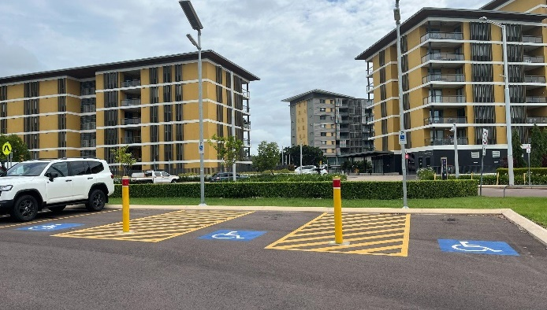
- There are three Accessible parking bays located at Fort Hill. The venue is approximately 130 m from these bays.

Arrival
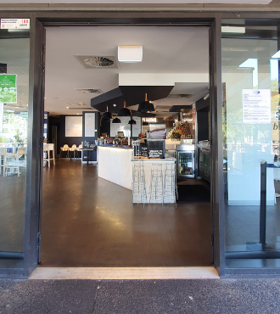

Path to the main entrance
- The external terrain is concrete. From the frontage to the main entrance, there is level access.
- The path is 1000 mm wide, or more.

Main entrance
- There is a clear path of travel from outdoor to indoor areas.
- The main entrance is level with concertina doors that remain open.
- Both doors have a clearance greater than 1000 mm wide.

What to expect
- The dining area has a mix of high and standard tables and chairs.
- Toilets are located inside.
- The open kitchen is located behind the bar.
- Air conditioning is available indoors and is typically used during the Wet season. Fans are available indoors and outdoors.

Indoor dining area
- Tables can be repositioned to increase circulation space to allow a forward or parallel approach to the tables.

Furniture

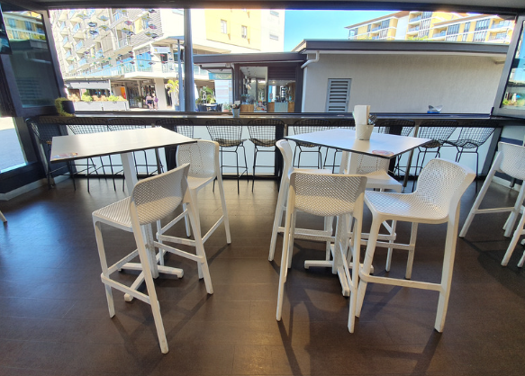
- Tables: Pedestal tables with a height of 745 mm and a clearance height underneath of 718 mm.
- Seating: Firm chairs without armrests with a seat height is 470 mm.
- Space between most tables is greater than 1000mm. Tables can be repositioned to increase circulation space.

Restrooms
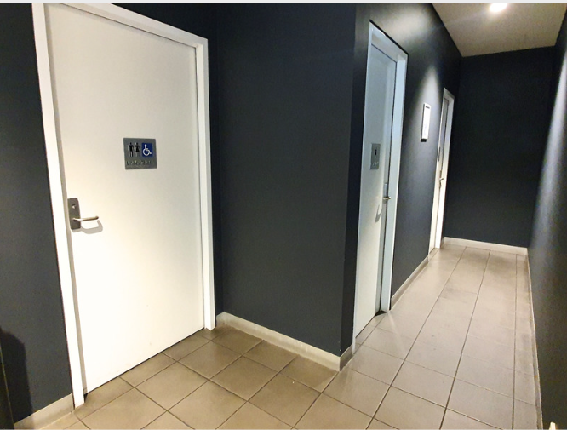
- There is a Unisex RHS Accessible toilet, female and male ambulant toilets and standard male and female toilets.
- Clear signal indicates the different toilets.

Accessible toilet
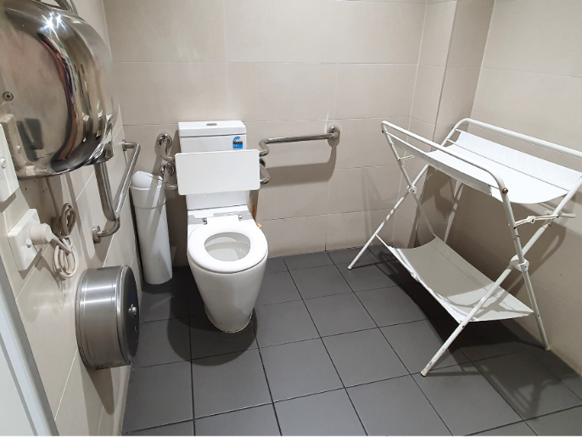
- The door of the accessible cubicle swings inward to the right when entering.
- The door width is greater than 850 mm.
- There is a door lever handle to enter and exit the toilet with a height of 1000 mm.
- Rails are on the right-hand side and to the rear of the toilet with a height of 800 mm.
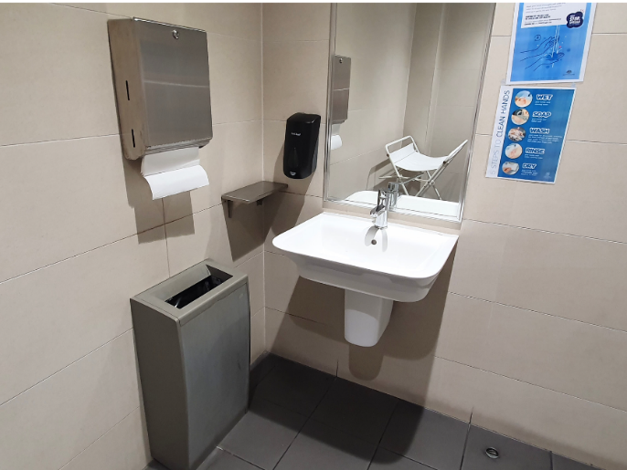
- The basin is located in the cubicle with a lever action tap at a height of 815mm.
- The soap dispenser is at 960mm.
- There is adequate knee and foot clearance under the basin.
- There is a paper towel dispenser at 1100 mm and a hand dryer at 960 mm.
- Lighting in the cubicles and hand washing areas is automatic.

Communication

Menu
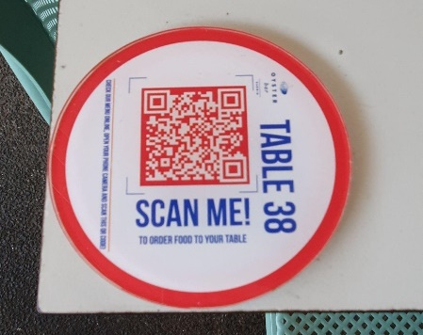
- The drinks and food menus are provided in written format.
- A QR code is available to access food menus online.

Sounds
- Typical sounds from the bar include sounds from glasses, bottles and cocktail shakers.

Scents
- The main scents you will experience will be from the food served.

Lighting
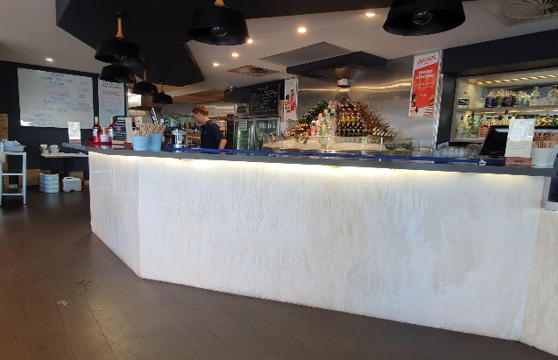
- Both indoor dining areas are well-lit in the day with over 1000 lux.
- In the evening the indoor area has bright lighting in most areas. The lighting of 150 lux is available in some areas according to the positioning of tables under lights.
We welcome your feedback on how we can continue to improve our accessibility. Please contact us with any questions, comments, or concerns.
Guide last updated: 29 May 2023.
Thank you for your dedication to accessibility and for being a part of our mission to make Melbourne more accessible, vibrant, and diverse for all of its residents and visitors.

Disclaimer:
Although we have done our best to ensure the accuracy and reliability of the information provided, we cannot guarantee that it is suitable for every individual's situation.
This advice is provided for general informational purposes only. Any reliance you place on such information is strictly at your own risk. In no event will the City of Melbourne or Flare Access be liable for any loss or damage, including without limitation, indirect or consequential loss or damage, or any loss or damage whatsoever arising from loss of data or profits arising out of, or in connection with, the use of this document.
Accessibility requirements and regulations may vary by location and may change over time. To ensure that your chosen solution meets all necessary standards and regulations, we strongly recommend consulting with accessibility experts or professionals who specialise in accessibility modifications. Their expertise can help tailor solutions to your specific needs and ensure full compliance with current accessibility standards.

