
Community Energy Models for the City of Melbourne

Purpose
The City of Melbourne has explored opportunities to provide access to renewable energy to residents and small businesses who are currently locked out of installing solar on their own roofs. The purpose of this report is to summarise the findings of the work that City of Melbourne has undertaken on community energy opportunities.

Background
The City of Melbourne has an ambitious goal to create a zero-emissions city powered by 100 per cent renewable energy. Our community faces specific barriers to accessing renewable energy generation. Over 80% of City of Melbourne residents live in apartments or rental properties. The density of the built environment, risk of overshadowing, and the complex governance structures of strata buildings means installing rooftop solar is rarely a simple option. A major challenge for the City of Melbourne is to provide residents living and working in these properties a way to engage in renewable energy.
The City of Melbourne declared a Climate and Biodiversity Emergency on 16 July 2019. The Declaration recognises that climate change and mass species extinction pose serious risks to the people of Melbourne and Australia, and should be treated as an emergency. To support our declaration, we have accelerated action and prioritised projects where we can make the most impact on climate change and biodiversity loss.
The Climate Change Mitigation Strategy (2018) identifies accessible community energy as a priority action. The City of Melbourne has investigated existing and emerging community energy models. These models have been assessed against their suitability and commercial viability in Melbourne as well as the potential impact on climate change action. We wanted a project that could provide the benefits of renewable energy to the community similar to traditional rooftop solar projects, and support a just transition.

What is community energy?
Community energy is still an emerging space whilst there is no strict definition it generally encompasses instances where communities are involved in developing, producing, distributing, selling and buying energy assets and their output. In the context of the City Of Melbourne, community energy models have been explored to overcome the identified challenges that our community face in accessing renewable energy. Enlisting community assistance in fulfilling this ambition is a challenge the City embraces.

Community engagement
The City of Melbourne engaged with residents in a number of ways find out what they want from community energy, including information sessions, conferences, market research and design sprints.
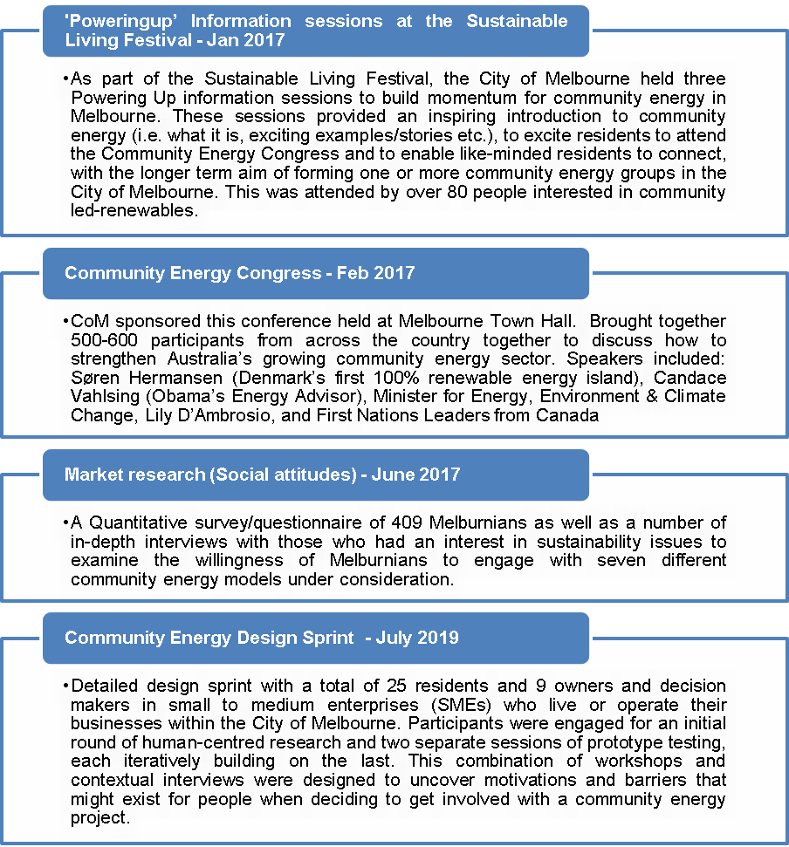

Community attitudes
A number of key insights were gained from this engagement. These findings have been summarised into four key actions to make a project most appealing for community participation.
Bridge the knowledge gap | Community members feel they do not know enough about renewable energy to have a strong preference about where, or how big, a community energy project should be. Any renewable energy project or product will need to address this knowledge gap and build confidence in the model.
People want community energy to feel tangible, and prefer it to make use of underutilised space. Residents don’t necessarily care if the energy is generated in the City of Melbourne - just knowing where it is, is enough to feel connected to the project. |  | Make it tangible
Design for flexibility | Community members would prefer a no-commitment, direct access virtual solar model. However, they do not want to give up the flexibility of choosing an energy provider independently of their community energy membership.
To understand and assess a community energy project, people need personalised information from a trusted source and transparency about their energy costs and returns on investment. |  | Provide a personalised way to consider the options
Make it similar to traditional rooftop solar | Community members expect that projects will return benefits similar or equivalent to that of rooftop solar. They anchor the costs and savings against their electricity bill. They are unlikely to support projects where commercial returns are worse than that of traditional rooftop solar installations. They would prefer that cost savings could be seen on their electricity bill.

Community energy models & options
A targeted scoping study assessed the potential suitability and commercial viability of different community energy models in the City of Melbourne. Six models were assessed:
Table 1 Description of community energy models considered
Model | Description
Networked solution  (e.g. embedded networks, microgrids) | This model provides community members with direct access to renewable energy. Participants invest in generation assets that are connected to their residence/business through network solutions such as embedded networks or microgrids.
Virtual solution  (eg. Solar gardens) | This model provides community members with access to renewable energy sourcing through investment in generation assets that are close by, connected to the grid and distributing electricity through virtual solutions.
Purchasing electricity  (eg. Downscaled Power Purchase Agreement (PPA)) | This model provides community members with remote access to renewable energy sourced through investment in generation assets that can be located anywhere. Purchase agreements allow participants to use the renewable electricity generated. This model is contract based.
Virtual solar,  (transferrable subscription arrangement) | This model provides community members with remote access to renewable energy through investment in generation assets that can be located anywhere and distributing electricity through virtual solutions. This model is subscription based rather than contract based and can be traded between subscribers.
Investment model  (expected return on investment) | This model provides community members with ways to invest to create renewable generation capacity within the City of Melbourne catchment area. While they might fund the energy, they won’t necessarily use it.
Donation model,  (no expected return on investment) | This model provides community members with ways to donate to help create renewable generation capacity where the investor is simply interested in helping a community organisation access renewable solar but them not using the produced renewable energy.

Solar gardens
The model analysis and the insights gained from the community engagement identified a ‘solar garden’ as the most suitable model for further investigation. This option was best understood by community and was seen as the most likely option for building local engagement. The term solar garden mirrors the terminology of ‘community garden’. In the same way that if someone lacks a suitable garden space in their own home they can access a neighbourhood community garden, if someone lacks access/ownership of their rooftop they could access and invest in a suitable local solar system.

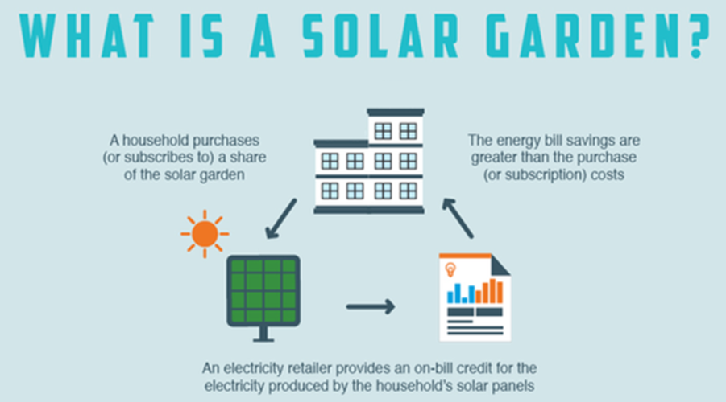
Figure 1 Description of a Solar garden (ARENA 2018)

Queen Victoria Market
The Queen Victoria Market (QVM) represented a suitable site for a large scale rooftop solar installation, due to its large north facing roof and Council ownership. The installation of solar has already been budgeted as part of the City of Melbourne’s efforts to redevelopment efforts to restore the QVMs heritage and improve facilities for traders, customers and visitors. A solar garden project would redirect the benefits of the solar from the market operations to the community participants. The site was identified to be able to support approximately 930kW of solar, servicing a maximum of 620 community participants
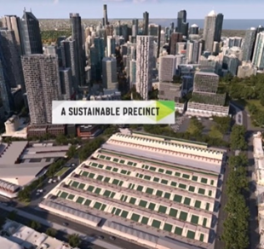
Figure 2 Render image of QVM sheds with solar installed

Solar gardens at the QVM site
.
Council engaged Point Advisory to undertake a study into the viability of a solar garden at Queen Victoria Market. The study found that all models (comprising both Solar Garden and ‘investment’ models) have long payback periods compared to a standard household rooftop solar PV system, which market research has shown will likely deter participation. However, a Solar Garden (or similar model of community renewable energy) could become more attractive at the QVM if certain independent factors could be changed for the better, as outlined in the table below.
 | Upfront cost of solar  all models | Price of LGCs  all models | Increase Behind-the-meter use  Investment and Hybrid SG models
QVM SG study | Solar was conservatively modelled at $1.50/W in the absence of a specific quote for the QVM site. Solar Choice (2020) notes that commercial solar systems can cost as low as $0.98/W installed for a 100 kW system in Melbourne in 20201. | Large Generation Certificate (LGC) prices were assumed to be $10 per MWh. LGC forward prices for 2020 and 2021 are $34.75 and $15.60 respectively (as published by the Clean Energy Regulator on 31 October 2019). | The QVM electricity tariffs (12-16c/kWh) are much higher than the modelled feed-in tariff (6c/kWh), and thus savings increase significantly if behind-the-meter (BTM) use is maximised. 62% of electricity generated is used BTM for the 930 kW system, and 82% for the 500 kW split system at the QVM site.
Future changes | Solar PV costs reduced by 88% between 2010 and 2019, and are forecast to reduce by 13% from 2020 to 20212 (in $/kWh terms). Further annual cost decreases of 13% would reduce solar PV to $0.74/W in 2022, and $0.64/W in 2023. | LGC prices in voluntary markets may converge to the cost of carbon offsets as companies seek to reduce their emissions. If this eventuates, a price of $30 per LGC and beyond in the coming decade is not beyond the realm of possibility. | The future load profile at the QVM may change due to (1) a significant change in base or peak load as a result of the redevelopment or (2) due to a change in market operating hours.

The payback period significantly reduces as a result of changes to the variables identified above for the Investment and Hybrid models, as shown in the table below. Success of the Pure Solar Garden model depends mostly on the feed-in tariff, as well as a moderate benefit from increases in LGC prices.

Payback period -930 kW | 2020 analysis:  $1.50/W, $10/LGC, 62-82% BTM use | Reduced upfront cost to $0.74/W | Increased LGC price to $30 | Increase BTM use to 75-90% (IM/HM) | Combination (all three changes)
Investment model (IM) | 9.9 years | 5.4 years | 8.7 years | 9.0 years | 4.5 years
Hybrid SG Model (HM) | 14.5 years | 7.4 years | 12.6 years | 13.7 years | 6.0 years
Pure SG model | >20 years | 19.4 years | > 20 years | No change | 12.8 years

Creating a successful solar garden for other sites
An optimal site for a solar garden can be identified through several key factors:
 | Solar generation by location | Site retail tariff | Solar PV system size
Optimal site | Other locations are more favourable to solar PV. In Brisbane, average daily solar generation is 4.2 kW/kW and in Perth is 4.4 kWh/kW  Increasing electricity generation by 15% in a more favourable location reduces payback period to 7.7 years (from 9.9 years) for the Investment model (indicative modelling only). | Sites with higher retail tariffs achieve higher savings for models with BTM use. Electricity prices in 2019 for residential properties ranged from around 24-30c/kWh.  When used BTM to displace grid electricity charged at a fixed tariff of 24c/kWh, the QVM Investment and Hybrid models have payback periods of 5.5-6.0 years (indicative modelling only). | Solar systems below 100 kW have two benefits:  - An upfront subsidy from Small scale Technology Certificates (STCs), reducing capital costs by ~30% (e.g. from $1.00 to $0.70/W)  - A guaranteed 10c/kWh feed-in tariff (for 2020).  An upfront subsidy ($0.70/W) and ongoing feed-in tariff (10c) result in a payback of 6.4 years for the Pure SG model at QVM.

Key findings
This commercial feasibility study determined it was not commercially viable to establish a solar garden at QVM. The key findings from this study were:
  - The models show relatively long payback periods (10-20+ years) when compared to a standard household rooftop solar PV system. This payback would be seen as unacceptable to most participants.
  - There is minimal incentive for an electricity retailer to partner on the project due the high administrative burden of solar garden customers and small potential for customer acquisition.
  - Administration of a scheme would require an active community group willing to manage the governance for the life time of the panels (25 years).
  - Council would need to contribute $60,000 set up costs as well as staff resources (estimated at ~1.5 FTE for 12 months) to initiate a project and establish contractual arrangements for community investment into the project.
Future policy changes could improve the viability of a solar garden project.
The following policies could address other key barriers identified regarding retailer participation and low feed-in tariffs:
  - The criteria of the Victorian Government’s Solar Victoria program was updated to include a subsidy for Solar Gardeners (i.e. allowing Solar Gardens to receive the subsidy based on individual ‘plot size’ rather than ‘total system size’).
  - An increase in the feed-in tariff (or bill credit) offered by retailers. A site paying a high electricity tariff than QVM would also expect better commercial returns in any model incorporating behind the meter consumption. However, a modest increase in feed in tariff or consumption tariff would not improve financial outcomes to the level expected by most community members.

Next steps
The findings of this project demonstrated that there are significant barriers to the establishment of a community energy project. These finding indicate that these projects are limited in their ability to deliver cost effective renewable energy provide to residents and small businesses who are currently locked out of installing solar on their own roofs.
The detailed commercial feasibility for a solar garden project at the Queen Victoria Markets found that the project would not generate significant impact in terms of emissions reductions or community engagement. Feasibility at alternative sites would likely deliver similar or worse results given Councils ownership of the market removing a layer of complexity and cost.
Due to the significant investment required by Council (particularly staff time), relative to community benefit, this project does not match the priorities identified as part of the Climate and Biodiversity Emergency declaration and will therefore not be progressed as an action.
The low emissions abatement as well as the low number of residents that would be able to access a pilot at QVM mean this project doesn’t have the reach to generate impact on climate change. Additionally, the low commercial returns that are not in line with community expectations mean that this pilot cannot be easily scaled through inspiring other projects which would be needed to achieve the desired greater impact
To achieve more significant impact we will explore other avenues for delivering low cost renewable energy and engaging our community on climate action. Rather than restricting our view to community energy delivery models, we will investigate options to service a much greater proportion of our residents and businesses. By providing a purchasing model which accelerates renewable energy purchasing by significant numbers of residents & small businesses we hope to be able to drive more significant emissions reductions and engage more of our community on climate action.

https://www.melbourne.vic.gov.au/about-council/vision-goals/eco-city/Pages/climate-change-mitigation-strategy.aspx
https://arena.gov.au/news/solar-gardens-bring-rooftop-solar-australians/

