1. Nature and Aesthetics in the Sustainable City – form, function, flora, fauna and art
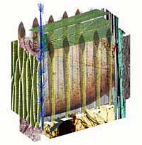
The following is a summary of a paper examining the design aesthetics of Council House Two (CH₂) and its relationship to central Melbourne.
One of the main questions examined in the paper centres around the role of green buildings and the socio-cultural, environmental and economic effects they can have beyond their technical performance.
The paper is presented as a dialogue in two complementary halves. Part A examines CH₂ from an architectural design perspective, discussing the building aesthetic. Part B analyses the building from the discourse of urbanism, viewing the building from within the local and greater urban contexts of the city.
Figure 1: Image of CH₂ as a representation of its environmental elements (DesignInc)
…CH₂ will add enormous vibrancy to this significant section of Little Collin’s Street, with new shops, cafés and pedestrian connections and, as it does, it will strive to set a new standard in how buildings can deliver financial, social and environmental rewards…
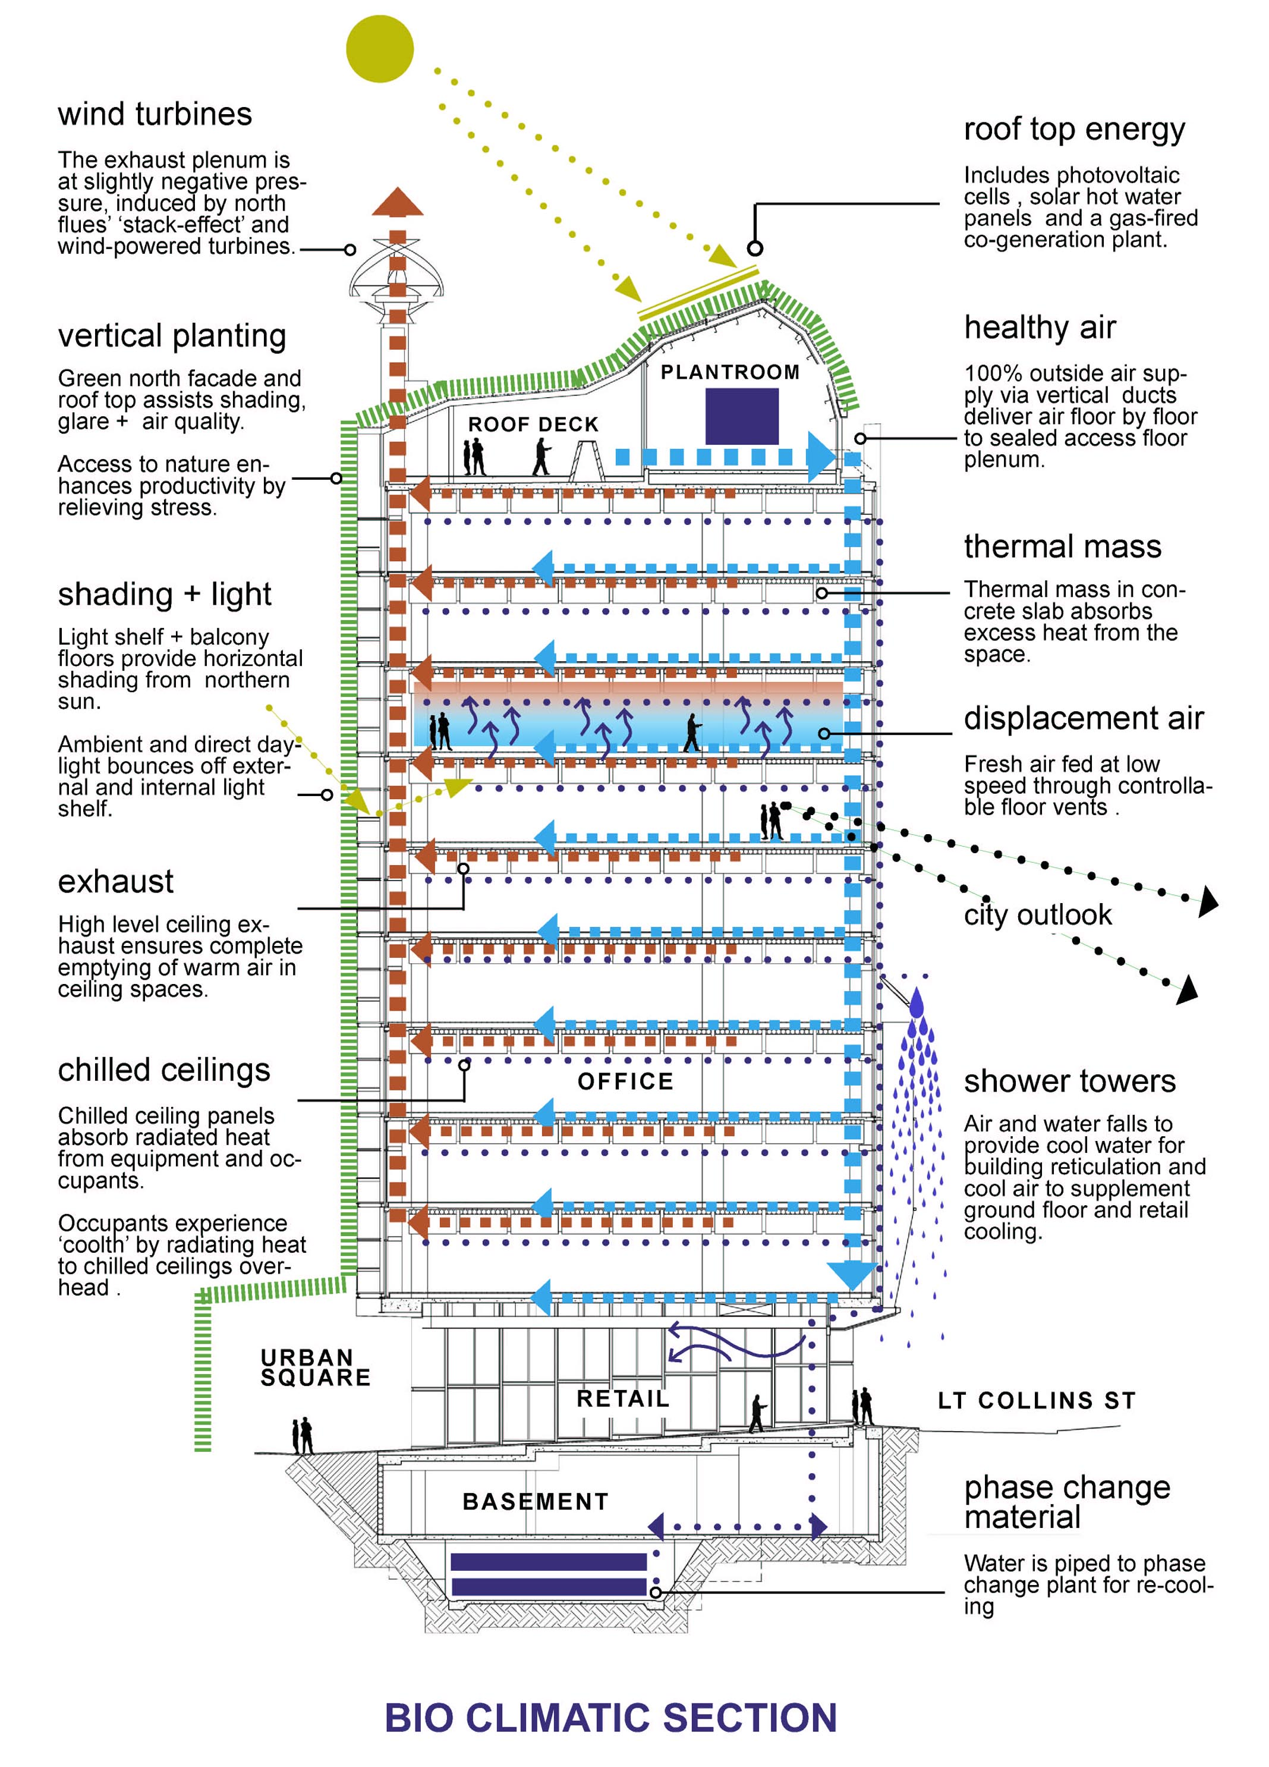
Lord Mayor John So (2004)

The role of aesthetics in promoting sustainability
Part A questions whether it is possible to speak meaningfully of aesthetics and sustainability together in architecture. The architectural style of CH₂ is examined in terms of its aesthetics and ornament. The purpose of aesthetics is also explored in terms of its social function and cultural benefits, in order to understand the aesthetic role of the CH₂ building as an exemplary green building.
One of the central roles of the CH₂ building is to stand as an example of innovative construction, inspiring change and conceptually re-orientating practice within the building industry. Aesthetics can play a powerful role in communicating this message, particularly in terms of how effectively that message is conveyed. By understanding the role of aesthetics in communicating the underlying sustainable intent of the building, it is important to distinguish between the images or symbols of green design and the real performance of the building.

Figure 2: Bio climatic section of CH₂
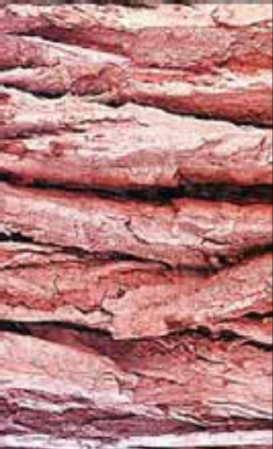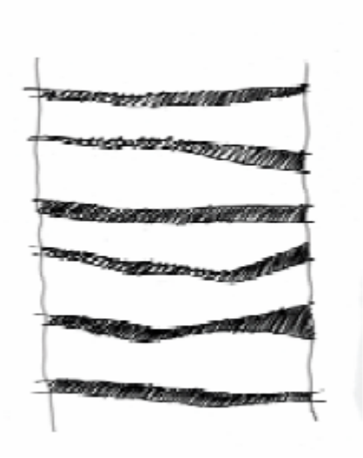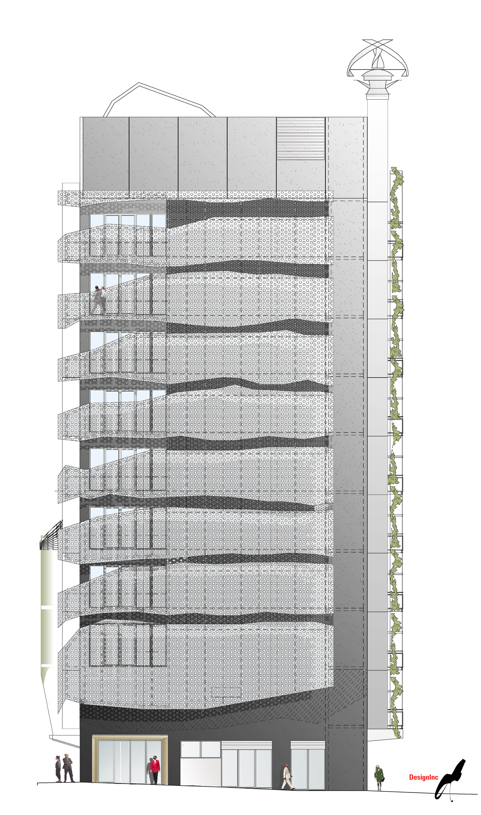
A. Pure nature B. Architectural concept C. Image of final design
Figure 3: Diagramatic east elevation and façade concept inspired by the bark of a tree (DesignInc)

General perceptions of green buildings commonly held by industry must also be addressed. Financial viability, cultural progressiveness and technical innovation all need to addressed as part of a high performance ecologically designed building as well as aesthetic attractiveness.

When I was first asked to attend (the charrette) I thought it was going to be a waste of time… but it became the most rewarding experience – a really emotional, rewarding experience… in those two weeks, virtually the whole building was… sorted out.
Nat Bonacci, Director Bonacci Group Consulting Structural and Civil Engineers
Integrated design approach
From the project’s outset, an integrated design approach was adopted, using the charrette process. This process involved the entire consultant team working as a single design unit until the primary issues were resolved. This process facilitated the rapid resolution of technical and design decisions within a ‘consensus style’ environment. The integrated decision-making approach used during the charrette phase was a mechanism for bridging gaps between disciplines, resulting in fewer setbacks later on in the project.

… bringing in the artists surprised me. … it was great having the artists, because it is part of the alignment of values. More than the artist giving ideas to the team, it became a matter of the artists absorbing the values and goals of the project—at least during the two-week workshop. So that at the end of it the artists were pretty well informed about the environmental performance of buildings.
Greg Foliente, Principal Research Scientist, team leader EVERGEN, CSIRO
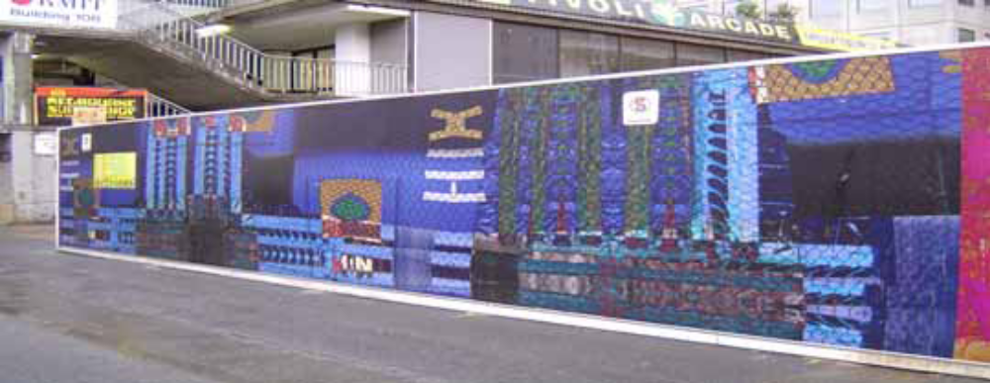
Figure 4: Art has been used to inspire the charrette process but is also integral to the whole building. Art work on the development site hoard brings vibrancy to the streetscape experience and expresses a message of difference. (Artist: Cara Jones)
This is a good example of how an artist can add to the vibrancy of the city by working on a feature that is necessary but often uninspiring. With Jones’ input, CH₂’s hoarding has become a 93m cultural advertisement for the building and for Melbourne.
Cr Kate Redwood, Councillor for Melbourne City Council 2001-2004

Signs and metaphors in architecture
The social function of aesthetics as interpreting signs in architecture is a way of integrating aesthetic issues with other life experiences. The role of aesthetics in a building is not simply ornamental but also important on a social and cultural level as well. Buildings can be understood as a language, by the signs they display and messages they give us.
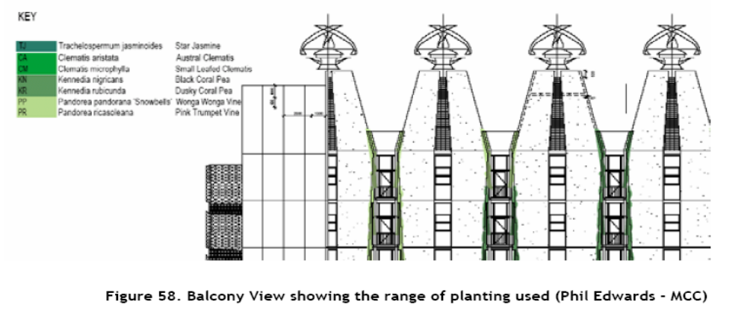
Figure 5: North-upper elevation view, showing wind turbines and range of planting used – integrated function expressed aesthetically
The messages contained in CH₂ can be read by looking at, and understanding the meanings conveyed by the elements and systems within the building. The composition of the different facades of the building is primarily the result of a range of intended indoor qualities. These include environmental performance, response to heat loads, ambient sunlight, and ultimately peoples’ desired comfort requirements – all expressed through aesthetics in functional ways.
Metaphors of natural processes and systems have been used to inspire the overall look of the building and some of its technical systems. The ingenious way that air flows through, and temperature is controlled, within a termite nest to suit its occupants is cited as having conceptually informed the design of systems within CH₂. CH₂ has equally been influenced by its own urban, cultural and natural environment.

The urban context
Part B of this paper looks at how an exemplary green building such as CH₂ expresses a sustainable development ideology. When discussing sustainable design it is important to not only apply principles of ecological sustainability but also cultural sustainability. In order to create spaces that are appropriate for the future, the link between ecological and cultural sustainability should be maintained.
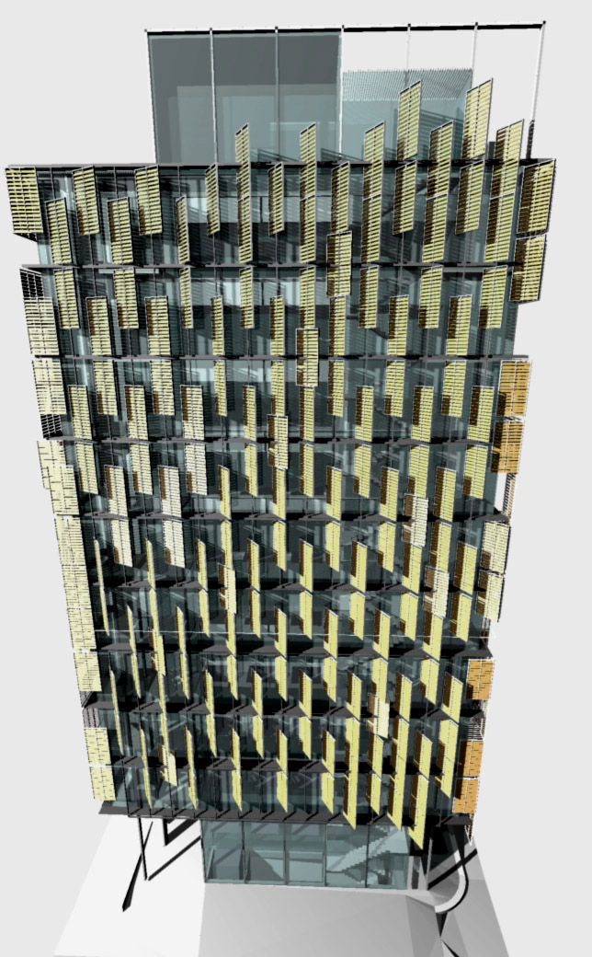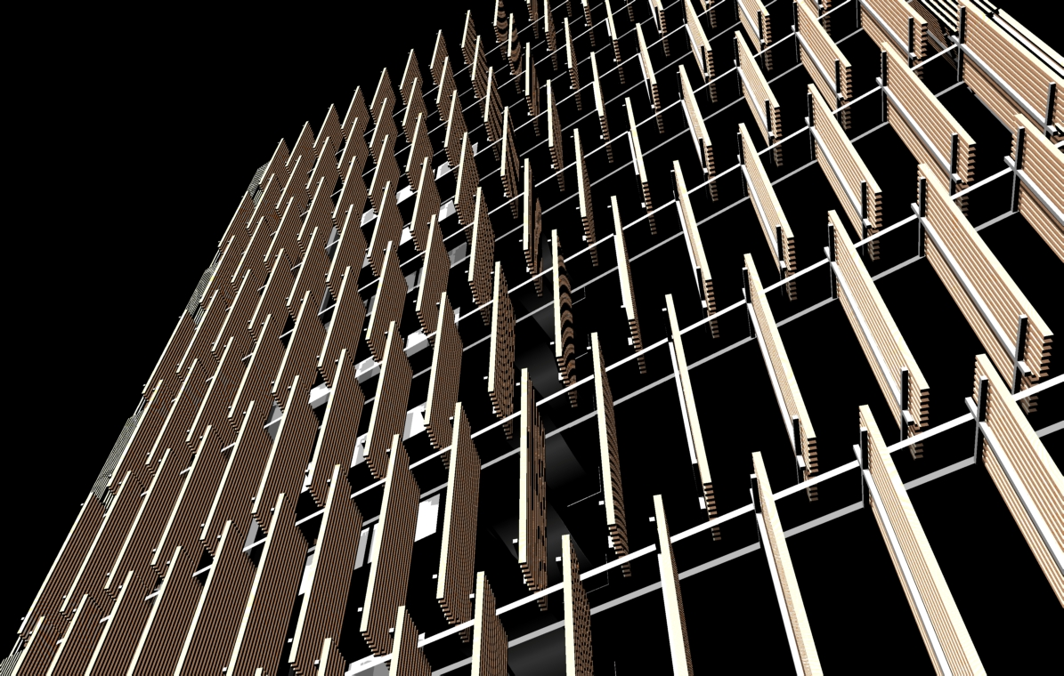
Figure 6: Concept images of CH₂ west façade showing movable wooden louvers for shielding against heat gains from low western sun – an expression of bioclimatic architectural language
CH₂ has been marketed as revolutionary; not only in a functional and environmental sense, but also in how it has been expressed architecturally using bioclimatic principles. The varying facades express these efforts, by responding accordingly through the 24 hour cycle of solar energy, natural light and air, wind energy and rainwater. The resulting design aesthetic and the power of the building’s architectural elements enhance its ability to communicate ideas about sustainability. Likewise the presence of CH₂ contributes to the cultural changes occurring in the City of Melbourne, helping to define a new urbanity and promote greater understanding of sustainability issues.
To analyse how CH₂ sits within its local and greater contexts, the paper draws on what Henri Lefebvre called the dialectique de triplicite or ’threefold dialectic within spatialisation’. This approach suggests that space can be analysed using three types of approaches. ’Spatial practice’ is the way we understand space in everyday life. ’Representation of space’ is the way we understand and conceive space. ’Spaces of representation’ is an historic or utopian way of conceiving space that inspires a new understanding of social space.
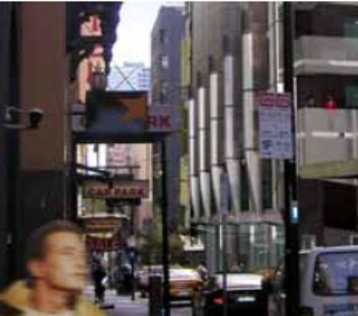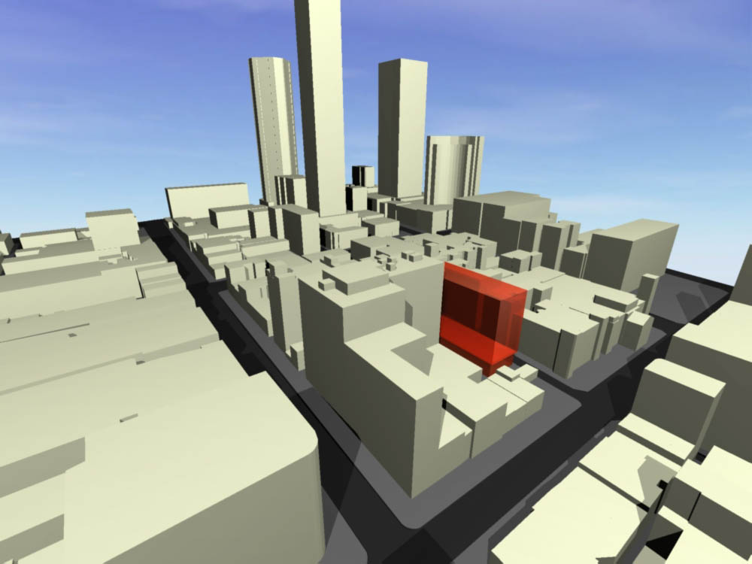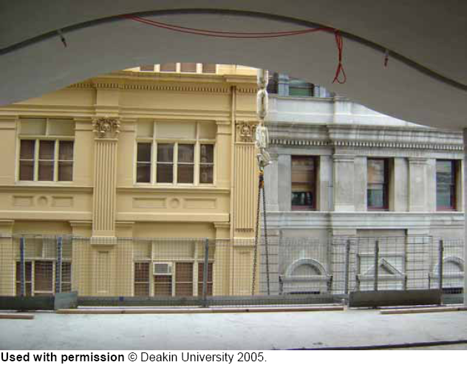
A. Spatial practice: CH₂ in passing B. Representation of space: CH₂ in CBD C. Spaces of representation: CH₂ framing historical neighbour
Figure 7: dialectique de triplicite or ‘threefold dialectic within spatialisation’
Green buildings may be described as urbane, because they are expected to relate to their surrounding environment in a civilised way. Inserting a truly sustainable building into an existing city – where regulations encouraging urbane principles such as the right to light, are not yet common – is somewhat difficult. Although much effort has been undertaken to address the impacts of CH₂, the building will cast a shadow across some adjacent buildings. The explanation for how this happened is simple. In that part of the Melbourne’s CBD a uniform, 40 meter height limit applies to all development. The CH₂ project had to follow those rules of urban development in central Melbourne. This solar overshadowing, therefore, exposes the problems of broader planning and urban design practices in Melbourne, Victoria and cities generally. The full resolution of which, remains beyond any individual architectural project. The shortfall, despite all the efforts of an extraordinarily sensitive and careful approach to architecture, should generate discussions about public interest and urban design regulation in central urban areas.
The success of CH₂ will be determined by the influence it has on future building practices. Only after time and use will a deeper understanding of its significance become possible.

