Distribution of stakeholder notification

Location of works: | e.g. Footpath outside 179 Collins Street
Project: | e.g. Inspection of xxx
Dates: | STARTDATE to ENDDATE (weekdays / all days)

Distribution Map key (use suggested colours below to draw over your distribution map)
Extent of traffic management
Location of works
Distribution of advance notice
(Select the map below and paste your map in its place, then use the key elements above.)
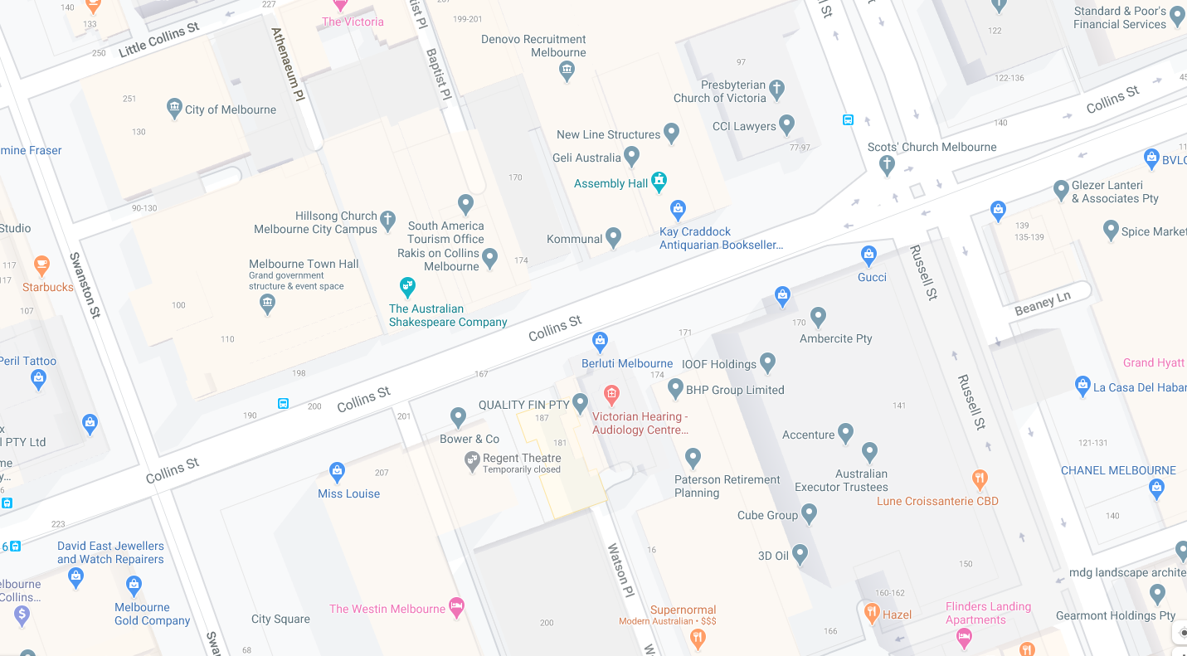

- Mark up your map to clearly show the properties where written notice will be provided.
- Upload this plan and a copy of your notification letter when you apply online.
Note:

- Written notice should be provided to properties at least five business days in advance of works and/or any traffic management measures. Some stakeholders may require additional lead time or approvals. More information is available on our website.
- All affected property occupiers should be provided notice, including but not limited to residential, business and car parking properties. This may include properties on other streets that share a laneway/driveway/rear access point or have emergency exits nearby.
- Where multi-tenanted properties are affected, notice should be provided to the body corporate or building management at a minimum and contain instructions for distribution to tenants.
- Before works commence you are expected to consult with and notify stakeholders as required by our Code of Practice for Building, Construction and Works.
- A table of example works and notification considerations is included below:
Type of works | Notification considerations
Requiring a Construction Management Plan | All properties within 50 m of any site boundary
Involving out of hours works | All properties within 50 m of any site boundary
Affecting lane(s) of road | All properties on both sides of the affected length of road, including adjacent intersections, and affected stakeholder agencies (such as Department of Transport, public transport operators and any affected venues or stadiums).
Affecting parking in road | All properties on both sides of the affected length of road
Affecting footpath access | All properties on the affected side of the affected length of road

