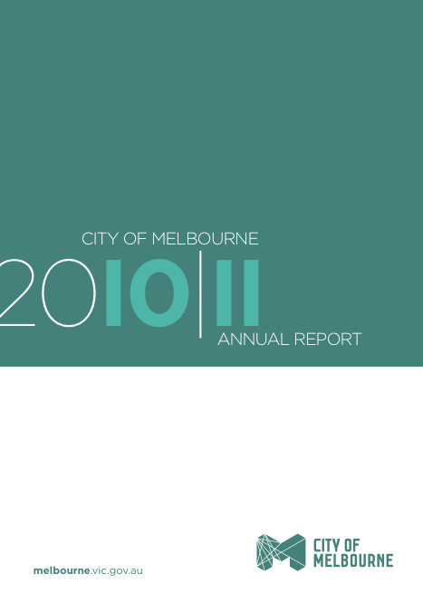

CITY OF MELBOURNE ANNUAL REPORT 2010-2011

Table of contents

Overview

Purpose of this annual report 3

City of Melbourne vision, mission and values 5

Lord Mayor’s message 6

CEO’s message 7

Introduction 9

Part 1 – The City of Melbourne

Melbourne 11

Melbourne City Council 13

Corporate governance 18

Our organisation 26

Organisational profile 29

Part 2 – Our Performance

City of Melbourne performance overview 34

1 – A city for people 35

2 – A creative city 37

3 – Economic prosperity 38

4 – A knowledge city 39

5 – An eco-city 40

6 – A connected city 44

7 – Lead by example 45

8 – Manage our resources well 46

City of Melbourne 2010-11 performance statement 47

Best value and local government indicators 69

Global Reporting Initiative (GRI) discussion and table 74

Part 3 – Financials

PURPOSE OF THIS ANNUAL REPORT
This annual report documents the City of Melbourne’s performance over the 2010-11 financial year against the eight goals of Council Plan 2009-13 and the 2010-11 Annual Plan and Budget. It includes issues that impact on the sustainability of our municipality and our organisation and outlines our sustainability performance.
The report comprises three main parts. The first part provides an overview of the City of Melbourne and the communities we serve. The second part includes highlights of our performance against the goals of the Council Plan 2009-13 and details of our performance against the key strategic activities of the 2010-11 Annual Plan and Budget. It also outlines our performance against strategic and global reporting indicators. The third part includes the financial statements.
As part of our commitment to environmental sustainability, the City of Melbourne has produced a summary report which will be downloadable from our website or by contacting 03 9658 9658.
The annual report meets our obligations under Section 131 of the Local Government Act 1989 (Vic) and the requirements of the Global Reporting Initiative (GRI) framework for sustainability reporting.

Measuring performance
Success is measured by our performance against the goals of our Council Plan 2009-13 which align directly with the goals of the Future Melbourne Community Plan. Future Melbourne’s ambitious goals inspire us to improve the liveability and sustainability of our municipality. The Annual Plan and Budget 2010-11 set the actions and results for the financial year.
Strategic indicators have been set to monitor progress against our Council Plan 2009-13 and performance against these indicators is outlined in the second part of this report.

The United Nations Global Compact
The City of Melbourne was the first local government in the world to align with the United Nations Global Compact’s 10 guiding operational principles covering human and labour rights and environmental protection. The City of Melbourne takes a collaborative approach to addressing the social, environmental and economic challenges, also known as addressing the ‘triple bottom line’. We continue to support the development of the United Nations Global Compact Cities Program.

Sustainability reporting
Melbourne is a recognised leader in the field of environmental sustainability. We aim to improve the sustainability of the municipality’s building stock, reduce carbon emissions, develop ways to capture, store and use water efficiently, better manage and improve the disposal of waste, and respond to the potential effects of climate change.
The GRI is an independent program that provides one of the world’s most widely used standards for sustainability reporting.
We follow the GRI’s sustainability reporting guidelines, which provide a framework to measure, track, report on and compare economic, environmental and social performance. The GRI index is located on page 74 of the annual report.

We want your feedback
Residents, ratepayers, businesses, visitors, staff, partners, suppliers and collaborators, sister cities, government departments and community agencies are all affected by the City of Melbourne’s decisions.
To improve reporting on our performance, we are keen to hear your thoughts on this annual report. For more information and to provide feedback, please visit melbourne.vic.gov.au or phone us on 03 9658 9658.

VISION, MISSION AND VALUES

Vision
Melbourne as a bold, inspirational and sustainable city.

Mission
The City of Melbourne will strive to achieve the community’s vision of Melbourne as a bold, inspirational and sustainable city which:
- makes Melbourne great for people to live in and visit
- achieves the creative potential of the city
- protects and strengthens the city’s economic prosperity
- makes Melbourne a recognised knowledge city that supports innovation and technology
- demonstrates leadership in environmental sustainability
- works vigorously for a connected city, which is safe and supports the efficient movement of people and freight
- leads by example and manages resources well.

Values
For City of Melbourne employees and Councillors to be the best at what they do and achieve the corporate vision and mission, their actions and decisions are guided by a set of five fundamental and unifying values: integrity, courage, accountability, respect and excellence.
Integrity: we take responsibility for our actions in an honest and transparent way.
Courage: we dare to create new and better ways of doing business.
Accountability: we take responsibility for decisions and actions to achieve agreed outcomes.
Respect: we consider and understand the perspective and contribution of others.
Excellence: we continuously improve our performance to achieve outstanding outcomes for Melbourne.

Realising our vision
Our Council Plan 2009-13 identifies eight goals that will guide us towards our vision.
Our aspirations for the city are reflected in the first six goals. Our municipality will become:
- a city for people
- a creative city
- economically prosperous
- a knowledge city
- an eco-city
- a connected city.

A further two goals relate to our internal performance and give direction for the good governance and management of our organisation. The City of Melbourne will:
- lead by example
- manage our resources well.

MESSAGE FROM THE LORD MAYOR
An historic investment in the city’s future was the centrepiece of Council’s budget this year. Our capital works spending plays a vital role in promoting Melbourne’s competitive advantage and creating opportunities for our community. We plan to spend a record $346.55 million on programs and services and $107.3 million to enhance and build new infrastructure. This means that Council is on track to deliver record investments of $1.3 billion in programs and services for the people of Melbourne and $250 million in infrastructure by the end of this Council’s term.

Last year we kept the rate rise at 1.9 per cent, our lowest rate rise in almost a decade. This year, we have gone a step further with a rate rise of 1.65 per cent. Three years of prudent financial management by this Council means that ratepayers are reaping the rewards. The redevelopment of Swanston Street has begun; planning for new community hubs, libraries, health services, artist studios in Docklands, Southbank and Carlton are well underway; we are putting in place measures to protect our city from extreme weather events; and we continue to expand our events program to keep our city safer at night.

A safe and prosperous city benefits all businesses, residents and visitors and City of Melbourne continues to work hard in activating all areas of the city to keep visitation numbers high. Retail floor space has expanded, and demand for office space is high – Melbourne’s central city has the lowest vacancy rate of all the big city centres in Australia. All this points to continued prosperity in our city.

As the city’s population continues to grow it is vital that we deliver a range of initiatives and services to meet the needs of residents, workers and visitors – to strengthen Melbourne’s economic growth and ensure that our city remains one of the most sustainable and liveable cities in the world.

Robert Doyle
Lord Mayor

MESSAGE FROM THE CHIEF EXECUTIVE OFFICER

The 2010-11 financial year was a significant one, as Melbourne celebrated its 175th anniversary. The Council has worked tirelessly to ensure a bold, inspirational and sustainable city. Against greater than predicted population growth, we continued to deliver core services to the community, while also lifting Melbourne’s environmental, social and economic profile.

Delivering on our commitments

We delivered almost all of the 34 activities and initiatives (A&I) contained in the Council’s 2010-11 Annual Plan to 80 per cent or more complete. We also completed 80 per cent of the Council’s 10 key strategic activities (KSAs) identified as high priorities, while still delivering a surplus of $19 million. A snapshot of these achievements is contained in this report.

Efficient organisation

Our efforts to improve efficiency again reaped significant rewards. By further developing the Lean Thinking program, we were able to consolidate last year’s gains while taking important steps forward. This resulted in further savings of more than $700,000 and a productivity release of more than 3200 hours. These numbers only represent work programs where Lean implementation has commenced and measurement is possible. The Lean journey continues for some work streams with further improvements expected next year.

Engaging our community

In 2010-11, our approach to community engagement continued with an increasing number of work areas implementing the organisation-wide framework. Council has committed to this process with all of the 2010-11 KSAs identifying community engagement as an inherent component. More than 200 staff members undertook the half-day introduction to community engagement training, while a further 29 were trained in the practice of quality facilitation.

According to residents responding to the Local Government Community Satisfaction Survey, our overall performance remained consistently higher than the average for Victorian councils. We also achieved the highest satisfaction ratings in areas such as economic development and appearance of public areas.

Our people: Leading by example

Once again, our staff have excelled in a variety of domains this year. I thank all staff for their tremendous work over the past financial year. The dedication they have shown to ensure Melbourne remains one of the world’s most liveable cities has been inspiring.

Special mention must go to those work areas recognised with awards during this period. For the second consecutive year, our Customer Contact Centre won the Victorian ATA Teleservices Centre of the Year for Contact Centres with under 50 staff. The City of Melbourne also placed third in the 2011 Local Government Managers Australia Management Challenge’s Australasian Final, while also claiming the Victorian Government’s Fair and Flexible Employer Recognition Award, again for the second year running.

Other awards included national finalist at the HR Leader Awards for Best Health and Wellbeing Strategy, National Adaptation Champions by the National Climate Change Adaptation Research Facility, and finalist for the LGPro Excellence in Local Government Corporate and Community Planning Award for our Lean continuous improvement program.

Our City of Melbourne Education and Training (CoMET) Learning Program continued to flourish in 2010-11, offering 114 learning workshops which were attended by 920 staff. Additionally, 17 staff successfully gained a Diploma of Management, which the City of Melbourne partners with Swinburne University of Technology to deliver.

I would also like to recognise our Council. Its guidance and foresight throughout 2010-11 has been of the highest standard. The partnership between Council and staff is integral to our success and I thank the Lord Mayor and councillors for their vital contributions to the City of Melbourne.

Dr Kathy Alexander
Chief Executive Officer

BUILDING ON THE FIRST 175 YEARS TO ENSURE A LIVEABLE, SUSTAINABLE MELBOURNE
Each year the City of Melbourne includes an ‘in focus’ section of the annual report.
This year our focus is Building on the first 175 years to ensure a liveable, sustainable Melbourne.
Melbourne and its surrounds have been inhabited by Aboriginal Australians for thousands of years. On 30 August 1835, a ship called the Enterprize and its crew arrived on the north bank of the Yarra River, close to the present day central business district, establishing what would become the City of Melbourne.
This city is now 175 years old and has drawn its population from the four corners of the world. The city centre is home to almost 100,000 residents, who are joined daily by hundreds of thousands of office workers, students and visitors who share the streets, laneways, parks and gardens of the modern city.
Contemporary Melbourne is consistently acknowledged as one of the world’s most liveable cities. Shortly after the completion of the 2010-11 reporting period, Melbourne was awarded the title of “World’s most liveable city”, based on achievements across a broad range of criteria which includes political and social stability, crime rates, access to quality health care, cultural events, the environment, education and the standard of infrastructure.*
This annual report chronicles the financial year 2010-11 in which the City of Melbourne focused on building an even more sustainable and liveable city.
Capital works spending of more than $75 million included:
- completion of the final stage of the Royal Botanic Gardens ‘Tan’ running track
- refurbishment of the ‘Creative Spaces’ West Melbourne artists’ studio which won an Architecture Victoria Award
- completion of a new children’s playground at the Grant Street Reserve on Southbank and
- commencement of Stage 1 of the Swanston Street redevelopment – a multi-million dollar project to transform the city’s civic spine and deliver new bicycle routes, high-quality bluestone and white granite paving, attractive floral displays, new trees in select locations, public art, new street benches, upgraded cafe awnings and world-first technology feature lighting.
Melbourne is recognised as a leader in the field of sustainability and in 2010-11 the city moved to harvest stormwater in the vicinity of the Royal Exhibition Building, in Darling Street East Melbourne, Birrarung Marr and the Fitzroy Gardens.
These works are designed to increase the use of reclaimed water in the city from 20 per cent to 70 per cent in the next few years. And as part of a commitment to be carbon neutral by 2020, the City of Melbourne is partnering in the 1200 Buildings program to encourage and support building owners, managers and facility managers to improve energy and water efficiency as well as reduce waste to landfill from commercial buildings.
Retrofitting benefits owners by future proofing building assets against rising energy costs, as well as attracting and retaining tenants. The program contributes real ‘triple bottom line’ benefits by reducing the sector’s contribution to global greenhouse gas emissions.
We are building on the first 175 years to ensure a liveable, sustainable Melbourne for all those who call this city home today or will become residents of this great city in the years to come.

* Economist Intelligence Unit’s Global Liveability Survey, August 2011.

MELBOURNE
Melbourne is the capital of Victoria and Australia’s second largest city. It sits on the south-east edge of our continent on the shores of one of the world’s largest bays, Port Phillip Bay.
The municipality of Melbourne has a residential population of almost 100,000 and covers 37.6 km². It is the anchor of the much larger Melbourne metropolitan region which has a population of four million people and spreads more than 40 km to the south, 30 km to the east and 20 km to the north.
Workers, students and visitors swell the municipality’s daily population to around 788,000 during week days and each weekend more than 548,000 people visit the city.
Melbourne is the gateway to Victoria, the seat of the Victorian Government and a major city in the global economy. It has a strong export focus and is a leader in professional and business services, financial services, education, health and medical research, retail and major events.
The municipality has changed dramatically over the last decade with more than 100 new commercial and residential buildings added, including extensive development at its waterfront suburbs, Docklands and Southbank.
Melbourne offers the best of many worlds with magnificent tree-lined boulevards, a mix of classic and modern architecture and a unique blend of Asian and European style. As noted in the introduction to this year’s annual report Melbourne is consistently ranked as one of the world's most liveable cities by the Economist Intelligence Unit, including first place shortly after the conclusion of the 2010-11 reporting period.

The people
The municipality of Melbourne has approximately 96,000 people and is culturally very diverse. Just under half the residents were born overseas or have at least one parent born overseas. At least a third speak a language other than English at home, with Mandarin the most common language spoken.
The city also has the youngest population of the wider Melbourne metropolitan area, with a median age of 28 years. Approximately 30 per cent of residents are aged between 25 and 34 years. Many city residents are international students.

Facts and figures
- median house price: $940,000 (March 2011)
- 145,300 cafe and restaurant seats for diners
- almost 1.5 million international visitors per year
- 471 hectares of parks and reserves
- 15,400 businesses located in the city
- 406,000 workers located in the city
- key industry sectors: professional and business services, advanced manufacturing, biotechnology, creative industries, financial services, healthcare, higher education, hospitality, information communications technology, retail and tourism.
The City of Melbourne’s extensive research program has a large collection of statistics, maps, area profiles and other information about Melbourne.

Stakeholders
Our stakeholders include anyone with an interest in what we do and the services and programs we provide. They are:
- our local community, including residents, ratepayers, businesses, workers, students, visitors, unions, the media, community groups and associations, the education sector and other local government authorities
- our working partners, including other government bodies and agencies, our suppliers and consultants, neighbouring communities, the business community and others
- our global partners, including our city partners, investors, event organisers and others.
We work with stakeholders in many ways. Our community engagement framework guides the way we communicate with our stakeholders, from how we conduct formal consultations on significant policies, programs and services, to specific issue advisory groups and our daily interactions with those who use our services and facilities. These interactions provide an important insight into how we can continue to improve the quality of our services.

MELBOURNE CITY COUNCIL
Melbourne City Council is the local government body responsible for the municipality of Melbourne. The Council consists of a lord mayor and deputy lord mayor (the leadership team) and seven councillors.
Under the provision of the City of Melbourne Act 2001 (Vic):
- Melbourne is not divided into wards
- the leadership team is elected separately from councillors
- the preferential voting system is used to elect the leadership team and proportional representation is used to elect councillors.
The current Council was elected for a four year term in November 2008. A vacancy was created on 24 June 2011 with the resignation of Cr Peter Clarke. Cr Jackie Watts was elected at the countback held on 19 July 2011. The next council election is scheduled for October 2012. Further information about local government elections is available from the Victorian Electoral Commission at www.vec.vic.gov.au

The Council’s role
The Local Government Act 1989 (Vic) sets out the primary purposes and objectives of Melbourne City Council and defines its functions and powers. The Council is a public statutory body incorporated under the Act. Its role is to govern the municipality of Melbourne in service of the community.
The Council:
- acts as a representative government and considers community needs when making decisions
- establishes strategic objectives for municipal services and monitors their achievement
- ensures the responsible and accountable management of the City of Melbourne’s resources
- advocates local community interests to other communities and governments
- is a responsible partner in government, taking the needs of other communities into account
- fosters community cohesion and encourages participation in civic life.

Councillors’ profiles

Lord Mayor Robert Doyle
First elected in 2008.
The Lord Mayor is Chair of meetings of the Melbourne City Council and represents the City of Melbourne on the following advisory committees and external organisations:
- Council of Capital City Lord Mayors
- Shrine of Remembrance
- Australian Council of Local Government Steering Committee
- Lord Mayor’s Charitable Foundation
- Melbourne Arts Trust
- Cancer Council of Victoria
- Enterprise Melbourne Advisory Board.
.

Deputy Lord Mayor Susan Riley
Served as Deputy Lord Mayor, 2001-04. Re-elected in 2008.
The Deputy Lord Mayor represents the City of Melbourne on the following advisory committees and external organisations:
- Audit Committee
- Inner South Metropolitan Mayors’ Forum
- Major Projects Advisory Committee
- Melbourne Awards Advisory Board Chair
- Melbourne Arts Trust
- Melbourne Retail Advisory Board 2009-12
- Melbourne Spring Fashion Week Advisory Board (Deputy Chair)
- Moomba Advisory Board
- Police Community Consultative Committee – Central Activities District
- Procurement Australia
- Shrine of Remembrance – Remembrance Day Dinner Committee Chair
- Lady Mayoress’ Committee (Acting Chair).

Councillor Peter Clarke
First elected in 2004 and re-elected in 2008.
Cr Clarke is Chair of the Future Melbourne (Planning) Committee and is the council’s representative on the Inner Melbourne Action Plan Implementation Committee. Cr Clarke represents the City of Melbourne on the following advisory committees and external organisations:
- Central City Standing Advisory Committee
- Inner South Metropolitan Mayors’ Forum
- Major Projects Advisory Committee.

Cr Clarke resigned from Council after the 2010-11 reporting period concluded.

Councillor Carl Jetter
First elected in 2004 and re-elected in 2008.
Cr Jetter is Chair of the Future Melbourne (Economic Development and Knowledge City) Committee and currently represents the City of Melbourne on the following advisory committees and external organisations:
- City Licensing Approvals Forum
- District Precinct Program 2007-11
- Melbourne Hospitality Advisory Board 2009-12
- Moomba Advisory Board.

Councillor Jennifer Kanis
First elected in 2008.
Cr Kanis is Chair of the Future Melbourne (People and Creative City) Committee, Deputy Chair of the Future Melbourne (Planning) Committee and represents the City of Melbourne on the following advisory committees and external organisations:
- Disability Advisory Committee
- Family and Children’s Advisory Committee
- Housing Choices Australia
- Indigenous Advisory Panel
- Melbourne Music Steering Committee
- Melbourne Symphony Orchestra Board
- Parks and Gardens Advisory Committee
- Queen Victoria Market Sub-Committee.

Councillor Kevin Louey
First elected in 2008.
Cr Louey is Chair of the Future Melbourne (Connected City) Committee. He is also Co-Chair of the Docklands Co-ordination Committee. Cr Louey also represents the City of Melbourne on the following advisory committee:
- Metropolitan Transport Forum.

Councillor Cathy Oke
First elected in 2008.
Cr Oke is Chair of the Future Melbourne (Eco-City) Committee, Deputy Chair of the Future Melbourne (Connected City) Committee, Deputy Co-Chair of the Docklands Coordination Committee and represents the City of Melbourne on the following advisory committees and external organisations:
- Bicycle Reference Group
- International Council for Local Environment Initiatives (ICLEI) Australia/New Zealand Oceania Board
- ICLEI Executive Committee
- Melbourne Music Steering Committee
- Metropolitan Waste Management Group
- Parks and Gardens Advisory Committee
- Queen Victoria Market Sub-Committee
- Victorian Road Based Public Transport Advisory Council
- Water Reference Group
- Yarra Park Advisory Committee
- Zoos Victoria 150th Anniversary Committee.

Councillor Ken Ong
First elected in 2008.
Cr Ong is Deputy Chair of the Future Melbourne (Economic Development and Knowledge City) Committee, Deputy Chair of the Future Melbourne (Finance and Governance) Committee and Deputy Chair of the Future Melbourne (People and Creative City) Committee. Cr Ong also represents the City of Melbourne on the following advisory committees and external organisations:
- Committee for Melbourne
- District Precinct Program 2007-10
- Litter Advocates Group
- Major Projects Advisory Committee
- Metropolitan Waste Management Group
- Moomba Advisory Board.

Councillor Brian Shanahan OAM
First elected in 2004 and re-elected in 2008.
Cr Shanahan is Chair of the Future Melbourne (Finance and Governance) Committee, Deputy Chair of the Future Melbourne (Eco-City) Committee and currently represents the City of Melbourne on the following advisory committees and external organisations:
- Association of Bayside Municipalities
- Audit Committee, City of Melbourne
- Melbourne Arts Trust
- Victorian Local Governance Association.

Council decisions
Councillors make decisions at council meetings and delegated committee meetings. Committee meeting decisions are subject to a ‘referral notice process’ meaning that where fewer than five committee members vote in favour of a motion, members have the option of referring the matter to the next council meeting for decisions.

Delegations
Melbourne City Council’s powers under the Local Government Act 1989 (Vic) or any other Act may be delegated to a council committee, to the chief executive officer (CEO) or to a City of Melbourne officer via the CEO. Staff members are accountable to the CEO. The council and its committees provide policy and staff members make decisions in accordance with that policy. The exercise of delegation is subject to the council’s Delegations Policy.

Relationship with other tiers of government
Statutory responsibility for local government lies with each Australian state or territory. An Act of each state parliament specifies local government powers, duties and functions. In Victoria, the legal basis for councils is established under the Constitution Act 1975 (Vic) and the Local Government Act 1989 (Vic).

Subsidiaries and trusts
The City of Melbourne has three wholly owned subsidiaries.
CityWide Service Solutions Pty Ltd, a company established to provide contract services on a competitive basis to local government and other public and private sector clients.
Queen Victoria Market Pty Ltd, a company established to manage and develop the Queen Victoria Market.
Melbourne Wholesale Fish Market Pty Ltd completed the sale of the Melbourne Wholesale Market site to VicTrack on 30 June 2011. The company is expected to be wound up over the forthcoming year.
The City of Melbourne has an interest in other entities including:
- the Sustainable Melbourne Fund (the City of Melbourne holds all units in this trust), a strategic trust established to support and promote sustainable development
- the Regent Management Company Limited. Shared with the State Government, the City of Melbourne has a 50 per cent interest in this company, established to manage the historic Regent Theatre in Collins Street, Melbourne
- MAPS Group Limited trading as Procurement Australia. The City of Melbourne is majority shareholder of this company.

Member, Council of Capital City Lord Mayors
The Lord Mayor of Melbourne is a member of the Council of Capital City Lord Mayors, which comprises the lord mayors of all capital cities and the ACT’s Minister for Territory and Municipal Services. It coordinates and represents the special interests of Australia’s state and territory capital cities and their relations with other spheres of government.

Partner, Inner Melbourne Action Plan (IMAP)
The Inner Melbourne Action Plan (IMAP) is an initiative of the local governments of Melbourne, Yarra, Port Phillip and Stonnington to make the inner Melbourne region more liveable. IMAP coordinates the implementation of 11 regional strategies, which focus on priority areas including affordable housing, environmental improvements, tourism and sustainable transport.

Participation in council
The City of Melbourne welcomes community and stakeholder attendance and participation at council and committee meetings. Members of the public can make submissions to the council or a committee on matters listed on meeting agendas. A register of public submissions made under Section 223 of the Local Government Act 1989 (Vic) is available for viewing at the City of Melbourne’s offices.
Records of meetings, meeting dates and times or how to interact with council can be found on the City of Melbourne website melbourne.vic.gov.au

CORPORATE GOVERNANCE
Corporate governance encompasses the processes, protocols, conduct and relationships that guide the Melbourne City Council’s actions and decision-making. Some mechanisms of governance are legislative requirements and others are the council’s initiatives.

Council meetings
The council generally meets monthly, with a schedule of meeting dates available on notice boards at the Melbourne Town Hall, North Melbourne Library, East Melbourne Library, City Library, Carlton Baths Community Centre, the Hub at Docklands and the City of Melbourne website.
All meetings of the council and its committees are conducted in accordance with the Conduct of Meetings Local Law 2010. While meetings are open to the public and the public is encouraged to attend, the council may close any meeting to the public to discuss any of the following:
- personnel matters
- the personal hardship of any resident or ratepayer
- industrial matters
- contractual matters
- proposed developments
- legal advice
- matters affecting the security of municipal property
- any other matter which the council or special committee considers would prejudice the council or any person
- a resolution to close the meeting to members of the public.
http://www.melbourne.vic.gov.au/AboutCouncil/PlansandPublications/AnnualReport/2010/CityofMelbourne/Governance/Pages/MeetingAttendance.aspx

Council and committee meeting attendance
Council and committee meeting attendance: 1 July 2010 to 30 June 2011
 | Number of meetings | LM Robert Doyle | DLM Susan Riley | Cr Peter Clarke | Cr Carl Jetter | Cr Jennifer Kanis | Cr Kevin Louey | Cr Cathy Oke | Cr Ken Ong | Cr Brian Shanahan
Melbourne City Council meetings | 13 | 12 | 13 | 11 | 9 | 13 | 11 | 13 | 13 | 12
Committee meetings
Future Melbourne | 22 | 16 | 21 | 18 | 15 | 22 | 20 | 20 | 22 | 21
Inner Melbourne Action Plan | 3 | .. | .. | 3 | .. | .. | .. | .. | .. | ..
Docklands Coordination | 4 | .. | .. | .. | .. | .. | 3 | * | .. | ..
.. Not a member
* Alternate member
Further explanation of absences from Future Melbourne Committee/Council meetings is provided below.

Absence from Council meetings

- Lord Mayor: One absence was due to representing the Council on other Council business
- Deputy Lord Mayor: Attended all meetings
- Cr Clarke: One absence was due to representing the Council on other Council business
- Cr Jetter: Absences were not due to representing the Council on other Council Business.
- Cr Kanis: Attended all meetings
- Cr Louey: One absence was due to representing the Council on other Council business
- Cr Oke: One absence was due to representing the Council on other Council business
- Cr Ong: Attended all meetings
- Cr Shanahan: Absences were not due to representing the Council on other Council Business.

Absence from Future Melbourne Committee meetings

- Lord Mayor: Four absences were due to representing the Council on other Council business
- Deputy Lord Mayor: Absences were not due to representing the Council on other Council Business
- Cr Clarke: Two absences were due to representing the Council on other Council business
- Cr Jetter: One absence was due to representing the Council on other Council business
- Cr Kanis: Attended all meetings
- Cr Louey: Absences were not due to representing the Council on other Council Business
- Cr Oke: One absence was due to representing the Council on other Council business
- Cr Ong: Attended all meetings
- Cr Shanahan: One absence was due to representing the Council on other Council business.

Legislative compliance

Freedom of information
The Freedom of Information Act 1982 (Vic) gives any individual or organisation the right to access information held by the City of Melbourne unless that information is deemed exempt under the Act.
In 2010-11 the City of Melbourne received 42 valid applications seeking documents about building and planning matters, parking infringements and the costs and activities of councillors and officers. The number of requests received was the same as the total for the previous financial year.
There were three requests for internal review in 2010-11 (two decisions were upheld and one decision was varied). One appeal went to the Victorian Civil and Administrative Tribunal (VCAT), where a Council decision was overturned. The Act specifies a 45-day statutory time limit to process requests. The average processing time for requests was 35 days.

National Competition Policy compliance
The City of Melbourne complied with the requirements of the National Competition Policy Principles in 2010-11, which covers compliance in trade practices, local laws and competitive neutrality.

Privacy Act
Standards set out by the Information Privacy Act 2000 (Vic) and the City of Melbourne’s Privacy Policy Statement control how we manage personal information. Privacy compliance is included in our staff induction program. We have a dedicated privacy officer within our Governance Services Branch to assist staff and members of the public with privacy-related queries or issues.
The City of Melbourne received two privacy complaints from members of the public during 2010-11. Both matters were successfully dealt with by the respective work areas.

Whistleblowers Act
Complaints about the improper conduct of any City of Melbourne officer can be made confidentially, under the Whistleblowers Protection Act 2001 (Vic), to the Victorian Ombudsman or to any one of the following officers appointed to receive disclosures:
- Keith Williamson, Manager Governance Services
- Linda Weatherson, Director Community Development
- Mark Stoermer, Director Corporate Business
- Jane Sharwood, Manager Business and International
In 2010-11, there were no disclosed matters referred to the City of Melbourne by the Ombudsman, or from the City of Melbourne to the Ombudsman.

Risk management
The City of Melbourne manages its risks to maximise opportunities and minimise losses. Risk management planning is done as an organisation-wide exercise, covering the top strategic risks plus operational and project risks. It is also part of the daily business activities of individual branches and contractors.
The Council has in place a risk management framework, integrated with its corporate and business planning system.

Risk management strategy, integrated reporting, competitive neutrality and fraud awareness and training
The first year of the risk management strategy for 2010-13 was implemented.
In 2010-11, the risk exposures were revised for all of the City of Melbourne’s branches, with updated details recorded in the risk module of the organisation’s integrated corporate business planning software. Integrated quarterly and annual reporting of risks was introduced, and the CEO and directors undertook two major reviews of the top strategic risks. These top risks were reported to the Audit Committee throughout the year, along with the high operational risks.
The use of the new risk and audit modules in the organisation’s business planning software was extended. The risk data used in the design and targeting of the internal audit program included a pilot integrated audit that was designed to proactively assist in the development of new and efficient business processes. The review of Council’s businesses in relation to competitive neutrality also continued as scheduled.
As an enhancement of the corporate induction process for all new staff who join the City of Melbourne, a new online training and awareness module for fraud and improper conduct was developed for launch in 2011-12. This seeks to maintain the very high level of awareness and understanding that was confirmed through a major staff survey associated with a related internal audit. It seeks to ensure that expectations in this area are understood by staff at the beginning of their work at City of Melbourne, while reducing the time involved. Development work was also undertaken on a new online module for an introduction to risk management for all staff. A range of other face-to-face training courses were conducted in 2010-11, such as an introduction to risk management, event risk management and other specialist risk sessions for work areas.

Insurance and risk financing
The number of claims received by the City of Melbourne from members of the public increased 25 per cent, a common trend emerging across local government. This included an increase in the number of claimants being represented by a lawyer. Staff reviewed this trend and put in place active measures to manage the increase, investigate the reasons behind the trend, identified any additional preventative measures that were required and implemented strategies to manage the cost of any claims.
The five-yearly major insurable risk profiling review was undertaken to assess the adequacy of our insurance and risk financing coverage and identify any gaps associated with new or altered business processes and services. Adopted recommendations from that review will be implemented during 2011-12.
The overall cost of insurances to the City of Melbourne increased only marginally and within expectations during 2010-11. In part, this reflects the organisation’s proactive approach to managing identified risks and controlling any losses that arise.

Business continuity planning, crisis management and influenza pandemic
In 2010-11 the City of Melbourne updated the Corporate Business Continuity Plan, all branch business continuity recovery plans, and the Information Technology Disaster Recovery Plan. This worked towards the preparation of an exercise scenario based on the temporary loss of the information and communications systems across the organisation. This exercise was conducted with staff from a wide range of the organisation’s business branch, and designed in concert with staff from the Business Information Systems area. It was based on real test data from the regular testing of the IT Disaster and Recovery Plan. This exercise was designed and conducted by staff as part of the ongoing strengthening of in-house knowledge and skills. Exercises are undertaken on an annual basis and based on different scenarios. The revision of the City of Melbourne’s Crisis Management Manual was also completed and is now consistent with other plans.

Council special committees
As well as council meetings, Melbourne City Council has three special committees:
- Future Melbourne Committee
- Docklands Coordination Committee
- Inner Melbourne Action Plan Implementation Committee.

Future Melbourne Committee (meets twice monthly)
This committee has delegated powers, duties and functions directly relating to, or ancillary to, all aspects of the City of Melbourne’s activities. The Future Melbourne Committee’s terms of reference are grouped into six themes or portfolios being:
- planning
- connected city
- eco-city
- economic development and knowledge city
- people and creative city
- finance and governance.
All Councillors participate in the Future Melbourne Committee.

Docklands Coordination Committee (meets quarterly)
This committee manages coordination between the City of Melbourne and VicUrban to ensure an open public discussion in this developing area. The committee, which includes senior representatives from both the City of Melbourne and VicUrban, meets quarterly to monitor place management services within the coordination area.

Inner Melbourne Action Plan Implementation Committee (meets quarterly)
This committee has delegated powers, duties and functions directly relating to, or ancillary to, overseeing implementation of the Inner Melbourne Action Plan in accordance with the agreed three year implementation program. The committee comprises representatives from the local governments of Melbourne, Port Phillip, Stonnington and Yarra.

Councillor conduct
The City of Melbourne’s Councillor Code of Conduct outlines the role of the council and provides an overview of the councillors’ responsibilities in accordance with the Local Government Act 1989 (Vic). The code includes guidelines for rules of conduct, decision making and use of the City of Melbourne’s resources. It also includes procedures for disclosure of interests and conflicts of interest that go beyond legislative requirements. There were no known breaches of the code by Councillors in 2010-11.

Councillor allowances and expenses

Councillor allowances
Councillors are paid an allowance set by the Victorian Government. This allowance is paid in recognition of the demands placed on councillors in carrying out their civic and statutory duties, and for their work on policy development, as spokespeople on community matters and as representatives of the Melbourne City Council and Melbourne, both in Australia and overseas.
The allowances are:
- lord mayor: $156,146
- deputy lord mayor: $63,873
- councillors: $35,473.

Expenses
Councillors incur expenses in the course of fulfilling their roles. Expenditure is regulated by the Councillor Expenses and Resources Guidelines, as endorsed by the Finance and Governance Committee and consistent with Section 75 of the Local Government Act 1989 (Vic). Councillor expenses are reported in detail every quarter on the City of Melbourne website.

Audit Committee
In line with good governance practices and in accordance with Section 139 of the Local Government Act 1989 (Vic), the City of Melbourne has operated an Audit Committee since 1996. The committee oversees the activities of the City of Melbourne’s external and internal auditors and gives independent advice to the Future Melbourne Committee on appropriate accounting, auditing, internal control, business risk management, compliance and reporting systems, processes and practices within the organisation.
The Audit Committee met five times during 2010-11. The committee considered many issues including:
- information technology security systems
- occupational health and safety
- the City of Melbourne’s business continuity planning procedures
- the City of Melbourne’s risk profile and legislative compliance frameworks
- statement of annual accounts and performance report for council, and reports on its wholly owned subsidiaries
- governance responsibilities applicable to associated entities and trusts in which the City of Melbourne has either an indirect interest or stake
- legal action reports
- procurement process compliance
- contract management procedures
- Community Development Regulatory and Accreditation framework
- Customer Service Charter implementation
- councillor and employee expenses.

Audit Committee members

The City of Melbourne Audit Committee is made up of three Council representatives and three independent members.

The Council representatives for 2010-11 were Lord Mayor Robert Doyle, Deputy Lord Mayor Susan Riley and Chair Future Melbourne (Finance and Governance) Committee, Councillor Brian Shanahan.

The independent members are detailed below.

Richard Moore – Chair
Richard was appointed to the Audit Committee in July 2009.
Qualifications:
- partner of PriceWaterhouseCoopers for 23 years
- five years Group Manager, Audit for the ANZ Banking Group
- extensive consulting and management experience in risk management and internal control.

Theresa Glab
Theresa was appointed to the Audit Committee in September 2008.
Qualifications:
- Masters in Accountancy
- Certified Practicing Accountant
- partner at Moore Stephens, Melbourne.

John Stewart
John was appointed to the Audit Committee in May 2010.
Qualifications:
- Director of BDO Kendalls 1986–2008
- Board member of the Executive of BDO Kendalls for six years
- Chairman of the Audit Committee of Harness Racing Victoria
- Chairman of the Finance and Audit/Risk Committee of Ritchies Stores Pty Ltd.

Internal audit
The internal audit service helps the City of Melbourne, its management and the management of its subsidiary companies perform their responsibilities. The internal audit service helps us maintain an organisational environment with strong, relevant and effective internal controls.
The City of Melbourne's internal auditor reports to the Audit Committee. The service has been contracted to Deloitte Touche Tohmatsu since July 2009.
A strong internal control environment ensures our systems contribute effectively to management of operations. Services provided by the internal audit service include:
- risk assessment
- development and management of an audit program
- conducting audits and reviews
- reporting audit opinions, findings and recommendations
- presenting, discussing and providing advice on key issues.

External audit
The Victorian Auditor-General is responsible for the external audit of the City of Melbourne and its subsidiary companies. Our external audit focuses on three key areas:
- strategic planning
- detailed audit system testing
- review of financial statements.

Documents available for inspection
The Local Government Act 1989 (Vic) requires the City of Melbourne to keep certain statutory registers and documents, which can be viewed on request, or in certain cases, on application. Available documents include:
- Council and committee meeting agendas and minutes
- list of special committees established or abolished
- agreements to establish regional libraries
- list of contracts valued at $150,000 or more which the council entered into outside the competitive process, except section 186(5) contracts
- names of councillors and City of Melbourne officers required to submit a return of interest and the date returns were submitted
- details of interstate and overseas travel by councillors and City of Melbourne officers
- details of senior officers’ total salary packages
- details of all property, finance and operating leases involving land, buildings, plant, computer equipment or vehicles entered into by the City of Melbourne (as lessor or lessee)
- list of donations and grants made by the City of Melbourne
- list of organisations of which the City of Melbourne is a member, and details of membership fees
- mayoral and councillor allowances
- register of authorised officers
- register of delegations
- Whistleblowers Protection Act 2001 (Vic) procedures
- submissions received under section 223 of the Local Government Act 1989 (Vic)
- election campaign donation returns.

CITY OF MELBOURNE, THE ORGANISATION

The City of Melbourne is a public statutory body corporate under the Local Government Act 1989 (Vic). The City of Melbourne’s headquarters is at Melbourne Town Hall in Swanston Street and operates a range of facilities, services and administration functions at more than 30 other locations across Melbourne.

ORGANISATION STRUCTURE

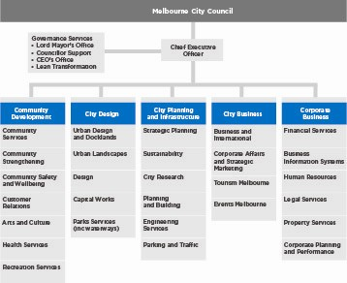

Chief Executive Officer

Dr Kathy Alexander is the City of Melbourne’s Chief Executive Officer (CEO). Her functions and powers are principally determined by the Local Government Act 1989 (Vic) and include:
- establishing and maintaining organisational structures to implement the Melbourne City Council’s decisions
- ensuring the council’s decisions are implemented
- managing the organisation’s day-to-day operations
- providing advice to the council
- appointing, directing and terminating staff, and managing all other issues that relate to staff.
The office of the CEO liaises with the offices of the Lord Mayor, Deputy Lord Mayor and councillors, the Australian and Victorian governments and other major community and corporate stakeholders. The CEO also attends council meetings.
City Design – Rob Adams AM
The City Design Division is responsible for developing strategic plans and urban design policy as well as delivering best practice in design, project management and parks services. This division delivers a range of projects and services for residents, workers and visitors to the municipality. The division has primary responsibility for Docklands and the coordination and delivery of major projects and the capital works program. It also ensures the City of Melbourne maintains its reputation as a leader in the sustainable design and management of public spaces.
City Business – Martin Cutter
The City Business Division focuses on supporting existing business and business development in Melbourne. The division contributes to positioning Melbourne as a world-class city in local, national and international markets through managing events, tourism services, international business relationships and marketing programs. The division works with a wide range of stakeholders including ratepayers, businesses, retailers, city visitors, tourists, sister cities, major sporting bodies and government departments.
City Planning and Infrastructure – Geoff Lawler
The City Planning and Infrastructure Division advises the council on research, city planning and the future sustainable development of Melbourne. It manages the City of Melbourne’s bridges and drainage, road infrastructure, as well as municipal services such as parking and traffic management, waste management and street cleaning. This division also administers local laws and regulations to develop, improve and protect the general amenity of the municipality. The division is also responsible for the City of Melbourne’s interests in the Sustainable Melbourne Fund and the Office of Knowledge Capital and is a member of the Inner Melbourne Action Plan Implementation Committee.
Community Development – Linda Weatherson
The Community Development Division plans and provides high quality, cost-effective and customer-focused human services to the community. The division assists the organisation with community engagement and provides the community with recreation services, health services, family and children’s services, aged care services, the library service and the customer relations service. This, coupled with the delivery of cultural programs, management of the municipality’s cultural infrastructure and implementation of Melbourne’s policy for the 24-hour city, enhances the City of Melbourne’s reputation as a safe, attractive, liveable and accessible city.
Corporate Business – Mark Stoermer
The Corporate Business Division is primarily responsible for providing support services to the organisation. These services include legal advice, human resource management, information technology systems, corporate planning, financial reporting, property services and management of the municipality’s financial assets. The division also plays a role in liaising with our wholly-owned subsidiaries which contribute to the City of Melbourne’s revenue.

ORGANISATIONAL PROFILE

The majority of staff work in the central city, however some staff members are located at other sites across the municipality. As at 30 June 2011, the City of Melbourne employed 1300 people. We have:
- 995 full-time staff
- 305 part-time staff.

143 are non-permanent staff, including:
- 97 maximum-term temporary
- 46 casual.
The gender balance of staff at the City of Melbourne is split approximately 55 per cent female and 45 per cent male. Women hold 29 per cent of executive positions. Seventy five per cent of female staff and 67 per cent of male staff are employed in medium-paying positions ranging from classifications 3 to 6.
Employee classification by gender as at 30 June 2011
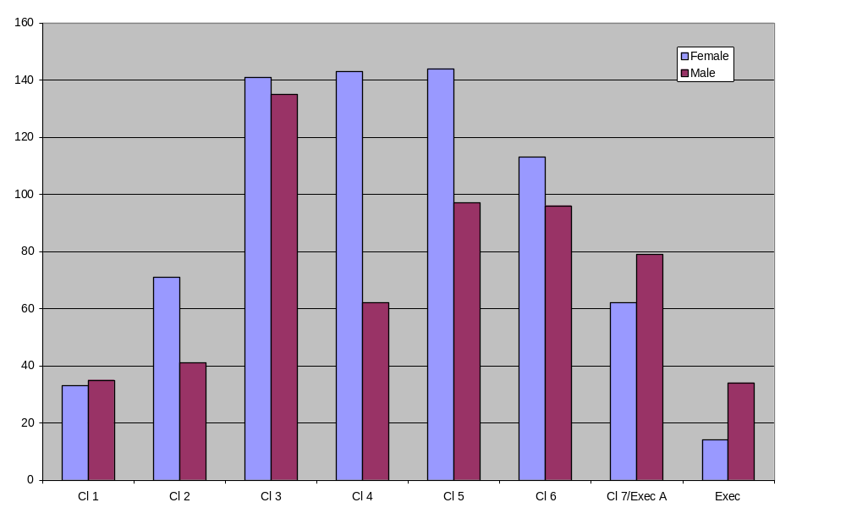
Staff classifications
Class 1 and 2: child care workers, school crossing supervisors, fitness instructors, information officers
Class 3: child care workers, parking and traffic, office administrative support
Class 4: administrative support, immunisation nurses, environmental health, project officers
Class 5 and 6: professionals, analysts, programmers, technical staff, maternal and child health nurses, event managers
Class 7: team leaders and professionals
Executive: managers, directors and CEO.

Number of staff by age group and gender as at 30 June 2011
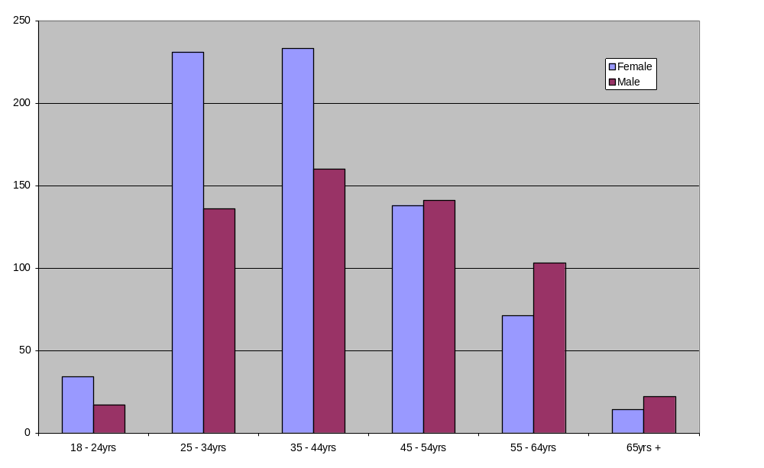
Number of staff by years of service and gender as at 30 June 2011
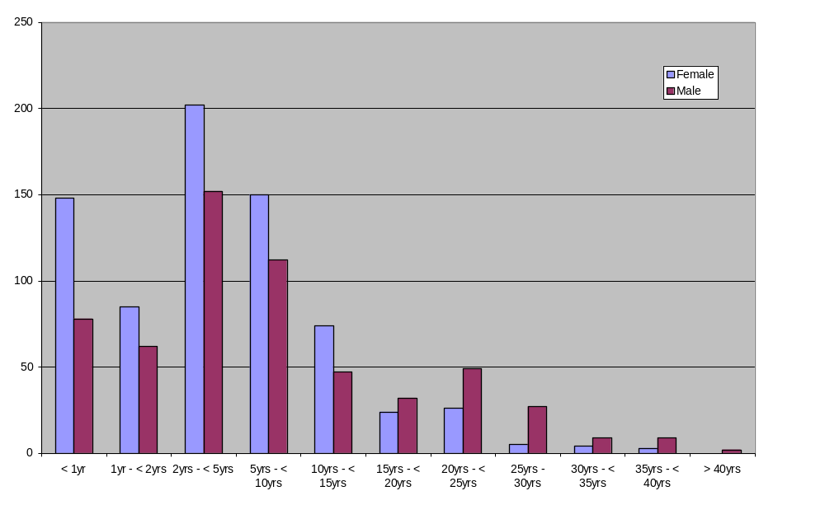
Health and wellbeing programs

At City of Melbourne we recognise that work is just one part of our employees’ lives. The City of Melbourne has a number of support mechanisms to help staff manage a work-life balance and their health and wellbeing. These programs include the Leap into Life program and an Executive Health program, through which we provide staff with information via educational sessions and online interactive tools. Current initiatives focus on physical activity and healthy eating habits.

Our Employee Recreation Association, CoMLife, also provides a range of health and wellbeing programs and social opportunities for staff. Membership of CoMLife has continued to grow in 2010-11. During the year the association provided discounted wellbeing classes, supported corporate sports teams, encouraged participation in charity events such as Movember and Cancer Council fundraising, and sourced discounts for staff on a range of health related products.

Staff retention and enterprise bargaining
Improving staff retention rates is a high priority for the City of Melbourne. Voluntary staff turnover decreased in 2010-11.
Staff turnover table

 | Positions advertised | Average applicants per position | Staff turnover(1) | Absenteeism(2)
2010-11 | 284 | 24 | 8.42% | 2.89%
2009-10 | 232 | 26 | 9.6% | 2.8%
2008-09 | 222 | 28 | 7.9% | 2.7%
2007-08 | 381 | 23 | 12.7% | 3%
2006-07 | 164 | 34 | 12.7% | 3.1%
Note 1: Voluntary (resignations) turnover only
Note 2: Total sick leave absences as a percentage of ordinary time available

Enterprise bargaining agreement
The City of Melbourne has a collective bargaining agreement that covers approximately 90 per cent of employees. This bargaining agreement includes sustainability targets, work conditions and employee benefits. To maintain its position as a fair and flexible employer, the City of Melbourne monitors the operation and application of the agreement through a staff consultative committee that meets quarterly.
Occupational health, safety and wellbeing

The City of Melbourne manages risk and occupational hazards by continuously improving its work environment and occupational health and safety (OHS) management system. Our OHS management system is audited against the Australian Safety Standard AS/NZS 4801:2001 and our accreditation has been maintained during 2010-11.

Safety is embedded in our work culture, and occupational health and safety is extremely important. The continuous improvement of our safety systems and processes across the organisation ensures our people are safe at work.

Staff development and support services
At the City of Melbourne, our staff is our most important asset and in addition to providing services to our community, the wellbeing of our staff is our highest priority.
We are committed to developing our people through a range of leadership development programs, study assistance and corporate learning programs. Our CoMET Learning Program offered 114 learning workshops, which were attended by 920 staff in 2010-11.
In addition, 17 staff successfully achieved a Diploma of Management, in partnership with Swinburne University of Technology.
In 2010-11, we had two teams represent the organisation in the Local Government Managers Australia Challenge, an internationally acclaimed professional/team development program which aims to build future leaders within local government.
One of our teams finished in first place in the regional finals and will represent Victoria in the Australasian finals in August 2011.
A broad range of support services and initiatives are available for all staff, including career and personal counselling, podiatry, nutrition advice through a dietician and an on-site physiotherapy trial. In addition during 2010-11 the City of Melbourne supported staff in returning to work from personal or work related illness or injury by providing:
- in-house allied health professional services
- access to specialists in occupational and environmental medicine
- early intervention strategies such as ergonomic reviews and adjustment to the workplace and,
- the development of return-to-work plans.

Training

The average number of training hours per employee within the City of Melbourne was 56.67 hours during 2010-11. This reflects both technical skills development and corporate learning programs. The following table provides a breakdown of average training hours by gender and classification. Variances across classification are impacted by a number of factors, including the gender diversity at each classification level, and the high number of males in classification 3 and 4 roles that receive a larger amount of technical skills development required by their role.
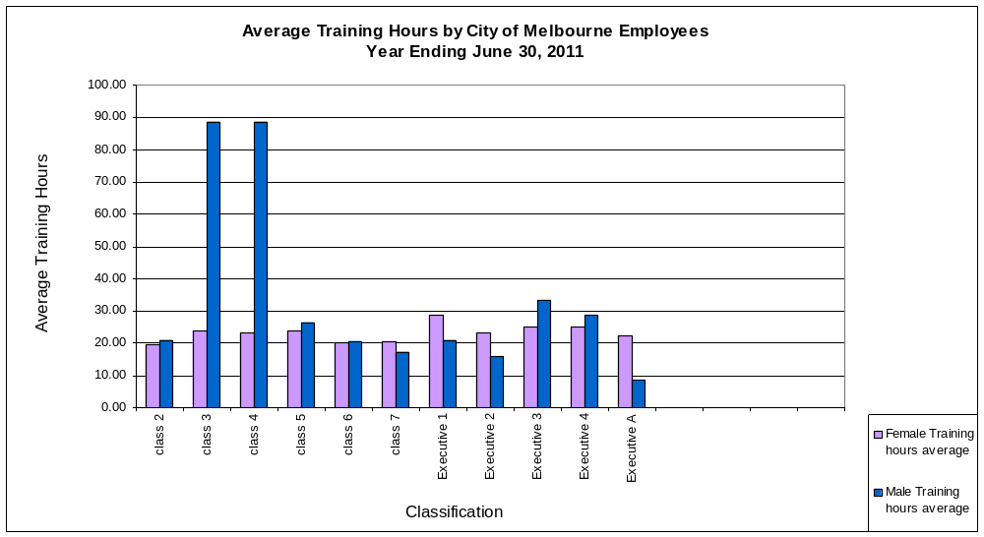

WorkCover Claims
The City of Melbourne received 20 WorkCover claims in 20010. Our WorkCover premium is now at 0.80 per cent. This remains significantly lower than the local government sector rate of 1.73 per cent.
The City of Melbourne has a proactive injury prevention strategy and adopts an early intervention approach to all work related injuries and illnesses by focusing on sustainable return-to-work programs.
WorkCover claims
Year | Standard claims | Minor claims | Premium incl GST ($) | Premium as % of remuneration
2010-11 | 4 | 1 | 818,600.13 | .80*
2009-10 | 16 | 4 | 599,653 | .64
2008-09 | 3 | 5 | 754,000 | .65
2007-08 | 8 | 17 | 767,000 | .88
2006-07 | 7 | 19 | 940,000 | 1.15
*Increased premium rate for this period was due to a Victorian Workcover Authority increase in the industry rate.

Equal Employment Opportunity Policy
The purpose of our Equal Employment Opportunity Policy is to prevent discrimination and harassment in the workplace. The City of Melbourne is an equal opportunity employer and is committed to the provision of a work environment that is safe and supportive, where individuals treat each other with respect. Our network of equal employment opportunity contact officers are trained to assist employees to identify options and resources to deal with workplace issues.
In 2008 we introduced an Aboriginal and Torres Strait Islanders traineeship program. In 2011 there were six trainees deployed across different work areas. In addition, an integral part of the induction process for all new employees is a walk highlighting Melbourne’s Aboriginal heritage.
Our equal employment opportunity commitment is supported by our Workplace Diversity Framework and addresses requirements under Schedule 6 of the Local Government Act 1989 (Vic).

Workplace diversity
Workplace diversity involves recognising the value of individual differences.
Our Workplace Diversity Framework includes principles, objectives and strategies to increase the diversity of City of Melbourne staff. The framework builds on our existing values: integrity, courage, accountability, respect and excellence.
In April 2010 we undertook our first diversity census, inviting participation from all staff across the organisation. Our organisational strengths were that staff felt welcome and respected at work, and felt they were treated fairly. Staff also felt they had access to professional development and training opportunities, and felt safe from bullying and harassment.
In 2011 an organisational Workforce Diversity Strategy was completed. This strategy establishes a Workforce Diversity Steering Committee which meets biannually to oversee workforce diversity action plans.

PART 2 – OUR PERFORMANCE

City of Melbourne performance
Details of our performance in 2010-11 can be measured in a number of ways, including how the City of Melbourne has delivered against the eight goals outlined in the Council Plan 2009-2013.
We aspire to be:
- a city for people
- a creative city
- economic prosperity
- a knowledge city
- an eco-city
- a connected city
- an organisation that leads by example
- an organisation that manages our resources well.

In 2010-11 the City of Melbourne annual report highlights a key achievement within each goal as well as specific information and data.

GOAL ONE – A CITY FOR PEOPLE

Highlighting city safety

Safety is a key concern of the City of Melbourne. We work in partnership with the Victorian Government, Victoria Police, transport operators and other agencies to ensure everyone enjoys a safe experience visiting the city.

In 2010-11, the City of Melbourne supported a Friday and Saturday night program managed by the Salvation Army which involved volunteers handing out advice and late-night essentials to ‘after hours’ visitors to the city. The volunteers divide into groups of four and walk city streets between 11pm and 5am providing practical advice as well as essentials including bottles of water, maps and blankets for young people. Each volunteer group on average engages with more than 100 people a night, for about five minutes each.

Discussions range from tracking down lost friends and providing thongs for sore feet to charging mobile phones and distracting revellers from altercations. The initiative is a practical example of the City of Melbourne’s commitment to city safety. The program will operate again in 2011-12. Other city safety initiatives include the provision of more than 50 closed circuit television cameras (CCTV), two mobile CCTV vans and the continued rollout of safe city taxi ranks to give quick access to late night taxis throughout the central city.
Name | Indicator | Comment | Actual | Target
Community satisfaction rating for City of Melbourne owned recreational facilities. | # | Consistent with results from previous years. | 76 | 75
Community satisfaction rating for health and human services. | # | Declined marginally since last year. | 71 | 70
Community satisfaction with the overall performance of enforcement of bylaws. | # | Consistent with results from previous years. | 63 | 63
Community satisfaction for City of Melbourne on leading debate and taking action on crime and violence and antisocial behaviour in the municipality. | % | The 2010-11 target of 85 per cent satisfaction with City of Melbourne leading debate and taking action on crime and violence was unrealistically high compared with the previous 2009-10 target of 53 per cent. Our performance has improved from a score of 53 per cent in 2009-10 to 59 per cent in 2010-11 and we are endeavouring to continue to advocate for more locally based solutions to crime. A successful example of this is the City of Melbourne precinct policing strategy adopted by Victoria Police in 2010-11. | 59 | 85
Community satisfaction rating for overall performance of waste management. | % | In 2010-11, the City of Melbourne provided additional public place waste service collections in the CBD late at night. In addition, new Eco-waste collection services were introduced and assistance was provided to high rise buildings to help improve their recycling collection programs. | 71 | 71
Community satisfaction rating for overall performance of appearance of public areas. | # | The City of Melbourne has invested additional resources in 2010-11 to improve waste services late at night, remove graffiti from private properties and maintain our city streets at a high standard. | 73 | 72
Participation rates at key events, festivals and programs conducted by the City of Melbourne. | # | More than 750,000 attendees at key City of Melbourne events including Melbourne Spring Fashion Week, New Year's Eve, Moomba, Summer Fun in the City and Melbourne Awards. | 750,000 | 750,000
Number of sporting groups using City of Melbourne parks. | # | In 2010-11 City of Melbourne allocated use of sports fields and associated pavilions to 36 community sports clubs during winter season and 31 community sports clubs during summer season. Additionally, 16 schools utilised Council facilities across both seasons. | 83 | 75
Percentage of visitors who feel safe in the central city. | % | The Perceptions of Safety survey is conducted on a three yearly basis. The percentage noted is the 2009 figure, the year of the last survey. | 89 | 90
Annual reduction in the number of people experiencing chronic homelessness as measured by Street Count results, compared to previous years. | # | This increase may be partly attributed to the involvement of the Salvation Army who partnered with the project to access squats and more isolated areas. In previous Street Counts these areas were considered unsafe for volunteers to enter and therefore were not included in the count. | 105 | 70

GOAL TWO – A CREATIVE CITY
Creative spaces for a creative city
‘Creative spaces’ began as a database of affordable and available spaces for creative industries in Melbourne’s central city. By regenerating abandoned buildings and creating affordable studios in inner urban areas where artists can thrive, the City of Melbourne is demonstrating a commitment to inspiring creative activities. In 2010-11 new studio space was created in a warehouse on the Maribyrnong River. A disused, three storey West Melbourne address has been converted into 57 studios in partnership with Arts Victoria and the property owner.
Resident artist Megan Evans moved to the new space after 10 years of using her garage as a studio. ‘It’s great to be around so many other artists,’ she said. ‘There’s a diversity of practice, everyone is making art. You don’t feel isolated and there’s a mix of ideas.’
River Studios was made possible by a $100,000 contribution from the City of Melbourne, which has helped the conversion of the property into a space accommodating 75 artists. The studio won an award for best Small Project in the Australian Institute of Architects awards (Victorian chapter) for Breathe Architecture.
The Creative Space program continues to contribute to Melbourne’s art scene across the city. The former JH Boyd Girls’ High School in Southbank was converted into an artistic hub in 2007 and resident artist, Vincent Fantauzzo, recently won the Doug Moran National Portrait Prize, which is among the world’s most lucrative portrait prizes, for his painting of friend, collaborator and well-known film director Baz Luhrmann.
Name | Indicator | Comment | Actual | Target
The number of new artist/arts organisations located within the municipality linked to City of Melbourne's Housing of the Arts Strategy. | # | River Studios launched in April 2011, houses 75 new artists. Boyd School Studios continues to house 50 artists. | 75 | 50
GOAL THREE – ECONOMIC PROSPERITY
New events to create a stronger city
Melbourne has long enjoyed a reputation as an ‘events’ city, with a range of major sporting fixtures, arts and cultural events, as well as festivals that drive tourism and economic opportunities for local businesses.
In 2010-11 the City of Melbourne hosted the inaugural Melbourne Music event, featuring gigs, workshops, public lectures and industry shows attracting musicians and music lovers from across Melbourne, around Australia and throughout the world. Every genre was represented including indie, electro and jazz, hip-hop, disco and rock’n’roll.
For 12 days and nights in September the sounds of Melbourne Music filled the city’s laneways, trams, trains and squares with music, including 100 free gigs from grass-roots and internationally renowned artists, at the city’s many iconic music venues, as well as some novel venues including trains and trams and even the steps of the State Library of Victoria. The success of the inaugural event will see it return in 2011-12.
Name | Indicator | Comment | Actual | Target
Community satisfaction rating for overall performance of economic development. | # | City of Melbourne s economic development activities such as Enterprise Melbourne, small business grants program and sector strategies are well regarded in the business community but less well known in the residential community who are the primary respondents to the Department of Planning and Community Development survey. | 66 | 72
Average number of daily visitors to Melbourne municipality on a typical weekday. | Days | City of Melbourne supplements surveys with more targeted feedback mechanisms for business which indicate high levels of satisfaction with the business support provided by council. The number of daily population, including overseas and interstate visitors, continued to grow over the past two years despite patchy economic conditions and relative strength of the $A. | 788,000 | 771,000
Number of visitor contacts at the Melbourne Visitor Centre. | p.a. | There has been an increase of five per cent compared to last year. Anecdotal feedback indicates that this is due to an increase in domestic visitors, attending major events in Melbourne. | 822,000 | 800,000
Number of businesses located in Melbourne municipality. | # | Achieved target for 2010-11. | 17,200 | 17,200
Level of investment by recipients of Small Business Grants. | $ | The investment generated by Small Business Grant recipients has risen significantly from previous years due to the support of a high tech company which will invest $2 million in their business and the introduction of the pilot Social Enterprise and Micro Business grant program and the resulting investments. | 4,060,000 | 1,000,000

GOAL FOUR – A KNOWLEDGE CITY
Sharing our knowledge with the world
In 2010-11 the City of Melbourne hosted the Knowledge City World Summit, an annual international event focused on research and development of knowledge cities, knowledge societies, knowledge-based development and knowledge ecology. The Melbourne event formed part of an inaugural ‘Knowledge Week’ which drew on the theme of moving knowledge from theory into practice. City of Melbourne’s focus for the week was engaging with the community in a celebration of Melbourne’s knowledge assets. Events included public forums, workshops, networking functions, performances, exhibitions, tours and information sessions. The decision to specifically focus on knowledge was made by council in 2008.
Knowledge-based development is a key to the future of Melbourne and it is also a means to further Melbourne’s reputation on an international scale. During the Knowledge City World Summit, Melbourne was awarded the prestigious Most Admired Knowledge City Award, in the category of Knowledge Metropolis. The city was founded on primary industries, gold and manufacturing. Today Melbourne’s economy is driven by knowledge-based industries in biotechnology, advanced manufacturing and design and more broadly is known as a city for the arts, literature, fashion and major events, highlighting its transformation to becoming a knowledge city.

Name | Indicator | Comment | Actual | Target
International students studying in the city as a proportion of total tertiary students. | % | The proportion of tertiary enrolments accounted for by international students increased between 2008 and 2009 - these are the latest available. These figures relate to the calendar year preceding the start of the relevant financial year. | 22 | 15
Local students studying in the city as a proportion of total tertiary students. | % | The proportion of tertiary enrolments accounted for by domestic students increased between 2008 and 2009, in the latest available data. These figures relate to the calendar year preceding the start of the relevant financial. | 79 | 85
Number of primary, secondary and tertiary educational facilities in the city. | # | City of Melbourne, Census of Land Use and Employment (CLUE) indicate that the 2008 Census data recorded 385 facilities within the city including Primary Education, Secondary Education, Combined Primary and Secondary Education, Special School Education, Technical and Vocational Education and Training and Higher Education. | 385 | 385

GOAL FIVE – AN ECO CITY
Playing our role in protecting the environment
In 2010-11 the City of Melbourne was one of the first councils to be recognised as a ‘Climate Adaptation Champion’ – which acknowledges leadership and innovation in adapting to and preparing for the impacts of climate change. It reflects the change in behaviour, business practices and policies the city is making to prepare for the expected changes in climate in the years ahead. The award organisers commended the City of Melbourne for being one of the first councils in Australia to begin preparing for climate change. Innovative adaptive tools have been developed to prepare for a change in the climate, including visual and scenario planning around increased sea levels, for example.

More broadly the City of Melbourne invested $30 million during 2010-11 in climate change policy and initiatives including a Greenhouse Action Plan and a commitment to zero net emissions by 2020. Practical actions include:
- funding urban forest projects
- improving water efficiency in parks and gardens
- promoting energy efficiency
- development of a City of Melbourne Water Sensitive Urban Design policy.
One of the City of Melbourne’s headline environmental initiatives is the 1200 Buildings program, which supports and encourages building owners and managers to improve water and energy efficiency of commercial buildings within the City of Melbourne. As an example, 530 Collins Street received an energy retrofit designed to reduce its annual greenhouse gas emissions by 40 per cent compared to industry average. The program is delivered with the support of the Victorian Government.
The City of Melbourne also announced in 2010-11 it will pave its streets ‘green’ with a new environmentally friendly asphalt, to reduce fumes and greenhouse gas emissions by 30 per cent. With around 18,000 tonnes of asphalt poured each year within the City of Melbourne, this is a strong contribution to becoming a more carbon friendly municipality.
Name | Indicator | Comment | Actual | Target
City of Melbourne performance on refuse recycling initiatives and effective and efficient water usage. | % | Consistent with results from previous years. | 68 | 70
Percentage of municipal waste diverted for recycling. | % | Total residential recycling/total residential waste stream is down slightly from 2009-10 but still just above target for the period. | 26 | 25
Reduction of residential waste to landfill per household. | % | The City of Melbourne continues to deliver education programs to encourage more residents to recycle. There has been a 12 per cent increase in volume of waste going into landfill. Multi-storied residential towers being built without adequate recycling facilities is attributed in part to this growing trend. | 12 | -1
Reduction of greenhouse gas emissions from City of Melbourne operations. | % | The estimated 2010-11 emissions for all City of Melbourne operations was 22,770 tonnes, a 26.7 per cent or 8,395 tonne reduction from the base year. The major contributing factor for the difference from last year appears to be a total reduction in the percentage of green power purchased from electricity retailers. | 27 | 34
Number of commercial buildings retrofitted under the 1200 program. | # | An additional seven signatories committed to retrofit works. A survey conducted in June 2011 showed an additional 15 buildings had undertaken retrofit action. | 44 | 50
Reduction of drinking quality water consumed for Council building and gardens. | % | Total water use from potable water sources was 412 megalitres down 73 per cent from 1,544 megalitres in the base year. | 73 | 60

City of Melbourne sustainability indicators

The City of Melbourne consumes energy in the daily operation of its administration and buildings, community buildings such as childcare centres, public lighting and the corporate fleet. We monitor the consumption of three major energy types; electricity, natural gas and fuel.

City of Melbourne’s energy use by source

Energy use by source | Base year(1996-97*) | 2006-07 | 2007-08 | 2008-09 | 2009-10** | 2010-11***
Electricity (Vic grid) | 76,070 | 52,689 | 56,532 | 70,725 | 57,635 | 63,418
Electricity (green power) | 0 | 33,496 | 34,660 | 24,243 | 42,695 | 33,014
Natural gas | 14,626 | 14,172 | 18,157 | 19,276 | 21,079 | 17,182
Unleaded petrol | 13,700 | 8,509 | 6,714 | 5,787 | 4,896 | 4,026
LPG fuel | 0 | 193 | 431 | 477 | 511 | 354
Diesel | 0 | 0 | 118 | 431 | 741 | 886
Ethanol | 0 | 0 | 0 | 0 | 0 | 2
Total energy use (GJ) | 104,396 | 109,029 | 116,612 | 120,589 | 127,561 | 118,882
% renewable | 20% | 30.7% | 29.7% | 20.1% | 33.4% | 27.8%

Notes
* In 1996-97 a baseline was established which became our base year. An investigation of our historical records has resulted in changes to these figures from previously reported results.
** Figures previously published for this year were estimates and adjustments have been made to reflect actual results available at the time of printing.
*** Due to billing cycles these figures include estimated calculations based on current and seasonal trends.

City of Melbourne’s energy use by activity

Energy use by source | Base year(1996-97*) | 2006-07 | 2007-08 | 2008-09 | 2009-10** | 2010-11***
Administration - buildings | 18,632 | 19,388 | 22,356 | 21,967 | 21,386 | 20,269
Administration - fleet | 13,700 | 8,702 | 7,264 | 6,695 | 6,151 | 5,267
Commercial - buildings | 2,754 | 2,988 | 3,434 | 3,094 | 5,057 | 4,250
Community use – public lighting | 21,688 | 22,407 | 23,977 | 26,016 | 30,707 | 27,884
Community use - miscellaneous | 1,230 | 3,970 | 4,033 | 4,884 | 6,019 | 5,826
Total energy use (GJ) | 104,396 | 109,029 | 116,612 | 120,589 | 127,561 | 118,882

Notes
* In 1996-97 a baseline was established which became our base year. An investigation of our historical records has resulted in changes to these figures from previously reported results.
** Figures previously published for this year were estimates and adjustments have been made to reflect actual results available at the time of printing.
*** Due to billing cycles these figures include estimated calculations based on current and seasonal trends.

Total direct and indirect greenhouse gas emissions

Total emissions | Base year(1996-97*) | 2006-07 | 2007-08 | 2008-09 | 2009-10** | 2010-11***
Emissions (t CO2-e) | 31,165 | 19,506 | 20,638 | 25,339 | 21,074 | 22,770
Percentage from base year |  | -37.4% | -33.8% | -18.7% | -32.4% | -27%
Percentage from previous year |  | -17.2% | 5.8% | 22.8% | -20.7% | 7%

Notes
* In 1996-97 a baseline was established which became our base year. An investigation of our historical records has resulted in changes to these figures from previously reported results.
** Figures previously published for this year were estimates and adjustments have been made to reflect actual results available at the time of printing.
*** Due to billing cycles these figures include estimated calculations based on current and seasonal trends.

City of Melbourne total water use

Total COM water use | Base year (1999-2000)* | 2006-07 | 2007-08 | 2008-09 | 2009-10** | 2010-11***
Potable (Ml) | 1,544 | 721 | 520 | 607 | 623 | 412
Reclaimed (Ml) | 0 | 30 | 87 | 73 | 90 | 65
Total Water | 1,544 | 751 | 607 | 680 | 713 | 477
Percentage from base year |  | -51.4% | -60.7% | -56% | -53.8% | -69.1%
Percentage from previous year |  | -39.8% | -19.2% | 12% | 17.4% | -29.9%
Percentage reclaimed |  | 4% | 14.3% | 10.7% | 12.7% | 13.7%

Notes
* In 1999-2000 a baseline was established which became our base year.
** Figures previously published for this year were estimates and adjustments have been made to reflect actual results available at the time of printing.
*** Due to billing cycles these figures include estimated calculations based on current and seasonal trends.

Water use by activity

Total COM water use | Base year (1999-2000)* | 2006-07 | 2007-08 | 2008-09 | 2009-10** | 2010-11***
Administration - buildings | 11 | 7 | 4 | 4 | 9 | 15
Commercial - buildings | 1 | 1 | 2 | 6 | 4 | 4
Community use - buildings | 70 | 50 | 45 | 41 | 47 | 42
Community use – open space | 1,462 | 693 | 557 | 629 | 654 | 416
Total water (ML) | 1,544 | 751 | 607 | 680 | 714 | 477

Notes
* In 1999-2000 a baseline was established which became our base year.
** Figures previously published for this year were estimates and adjustments have been made to reflect actual results available at the time of printing.
*** Due to billing cycles these figures include estimated calculations based on current and seasonal trends.

Procurement

The City of Melbourne is committed to a sustainable procurement policy which includes the use of recycled materials, ecologically sustainable and the use of technology which contributes to a reduction in greenhouse gas emissions where possible. An example of this approach is the City of Melbourne's decision in 2010-11 to introduce new asphalt which emits 30 per cent less greenhouse gas emissions. Detailed information about City of Melbourne’s procurement policy and practices, including the sustainability approach to procurement which takes into account the social, financial and environmental impact can be located at: www.melbourne.vic.gov.au/AboutCouncil/Tenders/Pages/ProcurementPolicy.aspx

GOAL SIX – A CONNECTED CITY
Providing better transport options across the city
During 2010-11 the City of Melbourne released a draft Transport Strategy Update designed to deliver an integrated and connected transport system for the people of Melbourne over the next five years and beyond. The focus was working with the Victorian Government on delivering safe and practical transport options.
The key directions are to:
- go anywhere, anytime public transport for inner Melbourne
- support public transport, walking and cycling as the dominant modes of transport in inner Melbourne
- develop high-mobility pedestrian and public transport streets in the central city
- make Melbourne a true cycling city
- foster innovative low-impact freight and delivery in central Melbourne.
The update contains ambitious targets for non-car use in the City of Melbourne. The aspiration is for 90 per cent of all commuter trips to the central city to be taken by public transport, cycling or walking by 2020, compared with the 72 per cent recorded in the 2006 census. In addition to a broader, updated, transport strategy, work began in 2010-11 on a major revamp of Swanston Street which will enhance its reputation as Melbourne’s civic ‘spine’.
Name | Indicator | Comment | Actual | Target
Community satisfaction rating for overall performance of local roads and footpaths. | # | The 2010-11 works program included $10.7 million on road, footpath and kerb channel programmed renewal works and $739,000 on unplanned minor maintenance. In addition, $360,000 was spent on works to improve footpath accessibility and amenity to comply with the Disability Discrimination Act. | 65 | 68
City of Melbourne performance on promoting use of public transport. | % | There was a significant increase of 7 per cent from 2010 (73) to 2011 (80). This represents broad satisfaction with the City of Melbourne's performance on encouraging the use of public transport. | 80 | 65
CoM performance on quality and coverage of bike and footpaths and convenience of walking around the central city. | # | City of Melbourne continues to invest in bicycle and pedestrian infrastructure to improve mobility and safety across the inner city network. | 70 | 70
Community satisfaction rating for overall performance of traffic management and parking facilities. | # | City of Melbourne has received a higher than usual number of complaints this financial year relating to congestion on the arterial road network managed by VicRoads. There was also significant reconstruction of Harbour Esplanade, creating traffic congestion around the city. | 53 | 55

GOAL SEVEN – LEAD BY EXAMPLE
Looking after all Melburnians
The City of Melbourne continues to be committed to responding to the needs of people experiencing homelessness and those at risk of homelessness. The City of Melbourne’s fourth annual street count of homeless people revealed approximately 105 people were found sleeping rough in parks and streets of the central city, North and West Melbourne, Flagstaff and Fitzroy Gardens on the evening of 7 June 2011. This compares with 101 in 2010, 75 in 2009 and 112 in 2008. City of Melbourne continues to address the issue by funding support services, strengthening partnerships and building a strong and inclusive community.
A new Homelessness Strategy was also endorsed in May 2011 which is focused on people sleeping rough and people living in boarding or rooming houses in the City of Melbourne. Councillors felt homelessness was an issue for the whole community to address, together. The City of Melbourne currently funds a number of projects for the homeless including community grants for employment training at SecondBite food collection organisation, annual funding of the Cafe Meals program and providing information to help people access support services. The Cafe Meals program offers access to a dietitian and subsidised meals at nine participating cafes for the homeless or those at risk of becoming homeless for just $2. Many participants have not eaten regular meals for weeks and in some cases much longer periods of time.

The Homelessness Strategy is a practical demonstration of the City of Melbourne reaching out to those in need in the community and leading by example.

Name | Indicator | Comment | Actual | Target
Community satisfaction rating for City of Melbourne 's engagement in decision making on key local issues. | # | Consistent with results from previous years. | 59 | 59
Community satisfaction rating for overall performance generally of the City of Melbourne. | # | Improved from last years result. | 68 | 70
Community satisfaction rating for City of Melbourne s interaction and responsiveness in dealing with the public. | # | Consistent with results from previous years. | 72 | 73

GOAL EIGHT – MANAGE OUR RESOURCES WELL
Delivering services more efficiently
During 2010-11 the City of Melbourne’s health services branch was required to undertake a new food sampling regime as part of changes to Victorian food safety requirements. New rules meant sampling was based on the number of food outlets in a municipality rather than number of residents. This led to a fourfold increase in sample numbers required to be taken by officers annually, from 240 to 917 in total. Through a ‘lean thinking’ initiative, The City of Melbourne was able to adapt to the new laws with minimal impact on resources.
By applying lean thinking methodology the sampling program was redeveloped into an annual program rather than a quarterly one, improving timeliness and quality. To reduce the number of process steps and save time, sampling was incorporated into other compliance checks, rather than being run separately.
Lean thinking was introduced at the City of Melbourne in 2009. It is a continuous improvement system which focuses on improving the quality, timeliness and cost of services delivered, from the perspective of the customer. This lean thinking initiative is a practical example of how the city is managing its resources well.

Goal 8 |  | Managing our resources well
Name | Indicator | Comment | Actual | Target
Percentage of planned City of Melbourne works programs completed. | % | Very strong progress made in the fourth quarter increased achievement to 93.6 per cent. | 94 | 90
Liquidity Ratio is greater than 1.5. | % | The City of Melbourne remains highly liquid in 2010-11. | 3 | 2
Maintain a positive underlying surplus. | $ | Positive small surplus maintained for 2010-12. | 18 | 3
Percentage of our customers satisfied with the overall customer experience when contacting the City of Melbourne. | % | The organisation is 1.6 per cent shy of its target of 85 per cent (+/- 3.4 per cent) of customer satisfaction. Initiatives outlined in the Customer Focus Strategy should affect an improvement in performance of this measure in ensuing years. | 83 | 85
Staff retention rate. | % | Staff retention rate has improved since the previous year. | 92 | 90
Staff satisfaction rating. | # | Consistent with results from previous years. | 6 | 6
Maintain Australian Standard 4801 accreditation.* | % | Re-accreditation attained in May 2010 for a three year period. | 100 | 100
* AS/NZS 4801 is the Australian Standard and New Zealand Standard for Occupational Health and Safety Management Systems. It is a Standard that requires five main components of OH&S Management that are implemented into a businesses activities to ensure all OH&S issues are effectively managed.

City of Melbourne 2010-11 Performance Statement

Introduction

In accordance with Section 127 of the Local Government Act 1989 (Vic), the City of Melbourne must provide a description of Key Strategic Activities (KSAs) to be funded in the 2010-11 Annual Plan and Budget.
Each year the City of Melbourne conducts a thorough planning process to identify the KSAs and they are published in the Council’s Annual Plan and Budget.

The City of Melbourne again adopted the framework from the Victorian Auditor General’s Office Better Practice Guide to prepare the KSAs. In doing so, we developed cost, time, quality and quantity measures and targets for the KSAs. Depending on the nature of the KSA some of these elements were found to be more relevant and material than others, therefore not all KSAs have measures and targets for all four elements.

Rating Scale
For the 2010-11 Performance Statement, the City of Melbourne has used a rating scale that is consistent with the methodology used to monitor performance of KSAs throughout the year. This is based on a ‘percentage complete’ result against targets set at the beginning of the year and published in the 2010-11 Annual Plan and Budget. This year we have continued to use percentage complete as we believe it gives stakeholders a very specific indication of the actual result. However in recognition of the importance of a clear statement of achievement, we have applied the following scale to the Performance Statement:

100% Complete = Achieved
90-99% Complete= Substantially Achieved
80-89% Complete= Partially Achieved
Less than 80% Complete = Not achieved

The method for determining percentage complete is based initially on the professional judgement of the responsible officer who weighs up what has been achieved against what was planned. A rigorous process of review then occurs where the percentage complete determined by the responsible officer is reviewed first by the appropriate Manager and then the responsible Director. The final determination of percentage complete is jointly reviewed by the CEO and Directors each month.

External factors impacting on achievement of KSAs
The City of Melbourne’s ability to implement KSAs can be impacted upon by external matters outside of its control. In most cases, KSA measures are established to focus on our specific role however this is not practical in all cases, especially where an external reader needs to understand the full context of the KSA.

The following Performance Statement outlines the City of Melbourne's achievement against the 10 KSAs for 2010-11.

KSA 1 Melbourne Planning Scheme

Key Strategic Activity: Complete the Melbourne Planning Scheme review and submit for approval by Council
Goal: 1 A city for the people
Outcome: 1.8 A well planned city with a vision of the future |  | Objective: 1.8.1 Establish a robust planning scheme that facilitates sustainable growth and development and protects heritage
Division: City Planning and Infrastructure
Measure | Target | Actual | Comments
Cost - Operational | $525,000 | $496,656 | Achieved  Achieved within budget.
Time – City North precinct structure plan and draft planning scheme amendments for the area completed and reported to Council | June 2011 | 85% | Partially Achieved  On 10 May 2011 the Future Melbourne Committee (FMC) endorsed the draft City North precinct structure plan for public consultation. The draft planning scheme amendment component is delayed until after the adoption of the final plan.
Time - Planning Scheme amendment for built form policy and controls for the Central City completed and results of exhibition reported to Council | June 2011 | 75% | Not Achieved  On 12 April FMC deferred this deliverable until November 2011 to allow for further stakeholder consultation and review the proposed planning controls. FMC approved the draft amendment to be submitted to the Minister for exhibition on 17 May 2011 and we await the Minister’s response in due course. In view of the work undertaken to date and in light of the decision to defer completion to November, a rating of 75% complete is given.
Time - Planning Scheme amendments for zones and overlays in Southbank completed and results of exhibition reported to Council | June 2011 | 85% | Partially Achieved  On 12 April 2011 FMC deferred this deliverable until August 2011 as the Minister’s authorisation was received later than anticipated. In view of the work undertaken to date and in light of the decision to defer completion to August, a rating of 85% complete is given.
Time - North Melbourne / Kensington area Structure Plan completed and reported to Council | June 2011 | 100% | Achieved  The FMC endorsed the community consultation for the North Melbourne / Kensington area structure plan (renamed the Arden Macaulay Structure Plan) on 10 May 2011.
Time – Energy, water and waste efficiency planning scheme policy report to Council on the draft amendment completed | June 2011 | 95% | Substantially Achieved  A draft energy water and waste efficiency amendment was prepared for the 14 June 2011 Future Melbourne Committee but subsequently withdrawn from the agenda at the request of Council to allow for further public consultation. The work has therefore been substantially completed but presentation of the amendment will now be deferred until 2011-12.
Time - Climate Change Adaptation: Develop an inundation overlay and heat island policy. Report to Council on the amendment | June 2011 | 66% | Not Achieved  FMC resolved to defer completion of this deliverable on 12 April 2011. The inundation overlay depends on Melbourne Water’s direction and they have requested a time extension that will delay completion to June 2012. An unusually cool summer has also prevented collection of the aerial thermal imagery required for the heat island policy.
Time – With VicUrban develop the new Docklands Strategic Framework as part of the Docklands Second Decade plan | June 2011 | 5% | Not Achieved  FMC resolved to defer completion of this deliverable on 12 April 2011 as it is dependant upon completion of the Docklands Second Decade (D2) whose finalisation depends on the new government’s approval.
Quantity - Planning Scheme amendments prepared and presented to Council for approval | 100% | 0% | Not Achieved  Reasons are outlined above.

KSA 2 City Safety & Security Initiatives

Key Strategic Activity: Implement city safety and security initiatives
Goal: 1 A city for people
Outcome: 1.3 Residents and visitors feel safe |  | Objective: 1.3.1 Work towards a safer city through partnerships with other agencies
Division: City Planning and Infrastructure
Measure | Target | Actual | Comments
Cost - Capital Works Program | $620,000 | $591,511 | Achieved  Achieved within budget
Time: Additional waste management services on Thursday-Sunday nights within the CBD delivered (particularly at Elizabeth Street and Flinders Street intersection and Swanston Street between Collins and Flinders Streets) | December 2010 | 100% | Achieved  Work instructions were issued to CityWide Service Solutions and the additional services were provided under the existing contract arrangements for 12 months from 1 July 2010.
Time - Two enhanced taxi ranks implemented in Collins Street (#3) and Flinders Street (#4) subject to usage survey | June 2011 | 100% | Achieved  Following usage survey results rank #3 was installed at 8 King Street between Flinders Lane and Flinders St and rank #4 at 200 Queen Street between Lonsdale and Little Bourke streets by June 2011 as posted on the City of Melbourne web site.
Time - A forward plan to June 2013 of actions across the organisation to support late night activation developed | June 2011 | 100% | Achieved  The late night activation plan for 2011-13 was presented to Councillors in May 2011 and endorsed.
Time - Two surveillance vehicles to patrol CBD hotspots in highly visible vehicles fitted with 360o CCTV cameras every Friday and Saturday 22:00 to 6:00 during the peak activity period (6 months) of the year | April 2011 | 100% | Achieved  Work instructions were issued for the additional surveillance services which were provided under a variation to the existing contract arrangements for prescribed peak activity periods.
Quantity – Enhanced taxi ranks installed as planned | 2 taxi ranks installed | 100% | Achieved  As per time measure regarding two enhanced taxi ranks implemented.
Quantity - Reduced litter presence in the additional CBD waste management areas | No more than 80% full at any time and verified through surveillance audit | <80% | Not Achieved  A significant number of bins were found to be more than 80 per cent full during audit surveillance inspection times.
Quality – Positive feedback from Victorian Taxi Association, Victorian Taxi Directorate, Victorian Taxi Drivers Association. | Positive feedback received indicating a reduction in anti-social incidents. | Mixed feedback | Partially Achieved  Consultant group, Village Well were engaged to complete a survey of taxi rank users with mixed (positive / negative) results including very positive feedback about the presence of taxi marshals. Due to the varied nature of the feedback the target is regarded as partially achieved.

KSA 3 1200 Buildings

Key Strategic Activity: Accelerate the energy and water retrofit of commercial buildings in the municipality through the 1200 Buildings Campaign, in partnership with other organisations
Goal: 5 An eco-city
Outcome: 5.1 A reduced ecological footprint |  | Objective: 5.1.1 Influence the municipality to become a zero net emissions city
Division: City Planning and Infrastructure
Measure | Target | Actual | Comments
Cost – Operational | $600,000 | $545,834 | Achieved  Completed within budget.
Cost – Capital Works Program | $75,000 | $45,073 | Achieved  Completed within budget.
Time - Funding agreement with the State Government to address set up costs established | August 2010 | 100% | Achieved  An agreement with Victorian Government to fund 1200 Building Program set up costs was signed with the Victorian Government on the 12 October 2010.
Time - Ongoing program development and management of rollout including building recruitment (up to 50 more buildings), events, marketing and evaluation activities | June 2011 | 100% | Achieved  The overall program included the development of information kits and case studies, videos, advice sheets and collateral (e.g. post cards) support for conferences, surveys, public engagement events for signatories as well as one-to-one meetings.
Time - The 1200 Buildings database developed and website updated | June 2011 | 100% | Achieved  The website was updated to include usability enhancements and new content in accordance with the upgrade specification.  After an analysis of business requirements, an “off the shelf” software was purchased with an import file developed for importing data into the new database.
Time - A financial mechanism to accelerate the uptake of the program developed. Sustainable Melbourne Fund appointed to deliver the financial mechanism | December 2010 | 90% | Substantially Achieved  The Environment Upgrade Agreement and associated procedures have been developed. The Sustainable Melbourne Fund website, complete with information about the application process, is now live. Sustainable Melbourne Fund was appointed in August 2010 however it was subsequently identified that the value of these services would exceed $150,000. A report was presented to the Future Melbourne Committee on the 5 April 2011 recommending we seek an exemption from the public tender process under section 186 of the Local Government Act 1989 to confirm Council’s appointment of the Sustainable Melbourne Fund. We are awaiting Ministerial exemption, however as most of the work for the financial mechanism is complete the target is regarded as substantially achieved.
Quantity - Number of participating buildings | Up to 50 additional buildings by June 2011 | 8 additional buildings | Not Achieved  Eight new signatories were added to the program database including Sullivan Property, AMP Capital Investors, Crown Melbourne, Hayball , Norman Lindsay & Young, Selected Growth Property Trust, Eighth Grange , Electrical Trades Union. The number of participating buildings has not grown as planned and this is due primarily to resources being diverted into dealing with the complexity of the legislation enabling Environmental Upgrade Agreements. Progress is also slowed by the need to spend substantial time building relationships with companies so they are confident to commit funds required to participate.

KSA 4 Climate Change Adaptation

Key Strategic Activity: Climate change adaptation strategies including commencement of urban forest projects and water security for parks and gardens
Goal: 5 An eco-city
Outcome: 5.2 Melbourne is better adapted to climate change |  | Objective: 5.2.1 Influence the municipality to adapt to climate change
Division: City Design
Measure | Target | Actual | Comments
Cost - Capital Works Program | $6,120,000  $7,200,000 (including $1,500,000 of external funding)  $190,000  $230,000 | $4,595,600  $4,500,000  $86,150  $9,450 | Partially Achieved  The $7.2M budget included $1.5M external funding from a Federal Government Grant, which was not received in 2010-11.  Delays in construction of some projects have impacted on actual expenditure, resulting in partial achievement of the set target.
Time- Yarra River corridor landscaping enhancements commenced | June 2011 | 90% | Substantially Achieved  Landscape plan and community consultation is finalised. The trees have been purchased ready for planting, which is scheduled for late August.
Time - Greater support to existing mature park trees provided | June 2011 | 100% | Achieved  The program to provide a range of supplementary treatments to reduce stress on mature trees has been completed. Works included soil decomposition, extensive mulching of mature trees and modification of irrigation systems to provide adequate levels of watering for the trees to eliminate stress.
Time - Urban street tree plantings upgraded and extended | June 2011 | 100% | Achieved  A total of 891 trees were planted in the June / July 2011 period. Some of these trees replace the approximately 160 trees scheduled for removal. Planting is underway or has been completed for St Mary's Church, North Melbourne, Elliot Avenue, Bellair Street and Clarendon Street.
Time - Urban Forest Strategy Eades Place Greening | June 2011 | 80% | Partially Achieved  Detailed design complete. Community engagement and support for the project finalised. Materials for construction have been purchased. Now awaiting Citipower affirmation on redundancy of high voltage power cable which has delayed the construction. In view of the work already undertaken the target is regarded as partially achieved by the due date.
Time - Urban Forest Strategy Arden Street Greening | June 2011 | 90% | Substantially Achieved  Detailed assessment of the original scope led to a realisation that the best outcome would be to increase the scope to encompass the entirety of Arden Street, not just the original scope of one block. Therefore the 2010-11 scope was adjusted to achieve a detailed concept plan for the entirety of Arden and to include east / west bicycle link as advocated by VicRoads; stormwater abatement modifications; increased tree planting and greening opportunities; reduction in traffic speeds and volumes, increased pedestrianisation; and expansion of land adjacent to recreational grounds to increase open space. The detailed concept has been completed resulting in an assessment of substantially completed Joint funding for implementation is being sought with VicRoads.
Time - Design and documentation of water savings projects in Fitzroy Gardens as part of the Fitzroy Gardens Masterplan Review - including depot rationalisation and children's garden/cafe redevelopment | June 2011 | 90% | Substantially Achieved  The Fitzroy Gardens Masterplan Discussion Paper was reviewed and adopted by Council in March 2010. The Masterplan is still awaiting a few minor heritage issues which will enable it to be finalised. The revised Masterplan identifies water savings projects including design and documentation for a new depot, garden and installation of water tanks. Design and documentation for the installation of water tanks in Fitzroy Gardens was almost completed by June 30 but ultimately not fully completed for tendering until August.
Quantity - Percentage of planned tree plantings achieved | 100% | 95% | Substantially Achieved  Tree planting completed in numerous locations including Birrarung Marr, Royal Park and South Boulevard. Tree planting in Yarra River delayed until late August 2011. The work is not yet completed with a small number of tree plantings still to be completed

KSA 5 Streetscapes

Key Strategic Activity: Develop a framework to support an improvement plan for selected streetscapes and implement identified projects
Goal: 1 A city for the people
Outcome: 1.6 High quality public spaces |  | Objective: 1.6.1 Provide a range of high quality and welcoming public spaces
Division: City Planning and Infrastructure
Measure | Target | Actual | Comments
Cost - Operational | $154,000 | $113,673 | Achieved  Completed within budget.
Cost - Capital Works Program | $400,000 | $92,025 | Achieved  Capital Expenditure $92,025 + $30,300 (accrual for King Street feature survey) = $122,325 actual expenditure. Balance of budget funds, $277,675 to be carried forward to 2011-12 to undertake community engagement and detail design of Flinders Lane and Elizabeth Street streetscape improvement projects.
Time - Condition survey and improvement proposals for Elizabeth Street and Flinders Lane completed | June 2011 | 100% | Achieved  The improvement proposals for Elizabeth Street and Flinders Lane were approved by Council on 28 June.
Time - Concept alternatives to improve the pedestrian amenity of King Street and to support east-west public transport movements prepared | June 2011 | 100% | Achieved  The Concept alternatives to improve pedestrian amenity in King Street were approved by Council on 28 June.
Time - Asset management policy and strategy including evaluation criteria prepared | June 2011 | 100% | Achieved  The streetscape framework, asset management policy and asset management strategy including the evaluation criteria were presented to Council on 28 June and subsequently approved.
Time - Rolling program of improvements developed | June 2011 | 100% | Achieved  The rolling program of streetscape improvements was approved by Council on 28 June.
Quantity - Number of improvement proposals completed. | 2 | 2 | Achieved  Two improvement proposals for Elizabeth Street and Flinders Lane were approved on 28 June by Council.

KSA 6 Queen Victoria Market

Key Strategic Activity: Agree on the preferred option for the Queen Victoria Market site and undertake community engagement
Goal: 3 Economic Prosperity
Outcome: 3.1 A sustainable and resilient city economy |  | Objective: 3.1.1 Implement strategies to support a thriving and diverse economy
Division: City Design
Measure | Target |  | Actual | Comments
Cost - Capital Works Program | $1,230,000  $230,000  $1,000,000 |  | $580,000  $230,000  $350,000 | Partially achieved  Advanced design works – achieved  Queen Street - Expenditure to date was to complete the design for the upgrade of Queen Street at Queen Victoria Market (QVM) which was completed. The remaining budget was for the construction of the projects, however this has been delayed and anticipated that the works will be constructed in 2011-12.
Time - Community engagement plan developed and implemented and market research on market users and non-users conducted | December 2010 |  | 80% | Partially Achieved  The Market research component is complete and the Community Engagement Plan has been put together and implementation is underway. However, engagement with the QVM traders was delayed, commencing in July 2011 with the release of a survey, resulting in an overall assessment for this target as partially achieved..
Time - Site options agreed with the State Government | December 2010 |  | 90% | Substantially Achieved  A preferred option has been agreed in principle by council and discussions have progressed with Victorian Government.  Summary document prepared for Victorian Government consultation purposes as per Issues Management Plan and Community Engagement Plan.
Time - Public open space to Queen Street tender documentation completed | June 2011 |  | 55% | Not Achieved  In principal approval from QVM was received on 21 June 2011 but includes conditions. Design completed, however project on hold pending outcomes of the discussions with the Victorian Government.
Time - Strategic development framework (with State Government input) completed | June 2011 |  | 90% | Substantially Achieved  The QVM long term strategy has been drafted, drawing on a range of strategic inputs and research. A summary of the proposed long term strategy was presented to Councillor Forum in late March 2011. Following this presentation, at Council's request, feedback is being sought from key Victorian Government stakeholders prior to embarking on a broader public community engagement process. The target was substantially achieved, noting that further input from the Victorian Government is underway which will lead to full completion.
Time - Business Plan and Precinct Plan prepared | June 2011 |  | 85% | Partially Achieved  The finalisation of the draft strategic directions is a key document for the development of the 2012 QVM Business Plan. The Business Plan and Precinct Plan was not completed in its entirety however the target is regarded as partially achieved as there is an in principle agreement between the City of Melbourne and the Board of Directors of the Queen Victoria Market Pty Ltd on the structure of the 2012 QVM Business which will be finalised later this year.
Quantity - Strategic development framework completed | Framework complete |  | 90% | Substantially Achieved  The QVM long term strategy has been drafted. A summary of the proposed long term strategy was presented to Councillor Forum in March 2011. Feedback is being sought from key Victorian Government stakeholders prior to embarking on a broader public community engagement process.
Quality - A Strategic Development Framework that captures the vision for the precinct |  |  | 90% | Substantially Achieved  As above

KSA 7 Swanston Street Redevelopment

Key Strategic Activity: Deliver Stage one of Swanston Street redevelopment strategy
Goal: 6 A connected city
Outcome: 6.2 Melbourne is connected and accessible regionally, nationally and globally |  | Objective:6.2.2 Make Melbourne accessible for all Victorians including commuters, freight and delivery vehicles
Division: City Design
Measure | Target | Actual | Comments
Cost - Capital Works Program | $7,800,000 | $3,900,000 | Not Achieved  Expenditure at 30 June 2011 is behind plan due to delay of five months in obtaining regulatory approval from Transport Safety Victoria (TSV) for Stage 1.
Time - Stage one between Latrobe Street and Little Lonsdale Street complete | June 2011 | 40% | Not Achieved  Construction of Swanston Street Redevelopment Stage 1 was delayed as a result of issues raised by TSV in November 2010. Council was given approval to recommence the project in March 2011.  Stage 1 construction commenced on 20 May 2011 and is on track for completion in November 2011.
Time - Design and documentation of stage two works complete | May 2011 | 100% | Achieved  Completed within target.

KSA 8 Docklands Second Decade

Key Strategic Activity: Complete the Docklands Second Decade Plan
Goal: 1 A city for the people
Outcome: 1.8 A well planned city with a vision of the future |  | Objective: 1.8.2 Facilitate quality urban development and sustainable growth in Docklands
Division: City Design
Measure | Target | Actual | Comments
Cost - Operational | $324,000 | $140,193 | Partially Achieved  Underspent as the Final Docklands Second Decade Plan has not been adopted. It was anticipated that the remaining funds would be spent on production of the final document.
Time - Second decade plan - draft for consultation and final plan prepared | June 2011 | 95% | Substantially Achieved  A Draft Docklands Second Decade Plan has been finalised and the target is regarded as substantially completed. The plan is now subject to a response by the Minister for Planning.  The project was initially delayed due to the caretaker period in the lead up to the Victorian Government election during November 2010.
Time - Second decade communications activities and media launches delivered | June 2011 | 95% | Substantially Achieved  The draft shared vision for Docklands (collaboratively prepared by City of Melbourne and VicUrban) was launched at a media event on 28 October 2010. Minister Justin Madden and the Lord Mayor launched Phase 2 of the Second Decade of Dockland (D2) project to the media at an event on Central Pier, Docklands on 29 October 2010. The communication activities were focussed on internal communication with CoM and VicUrban staff, including a Councillor briefing on 24 May. Phase 2 of Stakeholder Engagement Program was completed in May 2011. Phase 3 is scheduled to occur in July and August with the final D2 Plan scheduled for release in September.  With the announcement of Urban Renewal Authority subsuming VicUrban and a change to the VicUrban board, external communications activities for June were placed on hold until further information and direction from the Minister for Planning. However the target is substantially achieved apart from phase three.
Time - Stakeholder engagement program delivered | December 2010 | 95% | Substantially Achieved  The stakeholder engagement program timeframe was amended late last year to accommodate the caretaker period in the lead up to the Victorian Government election during November.
Quantity - Project deliverables completed on time, as scheduled | 100% | 95% | Substantially Achieved  A Draft Docklands Second Decade Plan has been finalised and is now subject to the response by the Minister for Planning.
Quality - Final plan endorsed by Council and VicUrban Board and broadly accepted by key stakeholders and the community | Plan endorsed | 95% | Substantially Achieved  The document is now subject to the response by the Minister for Planning.

KSA 9 Community Infrastructure

Key Strategic Activity: Deliver new community infrastructure
Goal: 1 A city for the people
Outcome: 1.7 Improved access to relevant and affordable community services |  | Objective: 1.7.4 Establish and improve community infrastructure in all neighbourhoods
Division: Community Development
Measure | Target | Actual | Comments
Cost - Operational | $100,000 | $12,384 | Partially Achieved  Doutta Galla Community Health Service received a grant to undertake service planning for the Drill Hall. A major component of the City of Melbourne operational budget was no longer required for this project, resulting in an assessment of partially achieved.
Cost - Capital Works Program | $8,300,000 | $4,751,660 | Partially Achieved  Capital Works projects which are part of KSA 9 were not all achieved for various reasons. Expenditure of $4.7M is regarded as partially achieved.
Cost - External Contribution | $1,250,000 | $0 | Not Achieved  This external contribution was for the Docklands Library and Community Centre. The project has not progressed to construction in 2010-11, and therefore the contribution from VicUrban has not been paid to CoM.
Time - Docklands Library and Community Centre - design and work commenced | June 2011 | 35% | Not Achieved  Docklands Library and Community Centre is significantly delayed and has not met its deliverable target due to constraints on the previously proposed site (the “CLEC” site).  In February 2011 Council resolved to look at other sites and alternative procurement strategies. In March 2011 expressions of interest were sought from organisations and developers in the precinct to develop a library and community centre within Docklands. In May 2011 Council considered this matter and further negotiations are continuing with potential developers.
Time - Docklands Social and Recreation Hub - site identification and schematic design and Carlton Health and Aged Hub concept design completed | June 2011 | 65% | Not Achieved  Docklands Social and Recreation Hub:  Docklands Recreation Hub feasibility is being considered as part of the second decade of Docklands (D2) process. The main focus for a recreation facility is at Western Park in Docklands. Concept options have been developed by VicUrban and a community engagement process undertaken to look at the future social and recreational uses of Western Park.  Carlton Health and Aged Hub (“Carlton Service Model”)  The Carlton Health and Aged Hub (Carlton Service Model) has been put on hold by the Victorian Government, and a concept design was not delivered this financial year.  On 17 June 2011 CoM indicated to the Victorian Government its intention to purchase the Kathleen Syme Centre (in Carlton) for community use including the provision of aged, families and children's services from this building. The contract of sale and payment by CoM was made by 30 June 2011.
Time - Carlton Pool and Recreation Centre and Carlton Family Resource Centre - design and documentation completed | June 2011 | 100% | Achieved
Time - Drill Hall Community Centre - Grant of $600,000 to HCA (Housing Choices Australia) provided | June 2011 | 100% | Achieved
Time - Drill Hall and other homeless initiatives delivered | June 2011 | 80% | Partially Achieved  A draft business case has been developed in concert with the Doutta Galla Community Health Service to develop a Central City Health Service for homeless people in the Drill Hall Community Centre.  Other homelessness initiatives have also progressed including preparing a feasibility report for the proposed development of low cost housing and services at the rear of the Salvation Army site at 69 Bourke Street.  The target was partially achieved as the final business case was not presented to council by 31 June 2011.
Time - Boyd School community centre and library - design and construction commenced | June 2011 | 100% | Achieved  The design and early works contract for the redevelopment of the Boyd School community centre has been completed. The main contractor commenced on site in March 2011.
Time - Kensington Town Hall - upgrade commenced | June 2011 | 100% | Achieved  The underpinning works at Kensington Town Hall have been completed.  Plans and documentation have been completed for a further phase of works within the current funding allocation, including repairs to the building fabric and facade.
Quantity - The percentage of projects completed as planned | 100% | 83% | Partially Achieved  Docklands Library and Community Centre was significantly delayed due to overriding constraints on the previously proposed site. While a number of projects were completed as planned the Carlton Health and Aged Hub was been put on hold by the Victorian Government, and a concept design was not delivered this financial year.

KSA 10 CH1 Precinct

Key Strategic Activity: Complete the feasibility study for CH1 precinct and agree on a preferred option
Goal: 8 Manage our resources well
Outcome: 8.3 An efficient, service focused organisation |  | Objective: 8.3.3 Manage and use City of Melbourne property and assets effectively
Division: Corporate Business
Measure | Target | Actual | Comments
Cost - Operational | $240,000 | $157,520 | Achieved  KSA 10 was completed within budget.
Time - Independent market analysis report delivered | August 2010 | 100% | Achieved  Independent technical reports have been completed.  Consolidated overview report tabled at Councillor Forum 3 May.
Time - Design and Costing options prepared and analysed | December 2010 | 100% | Achieved  Completed report detailing the design and costing options that was then presented at Councillor Forum 3 May.
Time - Draft Property Management Policy completed | November 2010 | 100% | Achieved  The draft Property Management Policy was completed. Access and analysis of restructured lease register presented to Director's Forum 29 June. Consolidated lease register now embedded in normal real estate management processes. New Corporate Lease Management Policy has been presented to Directors.

MELBOURNE CITY COUNCIL

Statement by councillors, Chief Executive Officer and Principal Accounting Officer on the performance statement for the year ending 30 June 2011.

In my opinion the accompanying performance statement has been prepared in accordance with the Local Government Act 1989.

Signed by:
Phu Nguyen (CPA)
Principal Accounting Officer

In the council's opinion the accompanying compulsory performance statement presents fairly the performance of the Melbourne City Council for the year ending 30 June 2011.

As at the date of signing, we are not aware of any circumstance, which would render any particulars in the performance to be misleading or inaccurate.

We were authorised by the council on 30 August 2011 to certify the financial report in its final form.

Signed by:
Robert Doyle
Lord Mayor

Signed by:
Brian Shanahan
Councillor

Signed by:
Mark Stoermer
Acting Chief Executive Officer
Melbourne

VAGO

Victorian Auditor-General's Office

INDEPENDENT AUDITOR'S REPORT

To the Councillors, Melbourne City Council

The Performance Statement
The accompanying performance statement for the year ended 30 June 2011 of the Melbourne City Council which comprises the statement, the related notes and the statement by councillors, chief executive officer and principal accounting officer has been audited.

The Councillors' Responsibility for the Performance Statement
The Councillors of the Melbourne City Council are responsible for the preparation and fair presentation of the performance statement in accordance with the Local Government Act 1989. This responsibility includes establishing and maintaining internal controls relevant to the preparation and fair presentation of the performance statement that is free of material misstatement, whether due to fraud or error.

Auditor's Responsibility
As required by the Local Government Act 1989, my responsibility is to express an opinion on the performance statement based on the audit, which has been conducted in accordance with Australian Auditing Standards. These Standards require compliance with relevant ethical requirements relating to audit engagements and that the audit be planned and performed to obtain reasonable assurance whether the performance statement is free from material misstatement.

An audit involves performing procedures to obtain audit evidence about the amounts and disclosures in the performance statement. The audit procedures selected depend on judgement, including the assessment of the risks of material misstatement of the performance statement, whether due to fraud or error. In making those risk assessments, consideration is given to the internal control relevant to the entity's preparation and fair presentation of the performance statement in order to design audit procedures that are appropriate in the circumstances, but not for the purpose of expressing an opinion on the effectiveness of the entity's internal control. An audit also includes evaluating the overall presentation of the performance statement.

I believe that the audit evidence I have obtained is sufficient and appropriate to provide a basis for my audit opinion.

Independence
The Auditor-General's independence is established by the Constitution Act 1975. The Auditor-General is not subject to direction by any person about the way in which his powers and responsibilities are to be exercised. In conducting the audit the Auditor-General, his staff and delegates complied with all applicable independence requirements of the Australian accounting profession.

VAGO

Victorian Auditor-General's Office

Independent Auditor's Report (continued)

Auditor's Opinion
In my opinion, the performance statement of the Melbourne City Council in respect of the 30 June 2011 financial year presents fairly, in all material respects, in accordance with the Local Government Act 1989.

Matters Relating to the Electronic Publication of the Audited Performance Statement
This auditor's report relates to the performance statement of the Melbourne City Council for the year ended 30 June 2011 included both in the Melbourne City Council's annual report and on the website. The Councillors of the Melbourne City Council are responsible for the integrity of the Melbourne City Council's website. I have not been engaged to report on the integrity of the Melbourne City Council's website. The auditor's report refers only to the subject matter described above. It does not provide an opinion on any other information which may have been hyperlinked to/from this statement. If users of the performance statement are concerned with the inherent risks arising from publication on a website, they are advised to refer to the hard copy of the audited performance statement to confirm the information contained in the website version of the performance statement.

MELBOURNE
14 September 2011

Signed by:
D D R Pearson
Auditor-General

(Footer)
Level 24, 35 Collins Street, Melbourne Vic. 3000
Telephone 61 3 8601 7000 Facsimile 61 3 8601 7010 Email comments@audit.vic.gov.au Website www.audit.vic.gov.au
Auditing in the Public Interest

BEST VALUE AND LOCAL GOVERNMENT INDICATORS

Best value information
In 1999 the Victorian Government amended the Local Government Act 1989 (Vic) to add a new section on Best Value. This replaced the previous requirements for Compulsory Competitive Tendering.
These amedments require the City of Melbourne to review all services and adopt service delivery models that are the best on offer to meet the needs of the community.
The Local Government Act requires Council to take these six principles into account when reviewing its services under best value:
- the need for services to deliver against agreed quality and cost standards
- accessibility of services to those who need them
- services being responsive to changing community needs
- continuous improvement in the delivery of services
- community consultation on services and activities
- regular annual reporting to the community on Council's performance
The City of Melbourne is committed to the continuous improvement of its services and projects to ensure best value for the community.
Community engagement and ‘Lean Thinking’ (CoMLean) programs ensure the City of Melbourne applies best value principles in the services we operate and manage.
Lean thinking
Lean thinking is a business method that aims to create value for internal and external customers by eliminating waste and duplication. In service industries, ‘lean’ means the right service, in the right place, at the right time, provided by the right person and done right the first time. Value for the customer is increased by systematically removing waste from processes and the associated work.
In 2010-11 the CoMLean program comprised 11 large improvement projects. The program continued to embed continuous improvement into the culture of the City of Melbourne.
Teams from across the City of Melbourne applied lean thinking methods to council programs to increase value to ratepayers.
Community engagement
Community engagement involves informing, consulting with and seeking the active participation of the community in issues that impact on them. It is a formal process that is designed to seek out and facilitate the involvement of key stakeholders and a diverse cross section of the community so that the range of ideas and opinions are considered as part of the Council’s decision-making process. The techniques for engagement are varied and tailored to support accessible and well informed participation.
The City of Melbourne community engagement processes are exposed to continuous improvement through the development of an evaluation framework, as well as internal and external review.
Building a culture of community engagement that is integral to core business contributes to open and responsible government and a more informed and engaged society. Staff from across Council’s five divisions have been involved in training, and in developing and implementing community engagement planning processes. Through their contribution they contribute to embedding the desired cultural change.
This year the City of Melbourne has sought community input on a number of projects including:
- Docklands
- Melbourne Planning Scheme including key precincts of Kensington, North Melbourne and Southbank.
- Swanston Street redevelopment
- new opportunities for Carlton
- Carlton Baths and Resource Centre redevelopment design
- adapting to Climate Change projects
- review of the Street Trading Policy
- city safety and homeless strategy
- Children’s Policy and
- on-line mapping system.
The City of Melbourne has continued to apply the best value principles in assessing and improving its services in the following ways:
Best value principle  Quality and cost standards | Application at the City of Melbourne  This principle refers to the extent to which services are achieving or exceeding relevant key performance indicators of service quality and the service can demonstrate value for money.  The City of Melbourne measures the standard of service through a range of quality and cost measures including industry standards, the strategic indicators of its council plan and measures for Lean Thinking streams.  The following Lean Thinking streams have targets and metrics aligned to quality and cost:  - childcare – increased use of centres (increased revenue and increased services for parents requiring childcare), reduced agency spend  - recruitment – reduced number of ‘defective’ recruitment episodes (episodes delayed or readvertised)  - parking meters – increased uptime of parking  - committee reports – increased quality and timeliness of reports submitted to Council  - maintenance requests – increased internal customer satisfaction; reduced backlog  - Health Services – increased number of food samples, using existing resources  - Planning and Building – reduced outstanding debt.
Responsive to community needs | This principle refers to the extent to which the community feels that we not only understand what they are seeking from services offered but also the extent that the current service offerings reflect that understanding.  Community needs are established through review of relevant data and research, community engagement, the analysis of customer requests and survey results.  A robust community engagement process supports organisation decision-making by assisting those affected by a Council initiative to contribute to the decision-making process at a level that can be supported by the organisation. Some projects seek community opinion on options already developed, while other projects will partner with the community in each aspect of the process including identifying the preferred solution.  In 2010-11 the City of Melbourne’s community satisfaction rating for the overall performance of Council was 68 per cent. Broadly consistent with results over the last five years.  The primary focus of Lean Thinking is to improve value from the perspective of the customer, in our case, the community, by eliminating waste in processes. Some examples include:  - childcare centres – increased timeliness and quality of the child’s individual plan of care; and increased availability of online methods of fees payment  - recruitment – improved timeliness and quality of communication processes with applicants for positions available at City of Melbourne  - interim residential parking permit process – reduced waiting time for final permit, eliminating the need for a temporary permit.
Accessible services | This principle refers to the extent to which services are able to be readily accessed by those for whom the services are intended.
Continuous improvement | This principle refers to the extent to which our work is continuously improved. The City of Melbourne has adopted a Lean Thinking approach as our improvement model. These improvements have resulted in measurable savings of at least $711,000 and productivity release of 3200 hours.  Some specific improvement outcomes for 2010-11 include:  - parking savings of $17,000 per annum as a consequence of quality focussed process improvements  - reduced spend on executive recruitment estimated at $210,000; time to recruit reduced from 30 days to 25 days, productivity release for recruitment managers estimated at 1310 hours; 88 per cent of staff undertaking the recruitment process consider it has improved  - childcare fee payment savings of $6000 on Armaguard contract; cash payments reduced from 15 per cent to 1 per cent with increased parent satisfaction, planning day savings of $50,000 on agency staff, food $4000 savings due to changes in meal delivery, utilisation increased from 79 per cent to 88 per cent, delivering $13,000 in increased revenue.  - parking meter revenue increase of 1.1 per cent ($358,620).  - committee report monthly metrics indicate there is improvement in the timeliness and quality.  - maintenance request improvements include establishment of internal customer satisfaction metric with high satisfaction levels; backlog reduced by 50 per cent and 54 per cent reduction in time taken from logging of job to job close.  - increased health services sampling (up by 400 per cent) with same resource as a result of process improvement program.  The City of Melbourne has developed an interim evaluation method to apply to all projects that have a community engagement component. The evaluation method will assess the extent to which events that engage the community provide clear influence over project directions and major decisions.
Community consultation | Community engagement is any process that involves the public in problem-solving or decision-making and uses public input to make decisions. The City of Melbourne community engagement framework is built on the International Association for Public Participation (IAP2) core values and spectrum for public participation.  This year the City of Melbourne has sought community input on a number of projects as indicated earlier in this section.

Victorian LGA Indicators
Indicator | 2006-07 | 07-08 | 08-09 | 09-10 | 10-11
Overall performance  Community satisfaction rating for overall performance generally of council | 72 | 68 | 66 | 68 | 68
Advocacy  Community satisfaction rating for the council's advocacy and community representation on key local issues | 66 | 62 | 61 | 64 | 61
Engagement  Community satisfaction rating for the council's engagement in decision-making on key local issues | 61 | 59 | 59 | 62 | 59
All rates  Average rates and charges per assessment (all rates) | $2,255 | $2,265 | $2,318 | $2,457 | $2,412
Residential rates  Average rates and charges per residential assessment | $809 | $877 | $939 | $968 | $950
Operating costs  Average operating expenditure per assessment | $4,455 | $3,993 | $4,333 | $4,214 | $4,227
Capital expenditure  Average capital expenditure per assessment | $932 | $909 | $1,060 | $863 | $839
Infrastructure  Renewal gap | 76% | 67% | 70% | 76% | 73%
Renewal and maintenance gap | 80% | 71% | 72% | 79% | 77%
Debts  Average liabilities per assessment | $1,331 | $1,184 | $989 | $817 | $1,039
Operating result  Operating results per assessment  Note: This represents the operating results per assessment as per the subtotal profit/loss for the period. | $2,819 | $1,357 | $340 | $(360) | $474

GLOBAL REPORTING INITIATIVE DISCUSSION AND INDICATORS
The Global Reporting Initiative (GRI) is a network-based organisation that produces a comprehensive sustainability reporting framework that is widely used around the world. The City of Melbourne uses Version G3.0 of the framework, which sets out the principles and indicators that organisations can use to measure and report their economic, environmental, and social performance
The GRI’s principles of inclusiveness, relevance, sustainability context and completeness define the content of this report.
It is important to note that the GRI is a global framework that does not assume that reporting organisations have an established reporting process. The City of Melbourne’s annual report contents are substantially determined by the requirements of the Local Government Act 1989 (Vic). Like most local governments, the City of Melbourne has a long history of reporting both financial and non-financial performance to stakeholders. Many of the disclosures required as part of the GRI are also specified under the Act.
GRI Version G3.1
The GRI recently announced an updated version of its framework, the G3.1. The City of Melbourne is supportive of the new directions taken with G3.1 and an increased emphasis on human rights, local community impacts and gender. Indeed, the City of Melbourne has adopted significant strategies in the areas of diversity and community consultation and engagement, highlighting a strong congruence between our own practices and the evolving GRI framework.
Due to timing of the preparation of our annual report, the City of Melbourne has elected to continue working with G3.0 for this year’s annual report and intends to transition to G3.1 next year. The transition to G3.1 will coincide with a deeper analysis of our sustainability reporting priorities.
Reading the GRI index
The City of Melbourne has included GRI sustainability indicators as part of its performance measures since 2004-05. The GRI appears in this annual report as a list of indicators, each with a page reference to demonstrate where in the annual report the relevant data can be located.
GRI application level
‘Application levels’ were introduced with the release of GRI’s G3 guidelines in October 2006. The application level system provides organisations with a pathway towards continuous improvement of their sustainability reporting. The levels are intended to motivate reporters to enhance the quality of their reporting over time.
The application levels indicate the extent to which the G3/G3.1 guidelines have been applied in sustainability reporting. They communicate which part of the reporting framework has been addressed – which set of disclosures – varying with the different levels. The levels do not give an opinion on the sustainability performance of the reporting organisation, the quality of the report, or on formal compliance with the G3 or G3.1 guidelines.
This report was prepared to meet the requirements of application level B under the GRI’s sustainability reporting guidelines, maintaining the standard of reporting and disclosure of previous years.
To achieve a ‘plus’ rating (ie B+) organisations must seek external assurance by GRI approved means. Given the level and cost of audit currently in place for the annual report as a whole, the City of Melbourne has chosen not to pursue further external verification of the data at this stage.
The application level table below lists the requirements for each application level. The City of Melbourne has prepared its GRI report to meet ‘B’ level requirements.

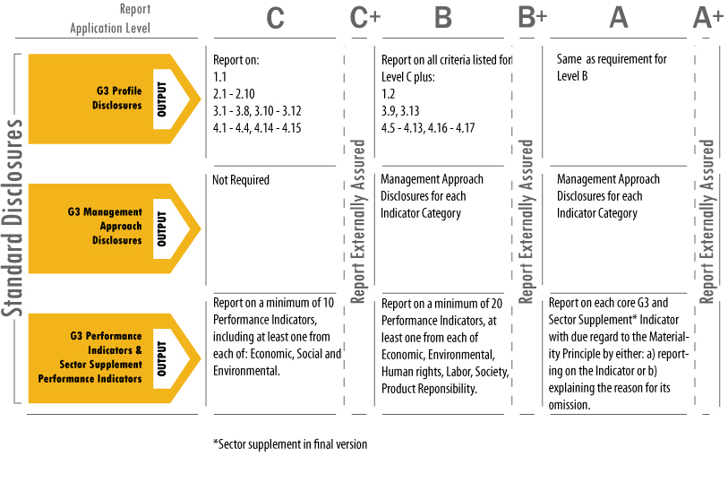

More information about the GRI is available at www.globalreporting.org
GRI content table

GRI standard disclosure | Section/Page | GRI indicator
Report profile – strategy and analysis
Message from LM & CEO | S.3/S.4 | 1.1
Risks and opportunities | S.3/S.4 | 1.2
Support for the UN Global Compact | S.1 | 1.3
Report profile – organisational profile
Council profile, products, services and organisational diagram | S.1/S.9/S.10 | 2.1 – 2.10
Report parameters
Report profile | S.1 | 3.1-3.5
Report scope and responsibilities | S.1 | 3.6-3.11
GRI context index | GRI Content Table | 3.12
Assurance | S.1 | 3.13
Governance, commitment and engagement
Governance and risk management | S.7/S.8 | 4.1 – 4.12
Memberships | S.1 | 4.13
Stakeholder engagement | Goals one-six/S.5 | 4.14-4.17
Public policies and implementation measures
Sustainable development policies | Part 2 | PA2-PA3
Goals, measures and targets | Part 2 | PA4-PA7
Economic indicators – performance
Economic value generated and distributed | Financials | EC1
Risk and opportunities due to climate change | Goal six | EC2
Significant financial contribution from government | Financials | EC4
Economic indicators – indirect economic indicators
Gross expenditure by type of payment and classification | Financials | PA8 – PA9
Economic indicators – expenditure and procurement
Procurement policy | Goal five | PA11
Economic, environmental and social criteria | Goal five | PA12
Procurement practice and policy priorities | Goal five | PA13
Environmental indicators
Energy consumption | Goal five | EN3-EN7
Water consumption | Goal five | EN9-EN10
Biodiversity | Goal five | EN14
Greenhouse gas emissions | Goal five | EN16, EN18
Labour practices and decent work indicators
Employment, labour/management practices | S.10 | LA1, LA2, LA4
OH&S, training and education, diversity and equal opportunity | S.10 | LA6-LA14
Social performance indicators
Community | Part 2 | SO1
Corruption | S,8 | SO2-SO4
Public policy | S.7 | SO5
Compliance | S.8 | SO8
Product responsibility indicators
Marketing and communications | S.8 | PR6-PR8

Standard Statements

For

City of Melbourne

Annual Report 2010-2011

Budget v Actual
Note 1. Significant accounting policies

The significant policies, which have been adopted in the preparation of these Standard Statements, are:

(a) Basis of preparation
The Standard Statements of the Council are special purpose financial reports that consist of a Standard Income Statement, Standard Balance Sheet, Standard Cash Flow Statement and Standard Statement of Capital Works. These special purpose financial reports have been prepared in accordance with the Local Government Act 1989 and the Local Government (Finance and Reporting) Regulations 2004. These special purpose financial reports do not form part of Council's general purpose financial reports.

CITY OF MELBOURNE
Standard Statements
For the year ended 30 June 2011

Standard statement of income

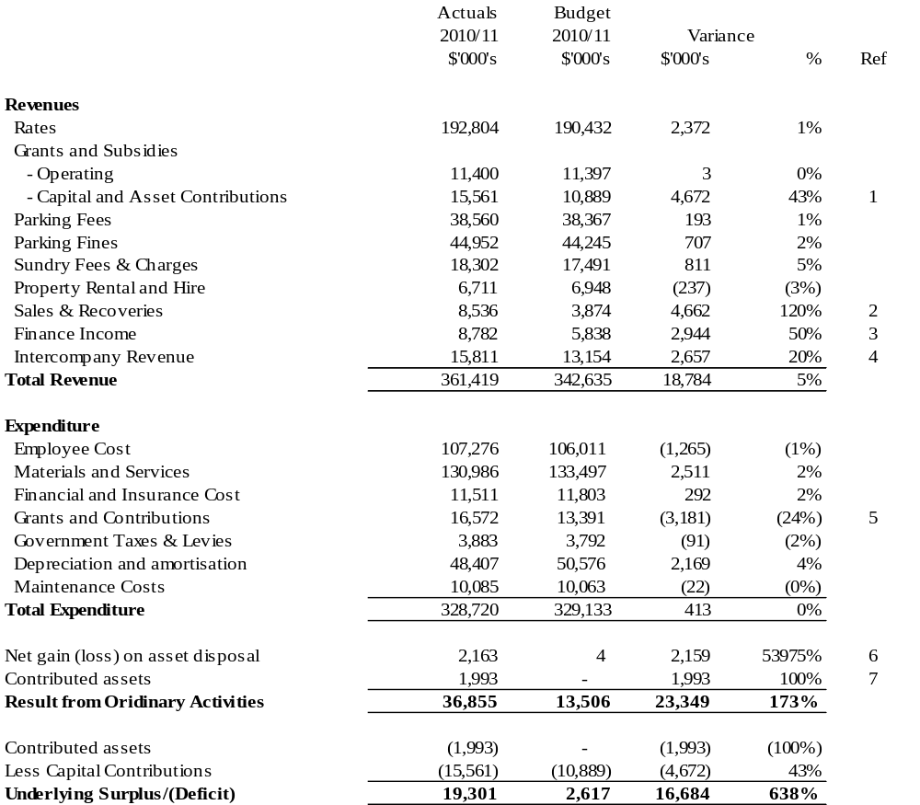

CITY OF MELBOURNE
Standard Statements
For the year ended 30 June 2011

Standard statement of income - comparison report

Ref. | Item | Commentary
1 | Grants and Subsidies (Revenue) –Capital and Asset Contributions | Additional external capital contributions received mainly in relation to:  - Northbank Promenade ($1.84 million)  - Public Open Space ($1.18 million)  - Culture Precincts improvement ($1.17 million)  - Kensington Town Hall Upgrade ($0.53 million)
2 | Sales & Recoveries | Additional recoveries received mainly in relation to:  - Building levies collected on behalf of the State Government ($0.12 million)  - Legal cost recoveries from Court proceedings ($0.21 million)  - Property valuations ($0.41 million)  - External labour recoveries mainly for community services and events ($0.14 million)  - Grants in Kind revenue ($3.42 million, fully offset from Grants in Kind payments, refer to Ref 4 below)
3 | Finance Income | The favourable variance is due to higher investment interest revenue generated through higher cash balances.
4 | Intercompany Revenue | Primarily related to better than anticipated operating performance by CityWide Service Solutions and Queen Victoria Market ($1.17 million) as well as higher tax equivalent revenue from the sale of the Melbourne Wholesale Fish Market site ($1.31 million).
5 | Grants & Contributions (Expense) | Primarily due to additional Grants in Kind payments ($3.42 million, fully offset by additional Grants in Kind revenue, see Ref 2 above).
6 | Net gain/(loss) on asset disposal | Due to the sale of part of Penfold Place, Elloit Lane and part of Merriman Lane.
7 | Contributed assets | Primarily due to contributed infrastructure assets from Docklands.

CITY OF MELBOURNE
Standard Statements
For the year ended 30 June 2011

Standard statement of Balance Sheet

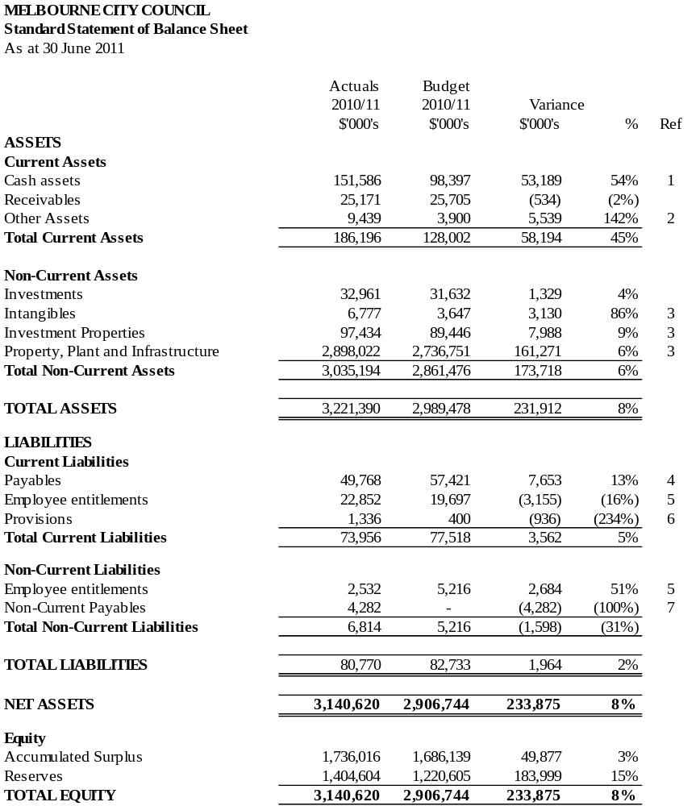
CITY OF MELBOURNE
Standard Statement
For the year ended 30 June 2011

Standard statement of balance sheet – comparison report

Ref. | Item | Commentary
1 | Cash assets | The higher cash balance is due to a higher underlying surplus generated from operations and some capital works projects carried over to 2011-12.
2 | Other (Current) Assets | Other assets are higher due to dividends and tax equivalent payments from Council’s subsidiaries at the 30th June 2011 being recognised as revenue but not yet received.
3 | Intangible Assets, Property, Plant & Infrastructure & Investment Properties | A revaluation of land, building and infrastructure assets conducted in June 2011 shows increases in value and intangible assets increase relates in part to the capitalisation of the Integrated Corporate System.
4 | Payables | The lower payables primarily due to lower operating accruals than budgeted and non-current payables to Docklands being budgeted in current payables.
5 | Employee Entitlements | Total employee entitlements are 2% higher than budget due to higher provision of annual leave and long service leave.
6 | Provisions | Higher than budgeted provisions including insurance claims.
7 | Non-Current Payables | The non current payables represent payables to Docklands. This was budgeted under current payables.

CITY OF MELBOURNE
Standard Statement
For the year ended 30 June 2011

Standard statement of cash flows (reconciliation)

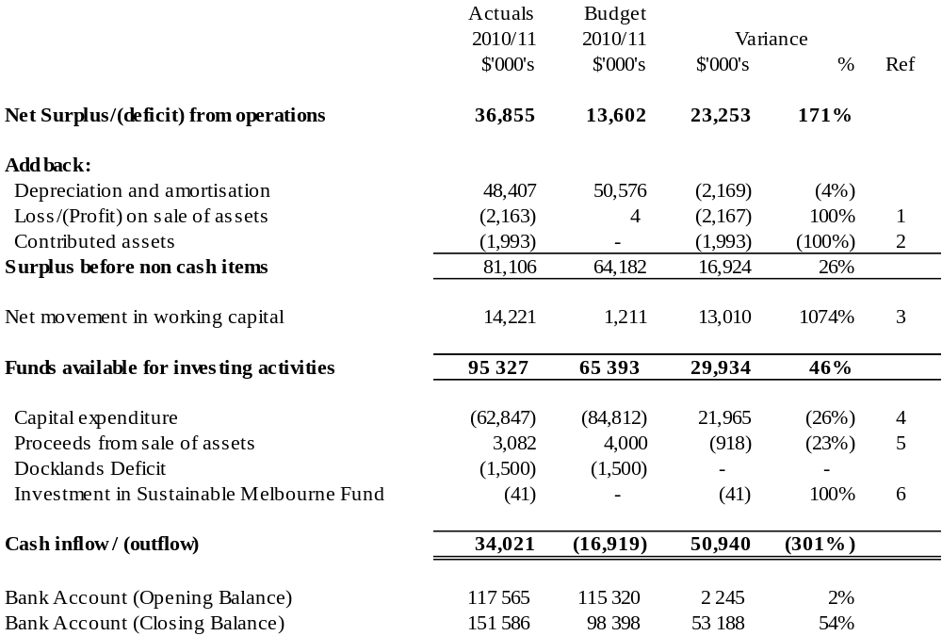

CITY OF MELBOURNE
Standard Statement
For the year ended 30 June 2011

Standard statement of cash flows (reconciliation)

Ref. | Item | Commentary
1 | Loss/(Profit) on sale of assets | Due to the sale of part of Penfold Place, Elloit Lane and part of Merriman Lane.
2 | Contributed assets | Contributed infrastructure assets from Docklands.
3 | Net movement in working capital | The net movement in working capital reflects an increase in creditors due to a higher level of accrued expenditure not yet paid.
4 | Capital Expenditure | Some capital projects have been carried forward into 2011-12 financial year resulting in lower cash outlay for capital expenditure.
5 | Proceeds from Sale of Assets | Lower than budgeted proceeds from the sale of Council’s assets.
6 | Investment in Sustainable Melbourne Fund | Annual distribution from the Sustainable Melbourne Fund which has been re-invested.

CITY OF MELBOURNE
Standard Statement
For the year ended 30 June 2011

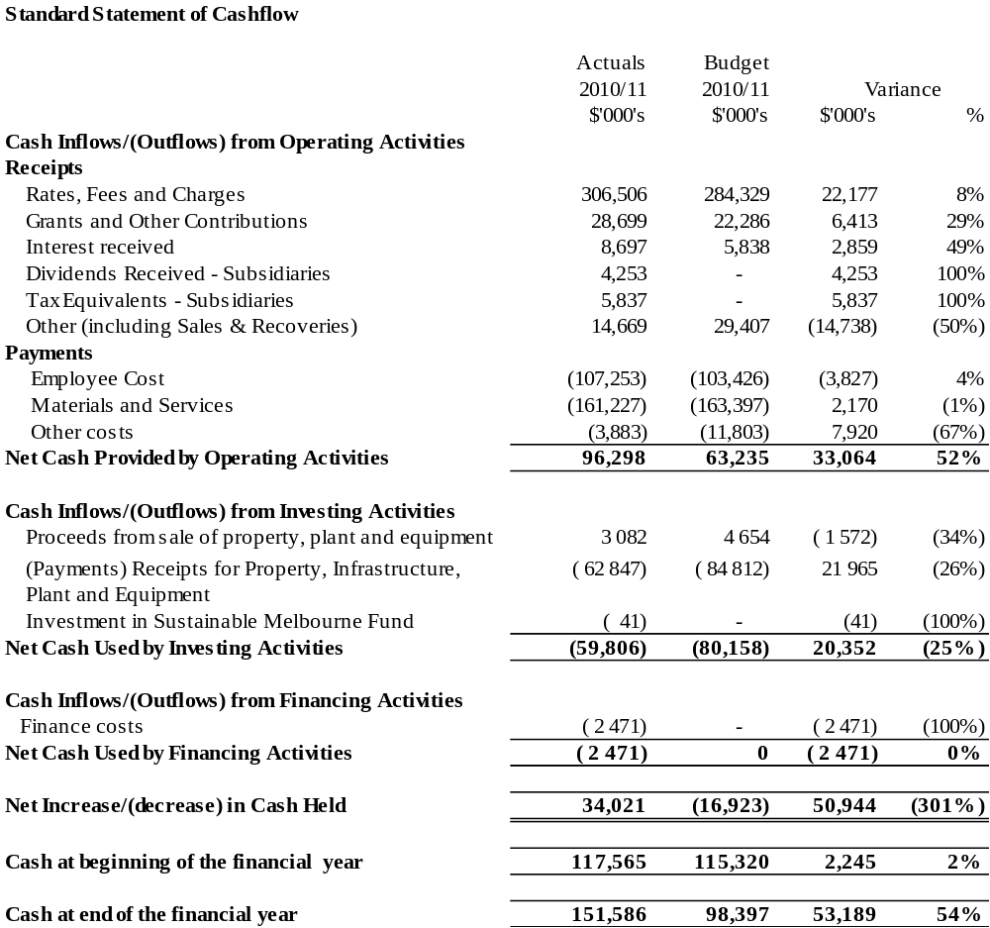
CITY OF MELBOURNE
Standard Statement
For the year ended 30 June 2011

Standard statement of capital works

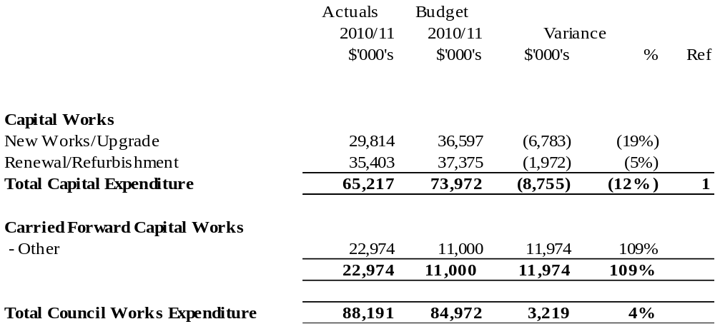

CITY OF MELBOURNE
Standard Statement
For the year ended 30 June 2011

Capital Works – comparison report

Ref. | Item | Commentary
1 | Capital Expenditure | City of Melbourne’s capital works program in 2010-11 included $4.67 million of unbudgeted works funded by additional contributions received from external parties. The value of capital works completed for 2010-11 is $65.22 million. A carry forward of $22.97 million into 2011-12 is required to complete the programs.  Highlights for the year included the completion of the following projects:  - Water Conservation & Climate Adaption Projects ($4.50 million);  - Commencement of Swanston Street Redevelopment Stage one on site ($3.90 million);  - Tan Track upgrade and redevelopment ($1.15 million); and  - Princes Park refurbishment of the Gardiner Stand ($0.82 million).

