Small Business Grants Program -Information Webinar

City of Melbourne

Contents
Acknowledgement of Country 3
Grant Program Overview 4
Objectives 4
Funding Streams 5
Open Stream 5
Shopfront Occupancy stream 5
Key Dates 5
Check your eligibility 5
Applicants must: 5
Assessment criteria 6
Business plan, workforce and experience 6
Benefits and impact to the City of Melbourne 6
Financial viability 7
What will we fund? 8
How to apply? 8
Applications must: 9
Assessment process 9
Additional support 9
Grant writing webinar 9
Questions about the grant? 9
Issues with your SmartyGrants application? 10
City of Melbourne’s Business Concierge 10
Previous recipients 10
MORK Chocolate 10
Wendy Voon Knits 11
Little Lon Distillery 11
Frequently Asked Questions 12

Acknowledgement of Country
The City of Melbourne respectfully acknowledges the Traditional Owners of the land, the Wurundjeri Woi Wurrung and Bunurong Boon Wurrung peoples of the Eastern Kulin and pays respect to their Elders past, present and emerging.
We are committed to our reconciliation journey, because at its heart, reconciliation is about strengthening relationships between Aboriginal and non-Aboriginal peoples, for the benefit of all Victorians.

Description of the figure above:
The Aboriginal Melbourne word mark acknowledges, the spiritual protector of the Birrarung. Five circular forms symbolise the Tanderrum Ceremony, and the bringing together of the five language groups of the Kulin Nation.

Grant Program Overview
The project must employ a workforce within the municipality.
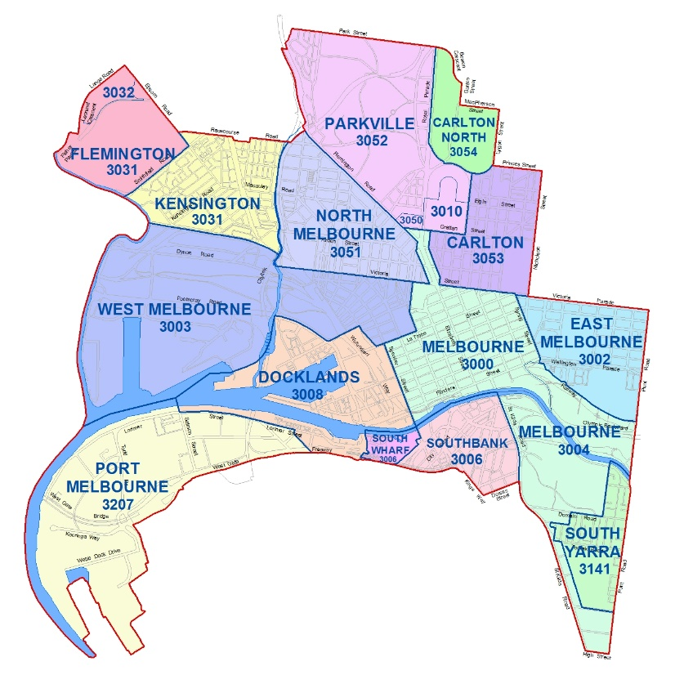
Description of the figure above:
A map of the City of Melbourne suburbs and their postcodes. From North to South these are: Flemington 3032 and 3031, Kensington 3031, North Melbourne 3051, Parkville 3052 and 3010, Carlton North 3054, Carlton 3053, West Melbourne 3003, Docklands 3008, Melbourne 3000 and 3004, East Melbourne 3002, Port Melbourne 3207, South Wharf 3006, Southbank, 3006, and South Yarra 3141.

Objectives
- encourage the establishment and growth of small businesses that:
  - enhance the City of Melbourne’s reputation for business innovation, creativity, diversity, inclusiveness and environmental sustainability
  - strengthen and diversify the local economy’s resilience by demonstrating a unique point-of-difference, sound business model and long-term financial viability
  - generate employment and investment opportunities
- enhance the city’s vitality by increasing the occupancy rate of shopfronts** across the municipality.
What is a Shopfront?
A street-facing, ground level commercial properties.

Funding Streams

Open Stream
Up to $20,000 available to any business that meets the eligibility criteria and program objectives.

Shopfront Occupancy stream
Has two options available:
- Up to $20,000 for shopfront vacant between 2 and 6 months
- Up to $30,000 for shopfront vacant for more than 6 months

Key Dates
Opened on Tuesday 22 August 2023 at 9am AEST
Closes at 12 pm AEST on Monday 25 September 2023
Assessment period will be in October and November 2023
Outcomes announced once letters of agreement have been signed.

Check your eligibility

Applicants must:
- be located within or committed to relocate promptly (within three months of receiving a grant) to the City of Melbourne municipality
- have a valid Australian Business Number (ABN)
- have less than 20 full-time or equivalent employees at the time of applying
- *Shopfront occupancy stream ONLY: provide evidence of a commercial lease (for a minimum length of 12 months) if relocating to City of Melbourne or moving to a larger premises within City of Melbourne.
*Please refer to full eligibility criteria in Program Guidelines.

Assessment criteria
- Business plan, workforce and experience 40%
- Benefits and impact to the City of Melbourne 20%
- Financial viability 40%

Business plan, workforce and experience
Demonstrate your business's operational plan including:
- Your unique point of difference
- Organisational structure and your team
- Main competitors
- Marketing strategy including target audience/customers
Your business’s purpose, vision and operational model.

Benefits and impact to the City of Melbourne
Familiarise yourself with two key Council documents:
- Council Plan 2021-25 is our long-term vision for Melbourne
- Economic Development Strategy 2031 is a 10-year economic, social and cultural plan
Outline your small business’s contribution to our City - it’s people and places.

Also refer to our commitment to United Nations Sustainable Development Goals.
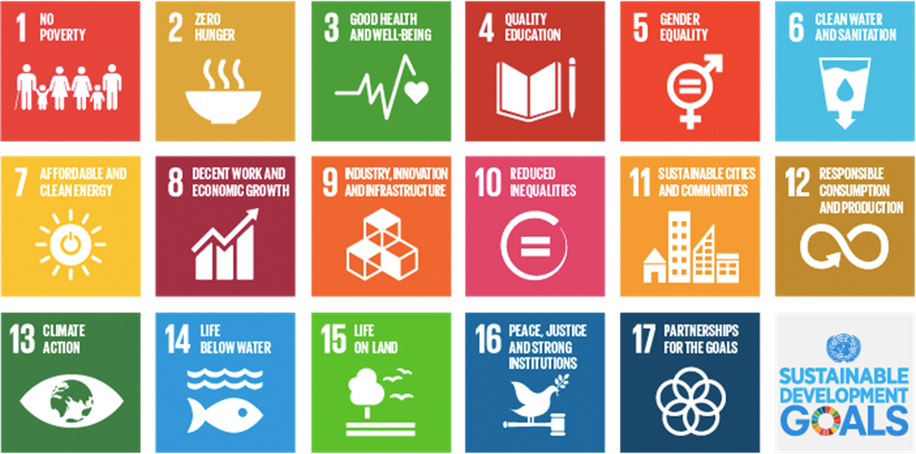
Pick the ONE your business identifies with the most.
Description of image above:
Graph showing the 17 United Nation Sustainable Developmental Goals.

Financial viability
You must provide financial statements and other additional financial information to validate your business’s financial viability.
Check our financial templates to support your application.
Evidence could include:
  - previous and projected financial statements
  - profit and loss
  - financial guarantee, or
  - financial reserve.
Outline the total investment in the enterprise
Note: It has been shown from previous grant rounds that those applications providing more financial information have a greater chance of success.

What will we fund?
Yes…
- Capital improvement costs associated with fit-out of business premises including, but not limited to furniture, cabinetry, joinery, partitioning, flooring, shelving, and painting.
- Website development or enhancements
- IT equipment (purchasing hardware (computers, laptops, printers, servers)
- Specialised equipment and software (directly related business operation)
- Other expenditure items (clearly demonstrate the need)

No…
- Operational expenses which are ongoing costs to run the business, such as rent, utilities, legal costs, marketing, wages and personal expenses.
- Applications that do not meet the eligibility or assessment criteria.
- Expenditure items incurred prior to the date the business submitted an application.

How to apply?

Applications can be completed online using SmartyGrants.

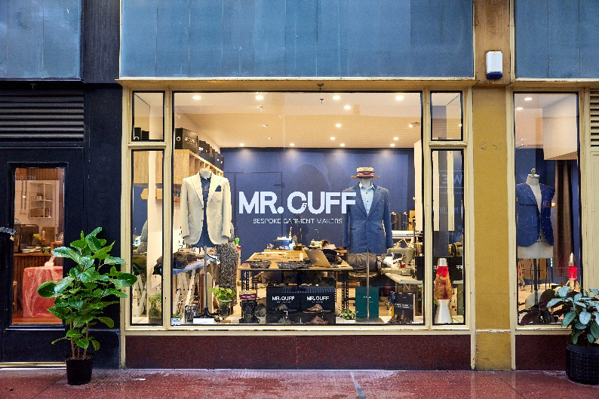
Description of image above:
Photo of Mr. Cuff Shopfront in Melbourne’s CBD.

Applications must:
- meet all eligibility criteria
- address all assessment criteria
- answer all questions
- submit by 12pm on Monday 25 Sept 2023

Assessment process
- Due diligence: ensure all eligibility criteria are met
- Panel assessment: applications individually assessed by a panel
- Recommendations: selected applications go to Council for their decision
- Notification: outcomes will be communicated through SmartyGrants

Additional support

Grant writing webinar
By Small Business Mentoring Services
11am on Monday 11 September
Register via QR code or using this link.
Description of image above:
QR code directing to the Grant writing webinar registration form.

Questions about the grant?
Contact businessfunding@melbourne.vic.gov.au to discuss the grant opportunity with our team

Issues with your SmartyGrants application?
Call 03 9320 6888 or email service@smartygrants.com.au
Open Monday to Friday 9am to 5pm.

City of Melbourne’s Business Concierge
A dedicated team of case managers who can assist:
- new businesses with getting started at all stages
- existing businesses to transform their operating models
- connecting all businesses with the right business mentoring service, at the right time to achieve business success
One-stop shop for your business
Providing information from all levels of Govt. and other organisations
Call 9658 9658 (press 1 for business) or book online or use the QR Code.
Description of image above:
QR code directing to the City of Melbourne Business Concierge booking form.

Previous recipients

MORK Chocolate
Opened their North Melbourne café in 2012 and after receiving a Small Business Grant in 2014 they have grown to multiple cafes, a chocolate factory and have operations in UK and Japan.
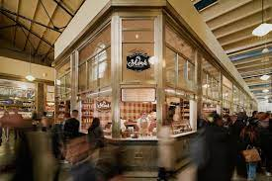
Description of image above:
Mork Chocolate shopfront at Queen Victoria Market.

Wendy Voon Knits
This local fashion designer received a small business grant in 2017 to expand her retail space by offering customers a personalised retail service.
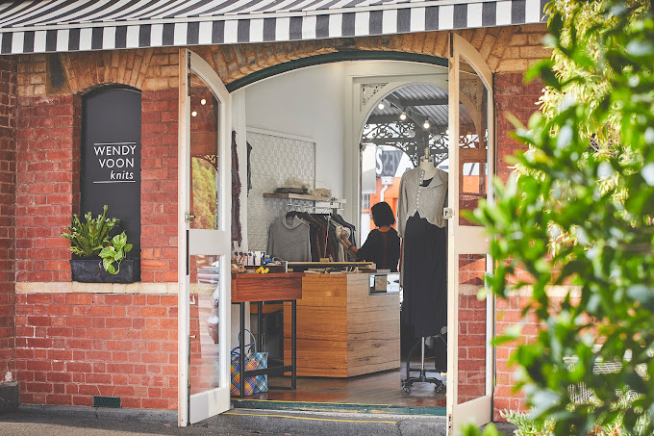
Description of image above:
Wendy Voon Knits shopfront at Queen Victoria Market.

Little Lon Distillery
Operating out of Melbourne CBDs last remaining single story house, this popular distillery received a small business grant in 2019 to create a special whiskey that’s been maturing in a cell at the Old Melbourne Gaol!
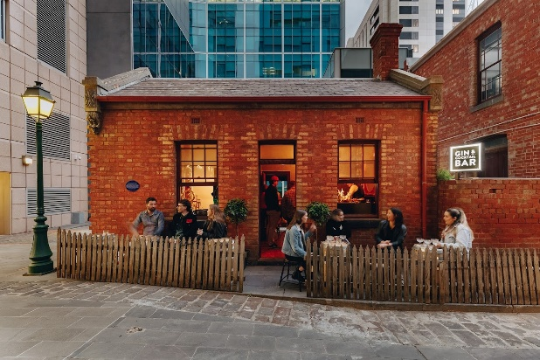
Description of image above:
Little Lon Distillery shopfront image at 17 Casselden Pl, Melbourne.

Frequently Asked Questions
Q – Can my business apply more than once?
A – No, only one application per business/ABN
Q – Can I apply for grant funding if I have received grant funding from other sources for my business?
A – Yes – however, you must clearly demonstrate how the funding request is different from the activity that you’ve received funding for.
Q – Insurance – Certificate of Currency – do I need to submit one?
A – Yes – your application requires you submit evidence of appropriate insurances to be accepted for assessment.
Q – Can I apply for retrospective activities?
A – No – only expenditure items incurred after the date your application was submitted. Please note, priority will be given to leases signed for vacant shopfronts after 1 July 2023.
Q – When will I get my money?
A – As per the funding agreement, once executed and an invoice is received. Standard payment terms are 30 days from the date being issued to City of Melbourne.
Q – What if my proposed activity fails or does not occur?
A – You must inform us as soon as you know this to be the case. If you are facing challenges with delivering your proposed activity, please contact us to discuss you options.
Q – Can you provide feedback on my application before I submit?
A – No, we cannot provide feedback or advice on the contents of your application. This is a competitive grant process.
Q – Can I get an extension to submit my application?
A – No, however we will consider on a case by case basis if you are having technical issues on the closing date. *Tip – don’t leave submission to the closing date.

Description of image above:
QR code directing to the Small Business Business Grants website.

https://www.melbourne.vic.gov.au/about-melbourne/melbourne-profile/Pages/City-maps.aspx
https://www.melbourne.vic.gov.au/about-council/vision-goals/Pages/council-plan.aspx
https://www.melbourne.vic.gov.au/about-council/vision-goals/Pages/economic-development-strategy-2031.aspx
https://www.melbourne.vic.gov.au/about-council/vision-goals/Pages/united-nations-sustainable-development-goals.aspx
https://www.melbourne.vic.gov.au/SiteCollectionDocuments/small-business-grants-2023-24-financial-templates.XLSX
https://fs11.formsite.com/tUhAxI/bbbwjijggj/index
https://www.melbourne.vic.gov.au/business/Pages/business-concierge-service.aspx
https://www.melbourne.vic.gov.au/business/grants-tenders/small-business-grants/Pages/small-business-grants.aspx

