Powering Business in Victoria – Market Facilitation Platform
City of Melbourne Submission to Department of Environment, Land, Water and Planning
November 2021
26 November 2021
Department of Environment, Land, Water and Planning
PO Box 500 East Melbourne VIC 8002
To DELWP Energy Transition Projects
RE: MARKET FACILITATION PLATFORM
The City of Melbourne welcomes the opportunity to provide input into the Powering Business in Victoria Market Facilitation Platform consultation. This submission is provided on behalf of Council by the management of the City of Melbourne. It is based on endorsed Council policy and informed by City of Melbourne’s direct experience in leading and facilitating two successful group Power Purchase Agreements.
City of Melbourne commends the Victorian Government for its Victorian Renewable Energy Target (VRET) and Renewable Energy Zone (REZ) initiatives to support the build-out of renewable energy generation and transmission; and for now seeking to develop pathways to enable large energy users to access the benefits of renewable PPAs through its Powering Business in Victoria program.
PPAs have, and continue to play, a vital role in driving renewable energy investment and grid decarbonisation in Victoria and across the nation. Supporting the uptake of PPAs would be a highly effective and worthwhile initiative for the Victorian Government to pursue to meet its energy sector pledge and support the community transition to zero emissions.
Moreover, by enabling businesses greater access to PPAs, the Victorian Government could support businesses to manage their energy costs and climate risk exposure. A well-designed PPA has the potential to deliver multiple benefits to buyers: electricity cost reductions, greater budget certainty, the ability to hedge against energy market volatility, reputation and brand benefits, rapid and substantial emissions reductions, and the ability to meet net zero or carbon neutrality commitments.
City of Melbourne applauds the intention of the Powering Business in Victoria Market Facilitation Platform (MFP) and the scope of the program being proposed. We believe that an MFP, if designed effectively, could bring enormous benefits to the Victorian economy and accelerate the energy transformation.
Having facilitated two group PPAs involving twenty diverse organisations, City of Melbourne has a deep appreciation of the benefits that PPAs can deliver to buyers, industries, and regions. We also possess a unique understanding of the challenges, complexities, and barriers facing buyers, retailers and developers; the role of advisers; the interests of financiers; and crucially, knowledge of the key success factors that enable a successful group transaction.
The City has a strong interest in seeing the creation of an effective MFP and has relevant insights to share. To this end, this submission highlights some key insights and opportunities for consideration and makes a number of recommendations for strengthening the MFP’s ultimate design.
- Establish an Expert Reference Group to inform the design of the MFP
In 2017 the City of Melbourne, along with 13 project partners, announced the Melbourne Renewable Energy Project (MREP) - one of Australia’s first renewable PPAs, and very likely the world’s first group retail PPA. The MREP Group’s purchase of 88GWh per annum over ten years catalysed the construction of the Crowlands Windfarm – a $200 million, 39 turbine, 80MW capacity windfarm near Ararat in Western Victoria. The project created 140 construction jobs and 8 ongoing operations and maintenance jobs, and led to the establishment of a Sustainable Communities Fund that will continue to deliver a portion of the revenue from the windfarm back to the local community each year, for 25 years. Building on the lessons we learnt in delivering the first MREP, the City facilitated a second renewable PPA in 2020 with a group of 7 leading corporates, who secured an 110GWh per annum retail PPA under a 10 year supply agreement with a portfolio of existing Victorian wind assets.
MREP1 was an innovative and ground-breaking initiative that supplies the equivalent of 2 per cent of the city’s electricity demand; and MREP2 demonstrated the viability of group PPA models for a broader range of industry sectors. Combined, MREP1 & 2 account for the equivalent of 5 per cent of the city’s community-wide greenhouse gas emissions.
The City of Melbourne pioneered, and successfully replicated, a model for collective renewable energy purchasing which has inspired and been emulated by local governments and businesses across the county. These include the SSROC Group of Councils in NSW, the South Australian Chamber of Mines and Energy, the Australian Hotels Association, and most notably the Victorian Energy Collaboration (VECO) – a landmark initiative led by Darebin City Council – that enabled 46 Victorian councils to switch to renewable electricity, under a 9-and-a-half year retail PPA deal for a combined load of 240 GWh per annum.
Since MREP1, only three group PPA deals have been struck in Victoria. All three involved local governments, and two of these, MREP2 and VECO, were led and facilitated by representatives from local government. The teams involved in these transactions possess deep expertise in running PPA programs. To draw on this experience, we recommend the Victorian Government establish an Expert Reference Group, comprised of local government representatives and others from the private and NGO sectors, who could help inform the design and development of the MFP and better ensure its successful delivery.
Furthermore, the release of this MFP consultation is ideally timed to access insights from a Business PPA program currently being developed by the City of Yarra, in collaboration with the cities of Darebin, Moreland, Port Phillip, Melbourne, and the Eastern and Northern Alliances for Greenhouse Action. The council working group has developed a specification for a facilitation service provider and is beginning an engagement process to recruit businesses. Close consultation and partnership with this group of local governments could avoid duplicated effort and deliver outcomes for Victorian businesses, the Victorian Government and the Councils involved.
- Prioritise and design the MFP around facilitation services
The MFP Consultation Paper provides an insightful and comprehensive assessment of the many barriers faced by parties involved in a PPA, particularly buyers. City of Melbourne agrees that complexity, lack of knowledge and internal capability, transaction cost, size, bankability, contract tenure, and difficulty in forecasting future market conditions and assessing financial risks and benefits, are all significant barriers that a well-designed MFP has the potential to address.
However, based on City of Melbourne’s experience, our view is that establishing a platform to connect PPA buyers and sellers and providing information, market intelligence, guides and templates, would be, in and of itself, insufficient to drive significant PPA uptake by businesses. The Business Renewables Centre Australia (BRC-A) already provides extensive resources, information, educational support to buyers, and does so freely and extremely well. Nevertheless, the deals struck in recent years have almost exclusively transacted by very large and sophisticated organisations.
Considering these facts, we conclude that load size, internal capacity, and transaction complexity present more of a barrier to buyers than information. This view is supported anecdotally as seven organisations have approached the City of Melbourne in the past 18 months seeking involvement in a group PPA, citing that they feel they lack the scale or capability to undertake a transaction alone. Furthermore, when City of Melbourne polled attendees to a BRC-A webinar it presented at in August 2020 on the topic of group PPAs, more buyers believed they would be unable to contract alone, compared to those who could (noting that the many were also unsure).
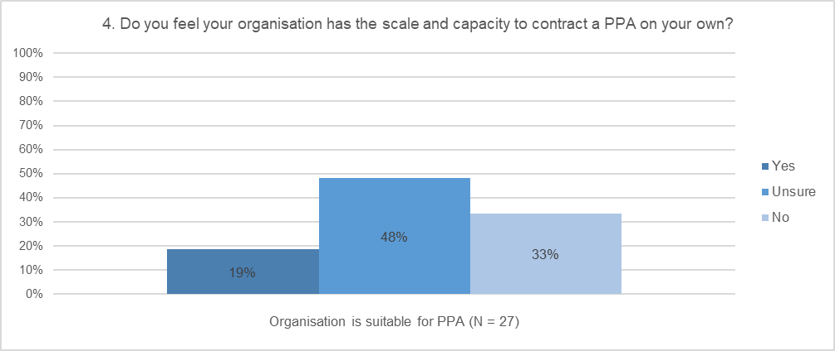

Aggregation
Aggregation through buying groups should be the central component of any program that seeks to enable more commercial and industrial (C&I) businesses to gain access to PPAs, as aggregation addresses barriers of scale and transaction costs, and increases the likelihood of sharper pricing for buyers through coincident demand/supply matching and economies of scale. By aggregating the electricity demand of multiple organisations, and by pooling knowledge and sharing resources, buying groups are able to increase their purchasing power and secure better commercial outcomes - while also achieving greater social and environmental impact by enabling investment in new renewable energy projects in the regions.
In the City’s view, the primary market barrier and gap that needs to be filled is not information or connection to developers and retailers, but rather access to aggregation and facilitation services to assist them through the transaction journey. In a group PPA, facilitation is necessary to coordinate and streamline the process and is fundamental to ensuring a successful transaction. As it relates to aggregating groups of buyers, the Consultation Paper and the MFP it contemplates is severely limited by not recognising the vital role, and need, for hands-on buyer support and project facilitation.
As demonstrated by MREP1&2 and VECO, aggregation and facilitation is a proven strategy for addressing many of the barriers facing buyers – scale, transaction complexity, transaction cost – and assisting the process of collective decision-making. Without experienced and effective facilitation, attempts at aggregation typically fail. A lack of facilitation providers, and access to credible and affordable facilitation services, should be one of the primary barriers that the MFP seeks to overcome.

Group PPA models
A group PPA will not be a necessary or desirable solution for every organisation, however for many C&I buyers, particularly those ranging in scale from 2-40 GWh, a group PPA may present an attractive proposition. Moreover, for entities motivated by the need to achieve broader social, environmental and economic outcomes, such as governments, industry peak bodies, or purpose-driven corporates; aggregated PPA models are potentially transformative.
Based on the 7 group PPAs that have been contracted in recent years, there are three broad types or models:
Model | Group
Lead customer | MREP1, VECO, Telstra Club
Regional or industry association | SACOME, AHA, SSROC
3rd party facilitator | MREP2
The BRC-A has (as presented at buyer Bootcamps) further classified the different types of group deals as follows:
Description | Group & Project | Comments
Form together | VECO (Portfolio)  SSROC (56 MW Moree Solar Farm) | Generally organisations of similar scale and nature. Jointly assess options, perform procurement and negotiation together.
Lead and Tag Along (anchor buyer) | Telstra Club (226 MW Murra Warra Wind Farm) | One lead (generally larger) off-taker takes lead, with others joining. Lead organisation sets agenda, manages process, others choose whether to join.
Procure first, bring others |  | Easier to pitch a tangible project and deal to buyer internal stakeholders.
An effective group PPA facilitation model typically involves the following elements:
Aggregation to achieve scale | Better price for buyers. Bankable revenue to catalyse new projects
Facilitation and coordination | Expert, structured facilitation and project management support to streamline, simplify and de-risk the transaction for buyers
Shared cost and effort among Buyers | Lower transaction costs (energy, legal, procurement, facilitation) and overall resourcing requirements

The value and need for facilitation
Aggregated Group PPAs are a more challenging prospect for all parties involved – buyers, retailers/developers, and advisors – however the upside benefits for these parties are significant.
 | Benefits
Buyers | - Increase scale: ability to access PPA products, and leverage collective buying power to achieve sharper pricing / more favourable terms  - Shared (lower) transaction costs: with lower individual costs but ability to properly fund energy and legal advisors and outside expertise (ie. facilitation)  - Greater choice: attract more offers from the market, access to lower risk price models (small buyer products tend to be more spot exposed / riskier  - Increased bargaining power: potential to negotiate more favourable terms (eg. volume management / flex provisions, account management resources, etc)  - Sharing of expertise and workload: potential for buying group to share knowledge and effort. More capable and experienced buyers can support lesser buyers.  - Internal approval: confirmation by group can provide greater comfort to decision makers  - Intangible benefits: increased confidence, peer learning  - Collective impact: achieve greater social, economic and environmental outcomes, ability to directly support new generation
Developers / Retailers | - Bankability: increased pool of revenue, secure credit-worthy off-takers  - Access to finance: demonstrate higher revenue stream and revenue certainty, to secure finance for new projects  - Amplified marketing: brand association with multiple customers, more customers promoting the PPA
While aggregation can unlock multiple benefits to buyers and retailers/developers, the also present a range challenges. These challenges can be addressed with access to, and resourcing of, a facilitation function.
 | Challenges | Facilitation Function
Buyers | - Agreeing common objectives  - Governance  - Establishing evaluation criteria and procedures  - Navigating diverse internal processes and requirements  - Balancing individual organisational priorities against group priorities  - Internal stakeholder management  - Interpret technical info, manage fees  - Certainty of outcome | - Ensure aligned group, clarify preferences  - Est. collective decision-making principles  - Ensure transparent evaluation procedures. A trusted party to Chair to evaluation sessions  - Expertise to support internal teams and senior decision makers  - Confirm and formalise the group’s approach to cooperation  - Resources to support buyer teams  - Translating and summarising material issues  - A robust, credible and supportive process
Developers / Retailers | - Understanding buyer requirements  - Contractual complexity, negotiation  - Different levels of credit-worthiness  - Certainty of outcome | - Clear tender spec, summary of group position  - Buyer side engagement to confirm key terms  - Forming a bankable buying group  - A robust, credible and supportive process

The roles of a facilitator
The experience with MREP 1&2 and VECO highlights the strong need for a project lead to facilitate the process and coordinate the parties. In each of these projects, local governments played this role, ensuring each individual buyer was supported through the process.
Resourcing constraints within local government and the unique skillset required means that ongoing facilitation for local governments, particularly in regional areas, is not a sustainable model. The MFP presents an opportunity to support a trusted facilitator. Commercial facilitation of group PPAs has not gained a strong foot hold in the Australian market, likely in part due to the importance of trust and impartiality required of an effective facilitator. The Victorian Government is well placed to overcome these barriers.
As facilitator in MRPE2, City of Melbourne was guided by the objectives and needs of Group participants. Decisions regarding the tender specifications, deal structure and preferred offer were made by the buyers themselves; nevertheless the role of a credible and independent facilitator was crucial to coordinate and guide the transaction.
The facilitator role is diverse and an effective facilitation service should include support for most, if not all, of the following:
Form the group | Seek EOIs from interested buyers, leveraging networks and channels of aligned partners (e.g. SV, BRC-A)
Build capacity | Workshops to educate buyers about the process and the energy market, as well as different PPA contract structures and pricing models.
Ensure alignment | Seek input from buyers on their drivers, objectives, risk tolerance, and contract model preferences.
Engage advisors | Assist development of a scope of work for professional services (energy, legal, procurement, etc.), run / support RFQ process to engage.
Develop business case | Obtain detail from buyers on energy load, credit rating, energy/sustainability strategy.
Confirm commitment | Primarily with input from an energy advisor, produce high level, buyer-specific financial assessment of renewable electricity procurement options.
Establish governance | Work with customer group to define PPA parameters and group arrangements (cost sharing, IP, confidentiality, etc.). Draft and execute an agreement to formalise collaboration and commitment (Memorandum of Understanding).
Develop go to market strategy and RFT package | With buying group members, establish governance and decision making arrangements, structures, and procedures (e.g. MOU, lead customer role, procurement and probity plan, Evaluation Panel, evaluation procedures, Negotiation Team and strategy, development of Participant Agreement, etc.)
Release tender | Coordinate buying group and energy, legal and procurement advisors to develop RFT package, and finalise go to market strategy
Support evaluation | Coordinate issuing of RFT and prepare Evaluation Panel for to undertake evaluation
Support contractual negotiations | Support Evaluation Panel; coordinate consultant technical, commercial, and legal review; facilitate Evaluation Panel moderation sessions and decision making to shortlist, obtain BAFO’s, and select preferred proponent
Support due diligence | Assist negotiation team with contractual negotiations with proponent, coordinate drafting and input from all buyers
Support contract execution | Work with buyers and legal advisors to draft a Participants Agreement to provide a framework for ongoing relationship between the parties post-contract
Award and announcement | Provide individual support and assistance to each buyer and their internal decision makers. Coordinate advisors as required
Project management | Confirm acceptance of contract terms, support contract execution
The MREP2 group formation and transaction process took 2 years – approximately half the time of the first MREP - and the Group’s transaction costs were considerably lower. This highlights to key points: group PPA models work and can be replicated, and an experienced facilitator saves buyers time and money.
The benefits of aggregation and the role of a facilitator are summarised below:
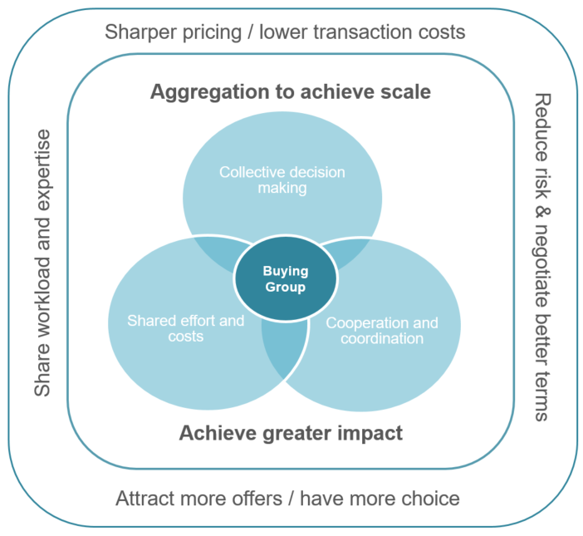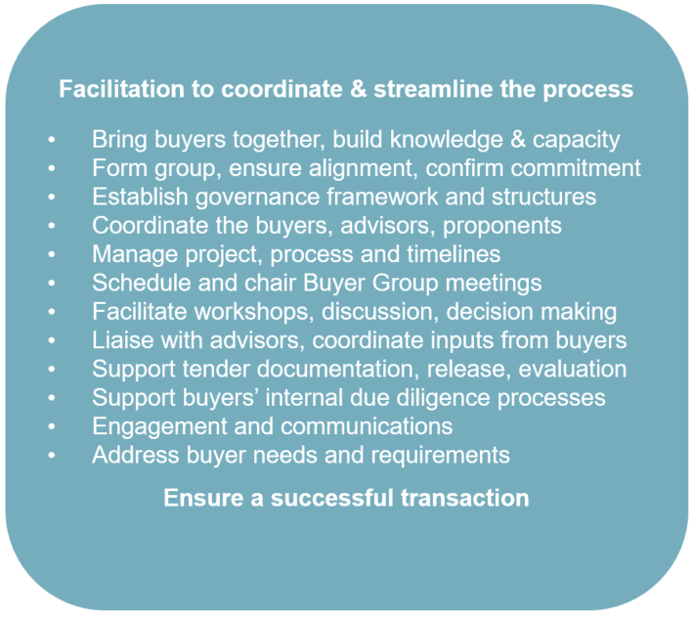
Figure 1: Elements of a successful group PPA Model. Source City of Melbourne
- Consider the needs of smaller C&I buyers
A deep understanding buyer preferences should help inform how the MFP is designed. The City of Melbourne has collected multiple insights into buyers’ needs and preferences through the process of supporting 20 organisations across a diversity of sectors, including:
5 Corporates – Next DC, Citywide, Australia Post, Bank Australia, NAB
4 Councils – Melbourne, Port Phillip, Moreland, Yarra
3 Manufacturers – Mondelez International, Fulton Hogan, Citywide Asphalt
3 Cultural institutions – Fed Square, Melbourne Zoo, Melbourne Convention and Exhibition Centre
3 Universities – RMIT, University of Melbourne, Deakin
2 Property owners – ISPT, CBUS
As demonstrated by the list above, often very large (and bankable businesses) still see benefit in group buying. This is driven by a number of factors, highlighted in Figure 2 below.
At a BRC-A webinar the City delivered on the topic of Group PPAs in August 2020, attendees were polled to understand the opportunities they see in group deals. The results reveal that PPA players see a broad range of benefits and opportunities:
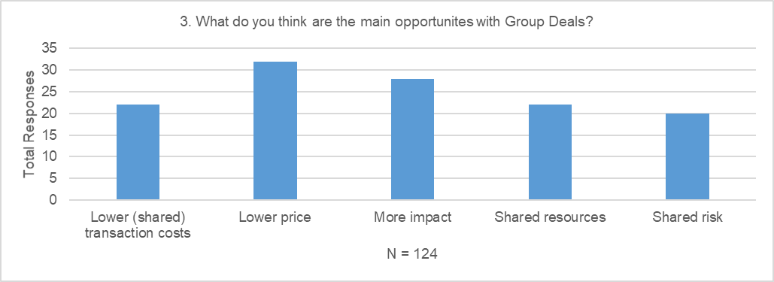
Figure 2: Insights on the opportunities with Group Deals
Through the City’s experience and direct engagement with businesses with annual loads of 2-40 GWh, we have developed a nuanced understanding of buyers’ needs and preferences:
Aspect | Summary of insights / buyer characteristics
Industry type | - Group PPAs are a viable option for buyers across industry sectors
Profile | - Educated and proactive energy buyers see PPAs as an attractive option  - PPAs attractive to buyers with strong sustainability drivers  - Energy spend >$1 million  - Group PPAs appealing to buyers with load size 2-40 GWh per annum
Risk | - Low appetite for risk  - Buyers wish to avoid risks associated with the development of new generation and/or connection to the grid impacting their business energy contracts, and prefer a retail-intermediated PPA where the retailer took this risk on
Product | - Buyers are disposed against ‘contract for difference’ (CFD) / wholesale PPA products due to: high spot risk exposure, derivative accounting requirements.  - Preference of retail PPAs due to: risk, familiarity, budget certainty  - Partial fixed price products desirable (portion of price set with reference to prevailing market conditions in future years manages upside and downside risk).  - Products with price reset mechanism (~2 years) seen as desirable to mitigate risk of paying above the market longer term
Price | - Buyers need prices to be competitive relative to existing energy contracts  - Buyers require a model of future energy market conditions and price forecasts to contemplate contracting longer term (ie. 5 years+), and as such they rely on expert advice
Tenure | - Whilst buyers preference is for a term comparable with traditional contracts, they accept and expect they will need to sign a longer-term deal for a renewable PPA  - 10 year acceptable for medium-large buyers  - 5-7 year more attractive to smaller C&I buyers, noting price benefits typically diminish
Capability | - Buyers tend not to possess high knowledge of PPA process, risks, and benefits  - Buyers do tend to have highly capable personnel with relevant skill-sets  - Group PPA models usually require a ‘lead customer’ to be the transacting entity for external advice (legal) and to play a leadership role in the Group. Lead customers ideally have greater in-house capability than their peers
Consultants | - Buyers accept they will have higher upfront costs as they will need to engage energy and legal advisors and invest resourcing the transaction process. Many already do this as part of their procurement and acknowledge that those costs will be amortised over a longer supply period
Resourcing | - Buyers are prepared to share transaction costs for external advisors  - Buyers will fund facilitation, where overall transaction costs are lower than contracting alone  - Buyer organisations often have experienced and knowledgeable personnel and teams, and in-house capability that can be drawn on for material support
In the City’s experience, the positions of buyers have been fairly consistent across the board. The consistency of the feedback highlights a need for buyers to be able to access facilitation services to support them through the process, as well as an opportunity for the MFP to support the standardisation of retail sleeved PPA products.
- Core elements of a successful MFP
It is our strongly held view that direct engagement support and facilitation of businesses is critical for the MFP to be successful. While features such as information, guides, templates, data and research, and a database of projects, experts, and advisors would be valuable, an MFP would be unlikely to meet the needs of C&I businesses, or lead to PPA demand of a scale necessary to fill the pipeline of generation projects unless it provides a pathway for buyer aggregation and facilitation.
Recognising that most C&I businesses (i.e. those outside the top 100 largest energy users) typically do not have the scale to access PPAs products that meet their commercial requirements (e.g. low spot exposure retail PPAs) or the in-house capability to navigate a transaction; aggregation and facilitation must form part of the solution. As such, the City of Melbourne recommends Victorian Government consider designing the MFP to include the following elements:
Pathways to enable facilitation services
- Pathways and incentives to support the creation/development of facilitation service providers, including resourcing to substantially underwrite costs of service delivery.
Some facilitation costs should also be borne by buyers themselves, so the value of facilitation is visible and appropriately recognised in the marketplace. Over time (i.e. over 1-3 deals), the financial support from government to the approved facilitator could decrease, while buyer contributions increase; recognising that facilitators can be expected to become more efficient and effective with each transaction (as was the case from MREP1 to MREP2).
The funding model for facilitators ought to be designed with progress payments or similar, corresponding to transaction milestones, so as to ensure facilitators are incentivised to invest effort across all stages of the process. Such a funding model may serve to disincentive or even eliminate fee structures that do not serve interests of buyers; such as brokerage fees and trailing commissions, which erode the value of the PPA for buyers, and undermine the credibility of facilitation models.
- A selection process for prospective organisations to become ‘approved’ facilitators. Prospective approved facilitators to be assessed on eligibility criteria including capability and experience, public interest focus (eg. private or for purpose: industry association, council, NGO, etc), lump sum or schedule or rates, and proposed facilitation model / methodology. This could take the form of a supplier panel, similar to other Victorian Government initiatives, such as the Greener Government Buildings program.
We note that the Department of Treasury and Finance already runs a program for training and accrediting investment management facilitators, and suggest that such a program could be leveraged to ensure MFP approved facilitators are appropriately vetted and qualified. Such accreditation would build facilitator capability, and buyer trust in the facilitators’ ability and independence - both of which are critical ingredients for a successful transaction.
In addition to establishing a facilitator approval process, the MFP facilitation service should leverage resources and insights that local government representatives have developed through the course of MREP and VECO deals. Tangible resources include MOU’s, tender specifications, procurement plans, group evaluation procedures, and Participant Agreements, which could all be adapted into templates for prospective facilitators. Similarly, insights related to managing group dynamics, collective decision-making, and other diverse facilitation functions could be provided. Involving individuals with experience in group PPAs would assist knowledge transfer, help build facilitator capability and reduce the risk of deals falling over due to inadequate or ineffective facilitation support.
- An approach to facilitator approval that enables different types of facilitation providers as appropriate for different aggregation models (lead customer, regional grouping, industry association, third party – for profit and not for profit, or new models). The approach should allow for ‘lead customers’ to access resources, thereby encouraging lead buyer facilitation models such as MREP and VECO.
- A directory for facilitators to promote services, find buyers, and bring together groups of buyers with aligned preferences.
Pathways for aggregators
- Opportunities and support for aggregators (industry associations, anchor buyers, etc) to initiate buying groups and find group facilitators.
Councils also have extensive networks and existing relationships with businesses across the State and could be supported and resourced to recruit a ‘pipeline’ of interested business via their economic development teams.
Pathways for buyers to join group deals
- A directory for buyers to find facilitators, as well as other expert advisors (energy, legal). Platform to enable registrations of interest, collect details about organisational profile (load size and shape, supply contract end date, business drivers, sustainability commitments, etc), and PPA product preferences (wholesale, retail, tenure, etc). Preferences to be collected and made available to ‘approved’ facilitators to assist formation of aligned buyers groups.
Pathways for channel partners to stimulate demand
- Collateral and resourcing to enable for-purpose organisations to promote PPA opportunities to their stakeholders, and drive C&I buyers towards the MFP’s aggregation and facilitation support services. Such engagement would help stimulate buyer side demand and interest in the MFP, and help create a pipeline of prospective off-takers needed to support an increasing pipeline of generation projects.
Information to assist product side development to meet market needs
- Aggregated / de-identified data on buyer profile and preferences made available to retailers / developers, to enable PPA product innovation. This would support development of products to meet the commercial needs of mid-size C&I businesses (e.g shorter tenure, lower spot exposed retail products) and may lead to standardisation of PPA products (reducing complexity for C&I customers, simplifying evaluation, and reducing transactions costs associated with energy and legal advice). There should also be transparency for buyers of different PPA offerings, price and risk profiles, to simplify options and support buyers to make informed decisions.
Stimulate the supply side of the market by engaging with retailers
- Encouragement for retailers to develop more standardised contractual arrangements and commercial key terms that can be shared with prospective buyers before tendering processes are initiate. This would aid in managing expectations from the outset, expedite ‘match-making’ between buyers and sellers and create efficiencies in transactions processes.
The retail PPA market is relatively immature and PPA offers are historically bespoke in nature. There are approximately 10-15 retailers offering PPAs in the Victorian market, each with their own specific offer characteristics and commercial key terms. These characteristics and terms will often be a key determinant of its suitability for a particular buyer, based on their risk profile.
- Extend and enhance the Business Renewables Centre
The Business Renewables Centre Australia (which was seeded with funds from the Victorian Government) provides extensive resources, information, and educational support for parties involved on all sides of the PPA process. BRC-A has been operating for a number of years and has undoubtedly enhanced industry capability (buyer, retailer / developer, advisors) to transact PPAs. City of Melbourne staff have participated in multiple Buyer Bootcamps attended numerous webinars, and recommended the BRC-As roadmap, primers, and guides to prospective buyers; and befitted from the significant market insights contained in BRC-A’s State of the Market reports. The reach, impact and effectiveness of the BRC-A in educating and engaging buyers is difficult to overstate.
City of Melbourne staff have also contributed to the strategic direction and resources developed by the BRC-A through membership on the Technical Advisory Panel. This governance arrangement could be drawn upon to inform further engagement in the design of the MFP, as per recommendation 1 in this submission.
The City of Melbourne notes that many of the elements of the MFP outlined in the consultation paper – such as information, templates, and a marketplace – are offerings that are already very well provided by the BRC-A. The Marketplace element of the BRC-A’s portal, which connects corporate buyers with developers and retailers of available renewable energy, is arguably not as effective as envisaged, nevertheless it houses an extensive listing of projects and contact details to enable buyers and sellers to connect. Given PPAs are complex transactions which involve significant investment and risk, the under-utilisation of the BRC-A's Marketplace for deal-making purposes may be less a feature of its design and more a reflection that buyers are (understandably) unwilling to transact multi-million dollar deals in a superficial way and without thorough due diligence.
The City of Melbourne would support the MFP avoiding any duplication of effort and ensuring that the existing resources developed by the BRC-A are built upon. This could be achieved by extending and enhancing the BRC-A with funding to support its continued operations, and invest in its build-up and expansion with Victoria-specific content and service offerings.
The City of Melbourne appreciates the opportunity to provide input into this consultation process and is committed to supporting the Victorian Government’s development and delivery of a Market Facilitation Platform, and the transition to zero emissions.
Yours sincerely,
Krista Milne
Co-Director, Climate Change and City Resilience

https://www.pacifichydro.com.au/our-communities/community-investment-program/crowlands-sustainable-communities-fund/
https://businessrenewables.org.au/deal-tracker/
https://www.energetics.com.au/insights/knowledge-centres/corporate-renewable-ppa-deal-tracker
https://businessrenewables.org.au/webinars/
https://businessrenewables.org.au/webinars/
https://www.dtf.vic.gov.au/investment-management-standard/facilitator-guidance-and-templates

